Research Proposal

By Glesni Loveridge

Table of Contents

- Introduction................................................................................................ Page

  - Rationale.............................................................................................. Page 3
  - Background and Literature Review..................................................... Page 4
  - Aims and Objectives............................................................................ Page 5

- Research design and methodology

  - Methodology...................................................................................... Page 6
  - Philosophy.......................................................................................... Page 7
  - Research Approaches......................................................................... Page 7
  - Research Method and Strategy.......................................................... Page 8
  - Data Collection.................................................................................. Page 8
  - Data Analysis..................................................................................... Page 9
  - Time Managing Sample............................................................... ...... Page 9
  - Ethical Considerations....................................................................... Page 9

- Resources and planning

  - Resource.......................................................................................... Page 10
  - Gantt Chart...................................................................................... Page 11

- References............................................................................................ Page 12

List of Figures

Figure 1 – The Research Onion...................................................................... Page 7

Figure 2 – The Gantt Chart............................................................................ Page 11

- Introduction
___________________________________________________________________________

‘An investigation into the fast fashion industry and disposable nature of clothing –
What is fuelling this industry's success?'
___________________________________________________________________________

  - Rationale

As a portion of the ultimate year of study, there's a perquisite to compose a dissertation paper that investigates a chosen reasonably are of pondering. The fashion industry has continuously had solid intrigued, obtaining clothing over and over, and knowing the negative impacts. This intrigued has opened up an investigation into the topic. After perusing into the study of fast fashion, it is clear that there is an issue that needs addressing and investigation on what exactly is driving this business success.
Fast fashion is a term used to identify today's readily available, inexpensively made clothing.
The term "fast" depicts how rapidly retailers can move plans from the catwalk to stores, keeping pace with steady requests for more and diverse styles. All-inclusive, 80 billion items of unused clothing are acquired each year, deciphering to $1.2 trillion yearly for the worldwide design industry. 3.8 billion pounds every year is sent to landfills as strong squander, producing 80 pounds per year (Bick, Halsey, Ekenga, 2018).
Advertisement is a very important aspect of marketing communication; fast fashion companies use marketing and promotion in many different ways to advertise products these include websites and social media. Without advertisement, companies are unable to engage and promote their sales to target their customers.
  - Background and Literature review

There is a problem with the disposable nature of clothing. Despite second-hand shops being online and offline such as charity shops and Depop. Every week in the United Kingdom 11,000 items are sent to landfill new clothes brought in the UK produce 'carbon emissions per minute than driving a car around the world six times. Furthermore, only one percent of textiles worldwide are currently recycled (Oxfam, 2019). This problem has negative impacts on our environment because there are 140 million pounds worth of clothes that go to landfills or burnt every year (Wrap, 2020). Possible causes of the problem are individuals not wanting to wear the same clothes over and over and due to fast fashion becoming very disposable due to businesses offering clothes at cheap rates, this makes it easier for people to buy and chuck over again. As well as YouTube influencers receiving promotion packages to continuously promote clothes. This evaluates how big a problem fast fashion is.
The topic of Fast fashion has been covered by researchers who have looked to explore the topic in different dimensions. For example, one being, “impact of social network structure on content propagation: A study using YouTube Data "shows the strong influence YouTubers have over their subscribers (Yoganarasimhan, 2011).
Alternatively, research on what is driving fast fashion has also been looked at before “Fast fashion: response to changes in the fashion industry” by (Bhardwaj and Fairhurst, 2010). This looks at the changing dynamics of the fast fashion industry which have forced some retailers to desire low cost and flexibility in design and quality.
Furthermore, research from “A study on the sustainable development in the fast fashion industry from social content” research by (Junghyun, J., Ko, E., Chun, E. and Lee, E., (2012). This outlines the industry marketing for social content and how it is not sustainable and why.
  - Aims and Objectives
This dissertation aims to investigate the causes of fast fashion, which makes customers want to purchase inexpensive clothing and to see if items just want or need.
The objectives will be accomplished through extensive research:
- Investigate the consumer thoughts on fast fashion
- Compare and contrast fast fashion. Why do people buy fast fashion is it down to ethical reasons such as money income or influence?
- Review the reasonings by participant’s
- Provide recommendation’s for fast fashion industries and participant’s

- Research Design
  - Methodology
The concept of research is defined as 'disciplined inquiry' which for the rational claim to be carefully tested, it must be conducted and reported; it does not rely on surface plausibility or its author's eloquence, status, or authority; errors is avoided; proof checking and clarification are valued; philosophy is valued over the dispassionate quest for reality (Morgan, Gliner and Harmon, 1999). To collect valuable and reliable research an appropriate research method must be selected (Opoku, Ahmed, Akotia, 2016).
To provide a roadmap to conduct effective research, Saunders et al (2009) developed ‘The Research Onion’. This is a model used to outline the layers of research to give a more detailed description of the stages in the research process and what must be conducted during research. To create a successful direction of study, one element must be selected from each layer of the research onion. the onion of study consists of philosophies, methods, horizons, strategies, choices, and techniques following procedures. Figure 1 shows the research onion and the chosen pathways in each layer this research will be conducted.

Figure 1 – The research Onion (Saunders, 2009).
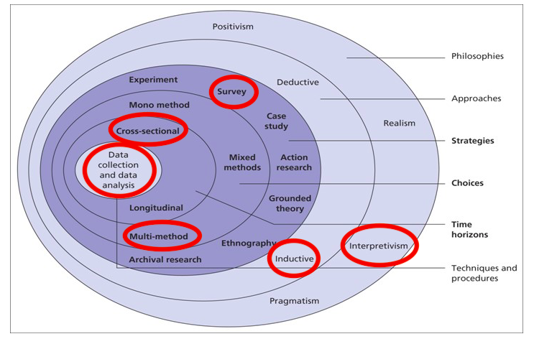
  - Philosophy
For this area of study, the most suitable philosophy is interpretivism due to it being defined as a principle observing the social environment, in which the researcher performs a specific function (Zukauskas, Vveinhardt and Andriukaitiene, 2018). This philosophy will allow the study and comparison of the different viewpoints to help to be utilised.
  - Research Approaches
After evaluating the data, the inductive research approach is concerned with gathering data and developing new hypotheses rather than forming a theory to prove it (Hayes, 2000). This approach is most fitting due to it making it possible to evaluate the set of data and conclusions can then be drawn from the result.
  - Research Method and Strategy
Using primary data such as survey research is commonly used, this can provide insights into participant's knowledge, attitudes, perceptions, and opinions (Kotler and Armstrong, 2006). using surveys will enable to collect different data to analyse various perceptions.
Quantitative research addresses different concepts of dependent and independent variables with the exploration of the concerns of measurement and association issues including error, reliability, and validity (Watson, 2015). Quantitative research will allow research into the main beliefs held by participants involved and provide an insight into their actions and attitudes towards fast fashion.
  - Data Collection
There are two forms of surveys, these being interviews and questionnaires. A decision needs to be made on what form is best for this dissertation (Trochim, 2020)
Firstly, questionnaires are a source of collecting information from different individuals., questionnaires are mostly a direct or indirect question (Gillham, 2015). Since questionnaires are versatile and can provide open and closed questions, this allows broader qualitative answers and quantitative answers that can be structured to represent answers in a statistical manner (Kotler and Armstrong, 2006). Deciding on questionnaires will allow participants to share their views on various questions in more depth and restrict the reach of their answers to others.
Secondly, interviews will also be a strong way of gaining a good response. Although interviews have sated us a limit to short questions and answers, receiving more in-depth answers with clear opinions expressing their answers (Alshengeeti, 2014).
2.6 Data Analysis
The data collected will be concluded through spreadsheets, tables, and figures. Using these tools will enable key findings of the research and pinpointing a conclusion. Besides, these tools will present work and findings in an effective manner which will give a clear outline.
  - Time Management Sample
The nature of this dissertation is time management and organisation, it must be adhered to. The pain possible aspect, could limit the depth of research will is conducted by simply not having enough time. A Gantt Chart will be provided to keep track of time management.
  - Ethical considerations
The research conducted will be with persons over 18 years old only. Furthermore, due to the research being from marketing and advertisement it is unlikely to cause any psychological harm.

  - Reliability and Validity
Reliability is defined as a concept in which the overall goal is to assess the degree to which knowledge is consistent. Whereas validity is defined as a methodology tests exactly what is supposed to be tested (Middleton, 2020). Using both reliability and validity within this research is essential the findings obtained must be relevant and accurate. This can be restricted by ensuring that the analysis is carried out in a consistent way to effect variable. The analysis must be conducted fairly and transparently which is consistent with all respondents.

- Resources and Planning
  - Resources
The resources used throughout this dissertation will consist of journals, articles, books, reports, handbooks, and professional websites. These will be accessed through online resources provided by the university, online databases, libraries, and different search engines. The literature used to source information will be read and checked and must be relevant to the area of study, this includes valuable results that can be analysed to achieve goals and objectives. These services will contribute to the analysis of literature and make up secondary data knowledge.
  - Gantt Chart
Using a Gantt Chart will map out each task that needs to be completed within a deadline, having each task set out with a specific deadline will make planning easier. The Gantt Chart will also maintain that the individual is on track to achieve the end goal by creating this checklist. Attached below Figure 2., the Gantt chart shows the plan for this dissertation including each deadline for each task.
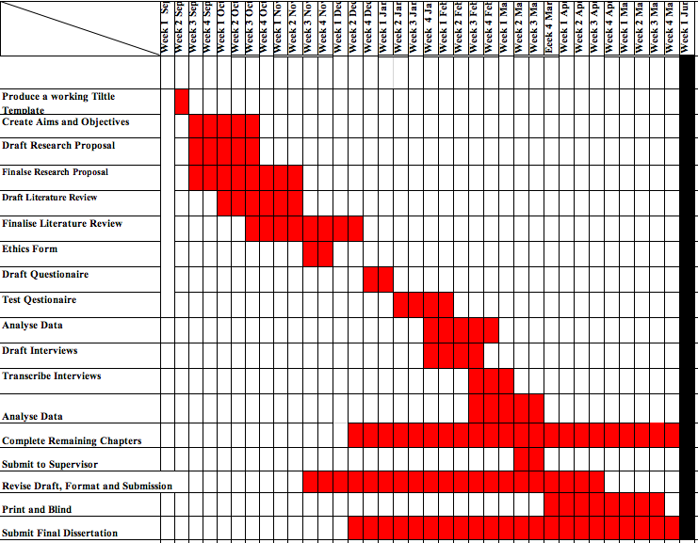
Figure 2. Gantt Chart

- References

Ahmed, V., Aziz, Z. and Opoku, A., (2016). Research Methodology In The Built Environment. pp.33-49.

Alshenqeeti, H., (2014). Interviewing as a Data Collection Method: A Critical Review. English Linguistics Research, 3(1).
Available at: <https://oxfamapps.org/media/press_release/fast-fashion-produces-more-carbon-emissions-per-minute-than-driving-a-car-around-the-world-six-times-oxfam/> (Accessed 12 October 2020).

Bhardwaj, V. and Fairhurst, A., (2010). Fast fashion: response to changes in the fashion industry. The International Review of Retail, Distribution and Consumer Research, 20(1), pp.165-173.

Bick, R., Halsey, E. and Ekenga, C., (2018). The global environmental injustice of fast fashion. Environmental Health, 17(1).

Gillham, B., (2015). Developing A Questionnaire. 2nd ed. London: Bloomsbury, p.2.

Jang, J., Ko, E., Chun, E. and Lee, E., (2012). A Study of a Social Content Model for Sustainable Development in the Fast Fashion Industry. Journal of Global Fashion Marketing, 3(2), pp.61-70.

Kotler, P,. Armstrong, G. (2006). Principles of marketing. 11th Edition. New Jersey: Prentice hall.

MORGAN, G., GLINER, J. and HARMON, R., (1999). Definition, Purposes, and Dimensions of Research. Journal of the American Academy of Child & Adolescent Psychiatry, 38(2), pp.217-219.

Oxfamapps.org. [2019]. Fast Fashion Produces More Carbon Emissions Per Minute Than Driving A Car Around The World Six Times – Oxfam. (Online)

Saunders, M., Lewis, P., Thornhill, A. (2009). Research Methods for Business Students. 5th Edition. Harlow: Parson Education.

Trochim, W., (2020). [online] Conjointly.com. Available at: <https://conjointly.com/kb/types-of-surveys/> [Accessed 27 November 2020].

Watson, R. (2015). Quantitative research. Nursing standard : official newspaper of the Royal College of Nursing, 29(31), 44-48 Available at: https://hull-repository.worktribe.com/output/374637 [Accessed 28th November 2020).

Wrap.org.uk. [2020]. Textiles – Overview | Available at: <https://www.wrap.org.uk/content/textiles-overview> (Accessed 12 October 2020).

Yoganarasimhan, H., (2011). Impact of social network structure on content propagation: A study using YouTube data. Quantitative Marketing and Economics, 10(1), pp.111-150.

Žukauskas, P., Vveinhardt, J. and Andriukaitienė, R., (2018). Philosophy and Paradigm of Scientific Research.

