

BA Leadership and Management
Module Assignment Submission

Student Name: | Holly Graham
Student Number: | 1910922
Module No: | BMSK5006
Module Title: | Knowledge and Information Management Skills for the Workplace

Statement of Confirmation of Authenticity
By the act of making this submission, the student declares that this is the work of the student named above. The work has not, in whole or in part, been knowingly presented elsewhere for assessment, or where assessment has been built on a previous assessment, this has been identified. Where materials have been used from other sources it has been properly acknowledged. If this statement is untrue, the student acknowledges that an assessment offence has been committed.
Attention is drawn to the plagiarism and unfair practice policies of UWTSD
Introduction 2
Management Synopsis 3
1. Provide an evaluation of the concept and importance of knowledge management in the context of an organisation’s knowledge assets 3
1.1 Explain the relationship between data information and knowledge 3
1.2 Explain the relationship between individual knowledge and organisational knowledge 4
1.3 Apply analysis and modelling techniques to identify knowledge assets 4
1.4 Evaluate actual and potential knowledge assets. Provide a rationale for capturing and managing knowledge 5
2. Demonstrate an understanding of important knowledge management processes in the context of organisational development 5
2.1 Explain what is required to create, store, apply and integrate knowledge 5
2.2 Consider the importance of intellectual property rights 5
3. Provide a framework for establishing a knowledge management culture 6
3.1 Explain the contribution knowledge assets have on an organisation 6
3.2 Evaluate the knowledge requirements for the organisation 6
3.3 Evaluate the organisations framework for enabling knowledge sharing 6
3.4 Recommend improvements to the current framework 6
Conclusion 7
References 7
Bibliography 8
Appendix 8
Appendix A 8
Appendix B 9
Appendix C 11
Appendix D 12
Appendix E 12

Introduction

The report writer is a student at The University of Wales Trinity St David and is currently enrolled on the second module of the Leadership and Management BA, which seeks to understand Knowledge and Information Management (KIM) as a skill for the workplace. Bellinger, et al. (n.d) and Martina, et al. (2007) both agree that Knowledge Management (KM) has gained traction and popularity in the subject of business, yet lacks a wealth of sources in a simple explanation, proving KM to be a complex subject that requires further study to be applied to the report writers workplace.

Management Synopsis

The report writer has conducted a thorough evaluation on the workplace and analysed the importance and value of Knowledge Management within their workplace. They have thought critically about their area of interest and has used Pearson (2013) RED Model (Appendix A) to analyse a thorough and critical thought process. They have also applied a CRAAP analysis to all sources to ensure they remain current and reliable in their workplace study (Appendix B)

1. Provide an evaluation of the concept and importance of knowledge management in the context of an organisation’s knowledge assets

1.1 Explain the relationship between data information and knowledge

In the report writers workplace data is collated in the form of figures from takings, which is turned into information providing profit and loss and any accompanying trends, which can then be evaluated as knowledge by discovering client retention rates, spending habits, resulting in the wisdom to forecast future successes or failures. Without this formulation, the business would have no structure or credibility and would fail to self-correct. (it is this knowledge, regarding clients that needs KM withinn the workplace)
The notion that data leads to information, to knowledge and then wisdom was first thought to be identified in detail by R.L. Ackoff in 1989. This concept of development is frequently identified as a hierarchy, with data creating the start of the process. Ackoff estimated that “forty percent of the human mind consists of data, thirty percent information, twenty percent knowledge, ten percent understanding and virtually no wisdom” (quoted in Bernstein, 2009, p.68). This leaves the arena open for questioning, not only on the true measurement of these estimations but also considers whether wisdom can be turned back into data, and does this in turn create a constant flow of information, the hierarchical model does not indicate that this is a possibility and also fails to explore people’s level of intelligence in relation to obtaining wisdom. Sternberg (2004) argues that wisdom related skills are a beneficial attribute but that ‘people can be intelligent without being wise’. In the workplace the report writer identifies that wisdom comes from the collaboration of Ackoff’s (1989) formula and being capable of applying knowledge to their situation, therefore, if wisdom is being applied back to the workplace it must provide another channel for knowledge, the report writer identifies the relevance of wisdom in relation to their own values, as further discussed by Sternberg. Whether in Tacit or Explicit form, the extension of wisdom in the workplace can therefore be introduced back into the arena through the inclusion of data, information and knowledge, between stakeholders.

1.2 Explain the relationship between individual knowledge and organisational knowledge

Tacit and explicit knowledge, also known as tacit and implicit knowledge, is an organisational interest when considering KM. According to Polanyi (1966,quoted in Gebert, 2003, p.111), tacit knowledge is hard to articulate and transfer, alternatively explicit knowledge is easily articulated and shared. Tolle, E. (2018, p.25) has a spiritual perspective on tacit and explicit knowledge, ‘Words, no matter whether they are vocalised and made into sounds or remain unspoken as thoughts, can cast an almost hypnotic spell upon you’ Tolle continues to explain that because you have attached a word to something, you implicitly believe it is true or know what it is. Furthermore, Tolle argues that everything is ultimately unknowable because of the unfathomable depth. ‘All we can perceive, experience, think about, is the surface layer of reality, less than the tip of an iceberg’. These two viewpoints prove that similar ideas can be perceived differently between individuals, based on their own world view. The report writer values their spiritual beliefs and seeks to understand the link between academic research and alternative viewpoints to strengthen their own view on how to strengthen their own business.
Include mind map appendix here to follow on to next question

1.3 Apply analysis and modelling techniques to identify knowledge assets

Write about SWOT in relation to KM here and then put table in appendix.
ALSO CONSIDER TURNING INTO K-SWOT

STRENGTHS  - Online booking system instead of paper diary  - Industry led booking system and accessible to all apart from those who don’t use smart phones or laptops.  - Ease of Whatsapp communication  - Customer relationships are very good, 3 complaint in the life of the business.  - Increased communication through use of booking system  - Company policies available to clients via social media pages | WEAKNESSES  - Online booking not fully utilised  - Infrequent meetings  - Unsociable contact hours between clients-staff and staff-staff
OPPORTUNITIES  - Increased bookings because of ease and speed with fully utilised booking system  - Can leave other staff notes and also inform them if room is full  - Can identify free spaces to advertise  - Making staff aware of repeat booking option so their client always gets their preferred space, communicating this with clients also.  - Create a storage facility where all staff can log in and store their work, to use on Instagram etc.  - To create an online selling platform, products, training, masterclasses, website.  - Policies can be added to booking confirmations? | THREATS  - Decreased bookings, because of the impersonal approach  - Clients can see true availability (explain further in text)  - Whatsapp isn’t secure, staff could forget and display client info. Needs to be covered in framework.  - Further covid restrictions and lockdowns

1.4 Evaluate actual and potential knowledge assets. Provide a rationale for capturing and managing knowledge

WHAT ARE THE KNOWLEDGE ASSETS IN MY WORKPLACE, AND PROVIDE A WAY TO CAPTURE.
Drop box-

2. Demonstrate an understanding of important knowledge management processes in the context of organisational development

2.1 Explain what is required to create, store, apply and integrate knowledge

DISCUSS GDPR
Data protection

2.2 Consider the importance of intellectual property rights

(what do we have in the business, what are the benefits and downsides if people use it)

3. Provide a framework for establishing a knowledge management culture

3.1 Explain the contribution knowledge assets have on an organisation

(makes them quicker, faster smarter etc) how to get everyone into the culture of this knowledge management

3.2 Evaluate the knowledge requirements for the organisation

(what do they need to sustain)

3.3 Evaluate the organisations framework for enabling knowledge sharing
We don’t really have one that is utilised to full potential.

3.4 Recommend improvements to the current framework
Dropbox, booking system and staff forum. Training, explain why it’s needed and the benefits to work life balance etc.
Manual to go in appendix
Knowledge Management (KM) and Customer relationship management (CRM) Manual

Clients can now book beauty treatments online, through the booking link that will be displayed on each of our pages. We are also listed on the Fresha app for new clients.
- When a client books, you will get a notification on your personal app. Please check these bookings don’t clash whilst we navigate the new system over the next few months.
- Use the ‘blocked time’ to leave each other notes if the beauty rooms are full, taking into consideration external clinic days. Move this information to the next available space if you need to fill with an appointment. Always provide adequate information.
- When holding spaces for clients as blocked time whilst awaiting their contact details, please put as much information as possible so that we can check the hold in case another request comes in.
- When ‘blocking time’ for a wedding, please include their name, location and email in the notes, so that this can be chased up. Don’t leave comments like, possible wedding, or even possible wedding in Swansea for example. These notes can sometimes be overlooked and left in the system, causing a last minute pan ic.
- If you want the booking system to show a low availability (as per advertised on Instagram etc), block out time. Including if you want to fill morning or late spaces first. You can always ‘release new times’ at a later date. This is an effective form of creating interest in the form of fear of missing out.

notes
Different channels of information in the workplace
Chanel | Benefits | Disadvantages
Telephone | - Clients can contact during opening hours to make an appointment.  - Suppliers can call to take payment and notify of offers. | - Noise disruption, salon has a load environment so online booking is preferred.  - Suppliers may call during busy periods when desk is un-manned.  - We don’t playback mailbox as we don’t have a receptionist.
Paper files | - Client consultations are held in store cupboard, easily accessible by all staff. Backs up insurance claims, allows to cross reference staff patch testing and what products are used. | - We have had over 1500 new clients in our first year and running out of space for paper consultations.
Online booking system | - Some patch test information is held on the online account. Along with a history of appointments.  - Staff can leave each other notes and block out times. | - This is being duplicated or missed as two channels hold this information  - Sometimes staff forget to remove blocked times and can result in staff missing out on bookings.
Instagram | - Client enquiries and bookings can be made online and personally with the salon staff. | - Booking of appointments can be delayed due to response time.
Email | - Currently used for wedding bookings on one wedding email, keeps all requests together.  - Other email used for orders and general enquiries. | - Delay in response time due to no receptionist and an inconsistent habit around answered them.  - General enquiries sometimes missed

Conclusion

References

Ackoff, R. L. (1988) ‘From Data to Wisdom’, Journal of Applies Systems Analysis, 16, pp. 3-9

Bellinger, G. et al. Data, Information, Knowledge, and Wisdom. Available at: https://www.systems-thinking.org/dikw/dikw.htm (Accessed:18th April 2021).

Bernstein, J.H. (2009) ‘The Data-Information-Knowledge-Wisdom Hierarchy and its Antithesis’ Publications and Research, pp. 68-75 (Accessed 18th May 2021) https://academicworks.cuny.edu/cgi/viewcontent.cgi?referer=https://scholar.google.co.uk/&httpsredir=1&article=1011&context=kb_pubs

Gebert, H. et al. (2003) ‘Knowledge-enabled customer relationship management: integrating customer relationship management and knowledge management concepts’, Journal of Knowledge Management, 7(5), pp. 107-123. (Accessed 10th May 2021) DOI:10.1108/13673270310505421

Martina, E, G. et al. (2007) ‘A strategy for knowledge management’, Journal of Knowledge Management, 11(6), pp. 3-15. (Accessed 1st May 2021) DOI: 10.1108/13673270710832127

Sternberg, R.J. (2004) ‘What Is Wisdom and How Can We Develop IT?’ The ANNALS of the American Academy of Political and Social Science. 591(1), pp.164-174. (Accessed 19th May 2021) doi:10.1177/0002716203260097

Tolle, E. (2018). A New Earth. UK: Penguin Books

Bibliography

edit
https://journals.sagepub.com/doi/pdf/10.1177/0002716203260097

https://www.youtube.com/watch?v=k3jo7oWzUUc

Appendix

Appendix A

Pearson RED Critical Thinking Tool, used to identify critical thinking in this report.
Section | Recognise assumptions | Evaluate arguments | Draw conclusions
1.1 | Ackoff’s estimation | The model doesn’t provide answers to a what happens beyond wisdom, or explore peoples level of intelligence. | That wisdom can be processed into further data within the workplace and that intelligence doesn’t necessarily result in wisdom.
1.2
1.3
1.4

Appendix B

CRAAP Analysis of all References
Reference in order of listing | Current | Relevancy | Authority | Accuracy | Purpose
- Ackoff | Continually used in academia | Origin of DIKW | Origin of DIKW | Multiple citation and well known model DIKW | To explain the process of Data, Information, Knowledge and Wisdom.
- Bellinger | No date but copywritten 2004 | Elaboration of Ackoff’s DIKW | Theorist and System Thinker | Multiple citation and university handout | To compare and explain DIKW.
- Bernstein | 2009 | Antithesis of Ackoff’s DIKW | City University of New York. | Multiple citation, published by University. | To provide an argument for and against Ackoff’s ideas.
3.
4.
5.
6. Gebert | 2003 | Provides explanation of tacit and explicit | Researchers and Professors at the Institute of Information Management. | Multiple citation, journal article. | Focus on KM and customer relationship management.
7.
8.
9.
10.
11.
12.
13.
14.
15.
16. Martina | 2007 | Relevant to workplace | University of Georgia and Technical University of Munich | Multiple citation | Focus on business and KM strategy and the success of KM initiatives
17.
18. Sternberg | 2004 | Argument against obtaining wisdom | Professor of Psychology and Education.  Sage publication | Multiple citation. | Explanation and argument in the relation between application of knowledge and attainment of wisdom.
19. Tolle | 2018 | Alternative viewpoint of tacit and explicit | Bestselling spiritual teacher/ author.  Studies philosophy, psychology and literature. | Intangible evidence, yet multiple citations to provide alternative viewpoints. | Provides a spiritual viewpoint that can be identified as implicit and explicit knowledge.
20.
21.
22.
23.

Appendix C
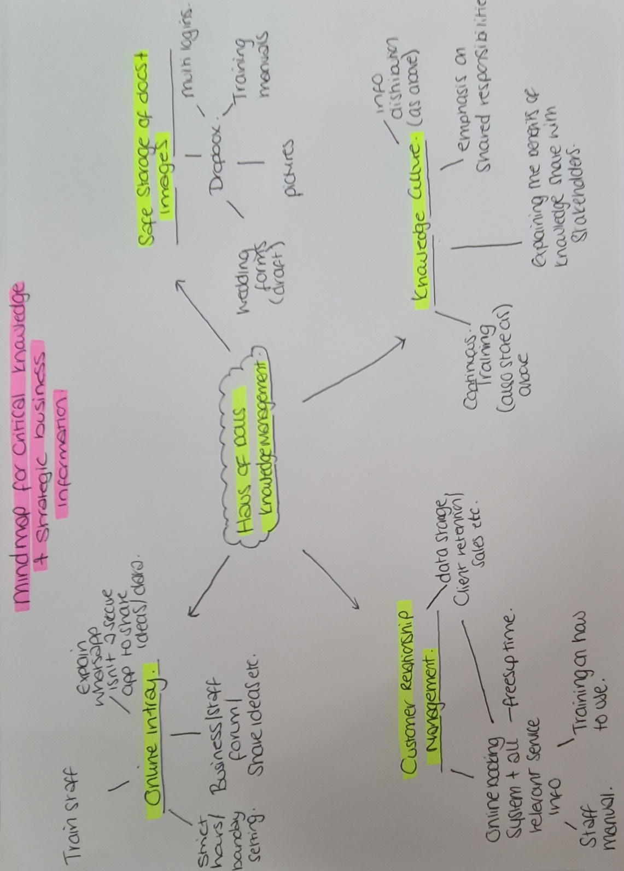
Mind Map to identify KM Initiatives

Appendix D

Conversation with business partner, confirming that holly can carry on with setting up processes to be reviewed before going live.
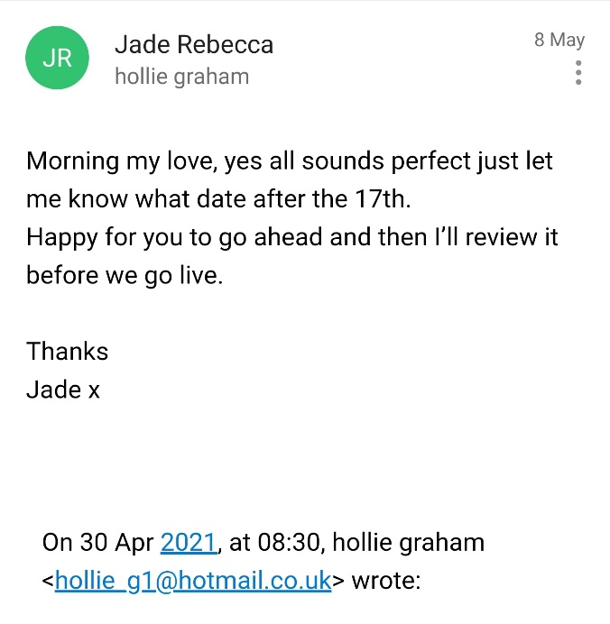

Appendix E

Gannt Chart for implementing KM Initiatives



