University of Wales Trinity Saint David



Program: Certificate of Higher Education Skills for the Workplace (Health and Social Care)
Title: Portfolio-Two Taks
Module: Introduction to Health and Social Care
Name of Student: Faiz Hussain (2527683)
Lecturer Name: Helen Parsons

Table of Contents
Task 1 3
Ambulance Services in the NHS: Lifesaving Care on the Move 4
TASK 2 5
Introduction 6
Origin and Development of Community Mental Health Services 6
Structure and Functioning of Community Mental Health Services 6
Why Community Mental Health Services are Important 7
Challenges Faced by Community Mental Health Services 7
Conclusion 7
Reference List 8

Task 1

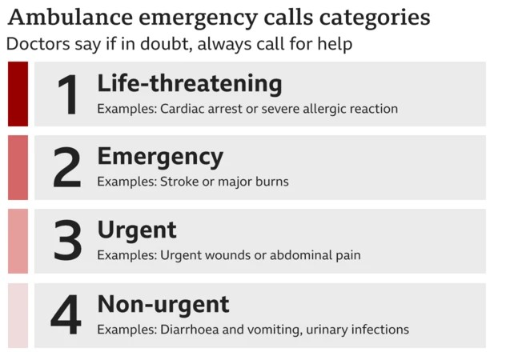
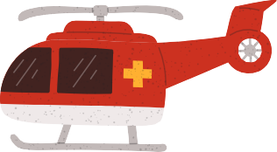
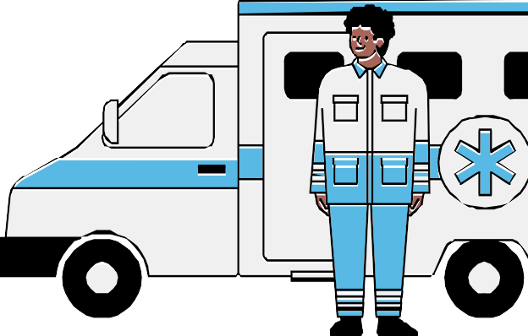
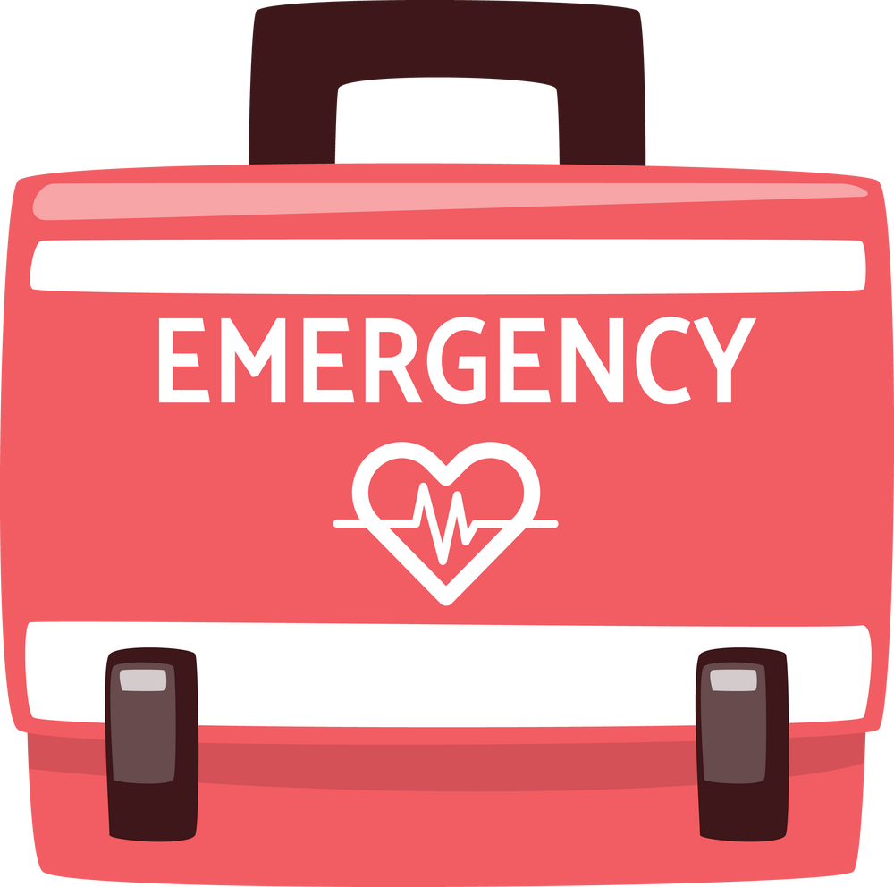



ng Ca
1. Long, stressful shifts in high-pressure environments.
2. Frequent exposure to traumatic events and emergencies.
3. Pressure to meet rapid response-time targets.
4. Delayed hospital handovers increase workload and frustration.
5. High levels of burnout, fatigue, and low morale.
6. Stress contributes to staff turnover and workforce shortages.
7. Reduced staff wellbeing can affect patient care and safety.
Workforce Stress

Funding and Resources

How the Service Works?
Emergency Call (999): Calls are prioritised (Categories 1–4) by emergency call dispatchers.
Life-threatening (category 1) = Target response of 7 minutes (e.g., cardiac arrest).
Category 2: Severe conditions (e.g. chest pain or stroke): 18 minutes is the target response time.
Category 3-4: Urgent but not life-threatening, may take longer than these waiting periods.
Depending on the severity, dispatch may be given helicopters, ambulances or rapid response vehicles.
On-Scene Treatment: Advanced methods are used by paramedics and technicians. They administer trauma care, IV medications and airway support to stabilize patients. Hospital Transfer: Patient transported to the best hospital, may be different to the hospital closest to patient (e.g. major trauma hospital).
Aftercare: Instead of going to the hospital for treatment, patients might be able to stay at home or get help from local resources.

A Brief History of the Service
1. Rising 999 calls with insufficient funding.
2. Staff shortages and limited training opportunities.
3. Outdated ambulance fleet causing longer response times.
4. Delayed hospital handovers reducing ambulance availability.
5. Rural areas struggling to meet response targets.
6. Limited mental health and community support services.
7. Growing maintenance backlog (£65m in 2019 to £146m+ in 2024).
8. Resulting in delayed treatment, increased pressure on staff, and reduced quality of patient care.
Two Major Challenges Faced by the Ambulance Service
999 Emergency Response: Quick response for emergencies.
Paramedic-Led Treatment: On-scene medical interventions such as CPR, defibrillation, administering oxygen, and pain relief.
Patient Transport Services (PTS): These are services that assist people with chronic conditions, disabilities or frailty to get to hospital appointments.
Urgent community response (UCR): Home care for patients so as to avoid unnecessary hospital admission.
Air Ambulance Support: Helicopters are used for critical cases in conjunction with charities
Specialist Services: Transport to neonatal unit, mental health crisis response, major incident management.

What Do NHS Ambulance Services Provide?

1867 – St John Ambulance Association founded.
1948 – NHS was established; local authority control of ambulance services.
1980s – First paramedics hired.
1970s-80s – Paramedic role introduced. Ambulance services reorganised into Regional NHS Ambulance Trusts in 2006.
Today – High tech mobile health care units are responding to over 10 million 999 calls each year essential for the NHS emergency services.

Ambulance services are a crucial part of emergency services in the UK and are run by the National Health Service (NHS). These services act as the first point of contact for those who have a life threatening condition such as a heart attack, stroke, accident or other life threatening conditions. As well as emergencies, the ambulance services also provide patient transport, urgent community care and specialist medical treatment and are a cornerstone of public health.

Introduction

Ambulance Services in the NHS: Lifesaving Care on the Move

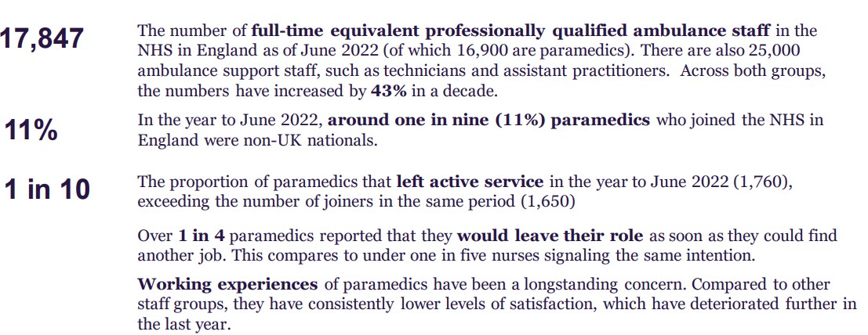

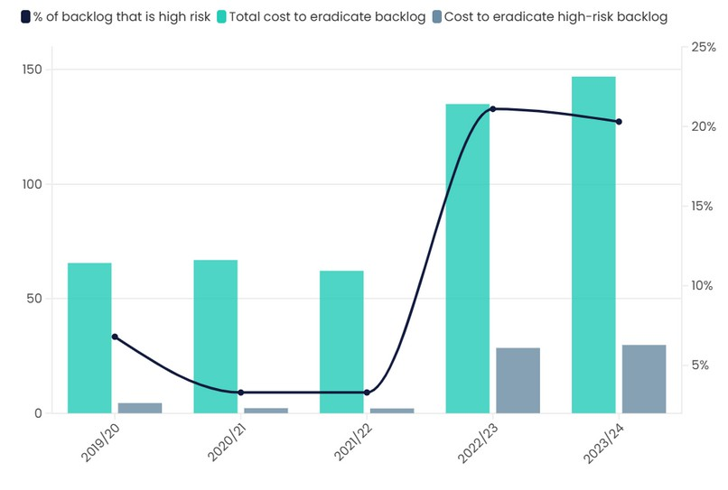
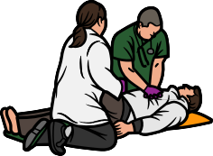

TASK 2

Essay
Community Mental Health Services

Introduction
Community Mental Health Services (CMHS) are a key component of contemporary healthcare services. They offer support, treatment and rehabilitation to people who are in mental health problems without having to leave their local communities. Such services seek to foster recovery and independence, and social inclusion, not just hospital-based care. The role of community mental health services is becoming more vital with the burden of mental health issues on millions of people around the world and the need for these services in healthcare systems.

Origin and Development of Community Mental Health Services

In the past, people with mental illnesses were typically hospitalized in large psychiatric facilities. In the twentieth century, as worries about the quality of institutional care and the rights of service users emerged, community-based approaches developed. The policy of deinstitutionalisation in the United Kingdom led to the closure of many long stay psychiatric hospitals and the growth of community services. The mission was to deliver patient care in a more localised location, encouraging the patient to become independent and to live their life to the fullest. Modern community mental health services are an integral part of the National Health Service (NHS) and are supported by social care organisations, charities and voluntary services, which work together to offer comprehensive support to the patient.

Structure and Functioning of Community Mental Health Services

The organization and operation of community mental health services. Multidisciplinary teams of psychiatrists, mental health nurses, psychologists, social workers, occupational therapists and support workers provide community mental health services. These people collaborate to evaluate needs, create care plans and deliver continuous support. Services can range from mental health assessment, counselling, psychological therapies, medication management, crisis intervention and rehabilitation programmes. Community Mental Health Teams (CMHTs) are responsible for planning the care and ensuring that the right care is provided based on the needs of the individual. The NHS Community Mental Health Framework is an example of a real-world implementation of this framework, designed to deliver person-centred care and enhance access to Mental Health services. Outreach services and community clinics can provide care to the user in the community, which decreases the need for hospitalisation.

Why Community Mental Health Services are Important

Community mental health services are crucial to the mental wellbeing and to the recovery process. One of their primary benefits is that they allow individuals access to treatment and continue to have family, employment, learning and social relationships. This method can help decrease the stigma that frequently is attached to mental disorder and can foster greater involvement in the community. Such services also participate in early intervention. Early detection and treatment of mental health issues can successfully prevent deterioration of the problem and avoid the need for emergency/inpatient services. Additionally, a community-based support system can help to enrich a person's quality of life, independence and wellbeing. For instance, people can receive psychological therapies from NHS Talking Therapies where they are experiencing depression and/or anxiety, before it worsens.

Challenges Faced by Community Mental Health Services

There are a number of problems with community mental health services, although they play an important role. The first problem is the rising demand. More people now recognise the importance of mental well-being and have sought assistance, putting strain on mental health resources. Other major issues include a lack of staff. There is a high level of difficulty in recruiting and retaining qualified mental health workers, which results in high workloads and waiting times. However funding constraints can also impact the quality of services and access. Moreover, certain people may face challenges in accessing support services because of stigma, cultural considerations, geographic location or their lack of knowledge regarding services. Both of these problems can hinder people from getting prompt and proper treatment.

Conclusion

To conclude, community mental health services play a crucial role in aiding people with mental health issues in their communities. They have grown beyond an institutional approach to care and now offer person centred care in multidisciplinary teams. These services have a positive impact on wellbeing, promote recovery and decrease the need for hospital treatment. But, issues like demand pressure, labour shortage and financial constraint still remain a concern in service delivery. It is important to consider these issues to make sure services in the community are effective and accessible for those who need them.

Reference List
- American Psychiatric Association (2023) Mental health services and support systems. Washington, DC: APA.
- Care Quality Commission (2024) The state of health care and adult social care in England 2023/24. London: CQC.
- Department of Health and Social Care (2023) Major conditions strategy: Case for change and our strategic framework. London: DHSC.
- Health Education England (2023) NHS workforce and training priorities. London: HEE.
- Mental Health Foundation (2024) Mental health statistics: UK trends and challenges. London: Mental Health Foundation.
- Mind (2024) Community mental health services. London: Mind.
- National Health Service (2024a) Ambulance services.
- National Health Service (2024b) Community mental health services.
- NHS Confederation (2024) The future of ambulance services in England. London: NHS Confederation.
- NHS England (2024a) Ambulance quality indicators. London: NHS England.
- NHS England (2024b) Community mental health framework for adults and older adults. London: NHS England.
- NHS Providers (2024) Ambulance services: Challenges and opportunities. London: NHS Providers.
- The King's Fund (2024a) The NHS explained: Ambulance services. London: The King's Fund.
- The King's Fund (2024b) Mental health policy and services in England. London: The King's Fund.
- World Health Organization (2024) Mental health: Strengthening our response. Geneva: WHO.

