Distinctiveness of Blaenavon
Ebony Goddard 1910397
Introduction
Blaenavon is a small town in south east wales, it was a thriving town with a lot to offer from coal and iron production it offered a lot of job opportunities to families who lived within the community, although staying so close to these production areas caused a lot of health deficiencies as the smog and dust which left the iron works and the mines would cover the town, a lot of people developed chest problems and working the mines in such dark areas would also cause a lot of eye problems for young children and horses who helped cart the coal out from the mines. The history of the industrial revolution took place in the 18th, 19th, and the 20th century it created a lot of history for the town of Blaenavon, The town now has 26 listed buildings which create a lot of historical destinations for tourists including the big pit and the iron works being the main areas as an attraction. ( A, Burns , pre lecture work, 2020 )
Industrial revolution
The industrial revolution for Britain was the start of the production of iron and coal which was the main products exported from heart of the town Blaenavon. The materials which were exported were also used to build the railways, factories and engines all round the world the main material used for this was pig iron. The steam train was one of the biggest inventions of the industrial revolution they used it to get deeper in the mine pits and transport materials between towns and cities. In the factories with the new machinery which was made, men, woman and children as young as 8 worked the machines spend long days working in dangerous conditions the factories had poor lighting, and filthy conditions, some people died during work in these conditions.( UK industrial revolution, 2020)
Although people worked in these poor conditions the industrial revolution was a great way for Britain to obtain a capital, with the rails expanding to different areas of exporting this also boosted the population in Britain.
Blaenavon early industry it’s a nearby town to Pontypool which had a forge for producing iron from the year 1425, in 1556 Hanbury’s family had leased rights to the use of timber and minerals from land between Blaenavon and Pontypool one of the main employment areas were wood cutters they were needed to collect timber and fuel the furnaces.
Lord Abergavenny leased the common lands to Thomas hill, Thomas Hopkins and Benjamin Pratt in 1788, these entrepreneurs built an enterprise for ironworks of Blaenavon utilising industrial revolution technologies , the first multi- furnace iron works in wales this is where Sidney Gilchrist perfected the process of dephosphorising iron to make steel.
The main way to produce pig iron is for iron, ore, or coke limestone to be heated at 400 degrees in the furnace as it goes through the heated process it is then crushed and binded to produce the iron.

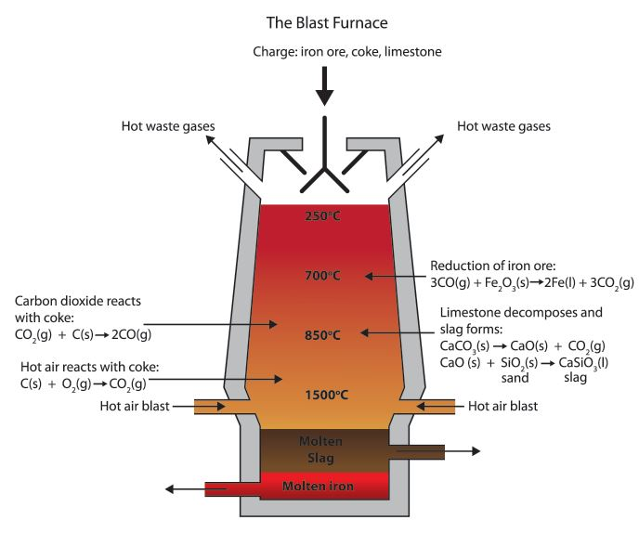( google images, 2020) Blaenavon iron works were producing 5,400 tons of iron a year, this encouraged housing to be built near the quarries and encouraged more housing for the large population this industry was attracting, having the houses so close to the works was not the best of living conditions the dirt and smog would blow into the houses cause a dingy look all round the area of dirt, the pollution in the air was growing with the large amount of product that was being developed, 1805-1810 two more furnaces were developed and grew the amount of iron being produced to a staggering 14,220 tons of pig iron per year. ( A. burns, lecture, 2020)
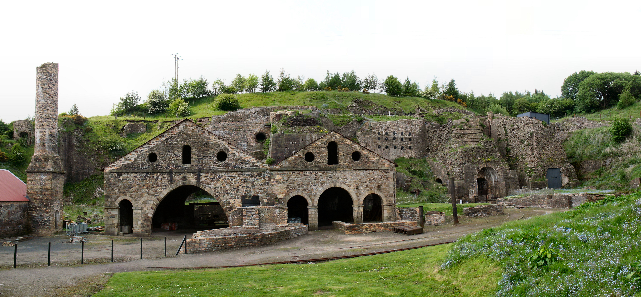

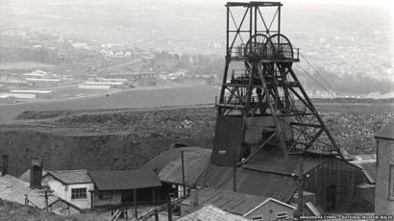
The first picture is Blaenavon iron works and the second is the big pit coal mine also located in Blaenavon (google images, 2020)
Big pit
In the 19th and 20th centuries, in the Blaenavon region, Big Pit, now the National Coal Museum in Wales, was just one of many necklaces. However, for more than a hundred years the mine was the most important colliery in the city and has an interesting history. In 1860 the Blaenavon company lowered the shaft in the Big Pit, which was originally named Kersley’s Pit. In 1880 it was expanded to its current depth of 300 ft and was known as "Big Pit" due to its incredibly big elliptical pipe. Nonetheless, portions of the Big Pit date from the beginning of the 19th century. The Big Pit was the amalgame of the Coity Pits, the Dodd's Slope, Coity Point, the New Blaenavon Mine, the Elled Drift, the Forge Pit, the Forge Slope, and the Forge Stage. In the Blaenavon area, several mines, including Forge Level, were used to collect iron and not coal for the purpose of supporting local ironworks. Coal was also produced in Blaenavon to meet local demand, but the reign of' King Coal' came to southern Wales at the end of the 19th century. By the late 19th century, steel and iron making were becoming less important in Welsh, but Welsh coal was increasingly in demand for fuel locomotive, steam, factory and buildings. In order to benefit the high demand, many towns of Welsh, including the Blaenavon, specialise in the production of coal.

Instantly successful was the Big Pit Mining Museum, which offered tourists the unique experience of discovering underground passes by former miners. But financial difficulties also made the Museum impossible. The National Galleries and Museums of Wales in 1999 took over the management of the site and the museum was improved by the number of visitors after Blaenavon was recognised as World Heritage in 2000. In 2004 a major reform was completed through funding from the Heritage Lottery Fund, the budget of the Welsh Assembly and the Welsh Budget. Tourist Council. In 2005, the prestigious Gulbenkian Prize for Museum was awarded in big pit to the new surface exhibits, exhibitions and presentation features. Since 1983 more than three million visitors have been welcomed on this site and Big Pit will continue to attract global attention for many years to Wales ' coal-mining heritage.(big pit history, 2018)

References
- Burns pre lecture work week 1
- Burns lecture work week 2
The UK Industrial Revolution video link
https://www.google.com/search?q=pig+iron+production&tbm=isch&ved=2ahUKEwj6-cCc54PoAhUW-BoKHWa0AIMQ2-cCegQIABAA&oq=pig+iron+production&gs_l=img.3..0j0i5i30j0i24l5.1537.7963..8463...0.0..2.185.2838.20j11......0....1..gws-wiz-img.....0..0i67j0i131j0i8i30.L7VZHDcR24Q&ei=yy9hXrroM5bwa-bogpgI&bih=597&biw=1242&rlz=1C1AVFB_enGB792GB792#imgrc=vDacTbK9TeXeIM

https://www.google.com/search?q=blaenavon+ironworks&tbm=isch&ved=2ahUKEwjclMeh54PoAhUBpBoKHfF9BpUQ2-cCegQIABAA&oq=blaenavon+&gs_l=img.1.0.0l10.574014.578878..581896...0.0..2.119.2204.25j3......0....1..gws-wiz-img.....0..0i67j0i5i30j0i24.DEXgavs9uf8&ei=1i9hXtzRGoHIavH7magJ&bih=597&biw=1242&rlz=1C1AVFB_enGB792GB792#imgrc=1MpoOUVxp8tfSM
https://www.google.com/search?q=blaenavon+big+pit&tbm=isch&ved=2ahUKEwjhkvK36YPoAhUW_hoKHUY0AtEQ2-cCegQIABAA&oq=blaenavon+big+pit&gs_l=img.3..0j0i24l2.221173.229142..229430...8.0..0.131.1905.20j4......0....1..gws-wiz-img.......0i67j0i8i30.mkPm4I26Iyo&ei=HjJhXuGLCZb8a8boiIgN&bih=597&biw=1242&rlz=1C1AVFB_enGB792GB792#imgrc=0LxD7Em-GcrCJM
https://www.visitblaenavon.co.uk/en/Publications/Blaenavon-Story/Big-Pit.pdf

