Element 1
When it comes to reflection there are many resources to support the effective reflective practice within early years setting. Therefore, when it comes to the Kolb Theory there are four elements Experience, Reflect, Conceptualise and Plan. Dr, N Brown, 2015 stated Kolb’s reflective model is described as “experiential learning”. The starting point for this model is our own knowledge, which is then evaluated, studied and assessed systematically in three stages. Once the procedure has been undertaken completely, the new skills will form the starting point for a new cycle.
According to Unknown source, 2021 To see Kolb, D. A. (1984) model of reflection, its essential to firstly understand how Kolb seen the method of learning and progress. Like Piaget, Inhelder. (23 Apr 2019)., Kolb, D. A. (1984) contemplated the learning to be realistic and mostly self-driven. Or, in Kolb’s own words “Learning is the process whereby knowledge is created through the transformation of experience” LibQuotes. (2021).
However, Kolb, D. A. (1984) claimed that it is our ability to enthusiastically reflect on our capabilities which accelerates our learning and development. But on the other hand, it can be said that Kolb’s theory is an exploratory learning theory which highlights the importance of reflection. According to Turesky and Wood (2010), Kolb’s theory is like former theorists such as Piaget stated by Dubinsky, E. (unknown) and Dewey also stated by Popova, M. (2014) because these theorists similarly believed that the core of learning remains in the way we deal with the experience at hand and the important reflections on skills and the values we draw from them. Kolb, Piaget and Dewey are all have recognized for advocating “learner-centred pedagogy” as a teaching-led education.
Now to go on to the Gibbs Theory there are six elements to the cycle and they are Description, Feelings, Evaluation, Analysis, conclusion and Action Plan. Rumson, (2018) stated that the Gibbs cycle description is a element that requires a accurate report of the case. At this point, no assumption is taken, the attention is on the knowledge which is relevant. Some questions would be What happened? How did it happen? Where did it happen? When did it happen? Who else was there when it happened? Did anyone react? How did they react? Why were you there currently? What did you do in this situation? What happened in the end? This will build up a better background and so the situation is better understood according to Rumson, (2018). When it comes to Discussing the feelings element within the cycle and the opinions about the skill University of Cumbria, (2020) believes questions such as what did you feel at the time? how did you think at the time? How and what impact did this have on your emotions, beliefs and values? What do you think others around the situation were feeling? What did you think about the situation afterwards? You can speak honestly about your emotions. University of Cumbria, (2020) goes on to discuss Evaluation part of the cycle to evaluate the experience, both good and bad parts of it. Then University of Cumbria, (2020) goes on to the analysis section of the cycle within making sense of the situation and This part can be improved. Moving on to conclusion part of the Gibbs cycle Rumson, (2018) stated that considering what abilities will help you manage better next time? What else could have been done in that situation, how could you avoided it if the outcomes were negative in that situation and on the other hand what If there were positive outcomes, how could you enhance them for everyone. Then on to the last part of the cycle is the action plan and according to Rumson, (2018) this is a plan to effectively improve the situation. As in if any training was needed to be better so certain mistakes did not happen again. More learning for better out comes so practitioners can thrive to improve the situation they are in.
According to Rumson, (2018) Gibbs’ Reflective cycle is used in a variety of circumstances and is valuable in evaluating it. Reflection is always used to enhance knowledge and is evidence of practice-based learning. It is considered as a significant method to use after important incidents that has help practitioners and let Early years children reflect on what happen within the sitting and create new learning ideas.

In summary Kolb’s experiential learning cycle (1984) comprises of four stages while Gibbs’ (1988) has both practice and theory in an interactive circle using six stages. Each stage leads onto the next stage Both Kolb and Gibbs place importance on experience but Gibbs’ cycle also includes emotion. This is vital as there is a link between cognition and feelings which is acknowledged in Gibbs’ Cycle. The structure of the cycle makes it easy to adhere to when undertaking reflective practice.

Using a model of reflection is vital in Early Year’s Practice as it helps develop skills necessary for handling a variety of situations in a setting both from a practitioner’s point of view, the children’s experience and the input of the parents and main carers. Experiential learning is important as part of active reflection. Reflection within early years is an essential in maintaining and developing competency. Reflection is a part of learning and when one reflects on an experience in greater detail one can develop already known knowledge and add to new knowledge. From this one can obtain greater understanding and even new meaning. Early Year’s Practitioners through engaging regularly in reflective practice can become more confident and more proactive as they look at their feelings their actions and responses to events.

Element 2 Briefing Paper

The importance of reflective practice for early years practitioners!
What is reflective practice?
As a professional practitioner in an early year setting you want to deliver the best care possible for the children in the early years setting. Reflective practice is an outstanding way to preserve and constantly improve the quality of your training. Reflective training is the method of thinking about and analysing the practice within the setting, with the objective of inspiring, changing, altering, improving and enhancing it. This should be a constant cycle of reflection and development stated by Pacey, (2016).
Importance of reflection
According to Houghton, K (2017), There are 6 key areas to consider when using reflection on Early Years Practice.
- Relationships
- Environment
- Pedagogy
- Direct Teaching
- Assessment and Interactions
- Observations in Play
Pacey, (2016) stated that throughout reflection and constant improvement practitioners will accomplish better outcomes for the children. When thinking about some of the benefits this could consist of for the children:
• Each individual need is met for the children.
• The children’s self-esteem is increased.
• A suitable, empowering, interactive setting including proper resources for the children and opportunities indoors and outdoors.

A reflective practitioner
Stated by Pacey, (2016), a reflective practitioner are praises by their skills and recognises areas that will need developing. In engaging regularly with reflective practice professionals take ownership of improving and enhancing their own professional competency. Practitioners Strategies on how to uphold and advance their practice in forthcoming future. Practitioners think about how they work and why they decide to do it on that certain way. Considers the impact of their practice on the children and families in their care. Considers working in different ways and introduces new ways of working.

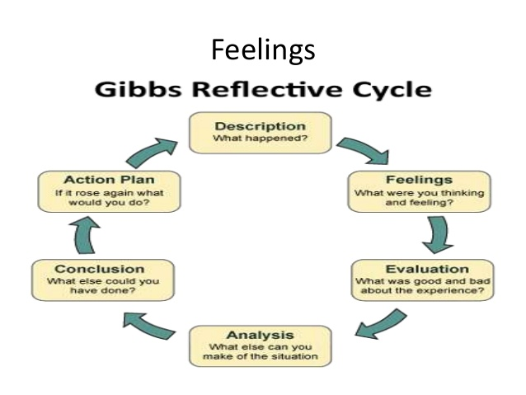
Gibbs
Stated by The University of Edinburgh, (2020) the Gibbs Reflective Cycle is a model that is simple to understand and easy to make use of. It improves the tools of Learning by Doing. Gibbs invented a circle model which is designed in stages. Gibbs stated that by reflecting on your knowledge experience, it lets the practitioners to better their performance as its occurring and improves going forward into the future. It also allows the practitioners to understand over a time bases the experiences that taught. It provides practitioners with a more balanced and precise judgment. The Gibbs reflective cycle offers a structure for assessing experiences according to The University of Edinburgh, (2020).
Picture Sourced at Blogspot.com
Kolb
According to Brown, (2015) Kolb’s reflective model is described as “experiential learning”. The foundation of this model is the practitioner’s own skill, which is then evaluated, studied, and assessed systematically in these 3 stages. Once this method has been completed. The new encounters will form a starting point for an additional cycle. Kolb's model underlines the significance of the reflection elements in the learning cycle. Reflection lets one to handle what just happened during a experience. In relation to a career development, it is thought that the cycle model lets one to reflect on a practitioner’s practice allowing them to think of new idea and put all of this into practice and reflect on them and process to an evaluation stage leading to improvements in practice stated by Brown, (2015).

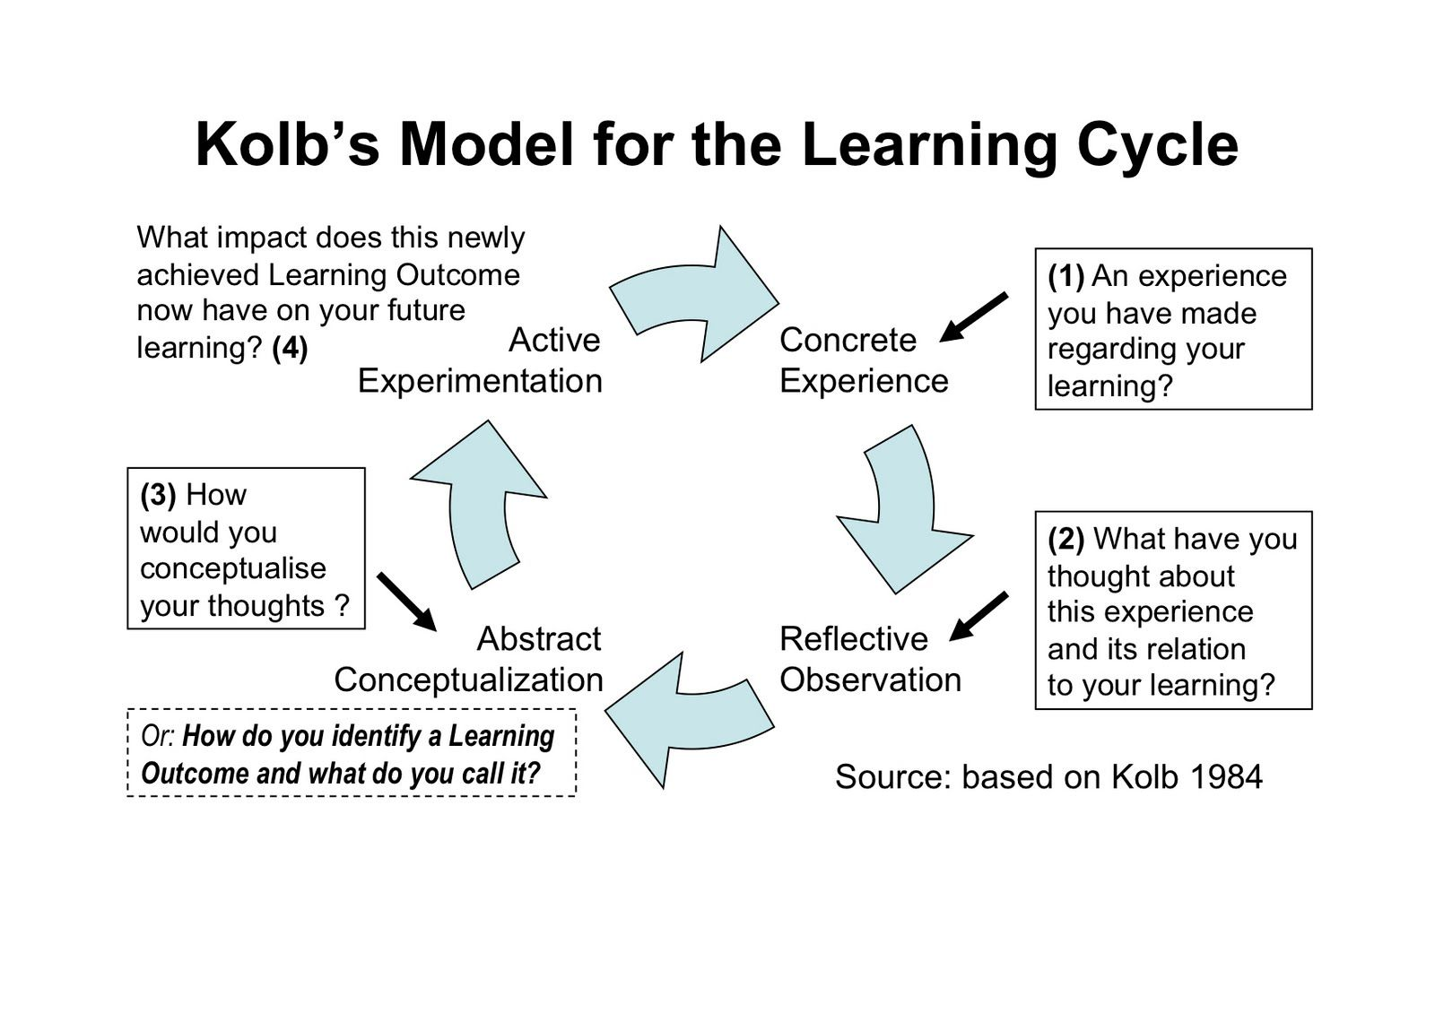
Picture sourced at pintest.com

Element 3 Reflective log
Brief description of the activity (no more than 50 words)
The activity chosen is for the children to build a den. Using materials outside in the outside play area. With the time frame of an hour a half. To encourage literacy and mathematics, team building, working by themselves, time management and more.

Aim/Objective of the activity
The aim of the activity is to get the children to use their imagination, while using speech, science, team building and working by themselves all within this activity. Also, for the children to develop an understanding of mathematical concepts such as – classification, that will support shape size, weight and height. Also, spatial and positional concepts such as centre corner- top, bottom and middle.

Your role
My role as the practitioner is the help and guide the children within this activity when they ask for help. For the children to have fun while they learn and further their education. To provide the best opportunities for children to learn with open-ended questions and help with sustained thinking to empower children to think and problem solve as the practitioner.

Positive aspects – why? How could these be developed further?
Out of this activity the children will having more confidence, a sense of achievement. Learning while having fun that keeps them consecrating on the task at hand.
The children learn to vent their own feelings and views. Imagination is also a big aspect of this activity due to the children’s opened mindedness. To help alongside developing the children’s mental and emotional abilities that will help children understand their surroundings. This Activity also helps develop social skills which lets children to determine boundaries and how the other children respond to their behaviours and allowing the child to solve possible disagreement in a friendly way. These are skills that the children will need in adulthood. All these positive aspects can process going forward and adjusts with their journey throughout life not just in education.

Challenging aspects – why? Link to your own practice.
The challenging aspects of this activity are very over excited children and making sure they listen and understand the activity ahead of them. Some children may fidget and loose focus making it hard to listen which can cause anxiety and stress. Which means not all the children would be stimulated by this activity, that will knock a child’s confidences and want to not get involved. So as a practitioner’s job is to be there for the child and try to get the child to be more involved and feel no secure in the activity/setting.

What knowledge did you demonstrate?
The knowledge I displayed during my activity is mathematical concepts such as – classification, that will support shape size, weight and height. Also, spatial and positional concepts such as centre corner- top, bottom and middle. Literacy concepts Vocabulary, Spelling, Reading, Comprehension, communication and characterization. The activity allowed me to gain confidence due to inspiring the children to connect with myself and the other children.

What skills did you demonstrate?
My activity will demonstrate these different skills timing, literacy, spelling, communication, reading and many more. Showing imagination sparks creativity during den building demonstrating how fun and stress free this activity can be for the children and encourages all children to get involved. Timing is also a skill that is required for den building. When it comes to the attention span in children, they tend to be short, so it was more effective to have a short but realistic time to building a den.

Which values did you demonstrate?
The values I demonstrated in my activity were stimulation, motivation and listening. Listening is key during building a den. The motivation used on the building a den activity let me inspire and support the children to speak and contribute with myself the practitioner but with theirs within the Early’s year’s setting. During the activity listening and paying attention to little details gives you an inside understanding to the children and their development and skills which the children are displaying you. However, showing the children the respect and interest, they deserve when they are communicating with you the practitioner is a good value to gain. The den building activity has the overall purpose to develop, sustain and improve all the skills and experience for the children.

What could be done differently in future? Why?
A small number of things could of been done in a different way in future activities such as a different place for the activities so it’s equipped of all children. Different types of equipment for children with needs. This could make the activity more successful for the children. Children who are foreseen to have anxiety or by stressed could work closer to the practitioner or other members in the early years setting so they can help the children by motivating and reassuring them for the activity. Children with focusing issues can have one to one to help benefit the child more with the extra help and motivation that is needed to keep them focused on the activity at hand. Some children may have learning difficulties, so it is critical to take this into consideration when planning a activity to cover all aspects. When it comes to the materials and props, they can help children with sensory deprivation. Children with hearing difficulties can benefit with the practitioner making sure they are positioned to accommodate everyone within the setting, which allows their lips to be read without any difficulty for anyone who may have hearing difficulties.

Element 4 Personal Development Plan

Area for further development (provide further details) | Why? | How? | Who/Where? | When?
Time management is something I need to work on. | I am leaving everything last minute because either I try fitting to much in at once or I don’t understand the task giving properly until last minute. | Try to spread things out over time instead of it being all together.  Dedicating more time to the more important tasks.  Ask for help to understand certain tasks properly i.e., assignments | I should be doing this in every aspect of my life.  University included. | Day to day.  During my course.
Confidence is key and I lack it. | I have suffered with anxiety, dyslexia, dyspraxia, OCD and ADHD.  Which makes me struggle with confidence, | I need to speak out more and ask for help when its need.  Speak to my tutors. | Family  Friends  Tutors  Lecturers | During my course.
Scared of my future and what could and could not happen. | Feeling that I wont past my course that scares me because I want my children to be proud of me and look up to me. | My keeping up with my work and speaking to my tutor and my one to one. | Lectures  Tutors  One to one | Though out my course till the end.
Personal Reflection | Being the best I can be | By pushing through what holds me back | University  Work  Home | Day by Day

References List
Dr. N Brown. (2015). Reflective model according to Kolb. Available: http://www.nicole-brown.co.uk/reflective-model-according-to-kolb/ Last accessed 18th April 2021.
Dubinsky, E. (unknown). Reflective Abstraction In Advanced Mathematical Thinking. Available: http://www.math.wisc.edu/~wilson/Courses/Math903/ReflectiveAbstraction.pdf Last accessed 5th April 2021.
Houghton, K. (2017). Do you need to reflect on your Early Years practice?. Available: https://www.earlyyearsstaffroom.com/reflective-practise-aspects-early-years-important-reflect/#:~:text=In%20conclusion%2C%20reflective%20practice%20is%20essential%20to%20working,of%20constant%20reflec Last accessed 22nd April 2021.
Jean Piaget, Barbel Inhelder. (23 Apr 2019). The Psychology Of The Child. Available: https://books.google.co.uk/books?id=d45-DwAAQBAJ&source=gbs_book_other_versions Last accessed 1st April 2021.
Kolb, D. A. (1984). Experiential Learning: Experience as the Source of Learning and Development. Englewood Cliffs, NJ: Prentice Hall.
http://academic.regis.edu/ed205/Kolb.pdf
LibQuotes. (2021). David A. Kolb Quote. Available: https://libquotes.com/david-a-kolb/quote/lbp4r8j Last accessed 29th March2021.
Pacey. (2016). Developing Self Reflective Practice. Available: https://www.pacey.org.uk/Pacey/media/Website-files/PACEY%20member%20practice%20guides%20(PDFs)/PG04-self-reflective-practice.pdf Last accessed 12th April 2021.
Popova, M. (2014). How We Think: John Dewey on the Art of Reflection and Fruitful Curiosity in an Age of Instant Opinions and Information Overload. Available: https://www.brainpickings.org/2014/08/18/how-we-think-john-dewey/ Last accessed 7th April 2021.
Rumson, R. (2018). GIBBS – REFLECTIVE CYCLE MODEL (1988). Available: https://www.eln.io/blog/gibbs-reflective-cycle-model-1988 Last accessed 10th April 2021.
THE UNIVERSITY OF EDINBURGH. (2020). Gibbs' Reflective Cycle. Available: https://www.ed.ac.uk/reflection/reflectors-toolkit/reflecting-on-experience/gibbs-reflective-cycle Last accessed 21st April 2021.
Turesky, E. & Wood, D. (2010). Kolb’s experiential learning as a critical frame for reflective practice. Academic Leadership: The Online Journal, 8(3), 118-131."Kolb’s experiential learning as a critical frame for reflective practi" by Elizabeth Turesky and Diane Wood (fhsu.edu)
University of Cumbria. (2020). Gibbs’ reflective cycle. Available: https://my.cumbria.ac.uk/media/MyCumbria/Documents/ReflectiveCycleGibbs.pdf Last accessed 18th April 2021.
unknown. (2021). Kolb Reflective Model. Available: https://essaywritingserviceuk.co.uk/advice-and-guidance/kolb-reflective-model Last accessed 25th March 2021.

