
Student Name: | Tracy Asantewaa
Student Number: | 1713700
Module No: | BMSK4004
Module Title: | Problem Solving and Decision Makings
Skills for the Workplace
Module Assignment Submission
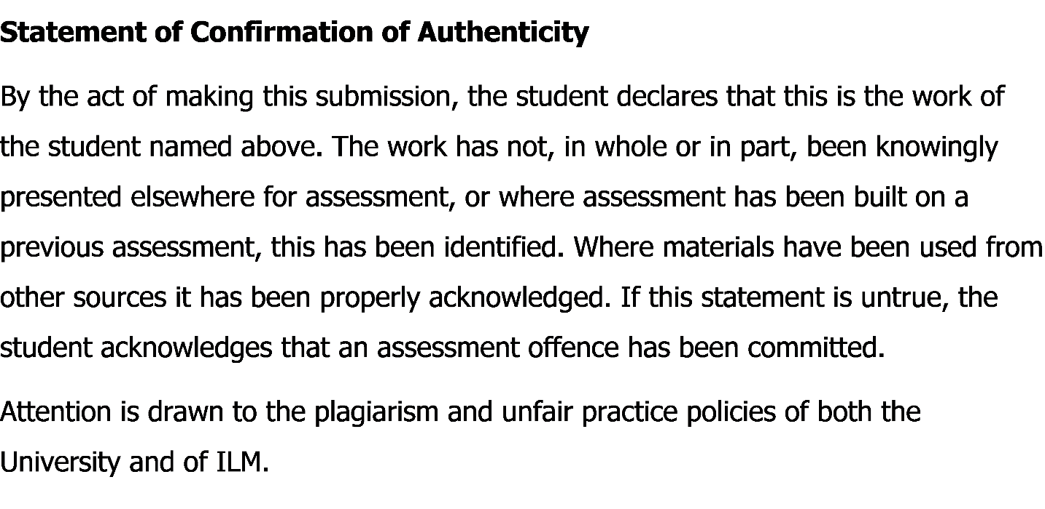

Executive Summary

One of the very common skills in business is problem solving and it is usually used in any industry or position. There are different types of employees are found in a business organization and they all are not good equally in solving organizational problem in workplace. Solving different organizational problem is an important skill to possess and this skill can be developed by properly understanding its main components. Every skilled problem solver is a blessing for any organization or team. Different companies use different methods in solving problem and nonetheless whatever the method is they usually go through certain stages. So it is very important to properly understand the different stages and aspect related with problem solving.

Contents
Executive Summary 2
Introduction 4
The selected company’s overview 5
Internal and External Environment Analysis 6
PESTEL Analysis 6
SWOT Analysis 7
Identifying the problem 9
Nature, scope and impact of the problem 10
Change Management Models 12
Kurt Lewin Model 12
Burke Lit win's change model 13
Possible Solution to the Change 15
Monitoring and review of the aftermath of the solution 18
KPI or Key performance indicators 18
Performance Appraisal 18
360 degree feedback 18
MBO or Management by objective 18
Awards and Recognition programs 18
PDP or Personal Development Plan 19
Conclusion 20
Bibliography and References 21

Introduction

Facing different problem s and solving those in the proper way is very common to human and different types of organizations. In order to ensure proper functioning of the company and get the desired outcome, the authority should properly identify and solve problems. A skilful problem solver is a blessing for any types of company. The skill of problem solving can be achieved through following certain instructions, erudition and exercise. This skill can help any organization to solve the complexity of their organizations through solving the problems in a proper way. Solving different problems and making correct organizational decision in proper way can help any organization to achieve a sustainable progress in the market.

The selected company’s overview

The author has been working in a retailing company called Boots UK which is mainly a subsidiary of The Boots Company plc. The company is a well-known retailer of beauty, health and pharmacy in the market of UK. The company was founded by John Boot about 170 years ago in 1849 in Nottingham of United Kingdom. The current headquarter of this company is in Beeston, Nottingham, United Kingdom. Their serving areas include United Kingdom, Republic of Ireland, Thailand, Bahamas and South Korea. The company has 2500 shops all over UK and Ireland and one of the top retailing companies in term of number of shop and revenue. From September, 2018 the President and Managing Director of this company is Sebastian James. The current number of employees in United Kingdom is about 56,000 and 1,900 in Ireland. Subsidiaries of the Boots UK are Boots Opticians and Boots Retail Ireland.

Internal and External Environment Analysis

PESTEL Analysis
This analysis helps to identify and evaluate the external uncontrolled factors than can affect the functions of Boots UK. With the help of this analysis the Boots UK can know about the potential impact by minimizing and controlling Boots UK’s future wind.
Political Factors: This factor strongly affects the company through European commission’s free trade agreement. The agreement emphases import and decrease purchase cost. As the costs structure is high relatively than others it lost the market structure by going to new market. The political disturbances in geopolitical areas have also affected the functions of the Boots UK in other countries (Maund and Tinkler, 2017). So the progress of the company in abroad is hampered because of less productivity in the new markets.
Economic Factors: Even after the financial catastrophe in 2008 many competitor companies of Boots UK emphasized on delivering the customer with products of great quality. Though their approach resulted in reduction of sales temporarily but they managed to retain their loyal customers (Morgan, 2016). Great product quality only can ensure the customer contentment. Their approach resulted later resulted in the possession of most of the market in both local and abroad.
Social Factors: The development and research department of Boots UK emphasizes keeping good relationship within the company between different departments and outside with the customers, suppliers. Social factors are very important for any organization to keep a sound relationship with the customers (Belton and Stewart, 2001).
Technological Factors: With the use of latest technology the company can reap the full benefit out of it. The online shopping system can attract huge number of customers. The companies now can keep a good relation with their customers (Adair, 2013). The company now can engage with their potential and loyal customers through website, social media and other online platforms. Both the online and physical shopping in the stores has become more reliable and efficient.
Environmental Factors: The Company is very much concerned with the protection of the environment as per the rules and regulations of Europe (Reed and Learning, 2014). The Boots UK taken programme related with the protection of the environment called Plan E which can be considered as the backbone of Boots UK’s internal and external business procedures and moreover, the taken programme can help the company to ensure proper use of their resources.
Legal Factors: When United Kingdom left European Union, there are many British business organizations faced problems related with legal factors. As a result of the decision taken by UK required new rules regarding imposing VAT which was previously zero VAT in domestic product’s purchase (J. Hicks, 2004). The company has taken all necessary steps to overcome the complexity of their business that created after the exit of UK from EU.

SWOT Analysis
This analysis is used to evaluate the internal Strengths, Weakness, Opportunity and Threats of a company.
Strength: The main strength of the Boots UK is that they have about 2500 shops all over UK and Ireland. So, the availability of their produced products and services will be available all over the market. The company can easily reach to the customers with their large number of shops and outlets all over the market (Helfand, 2007). The company has been in the market for about 184 years and gained brand reputation in the market and they have a large number of loyal customers. The product quality of the company is great and able to fulfil the demand of the customers.
Weakness: The pharmaceuticals industry under the company has faced some decline in sales in the recent years. The number of employs of the company also decreased than before so it is hampering the overall functions of the company. Also there are other competitors in the market who are dominating the market with their creative and innovative products (Crowley, 2013). The company also facing difficulties in expanding number of shops and outlets across the country and beyond.

Opportunities: The recent policy and strategy of the company has resulted in increased number of sales in health and beauty industry under the company. The company also has website for each of the industry under the company (Brest and Krieger, 2010). The company has about 5 millions of potential customers and in the future it can lead to real customers in future which can result in increase in number of sales.
Threats: Due to decrease in the number of sales, the company is facing difficulties to remain in the top position in the market. The number of competitors in the market is increasing day by day and becoming a threat for the Boots UK. As the other companies in the market are producing and marketing new and innovative products with a low price some customers are going for them (Allwood and Selart, 2010).

Identifying the problem

In recent times the British retail market has become so much competitive. The establishment of new companies in the market and cheap innovative products from other well-known companies have made market so competitive (Brest and Krieger, 2010). As a result, now the customers are choosier in terms of buying something from the market as they have many choices in their hand. So, in order to sustain in the market the existing companies have to come up with new and unique business ideas to attract the attention of the customer. For the better start the companies in the market have to start with fresh business ideas and its resulting in completely new and changed environment in the organization. In this case the managers are also required to be ready and cope up with the new business environment. All necessary trainings must be given to the employees of the company.
The Boots UK has recently lost a number of employees because of the changes in the organization functions. As the number of employees now decreased, the existing employees are now required to be more responsible than ever before (Crowley, 2013). Now they also have the scope to take fast decisions for the betterment of the company. Currently, because of change in the organizational structure the employees more responsible than previous time. At this point the workers are required to prove the effectiveness of their decisions.
Boots UK also has shops and outlets in other countries. So to ensure the proper functioning of the business in the foreign market the Boots UK must provide all necessary trainings for the workforce so that they can fulfil their targets (Helfand, 2007). Proper administration in appointing workforce or employees in the organization is very much important. The Boots UK hires employees with past experience and proper knowledge so that they can deliver more than the new comers.
So, the main problem of the Boots UK is to properly train their employees with all necessary and mandatory knowledge and skills.

Nature, scope and impact of the problem

Most of the jobs in United Kingdom give priority to candidate with previous skills and knowledge and it is also mandatory to have at least secondary level education. The workforce of an organization must be trained and skilled to ensure the organizational functions running properly (J. Hicks, 2004). The Boots UK face many problems as the employees of the organizations are lacking proper training and skills and it will hamper the proper development of the company. The probable problems have been depicted below:
- The authority of Boots UK will need to teach the employees about basic functions of the company especially those who are lacking the necessary skills. As a result the authority needs to spend relatively more times with the employees (Reed and Learning, 2014). The employees are not that flexible when they are assigned with different functions of the company.
- The unskilled employees of the company can create a problem by influencing other workers and hampering the working environment of the company. They are more responsible for reducing the company’s efficiency they can be the reason of others unemployment (Adair, 2013).
- The unskilled job seekers are not capable for the job. As they lack proper skills and knowledge mandatory for the expected productivity of the company. Due to the unskilled employees the overall productivity of the Boots UK can be decreased significantly (Allwood and Selart, 2010).
- The unskilled employees are needed to be trained in a proper way and it is a time consuming long process as they lack the basic ideas.
- Significantly a lot of money is necessary to develop the skills of the unskilled employees and increase the productivity of the company.

One of the crucial tasks for every company is to be careful in appointing and hiring employees for the company. A skilled employee is blessing to a company on the other hand the employees with less or no skills are like a burden to the productivity of the company. Making the unskilled employees to skilled is long time consuming process and require a lot of money (J. Hicks, 2004). So if the company hire candidates with necessary skills and knowledge they can directly contribute to the productivity of the Boots UK. The skilled employees are a great asset to the company so Boots UK should either replace the unskilled employees with skilled ones or they should take all necessary steps to develop their skills.

Change Management Models

There are deferent models available for the company to easily implement the changes if they want to bring changes to their business process and in the department of human resource. Change Management Model greatly helps in increasing the productivity and work quality of the company. It improves communication and collaboration inside the company. Applying this type of change model can help all the employees of the company to reduce stress and be more loyal and sincere to their job (Helfand, 2007). Few of the alternative methods for the company have been discussed below:

Kurt Lewin Model

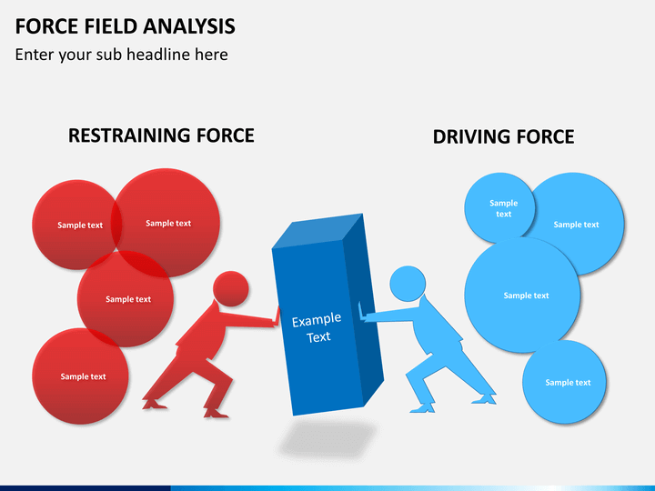
This theory was designed by Kurt Lewin who was a professional psychologist. The theory is also known as Force Field Analysis. The main job of this theory is to evaluate the decisions or plans whether they are implementable or not. Force Field Analysis helps the company to evaluate every aspect of a decision, and enables the company to think about what is required to do to make changes fruitful. The theory of force field analysis is founded on the resistance principles where some principles force it and some limit it. Outcome of a particular behaviour can be known by the accrued forces of the opposite force (Crowley, 2013). The managers can get the best performance from the company’s employees and eradicate the performance obstacles by bringing changes in these powers.
Benefits of this theory:
- Force Field Analysis assist the Boots UK to recognize barriers which lie ahead and hence the company become able to develop a plan to fortify the forces that support the decision and take all necessary actions to decrease forces opposing it.
- The company can use the Force Field Analysis Diagram as a visual support as it can make communication simpler between the staffs and eliminate communication hindrances.
- The Force Field Analysis diagram also can help the employees to build up common ideas of the subject.
Disadvantages of Force Field Analysis
- The Force field analysis wants every single member of the company to partake so that they can get all essential information required for a healthier analysis, which is generally not easy to achieve (Brest and Krieger, 2010).
- When the full partaking of the employees is not possible, it cannot present a full picture of the restraining forces and driving forces.
- Another probable difficulty is that Force Field Analysis can badly influence the team work of Boots UK.

Burke Lit win's change model

The model was designed in the 1960’s by Warner Burke and George H. Litwin. The Burke Litwin Change model mainly identifies and establishes cause and effect relationships. The model considers about twelve organisational factors identify the changes within a business organisation (Allwood and Selart, 2010). It is a helpful change management model to properly understand the aspects of a company and it also helps to view the aspects from a viewpoint of change.
The Burke Litwin change Model develops a framework where four groups of an organization are identified and represented in the columns. The middle column is often called as the spine of the model (Adair, 2013). The left column holds all of the hard elements of the company that are considered as tangible and measurable on the other hand the right column holds all the soft elements of the company that are mostly abstract.
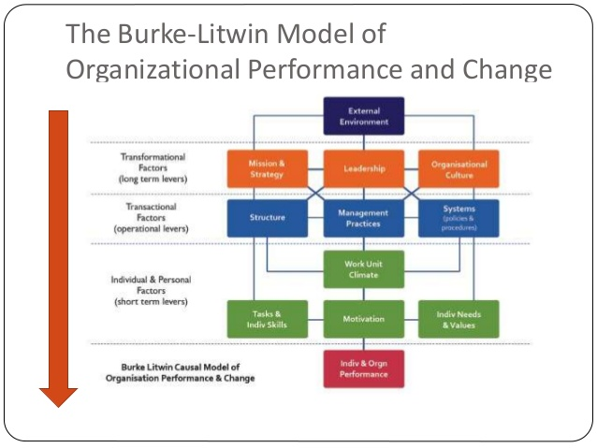

Advantages of Burke Lit win's change model
- This model organizes many main alteration issues.
- It identifies the difference between various factor’s position which influence and also get influenced by the businesses environment (Reed and Learning, 2014).
- It recognizes the connection between different outer and inner variables and presentation that influence the presentations.
Disadvantages of Burke Lit win's change model
- This model is multifarious in some extent.
- The control of outer and inner variables can bring some changes in business rather than the influence of the external surroundings (Crowley, 2013).

Possible Solution to the Change

The workforce of the Boots UK have been trained to increase their as well the overall productivity of the company. To ensure the outmost productivity of the company, the managers should have to ensure that all of the employees of the Boots UK are properly trained and motivated. The proper knowledge and skills of the employees of the company can ensure the best possible outcome from the company. The management team of the company must analyse and evaluate the changes before going to implement the process (Brest and Krieger, 2010). The change model which has been selected for the Boots UK is Force Field Analysis. The forces illustrated below are identified as causes of change.
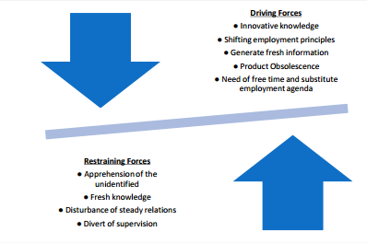

The Boots UK should take all initiatives to boost the influence of the driving forces and minimizing the effects of retraining forces. Boots UK also must ensure the proper use of their resources. Maximum time and effort should give by the company to reach to their destination. The management team of the company must ensure that all of the personnel are taking part in the decision making process (Maund and Tinkler, 2017). They also should identify the interest of the personnel like bonus, salary, identity etc. Providing the freedom of expression and decision making of the employees can result in their proper motivation. The personnel of the company will be more responsible and sincere to their duties and responsibilities if their opinions are valued in the company.
The Boots UK can develop a process of changes by utilizing the Force Field Analysis as depicted below:
Unfreezing: The first stage involve of this model involves the preparation of the company to acknowledge that change is mandatory and the present way of doing cannot be continued. This process is very necessary process to breakdown the current status quo because only after that the company can build up a new business operating way (Reed and Learning, 2014). The authority should perform as mentioned below:
- Must decide what he is willing to change
- Must ensure that there is support from the higher authority of the company
- Produce the motivation and need of change
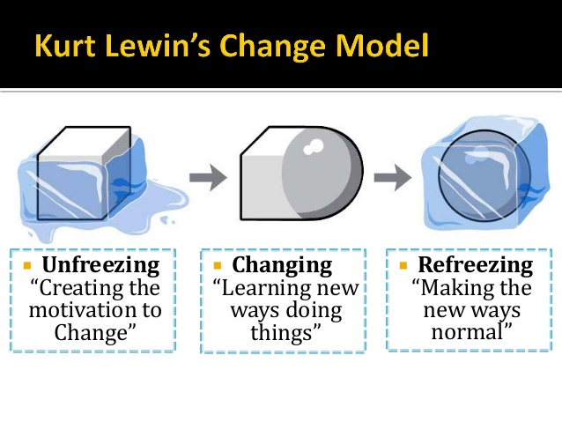
- Must manage confusions and appreciate the intellections

Change: This is the step where change actually happens and the way of operating business changes to the desired one. As the way of operating business changes in this step all of the personnel must cope up with the changing status quo of the company and learn the new way of doing things (J. Hicks, 2004). The Boots UK authority should do as following:
- Proper communication with the employees of the organization on a regular basis
- Eradicate any sorts of existing rumour from the company.
- Must motivate and teach the personnel of the company to do things in new ways.
Refreezing: When the individuals of the company, Boots UK, have accepted the new working environment and ways, the company is ready to refreeze. The refreeze stage itself also requires assisting the organization and the employees internalize the changes (Helfand, 2007). The Boots UK authority should do as following:
- Implement the changes in the customs of the business organization.
- Provide all necessary support and aid to the personnel of the company
- Make the personnel believe that any change in future will be successful
- Celebrate success
All the stages discussed above can help in successful implementation of the changes in sort of organization. Boots UK must analyse the situation before applying the changes in the organization to get the best possible out come from the organization.

Monitoring and review of the aftermath of the solution

Every organization in the market trains their employees to improve their performance. Once the training is over the management team of the company must evaluate the performance of the employees of the company to ensure the maximum productivity from them (Helfand, 2007). The performance management team of the Boots UK can greatly help the company to gain desired success and skip the competition.
There are a number of performance reviews and management techniques available as described below:

KPI or Key performance indicators
It helps greatly in determining performance of the company or individual in requisites of their objectives and goals. It is a very useful tool that presents a clear outlook of the present performance level.

Performance Appraisal
This is considered as one of the most well-known tool s of performance management. The tool greatly helps the organization to align each target of the company with their objectives.

360 degree feedback
Many business organizations are using this technique of 360 degree feedback in order to evaluate the overall performance of the company. Though this tool is useful it requires more time and become a burden to the Human resource department (Crowley, 2013).

MBO or Management by objective
This tool greatly helps in determining specific goals and the way in which the goals can be achieved. This tool involves the measurement of the employee performance and the comparison with certain criteria (Brest and Krieger, 2010).

Awards and Recognition programs
The employees of any company want reward in exchange for their great contribution to the company when the worker don’t get awards or recognition from the company they don’t give their best to the company. At least to get reward the worker can be very responsible and sincere to their job (Allwood and Selart, 2010). The management team of the Boots UK must ensure the award and recognition for the employees to get the best performance form them.

PDP or Personal Development Plan
This tool can be used both in the context of individual and organization after properly analysing the need of the demand need of the prospect. The personal development plan is a procedure that helps to identify what is the best or important for an individual or organization, what an individual or organization want to attain, what strengths an individual or organization already possess that can help to accomplish the goals, and on what an individual or organization need to develop with time (Reed and Learning, 2014).

Conclusion

Both in working life or personal life, problem solving and decision making are very significant. There are some useful tools that can help in taking better decisions and solving different problems both in working and personal life. So proper understanding of the different necessary tools is very important to take the best decisions or solve problems efficiently. The different ways and techniques discussed in this report can greatly help the Boots UK to solve their problems in a proper way.

Bibliography and References

Adair, J. (2013). Decision making and problem solving strategies. 2nd edn. London: Kogan Page
Allwood, C. and Selart, M. (2010). Decision Making. Dordrecht: Springer Netherlands.
Brest, P. and Krieger, ‎. (2010). Problem Solving, Decision Making, and Professional Judgment: A Guide.
Belton, V. and Stewart, T.J. (2001). Multiple criteria decision analysis: An integrated approach. 2nd edn. Boston, MA: Kluwer Academic Publisher
Crowley, P. (2013). Comparative decision making. New York, NY: Oxford Univ. Press.
Helfand, M. (2007). Shared Decision Making, Decision Aids, and Risk Communication. Decision Making, 27(5), pp.516-521.
J. Hicks, M. (2004). Problem Solving and Decision Making: Hard, Soft and Creative Approaches.
Morgan, P. (2016). The Business Student’s Guide to Study and Employability. Sage Publications
Maund, A. Schriek, M. and Tinkler, P. (2017). Certificate in Higher Education: Skills for the Workplace Student Yearbook. Sage Publication
Reed, C. and Learning, B. (2014). Problem Solving. Chicago: Britannica Digital Learning.

