

Modern & Traditional Construction – Managing the Design and Construction Process/Civil Engineering Technology

ACBA5000/ACBA5007

Paxton Street Car Park Development

Works & Site Information Document

Prepared by – Ellis Jones

Student Number 1708692

Index
1 – Introduction 3
2 – Excavation Works 4
3 – Basement Construction 8
4 – Drainage 12
5 – Façade 14
6 – Appendix 15
7 – Bibliography 24

1 – Introduction

The proposal of a new commercial development has arisen on the site of Paxton Street Car Park in Swansea. The scheme comprises of the construction of a twenty-storey building with three floors of underground basement parking and all associated infrastructure works. The building consists of a 30-metre footprint and is categorised as a medium-high rise building.

Historically, the site is located in the old Swansea Docks and so the potential for contamination and made ground would be considered quite high.

Certain methods of construction will have to be adopted due to the “postage stamp” conditions in which the site is set such as the use of vertical retaining walls as it will not be possible to “batter” the excavation.

2 – Excavation Works

Before carrying out excavation works, it would be advised that the contractor studies the bore hole investigation in Appendix 1a to determine how deep they should excavate. There should also be a detailed site investigation available, documenting information such as site topography, the location of buried services, the history of the site, the likelihood of flooding, ground water conditions and the general geology of the area. It would also be prudent for a contractor to converse with locals to become better informed of the site and its history.

Minimum Amount of Earth to be Removed

According to the borehole investigation results in Appendix 1a, the first 4.95 metres of strata consists of made ground. Made ground is usually a result of backfilling or past demolition and is manmade. It is not often that made ground will span across the whole site and so this is likely to lead to differences in settlement. It can also often be contaminated by substances such as asbestos. It is for these reasons it would likely be advised that all made ground should be removed from site. If any asbestos is detected in the site investigation, a specialist contractor should be appointed to remove the material and deposit it at a licensed tip.

As previously mentioned, the site footprint is small, meaning there is less opportunity for the contractor to create a gradually sloped “battered” excavation.

It may be advised that the contractor excavates to 11 metres, disposing of the unsuitable strata consisting of made ground and gravelly clay. If the contractor decides to have floors -3 and -2 at a height of 3.5 metres each with floor -1 at a height of 4 metres, the total basement depth would be 11 metres.

As the excavation is 30 metres wide and 30 metres in length, the square meterage of the excavation is 90m² and the depth, as previously mentioned, is 11 metres.

30m x 30m x 11m = 9900m³

Original Volume (V₀) = 9900m³

As soil becomes compressed in the ground however, it consists of more solid material and less air.

“Compaction is the process of increasing the density of a soil by packing the particles closer together with a reduction in the volume of air.”
(R.F Craig, 2019)

It is due to this reason that the original volume of soil will differ from the excavated soil (the bulk volume, V_{b}).

The soil samples taken have a bulk factor of 1.30 and so to find out the bulk volume, the following equation should be used:

Bulk Volume (V_{b}) = Original Volume (V_{o}) x Bulking Factor (F_{b})

9900 x 1.3 = 12,870m³

As the bulk volume is 12,870m³, this means there is 12,870m³ of material to transport away from site.

Before work commences, the contractor/groundworker should plan the amount of plant required on site to transport the 12,870m³ of material away from site. This will ensure there is continuity and that all machinery is being used to its optimum capacity. It would also be cost effective in that there would not be an excessive amount of plant on site, leading to potential unnecessary hire costs and idle plant operators. Production wise, this would also be beneficial as the excavator can constantly operate throughout the day without having to stop and wait for haulage vehicles/dumpers to return to site.

In order to effectively calculate the above, the contractor must first decide where the material is being transported to. The following calculations are based on the contractor using a dumper with a capacity of 12m³ and an excavator with a bucket capacity of 0.8m³. They are also based on the excavation and downloading process taking 40 seconds on average, and the tipping time taking 3 minutes.

Dumper capacity
Bucket capacity
× Time taken to excavate and download = Time taken to fill dumper

12m³
0.8m³
× 40 seconds = 600 seconds = 10 minutes

The material excavated is to be dumped 5 miles from site.

= Time taken to transport excavated material
Transport distance
Speed of haulage vehicle

5 miles
30 mph

= 0.1667 hour = 10 minutes

Transport time + Tipping time + Transport time + Time to fill dumper once = Cycle of dumper

10 minutes + 3 minutes + 10 minutes + 10 minutes = 33 minutes

To work out the number of haulage vehicles required, we use the following calculation:

Round trip time of vehicle
Loading time of vehicle

+ 1 = Number of haulage vehicles required
10 minutes + 3 minutes + 10 minutes
10 minutes

+ 1 = 3.3 = 4 haulage vehicles required

By adding 1, this provides a vehicle waiting overlap which enables the excavator to be fully utilised at all times which is economically desirable.

The total number of trips required by the haulage vehicles to complete the excavation would be:
12,870m³
12m³

= 1,072.5 trips = 1,073 trips

Whilst carrying out excavation works; it is vital that certain procedures are adhered to in order to ensure the health and safety of site operatives and also the general public. The Health & Safety Executive, also known as HSE, have produced documentation for contractors to refer to and instill on their sites.

“1 – Ensure that excavations are made safe by trench supports, battering back, fencing or other equally effective measures.
2 – Be aware that there is no safe minimum depth of excavation.
3 – Provide training for your staff which highlights the risks.
4 – Ensure that adequate inspection, at least weekly, and after bad weather, are carried out on all excavations.
5 – Provide competent supervision.
6 – Ensure that plant does not work too close to the edge of an excavation.”

(https://www.hse.gov.uk/construction/lwit/assets/downloads/excavations.pdf Date Accessed 15.12.19)

Plant Required

- Dumpers with capacities of 12m³ to transport soil away from site.

- Excavator with a bucket capacity of 0.8m³ – Typically a machine size of 15-22 tonne with a bucket width of 1.1 metres. Hydraulic clamshell excavators can also be used in situations where access can be difficult but oftentimes have a smaller bucket capacity.

- Earth moving plant such as a bulldozer or a tractor shovel to carry out the reduced level on site.

The following report is based on the Contractor adopting the “top down construction” method which wouldn’t necessarily require a ramp access. Most excavations would require a ramp and so not all material would be excavated away from site as it could be used to develop a ramped access into the excavation. This ramp should be designed by a competent person who will calculate a safe angle for the slope and also any temporary supports, if required.

Access to the Site & Safety

The contractor should ensure that the site is adequately fenced off to ensure that only site personnel can gain access. Site personnel should be fully trained and inducted before beginning any works and all appropriate signage must be in place. Appendix 1b shows an indicative site layout that could be adopted by the contractor to ensure site safety and also safety to the general public due to the site being situated in a densely populated area.

Access to the various basement floors should be maintained by leaving openings in each slab as they are constructed. This provides access and egress for operatives and their machinery whilst also providing an exit for the excavated soil to be transported through.

3 – Basement Construction

Tall buildings often require a large amount of parking and with limited space, it is ideal to accommodate parking spaces underground. There are a number of techniques for basement construction such as the construction of diaphragm walls, secant piling, contiguous piling and also other methods which involve completing the excavation process first. Typically, the cheapest and arguably the most popular option is secant piling.

“In secant walls, piles are installed in an alternating pattern where the second set of piles is cut into the first to provide an interlock. This not only improves the structural integrity of the wall but also limits the potential for seepage.”
(Bryan, T, 2015)

There are a number of advantages to including secant piles in a design. They are well suited to postage stamp sites such as this as they mitigate the need for temporary retaining elements such as sheet piles or trench boxes. They are also ideal for creating deep basement walls and can span the 13 metre or so depth required in this particular project. The extra two metres or so are due to the need for the secant piles to project beyond the floor slab of floor -3, as shown in appendix 1c, reducing the possibility of collapse due to lateral forces.

The method of installing secant piles and utilising them as basement walls is known as top down construction. This is often a preferred method of construction as superstructure works can begin during basement construction, speeding up the whole project and mitigating delays in programme which inevitably could lead to the job being handed over late.

There is also less risk of water building up within the excavation.

“Top down technique constructs the permanent structural elements of a basement downwards along with the progress of excavation. Unlike bottom-up methods, there is no holding of an excavated open pit which could result in soil movement and water retention”
(Chew, M,Y,L 2017)

Guide Walls

Firstly, guide walls should be constructed around the perimeter of the excavation to ensure the piles are aligned correctly. This will be done with the aid of a setting out engineer and will be built to drawings provided by a qualified structural engineer.

Specialist shuttering will act as the formwork for the piles and this will then be concreted to create a mould for the piles to be installed to. “Sacrificial” polystyrene wall formers are single use. These are convenient as the contractor would not have to worry about striking/removing the guides and can just continue to pile straight through the formwork.

Below is an example of a Sacrificial Guide Wall Former from a specialist supplier, Cordek.

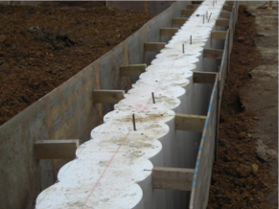

(https://cordek.com/uploads/data_sheets/M-DS28_sacrificial_guide_wall_former_data_sheet_v2_cordek.pdf Date Accessed 08.12.19)

Piling Mat

Prior to the piling contractor starting on site, plans should be in place to install a pile mat in preparation for the piling rig. The structural bearing capacity of the mat would typically be decided by the structural engineer who would specify the thickness of the mat and whether or not any steel reinforcement is required. The mat should then be plate load tested to ensure it has the correct bearing capacity.

Secant Pile Installation

Often with secant piling, piles alternate between male (hard) and female (soft) piles, with the former receiving steel reinforcement. Soft piles contain bentonite and a lower content of cement than hard piles. It should be specified by the appointed structural engineer as to whether piles should all be hard or a combination of both male and female.

This interlocking feature is displayed below and is key to preventing water ingress into the basement.

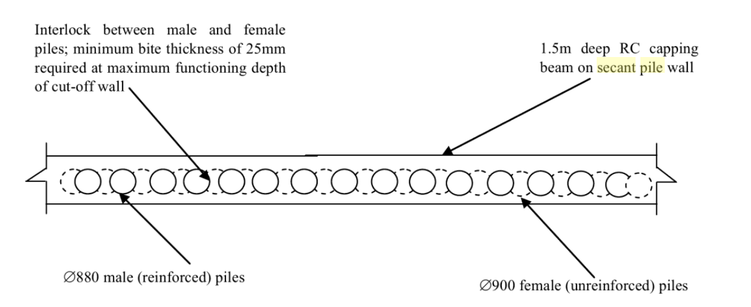

(V.M. Ulitsky, M.B. Lisyuk, A.G. Shashkin, 2015)

If the piles are to alternate, the female piles are typically installed first, in a hit and miss sequence.

The hollow auger stem is positioned in line with the first pile mould of the guide wall former and the drilling then commences.

Spoil is transported up through the casing and exits out through a spoil chute.

As the pile reaches the desired level (13 or so metres in this case), the concreting then commences and is pumped though the stem. The concreting continues as the stem is removed, gradually filling from the bottom upwards.

Reinforcement is then applied to the specified piles by lowering the steel reinforcement cage into the concrete before it has set. A crane will be required to assist with this process and to lift the cage.

Pile/Column Installation

Heavy structures often require piles to transmit the load of their foundations to strata with a high ground bearing capacity. A twenty-storey building like the development proposed would have a high vertical load to be supported by its foundations. The bearing capacity of the foundation will increase greatly with the introduction of piles. The contractor should then install piles to the bearing stratum at 20 metres deep. These piles will serve as load bearing components for the main structural columns of the building.

Excavation

Once the retaining wall has been formed through the installation of continuous secant piles, the excavation works can then begin.

With the use of hydraulic excavators, the site operatives can excavate each floor level, forming each slab from top down. M,Y,L Chew states that “the excavation can proceed from a working platform with large excavators until it reaches the depth where small excavators need to be mobilised”
(Chew, M,Y,L 2017)

Temporary struts should then be installed to offer bracing to the lateral pressure of the walls and stabilize the excavation. When each slab has been poured, these will then offer lateral bracing and so the temporary struts can then be removed.

4 – Drainage

At the time of the investigation in Appendix 1a, the water table is situated at a depth of 5.7 metres. The depth of the water table however can fluctuate, and so it may be prudent to carry out further tests.

“The level of the water table will vary seasonally, being closest to the surface during rainy seasons and deeper during dry seasons when most evaporation to air occurs”.
(Emmitt, 2012)

Whilst in their finished form the secant pile system will offer resistance to potential water ingress, the design team will also have to implement a temporary system until the sub-structure works are complete.

Several temporary methods can be used to dewater excavations, such as sump pumping, wellpoint systems, shallow bored wells and deep bored wells. Wellpoint systems can be installed around the perimeter of site to reduce the lateral pressure being exerted from the water table.

This external source could consist of a public sewer, the sea or a river, provided the water is clean enough and free of contaminants. This will require permission from the local authority and so it may be more practical to create a source on site. It would also be advised that if a contractor was discharging water to an external source, it should be filtered by means of hay or other material to ensure the water is as clean as possible. Therefore, in this instance, the contractor should test the water being pumped away as if it is deemed clean enough, there is the possibility that the authority would allow the water to be discharged from site straight to the beach/sea.

Permanent drainage solutions can be achieved through a number of methods, depending on the waterproofing level required and the form of construction used.

The Structural Engineers Pocket Book specifies three types of basement waterproofing systems as tanked, integral and drained -

“Tanked – Internally or externally applying paint or sheet membranes.

Integral – concrete retaining walls can resist the ingress of water in differing amounts, depending on the thickness of the section. Caltite or Pudlo additives can be used to create waterproof concrete

Drained – Moisture is collected in a sump and pumped away”
(Cobb, 2014)

The author also states that it is possible to use these methods “individually or together, depending on the requirements”

Whichever method is deemed the most suitable for the project, it is essential the design team work in accordance with British Standard 8102:2009 the ‘Code of Practice for Protection of Below Ground Structures Against Water From the Ground’.

Within this document, the various grading of basement waterproofing is outlined as shown in appendix 1d.

As the basement floors will be used for car parking, the basement would be deemed as Grade 1, meaning “some water seepage and damp patches are tolerable”.
A Grade 1 basement requires a Type B structure at the minimum “where the structure itself is constructed as an integral water resistant shell, using a concrete of low permeability, and appropriate joint detailing” (Best Practice Guidance, 2014).

Whilst it is often more desirable to waterproof a basement externally, this is not possible in a scenario where secant piles/diaphragm walls have been specified as the secant piles are acting as a retaining wall and it will be extremely difficult to get behind them to externally apply membrane or other forms of waterproofing such as bitumen solutions. As secant piles give a rough finish due to their interlocked, curved shape, it is quite common for a secondary wall to be formed in front of the piles on top of a slab, as shown in appendix 1d. This can also introduce a cavity element if desired which can act as a water barrier providing the correct drainage is installed. It would also be possible to use “shotcrete” to spray the walls, giving them extra waterproofing qualities.

Due to the nature of the works, it would be difficult for the contractor to complete the whole concrete pour in one go. The secondary wall and the reinforced concrete slab should be poured in controlled sections in order to introduce “control joints” between concrete elements. It would also be impractical to pour the concrete in one go as no control joints will lead to natural shrinkage and cracking in the concrete.

A waterbar is a PVC strip that restricts movement between construction joints in concrete structures and is high in tensile strength. It is essential the groundworker installs waterbar between joints to prevent seepage in jointed areas.

Appendix 1e is a possible detail that could be implemented in this project. This includes a drainage channel which needs to be maintainable. This should also lead to a sump or another kind of discharge point.

5 – Façade

“The façade is the separating and filtering layer between outside and inside, between nature and interior spaces occupied by people. In historical terms, the primary reason for creating an effective barrier between interior and exterior is the desire for protection against a hostile outside world and inclement weather”
(De Gruyter, W, 2012)

Typically, the main functions of a façade are to protect the building from external conditions such as rain and wind, create a controlled internal environment, prevent the transmission of sound, provide thermal insulation, prevent the spread of fire, generate an airtight envelope and also provide openings for access, daylight and ventilation.

There are a number of factors to be considered when choosing the most appropriate type of façade such as:

Cost – expensive options mean less profitability for the contractor/developer.

Suitability – a building set in a marine environment like in this instance will need speciality treated metals to prevent corrosion, metal cladding should be material such as zinc.

Buildability – construction projects are typically set to strict timescales and so systems that can take a long time to build such as masonry walls may not be practical. Complicated systems can also take longer and there is also higher potential for things to go wrong.

Appearance – aesthetics are extremely important to developers and planners. If a building is not aesthetically pleasing and does not tie in with its surrounding areas, it is unlikely it will even receive planning permission.

It is extremely important that the design of the vertical envelope is correct in order to avoid thermal bridging, avoid water ingress, prevent fire spreading and ensure the building is acoustically compliant.

The contractor could adopt a number of different façade systems such as rain screen cladding, brick slips or masonry. One very popular facade system in high rise buildings in particular is curtain walling.

Appendix 1f shows an example of a curtain wall system that could be implemented by a designer/contractor. This detail shows the curtain walling system fixed to the structural concrete frame with specialist fixings. An example of these specialist fixings can be seen in appendix 1g.

Appendix 1h shows an example of how sliding doors/large glazed elements can be integrated into a building such as this one.

6 – Appendix

Appendix 1a – Borehole Investigation

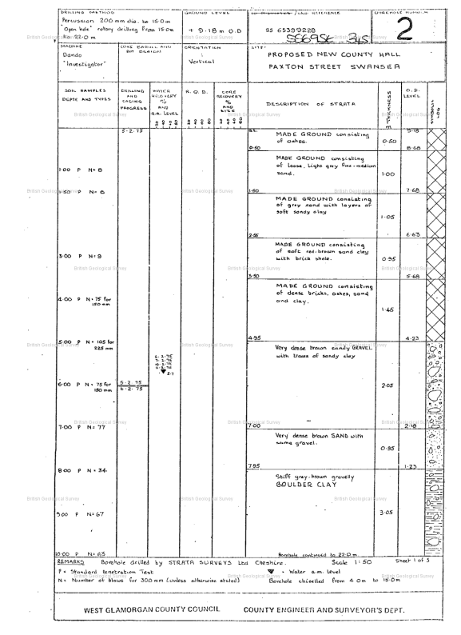

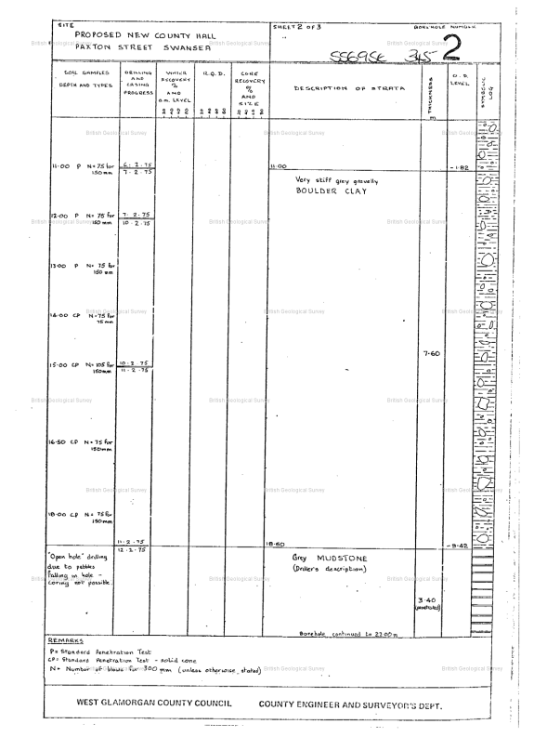

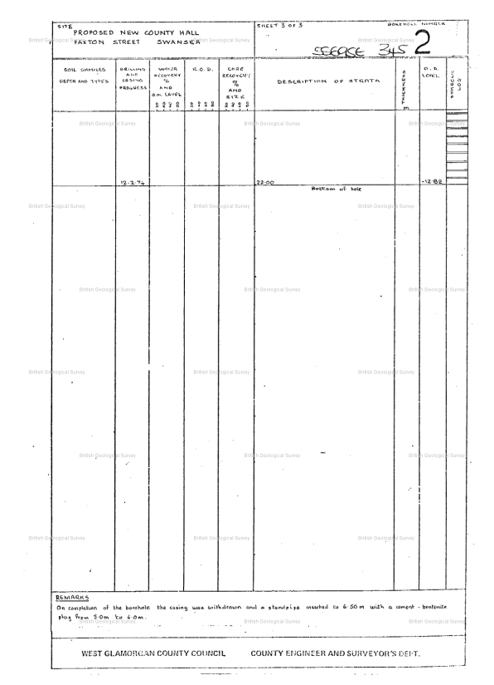

Appendix 1b – Potential Site Layout & Satellite View

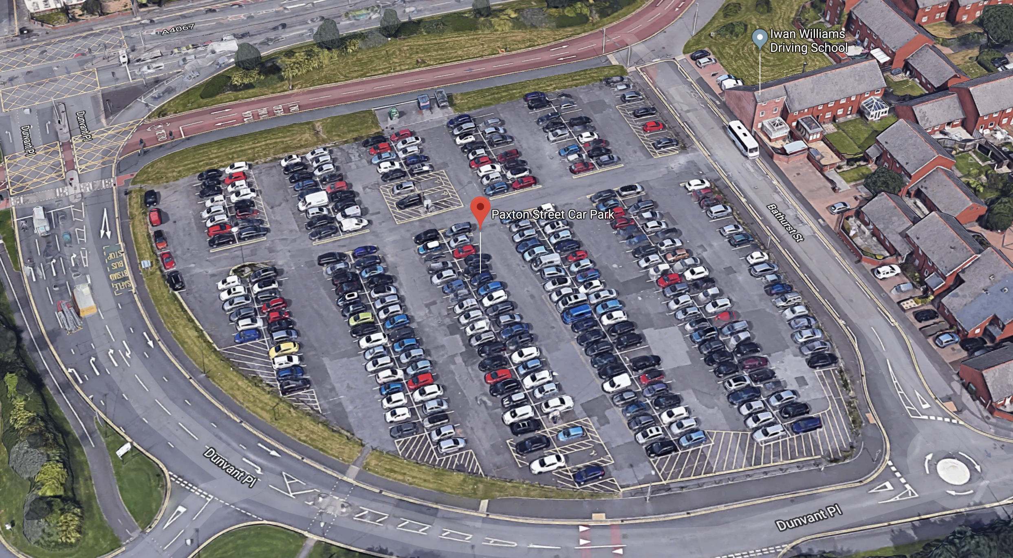

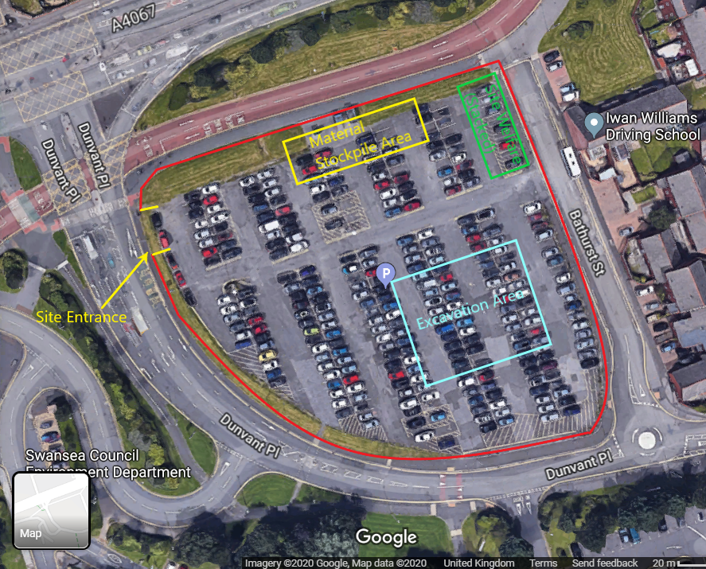
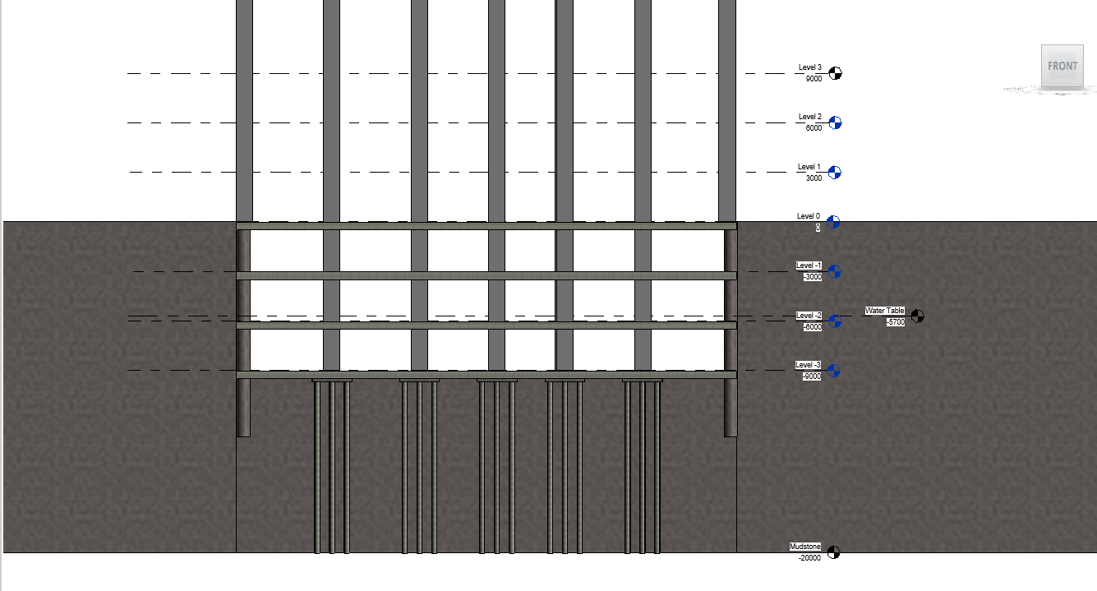
Appendix 1c – Section Displaying Potential Foundation Arrangement

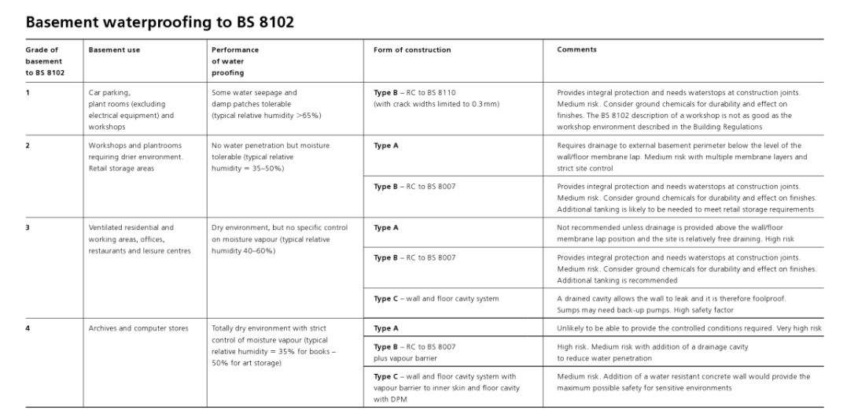
Appendix 1d – BS8102 Basement Waterproofing

Appendix 1e – Waterproofing Detail

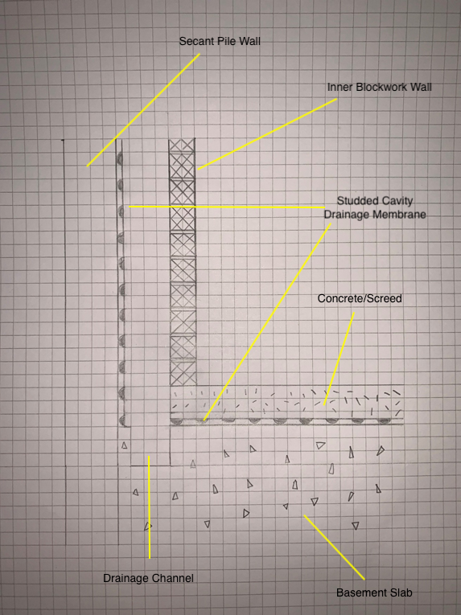
Appendix 1f – Curtain Wall Intermediate Floor Section

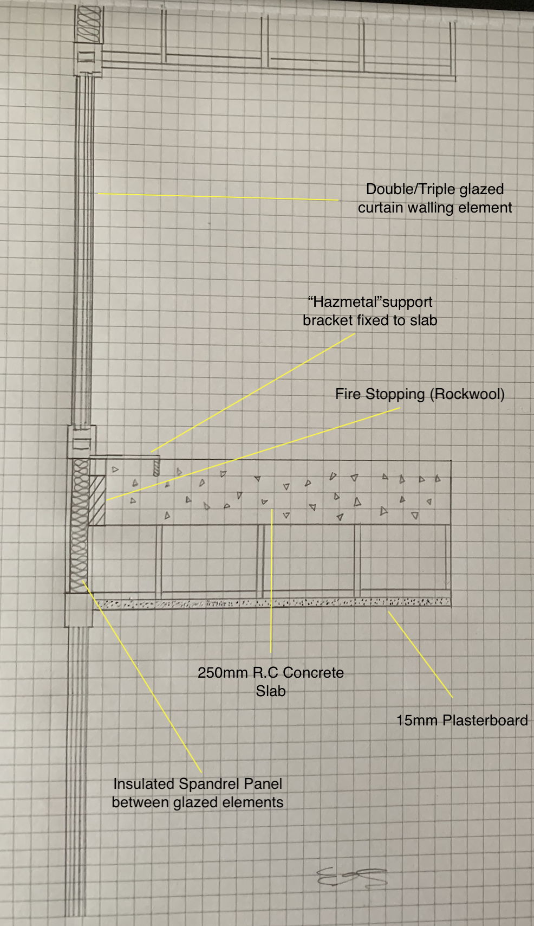

Appendix 1g – Curtain Wall Fixings

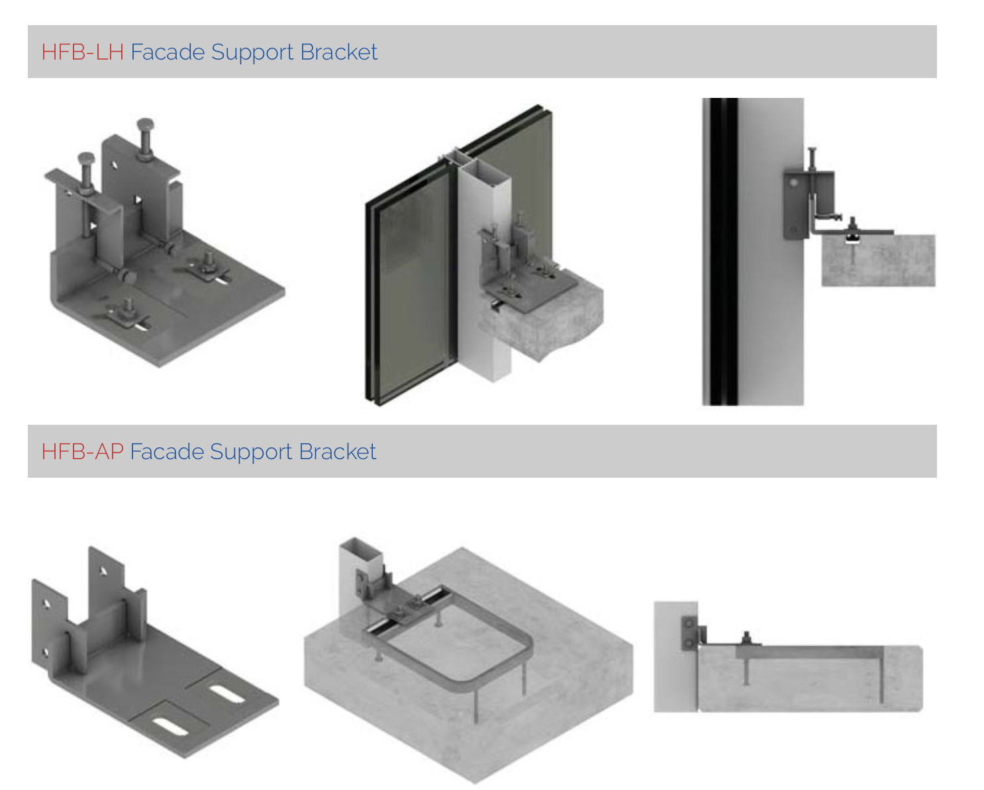

http://www.hazmetal.com/products/curtain-wall-brackets/

Appendix 1h – Section Through Foundation/Glazed Element

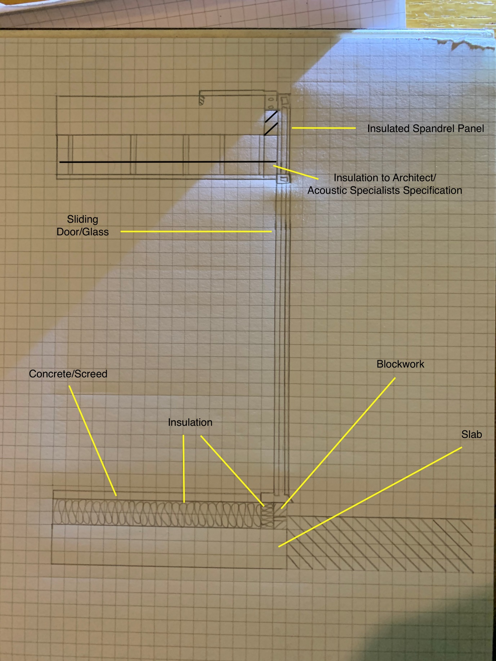

7 – Bibliography

- Craig, R.F (2019). Soil Mechanics. 9th ed. London: CRC Press. 26-27.

- (https://www.hse.gov.uk/construction/lwit/assets/downloads/excavations.pdf Date Accessed 15.12.18)

- Bryan, T (2019). Construction Technology: Analysis & Choice. 2nd ed. London: J Wiley. 378.

- Chew, M,Y,L (2019). Construction Technology for Tall Buildings. 5th ed. London: World Scientific. 191.

- (https://cordek.com/uploads/data_sheets/M-DS28_sacrificial_guide_wall_former_data_sheet_v2_cordek.pdf Date Accessed 08/12/2019)

- V.M. Ulitsky, M.B. Lisyuk, A.G. Shashkin (2015). Soil-Structure Interaction, Underground Structures and Retaining Walls. .: IOS Press. 251.

- Emmitt,S, Gorse,C, (2012). Introduction to Construction of Buildings. 2nd ed. United Kingdom: J Wiley. 69.

- Cobb, F (2014). Structural Engineers Pocket Book. 3rd ed. London: CRC Press. 362.

- The Property Care Association Guide to Type B Waterproofing, 2014

- De Gruyter, W, Lang,W, (2012). Facade Construction Manual: 18-19.

