AHAN7028 Heritage: Representation and Interpretation
The Representation and Interpretation of
Penllergare

A Critical Exploration
Michael Norman
University of Wales Trinity St Davids
December 2019

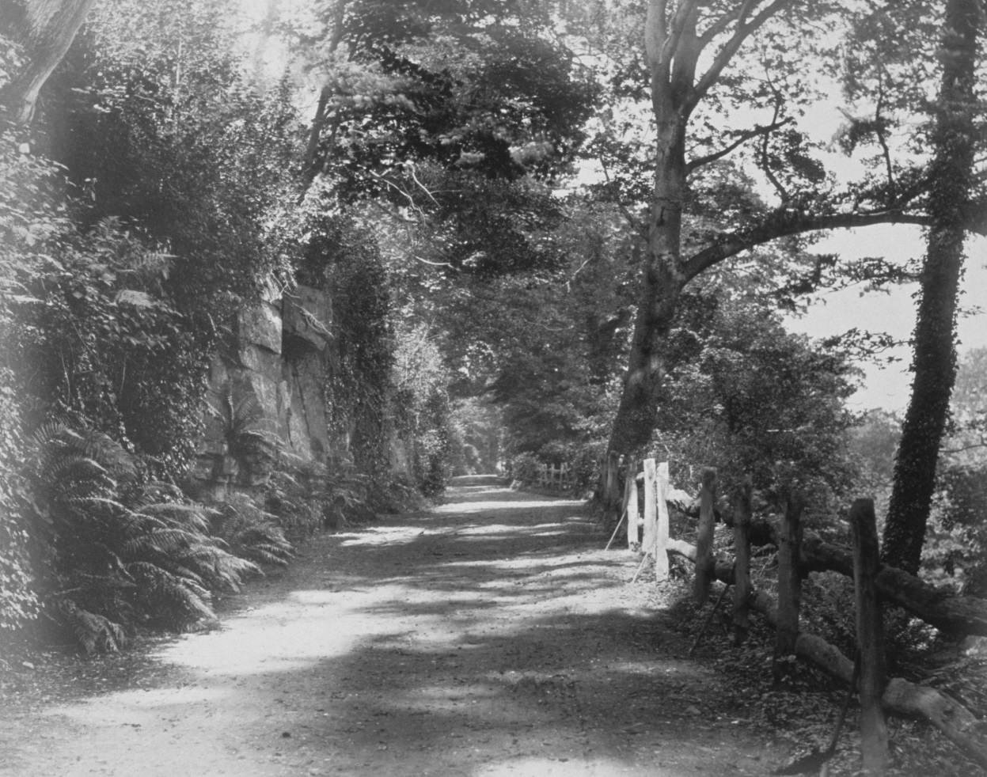

The Drive, Penllergare
Photo: John Dillwyn Llewelyn c. 1850

The Representation and Interpretation of Penllergare
A Critical Exploration
Introduction
Based on an appraisal of the representation of the unique genius loci of Penllergare created by its Victorian owners this study recommends means by which it could be re-interpreted for a modern audience.
The Place and Context
On the north-west fringe of Swansea, in a valley gouged out by glacial melt-water, nestles the once-private, Victorian paradise of Penllergare in the Romantic Picturesque style, its creators three successive Dillwyn Llewelyns, pioneers in science, horticulture, natural history and photography.
Three generations later the family had decamped and thereafter the landscape fell into ruination, divided ownerships, pressures from highway encroachment and insensitive commercial development, procrastination and failures in the planning system. As a result its historic character became seriously, and, in parts, irreversibly compromised.
So it was in 1990, following an initiative by the Welsh Historic Gardens Trust, and responding to a tradition of unofficial community appropriation, that the independent charitable Penllergare Trust was founded to save and revitalise the core of the estate as a recreational green space, Penllergare Valley Woods. Where once one visited only by invitation, now it was to be freely open to all (Norman, 2012).
In setting out to conserve, interpret and celebrate this albeit degraded cultural (i.e. humanly influenced) landscape the Trust also sought to mingle the official values (Cadw, 2000) with the other, unofficial community and natural heritage values represented by Burra Charter, in that
There are places worth keeping because they enrich our lives – by helping us understand the past; by contributing to the richness of the present environment; and because we expect them to be of value to future generations. (Walker, 1996)
Schama’s concepts of layers of place and memory were also germane, e.g.
Landscape and Memory …might be thought of as an excavation, beginning with the familiar, digging down through layers of memories and representations towards the primary bedrock, laid down centuries or even millennia ago, and then working up again towards the light of contemporary recognition. (Schama, 1995, pp 16-17).
His concept is therefore consistent with Benton’s definition of landscape in three broad dimensions: i.e.
as a natural environment, as a particular type of cultural environment and as a canvas for memories. All three have important claims to be heritage dimensions, carrying elements that we recognise and celebrate now and wish to pass on to successive generations’. (Benton, 2010, p.234).
And of cognitive landscapes that
refer to the different layers of meaning that accrue around landscape, derived from the different ways people react to it, based on what they know about its physical and cultural history (ibid pp.318 & 215-6).
The Trust’s involvement of local people ab initio was consistent with Section 8 of the ICOMOS Nara document of 1994 that calls for local communities to be recognised as the primary carers for their heritage (West, p.60).
However the Trust’s charitable object to further knowledge and appreciation of the cultural landscape has been somewhat down-played recently, but a grant by the National Lottery Heritage Fund (NLHF) will enable a fresh start, including a purpose-built ‘discovery centre’.
Representing Penllergare
Using Walsh’s definition of ‘ representation’ as a depiction of the past created visually or in words (1992) Penllergare may be characterised and celebrated by the following themes from Penllergare’s heyday.
The Afon Llan threads the valley and erratics and glacial tills bear witness to its violent origins. However, other than references to a land grant in the 14th century, there is no other evidence until the 16th and 17th centuries when the estate was recorded as Penllegeer. There are some 20 variants of this spelling that translate as the head of the camp of fortified earthworks, indicating a prehistoric settlement, though its location remains a mystery. The spelling Penllergare that was current during its Victorian heyday was therefore adopted by the Trust (Childs, 2004). The adjoining medieval estate of Nydfwch was subsumed into Penllergare through marriage and its core comprises the lower portion of the valley.
Lewis Weston Dillwyn (Lewis, 1778 - 1855) was acquainted with distinguished inventors, chemists, scientists and astronomers, as well with leading plant collectors and botanists; all to benefit Penllergare. His diaries contain detailed references to the estate’s management (Morris, 1991), with special emphasis on silviculture and the future layout of the valley. Being also a shrewd businessman he bought up land with coal-mining potential.
His son John Dillwyn Llewelyn (John, 1810 - 1882) was involved from an early age in the joint creation of the designed landscape at Penllergare, but when he took possession, with the energy and wealth of the young newly married, he and Emma brought new impetus and resources into this family project.
In 1833, the main drive was complete, forming a backbone to the rest of the landscape. Work on the three lodges followed quickly, one of which (much altered) is occupied now, whereas only the footings of the others remain. The quarry’s rawness was transformed by planting and a cascade, topped out by a summer house.
John then took the boldest steps yet to enhance the grandeur of the landscape, damming the Afon Llan to create the Upper Lake, with its iconic waterfall and followed it by the Lower Lake with boathouses and complex cascades though, probably through Lewis’s influence, efforts were made to conserve the work of previous generations – a strategy that would be applauded today. (Nicholas Pearson Associates, 2008).
The equatorial observatory was built to celebrate John and Emma’s daughter Thereza’s 16th birthday and there she and her father took some of the earliest pictures of the moon. Another scientific first for Penllergare was the first demonstration in Britain of an electrically powered boat.
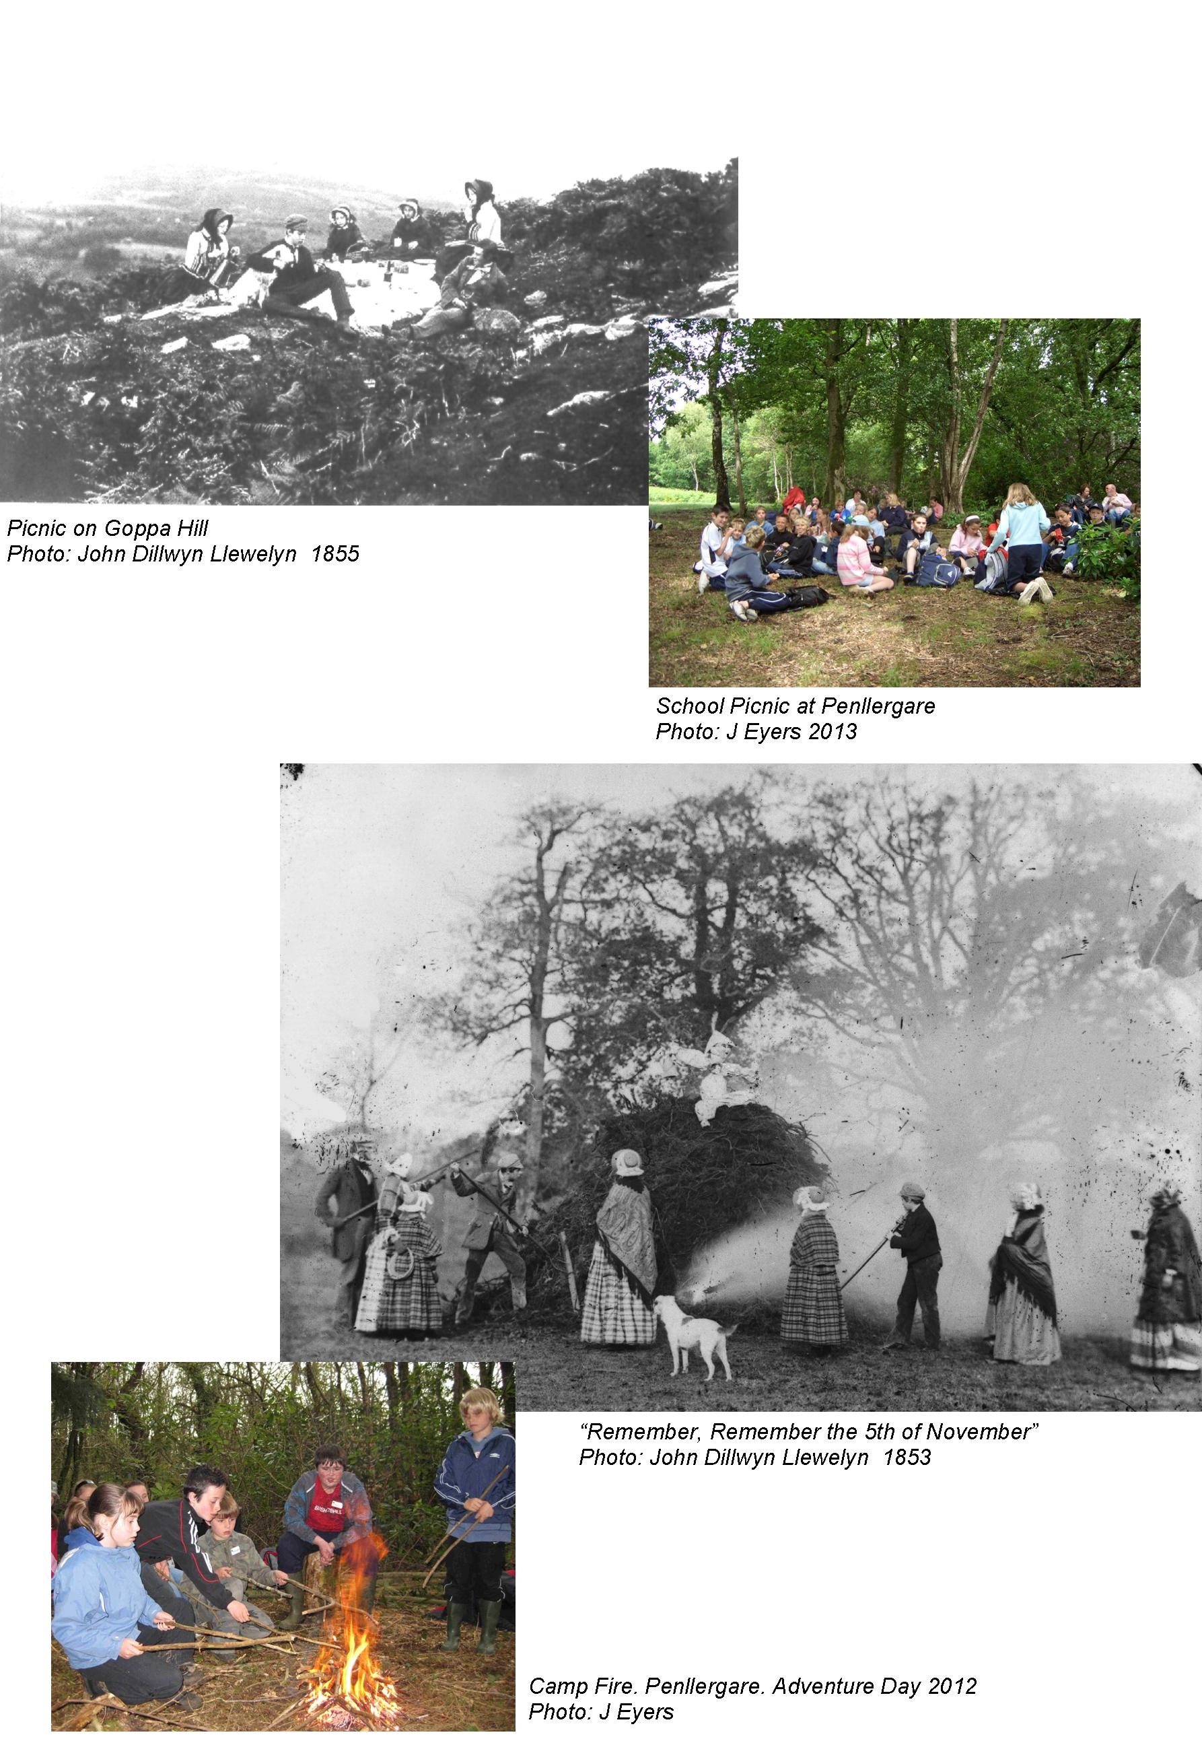
Developing planting and structures were also at the cutting edge of Victorian horticulture and science. For example the walled kitchen gardens, including John’s pioneering orchid house, have been described as
... Even in their present derelict state (they are among) the most extensive surviving in Wales outside a major stately home … Of particular interest to the history of botany is the orchid house, a building at the leading edge of orchid cultivation from c1835. (Briggs & Ward, 2000)
He was also a prolific planter of trees, as described by Emma in 1841
he is so busy now, planting Ghent azaleas, hemlock spruces, deciduous cypresses, yews, laburnums, & Norway maples and Weymouth pines down by the Lago Maggiore [the Lower Lake] (Morris, 1999) ,
although a lease to the Forestry Commission in 1919 resulted in a mundane overlaying of the former, predominantly semi-ancient, woodland.
Emma was herself a devoted plants-woman - her letters reflecting her horticultural enthusiasms often left family news to an after-thought. She also took a leading role in the laying out of (now) Parc Llewelyn, on land donated by John for the use of the people in the grimly industrialised Tawe valley below (Skinner, 2006). At the opening of the park in October 1878 The Cambrian newspaper reported
it is everything that could be wished for the health and recreation of a large population, who are crowded in their works and houses, and who, after work, ought to have an outlet for play and health.
Of all John’s achievements, it is perhaps the development of photography that is his lasting legacy, with Emma closely involved - unsurprisingly since Henry Fox Talbot was her cousin. The many surviving photographs of the estate provide an invaluable and almost unique insight into the appearance of the valley landscape, conveying a Romantic and Picturesque sense of untamed nature; evoking a sense of exploring and experiencing wilderness; a ‘natural’ world in deepest contrast to the noisome copper manufactories of Swansea, a brisk canter distant (Chanan, 2013).
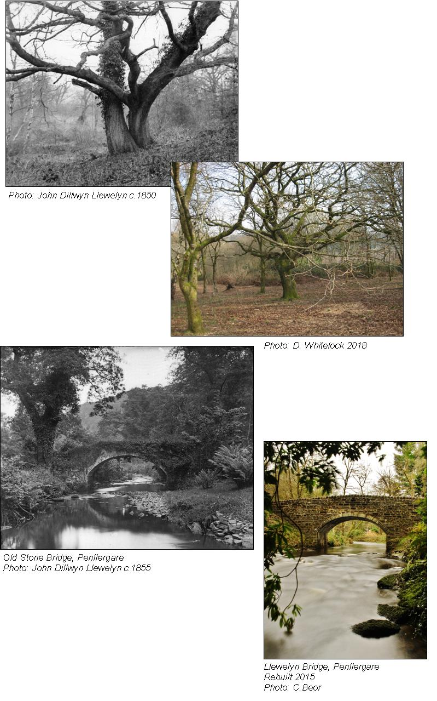
On retirement Penllergare passed to their eldest son, John Talbot (1836 – 1927), whose early interest was archaeology but he inherited a passion for horticulture and became an authority on rhododendrons, still represented at Penllergare today. The South Wales Daily News reported on 20 August 1910 on the estate’s heyday
The real glory of Penllergare consists of its truly magnificent grounds, and its rare and beautiful plants which add a superabundance of attractions to a spot already marked by nature for special favours … For beauty and scenery there is nothing in the whole land of Morganwg [Glamorgan] to excel the valley of Penllergare.
However falling incomes necessitated exploiting the remaining coal reserves under the valley for the lucrative French market, so long as none of the pithead buildings were visible from the house (Rees, 2008).
All three successive generations fostered a close relationship between Penllergare and local people. The grounds were open to the public three times a year, with special openings for local Sunday Schools. The new village school (founded by the family, as was the church) logged Nature Study Excursions, arranged by John Talbot. The enjoyment of Penllergare, which this occasional public access encouraged, remained and grew beyond his death, leading to a sense of unofficial ownership prevailing to the present day.
In any case the family ties with Swansea had begun to loosen and Penllergare was effectively abandoned in 1936, although parts of the estate were subsequently bought-back. Their Big House fell into dereliction, was judged dangerous and provided a weekend exercise with explosives for the Territorial Army. It was replaced by Council offices that were, in turn, reduced to rubble in 2016. Today only a hatched outline on a developer’s plan (Swansea City and Council, 2017-0986-FUL) marks the spot, on which Nos 69 – 71 Mansion Gardens have been built. World War II occupations also left their mark. The M4 motorway top-sliced the valley and another dual carriage-way shaved off the left flank, obliterating Home Farm and severing the estate from its village. All the while the landscape became blurred and eventually near-impenetrable by luxuriant vegetation. So this focus of intellectual and practical polymathy and centre of local life began to sink out of sight and mind and vandals took possession.
Outer Walls 2005
Photo: C Cray
Frontispiece from the Journal of the Horticultural Society Vol. 1 1846
Outer Walls 2005
Photo: C Cray
Frontispiece from the Journal of the Horticultural Society Vol. 1 1846
Outer Walls 2005
Photo: C Cray
Frontispiece from the Journal of the Horticultural Society Vol. 1 1846
In the face of this violent anarchy and impatient with the planning impasse the Penllergare Trustees commissioned a report on the state of the park from the perspective of strangers with an informed eye. Among its conclusions were
Its appeal is greatly reduced by the effects of anti-social behaviour, theft and criminal damage and an unsafe atmosphere. It is difficult to imagine a site which is supposed to function as a place which actively encourages public access that could be so discouraging. (Anthony Jellard Associates, 2005).
But even as the landscape deteriorated a nucleus of other local people still retained a proprietorial concern for their remembered Woods. Some, younger and more adventurous, adopted this beautiful, neglected wildscape. Their nicknames were – and still are - used for special places; ‘Kiddies’ is the river pool in which children had to stay until their peers were satisfied that they were capable of swimming in the lake. The observatory was The Lighthouse’ and the waterfall was ‘The Hidden’. In this regard the Valley Woods echo the definition of Cynefin as
that area where we feel we belong, the immediate environment, the surroundings which impress themselves upon us in the formative years between 5 and 15; and
… an attachment to place, the landscape, in which we first lived and learned to see (Williams 1973.84), the immediate neighbourhood, the window through which we view the world, a personal construct of land, language, history. (Pearson & Shanks, 2001, pp. 139-40).
What Then
The protracted delays in the Trust gaining possession of Valley Woods were put to good use by undertaking detailed research and surveys to provide a thorough understanding of the place. For example a cultural, archaeological and historic landscape database (compiled by a Lampeter post-graduate student on work
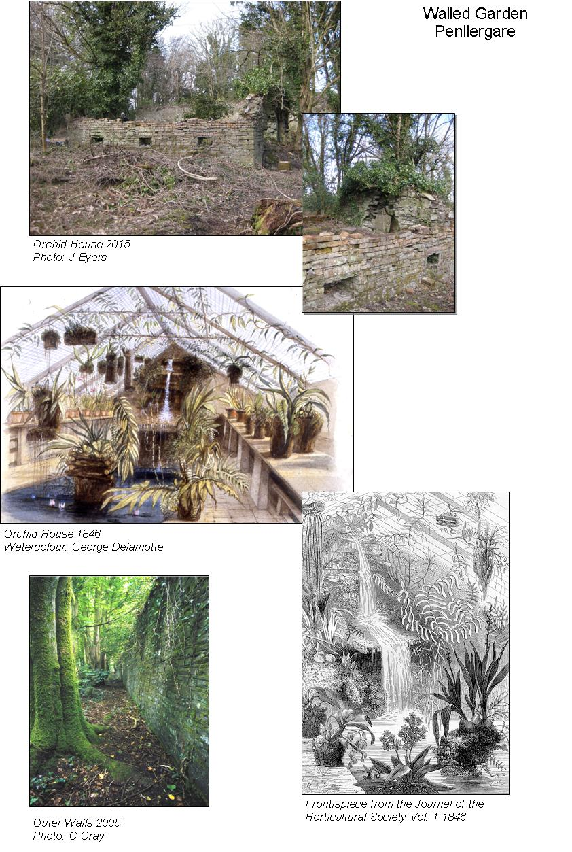
experience with Cambria Archaeology, 2002) comprised 203 data points, whereas previously the SMR had recorded only five. Together with Jeff Child’s appreciation of the place, people and its context (2004) this programme further confirmed the heritage values of the place and helped define how it would be conserved, repaired and managed with community benefit high on the agenda.
The observatory shell remains as the one up-standing marker in what had been the focus of the estate, but isolated now in the new development. The site of the former Nydfwch has been determined by non-intrusive survey but awaits detailed investigation. On the eastern bank only the footings of the small holdings, Gelly Evan & Glyn Shilling remain, shrouded in undergrowth. The colliery spoil tips are a target for fossil hunters but the pithead site is identifiable only by a modest plaque, also well-hidden by undergrowth, together with other surface vestiges. A mound conceals what may have been a grist water mill, pre-Dillwyn Llewelyns (Taylor, (2008). Downstream the cascades and boathouse for the former and much modified lower lake are in dereliction, but still worthy of conservation.
Remnants of the exotic plantings have suffered from neglect, vandalism and encroachment by softwoods though, in spite of – and partially because of – the pervading neglect some nationally significant natural habitats survive in relatively good condition.
Meanwhile robust security measures and ‘boots on the ground’ led to a big drop in vandalism, illegal bikers and burnt-out cars. So where less than a decade ago Valley Woods was shunned as un-welcoming, more and more people – some returning after decades – were enjoying the quiet beauty of Valley Woods and its wildlife. However there was a cost. Paths designed for occasional use are being eroded by boots and dog-paws. The Waterfall, subject of many of John’s photographs, is the destination for most visitors and its setting is suffering accordingly.
Today upwards of 100,000 visitors use Penllergare Valley Woods annually, hardly surprising given that it is the main recreational green space for a resident population of over 325,000 within a 15-minute drive-time and over two million within an hour’s drive.(VZJ Associates, 2008 et al). An additional factor is that
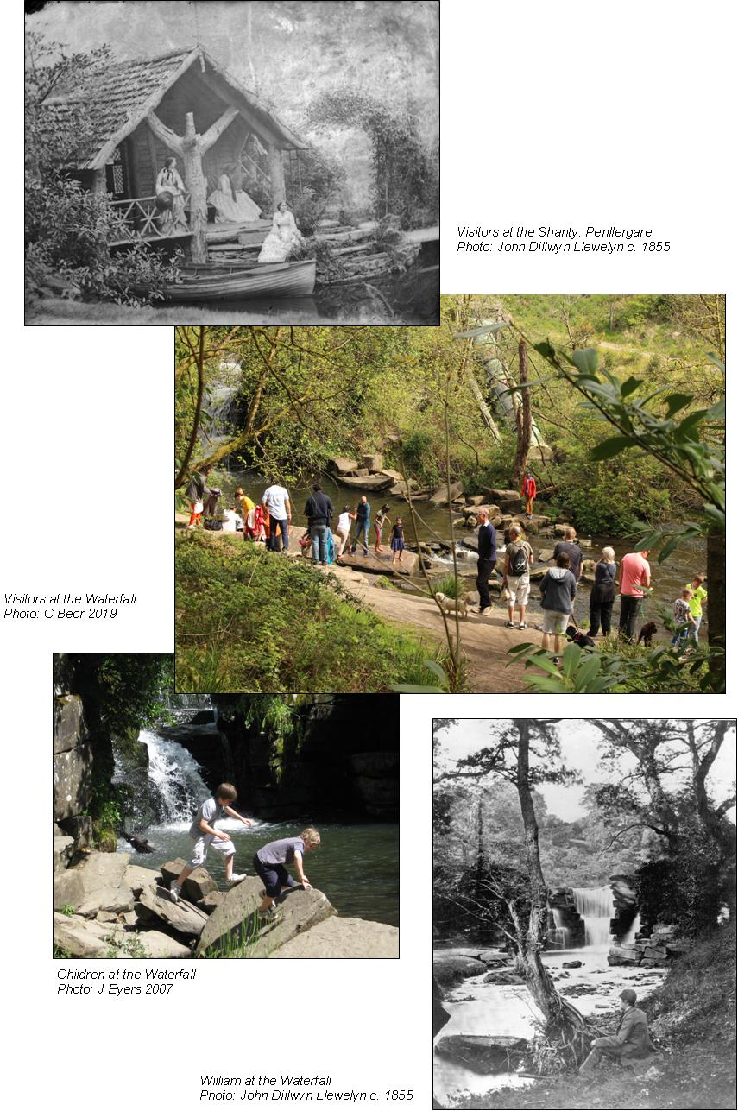
several socially disadvantaged communities are within walking distance, for which – as already noted – Valley Woods has always been their back-yard. The Big Lottery-funded Community Engagement & Education programme played a significant role in engaging local people, particularly schools, together with the thriving Friends’ support group and volunteers at every level of management.
Of those local returners many were introduced or re-introduced by children who had taken part in the school programme. A growing collection of historic and contemporary letters and oral statements were compiled in the Trust’s, Penllergare, Echoes from Valley Woods (Eyers, 2006)
Years of wonder and delight are the memories of my childhood at Penllergare. It was a magical place”. “Penllergare was my playground of delight, discovery and learning for ten years.
Visitor surveys (Penllergare Trust, 2011) and GKA & Letha Consultancy Ltd, (2017, et al) mirror the key statistics from UK-wide surveys, e.g. the HLF Public Perceptions of Heritage Report (Ellison, 2018) that concludes:
The two most popular reasons why heritage matters to people are that it helps them to learn from the past (62%) and that it preserves important things (61%). 73% of 65 and over think that heritage matters as it helps people to learn from the past, significantly higher than 16-24 year olds (45%).
National policies recognise the economic importance of these trends, complemented by A curriculum for Wales, a curriculum for life, that sets out the framework for 3 to 7-year-olds to, promote discovery and independence in the outdoor environment. (Welsh Government, 2015 et al).
Interpretive Principles
Turning to interpretation, how do these representations and strategies apply to Penllergare? Self-evidently the Dillwyn Llewelyns interpreted the place they created for their own pleasure while escorting invited guests round, before taking tea on the terrace. Today’s trustees have no such advantages. The thousands of uninvited visitors come whenever they choose. Furthermore they need contribute nothing for the privilege of doing so, or for the wear and tear

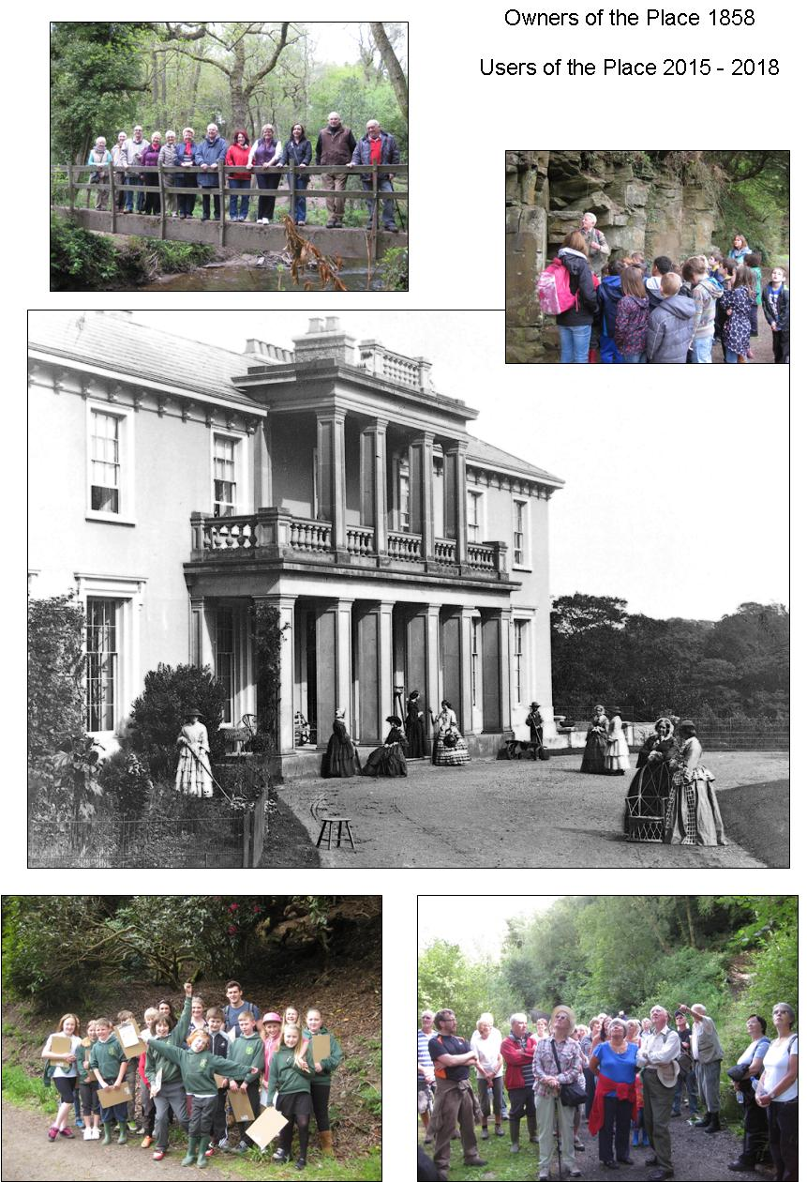
they inflict. The NHLF and many grant-making trusts therefore make demonstrable enjoyment and interpretation conditional for support, but in the longer term the Penllergare Trust has to earn money from its visitors and supporters through positive engagement. Catching and maintaining that engagement is therefore obligatory and effective interpretation is essential to that end, recognising also that its delivery will often merge with activities e.g. learning, volunteering, events - and that all-important process of generating income.
Echoing the Burra Charter interpretation has been defined as:
Bringing the past to life so that it resonates with visitors, and gets them thinking and talking is the role of interpretation. It is a communication process that links factual information to the immediate, first-hand experience of the place and to the contemporary lives of visitors. It sheds light on the present and gives meaning to the past. It links us to the stories of the generations who were here before us. These are the rewards that heritage sites can offer visitors, and interpretation delivers them. (Fáilte Ireland, 2019).
And this chimes with the Pearson & Shanks’ tenets of interpretive archaeology (2001, especially pp xvii, 11 & 159 &. 157), as well as the invaluable NHLF Guidelines (2010 & 2013). Regarding methodologies the following two sources are relevant here. Firstly Clark’s:
- Catch people’s attention
- Provide a connection between [Penllergare’s] heritage and people’s own experience
- Be pleasurable, interesting and meaningful
- Be well organised and easy to use and understand. (Clark, 2019).
Then the National Trust’s
- Are we creating the right first impression?
- Does the spirit shine through?
- Does the visit appeal on different levels?
- Does every detail count?
- Can the place speak for itself?
- Are there reasons to return?
- Are we stretching and surprising people? (National Trust, 2010)
Thus ranging from the superficial to the immersive interpretation must meet the needs of a variety of audiences that may be categorised as:
- ‘Skimmers’; e.g. walking the dog and a coffee being the priority
- ‘Dippers’; e.g. a general interest in the place, referencing the information leaflets and website, but not exclusively so; and
- ‘Divers’; e.g. a particular interest in one or more aspects of the place, people and / or project, possibly involving some research and participation. The origin of the fortified camp is a possible candidate. (after West, 2010).
To which must be added providing on and off-site learning, reflecting the importance of engaging young people with dedicated programmes (e.g. Tilden’s 6th principle, 2008).
Accepting Pearson & Shank’s view that, ‘Meaning comes from making connections and exploring contexts’, (p. 157), how should the Trust approach translating those representations into delivering interpretation with the requisite authenticity?
On the face of it everything has changed; Penllergare is no longer the pristine private paradise but its recreational remnants. But looking closer there is a remarkable symmetry with the Dillwyn Llewelyn’s own passions and priorities, as well as a haven from surrounding development - to which may be added the mitigation of climate change. In other words, despite the vastly different circumstances, practically all the Dillwyn Llewelyn’s representative values are still valid themes for interpretation, inspiration, celebration and enjoyment today. In summary these are:
- The roles of the Dillwyn Llewelyns and their families; pioneers in industry, technology, horticulture, and the sciences.
- A nationally-recognised 19th century designed landscape with an extensive archaeological record.
- An internationally unique collection of early photographs.
- Important scientific discoveries and experiments, surviving in documentary accounts, as well as the equatorial observatory and orchid house, both scheduled ancient monuments.
- A substantial and well-recorded walled garden, and the intensity, innovations and discoveries of Victorian gardening.
- A rich diversity of habitats and wildlife.
- A tradition of local community engagement, now also open to audiences further afield.

Alert to the need to preserve authenticity (e.g. Nezhad & Eshrati, 2015), these themes could be presented through well-established, predominantly collaborative outdoor activities as:
- Guided walks / theatre: “It’s Our Place” and “Wild for Woods”.
- Video loops: ‘Layers of Stuff and Memories’, ‘Involving the Family’.
- Self-guided walks, GIS-data activated.
- Innovative horticulture and silviculture.
- Archaeological investigations, Nydfwch and the old mill especially.
However the growth of digital technology also provides opportunities largely unexploited in this type of environment, including distance access and virtual reality techniques, notably but not confined to a virtual observatory. How this would work at Penllergare requires further study, including scope for providing alternative interpretations of the place and its people (e.g. Staiff, 2014).
Conclusion
Combining both official and unofficial heritage values this study has proposed representative values and interpretive principles for adoption at Penllergare for those who wish to explore them. However it is just as likely that people value Valley Woods because it is here that they can bunk off, or just unwind, have a picnic and enjoy the scenery and wildlife. But so of course did the Dillwyn Llewelyns.

References
Anaheir, H.K. and Isar Y.R. (2011) Cultures and Globalization: Heritage, Memory and Identity: Sage
Anthony Jellard Associates. (2005) Penllergare Country Park, State of the Park: report for Penllergare Trustees
Benton, T. (ed). (2010) Understanding Heritage and Memory: Manchester University Press
Briggs & Ward (2000) Preliminary Notes to Accompany a Survey of the Kitchen Garden at Penllergare: RCAHMW, NPRN 265643.
Cadw. (2000) Register of Landscapes, Parks and Gardens of Special Historic Interest in Wales, Part 1: Parks & Gardens, Glamorgan Penllergaer (Penllergare) PGW (Gm) 54 (SWA)
Cambria Archaeology with Pert T. (2002) Penllergare Cultural, Archaeological & Historic Landscape Database: CD ROM for Penllergare Trust
Chanan, N. (2013) The Photographer of Penllergare: Chanan
Childs, J. (2004) Penllergare: An Appreciation of the Place, People & Context: report for the Penllergare Trust
Childs, J (2019) The Parish of Llangyfelach: Childs & West Glamorgan Archive Service
Clark, K. (2019) Playing with the Past: Berghahn Books
Evans. J. and Boswell. D. (1999) Representing the Nation: A Reader. Histories, Heritage and Museums: Routledge
Ellison G, (2018). Public Perceptions of Heritage: for Heritage Lottery Fund
Eyers, J. (2006) Penllergare Echoes from Valley Woods: The Penllergare Trust
Fáilte Ireland. (2019). https://www.failteireland.ie/ (accessed 9 Dec 2019)
Fairlough, G. et al (2008). The Heritage Reader: Routledge
Harrison, R. (2010) Understanding the Politics of Heritage (Understanding Global Heritage): Manchester University Press.
Jones, S. (2009) Experiencing authenticity at heritage sites: some implications for heritage management and conservation, University of Manchester Conservation and Management of Archaeological Sites Volume 11, Issue 2
Lloyd, T. (1986) The Lost Houses of Wales: for SAVE Britain’s Heritage, 2_{nd} edn.
Morris, R. (1999) Penllergare – A Victorian Paradise: The Penllergare Trust
National Lottery Heritage Fund, especially: (2010) Thinking About Audience Development: and (2013) Interpretation Good Practice Guidance
National Trust, (2010) Everything Speaks. Seven Working Principles for Interpretation
Nezhad S.F., Eshrati P & E A. (2015) Definition of Authenticity Concept in Conservation of Cultural Landscapes, International Journal of Architectural Research
Nicholas Pearson Associates. (2008) Penllergare Conservation Management Plan: for the Penllergare Trust
Norman M. (2012) Penllergare –A Paradise Almost Lost, Trafodion, Issue 2:Welsh Historic Gardens Trust.
Pearson M, Shanks M. (2001) Theatre /Archaeology: Routledge
Penllergare Trust. (2011) Penllergare Valley Woods Activity Plan
Peter Neal Consulting & Community First Partnership. (2016). State of UK Public Parks 2016: for Heritage Lottery Fund: (accessed 16 Dec 2019)
Rees, R. (2008) The Black Mystery: Y Lolfa
Schama S. (1995) Landscape & Memory: HarperCollins
Skinner R. (2006) Parc Llewelyn, unpublished UWTSD dissertation.

Staiff, R. (2014). Re-imagining heritage interpretation: enchanting the past-future: Ashgate
Taylor, B. (2008) Watermills of the Lordship of Gower: Brydor Publishing
Tilden, F. (2008) Interpreting Our Heritage: University of North Carolina, 3rd edn
VZJ Associates. (2008) Penllergare Valley Woods, Access, Audience Development and Training Plan: for Penllergare Trust
Walker, M. (1996) Understanding the Burra Charter, Australia ICOMOS, 1996 http://www.teachingheritage.nsw.edu.au/section01/burra.php Accessed 06 Dec 2019
Walsh, K. (1992) The Representation of the Past: Museums and Heritage in the Postmodern World: Routledge.
Welsh Government, 2015, A curriculum for Wales, a curriculum for life; Planning Policy Wales (Edition 6, February 2014), Tourist Attractions: Current Trends 11/2014, Cadw’s Priorities for 2011 – 17 and Cadw (2019) Managing Historic Character in Wales: downloaded 06 Dec 19
West S. (ed). (2010). Understanding Heritage in Practice: Manchester University Press.

