

Strategic Management (LCMB7003)
Strategic Analysis of Wagamama


Student Name: Md Abdur Rahman Sayem
Student ID: 2503775

Lecturer: Amare Desta
Submission date : 30/04/2026

Contents
1. Section 1: Strategic report 4
1.1 Introduction 4
1.2 Organisational Context and Overview 4
1.2.1 Wagamama background 4
1.2.2 Mission, vision and business model 5
1.2.3 Industry, competitors and market position 5
1.3 External and Internal Environment Analysis 6
1.3.1 Macro-environment analysis: PESTEL 6
1.3.2 Micro-environment analysis: Industry Life Cycle and Porter’s Five Forces 8
1.3.3 Critical success factors and strategic challenges 10
1.3.4 Internal environment: resources, capabilities and competencies 11
1.3.5 Value Chain analysis 11
1.3.6 VRIO analysis 13
1.4 CSR and Sustainability Objectives 14
1.5 Comprehensive and Holistic View: Balanced Scorecard 16
1.5.1 Financial perspective 17
1.5.2 Customer perspective 17
1.5.3 Internal business processes perspective 17
1.5.4 Learning and growth perspective 18
1.5.5 Integration paragraph 18
1.6 Strategic Choices and Implementation 18
1.6.1 Business-level strategy 18
1.6.2 Corporate-level / growth choices 19
1.6.3 Recommended strategic choice 20
1.6.4 Change management and implementation 20
1.7 Strategic Evaluation and Recommendations 22
1.7.1 SWOT analysis 22
1.7.2 Evaluate current strategy using Ansoff 23
1.7.3 Recommendations 23
1.8 Conclusion 24
2. Section 2: Reflective Account 25
2.1 Description 26
2.2 Feelings 26
2.3 Evaluation 26
2.4 Analysis 27
2.5 Conclusion 28
2.6 Action plan 28
3. Reference 29

Section 1: Strategic report

Introduction
This report critically analyses Wagamama’s strategic position by examining its external environment, internal capabilities, CSR and sustainability priorities, performance measures, strategic choices, and future recommendations. To substantiate this analysis, the report implements major strategic management models, such as PESTEL, the Industry Life Cycle, Porters Five Forces, Value Chain analysis, VRIO, the Balanced Scorecard, SWOT, and the Matrix of Ansoff. These are tools that not only help in evaluating the current market position of Wagamama but also help in determining the pressures, resources and strategic options that influence its future. Finally, the report will seek to establish whether Wagamama can maintain the competitive advantage in the unstable casual dining market.

Organisational Context and Overview

Wagamama background
Wagamama was established in London in 1992 and its first restaurant was in Bloomsbury and it was founded based on a Japanese-inspired ramen-bar concept with communal bench seating and fast, freshly-prepared Asian cuisine (Wagamama, 2026a).

Figure 1: Trademark of Wagamama. Source: Wagamama (2026b).
Since that time, it has become the most popular pan-Asian casual dining operator in the UK, operating 166 outlets in the UK, and 63 restaurants in 18 overseas markets as at 29 December 2024, including eight in the United States (Wagamama, 2025). Ownership is also a strategic consideration since following Apollo-led transformations of The Restaurant Group structure, Wagamama is now part of a more specific financing and ownership framework under Wagamama (Holdings) Ltd that enhances its strategic role as a core growth brand and not a secondary chain (The Restaurant Group Ltd, 2024; Wagamama, 2025).

Mission, vision and business model
Despite the fact that Wagamama does not provide an official mission statement in the typical corporate language, its official brand story revolves around the establishment of a special manner of the meal by offering the fresh, nourishing, flavours of Asia to the customers in the modern dining environment (Wagamama, 2026a). Its value proposition hence goes beyond the food to experience, speed, informality and social dining. The business model is an integration of dine-in, click-and-collect and delivery, backed by a wide range of more than 100 dishes, good plant-based alternatives, direct operations in the UK and the US and franchising in the other foreign markets (Wagamama, 2025; Wagamama, 2026b). This is a strategic consideration since it places Wagamama in the casual-premium category: it provides a higher perceived quality and brand recognition than most mainstream chains, but still counts on operational speed, menu innovation and high site productivity as a competitive tool (Wagamama, 2025).

Industry, competitors and market position
Wagamama is in the UK Asian restaurant and broader casual dining market, in which competition is influenced by dine-in and off-premise sales (IBISWorld, 2025). The major rivals will be Dishoom and Yo!. Although indirect rivalry, sushi is also rivaled by wider fast-casual and delivery-based concepts. Wagamama is at a good place: according to IBISWorld, the company is recognized as the largest by market share in UK Asian restaurant segment, and its 2024 yearly report identifies it as one of the two leading chain brands in the UK in terms of customer ratings (IBISWorld, 2025; Wagamama, 2025). It is this scale coupled with differentiation and brand loyalty that allows one to further analyze the strategic level below.

External and Internal Environment Analysis

Macro-environment analysis: PESTEL
PESTEL analysis assists in defining the macro-environmental forces influencing strategic choice by bringing out how political, economic, social, technological, environmental and legal forces change opportunity and risk (Whittington et al., 2019).

Figure 2: PESTEL factor map for Wagamama. Source: Own Contribution.
Labour-cost inflation is the nearest political and economic pressure. Since April 2025, the National Living Wage was increased to £12.21 and the employer National Insurance went up to 15 per cent, with a reduced secondary threshold, significantly increasing the payroll costs in a labour-intensive industry (Low Pay Commission, 2024; HMRC, 2025a; HMRC, 2025b). Meanwhile, UK CPI continued to be 3.0 percent in February 2026 and services inflation was still high, and Wagamama could not afford to transfer even greater expenses to price-sensitive consumers without destroying value perceptions (ONS, 2026; Wagamama, 2025).
Social and technological changes are more opportunity-rich, yet they also change strategic choices. The trend is shifting to healthier and plant-based and convenience-based eating, which is consistent with the pan-Asian menu of Wagamama and its continued 50% vegan or vegetarian menu ratio (Villiers et al, 2024; Wagamama, 2025). Nevertheless, convenience is now driven by the digital capability rather than menu allure. It has been found that online food ordering is being influenced by trust, convenience and perceived quality, and this implies that the app-based loyalty, click-and-collect, and delivery alliances of Wagamama are no longer the optional add-on features, but rather the parts of competitive delivery (Al Maalouf et al., 2025; Wagamama, 2025).
There is a growing influence on operating resilience by environmental and legal pressures. Wagamama gives extreme weather and sourcing disruption and the cost of electrification as strategic climate risks, and food allergen compliance is a legal requirement in the out-of-home sector that cannot be compromised (FSA, 2022; Wagamama, 2025; FSA, 2025a). The three most strategic PESTEL pressures are labour-cost inflation, consumer spending pressure sustained by incessant inflation, and climate-induced supply-chain risk.

Micro-environment analysis: Industry Life Cycle and Porter’s Five Forces

Industry Life Cycle
According to industry life-cycle theory, industries progress to maturity as they continue to grow but competition stiffens and profitability is increasingly difficult to defend (Klepper, 1997). The UK Japanese and sushi restaurant market segment in the case of Wagamama can be said to be in a late-growth to early-maturity phase: the market size experienced a 8.9% CAGR between 2020 and 2025 and is projected to grow, however, the competition in the industry is also reportedly high and on the rise (IBISWorld, 2025a). It implies that there are still growth opportunities, but margins are getting more competitive and scale is no longer a sure way of making good returns.

Porter’s Five Forces
The Five Forces by Porter support the reasons why the casual dining environment posed structural challenges to Wagamama.
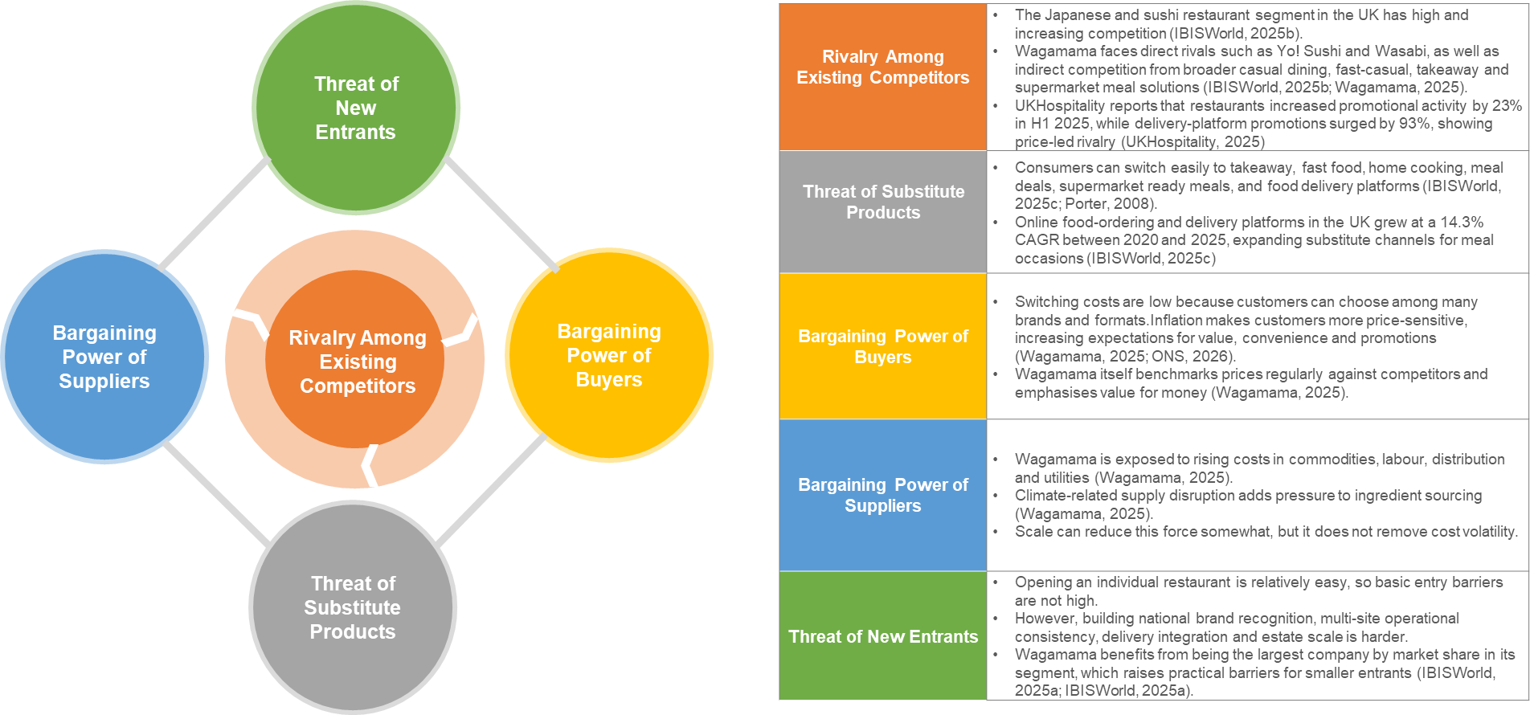
Figure 3: Porter’s Five Forces factor map for Wagamama. Source: Own Contribution.

Competition is intense due to the fragmented market, increase in promotional activity, and easy price and experience comparison by customers; according to UKHospitality, restaurant promotions increased 23% and delivery-platform promotions increased 93%, meaning that the market is actively competing to capture demand (UKHospitality, 2025). Buyer power is also strong due to low switching costs and high value-consciousness among customers, which is why Wagamama checks competitor prices and focuses on value-consciousness (Wagamama, 2025). Substitutes are high as the competitive group consists of not only competing casual dining chains but also takeaways, delivery, supermarkets, and home cooking; online food-ordering services in the UK also grew intensively between 2020 and 2025 (IBISWorld, 2025c). Supplier power is medium-high since Wagamama is still vulnerable to inflation in commodity, labour, distribution and utility (Wagamama, 2025). Entry threat is medium: the restaurant concept may be easy to start, but the replication of the Wagamama national presence, brand awareness, operation system is harder, particularly because the company takes the biggest share of the market in its segment (IBISWorld, 2025b). On the whole, casual dining has structural challenges, though selectively appealing to differentiated scale operators like Wagamama.

Critical success factors and strategic challenges
Within the casual dining market, companies are required to perform well in few performance drivers namely consistency of operations, menu innovativeness, speed of service, digital convenience, cost control, quality of site, employee retention and brand relevance. These factors in the case of Wagamama are highly interdependent. Restaurant-brand studies reveal that the perceived quality, brand image, awareness and loyalty support performance, and digital food-ordering research highlight convenience, trust and food quality as drivers of customer choice (Kim and Kim, 2004; Hyun and Kim, 2011; Al Maalouf et al., 2025). Wagamama seems robust on some of these dimensions, with like-for-like sales growth of 2.8%, NPS of +42 in December 2024, and more than 800,000 soul club sign-ups and further expansion of new sites on selective location strategy (Wagamama, 2025). Nevertheless, its key strategic issues are how to maintain value perceptions as the cost of labour and input increase, how to ensure service consistency between the dine-in and delivery services and how to retain skilled personnel in an industry where turnover undermines service quality and reliability in service delivery (Ghani et al., 2022; Wagamama, 2025).

Internal environment: resources, capabilities and competencies
A resource-based perspective considers competitive advantage to be dependent on the value of resources, as well as the capacity of the organisation to utilise and replenish them (Mailani et al., 2024). The physical resources of Wagamama are listed in 166 restaurants in the UK, 63 outside the UK in 18 countries, digital ordering and loyalty, and positive operating cash generation of £74.5 million in 2024, but its annual report also notes that financial flexibility is not exaggerated (Wagamama, 2025). More valuable assets are intangible: a solid brand equity, an exclusive communal dining vision, customer loyalty, and the culture of constant improvement, menu freshness, and culturally relevant marketing (Wagamama, 2025). These underpin a number of core competencies: menu development, kitchen standardisation on a large estate, brand-led guest experience, multichannel delivery and click-and-collect integration and people management. Strategically, Wagamama is not so much a company whose core competence is represented by a single asset as one that is able to seamlessly integrate brand, operations and innovation to create a repeatable casual-premium experience that competitors can only replicate imperfectly (Kim and Kim, 2004; Hyun and Kim, 2011).

Value Chain analysis
Porters value chain reveals the production of competitive advantage that is based on interconnected primary and supportive activities as opposed to the products themselves (Porter, 1985).
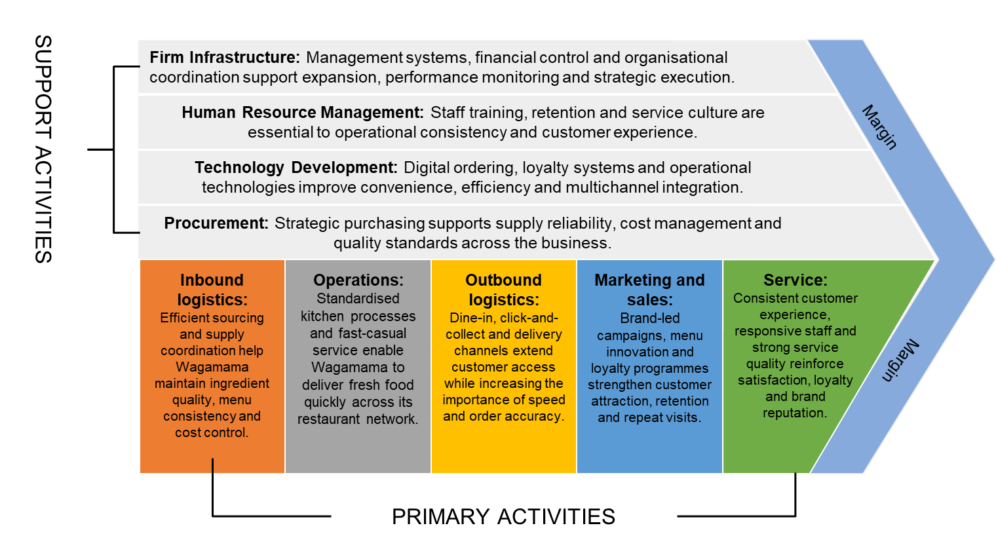
Figure 4: Value Chain analysis for Wagamama. Source: Own Contribution.
Inbound logistics and procurement are also crucial to Wagamama since the quality of the ingredients, the continuity and cost discipline of its sourcing directly influence menu consistency and margins; the company itself points to inflation in commodities, distribution and utilities as a continual threat (Wagamama, 2025). Value creation will be largely reliant on operations since the brand relies on quick, freshly prepared food served consistently in an expanding estate with ten new locations in the UK opened in 2024 (Wagamama, 2025). Dine-in, click-and-collect and delivery are now considered as part of outbound activity, and order accuracy and channel coordination is now strategically relevant (Wagamama, 2025). In the marketing and sales, Wagamama generates value by creating menu innovation, culturally-relevant campaigns and its loyalty programme, the soul club, which surpassed 800,000 sign-ups by the end of 2024 (Wagamama, 2025). Service is supported by good customer ratings and emphasis on repeat visits. This model is reinforced by HR, technology, procurement and infrastructure, among other support activities. Wagamama thus generates value superior to most of its competitors with its brand-led demand, repetitive operations and multichannel implementation.

VRIO analysis
Only most strategically significant resources of Wagamama can be tested with the help of Barneys VRIO logic such as the brand equity, menu and concept innovation, and multichannel operating capability (Barney, 1991).
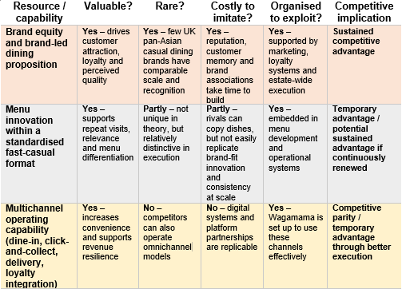
Figure 5: VRIO analysis of Wagamama. Source: Own Conrtribution.
The value of brand equity is obviously high, since restaurant studies have identified brand image, perceived quality and loyalty as positively associated with better performance; and it is also comparatively scarce in UK pan-Asian casual dining, as Wagamama will have both established recognition and high guest scores of +42 and over 800,000 soul club members in 2024 (Kim and Kim, 2004; Hyun and Kim, 2011; Wagamama, 2025). This renders it hard to copy rapidly and efficiently organisationally backed and thus is a long-term competitive edge.
The fact that Wagamama has the ability to innovate their menu within a standardised service format is also worthy and somewhat uncommon. That it can refresh the menu and keep operations consistent facilitates return visits and consistency with health- and plant-based demand trends, implying a short-term to possibly long-lasting benefit, with a continued renewal (Wagamama, 2025). In comparison, multichannel delivery, click-and-collect and loyalty integration are useful, but less unique since competitors can develop systems like that; this feature creates competitive equality or short-term competitive benefit, rather than enduring competitive benefit. In general, the brand-based experiential proposal is the most significant VRIO factor of Wagamama, whereas digital convenience has become a competitive requirement rather than a competitive edge (Barney, 1991; Wagamama, 2025).

CSR and Sustainability Objectives
Wagamama has the most strategic CSR and sustainability agenda where it is integrated in its operations and not a form of philanthropy. Its 2024 reporting shows a science-aligned net zero by 2040 target, 100% renewable electricity for directly contracted supplies, fully electric new UK sites opened in 2024 where grid capacity permits, a maintained 50% vegan/vegetarian menu target, and the use of menu carbon data in menu development (Wagamama, 2025). Socially, the business also records apprenticeship growth, leadership growth, mental-health provision in the employee offer and community relationships such as a £40,000 donation to Shout and support via the Bowl to Soul fund. This aligns with the thesis that corporate sustainability leads to competitive advantage when targeted by strategy and tied to stakeholder expectations as opposed to being disconnected to core business decisions (Bhuiyan et al., 2023).
These priorities are in line with business objectives in a number of ways. Climate and sourcing action help reduce risks and increase operational resilience over time; renewable electricity and electrification can enhance efficiency in the long term; developing a plant-based and lower-carbon menu can help in brand reputation and customer relevance; and employee wellbeing and development can enhance employee attraction and retention (Jin et al., 2024). In its own report, Wagamama acknowledges sustainability as applying to customers, colleagues and landlords, indicating that it is the CSR that is being applied to safeguard both legitimacy and performance (Wagamama, 2025). Nevertheless, the limitation to the strategy is also that disclosure to the masses is far more extensive regarding climate than overall social outcomes. The company discloses transparent climate-related targets and measures, but fewer quantified measures of publics on turnover, diversity, supplier labour standards, waste or broader community impact. That renders the strategy plausible, yet at the same time a bit shallow in quantifiable detail.

Comprehensive and Holistic View: Balanced Scorecard
A Balanced Scorecard can help Wagamama as it transforms strategy into interconnected financial and non-financial metrics instead of basing on short-term sales results. This section examines Wagamama using the Balanced Scorecard, which combines financial and non-financial performance measures to consider not just returns on sales but also customer relations, process improvement and staff learning (Kaplan and Norton, 1992).
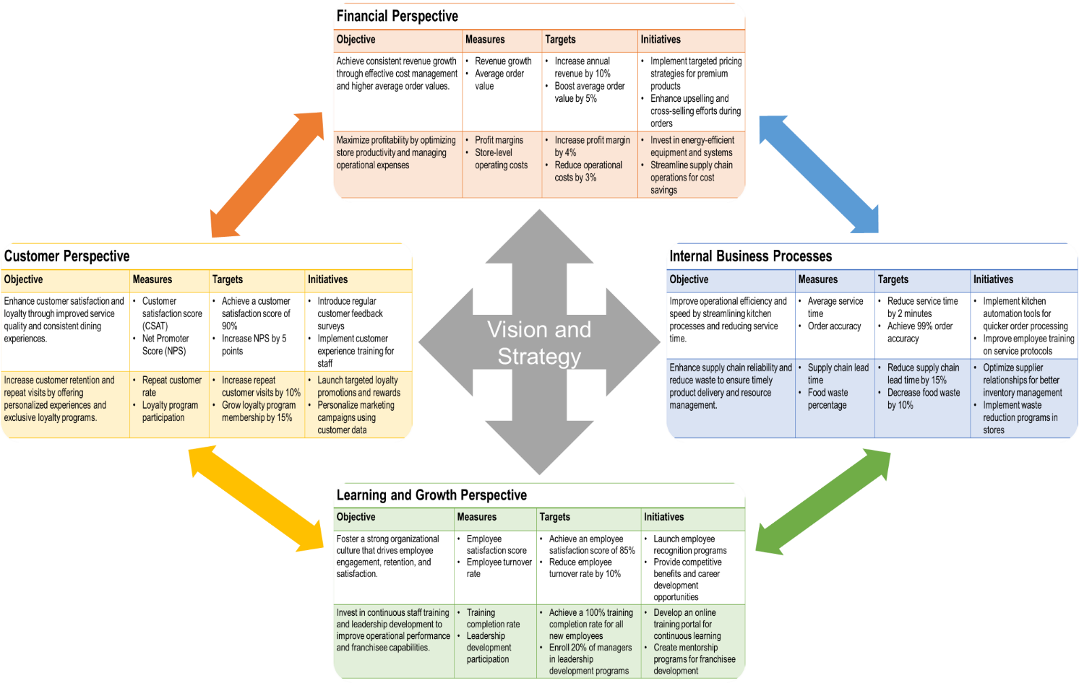
Figure 6: Wagamama Balanced Scorecard – A strategic framework integrating financial, customer, internal processes, and learning & growth perspectives. Source: Own Contribution.

Financial perspective
Wagamama's key financial objectives are profitable growth with the preservation of margins and cash generation. In 2024, it generated 8.2% revenue growth to £501.5 million and healthy cash generation of £74.5 million (Wagamama, 2025). Performance indicators (KPIs) are revenue growth, like-for-like growth, operating cash generation, average spend, store productivity, and delivery profitability. Challenges must include achieving like-for-like growth, boosting average spend through menu upgrades and preserving cash conversion in a high inflation environment (Struckell et al., 2022). Programs need to include targeted expansion, menu development and managing labour and procurement costs.

Customer perspective
The customer perspective is about loyalty, satisfaction and value, and Wagamama's unique pan-Asian brand. Wagamama recorded an NPS of +42 in 2024 and launched its first ever Soul Club loyalty card, with 800,000 members at the end of the year (Wagamama, 2025). Other KPI's include repeat business, loyalty engagement, order accuracy, satisfaction and digital engagement (Redwan et al., 2025). Suggested goals could be to increase NPS to +45 and reach more than 1 million members for Soul Club. These measures are justified because brand equity is strongly related to retention and satisfaction (Hyun and Kim, 2011).

Internal business processes perspective
The internal business process perspective aims to improve efficiency, quality, compliance and sustainability for Wagamama dine-in and off-premise operations. Operational successes include allergen training, regular tracking of training statuses, and 100% electric new sites in 2024 (Wagamama, 2025). Key performance indicators (KPIs) should include ticket times, order accuracy, allergen-compliance, waste, energy intensity per site, and menu innovation (Redwan et al., 2025). Performance targets should include 100% allergen-compliance monitoring, year-on-year energy reduction, and further enhancements on delivery times (Jia and Evans, 2021). The key initiatives include site standardisation, supply chain management, and low-carbon site designs.

Learning and growth perspective
The learning-and-growth perspective targets learning and development to improve employee skills and organisational growth. In Wagamama's 2024 report, advances in induction, with an emphasis on the first 90 days, and monthly tracking of staff turnover and leadership development programs are noted (Wagamama, 2025). Key performance indicators include employee turnover, training completion, internal promotions, leadership and employee engagement (Kushariyadi et al., 2015). Suggested targets include lower preventable turnover, more internal promotions to management, and more e-learning. These programs are important as they impact service quality and consistency (Subramanian, 2018).

Integration paragraph
These four views are self-supportive. Better people capability enhances internal functions; increased processes enhance customer satisfaction and loyalty, and enhanced customer results facilitate revenue expansion and cash creation (Rane et al., 2023). In the case of Wagamama, the Balanced Scorecard thus presents a balanced strategic control system, which interconnects brand, operations, sustainability and financial resilience into a single unit.

Strategic Choices and Implementation

Business-level strategy
With the help of the generic strategies proposed by Porter, Wagamama could be interpreted as being focused differentiation instead of cost leadership or mass-market differentiation. It has a market space based proposition of pan-Asian casual dining served in a recognisable communal format, fresh menu development, good brand recognition and an experience that is priced above mainstream value chains but below fine dining (Porter, 1980; Wagamama, 2025). This emphasis is supported by customer performance: Wagamama has reported a December 2024 NPS of +42, over 800,000 soul club sign-ups and an ongoing emphasis on value-for-money and culturally relevant menu development, which all suggest that customers are purchasing a unique experience and not merely the cheapest price (Wagamama, 2025). This strategy remains justifiable in the present market conditions, however, it is only the case when price discipline is upheld (Nunan and Di Domenico, 2022). Pure premium positioning is a risky endeavor when faced with high inflation, wage pressure and aggressive promotions in hospitality and a switch to cost leadership will destroy the strongest assets of the brand (English et al., 2024). The best move that Wagamama may take is thus maintaining differentiation and safeguarding perceived value, speed of service and relevancy of the menu in a more cost-conscious market.

Corporate-level / growth choices
Using Ansoff’s product-market logic, Wagamama has four broad growth paths: market penetration, product development, market development and diversification (Ansoff, 1957).
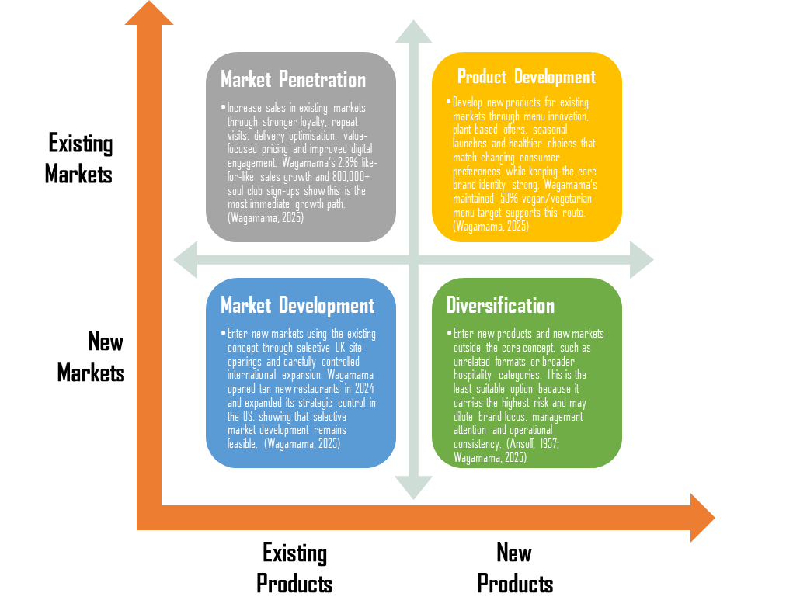
Figure 7: Ansoff matrix for Wagamama. Source: Own Contribution.
In the case of Wagamama, the first three are the most sensible. Market penetration is also appealing since the brand can continue to increase same-store sales with loyalty, digital ordering, delivery optimisation, and better repeat visit; the soul club opening and further emphasis on the current estate can make this direction (Wagamama, 2025). Product development is also strategically coherent since the menu innovation, plant-based offers and limited-time launches are capabilities and brand expectations of Wagamama. The selective market development, such as the selection of new UK locations and selective global growth is possible since the company is still adding locations selectively and already operating in several markets (Wagamama, 2025). In comparison, the adjacent diversification would be less coherent. It would stretch management focus and water down the brand when the business still has capacity to add more value to capturing within its core concept (Heim et al., 2025). In the case of Wagamama, Ansoff would suggest disciplined expansion of the current brand as opposed to unrelated diversification.

Recommended strategic choice
The best strategic option is focused differentiation at the business level, with market penetration with selective product development Struckell et al., 2022). This option is better than the fast international growth or the neighboring diversification since it aligns with the resources of the company that have been proven like brand equity, menu innovation, digital interaction and repeating operations (Rumyantseva and Welch, 2023). Previous discussion indicated that Wagamama has a competitive advantage but it is faced with competition, substitute and increasing costs. At that, the ability to draw greater value out of the core UK estate by loyalty, menu engineering, delivery discipline and selective innovation is less risky and more strategically coherent than larger expansion before fully solidifying existing advantages (Albattat et al., 2025).

Change management and implementation
Wagamama seems to have been able to cope with strategic change reasonably but not without risk of execution. The business has managed to integrate choosy site openings, loyalty-platform introduction, menu refresh, climate-related site adjustments, and ongoing investment in people systems, which indicate change has been gradual and capability-driven as opposed to disruptive (Wagamama, 2025). This is widely in line with the argument by Kotter that effective change must be urgent, congruent systems and short-term wins (Kotter, 1995). Nevertheless, the primary risks of implementation are also considerable: the growth can place pressure on training and service-level, digital growth may reveal the gaps in delivery quality, and labour-market pressure can undermine staff buy-in and reliability of the operations (Abhari, 2025). The future success of Wagamama will not, therefore, be tied to the bold approach but a coherent approach that has disciplined leadership, strong culture, and tight operational control.

Strategic Evaluation and Recommendations

SWOT analysis
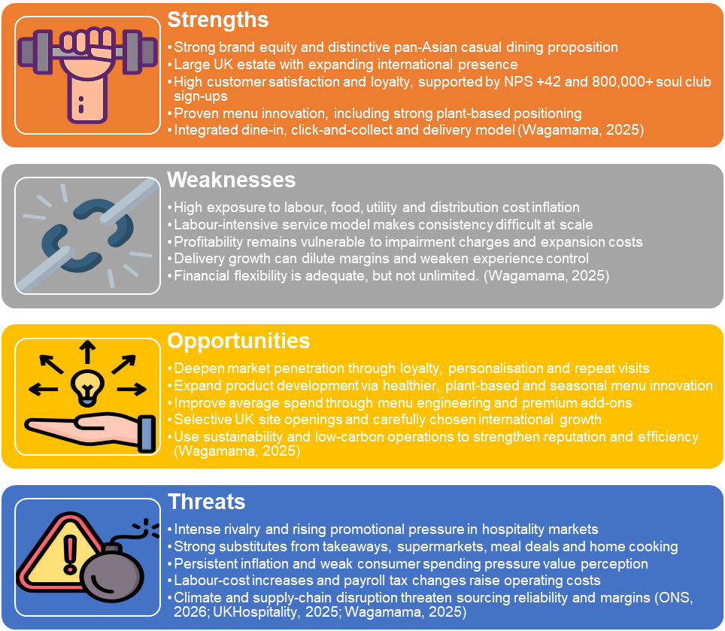
Figure 8: SWOT analysis for Wagamama. Source: Own Contribution.
Wagamama strengths include the high brand salience, excellent customer ratings, successful menu innovation, the national scale in the UK and increasing digital presence in the form of the soul club that surpassed 800,000 sign-ups in 2024 (Wagamama, 2025). These resources contribute to differentiation and return visits. Its primary weaknesses are its exposure to labour and input-cost inflation, its dependence on the consistency of operations in a labour-intensive model, and some financial strain due to impairment charges and investment necessary to expand the firm. The key opportunities include further penetration of the market with loyalty and menu engineering, ongoing development of products based on plants and health, and a selective expansion in UK white-space locations and target international markets (Albattat et al., 2025). The main threats include stiff hospitality competition, good substitutes in dine-in, takeaway and supermarket meal options, and volatility in costs due to climate and policies (Maumbe, 2012). The most important aspect of the analysis is that Wagamamas strengths are demand making, whilst threats are margin making, strategy then has to translate brand strength into profitable and not just visible growth.

Evaluate current strategy using Ansoff
The better framework here is Ansoff since the strategic problem facing Wagamama is not balancing the portfolio between various and unrelated business units, but the growth of a single core restaurant brand though products and markets. Wagamama is a single branded business with expansion into the UK sites, the US business and international franchising, making the product-market expansion logic more applicable than a portfolio matrix (Wagamama, 2025). It is based on that that the current strategy of Wagamama already incorporates market penetration, product development and selective market development; it matches the brand much better than any classification of the strategies could do based on the BCG style. The rationale of that judgement is a direct consequence of the initial growth logic of Ansoff, and the established strategic positioning of Wagamama.

Recommendations
First, focus on market penetration in the core UK estate by use of loyalty-based personalisation, increased menu engineering and delivery discipline (Albattat et al., 2025). This is based on the previous analysis that revealed that brand equity, customer loyalty and menu innovation are the greatest strengths of Wagamama, and the greatest threats are the pressure of cost and strong substitutes. The anticipated advantage is an increase in the frequency of repeats, increased average spend and enhanced cash conversion of the current assets (Laghari and Ahmed, 2023). The most important implementation risk is excessive dependence on promotions, which may undermine the perceptions of premium-value, unless properly directed.
Second, keep selective site, international growth, where site economics and local fit are evident. The 2024 report of Wagamama indicates ten new openings in the UK and complete ownership of the US business, but also indicates impairment charges and the necessity of further refining site selection and adapting the proposition in the US (Wagamama, 2025). The strategic advantage of selective expansion is long-term scale and market-share growth; the risk is that the speedy expansion rollout might water down returns and put strain on service consistency (Hong, 2025).
Third, enhance operational resiliency with labour productivity, supply-chain resiliency and low-carbon efficiency. This is based on the existing cost and climate pressures that are already established in the own reporting of Wagamama. The advantage is a margin protection and less exposure to risk. The success criterion is that, systems changes, supplier management and staff training should be coordinated instead of being viewed as a separate cost-cutting step (Chowdhury, 2025).

Conclusion
To sum up, Wagamama has a strong and sustainable brand equity, customer loyalty, menu innovation and multichannel capability which has placed the company in a good strategic position as a differentiated pan-Asian casual food restaurant. Nevertheless, its competitive advantage is not always safe. It is best defined as sustainable and under pressure, as intense competition, good substitutes, labour-cost inflation and volatile supply-chains still put margins and implementation to the test. It is only through increased market penetration in its main property, preservation of operational stability, menu-relevance, and turning brand strength into profitable development as opposed to expansion by itself, that the business can sustain and enhance its advantage (Wagamama, 2025; Porter, 2008; Barney, 1991).

Section 2: Reflective Account
In this reflection, the Reflective Cycle of Gibbs will be used to analyze the way I conducted my research on Wagamama and chose and evaluated evidence, implemented strategic models, and formed my final conclusions in Section 1.

Figure 9: Gibbs reflective cycle. Source: Own Contribution.
It dwells on my research process, analytical decisions, difficulties, and what I learned regarding postgraduate strategic analysis and academic writing (Gibbs, 1988).

Description
In Section 1 I created a Wagamama strategic analysis of its external environment, internal capabilities, CSR and sustainability priorities, Balanced Scorecard, strategic choices and recommendations. I chose Wagamama due to the fact that I had already worked there as a Junior Chef and had a first-hand experience of its kitchen procedures, service stresses, coordination of the team, and its working standards. This brought the company to my attention and provided me with a viable starting point. But I backed that experience with official evidence in the yearly report of Wagamama and company materials and in the books. I organized and assessed the report with PESTEL, Porters Five forces, Value Chain, VRIO, SWOT, Ansoff and Balanced Scorecard.

Feelings
I was fairly confident at the start as I had direct work experience with the company. I was familiar with the business as I learned some of Wagamama service model, kitchen discipline and customer expectations. Simultaneously, I was unsure whether that familiarity would give me more strength in judgment or be a biasing element. I also struggled to strike a balance between evidence of the company and academic theory. It was the company itself that provided some explanation of what it would like to accomplish, and academic sources were required to evaluate the presence of relevance in those statements. The other challenge was description to critique. What Wagamama does was easier to explain than to judge how strong or weak or vulnerable its strategic position is.

Evaluation
Some of the areas of my research and analysis were successful. My previous experience of Wagamama allowed me to see how the service model of the company is implemented in practice, this is why my description of operations, people management, and implementation became more realistic. Another helpful combination of evidence that I chose was the company reports, which gave me up to date strategic data and academic articles that I used to critically analyze that data. Another strength was that the frameworks were related logically. PESTEL and Five Forces helped to define the pressure coming outside, whereas Value Chain and VRIO demonstrated how Wagamama reacts inside.
Nevertheless, there were areas of the process that were weaker. Initially, I would take excessive time in information collection and less time in decision making on what was strategically important. The notes I made were elaborate yet not always discriminate. I also observed that I was too descriptive to start with, particularly when I was talking about the strengths of the company. The most powerful phase was the subsequent synthesis when I connected evidence between sections. The most difficult phase was between the gathering of information and the critical judgement.

Analysis
This assignment made me realize that there were powerful sources in comparison to others depending on the purpose. The annual report of Wagamama proved very helpful in up-to-date facts, strategies, operating figures, customer measures, and sustainability reports. But it was a business document, too, and it was meant to show the business in a good light, and so could not be taken without question. Articles in academic journals proved to be more robust when I had to substantiate analytical propositions, including the effects of brand equity on restaurant performance, why digital convenience is important, or the way resources turn into sources of competitive advantage. The industry sources proved useful in competition and market trends though they had to be interpreted carefully as market summaries do not necessarily indicate strategic importance.
The application of various models enhanced my judgement since each model emphasised a different aspect of the issue. PESTEL has identified macro pressures, Five Forces has discussed structural competition, VRIO has discussed strategic resources, and Ansoff has discussed the direction of growth (Porter, 1985; Barney, 1991; Whittington et al., 2019). Meanwhile, the fact that many models were used posed a risk of repetition and fragmentation. I also realized that postgraduate analysis involves the choice of what each framework brings, and not their mechanical application. Another thing I came to know is that strategic judgement is ambiguous. Initially, I perceived Wagamama primarily as a powerful brand with definite benefits. I finally found myself more balanced as I went through more evidence particularly on the pressures on cost, substitutes, and the risk of implementation. I have decided that Wagamama has a significant competitive advantage, and that it is strained and needs to be replenished on a regular basis.

Conclusion
On the whole, this process helped me to realize that successful strategic analysis requires the integration of pragmatic knowledge and evidence, as well as disciplined judgement. The experience of working at Wagamama helped me to learn more about the company, but it was not a situation that required objective analysis. I acquired that effective academic performance requires less of what is gathered and more of how it is reviewed, related and assessed.

Action plan
To enhance my process in the future, there are several aspects that I will improve. To begin with, I will begin earlier and break my work into phases to collect sources, write notes, draft, and edit. Second, I will arrange notes in topics and arguments rather than in sources in order to compare it with others. Third, I will predetermine what each framework should provide, which will minimise repetition. Fourth, I will write more critically by posing the question of whether every paragraph describes significance and not just presents facts. Last but not least, I will be more careful with referencing since I will be able to write down complete bibliographic information initially and check the citation style throughout the writing process rather than at the conclusion.

Reference
Abhari, K. (2025) ‘Employee Participation in Digital Transformation: From Digitalization Sentiment to Transformation Predisposition’. Information & Management, [online] p.104212. doi:https://doi.org/10.1016/j.im.2025.104212.
Al Maalouf, N.J., Sayegh, E., Makhoul, W. and Sarkis, N. (2024) ‘Consumers’ attitudes and purchase intentions toward food ordering via online platforms’. Journal of Retailing and Consumer Services, [online] 82, p.104151. doi:https://doi.org/10.1016/j.jretconser.2024.104151.
Albattat, A., Fakir, F.Z., Yi, Z. and Hussain, Z. (2025) ‘Innovative Trends Shaping Food Marketing and Consumption’. [online] ResearchGate. doi:https://doi.org/10.4018/979-8-3693-8542-5.
Barney, J. (1991) ‘Firm Resources and Sustained Competitive Advantage’. Journal of Management, 17(1), pp.99–120. doi:https://doi.org/10.1177/014920639101700108.
Bhuiyan, F., Rana, T., Baird, K. and Munir, R. (2023) ‘Strategic outcome of competitive advantage from corporate sustainability practices: Institutional theory perspective from an emerging economy’. Business Strategy and the Environment, 32(7). doi:https://doi.org/10.1002/bse.3362.
Chowdhury, A.R. (2025). A SYSTEMATIC REVIEW OF RISK-BASED PROCUREMENT STRATEGIES IN RETAIL SUPPLY CHAINS: SOURCING FLEXIBILITY AND VENDOR DISRUPTION MANAGEMENT. American Journal of Advanced Technology and Engineering Solutions, 1(1), pp.466–505. doi:https://doi.org/10.63125/jr03rv07.
English, B., Forbes, K. and Ubide, A. (2024). Monetary Policy Responses to the Post-Pandemic Inflation ICMB INTERNATIONAL CENTER FOR MONETARY AND BANKING STUDIES CIMB CENTRE INTERNATIONAL D’ETUDES MONETAIRES ET BANCAIRES. [online] Available at: https://cepr.org/system/files/publication-files/197150-monetary_policy_responses_to_the_post_pandemic_inflation.pdf.
FSA (2022) ‘Allergen Guidance for Food Businesses’. [online] Food Standards Agency. Available at: https://www.food.gov.uk/business-guidance/allergen-guidance-for-food-businesses.
FSA (2025b) ‘Food Hygiene Rating Scheme’. [online] Food Standards Agency. Available at: https://www.food.gov.uk/safety-hygiene/food-hygiene-rating-scheme.
FSA. (2025a) ‘Updated industry guidance issued for food allergen information in the out-of-home sector’. [online] Available at: https://www.food.gov.uk/news-alerts/news/updated-industry-guidance-issued-for-food-allergen-information-in-the-out-of-home-sector.
Ghani, B., Zada, M., Memon, K.R., Ullah, R., Khattak, A., Han, H., Montes, A.A. and Castillo, L.A. (2022) ‘Challenges and strategies for employee retention in the hospitality industry: A review’. Sustainability, [online] 14(5), pp.1–26. doi:https://doi.org/10.3390/su14052885.
Gibbs, G. (1988) Learning by doing: a guide to teaching and learning methods. London: Further Education Unit.
Heim, I., Laker, B. and Tabaeifard, S.J. (2025) ‘Responsible leadership: A systematic literature review, theoretical framework, and future research directions’. Journal of Business Research, [online] 203, p.115801. doi:https://doi.org/10.1016/j.jbusres.2025.115801.
HMRC (2025a) ‘Rates and thresholds for employers 2025 to 2026’. [online] GOV.UK. Available at: https://www.gov.uk/guidance/rates-and-thresholds-for-employers-2025-to-2026.
HMRC (2025b) ‘April 2025 issue of the Employer Bulletin’. [online] GOV.UK. Available at: https://www.gov.uk/government/publications/employer-bulletin-april-2025/april-2025-issue-of-the-employer-bulletin?utm
Hong, T.K. (2025). Strategic International Marketing Plan: Patagonia’s Entry into India. [online] doi:https://doi.org/10.13140/RG.2.2.26893.86248.
Hyun, S.S. and Kim, W. (2011) ‘Dimensions of Brand Equity in the Chain Restaurant Industry’. Cornell Hospitality Quarterly, 52(4), pp.429–437. doi:https://doi.org/10.1177/1938965510397533.
IBISWorld (2025a) ‘Asian Restaurants in the UK - Market Research Report (2014-2029)’. [online] Ibisworld.com. Available at: https://www.ibisworld.com/united-kingdom/industry/asian-restaurants/14532/.
IBISWorld (2025b) ‘Japanese & Sushi Restaurants in the UK - Market Research Report (2014-2029)’. [online] Ibisworld.com. Available at: https://www.ibisworld.com/united-kingdom/industry/japanese-sushi-restaurants/5083/.
IBISWorld (2025c) ‘Online Food Ordering & Delivery Platforms in the UK - Market Research Report (2015-2030)’. [online] Ibisworld.com. Available at: https://www.ibisworld.com/united-kingdom/industry/online-food-ordering-delivery-platforms/14618/.
Jia, L. and Evans, S. (2021) ‘Improving food allergen management in food manufacturing: An incentive-based approach’. Food Control, 129, p.108246. doi:https://doi.org/10.1016/j.foodcont.2021.108246.
Jin, H., Li, X. and Li, G. (2024) ‘Impact of corporate social responsibility on employee loyalty: Mediating role of person-organization fit and employee trust’. PLoS ONE, [online] 19(3), pp.1–18. doi:https://doi.org/10.1371/journal.pone.0300933.
Kaplan, R.S. and Norton, D.P. (1992) The balanced scorecard: Measures that drive performance. Boston, Mass.: Harvard Business Review Press, pp.71–79.
Kim, W.G. and Kim, H.-B. (2004) ‘Measuring Customer-Based Restaurant Brand Equity’. Cornell Hotel and Restaurant Administration Quarterly, 45(2), pp.115–131. doi:https://doi.org/10.1177/0010880404264507.
Klepper, S. (1997) ‘Industry Life Cycles’. Industrial and Corporate Change, [online] 6(1), pp.145–182. doi:https://doi.org/10.1093/icc/6.1.145.
Kotter, J. (1995) Leading Change: Why Transformation Efforts Fail. Harvard Business Review, 73(2), pp.59–67.
Kushariyadi, K., Wahid, D.A., Albashori, M.F., Rustiawan, I., ARDENNY, A. and Wahyudiyono, W. (2025) ‘Performance Management Based on Key Performance Indicators (KPI) to improve Organizational Effectiveness’. Maneggio, [online] 2(1), pp.90–102. doi:https://doi.org/10.62872/7yx54j15.
Laghari, F. and Ahmed, F. (2023). Cash flow management and its effect on firm performance: Empirical evidence on non-financial firms of China. PLoS ONE, 18(6). doi:https://doi.org/10.1371/journal.pone.0287135.
Low Pay Commission (2024) ‘National Living Wage to increase to £12.21 in April 2025’. [online] GOV.UK. Available at: https://www.gov.uk/government/news/national-living-wage-to-increase-to-1221-in-april-2025.
Mailani, D., Hulu, M.Z.T., Simamora, M.R. and Kesuma, S.A. (2024) ‘Resource-Based View Theory to Achieve a Sustainable Competitive Advantage of the Firm: Systematic Literature Review’. International Journal of Entrepreneurship and Sustainability Studies, [online] 4(1), pp.1–15. doi:https://doi.org/10.31098/ijeass.v4i1.2002.
Maumbe, B. (2012). The rise of South Africa’s quick service restaurant industry. Journal of Agribusiness in Developing and Emerging Economies, 2(2), pp.147–166. doi:https://doi.org/10.1108/20440831211272607.
Nunan, D. and Di Domenico, M. (2022) ‘Value creation in an algorithmic world: Towards an ethics of dynamic pricing’. Journal of Business Research, 150, pp.451–460. doi:https://doi.org/10.1016/j.jbusres.2022.06.032.
ONS (2026) ‘Consumer price inflation, UK’. [online] Ons.gov.uk. Available at: https://www.ons.gov.uk/economy/inflationandpriceindices/bulletins/consumerpriceinflation/february2026.
Porter, M. (2008) ‘The Five Competitive Forces That Shape Strategy. [online] Harvard Business Review’. Available at: https://hbr.org/2008/01/the-five-competitive-forces-that-shape-strategy.
Porter, M.E. (1985) Competitive advantage: Creating and sustaining superior performance. New York: The Free Press, pp.11–15.
Rane, N., Achari, A. and Choudhary, S.P. (2023) ‘Enhancing customer loyalty through quality of service: Effective strategies to improve customer satisfaction, experience, relationship, and engagement’. International Research Journal of Modernization in Engineering Technology and Science, 5(5), pp.427–452. doi:https://doi.org/10.56726/irjmets38104.
Redwan, R., Niraula, S. and Swamy, A.S. (2025) ‘KPI Tracking and Performance Metrics for Brand Growth Optimization’. Research Journal in Business and Economics, [online] VOL 3 NO.2. doi:https://doi.org/10.61424/rjbe.v3i2.452.
Rumyantseva, M. and Welch, C. (2023) ‘The Born Global and International New Venture revisited: an Alternative Explanation for Early and Rapid Internationalization’. Journal of International Business Studies , 54. doi:https://doi.org/10.1057/s41267-023-00613-2.
Struckell, E., Ojha, D., Patel, P.C. and Dhir, A. (2022) ‘Strategic choice in times of stagnant growth and uncertainty: An institutional theory and organizational change perspective’. Technological Forecasting and Social Change, 182(1), p.121839. doi:https://doi.org/10.1016/j.techfore.2022.121839.
Subramanian, K.R. (2018) ‘The Connection Between Your Employees and Customers’. Journal of Advance Research in Business Management and Accounting (ISSN: 2456-3544), 4(8), pp.01-14. doi:https://doi.org/10.53555/nnbma.v4i8.28.
The Restaurant Group Ltd (2024) ‘Annual Report and Accounts FY2023’. [online] Available at: https://www.trggroupltd.com/wp-content/uploads/2024/09/The-Restaurant-Group-Ltd-Annual-Report-and-Accounts-FY2023.pdf.
Villiers, M.V. de, Cheng, J. and Truter, L. (2024) ‘The Shift Towards Plant-Based Lifestyles: Factors Driving Young Consumers’ Decisions to Choose Plant-Based Food Products’. Sustainability, [online] 16(20), p.9022. doi:https://doi.org/10.3390/su16209022.
Wagamama (2025) ‘Investor Information - Annual Report 2024.’. [online] Wagamama.com. Available at: https://www.wagamama.com/investors.
Wagamama (2026a) ‘About Wagamama’. [online] Wagamama.com. Available at: https://www.wagamama.com/about-us.
Wagamama (2026b) ‘Home page – Wagamama’. [online] Wagamama.com. Available at: https://www.wagamama.com/.
Whittington, R., Regner, P., Angwin, D., Johnson, G. and Scholes, K. (2019) Exploring Strategy. 12th ed. Hoboken: Pearson. Available at: https://www.pearson.com/en-gb/subject-catalog/p/exploring-strategy-text-and-cases/P200000007156/9781292479538

