TIME MANAGEMENT
Task 1A
The effectiveness of time management is an increasingly important topic. According to Forsyth, “Certainly any real progress with time management needs a plan. This must be in writing and must be reviewed and updated regularly; for most people this means a daily check.” (Forsyth, 2010).
Too little Time can affect the outcome of any task in the workplace. To complete assignments, some employees are working long hours. Long hours that are constant or sustained for extended periods of Time are stressful and inefficient. They can lead to fatigue, poor decision-making, slowed reflexes, muddled thinking, accidents, resentment against the company, and less than best performance. These consequences can be disastrous and always lead to decrements in health and productivity, or to high turnover. Perhaps restructuring the assignments or rescheduling assignments to better balance the workload is in order. Van Fleet, (2021).
After speaking to other mature students, we found that most find it difficult to manage Time due to having classwork added to a busy life with responsibilities at home compared to students that do not have similar responsibilities. However, all students have come to an agreement if Time was managed more efficiently it can be done with less stress and a perfect balance with classroom and home.
One effective tool is from steven covey Matrix of importance vs urgency
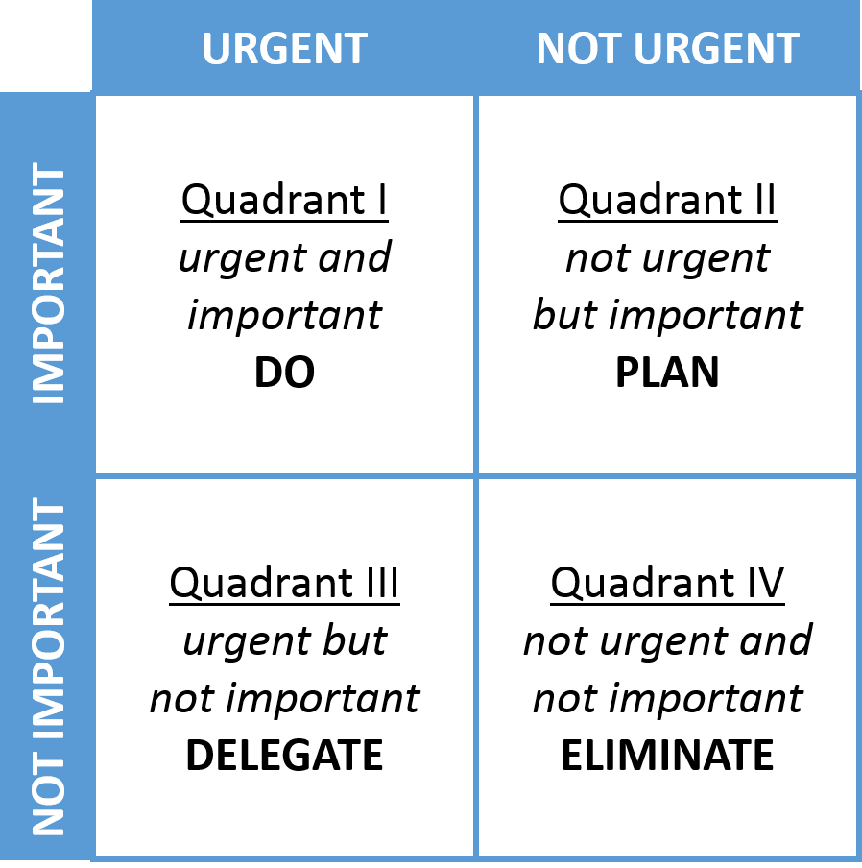 Covey, (1989)
Time management Benefits are Less distraction, better work-life balance, greater focus, more time freedom, less procrastination, less stress, Time to think, and Increased energy.
There is, therefore, a definite need for time management skills in any workplace or personal life.
As a programmer, I believe I can achieve my goals if I manage my Time efficiently. Some of the benefits of time management will make my employability, increase productivity, decrease stress, more energy for free Time, and Streamlined decision-making. Resulting in recruitment selection effortless.

Reference List

P Forsyth., 2010, Successful Time Management, Publisher Kogan Page
D Van Fleet.,2021, Quality time, Publisher Age Publishing
Covey S.,1989, The 7 Habits of Highly Effective People, Publisher Free Press

Similarity score

Task 1b

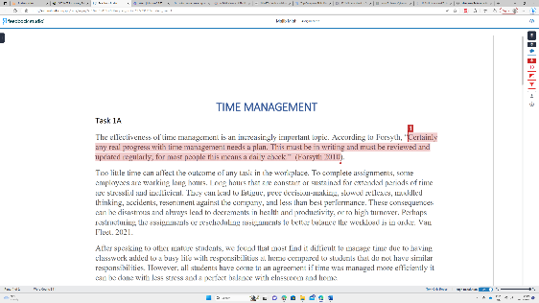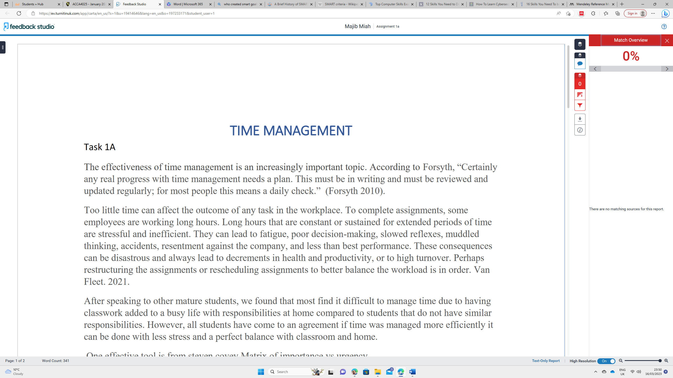
Image 01: 13% my similarity score Image 02: 0% my similarity score
I have returned to study after 20 years, and I am incredibly pleased with the similarity score of 13% on Turn it in tool. Once I selected remove bibliography, I had a score of 0%, which was exciting. Above are screenshots of my Turnitin:
There is always room for improvement, and A reasonable approach to tackle this issue could be to have better time management and pay more attention in the classroom. Another explanation for these results may be the lack of adequate research.
The present assignment was designed to determine my understanding of my digital era knowledge. I believe I understand Engagement with literature, Knowledge and understanding, Cognitive and intellectual skills, and practical skills. The use of e-portfolio. If I marked my assignment, it would be Very Good 2.1 merit.

E-Portfolio

Task 2

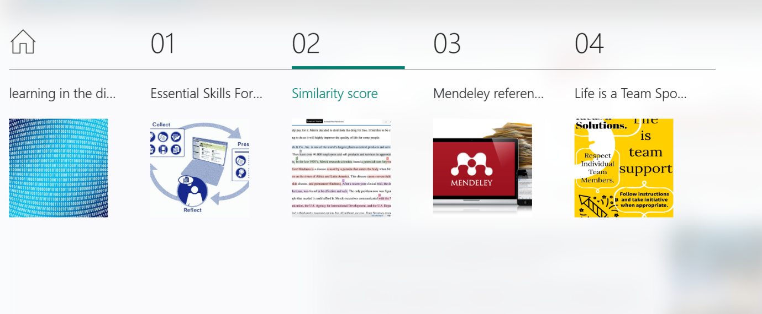
Image. Screenshot of my E-portfolio

An ePortfolio, or electronic portfolio, is a collection of digital evidence demonstrating a person's learning, skills, and achievements. Benefits of ePortfolios: Enhanced reflection and self-awareness: ePortfolios encourage learners to reflect on their learning experiences and identify areas where they have improved or need further development. (Beckers et al. 2016)
I have created an E-Portfolio. I have used Microsoft Sway to make this and have included all my tasks in my portfolio.

The link for my E-Portfolio is: Majib's E-Portfolio

Mendeley reference manager

Task 3
In this task, I will demonstrate how to download and use the Mendeley reference manager.
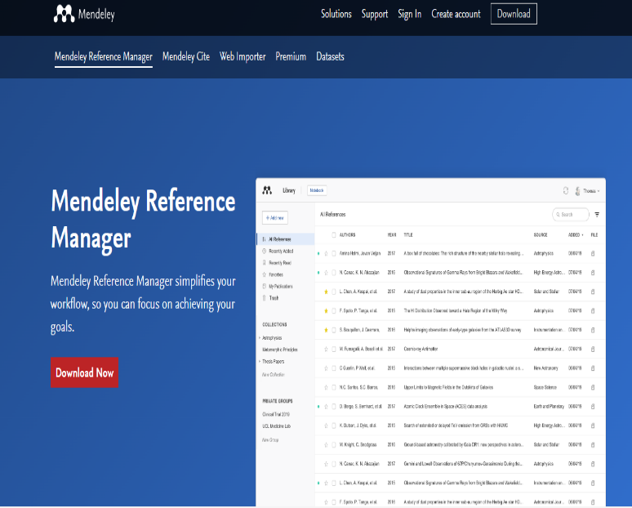

- Go to Mendeley.com and download the application. Once downloaded, you must register with a username and password and then sign in.

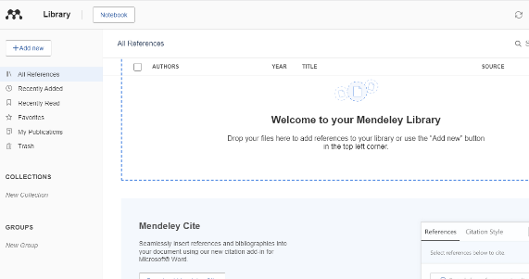
2. After installing the application, you must log in again to use Mendeley. Above is a picture of the Mendeley library.
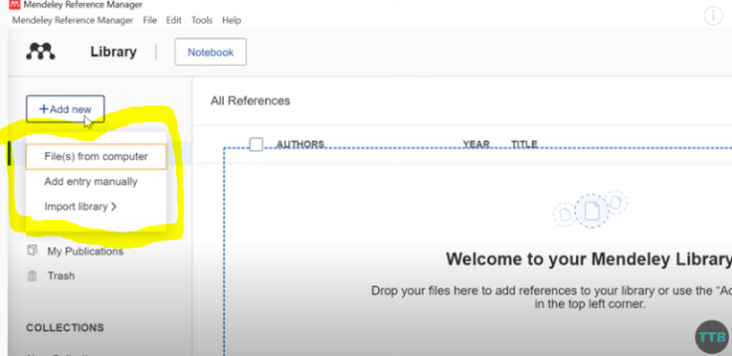
3. picture above the yellow highlighted is where you can add files, books, and web pages to your library. You can add files from your computer or import the library. In the manual entry, you can enter the details of the website and author. Another way is to use a web importer.
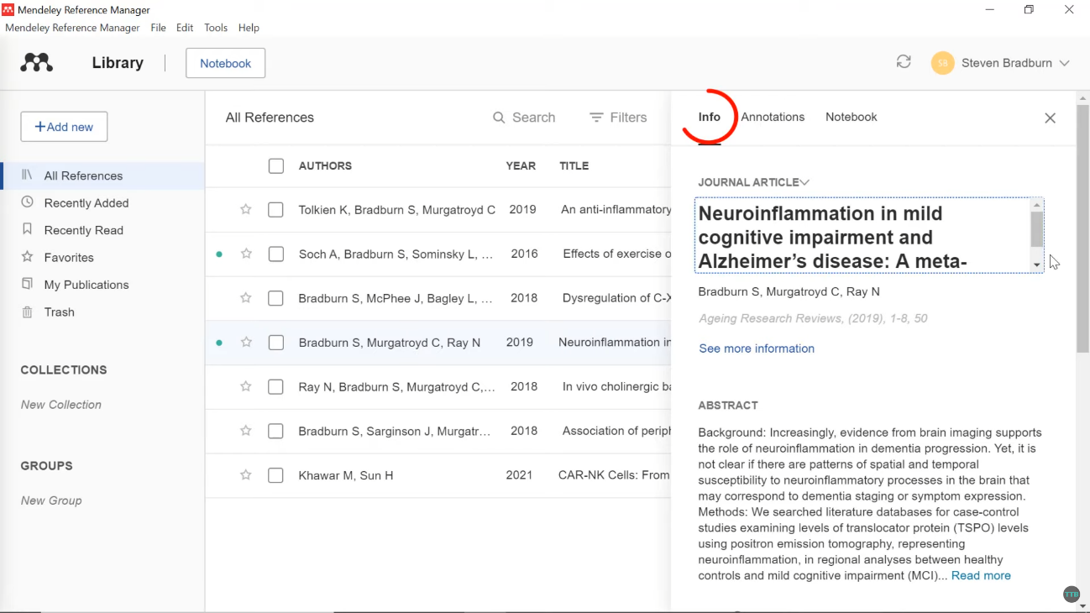
4. picture above shows all my references in the library. Once you click the reference, the info tab shows all your reference information. The left side shows all your references, recently added, recently read, favourites, my publications and trash.
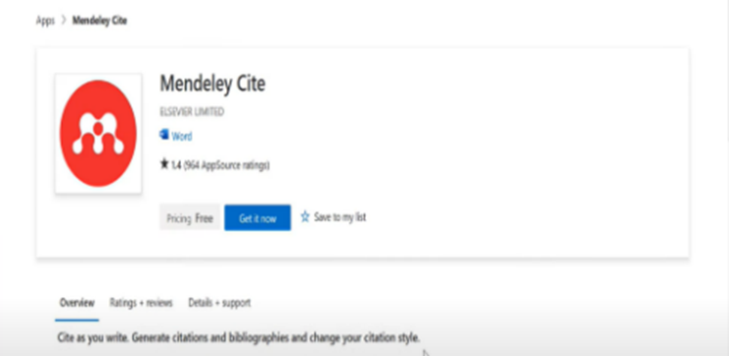
5. you need to download the Mendeley referencing tool for Ms Word. Go to Mendeley.com and download the Mendeley Cite. The picture above shows what it looks like. Click on the blue get it now.

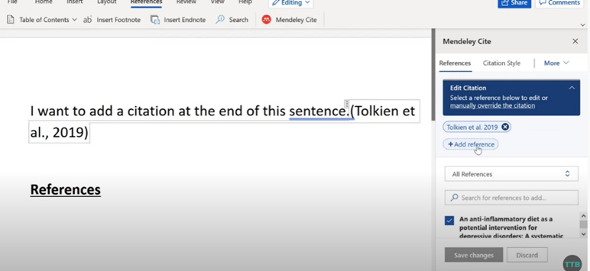
6. To use The Mendeley tool in Ms Word, click on the reference tab in Ms Word then the Mendeley cite will appear on the right. You can add citations or a bibliography from your Mendeley library. For example, the picture above shows that after the sentence, you want to cite the press, add a reference, and it will cite that from your library in Mendeley.

Poster Life is a Team Sport
Task 4

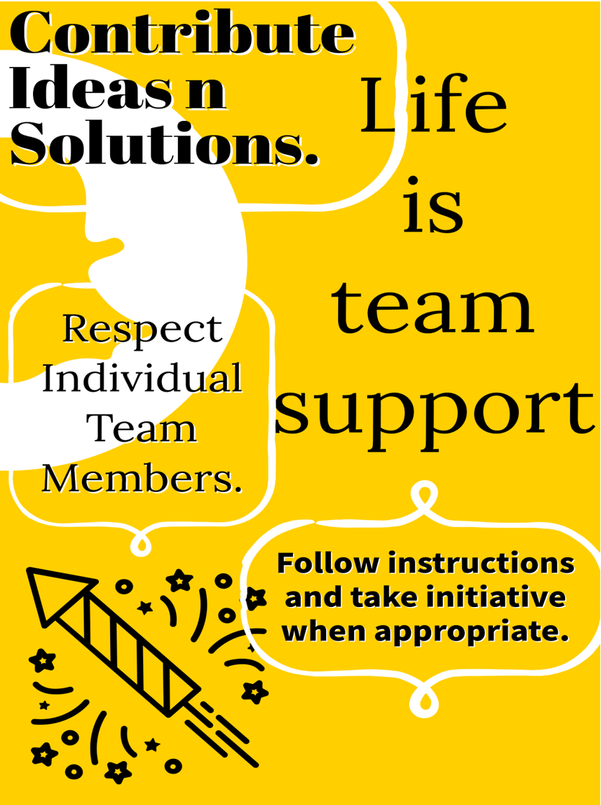
Respect Team Members(Khan, 2020). Contribute Ideas(Kuijsters, 2015) Follow Instructions(Sharon K, Ying Lena, 2019)
In this task Myself, Matt, Corey, and Shakil decided to be in a team to create a . “life as a team sport” poster through collaborative teamwork. We decided as a team that Corey would find the quotes and I would find citations, Shakil was the poster designer, and Matt was our Coordinator. First, we exchanged phone numbers and used wats app to communicate. On there, we exchanged emails.
On our adventure, Matt suggested using Microsoft teams, as I thought it would be a valuable tool for us to use, as this was my first time using this, we arranged Ms Teams live video on the set date and time. All discussed what kind of colour design, quotes we wanted to go with. We finalised everything on video call then we went back to communicating through wats ap messaging.
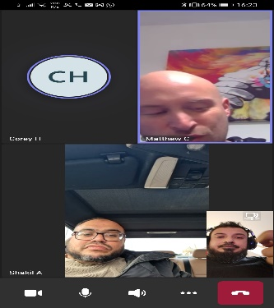 Image of live Ms Teams.
We then agreed to use Ms Outlook to send and receive our work by attaching it to an email.
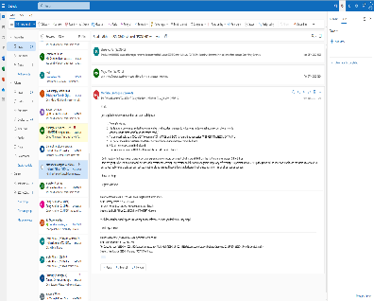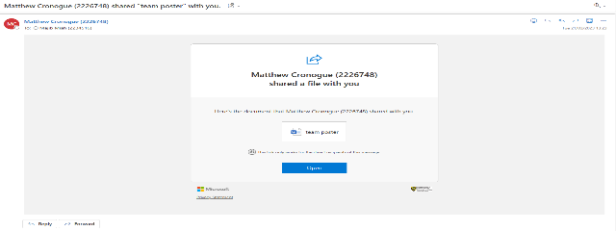
Image of my outlook with team members
Working in a team can be a rewarding experience, especially when everyone is committed to the shared goals and works collaboratively towards achieving them. It can also be an excellent opportunity to learn from others, build new relationships, and develop new skills. (Payne 1982).

Group Members: Majib, Matt, Corey, Shakil.

References
Beckers, J., Dolmans, D. and Van Merriënboer, J. 2016. e-Portfolios enhancing students’ self-directed learning: A systematic review of influencing factors. Australasian Journal of Educational Technology . doi: 10.14742/ajet.2528.
Khan, S.A.K. 2020. legacycultures.com. Available at: https://legacycultures.com/importance-of-respect-in-the-workplace-and-how-it-affects-employees [Accessed: 2 March 2023].
Kuijsters, F. 2015. www.linkedin.com. Available at: https://www.linkedin.com/pulse/9-ways-contribute-team-success-frank-kuijsters [Accessed: 2 March 2023].
Payne, M. 1982. Working in Teams. London: Macmillan Education UK. doi: 10.1007/978-1-349-16697-8.
Sharon K., P. and Ying Lena, W. 2019. hbr.org. Available at: https://hbr.org/2019/08/when-to-take-initiative-at-work-and-when-not-to [Accessed: 2 March 2023].

.

