Object Orientated Programming
Shamuel Hashan
1803153
Web Development
Lecturer: Mike Dacey
Module: Advanced Software development

Difference between class and objects

Class and objects are used in everything for object-oriented programming.
A class is a blueprint that is defined in an OOP that creates the objects. Classes have objects within them. Fields and methods are combined using a class.
Polymorphism and inheritance are also supported by the classes in c#. Classes are declared by using the keyword class.
Eg
Public class StaffDetails
{
public string name;
}
Real life entities are represented by the objects. The state of the objects is represented by certain attributes. The objects properties are reflected by the attributes given to it.
Methods represent the behaviour of the objects. This also follows the response the object has with other objects.
Objects also have an identity. They are given unique names that allows other objects to interact with each other. Data members in a class and member functions of a class are accessed using the objects.

Data encapsulation

Data encapsulation is when an object hides irrelevant data and its behaviour from outside the class. It groups the data and puts them into a single unit. Data will only be able to be accessed using getters and setters and other public methods.
Data encapsulation can be used to protect the data and attributes. It also makes the code less complex and more flexible. The code will also be easier to maintain.
To implement data encapsulation in c#. Variables will have to be declared as private. It can also be defined by having a pair of public getters or setters defined.
Eg.
namespace School
{
Public class students
{
Private double studentAge;
Public string getStudentAge()
{
Return studentID;
}
}
}
Objects can be given a various access levels to an objects data. Access modifiers specify this.
Variables are set as private, so they do not get directly accessed from outside of the class. Private variables are accessed using the public getters and setters’ methods. When it is set to protected. It means that it can only be accessed by same class members and the derived classes it has. Internal data can only be accessed by its current assembly. Protected internal data grants access to its current assembly. It can also be accessed by the types derived from containing class.
Data encapsulation can protect data and keep them secure. It can be used to validate the data provided by the user.
The user data will not be able to be given validation if data encapsulation is not followed.
Properties can be used to protect a field in a class. It does this by reading the values and writing the values of the field.
Data set as public can be accessed all the code in the program while private data is only accessed by the same class.

Interfaces

In the world of programming. Interfaces acts as a contract. The functionalities are declared by the interface. Those functionalities would have to be declared in the interface when being used by an entity that has an interface implemented. The syntax is governed by the interface. This declares the methods and arguments that would be received when it is returned.
Interfaces are defined using the word interface. A valid C# identifier name must be the interfaces name. A capital I is used before the interface name.
Eg.
Interface Iexample;
{
}
Interfaces are used in object orientated programming to make an abstract class. A class or struct can implement at one or more interfaces in C# if they use a colon.
Eg.
Class Cake : Chocolate
{
}
All the members in an interface are made as public members by default. There will be issues if an interface uses an access modifier. There will be a compile-time error. The interface will get compile time errors if it contains implementations. Only declarations can be contained by the interface.
An interface allows a class to use behaviours from multiple sources.
Too summarise interfaces, they a class that only has abstract members. All the members in an interface will need to be used if an interface is implemented by a class or struct. An interface contains properties, methods, events and indexers.

Testing Code

Getting staff details

Test no. | Test purpose | Test action | Expected result | Actual result
1 | Get user input for staff ID | Enter staff ID | User should enter the ID and then the code should move on to the next question | The user was able to enter the staff ID | 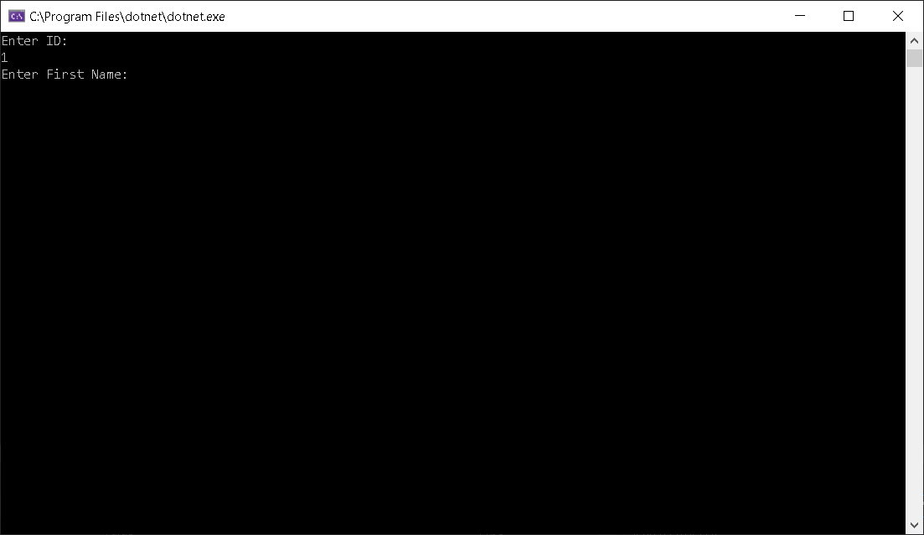
2 | Get user input for first name | Enter user first name | User should be able input data | The user was able to input their data | 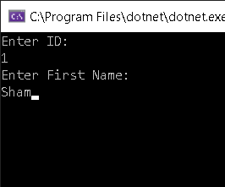
3 | Get user input for last name | Enter user last name | User should be able to input their last name | The user was able to input their last name | 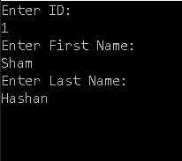
4 | Get user Input for age | Enter user age | User should be able to input their age | User was able to input their age | 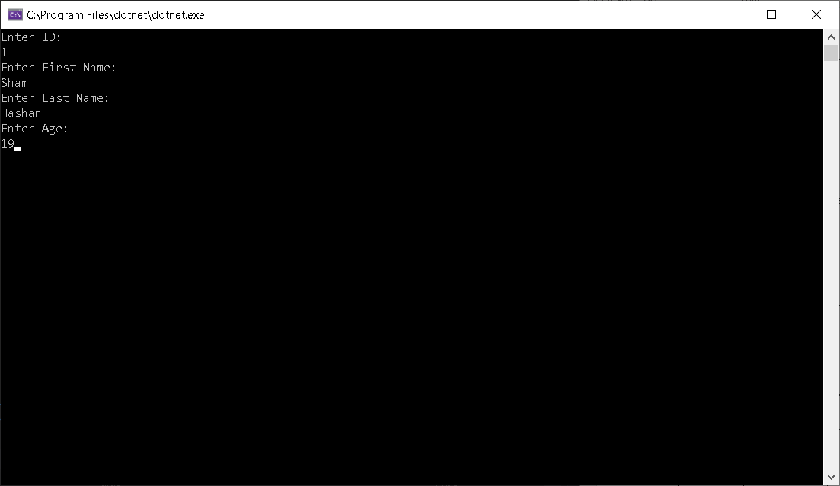
5 | Get user input for their sex | Enter user gender | User should be able to input their sex | User was able to input their sex | 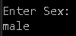
6 | Get user input for their address | Enter user address | User should be able to input their address | User was able to input their address | 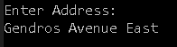
7 | Clear everything on the screen | Press enter | Everything on the screen should clear | Everything on the screen cleared | 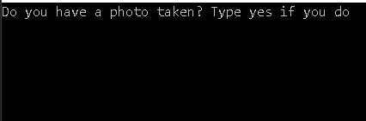
8 | It should show the user details depending on the ID that was entered | Enter the user ID | It should display the user details if the correct ID is entered | The user details were entered. | 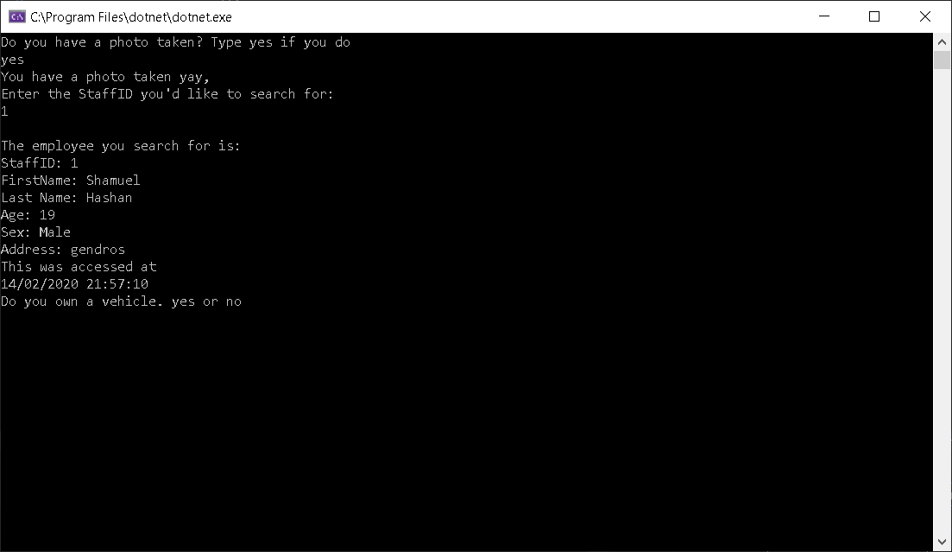
9 | Check if the user has a photo taken. | Ask if the user has taken a photo | It should ask the user if they have taken a photo | Asked the user if they have taken a photo | 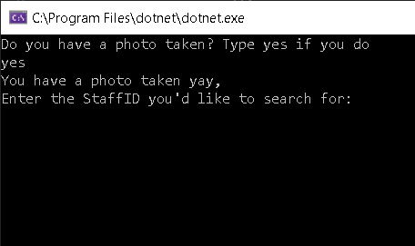
10 | Show date and time for when data was accessed | Press enter | It should show date and time | It showed the user the data and time. | 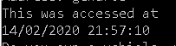
11 | Check if user has taken a photo. | Enter yes to say that user has entered a photo | It should ask if the user has taken a photo. If the user says yes, ask for staff ID they would like to search for | It asked if the user has taken a photo. If the user says yes, ask for staff ID they would like to search for | 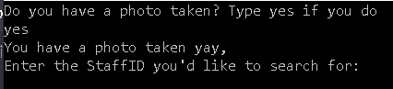
12 | Check if user hasn’t taken a photo. | Enter no to say that user has entered a photo | It should ask if the user has taken a photo. If the user says no, take a photo then ask for staff ID they would like to search for | It asked if the user has taken a photo. The user says no, take a photo and then ask for staff ID they would like to search for | 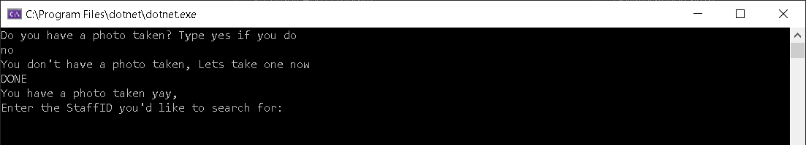
13 | Check if the user has a vehicle | Press yes to say the user has vehicle. | It should then ask if it is parked | It asked if it is parked | 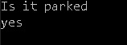
14 | Check if the vehicle is parked | Press yes to say the user has vehicle. | It should ask the user what vehicle it is | It asked the user what vehicle it is | 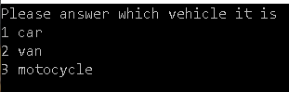
15 | Check if it allows the user to enter car details if user selects car | Enter 1 | It should allow the user to enter car details | It allowed the user to enter car details | 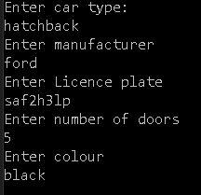
15 | Check if it allows the user to enter van details if user selects car | Enter 2 | It should allow the user to enter van details | It allowed the user to enter van details | 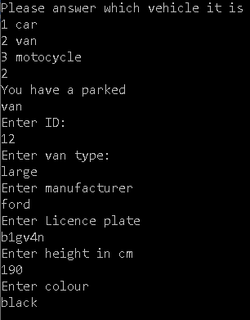
16 | Check if it allows the user to enter motorcycle details if user selects car | Enter 3 | It should allow the user to enter motorcycle details | It allowed the user to enter motorcycle details | 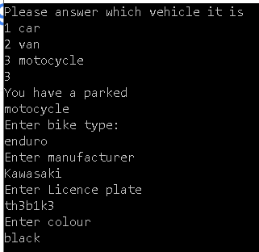
17 | Check to see if user owns a vehicle | Press yes | It should then ask if it is parked | It then asked “it is parked” | 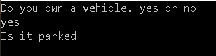
18 | Check to see what vehicle the user has | Press yes when asked if user is parked | It should put the user in a menu asking what vehicle they own. | It put the user in a menu asking what vehicle they own. | 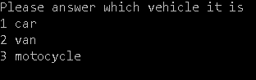
19 | Check to see what happens when user doesn’t own a vehicle | Press no | It should say “you do not own a car” | It said “you do not own a car” | 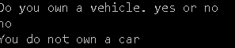
20 | Check to see what happens when the user’s car isn’t parked | Press no | It should say “your car is not parked here” | It said “your car is not parked here” | 
21 | Check validation for staffID | Leave text blank. | It should ask the user to make sure they enter it. | It did ask the user to make sure they enter it | 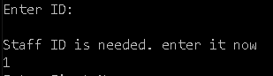
22 | Check validation for first name | Leave text blank. | It should ask the user to make sure they enter it. | It did ask the user to make sure they enter it | 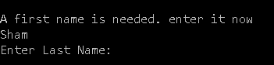
23 | Check validation for last name | Leave text blank. | It should ask the user to make sure they enter it. | It did ask the user to make sure they enter it | 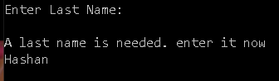
24 | Check validation for the gender | Leave text blank. | It should ask the user to make sure they enter it. | It did ask the user to make sure they enter it | 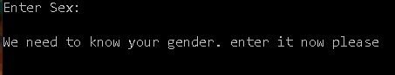
25 | Check validation for the address | Leave text blank. | It should ask the user to make sure they enter it. | It did ask the user to make sure they enter it | 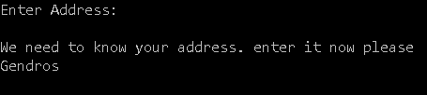
26 | Check validation for the car type | Leave text blank. | It should ask the user to make sure they enter it. | It did ask the user to make sure they enter it | 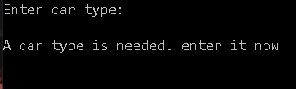
27 | Check validation for the manufacturer | Leave text blank. | It should ask the user to make sure they enter it. | It did ask the user to make sure they enter it | 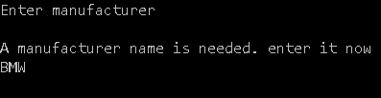
28 | Check validation for the car licence plate | Leave text blank. | It should ask the user to make sure they enter it. | It did ask the user to make sure they enter it | 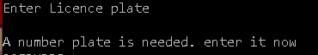
29 | Check validation for the car colour | Leave text blank. | It should ask the user to make sure they enter it. | It did ask the user to make sure they enter it | 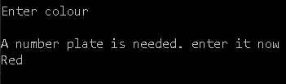
30 | Check validation for the van type | Leave text blank. | It should ask the user to make sure they enter it. | It did ask the user to make sure they enter it | 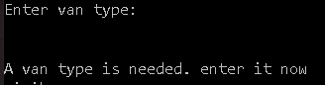
31 | Check validation for the van manufacturer | Leave text blank. | It should ask the user to make sure they enter it. | It did ask the user to make sure they enter it | 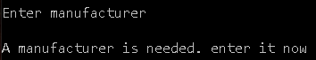
32 | Check validation for the van licence plate | Leave text blank. | It should ask the user to make sure they enter it. | It did ask the user to make sure they enter it | 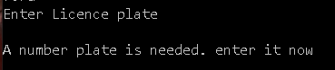
33 | Check validation for the van height | Leave text blank. | It should ask the user to make sure they enter it. | It did ask the user to make sure they enter it | 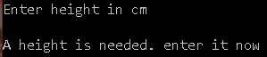
34 | Check validation for the van colour | Leave text blank. | It should ask the user to make sure they enter it. | It did ask the user to make sure they enter it | 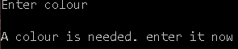
35 | Check validation for the bike type | Leave text blank. | It should ask the user to make sure they enter it. | It did ask the user to make sure they enter it | 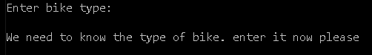
36 | Check validation for the bike manufacturer | Leave text blank. | It should ask the user to make sure they enter it. | It did ask the user to make sure they enter it | 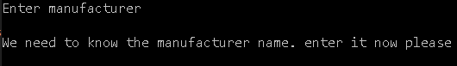
37 | Check validation for the bike licence plate | Leave text blank. | It should ask the user to make sure they enter it. | It did ask the user to make sure they enter it | 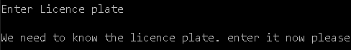
38 | Check validation for the bike licence plate | Leave text blank. | It should ask the user to make sure they enter it. | It did ask the user to make sure they enter it | 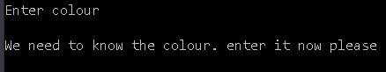

Conclusion

In this report, we have touched on some of the principles of object orientated programming. We learned about what classes and objects are as well as the difference between them. We also talked about data encapsulation and discussed how that is used in object orientated programming. I also discussed the impact interfaces have on developing code.

Creating the code has given me a better understanding of programming in c#.

References

Bibliography

[1] | “C# Class & Object Tutorial with Examples,” Guru99, [Online]. Available: https://www.guru99.com/c-sharp-class-object.html. [Accessed 12 feb 2020].
[2] | “Encapsulation in C#,” Dot Net Tutorials, [Online]. Available: https://dotnettutorials.net/lesson/encapsulation-csharp/. [Accessed 16 February 2020].
[3] | “Encapsulation,” Techopedia, [Online]. Available: https://www.techopedia.com/definition/3787/encapsulation-c. [Accessed 16 February 2020].
[4] | “Interfaces (C# Programming Guide),” Microsoft, 8 August 2018. [Online]. Available: https://docs.microsoft.com/en-us/dotnet/csharp/programming-guide/interfaces/. [Accessed 16 February 2020].
[5] | “C# Interface,” W3Sschools, [Online]. Available: https://www.w3schools.com/cs/cs_interface.asp. [Accessed 16 February 2020].
[6] | “C# - Interface,” tutorialsteacher, [Online]. Available: https://www.tutorialsteacher.com/csharp/csharp-interface. [Accessed 17 Februaru 2020].

