Student name: Jack Lewis
P number`: 2400664
Programme of study: Graphic design
Module: Ways of perceiving

Words - 1398

Upcycling

The construct of upcycling is an opportunity to do better, it provides us with an alternative option to brands providing fast fashion, unnecessary products etc. It keeps wats from landfills and reduces resource usage. Social media has heavily shaded my views on this topic as I am now seeing more and more content around the impacts of my actions. Upcycling creates opportunities for discarded, single use materials that would otherwise be left to biodegrade and introduce more harm via microplastics.

All the work in this gallery is constructed of waste materials that collect in landfills and scrap yards. That is why I’ve chosen a scrap yard to house this artwork. It is also to use surrounding visuals to create a sense of disgust from the viewer from the smells. Sights and more. This is effective as “unsanitary disposal of plastic waste is considered as an aesthetic and visual nuisance.” (Yadav, 2016, pg.64) This aesthetic provides a contrast from the before and after, as the artworks will be almost intertwined into the waste to show how we can evolve from our harmful consumerism ways.

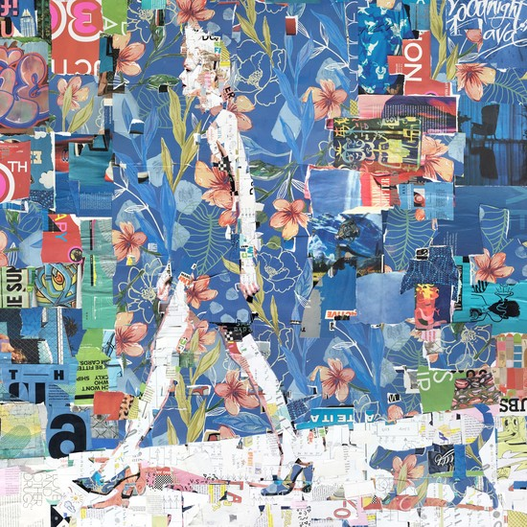

Fig 1 Gores, Springtime catwalk (2019)

Figure 1 shows a collage created by Derek Gores named “Springtime catwalk.” Derek’s artwork utilises scrap magazines curated in a way to create intricate yet chaotic art pieces. The colours and textures he gains from his medium highlights how old things can be made new. This piece is impactful due to its use of pop culture magazine images that connect with the viewer, art impacts life and influences change. His sustainable art practices provide a double motive behind his work along with the emotive message of the piece itself. The taught greed that is consumption is a communal experience we all face every day, with constant advertisements for new and “improved” products along with high end brands producing low quality products fills our landfill with unnecessary waste. Gores’s practice shows us how even something as humble as a magazine can be revitalised into sustainable and meaningful artwork. The focal point of the artwork is of an elegant woman walking in a manner like that of a catwalk. The cat tailing her reinforces this idea. Catwalks produce fashion and art simultaneously, some being spectacles while others flaunt fast fashion and a money grab at consumers. This connection between fast fashion and his art practice provides contrast and allows you to think about what we realy need verses want.

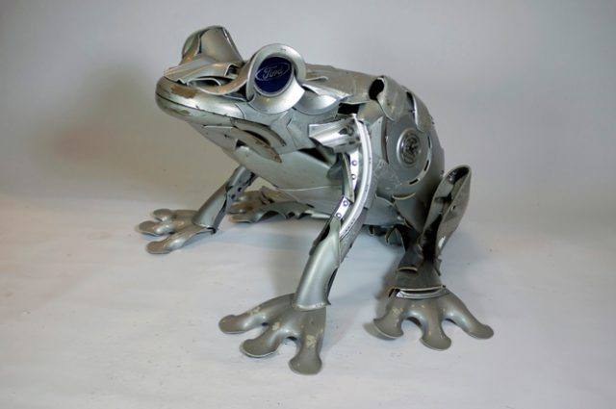

Figure 2 Erlington (2025)

This next piece was created by Ptolemy Erlington as a commission. His entire ethos behind his work stems from sustainability paired with his passion for model making, His start found him working in theatre set designs. Figure 2 presents one of his hubcap animals famously known for their unique material use and animatronic appearance. Erlington utilises hubcaps found on the side of the road or bought and repurposes them into these intriguing sculptures. The discarded material comes with its quirks and imperfections and “bear the scars of their previous lives in the form of scratches and abrasions.” (Erlington, 2019) This gives them texture and a story to tell. The material used pairs well with my location as it would tie into the background while standing out due to its polished state. The pairing of mechanical parts and organic life creates a conflict and contrast within the piece itself, it forces us to think about how these materials effect the lives of those who had no say in it. The static stance of the animals could connote to their frozen opportunities and no say in the matter of destruction of their homes and species. The shiny quality of these pieces provides a message of brand new and polished appearance, reinforcing the message of consuming less and creating more.

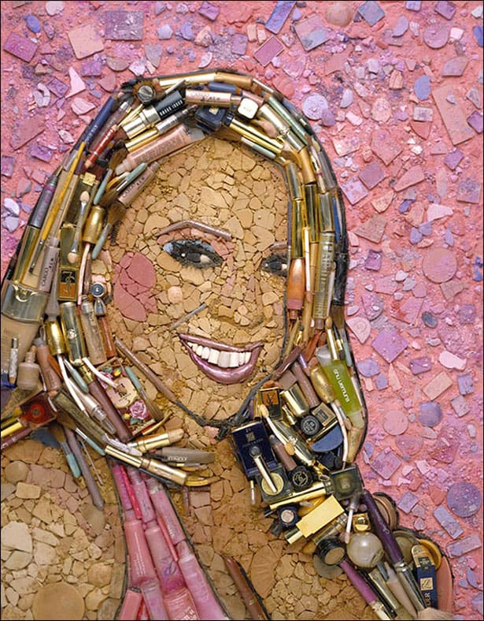
Figure 3 Mariah Carey (2009)

In a world of overconsumption, it’s important to look inwards in how we as consumers can make a change. While the real issue lies within the provider and creators it’s still mandatory that we reflect on our choices. The artist Jason Mercier has taken this thought on board and used his artistic skill to provide a similar message. His collage artwork of celebrity portraits consists of materials provided by his own waste. This is the premise of upcycling, taking something of no value to you and repurposing it to create something new. “Mosaic has been used as a decorative medium for over five thousand years” (Tate gallery, 2025)reinforcing the timelessness of this piece as well as its timeless impact on people. The visuals of celebrities within his artwork creates a connection of popularity, self-esteem and importance with upcycling. Recycling and upcycling isn’t a new concept as “recycling of materials has a history going back to the times of Plato BC400” (Achilias, 2012, p.195) yet it is still important to reiterate the message of a clean earth. I enjoy this piece as at first glance it doesn’t seem as intentional as it actually is. The more you look the more you see, and the more you understand.

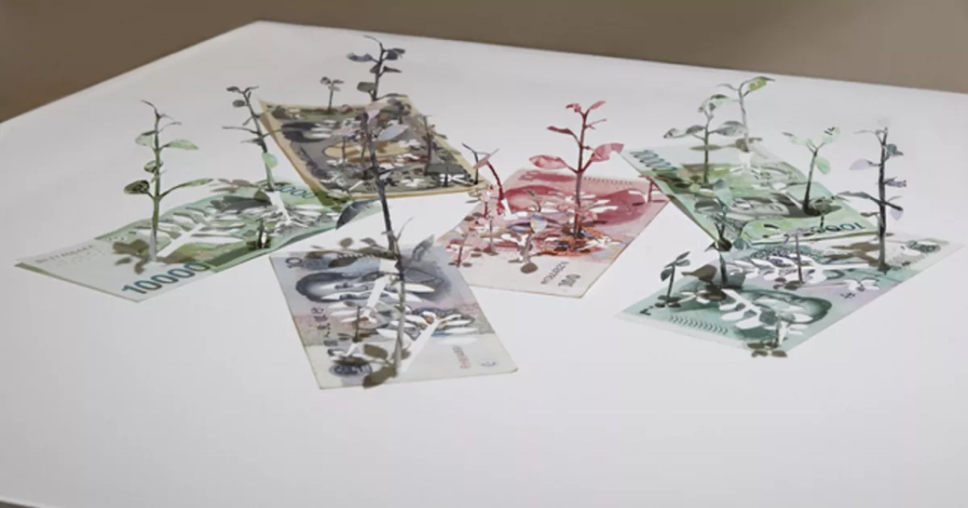
Figure 4 Green economy (2015)

This next piece takes a familiar route of connecting commercial aspects of our lives with nature. Figure 4 shows an artwork produced by Yuken Teruya. An artist who specialised in naturalistic and organic based artwork utilising accessible and common waste items such as plastic bags, money, paper etc. Figure 4 shows one of his artworks that depicts saplings growing from bills of money. This connection of nature and man-made materials creates a contrast between the two by exhibiting what was, and what is. The money we see was once made from natural forms. The money in Japan is made from different plants such as Edgeworthian, and the oriental pepperbush, reinforcing the connection made by Teruya with this piece. The use of upcycling on an object such as money holds impact into what Teruya is trying to convey, I think the artwork also speaks on the current state of the economy, life grows from money and riches. At the epicentre of survival in today’s world, is money. “upcycling minimizes the environmental and social costs associated with waste management’ (Tocco, 2025) Teruya creates a space to think within his artwork, the artwork itself is usually quite simplistic, not in its execution but the fact that it will be staged in a location that is completely blank, to give life to the artwork. Its important to think about upcycling as it connects with sustainability, overconsumption, the economy, and more. Teruya conveys all these topics within his art beautifully while getting the viewer to think internally about how they affect things in their lifetime. We don’t often think about

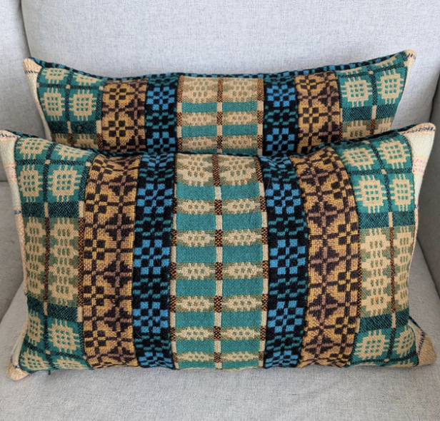
Figure 5, Debbire morris (2025)

The final piece of artwork for my exhibition will take a softer and closer to home route. Figure 5 shows a decorative pillow made from a special material. Made by Debbie Morris, this pillow and others like It is made from old Welsh blankets, some dating back more than one hundred years ago. The artist Debbie Morris collects, cleans, sews and sells these items. The premise of upcycling is to create something new from something old to produce less waste, this artwork Morris produces is creating something of immense value with a sustainable approach. The Welsh blankets used once belonged to someone, were gifted, bought, even hand made. The products give us space to think about what came before us and how it affects us now, the same thing applies for what we do now and how it will affect us in the future. Overconsumption of products has caused damage to our environment and damage to our own views on buy and sell. The mass production of fast fashion and unnecessary purchases is something we all should strive to avoid. Things such as thrifting clothing, charity shops, apps like vinted and Depop that allow people to sell second hand clothing etc. All of this contributes to a better future and the slight undoing of our overconsumption as “We make too much clothing as a society. We need to produce less.” Readers digest(2024).

The end goal of this exhibition is to make the viewer think, like all exhibitions. Art is supposed to be viewed from all different walks of life and hopefully it will impact an array of people in a positive way. The impact of this exhibition comes from its raw images and background and the effect to make people think, “This ability to provoke thought and motivate action makes art an indispensable element in the pursuit of social justice.”

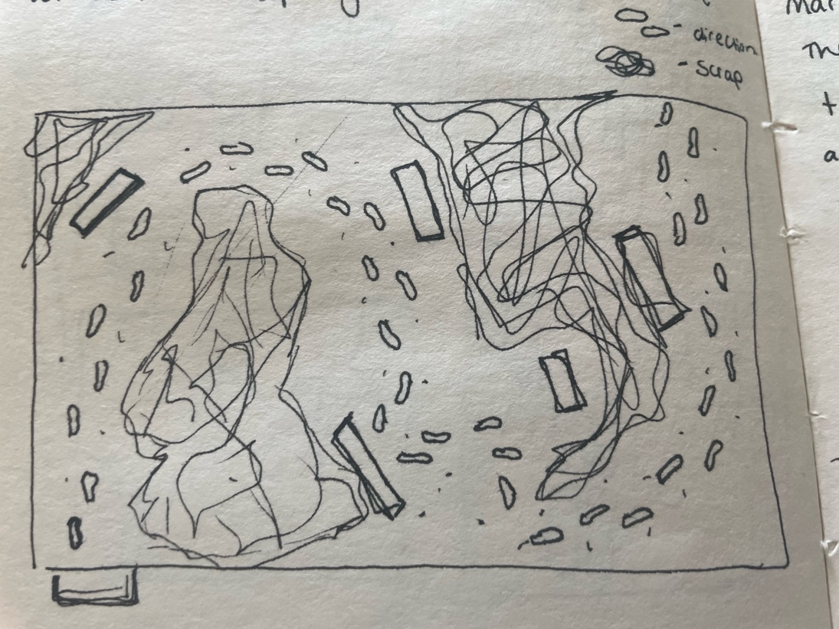

Figure 6, own image, map of exhibition (2025

Bibliography –

- Demitris s Achilias, (2012) Material recycling: trends and perspectives, IntechOpen
- Readers digest(2024)“Trash Walker” Anna Sacks Finds Treasure in New York City’s Garbage, available at: https://www.rd.com/article/trash-walker-exposes-excess-waste/ (accesed: 21st apr)
- Tate Gallery(2025) Mosaic, available at https://www.tate.org.uk/art/art-terms/m/mosaic (accessed: 25th apr)

- Tocco, (2025) Upcycled materials for a circular economy in Europe?, available at: https://tocco.earth/article/upcycled-materials-for-circular-economy-Europe/ (accessed: 27Th apr)

- Vinay Yadav, Waste-to-wealth (2025) First edition, CRC press

- Yuen Felice, (2016) Collage, Urbana: Taylor & Francis Ltd

Figures

Figure 1: Derek Gores (2019) Springtime catwalk, Available at: https://derekgores.com/collage/?aa_piece=sunshine-ballet-by-derek-gores
Figure 2: Ptolemy Erlington (2025) Available at https://www.hubcapcreatures.com/about-the-artist/
Figure 3: Jason Mercier (2009) Mariah Carey, Available at: https://thejasonmecier.com
Figure 4: Yuken Teruya (2015) Green economy, Available at: https://pieroatchugarry.com/artists/yuken-teruya
Figure 5: Debbie Morris (2025) Available at: https://hebodahs-house.sumupstore.com/product/vintage-welsh-blanket-bolster-cushion-covers

