Module name: Entrepreneurship
Assessment: Task 1 Business Plan Development
Module code: LCBB5013
Lecturer: Balendran Kandasamy
Student ID: 1921604
Student name: Vasile-Claudiu Neacsu.

The Business Plan of OmniCover life

Table of Contents

Task 1 :Business Plan Development …………………………………………...……3
Introduction…………………………………………………………………..……….….3
Element 1:Business Idea , Products/Services , Objectives & USP …………….4
Element 2:Business Environment & Competitor Analysis ………………………7
Element 3: 4Ps , Market Segmentation & Marketing Strategies …………..……9
Element 4: Financial Planning ……………………………………………..…….….14
Conclusion ………………………………………………………………….………..…16
Reference List …………………………………………………………………………..17

TASK1:BUSINESS PLAN DEVELOPMENT
INTRODUCTION
Entrepreneurship is the process of designing, launching and operating a new firm, centred on innovation, value creation, and risk-taking. Burns (2022) describes entrepreneurship as turning ideas into stable companies through opportunity identification, resource management, and business planning, while Wise et al. (2024) highlight ideation, lean start-up methodology, and case studies as core topics in business creation. This study develops a new business plan for OmniCover Life, an AI-powered insurance broker and comparison platform that will compare, recommend, and arrange coverage for customers on behalf of established underwriting insurers, who will issue policies and remain responsible for claims. This task covers the business idea, products and services, business environment, competitor analysis, marketing strategy, and financial planning.

Element 1:Business idea , Products/Services, Objectives and USP
Business idea

Figure 1: The Official logo of OmniCover Life
OmniCover Life will operate as an AI-powered insurance broker and comparison platform, using AI to compare, recommend, and arrange suitable cover for pets, homes, health, and cars. Rather than underwriting policies directly, the business will work with a panel of established, FCA-authorised insurers. These partner insurers will issue policies, hold regulatory capital, assess risk, and remain responsible for paying claims.

The platform will replace the slower, manual elements of traditional broking—such as repeated form-filling and paper renewal packs—with conversational bots, machine learning-based product matching, and digital claims assistance. Through a single app, customers will be able to compare policies and track claims across multiple insurance categories. OmniCover Life will operate as a limited liability business and generate income through commissions and fees from partner insurers, rather than through premiums.

Its AI-enabled services will support several product areas. For pet insurance, the platform will analyse breed-related health risks and use optical character recognition to process veterinary invoices before forwarding claims to the underwriter. For individuals, it will compare live quotes and manage health profilers to generate tailored recommendations. For home insurance, computer vision and aerial data will assess property conditions and identify suitable underwriting partners. For car insurance, telematics will identify usage-based discounts and support photo-based damage estimates, helping to speed up claims handling with the underwriter.

PRODUCTS AND SERVICES
OmniCover Life will offer AI-driven services, while underwriting, risk-carrying, and claims-paying responsibilities remain with its panel of partner insurers. Conversational AI chatbots will gather customer data and generate customised, comparative recommendations from across the panel in less than 90 seconds, offering instant quotes. The app will also provide touch-less claims assistance through machine learning and natural language processing, helping customers gather loss details and submit a complete claim to the underwriter in under three minutes; the partner insurer retains the decision on liability and pay-out. A behavioural fraud-screening feature will flag suspicious activity before claims are forwarded to the underwriter, reducing operational overheads for both parties. Granular data modelling will match assets, vehicles, homes, and pet profiles to the most competitively priced, suitable policy on the panel, helping people compare and buy cover with less time and effort.
Objectives (Short-term and Long-term)
Short-term objectives
- To launch the core platform of OmniCover Life for acquiring early customers and achieving operational efficiency
- To obtain FCA authorisation as an insurance intermediary and formalise distribution agreements with a panel of underwriting insurance partners
- To partner with car dealerships, real estate platforms, and pet networks for embedded distribution
- To publish initial customer satisfaction scores and claims turnaround times
Long-term objectives
- To increase the profitability of OmniCover Life by 30% by the end of 2027
- To enter new countries and offer the diverse services of OmniCover Life by 2028
- To increase the number of users of the OmniCover Life app by 60% within 2030

Unique Selling Point (USP)
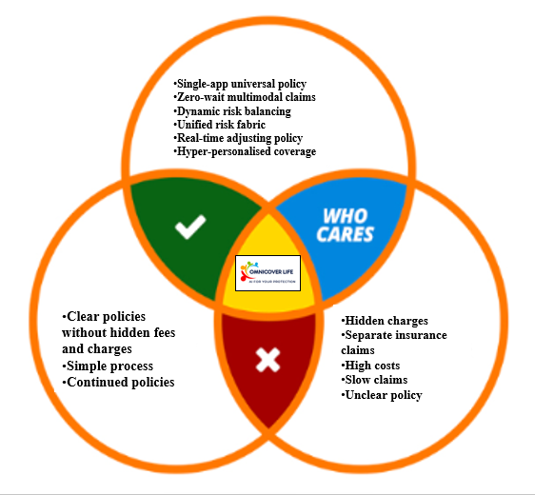
Figure 2: The USP of OmniCover Life
OmniCover Life differentiates itself through a single-app view across a whole panel of insurers, near-instant multimodal claims assistance, and continuous re-matching of customers to the most suitable policy as circumstances change, replacing fragmented portfolios spread across several insurers and apps with one unified customer profile. People currently juggle different premiums for different types of cover, which drives up costs, slows claims, and obscures policy terms (Khanal et al., 2023), while many insurers add hidden admin charges for minor changes such as updating an address or vehicle (Celestin and Vanitha, 2022). OmniCover Life will mitigate these pain points through a Unified Policy Fabric, built on a single digital identity, which compares and, where beneficial, rearranges pet, home, car, and life cover across the panel. Customers experience hyper-personalised recommendations and a single point of contact for claims, instead of managing separate insurer relationships themselves.

ELEMNT 2:Business Environment &Competitor Analysis
SWOT analysis
Strengths | Weaknesses
- AI-powered comparison and personalised recommendations  - Automated onboarding and claims assistance  - Unified customer experiences | - Lower brand reputation  - Dependence on partner insurers' risk appetite and pricing  - Black-box opacity
Opportunities | Threats
- Social media campaigns and ads  - Building hyper-local weather and flood-risk data partnerships for UK homes (External)  - Integration of point-of-sale | - Regulatory frictions (External)  - Fraud and security risks
Analysis
OmniCover Life's key strength is AI powered comparison and personalized recommendations which combine real time data integration , behaviour adjustment and deep segmentation across the insurer panel . The company will use telematics for cars, and vet history for pets to match customers to the most suitable, competitively priced products, instead of relying on broad demographic averages or a single insurer's range, re-ranking recommendations continuously as habits, circumstances, and partner quotes change. Automated onboarding and claims assistance form a second strength: computer-vision damage estimation supports faster, better-evidenced claims once they reach the underwriter, while natural language processing reads unstructured medical bills, vet receipts, and policy documents automatically (Davies et al., 2024) to help customers assemble what the insurer needs. AI can also support proactive fraud screening before submission, flagging duplicated bills, altered invoices, and abnormal reimbursement patterns.

The unified customer experience integrates pet, house, car, and life insurance from across the panel into a one frictionless interface. Virtual assistants monitor policy modifications, answer coverage inquiries, and file claims with the applicable insurer 24 hours a day, seven days a week, minimizing reliance on human brokers for simple queries while maintaining professional advisers available for difficult instances.As a new UK venture, OmniCover Life will have a limited reputation, which can mean lower profitability or brand loyalty in the market. Its “coverage for anything” positioning may also attract higher-risk applicants already declined or poorly quoted by traditional insurers (Celestin and Vanitha, 2022); since underwriting decisions and risk appetite sit with the panel rather than the platform, a mismatch between what OmniCover Life promises and what partners are willing to offer could damage trust. Black-box recommendations pose a related weakness: machine learning models can struggle to explain why one policy was recommended over another, or why a partner insurer declined or re-priced an application, which can undermine customer trust even though the decision was not the platforms to make (Barbierato and Gatti, 2024). Aggregating and sharing personal data with multiple insurers can also trigger surveillance concerns among customers fearing data leaks.
OmniCover Life can leverage social media ads and campaigns to build brand reputation and loyalty in the UK market and can build partnerships with data providers for hyper-local weather and flood-risk insights on UK homes, strengthening recommendation accuracy and widening its product range. Embedding distribution at the point-of-sale can bring pet, travel, and gadget coverage, arranged through partner insurers, directly into online checkouts, retail apps, and veterinary portals. On the threats side, OmniCover Life still faces UK regulatory hurdles, since insurance distribution requires FCA authorisation as an intermediary and compliance with conduct-of-business rules, albeit a lighter regime than the capital requirements placed on underwriting insurers. UK GDPR also limits how start-ups can harvest and share personal data with multiple partner insurers for AI-driven recommendations (Custers and Malgieri, 2022), while the FCA maintains strict oversight of algorithmic fairness, consumer duty, and commission transparency.
Fraudsters also utilise generative tools to create fake medical, pet, and property records and audio deepfakes (Romero-Moreno, 2024), a threat to OmniCover Life and to the partner insurers who ultimately bear the cost of fraudulent claims.

Two direct competitors
Two major direct competitors are Compare the Market and Jointly AI. Compare the Market, a long-established UK price comparison site, has moved into AI-driven distribution, launching its own ChatGPT-based shopping app for insurance in 2026 (Optimus Consulting, 2026). Jointly AI is a newer UK entrant offering an autonomous brokerage platform that contacts insurers, compares live quotes against a customer's stated priorities, and delivers a recommendation without carrying any underwriting risk itself (Reinsurance News, 2026).
Two Indirect Competitors
Hyperexponential and FintechOS are significant indirect competitors. Hyperexponential, a London-based pricing decision software developer, helps traditional and specialty insurers upgrade their own underwriting and direct-quoting workflows, potentially reducing their reliance on third-party brokers over time (Hyperexponential, 2022). FintechOS, a UK-active provider of modular AI software suites, lets insurers build their own automated, direct-to-customer journeys, competing with brokers for the same point of sale rather than partnering with them (Fintechos, 2026).
ELEMENT 3 :4PS, Market Segmentation &Marketing Strategies
STP Analysis
Segmentation
Market segmentation separates a larger client base into smaller sub-groups based on shared criteria including demographic , geographic, and behaviour ,helping businesses move away from a one-size-fits-all approach. OmniCover Life will consider demographic, geographic, behavioural, and psychographic segments together in developing its UK marketing strategy, targeting customers by age, income, occupation, and behavioural traits.

Target market
Demographic | Age: 18 to 45 years  Gender: Male, Female, LGBTQ+  Income group: Lower to middle income range
Geographic location | The UK
Behavioural | People who are comfortable with AI-driven comparison, automated document assistance, and chatbot-generated quotes, people who demand “cover anything” micro policies and bundled coverage sourced from a panel of insurers rather than rigid legacy contracts, and expect fast, AI-assisted claims support instead of multi-week verification delays
Psychographic | Technology-enablers, hyper-convenience seekers, and pragmatic risk optimisers, people who value personalisation, speed, and seamless mobile app integration
Analysis
Young adults, increasingly conscious of protecting their private assets and often pet owners themselves, position OmniCover Life to target digital-native millennials and Gen Z. Residents of major UK technology and financial hubs (London, Manchester, Birmingham) who manage multiple assets, such as home, car, and pet cover, are a natural fit. Behaviourally, the company targets people who demand AI comfort, modularity, speed, and efficiency, and who are comfortable trusting an AI-assisted platform to select and arrange suitable policies from a panel of insurers. These differentiations in service and marketing strategy help OmniCover Life stand apart from both modern and traditional insurance competitors.
Positioning mapping
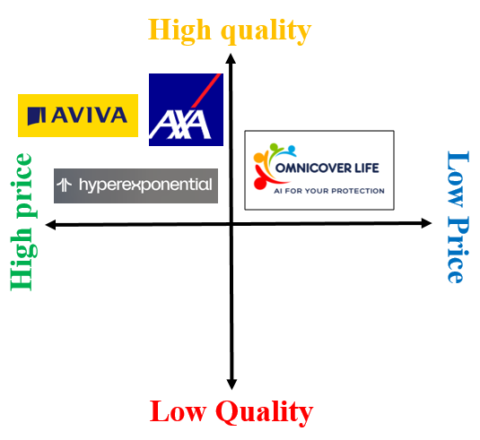
Fig3.The positioning map of OmniCover Life
4Ps Marketing Mix
Product
The product strategy relies on a unified data architecture, modular comparison across the insurer panel, and fast, AI-assisted claims support. Core pillars include AI-driven product matching using alternative data, awareness of partner insurers' usage-based pricing models, and a largely zero-touch application journey. OmniCover Life will track how car, home, and pet insurance needs change through telematics, smart home feeds, and wearable pet trackers, prompting customers to review or switch cover, and letting them toggle cover blocks inside a single app dashboard that draws on usage-based products priced strictly for active exposure (Abiodun et al., 2024). Conversational AI, using natural language processing, manages quote comparison, amendment requests, and routine queries 24/7, routing binding decisions to the relevant insurer, while explainable AI models comply with FCA fairness, consumer duty, and pricing transparency guidelines for intermediaries.

Price
OmniCover Life will earn revenue through commission paid by partner insurers on policies arranged through the platform, plus optional flat advisory or concierge fees for complex, multi-policy customers; it will not set or collect premiums itself, as these remain the underwriting partner's responsibility. For customers, the value proposition is a dynamic, usage-based, micro-segmented comparison of premiums already offered across the panel, rather than a single price set by OmniCover Life. Matching algorithms process thousands of real-time data signals, rather than static historical demographics, to surface the most competitive and suitable policy at a given moment, updating instantly as signals such as local crime rates, traffic data, and weather patterns feed through to partner insurers' own pricing. Home and pet cover benefit from low-cost smart-home IoT and wearable data, while hyper-personalisation supports granular risk scoring and on-demand bundles. As machine learning ingests application data without manual re-keying, it lowers OmniCover Life's cost to serve, and its commission model means the company shares in savings passed on to customers rather than in the premiums themselves.
Promotions
OmniCover Life will use hyper-personalised digital marketing, with generative AI customising ad creative and copy for niches such as gig workers, pet owners, and homeowners, and data-driven campaigns on TikTok, Instagram, and LinkedIn highlighting flexible coverage for non-traditional assets like short-term rentals, pets, and gadgets. Interactive AI Copilots on web and WhatsApp will qualify leads instantly, answer policy questions, and build real-time, comparative quotes drawn from the insurer panel.
Place
The core distribution channels are embedded point-of-sale partnerships, conversational AI, and the direct-to-customer app. Modern API infrastructure connects directly to the panel of underwriting insurers, pulling live quotes and policy documents into the app in real time rather than sending customers to each insurer's own site. The app is the core channel through which customers compare, select, and arrange policies underwritten by partner insurers.

The on-line
As an online-only business, OmniCover Life will rely on dynamic, personalised content, with generative AI analysing user data to draft real-time, individualised email campaigns and web copy embedding behavioural and psychographic segments. Piranda, Sinaga, and Putri (2022) note that social media plays a vital role in reaching target customers, supporting OmniCover Life's use of core AI marketing strategies for campaign and content development.

ELEMENT 4 : FINANCIAL PLANING
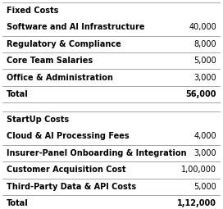
Figure 4: Fixed and Start-up costs of OmniCover Life
Fixed costs are business expenses that do not change with production or sales volume (Hansen, Mowen, and Heitger, 2025), while start-up costs are the initial, one-time expenses incurred before a business opens (Caglayan, Kabak, and Ucal Sari, 2025). The figure above shows OmniCover Life's estimated fixed costs of £56,000, covering software and infrastructure, regulatory and compliance (including FCA authorisation and professional indemnity insurance), core team salaries, and office and administration. Estimated start-up costs of £112,000, also treated as variable costs, cover cloud and AI processing fees, insurer-panel onboarding and integration, customer acquisition, and third-party data and API costs. Unlike an underwriting insurer, OmniCover Life holds no regulatory capital or claims reserves against the policies it arranges, since that responsibility sits with its partner insurers; its own costs are limited to running the platform and converting leads.
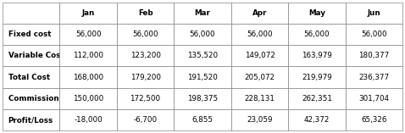
Figure 5: Profit and loss statement based on costing method

Profit and loss summarise a business's revenues, costs, and expenses over a period to show whether it made or lost money (Albuquerque, Velez, and Pinto, 2023). The figure above estimates OmniCover Life's profit and loss for the first six months, where revenue reflects commission and fee income from partner insurers rather than premiums, since the platform does not underwrite policies itself. Fixed costs of £56,000 are charged each month, while variable costs increase by 10% monthly on assumed UK market fluctuations. Revenue is projected at £150,000 in month one, growing 15% monthly. Profit and loss is calculated by deducting total costs from revenue each month; OmniCover Life is expected to make a loss for the first two months before turning to profit.
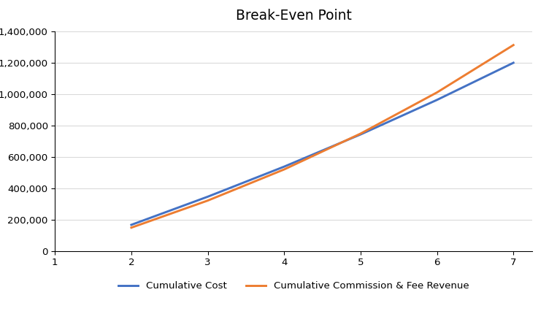
Figure 6: Break-even point of OmniCover Life
Break-even is the moment at which total cost and revenue are equal , resulting in no profit or loss.The figure above shows OmniCover Life's break-even point across the first six months, with costs and revenue converging around month four to five. As a broker, this £159,586 initial investment covers platform development, marketing, and working capital rather than insurance claims reserves or regulatory capital, since underwriting risk sits with the partner insurers.

Conclusion
According to the study, it can be concluded that OmniCover Life will be a profitable business with an innovative idea that will leverage AI to compare, recommend, and arrange insurance coverage coverage for pets, homes, cars, and individuals through a panel of established underwriting insurers, who will retain responsibility for risk-carrying and claims. The company will be an online-only business, which will utilise its app to help customers compare policies and manage claims with their chosen insurer. On the other hand, the company will use digital marketing strategies, which will help in highlighting its unique selling point and connect with customers directly. It will face moderate competition from established comparison sites, direct insurers, and other AI native brokers for its unique services and features.

Reference List
Burns, P. (2022) Entrepreneurship and Small Business. London: Bloomsbury Publishing.
Wise, S., Zacharakis, A., Corbett, A.C. and Bygrave, W.D. (2024) Entrepreneurship. Hoboken, NJ: John Wiley & Sons.
Celestin, M. and Vanitha, N. (2022) 'Ten secrets your insurance company doesn't want you to know', in 8th Indo American International Conference on Multidisciplinary Research and Review, pp.131-142. Available at: https://www.researchgate.net/publication/386216024_TEN_SECRETS_YOUR_INSURANCE_COMPANY_DOESN'T_WANT_YOU_TO_KNOW
Barbierato, E. and Gatti, A. (2024) 'The challenges of machine learning: A critical review', Electronics, 13(2), p.416. Available at: https://www.mdpi.com/2079-9292/13/2/416
Yang, K.H. (2022) 'Selling consumer data for profit: Optimal market-segmentation design and its consequences', American Economic Review, 112(4), pp.1364-1393. Available at: https://doi.org/10.1257/aer.20210616
Abiodun, K., Jinadu, S.O., Alaka, E., Igba, E. and Ezeh, V.N. (2024) 'Risk-sensitive financial dashboards with embedded machine learning: A user-centric approach to operational transparency', International Journal of Scientific Research and Modern Technology, 3(2), pp.1-18. Available at: https://doi.org/10.38124/ijsrmt.v3i2.678
Custers, B. and Malgieri, G. (2022) 'Priceless data: Why the EU fundamental right to data protection is at odds with trade in personal data', Computer Law & Security Review, 45, p.105683. Available at: https://www.sciencedirect.com/science/article/pii/S0267364922000309
Optimus Consulting (2026) AI in UK Insurance Distribution 2026. Available at: https://www.optimus-consulting.co.uk/blog/where-ai-moved-uk-insurance-distribution-2026/
Reinsurance News (2026) Jointly AI Introduces Autonomous Insurance Brokerage Platform for UK Personal Lines Brokers. Available at: https://www.reinsurancene.ws/jointly-ai-introduces-autonomous-insurance-brokerage-platform-for-uk-personal-lines-brokers/
hyperexponential (2022) hyperexponential. Available at: https://www.hyperexponential.com/
Fintechos (2026) The AI Platform for Financial Product Operations | FintechOS. Available at: https://fintechos.com/

