How do West End Productions Affect the Decision- Making Process in Amateur Societies?
  - A research proposal highlighting the plans and methods to the dissertation

  - Corey Crockett
  - 1802907
Contents
1.0 Introduction 3
1.1 Background 3
1.2 Rationale 3
1.3 Aims and Objectives 3
2.0 Research Design and Methodology 4
2.1 The Research Onion 4
2.1.1 Philosophies 4
2.1.2 Approaches 5
2.1.3 Strategies 5
2.1.4 Choices 5
2.1.5 Time Horizons 5
2.1.6 Techniques and Procedures 5
2.2 Data Analysis and Collection 5
2.2.1 Qualitative Analysis 5
2.2.2 Quantitative Analysis 6
2.3 Limitations 6
2.4 Ethical Risks 6
3.0 Resources and Planning 6
3.1 Resources 6
3.2 Timescale 6
3.3 Gantt Chart 7
4.0 References 8

1.0 Introduction
The focus of this dissertation will be to investigate into the full operations of Port Talbot Amateur Operatic Society. This will include the overall decision- making process of selecting a production for the year, as well as, considering the financial and social aspects of their choice. Parts of this study have been investigated previously, however, this dissertation will aim to investigate in depth as the availability of resources are now available for this investigation.

1.1 Background
Port Talbot Amateur Operatic Society (PTAOS) is based in Neath Port Talbot, which aims to provide a service to their audiences by putting on productions in the local theatre, but at an amateur level. The term, ‘Amateur’, is often disputed when the society is progressing to a much more professional standard company in Wales (Neve, 2018). The financial aspects to PTAOS, will be the most important aspect of this investigation as raising the funds for a production can be challenging (Caffrey, 2018). The costs involved will be different licensing costs needed to perform the chosen production to the public. These licensing costs will be the copyright acts in place to protect the writer of the production, so the society can use the individual’s work to benefit PTAOS. The society must have permission from the relevant company in order to copy a creative work from the named individual (GOV, 2018).

1.2 Rationale
The reason why this investigation is taking place is because of the dramatic change in the financial aspects of the society. This is when, a production in April 2015, helped the society secure a profit after over 10 years of losses from productions. This change had meant that this could be a new business strategy for the future generations, which will, help determine if this strategy was worthwhile investing in.
From 2015 up to now, PTAOS have been in a transformational process which can either have a positive or negative effect on the society. This can be categorised as a huge financial risk for the society which is when they spent just under £30,000 to produce Priscilla Queen of the Desert in April 2015 (Rees, 2017).
The focus of this study is the financial and strategic side of the business, and in this instance, it will help to highlight the various options to consider when PTAOS have a decision to make.

1.3 Aims and Objectives
An investigation of the causes of the financial turnaround of an Amateur Operatic Society in South Wales.
The Objectives are as follows:
- Carry out a comprehensive literature review in relation to the aspects that impact successful productions of Amateur Operatic Societies
- Carry out research on the financial trends since the 2017 turnaround
- Conduct primary qualitative research in the form of interviews with senior members of the society to determine the underlying causes of this financial turnaround

2.0 Research Design and Methodology

2.1 The Research Onion
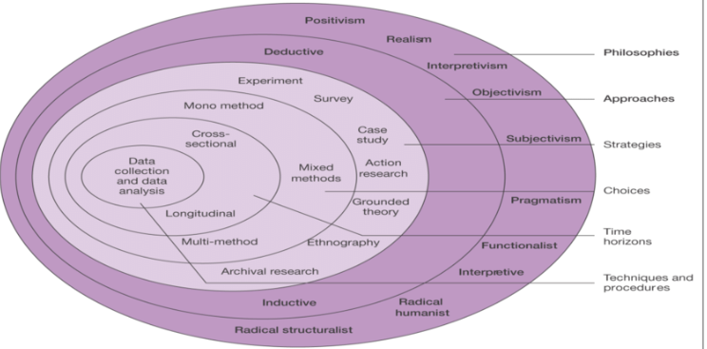
Research is an investigation into finding out new information and data (Adams, 2014). The basic understanding of research can be understood by the usage of the Research Onion, which was created by Saunders et al (2009).

Figure 2.1. The Research Onion. Source: (Saunders, et al., 2009)

The core of this Research Onion involves the final data collection and data analysis which is necessary for this investigation. This will help the researcher keep organised in which methods to carry out during this investigation. The dissertation will involve a cross- sectional approach as this will help to focus the research even more accurately. This is because the research will focus around the time that PTAOS put on the show to the after effects on the public and the accounts of the society. The approach that will be taken, as part of this investigation, will involve an inductive approach as the outcome of this investigation is unknown to the researcher. To help make this an accountable area to research there will be a mono method approach to this investigation. The main reason for this, is because, there might be an issue with receiving results from the surveys which will be put to the public. This is because, due to the area of study, not many people will be interested in answering a survey based on amateur productions in Neath Port Talbot.

2.1.1 Philosophies
The research philosophy covers the original nature and development of the ideas being generated for the research (Bajpai, 2011). This is the first step the researcher will take to generate their research methods.

2.1.1.2 Interpretivism
This is the best approach to follow with for the research as this will focus on the main methods that the researcher will carry out. With the link of interviews, being used in this dissertation, the Interpretivism favours the human interest within a study as being in contact with interviewees (Myers, 2009).

2.1.2 Approaches
The approaches within the research onion, highlight the inductive and deductive approach. The only difference between these two strategies are that, inductive is about researching new information. Whereas, deductive is about stating a theory and then trying to find the evidence to back it up (Bryman & Bell, 2015).

2.1.2.1 Inductive Approach
The research that will be carried out will involve an inductive approach, and the reason for this is because, there isn’t that much knowledge known about this area of study. This will ultimately mean, that, no possible theory or suggestion could be generated before the research begins.

2.1.3 Strategies
The strategies will involve any further research being carried out by the researcher, in order to fulfil the need for the investigation. In relation to this, the strategy that will be most appropriate for this dissertation will be gathering up data from surveys.

2.1.4 Choices
This section of the research onion involves the approach that the researcher will take to gather up the data that is needed for this investigation.

2.1.4.1 Mixed Methods
The idea of using the mixed methods approach will be beneficial for this area of study as it involves the usage of both quantitative and qualitative research (Bryman, 2012).

2.1.5 Time Horizons
This area will focus on the framework of time that the investigation will need to be completed by (Saunders, et al., 2009). The type of framework which will be used for this dissertation is the cross- sectional element because there has been a set deadline for the completion of all the work as this is not a continuous piece of work.

2.1.6 Techniques and Procedures
The techniques and procedures section of the research onion involves the overall result of collecting the data from the research that will be carried out throughout this investigation. It will also be the element of the research onion that has a true impact and influence on the outcome of the investigation (Saunders, et al., 2009).

2.2 Data Analysis and Collection

2.2.1 Qualitative Analysis
The Qualitative Data is data which will not be represented in numerical form (Punch, 1998) and is a much better method to gathering the type of research needed for this dissertation. The reason for this, is because the data needed will be explored in more depth as this is required for the conclusion of this investigation. To ensure that this data is received, the researcher will carry out interviews to the important figures of the society, as well as, a few of the members’ opinions about this topic. This is one of the best methods to carry out in this investigation as this way, no information can be changed or misheard.

2.2.2 Quantitative Analysis
The Quantitative Data will be the data that is represented in figures and statistics. This will be gathered from the surveys that will be collected from the various audiences of PTAOS, to help confirm the true aspects that affected the outcome of this financial turnaround.

2.3 Limitations
The main limitation that could come as a problem for the researcher is the time constraints could limit the data being collected. This is because of all the interviews that will need to be arranged and then analysed could come as an issue to the researcher. But the method that will be used in order to overcome this limitation, is trying to complete all interviews a month before the final deadline of the submission.

2.4 Ethical Risks
The ethical risk of this research is very low as there are no vulnerable parties to the development of this investigation. The difficulty with dealing with ethical risk is that it is difficult to tell how a person is feeling, so to deal with this issue, it is recommended to avoid being part of a scandal in your area of study (Webb, 2017). This ensures that all participants are willing to take part and are over the age of 18. The important aspect to maintain within this investigation is that all the information that is being analysed in this dissertation is all going to remain confidential. The information being gathered on this investigation will only be accessible by the researcher as this will be password protected on their device.

3.0 Resources and Planning
As part of the dissertation, the research will consist of timings and resources. The only resources that will be used in this dissertation will be there to help the researcher have a better understanding of the topic area which is being studied.

3.1 Resources
These resources will come as Secondary Data, and this will help increase the background knowledge about this area of study. This will include information that is not necessarily linked to PTAOS, but the information will link theoretically to the operations of a similar business.

3.2 Timescale
The timings previously discussed will be tracked using a Gantt Chart that will help keep an update on the progress of the dissertation which the researcher is carrying out. This will make the planning aspects of this investigation simpler as this will highlight the various tasks and research needed to carry out. The Gantt Chart on the following page will structure the entire dissertation up to the submission date, which is highlighted on the Gantt Chart itself.

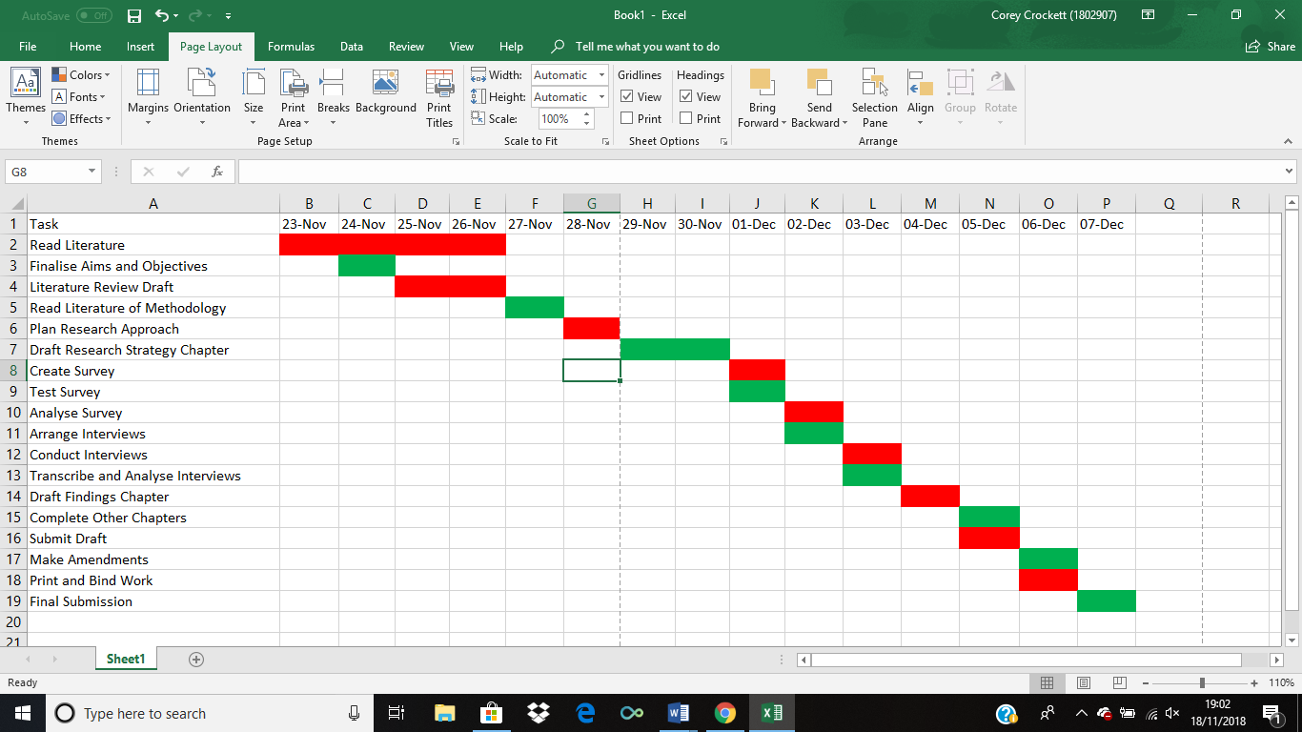
3.3 Gantt Chart
Fig 2.2 Gantt Chart for Dissertation

4.0 References
Adams, J., 2014. Research Methods for Business and Social Science Students (Second Edition). 2nd ed. London: SAGE Publications Ltd.
Bajpai, N., 2011. Business Research Methods. 1st ed. India: Pearson Education.
Bryman, A., 2012. Social Research Methods. 5th ed. London: Oxford University Press.
Bryman, A. & Bell, E., 2015. Business Research Methods. 4th ed. London: Oxford University Press.
Caffrey, A., 2018. Amateur Dramatics. [Online]
Available at: http://www.amateurdramatic.co.uk/financingyoursociety.html
[Accessed 10 November 2018].
GOV, U., 2018. Creative Works License Gov UK. [Online]
Available at: https://www.gov.uk/creative-works-licence
[Accessed 10 November 2018].
Myers, M. D., 2009. Qualitative Research in Business and Management. 1st ed. London: SAGE Publications.
Neve, D. D., 2018. Interview with Chairman [Interview] (20 March 2018).
Punch, K., 1998. Introduction to Social Research: Quantitatie and Qualitative Approaches. London: Sage.
Rees, M., 2017. Priscilla, Queen of the Desert is coming to Port Talbot - we take a behind-the-scenes look. [Online]
Available at: https://www.walesonline.co.uk/whats-on/arts-culture-news/priscilla-queen-desert-coming-port-12911424
[Accessed 10 November 2018].
Saunders, M., Lewis, P. & Thornhill, A., 2009. Research Methods For Business Students. 5th ed. Essex: Pearson Education Limited.
Webb, R., 2017. Clear Risk. [Online]
Available at: http://www.clearrisk.com/risk-management-blog/how-to-manage-ethical-risks
[Accessed 12 November 2018].

