Task: Researching your chosen building or site
Pompeii: The life, death and rediscovery of a Roman town (HPAH5078/HPAH6078)

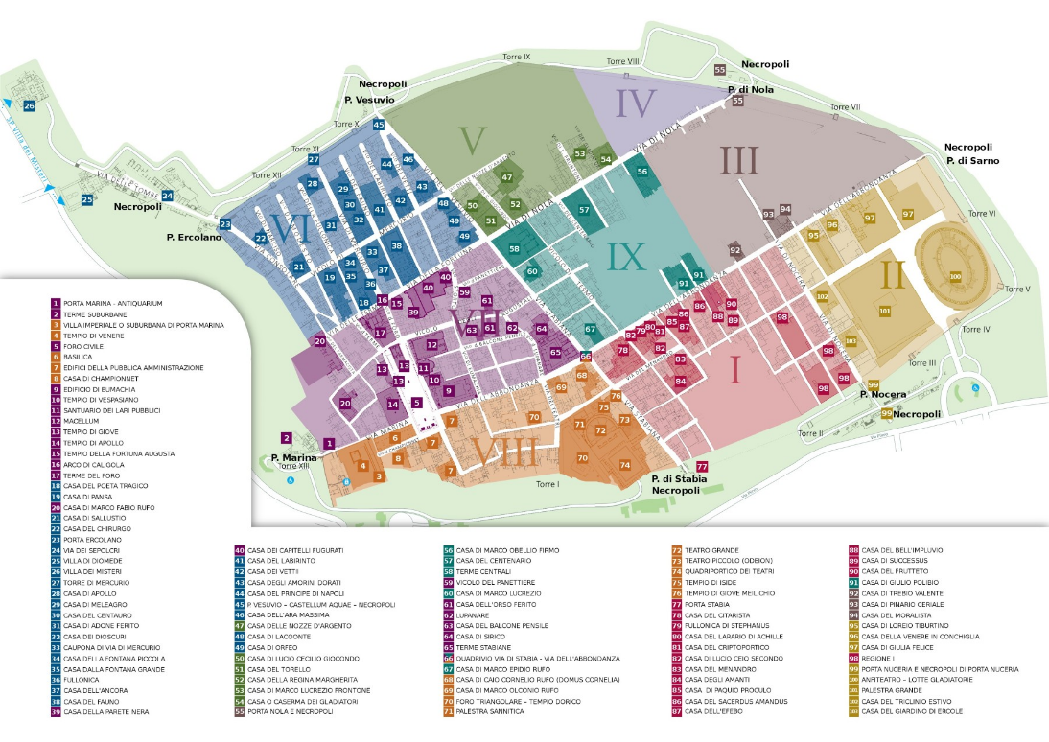

For the final part of this session, I have set a series of tasks related to your coursework. These tasks are designed to help you identify material that may prove useful to elements 1, 3 and 4 of the assessment portfolio: namely, the round table discussions that will take place during the four weeks (participation in each discussion being worth 3% or 2% each, with four discussions in total: see Moodle), the poster presentation assignment (3) and the analytical report (4). It is also a useful way to spot potential problems early on, such as accessibility of material. Put your responses / findings into a word document (clearly labelled) and email them to me when you are done – this document is uploaded on Moodle, so you can download it and copy and paste into it.
Ideally try to do these tasks by the late afternoon of the 3rd December, so that if there are any problems, there is plenty of time to react and find alternative solutions.

Task 1: identify two to three pieces of scholarship you can use which relate to your building / location. These can be chapters or subsections in monographs, chapters in edited books, journal articles (or segments within journal articles), and excavation reports. [Do not include online blogs]
Stabian Baths in Pompeii. New Research on the Archaic Defenses of the City
Logistics of Building Processes: The Stabian Baths in Pompeii
Stabian Baths in Pompeii. New Research on the Development of Ancient Bathing Culture

Task 2: try and locate a structural/architectural plan for your building (or a topographic layout of an area if you picked, for example, the Necropolis outside the Nuceria Gate).
Copy it in below
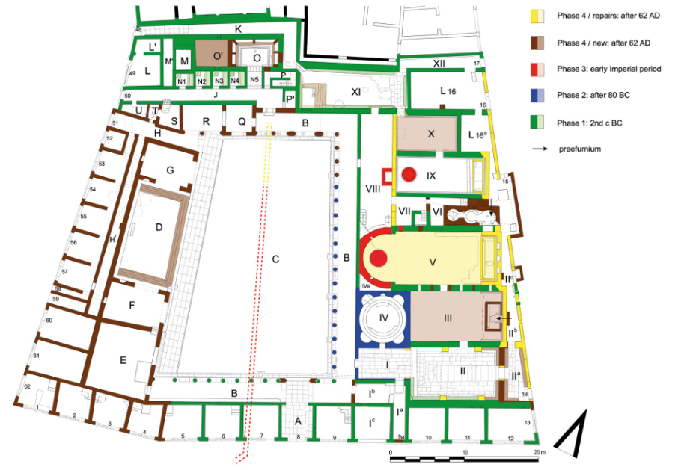

Task 3: on a topographic map, identify where your structure (or series of structures) is located and pick out any relevant buildings in the vicinity. Is your building part of a particular district?
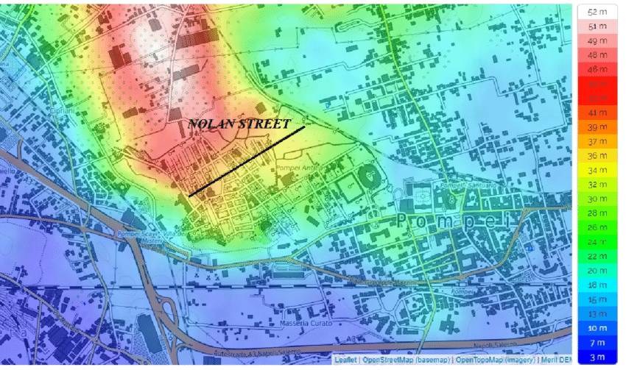
Foro triangulora- in an area associated with health and fitness. In district VII- south west of the city, Hans Eschebach argues this is because of earlier iteration of the city

Task 4: Identify any iconographic imagery (e.g., wall-paintings, etched (graffiti) images, statuary, mosaics, funerary reliefs, etc.). The goal is to identify material that you may find useful for your study.
Wall paintings- light blue walls and lush green scenery with a revealing image of old Silenus in the middle, and an image of an individual with coverings on the other side. Sphynx statues
Stucco ceilings, nudity common
Mosaics:
Ducks in female changing rooms
Mars in flight
Frigidarium: the most stunning fountains

Task 5: Identify a few items of material culture (physical objects), organic material (e.g., skeletal remains, archaeobotanical material, zooarchaeological material, etc.) or epigraphs evidence (e.g., inscriptions and graffiti) that have been discovered in connection with your building / site. The goal is to identify material that you may find useful for your study.
Graffiti of boats- womens bathroom
Basins
Two stone bowling balls in palaestra
Lamps
Statue of hermes

