Adam Willstead (2309258)
ACMA5001
Control and Automation
APPLICATION OF AUTOMATION IN WASTEWATER
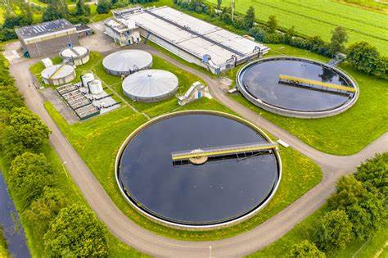

Contents
Contents: 1
List of Figures: 2
Abstract: 3
Introduction: 4
Instrumentation, Control and Automation in wastewater treatment systems: 5
The Wastewater Treatment Process/Application: 5
Stage 1: Screening and removal of large contaminants 6
Stage 2: Sedimentation of any leftover solid contaminants: 6
Stage 3: Biological treatment, removal of organic matter/carbon based compounds: 7
Stage 4: Treatment to remove all remaining nutrients: 7
Stage 5: Disinfection/treatment to disinfect water before finished stages of the water treatment: 8
Historical Context of ICA Adoption in Wastewater Treatment: 8
ICA Components in Wastewater Treatment Facilities: 9
1. Sensors: 9
2. Process Controllers: 9
3. Actuators: 10
4. Supervisory Control: 10
Regulations and Standards: 11
Enforcement and Compliance 12
Local Regulations and Standards 12
Role of ICA in Regulatory Compliance: 13
Recent Advancements in ICA for Wastewater Treatment 14
Conclusion: 15
References 16

List of Figures:
Figure 1: Plant operational diagram/Stages of a typical wastewaster treatment plant. (Nature, Springer, 2024)
Figure 2: Screening process in wastewater treatment system. (NetSol, 2023)
Figure 3: General type of screening process used in a wastewater system. (Aos, 2018)
Figure 4: Sedimentation process of a wastewater treatment system. (Nathanson, 2025)
Figure 5: Typical sedimentation tank of a wastewater treatment system. (TW, 2021)
Figure 6: SCADA Wastewater system schematic (RA, 2018)

Abstract:
Instrumentation, Control, and Automation are essential for enhancing the efficiency, reliability, and regulatory compliance of wastewater treatment systems. These technologies use sensors, controllers, actuators, and supervisory systems to automate complex processes, reducing human error and ensuring consistent water quality. ICA is crucial at every stage of wastewater treatment, including screening, sedimentation, biological treatment, nutrient removal, and disinfection. Over time, advancements in technology have transitioned wastewater treatment from manual processes to fully automated systems, enabling real-time monitoring and adjustments that optimize operations and reduce energy consumption. ICA also supports adherence to stringent environmental regulations by continuously tracking key water quality parameters and making real-time adjustments to maintain compliance. With recent innovations in IoT, artificial intelligence, and advanced sensors, ICA systems are becoming more sophisticated, driving improved sustainability and energy efficiency in wastewater management. As regulatory standards continue to evolve, ICA will remain central in meeting the increasing need for effective wastewater treatment and environmental protection.

Introduction:
Instrumentation, Control and Automation are essential within engineering overall. ICA can play a vital key role in ensuring that wastewater treatment systems are reliable and efficient throughout process. ICA will ensure that wastewater systems are automated, minimising human error and ensuring quality is consistent. Overall, when using instrumentation, control and automation within wastewater treatment systems they can remain autonomous, energy efficient and comply with all regulatory standards.

Instrumentation, Control and Automation in wastewater treatment systems:
ICA play a key role in the operation of wastewater treatment systems. The implementation of ICA will allow systems to automatically control complex processes. This will optimize usage and improve the overall quality of water treated.
Components of ICA in wastewater treatment systems: Each component will contribute to different sections and stages of water treatment. (Bączkowska, 2024)
- Sensors
- Controllers
- Actuators
- Supervisory systems

The Wastewater Treatment Process/Application:
Each stage requires careful monitoring and control, and this is where ICA technology becomes indispensable. Below is a breakdown of how ICA is applied to each stage of treatment. (Dieu, 2001)
The wastewater treatment process will envolve certain stages from start to finish to ensure all contaminants are removed.
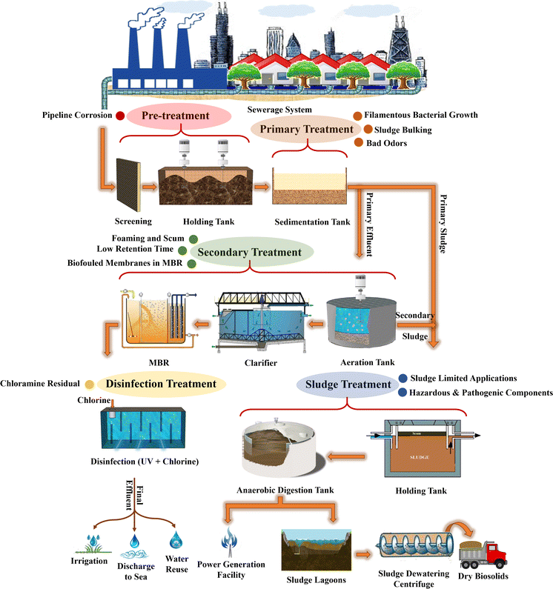 Figure 1
Stage 1: Screening and removal of large contaminants: For example rags, stones, grit, sticks, plastic waste etc.
Sensors will detect any changes in flow rate throughout system and adjust accordingly. Controllers will help the system adjust to the changing volume of wastewater which will maximize efficiency. (Dorf, 2022)
- Flow sensors to monitor incoming flow rate of wastewater and adjust screening process throughout.
- Actuators to control cleaning of screens.
- Grit removal systems to removal heavy contaminants. This part of the system may inclused automated pumps or conveyors.
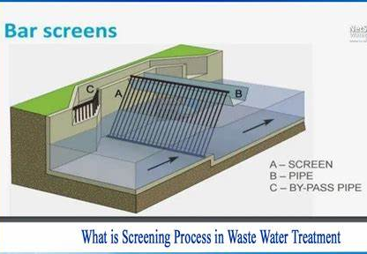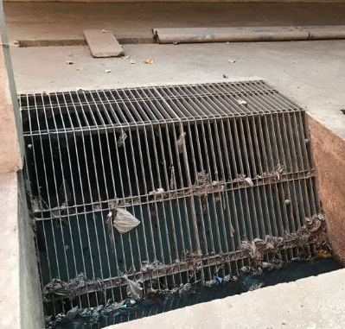
Figure 2 Figure 3

Stage 2: Sedimentation of any leftover solid contaminants:
Wastewater is stored in settling tanks during this stage of the wastewater process. This process will remove suspended solids while solid particles settle.
Valves and actuators will adjust the flow based on sensor feedback. Controllers will manage the operation of the tanks/clarifiers when adjusting flow rates. This will ensure sedimentation is optimized and reduce energy usage. (Dorf, 2022)
- Level sensors: Measure depth in the clarifiers/tanks.
- Flow meters: measure flow of wastewater in and out of the sedimentation tanks.
- Volume sensors: Give data about the amount of settled solids for sludge removal.
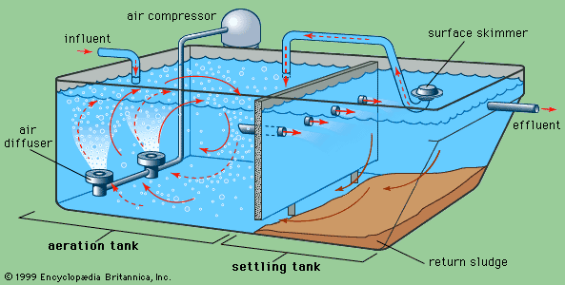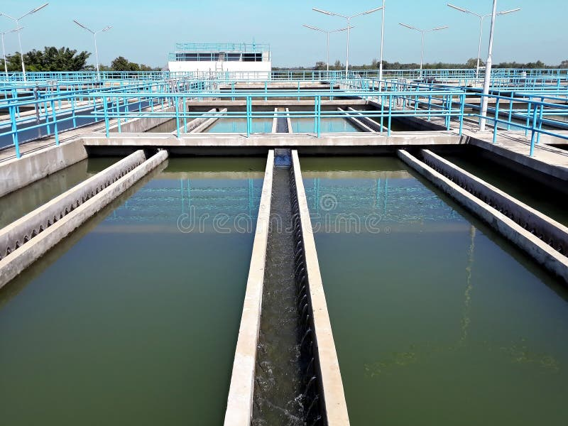
Figure 4 Figure 5

Stage 3: Biological treatment, removal of organic matter/carbon based compounds:
At this stage microorganisms in the tanks break down organic matter to further cleanse wastewater.
Automatic control of aeration tank systems based on sensor feedback. Needed to ensure enough oxygen is supplied for the biological treatment process to start. Dosing of chemicals using automated systems to add nutrients/coagulants into process. This will help removal any additional contaminates. SCADA systems used to collect data from sensor feedback. This wil allow continuous process monitoring and adjustment. (Shruthi, 2024)
- Dissolved oxygen (DO) sensors: Oxygen level monitoring. Critical for the survival of microorganisms in aeration tanks.
- pH sensors: Tractability of pH levels. Used to help maintain conditions for microbial activity.
- Temperature sensors: Ensuring biological process operates between a specified temperature range.

Stage 4: Treatment to remove all remaining nutrients:
Stage 4 involves advanced filtration techniques and removal of all nutrients to purify the wastewater. This stage of the process is important to ensure that wastewater will meet necessary environmental standards when leaving the process.
Using sensor feedback nutrients can be controlled. The system can be controlled to adjust all chemicals dosed. Automatic filtration cleaning can be included to ensure the system filters are working as intended and filtration of wastewater is efficient. (NetSol, 2023)
- Nutrient sensors: monitor nutrients in treated water treated water.
- Dosing pumps: Automated systems to add system cleaning chemicals.
- Filtration systems: Automated cleaning of filters using automatically controlled actuators and pressure sensors.

Stage 5: Disinfection/treatment to disinfect water before finished stages of the water treatment:
Disinfection at stage 5 will ensure harmful bacteria is removed from wastewater before its exit. For example chlorine/UV is dosed/used in some applications to ensure wastewater is purified further.

Automated realtime adjustment ensures dosing of chlorine or UV intensity is monitored and adjusted based on sensor data. This will ensure that the correct level of disinfection is applied while ensuring the system remains efficient. Automated adjustable flow controls adjust flow rare throughout disinfection process. (Bączkowska, 2024)
- UV intensity monitoring/sensors: Monitor the intensity of UV disinfection system.
- Chlorine sensors: Chlorine sensors are used to monitor concentration in wastewater to ensure correct level of disinfection.
- Flow control systems: Ensure that the correct volume of water passes through the system.

Historical Context of ICA Adoption in Wastewater Treatment:

Wastewater systems historically were manual and had little control over all variables linked to dosing, filtration and flow rates. Historic wastewater treatment systems were simple mechanical systems using components such as manual valves, gates and dosed by hand without effective monitoring.

Currently new wastewater treatment systems use ICA due to the years of advancements in electronic technology. The drive for ICA in wastewater systems is due to the strict environmental standards that wastewater needs to meet. (Bączkowska, 2024)
Early Developments (Pre-1980s): Wastewater treatment relied heavily on manual intervention. Operators manually controlled chemical dosing, pump operation, and valve settings.
Advancement to Process Control Systems (1980s - 1990s): With the advent of programmable logic controllers (PLCs) and distributed control systems (DCS), wastewater treatment facilities began to automate more functions. Real-time data collection, monitoring of water quality parameters (such as pH, dissolved oxygen, and turbidity), and basic feedback control loops allowed for more efficient operations.
Modern Automation (2000s - Present): The development of advanced sensors, wireless communication, and sophisticated algorithms has significantly improved the level of automation in wastewater treatment. SCADA (Supervisory Control and Data Acquisition) systems allow operators to monitor and control facilities remotely, enabling round-the-clock monitoring, optimization of energy usage, and automatic adjustments based on real-time data.

ICA Components in Wastewater Treatment Facilities:
- Sensors: Sensors are the backbone of any automated wastewater treatment system. They continuously monitor key process variables, sending data to the control system for analysis and action. Common sensors used in wastewater treatment include: (DiStefano, 2013)
Flow Sensors: | Measure the volume and rate of water entering or leaving the treatment plant.
pH Sensors: | Monitor the acidity or alkalinity of the water, which is crucial for controlling biological processes and chemical dosing.
Dissolved Oxygen (DO) Sensors: | Measure oxygen levels, which are critical for biological treatment processes like activated sludge systems.
Turbidity Sensors: | Monitor the clarity of water to assess the effectiveness of filtration and sedimentation processes.
Nutrient Sensors (e.g., Nitrogen, Phosphorus): | Monitor nutrient levels to prevent eutrophication and ensure compliance with environmental standards.
- Process Controllers: Process controllers interpret data from sensors and make real-time decisions to adjust process variables. Controllers are used to manage the operations of various components such as pumps, valves, and chemical dosing systems. Common controllers include: (Dieu, 2001)
Programmable Logic Controllers (PLCs): | Industrial-grade computers used to control and automate machinery. They are used for real-time process control and to ensure the proper functioning of mechanical systems.
Distributed Control Systems (DCS): | These systems allow for centralized control of multiple processes in the facility, offering greater flexibility and scalability than PLCs.
PID (Proportional-Integral-Derivative) Controllers: | Used to maintain specific process variables (e.g., DO, pH, flow) within predefined setpoints, minimizing oscillations and ensuring stability.

- Actuators: Actuators are devices that perform physical actions based on the instructions from controllers. These include:
Valves: | Control the flow of water, air, or chemicals through the treatment plant.
Pumps: | Regulate the movement of water through various stages of treatment.
Mixers: | Ensure even distribution of chemicals or aeration in treatment tanks.
Chemical Dosing Pumps: | Add specific amounts of chemicals (e.g., coagulants, disinfectants) to achieve required water quality levels.
- Supervisory Control: Supervisory control involves higher-level systems that monitor and control the entire treatment process. These systems typically consist of: (Dolatshahi-Zand, 2015)
SCADA Systems: | SCADA (Supervisory Control and Data Acquisition) systems provide operators with real-time data and remote control capabilities. SCADA interfaces enable monitoring of all critical parameters and processes at the plant and allow operators to intervene remotely.
Human-Machine Interface (HMI): | The HMI allows operators to visualize and interact with the system’s status, alarms, and notifications. Modern HMIs often provide advanced visualization techniques such as dashboards, process flow diagrams, and historical trend charts.
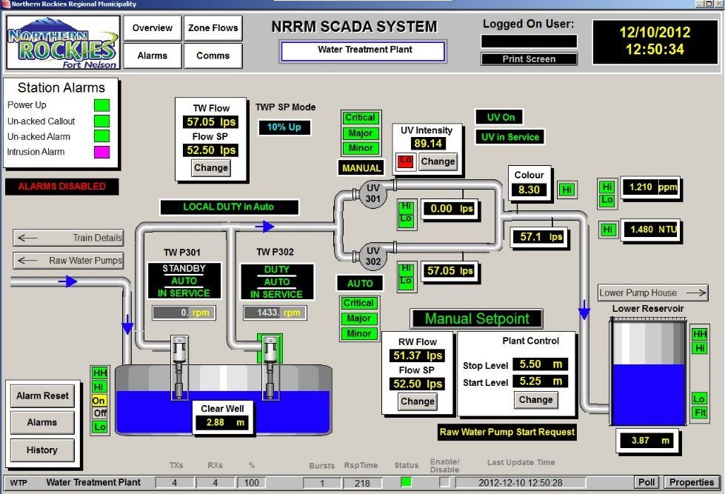 Figure 6

Regulations and Standards:
Wastewater treatment systems have a range of standards and regulations that need to be met. Environmental and public health protection regulations need to be met and will determine various aspects of the wastewater system. For example this could include the quality of wastewater filtering, procedures and the integration of ICA. (Jeppsson, 2002)
1. The Water Resources Act 1991: regulates the management of water resources and covers pollution prevention. It defines responsibilities of water companies and private entities in treating wastewater. (Bączkowska, 2024)
2. The Environmental Protection Act 1990: Focuses on the management and control of wastewater. Permits and licenses are used to ensure wastewater treatment systems are operating within boundaries, preventing pollution and disposal is correct.
3. The Water Industry Act 1991: Provides framework for the regulation of water and wastewater services in the United kingdom. It outlays the duties of water companies, including the treatment and disposal of wastewater and ensures that companies are compliant with standards related to wastewater treatment. (Bączkowska, 2024)
4. The Environmental Permitting (England and Wales) Regulations 2016: Cover the requirement for an environmental permit to operate a wastewater treatment system. Ensures that discharge is controlled. Issued by the Environment Agency and outlines the conditions for wastewater treatment, including limits on pollutants and operational standards.
5. The Urban Waste Water Treatment Directive (91/271/EEC): European Union directive sets minimum standards for the collection, treatment, and discharge of urban wastewater. Protects the environment by ensuring that wastewater is treated to appropriate standards before discharging. (Bączkowska, 2024)
6. The Sewage Sludge Directive (86/278/EEC): Regulates the disposal of sewage sludge and its treatment. Prevents pollution of the environment and ensures that sludge disposal does not adversely affect soil quality, crops, or water.
7. The General Binding Rules for Small Sewage Discharges (England): Apply to small, non-mains wastewater treatment systems (e.g., septic tanks and small sewage treatment plants). Outlines standards for discharge from private systems and conditions which an environmental permit is not required.
8. The Control of Pollution (Oil Storage) (England) Regulations 2001: Govern the storage of oils and other hazardous substances to prevent pollution in wastewater treatment systems. (Bączkowska, 2024)
9. Water Framework Directive (2000/60/EC): A framework for the protection of inland, transitional, coastal, and groundwater. Although the UK has left the EU, the principles of this directive are still in place and require the UK to manage wastewater discharges in a way that protects water quality.

10. Environment Agency's (EA) Wastewater Quality Standards: The Environment Agency in England and Natural Resources Wales (NRW) set specific discharge quality standards for wastewater systems, especially for systems that discharge treated water into natural water bodies. This includes setting limits on parameters like biochemical oxygen demand (BOD), suspended solids, nitrogen, and phosphorus. (Bączkowska, 2024)
11. Building Regulations: Building Regulations in the UK, specifically part H, govern the drainage and wastewater systems in buildings, including how wastewater should be managed in construction projects.

Enforcement and Compliance
- Environment Agency (EA): The EA regulates and enforces wastewater treatment standards in England. It conducts inspections and issues permits for discharge systems.
- Natural Resources Wales (NRW): Similar to the EA, NRW is responsible for regulating wastewater in Wales.
- Scottish Environment Protection Agency (SEPA): In Scotland, SEPA oversees wastewater treatment and discharge standards.
Failure to comply with these regulations can result in penalties, fines, and operational shutdowns. (RA, 2018)
The UK regulations on wastewater treatment systems are comprehensive and aim to protect both the environment and public health. They include provisions for the design, operation, and discharge standards of systems, with regulatory oversight from various environmental agencies depending on the region. Compliance with these laws ensures that wastewater is treated effectively and that harmful pollutants are not released into the environment. (Dorf, 2022)
If you need more details or specific guidance regarding wastewater treatment permits or standards for a particular system or region, feel free to ask!

Local Regulations and Standards
In addition to national and international standards, many countries, states, and local municipalities have specific regulations that govern the operation of wastewater treatment plants. These regulations may address issues such as: (Yang, 2024)
- Local discharge permits for effluent quality.
- Nutrient removal guidelines to prevent eutrophication of receiving water bodies (e.g., nitrogen and phosphorus removal).
- Odor control and air quality standards.
- Sludge management and disposal practices.
ICA systems in wastewater treatment are essential for ensuring compliance with these local regulations. Automated systems can monitor and control nutrient removal processes, effluent quality, and sludge treatment in real-time, making it easier to meet local compliance requirements.

Role of ICA in Regulatory Compliance:
Instrumentation, Control, and Automation (ICA) systems play a vital role in helping wastewater treatment plants comply with these regulations. Some of the key contributions of ICA in maintaining regulatory compliance include: (Dolatshahi-Zand, 2015)
- Real-Time Monitoring: ICA systems use sensors to continuously monitor key water quality parameters, such as pH, dissolved oxygen, BOD, COD, and turbidity. This real-time data helps ensure that treatment processes are operating within acceptable limits, preventing violations of discharge standards.
- Automatic Control: Automated systems can adjust process variables such as chemical dosing, aeration, and flow control in response to changing conditions. For instance, if nitrogen levels exceed acceptable limits, the system can trigger additional aeration or chemical dosing to reduce those levels.
- Data Logging and Reporting: ICA systems log process data and generate reports for regulatory authorities, ensuring that plants maintain a transparent record of their operations. This can be critical during inspections and audits.
- Early Warning Systems: Advanced ICA systems with predictive analytics and machine learning can detect anomalies and provide early warnings of potential regulatory breaches, allowing plant operators to take corrective actions before a violation occurs. (Dorf, 2022)

6. Future Trends in Regulations and ICA
As technology advances, regulatory requirements for wastewater treatment will likely become more stringent, particularly in areas such as nutrient removal, energy efficiency, and carbon emissions. ICA systems will need to evolve to incorporate: (Temido, 2014)
- Advanced sensors and AI for more precise monitoring and decision-making.
- Predictive maintenance and optimization to improve energy efficiency and reduce costs.
- Remote monitoring and control using cloud-based SCADA systems, enabling operators to manage multiple plants from a central location.

Recent Advancements in ICA for Wastewater Treatment
Internet of Things (IoT): IoT technology allows for the integration of smart sensors, actuators, and devices that can communicate with each other and the central control system in real-time. This enables predictive maintenance, data-driven decision-making, and greater optimization of treatment processes.
Artificial Intelligence (AI) and Machine Learning: AI algorithms can analyze large datasets from sensors and controllers to predict system behavior, detect anomalies, and recommend process optimizations. These technologies help improve the energy efficiency of treatment processes and optimize the chemical usage. (Dumée, 2023)
Energy Optimization: With rising energy costs, wastewater treatment plants are adopting energy-efficient technologies such as variable-frequency drives (VFDs) for motors, optimized aeration systems, and energy recovery systems like biogas production from anaerobic digestion processes.
Advanced Sensors: The use of advanced sensors, such as real-time nitrogen and phosphorus analyzers, is improving the precision of nutrient control. This allows for better optimization of chemical dosing, reducing costs and minimizing environmental impacts.
Smart Control Systems: New control systems, enhanced with cloud computing and remote monitoring capabilities, enable plant managers to access plant data from anywhere. This aids in quicker decision-making and ensures continuous compliance with environmental regulations. (Dieu, 2001)

Conclusion:
Instrumentation, Control, and Automation play a critical role in modernizing wastewater treatment facilities and ensure that wastewater treatment plants operate efficiently and comply with regulatory standards. From sensors that monitor vital process variables to controllers and actuators that ensure efficient operations, ICA technology enables the automation of complex processes, reduces human error, improves energy efficiency, and ensures regulatory compliance. The historical evolution of ICA systems in wastewater treatment has transformed the industry, and recent advances in IoT, AI, and smart sensors are pushing the boundaries of automation further. As regulations become more stringent and environmental concerns grow, ICA will continue to drive innovation, making wastewater treatment more efficient and sustainable.

References
Aos. (2018, March 20). A Complete Guide to Types of Screening in Wastewater Treatment. Retrieved from Aos treatment solutions: https://aosts.com/types-wastewater-screening/
Bączkowska, E. (2024). Journal of Water Process Engineering. On-site medical wastewater treatment enabling sustainable water reclamation: Merged advanced oxidation process for disinfection, toxicity, and contaminants removal.
Dieu, B. (2001). Application of the SCADA system in wastewater treatment plants. ISA Transactions, 267-281.
DiStefano, J. J. (2013). Schaum's Outline of Feedback and Control Systems . New York: McGraw-Hill Education.
Dolatshahi-Zand, A. (2015). Design of SCADA water resource management control center by a bi-objective redundancy allocation problem and particle swarm optimization. Reliability Engineering & System Safety, 11-21.
Dorf, R. C. (2022). Modern control systems. Harlow: Pearson Education Limited.
Dumée, L. F. (2023). Anaerobic treatment of refractory industrial organic wastewater:. Journal of Water Process Engineering, 55-64.
He, T. (2024). Treatment of simulated decontamination wastewater in nuclear power plants by membrane distillation using Janus membrane. Desalination, 30-34.
He, Z. (. (2021). Machine learning for monitoring per- and polyfluoroalkyl substance (PFAS) in California's wastewater treatment plants: An assessment of occurrence and fate. Journal of Hazardous Materials, 70-82.
Jeppsson, U. (2002). Water Science and Technology. Malmö, Sweden: IWA Publishing 2002.
Kumar, A. (2025). Engineering Applications of Artificial Intelligence. Insights into the application of explainable artificial intelligence for biological wastewater treatment plants: Updates and perspectives, 34-38.
Nathanson, J. A. (2025, March 27). Wastewater treatment and disposal. Retrieved from britannica: https://www.britannica.com/technology/wastewater-treatment/Primary-treatment
Nature, Springer. (2024). Reviews in Environmental Science and Bio/Technology. Reviews in Environmental Science and Bio/Technology, 1569-1571.
NetSol. (2023). What is screening process in waste water treatment? NetSol Water.
Nise, N. S. (2019). Control systems engineering. Hoboken, NJ: Wiley.
Olsson, G. (2012). ICA and me – A subjective review. In G. Olsson, Water Research (pp. Pages 1585-1624). Lund University, Lund, Sweden.
RA, R. (2018). Visualization and control of the treatment process at the Humpolec Wastewater Treatment Plant. Retrieved from Reliance industrial SCADA and HMI systems: https://www.reliance-scada.com/en/success-stories/water-wastewater/visualization-and-control-of-the-treatment-process-at-the-humpolec-wastewater-treatment-plant
Sean, W.-Y. (2020). Energy consumption analysis in wastewater treatment plants using simulation and SCADA system: Case study in northern Taiwan. Journal of Cleaner Production, 66-69.
Shruthi, V. (2024). Comprehensive insights into biological and bio-electrochemical treatment of the sago industry wastewater: Challenges and future perspectives. Sustainable Chemistry for the Environment, 3-10.
Temido, J. (2014). SCADA and Smart Metering Systems in Water Companies. A Perspective based on the Value Creation Analysis. Procedia Engineering, 1628-1638.
TW, V. U. (2021). Sedimentation tank in a sewage treatment plant. Retrieved from Dreamstime: https://www.dreamstime.com/royalty-free-stock-image-sedimentation-tank-sewage-treatment-plant-image20047056
Yang, Y. (2024). Journal of Water Process Engineering. Integration of soft sensors and model predictive control for denitrification at a full-scale wastewater treatment plant.

