MANAGING ENTERPRISE

IN THE 21ST CENTURY

BUSINESS PLAN - FINAL

Assignment by Paul Daniel Chirila

UWTSD

STUDENT NUMBER : 1705749

SUBMISSION DATE : 03/07/2019

EXECUTIVE SUMMARY

The Black Pearl is a type of activity in which it is desired to be a restaurant business. The restaurant wants to offer to its customers a variety of seafood meals influenced by all international cuisines.

The restaurant wants to be open in Swansea, Uplands, in which it aims to offer services to its clients of high quality seafood compared to other competing restaurants in the area.

The attractions of the restaurant will play an important role in the business , and that will be a special interior design and a wide range of seafood meals.

In the varied menu will also include speciality selection like a lighter options and smaller portions for children’s menu. The menu distinction will be through the “ speciality of the house” using only natural ingredients and best quality.

The prices will be similar to those of the competitors and in some even cheaper prices for the consumer’s appeal.

Another feature of the business will be the staff, through their excellent performing will help the business shape a prestigious image of the restaurant.

All these features will lead to a positive image of the restaurant, thus wining loyal customers wanting to return again and again.

By attending this restaurant with a friendly atmosphere, a versatile menu and qualified staff will give its customers the certainty of a continuous special service.

Contents page

Content Page no.

- Introduction 4-5

2. Main body - Business plan description 6-9

3. Physical Resources 10-11

4. Conclusion 12

5. References/ Bibliography 13

- Introduction

Why is so important to prepare a business plan?

A business plan can help you accomplish a number of tasks; written and then followed can help you find funding to support your business, find potential customers or partners for a new business, to negotiate with suppliers, or simply understand how to get you better manage of your business.

In a business plan it includes the business goals, the strategies used to get there, the possible issues the business can face and the ways of resolving the problems, the organisational structure ( type of business, name of business, aims/mission statements ), and the amount needed to finance the business.

When you want to launch a start-up it is very important to have a well-defined business plan, especially when you need financing, any potential investor will not pay attention if you lack in your elementary business plan.

The method of achieving a business plan can be followed as:

- The goal : what is the difference between your product and the existing one on the market, what change can make your product on the market, what can you give your customers to gain their attention?

- The need of money : you have to know exactly how mach money you need to open the business.

- The target : what are your product target, where these potential clients are located and how many, turn to all possible resources to find out more about the market.

- The competition : who are the competitors, which is the strategy to differentiate yourself from them.

- The price : one of the most important elements, if you do not put a correct price on your product the other points do not even matter.

- Marketing strategies and sales : how do you want to make your brand known, where and how do you want to promote it?

- Human Resources : establishing the necessary number of employees, establishing the necessary qualifications for employees.

2. Main body - Business plan description

The Black Pearl is a restaurant that wants the services it offers to change the image of Swansea restaurants by ‘appearing more different’ than other restaurants.

The Black Pearl will provide the best quality of cooked seafood for fish lovers, using fresh and local ingredients.

All our food is locally sourced to support the local seafood farmers in Swansea, and we help keep local producers in business. The supply of products will be done with our own transport to gain time and save our financial resources.

We chose to supply ourselves locally because fresher food tastes better, when food is picked and eaten at the peak of freshness, it not only retains more nutrients, it also healthy because we want to offer our customers an unforgettable experience.

The main purpose of the restaurant is to succeed in attracting a special, loyal customers, even if it takes time and the demand of high investment.

The type of our restaurant will be fish&chips/fast food, which will accommodate a few tables ( between 5-10 ), approximate 20-30 persons. Customers expected weekly will be around 1000- 1500, with a weekly sales around £ 7000-12000, which is considerate a good investment for a start-up business.

The theme of the restaurant will be something greek style, bright with shades of white and blue, a variety of selected music will be playing in the background providing a relaxing ambiance.

The customers can order different types of fish dishes, salads, see food, shrimps. Each product in the menu will have the description and the number of calories it contains to give the customers the choice to choose the desired product. The menu will be presented in four languages ( English, Romanian, Polish and Greek ), due to the variety of people with different nationalities in Swansea.

There is no possibilities of expanding the restaurant and we will not be pursued. We will only try to improve the services, the menu, the kitchen equipment, increase labor productivity, if all these investments result in increasing our profits.

2.1 Name of Business: The Black Pearl - Sea Food Restaurant

When you have to choose your business name you need to think about expressing your product brand; so it must be memorable, original, easy to read, according to your brand.

The name of our business came up from the fact that, as it is known, the pearls came from some mollusks or oysters that lives in water, this link of origin we want to reflect our business service.

Behind any thing is a myth or a legend, and it said that pearls symbolise purity, wisdom, bring power and health.

2.2 Business Owner/s

The restaurant will be partnership owned and will be operated by Paul Daniel Chirila, Aron Popoiu, Stanislav Kim, Tatjana Budreckiene and Claudiu Florin Dobre.

Idea of partnership is an asset to our business because it assumes everything a single person can do but multiplies on the number of partners. The efforts made for the business are fewer or equal but the results are amplified.

A strategic partnership is essential in the operation and development of our business, especially in a constantly changing environment and where competition is increasingly fierce offering the advantage we need.
We have altogether more or less then ten years experience in the restaurant and catering industry. Through our experience and qualifications will bring value in our business and can be used in the interest of our company which will have a better impact on the restaurant.

2.3 Mission Statement/Aim

The points of attraction that can positively influence potential customers to attend our restaurant are through the high quality of meal preparations, the friendly and pleasant behaviour of our qualified staff, the restaurant cleanliness, light interior design with a special atmosphere.

The motivations that can make consumers want to spend in our restaurant can be the following:

- spending a nice evening ( in the company of another person )

- serving delicious meals in a quiet atmosphere

- offering a romantic evening to your loved one

- Discretion when it comes to a business discussion or meeting.

The Black Pearl Missions are:

- To provide a unique and desirable experience by offering quality ingredients at reasonable prices

- Treating customers and staff with dignity and respect

- To provide a warm and friendly service expected by our customers by creating a comfortable environment

- To make the customers satisfied and want to return again and again.

The Aim of our business is:

‘To provide quality freshly cooked food at reasonable prices with an exemplary service’.

2.4 Objectives of the Business

The Black Pearl Objectives are:

To increase the value of the restaurant with its customers, owners, suppliers and employees by the next year.

To increase our sales and profits by the next year.

To provide the best service to our customers by employing the best staff to maintain the restaurant of high standards at all times by the next year.

3. Physical Resources

3.1 Location

The Black Pearl will be leasing a space located in Uplands, Swansea. ‘It lies about a mile to the west of Swansea City centre, and falls within the Uplands electoral ward’. ( Uplands, Swansea, 2019 )

In our searches shows, as reported in the local news, ‘Uplands turning into Wind Street II’ .( Wales Online, updated 9 Apr 2019)

The existing site is located in a major traffic area, it was previously utilised as restaurant, with planing permission. The site will need some additional renovation, furniture, fixtures and equipment.

The residential area comprise a mixture of students, single family and multi family housing. Consumers targeted by the restaurant are person over 18 years of age, with a high rate of 30-40 years of age; and those of 20-30 years of age form an important part of our business especially in the long term, this being part of a growing segment of customers that in the future they can become loyal.

We have decided of this area full of restaurants, pubs, fast foods because we considerate that the customers are already used with the offers in this region and they will be curious to try something new.

The area is suitable for our business having accessibility, visibility and density with which it is populated.

3.2 Equipment

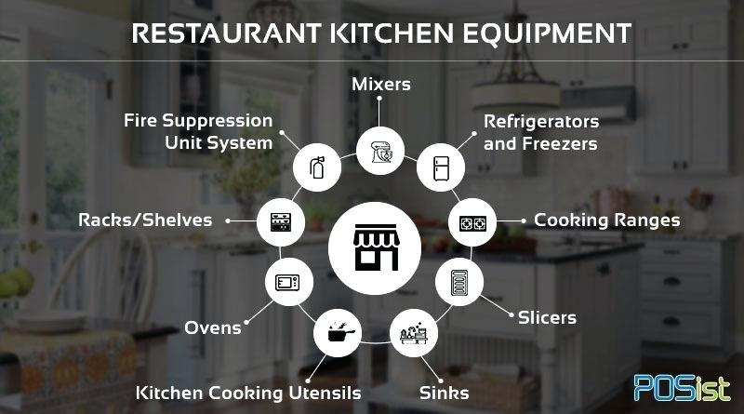
The kitchen is the heart of the restaurant, so it is important to be properly equipped adequate to our service.

Kitchen Equipment

4. Conclusion

In conclusion you have to define what business you want to do, to accept that can be failures if you do not consider all the risks from the beginning, but it is important to face them, to adopt something new in your business, and do not give up when you encounter difficulties.

5. References/Bibliography

Uplands,Swansea-Wikipedia. Available at: http://en.wikipedia.org.uk/wiki/Uplands,_Swansea ( Accessed: 9 June 2019 ).

Write a business plan. Available at: https://www.gov.uk/write-business-plan ( Accessed: 7 June 2019 )

Wales Online, by Nino Williams, ( Updated 9: 13, 9 Apr 2019). Available at: https://www.walesonline.co.uk/news/local-news/swansea-uplands-hippest-bars-restaurants-16072264 ( Accessed : 2 Jul 2019 )

Ronald Kinton, Victor Ceserani and David Foskett,(ninth edition), The Theory of Catering, (First published 1999).

Bernard Davis, Andrew Lockwood, Ioannis Pantelidis, Peter Alcott, (fourth edition), Food and Beverage Management, (first published1985).

David Freemantle, The Successful Manager’s Guide to Business Planing,( Published by Mc GRAW-HILL Book Company Europe).

Edward Blackwell,(fourth edition), The Sunday Times, Business Enterprise Guide, How to Prepare a Business Plan,(first published in 1989).

