Stephanie James (1807752)

Abstract
This is a 2500 world case study that provides clear investigation on Aging Population and Age UK Charity. The information gathered for this case study has been taken from reliable sources including charitable organization, Government sources, researchers and Journal articles that provide factorial information. The purpose of research is to inform action. The findings from this case study is that aging population has been rising over the years and is becoming a strain on the NHS and Government to try keep up with the rise.
Age UK Charity has been using their
skills and resources to support the health and care system. Age UK has shown the benefits that the charity has on the ageing population by providing help and support for those that need it. The structure and Funding of Age UK Charty has been looked at in the case study. Partnership working has been discussed in this case study and how it has helped with local services coming together. Shortfalls and issues have been considered.
Possible recommendations have been drawn together at the end of the case study and in the conclusion it was drawn together the impact Age UK are making to the health care services.
CASE STUDY AGE UK

Contents
Introduction 2
Case Study 3
Background: 3
Age UK 3
Structure of the organisation 3
Funding Structure 4
Pressures and shortfalls 4
Partnership working 6
Policies 6
Conclusion 7
Recommendation 7
Reference 7

Introduction

This case study will examine a brief background of aging population and some statistics of the increase over the years. It will examine and analyse Age UK, a charity that provides support for the aging population. Recommendations will also be considered.
WHO (2019) defines ageing population as the increase in life expectancy and this results in an increased number of people who are over the age of 60. The office of national statistics (2019) explain that there has been a steady increase in the UK population since the beginning of the 20th century and it was noted in 2016 there were 11.8 million UK residents aged 65 and over, compared to twenty-five years before when there were 9.1 million. The office of national statistics (2019) also state that the age group that has been the fastest increasing, are people of the age 85 and over, with there being 1.6 million people in this age group.

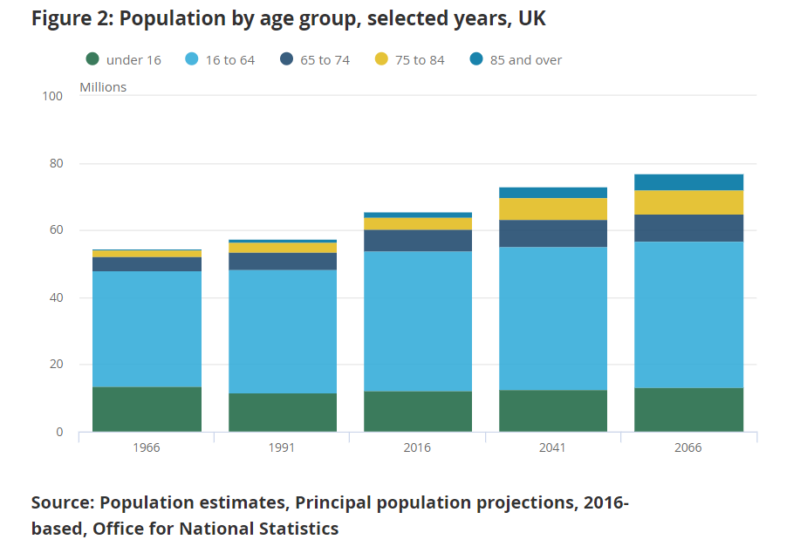
(The office of national statistics, 2019)

Case Study

Background:
Robert Wilde (2019) explains that the poor, the sick and elderly people were in desperate need before and during the Second World War. This was because there was no welfare state, and payments to support these people were provided by private and volunteer institutions. Robert Wilde (2019) also explains that in the 15th century, churches cared for the disadvantaged people in the parish. World War 2 brought hardship to the whole of Britain, and AGE UK() state that older people were especially vulnerable and also explained that the ‘poor law’ that meant that older people with no income were put in workhouses and often lived in bad conditions, was inadequate. After world war 2 the welfare state was developed as the government and voluntary organisations gathered to find ways of improving the welfare of everyone in need (Robert Wilde, 2019). At this time in the 1940s The Old Peoples Welfare Committee was developed.

Age UK
Age UK is a non-profitable organisation which was established in 1944 when it was known as the Old People Welfare Committee. The Health Foundation (1940) states that The Old People Welfare Committee was provided to give support to the elderly. In 1944 The Old People Welfare Committee became the National Old Peoples’ Welfare Committee (NOPWC). Many local organisations joined the committee to work together to improve older peoples’ welfare (Age UK, 2019a). In 1971 the NOPWC was renamed Age Concern. The name was changed to reflect that they were not just committees but active providers of direct services. In 2009 Age Concern England and Help the Age joined together to create a new charity aimed at improving later life for everyone, and then in 2010 the charity was named Age UK. Age UK is the leading UK charity that works to improve the lives of 14 million older people in the UK, and to help them live a more fulfilling life (Age UK,2019a).

Structure of the organisation
Age UK divide their charitable activities into six distinct areas: Information and advice, Health and care, wellbeing, Campaigning and research, Age UK network and international charity work. The organisation has 450 shops to raise money from selling donated goods. There are 75,000 volunteers that play a very big part of the functioning of the charity. The Age UK network are made up of around 130 local Age UK groups. Age UK cover support for more than 40 countries worldwide and work in partnership with other national organisation; Age Cymru, Age NI, Age Scotland and Age international (Age UK,2017).
Age UK have a range of highly specialised chief executives and directors, who carry out the day to day running of Age UK, and Trustees who monitor Age UK’s strategic objectives (Age UK,2019j). They are all highly experienced and have knowledgeable backgrounds that provide a high standard of service for the organisation. The Chief Executive is experienced in international work and partnership working. The Charity Director is a social scientist and barrister with experience in research, public policy, media and campaigns. The Service Director has extensive experience in working in the voluntary sector, local authority and NHS dealing with health, education, housing and well-being. The Fundraising director has a background career in fundraising and marketing, dealing with social isolation and exclusion. The performance and retail Director has a background in the financial conduct authority and human resource (HR)(Age UK, 2019j). The Trustees have a large amount of experience in working with the elderly sector, and issues related to aging. The Trustees play a big role in financial decisions, budget, policy, governance and upholding the organisation’s value's (Age UK,2019k).

Funding Structure
Age UK rely mostly on fund raising to gather their money. They also gain money from charitable activities, donations, grants from organisations such as Big Lottery Fund and trading and investments (Age UK, 2017). Age UK (2017) explain that in 2017/2018 they raised £50.5 million from fundraising. This was raised through people coming together in different activities to raise money, one being the London Landmark Half Marathon, which is one of many activities people do to raise money for Age UK. A fund of £11 million in 2017/2018 was given in grants from organisations like The Department of Health and Social Care and First Utility.

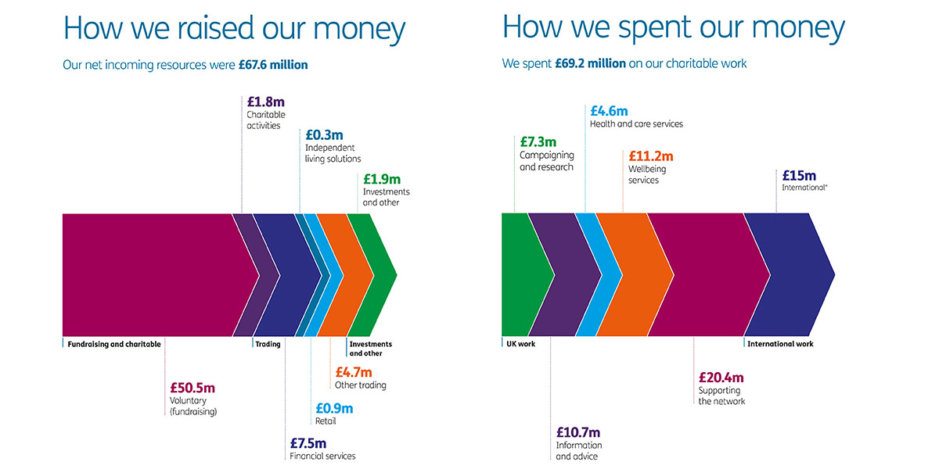

Pressures and shortfalls
UK Parliament (2019) explain that people are living longer as a result of progress, but this also creates major challenges for individuals, employers and for our welfare service. The report also states that our government are underprepared. Boseley, S (2019) report that there is a large increase in costs for the NHS and social care systems in the UK as a result of providing services for the aging population, which is putting a strain on these services. Age UK (2019b) highlights that older people are having delayed discharges from hospital due to lack of social care, and that there are escalating costs to the NHS with this issue with it costing £289,140,954 a year for delayed discharges. NHS (2019) states that they provide a service called NHS continuing healthcare, which means that individuals who have ongoing healthcare needs can receive care at home and the NHS will cover the costs. This can help to prevent the individuals going in and out of hospital for treatment and allows them to stay in their own home.
Age UK (2019c) provide free short-term care to the elderly which can be accessed within seven days of leaving hospital. This service is available for the elderly to settle back into their home making sure they are safe and retain their confidence at home. This can prevent delayed discharge and may prevent some elderly patients going in to care homes.
Age UK (2019d) argue that the NHS are not meeting the needs of the elderly population and there are still billions of people not getting the right care. Kings fund (2019a) agree that older people with a range of physical health, mental health and social care needs are not receiving the right support with often conflicting care rather than personalised support. Often, elderly people are in and out of hospital with no plan of how to keep fit and well. Kings fund (2019a) also explain that in 2012 Age UK used their skills are resources to support the health and care system. Age UK shows the benefits that the charity has on the ageing population by providing help and support for those that need it.
Growing older can come with a range of complex issues these are can be; Dementia, Arthritis, Kidney and bladder problems, Parkinson's disease, Alzheimer's disease, cardiovascular disease (Parent Giving, 2019). National Institute on Aging (2019) explain that around 85 percent of older people have ate least one chronic health condition. The King’s Fund (2019) states that it is estimated that treatment and care for people with chronic conditions can take up around £7 in every £10 of total health and social care expenditure.
Age UK (2019e) report that loneliness is big problem for older people, with there being 3.6 million individuals going through this feeling some factors of this is there are older people living and some feeling that they are being ignored.
Age UK (2019f) provide services to the elderly such as free weekly friendship calls which will match an elderly person with a volunteer for a friendly weekly chat to try to tackle loneliness. They provide local exercise classes, which are a great way to interact with others and keep people active, improve health and prevent loneliness. These classes are provided at a very discounted rate. Age UK provide friendship centres and day centres for individuals to become friends in their area, and are aimed to help older people improve their independence and be with other people.
Age UK (2019g) also provide information and advice on money saving and tips on how to budget, help with how to plan a will and end of life planning, which takes the pressure off friends and family. Information on illness and conditions and how to identify them and get the right diagnosis and help, is also available. They can also provide advice about what benefits are available, and help elderly people identify what they are entitled to and how to claim. An Age UK report (2017) states that £3.8 billion in pension credit and housing benefits goes unclaimed by older people every year due to them being unaware of what they are entitled to claim.

Partnership working
Age UK have developed an integrated care program around England. They are working with older people and local services to provide effective support to help the wellbeing of older people by enabling them to stay at home. Age UK (2019) state that 55 per cent of hospital admissions are older people in critical condition. The Kings Fund (2019) explain that the result from this program has been successful with helping reduce the emergency hospital admissions. The results from the Cornwall pilot where a reduction of 26 per cent of emergency hospital admissions in this area. In 2015 Kent surrey and Sussex AHSN joined with Age UK to support the programme. With the joining of these local services it is evident that the programme has achieved 600 to 700 cost reduction per participant for the NHS, in addition to the reduction in social care cost (The Kings Fund, 2019). Glosby, J and Dickinson, H (2016) state that there has been improvements with integrated care with reduces to some hospital costs in the long term, but there was little evidence that integrated care reduce cost more generally and the focus on the needs and prefences of end users can easily be lost in the challenging task of building the organisational platform for integrated care.

Policies

There are relevant policies in place built over the years to support the elderly to try tackle the issues that older people are faced with. In 2002 The World Health Organisation (WHO) developed a ‘Active Ageing: A Policy Framework’. The aim of the Framework is to provide a formulation of action plans to promote healthy and active ageing (The World Health Organisation,2002).
The Welsh Government launched the Strategy for Older People in Wales in 2003. The aims are to develop a community that are age friendly and for future generation to become equip for later life. “The role of the Welsh Government is to set direction for policy, make the case for change and create structures that are capable of delivering transformed services.”(Welsh Government, 2013).
In July 2019 “The UK Parliament All Party Parliamentary Group on Housing and Care for Older People has published Rental housing for an ageing population looking at rental housing for older people, now and in the decades to come.” (Centre for Policy on Ageing, 2019). Majority of Housing for older people are not accessible or adaptable for general needs. Older people are currently living in mainstream housing, rent social housing and low cost rented properties. In the publication The UK Parliament All Party Parliamentary Group on Housing and Care for Older People have recommend that higher level of accessibility and adaptability homes should be introduced by Local Planning Authority for wheelchair-user homes. They also state that they urge the government to provide lifetime homes for new built homes now to avoid the homes becoming inaccessible in the future. This can prevent high level of costs to the NHS for hospital admissions (Housing and Care for Older People, 2019).
The UK policy on The Ageing in place was developed for older people to age at home (Sixsmith, A. and Sixsmith, J, 2008). Roberts, O (2011) that the Welsh Government have been following the Aging in Place policy to ensure older people get to stay in their own homes as long as possible and that all new publicly funded social housing has to meet the lifetime homes standard.
Age UK is a charity that advocates on behalf of older individuals. Their team review the government published statistics in addition to communicate with older individuals to see if the government policies are being met. The charity liaises with members of parliament to campaign for changes to government policy. With their strong connections to older individuals they are well placed to gain a great deal of anecdotal evidence on the impact of policy to the individuals and following human rights standard (Age UK, 2019i).

Conclusion
This care study has looked at aging population and the issues involved. It has also looked examined Age UK charity. From the research it has shown that aging population has risen over the years and is continuing to be on the rise. Age UK that has been examined in this case study is a non- profitable third sector organisation that was developed to support the elderly. The charity has highly knowledgeable staff team with specialised background to play a big role in the running of the charity. As shown Age UK have come a long way since the charity was developed, with different organisations joining with Age UK over the years and partnership working with local services. It is evident that Age UK are picking up some strains that the NHS and the government are facing with providing care to the elderly after leaving hospital to help them gain back their confidence at home and helping to avoid them going back in to hospital. Also working in partnership with local services to help the elderly stay in their own homes has proven to help with cost reduction to the NHS. Policies are being provided by the government to support elderly individuals to stay active as they get older and policies for housing associations to follow for providing accessible homes.

Recommendation
For a possible recommendation a comparative assessment of each devolved government policy on aging to evaluate best practice. This assessment could be carried out by the third sector I.e Age UK and other charities. Another recommendation is for more research to be carried out on the issues that are affecting the aging population and what can be done for the future.

Reference
Age UK (2019a) History of Age UK. Available at: https://www.ageuk.org.uk/about-us/people/our-history/ [Accessed 2 Dec. 2019]
Age UK (2017) Report of Trustees and Annual Accounts 2017/2018. London: Age UK, p.p.9.
Age UK (2019b) New analysis shows number of older people with unmet care needs soars to record high | Age UK | Media. Available at: https://www.ageuk.org.uk/latest-press/articles/2018/july-2018/new-analysis-shows-number-of-older-people-with-unmet-care-needs-soars-to-record-high/ [Accessed 4 Dec. 2019].
Age UK (2019c) Personal care at home services | Age UK. Available at: https://www.ageuk.org.uk/services/in-your-area/personal-care-at-home/ [Accessed 3 Dec. 2019].
Age UK (2019d) Briefing: Health and Care of Older People in England 2019. Available at: https://www.ageuk.org.uk/globalassets/age-uk/documents/reports-and-publications/reports-and-briefings/health--wellbeing/age_uk_briefing_state_of_health_and_care_of_older_people_july2019.pdf [Accessed 7 Dec. 2019].
Age UK (2019e) Combating elderly loneliness | Age UK. Available at: https://www.ageuk.org.uk/information-advice/health-wellbeing/loneliness/ [Accessed 1 Dec. 2019].
Age UK (2019f) Befriending services | Combating loneliness. Available at: https://www.ageuk.org.uk/services/befriending-services/ [Accessed 2 Dec. 2019].
Age UK (2019g) Information and advice for older people and their loved ones | Age UK. Available at: https://www.ageuk.org.uk/information-advice/ [Accessed 2 Dec. 2019].
Age UK (2019h) Integrated Care Services. London: Age UK. Available at: https://www.ageuk.org.uk/contentassets/004fdd0c29354e4aae82ef1c9656b115/integrated_care_programme.pdf [Accessed 6 Dec. 2019].
Age UK (2019i) Age UK policy positions 2019. Available at: https://www.ageuk.org.uk/globalassets/age-uk/documents/policy-positions/policy_position_quick_reference_guide.pdf [Accessed 6 Dec. 2019].
Age UK (2019j) Directors | Age UK. Available at: https://www.ageuk.org.uk/about-us/people/directors-trustees/directors/ [Accessed 27 Nov. 2019].
Age UK (2019k) Trustees | Age UK. Available at: https://www.ageuk.org.uk/about-us/people/directors-trustees/trustees/ [Accessed 26 Nov. 2019].
Boseley, S (2019) NHS faces staggering increase in cost of elderly care, academics warn. the Guardian. Available at: https://www.theguardian.com/society/2017/may/24/nhs-faces-staggering-increase-in-cost-of-elderly-care-academics-warn-dementia [Accessed 10 Dec. 2019].
Centre for Policy on Ageing (2019) Policies on Ageing. Available at: http://www.cpa.org.uk/cpa/policies_on_ageing.html [Accessed 1 Dec. 2019].
Housing and Care for Older People (2019) Rental Housing For An Ageing Population. Available at: https://www.housinglin.org.uk/_assets/Resources/Housing/Support_materials/Other_reports_and_guidance/HAPPI-5-Rental-Housing.pdf [Accessed 1 Dec. 2019].
Government Office For Science (2016) Future of an Ageing Population. London: Open Government Licence. Available at: https://assets.publishing.service.gov.uk/government/uploads/system/uploads/attachment_data/file/816458/future-of-an-ageing-population.pdf [Accessed 1 Dec. 2019].
NHS (2019) NHS continuing healthcare. Available at: https://www.nhs.uk/conditions/social-care-and-support-guide/money-work-and-benefits/nhs-continuing-healthcare/ [Accessed 1 Dec. 2019].
National Institute on Aging (2019) Supporting Older Patients with Chronic Conditions. Available at: https://www.nia.nih.gov/health/supporting-older-patients-chronic-conditions [Accessed 16 Dec. 2019].
Office for National Statistics (2019) Living longer - Office for National Statistics. Ons.gov.uk. Available at:https://www.ons.gov.uk/peoplepopulationandcommunity/birthsdeathsandmarriages/ageing/articles/livinglongerhowourpopulationischangingandwhyitmatters/2018-08-13#how-is-the-uk-population-changing [Accessed 1 Dec. 2019].
Parent Giving (2019) Common Chronic Conditions of the Elderly | Elderly and Chronic Conditions. Available at: https://www.parentgiving.com/elder-care/common-chronic-conditions-and-aging-at-home/ [Accessed 15 Dec. 2019].
Roberts, O (2011) Key Issues for the Fourth Assembly. Cardiff: National Assembly foe Wales, p.P.66.
Sixsmith, A. and Sixsmith, J (2008) Ageing in Place in the United Kingdom. SpringerLink, 32(3).
The King's Fund (2019a) Age UK care co-ordinator roles. Available at: https://www.kingsfund.org.uk/publications/innovation-nhs/age-uk-care-co-ordinator-roles [Accessed 4 Dec. 2019].
The King's Fund (2019) Age UK care co-ordinator roles. Available at: https://www.kingsfund.org.uk/publications/innovation-nhs/age-uk-care-co-ordinator-roles [Accessed 1 Dec. 2019].
The King's Fund (2019) Age UK care co-ordinator roles. Available at: https://www.kingsfund.org.uk/publications/innovation-nhs/age-uk-care-co-ordinator-roles [Accessed 5 Dec. 2019].
The King's Fund (2019) Long-term conditions and multi-morbidity. Available at: https://www.kingsfund.org.uk/projects/time-think-differently/trends-disease-and-disability-long-term-conditions-multi-morbidity [Accessed 17 Dec. 2019].
UK Parliament (2019) Overview. Available at: https://www.parliament.uk/business/committees/committees-a-z/lords-select/public-services-committee/report-ready-for-ageing/overview/ [Accessed 1 Dec. 2019].
WHO (2019) WHO | Population ageing. Who.int. Available at: https://www.who.int/features/qa/72/en/ [Accessed 2 Dec. 2019].
Wilde, R (2019) The Creation of Britain’s Welfare State. [online] ThoughtCo. Available at: https://www.thoughtco.com/creation-of-britains-welfare-state-1221967 [Accessed 1 Dec. 2019].
World Health Organization (2002) Active Ageing A Policy Framework. Available at: https://apps.who.int/iris/bitstream/handle/10665/67215/WHO_NMH_NPH_02.8.pdf;jsessionid=F64DD058BDDE0878E630CB27049258E3?sequence=1 [Accessed 3 Dec. 2019].
Welsh Government (2013) The Strategy for OlderPeople in Wales 2013-2023. Available at: http://www.cpa.org.uk/cpa-lga-evidence/Merthyr_Tydfil_County_Borough_Council/The_Strategy_for_Older_People_in_Wales_2013-2023.pdf [Accessed 1 Dec. 2019].

