Digital Skills and Research Method
BMSW4003

Student Name: Anton Roscovan
Student ID: 1916145
Module Lecturer’s Name: Suneth Fernando

Table of Contents:
Introduction………………………………………………………………………………………3
Background………………………………………………………………………………………4
Literature Review - Virtual learning environment
Aims and Objectives…………………………………………………………………………….6
Research Methods………………………………………………………………………………7
Results……………………………………………………………………………………………8
Discussion………………………………………………………………………………………14
Conclusion……………………………………………………………………….....................15
References……………………………………………………………………………………..16
Appendix………………………………………………………………………………………..18

Introduction
“Virtual Learning Environment or VLE” is known as an online-based platform responsible for offering students and teachers a proper digital solution, which enhances the student’s learning experiences (Awang et al., 2019). In the era of digital technology, both students and teachers want seamless experiences during the entire learning session. To fulfil the requirements and provide new learning experiences VLE has been introduced as the popular web-based technology or platform. VLE is mostly adopted by the higher education university and it is used by both the learner and professor while conducting teaching-learning sessions. Change in the education culture became a big problem among learners. Due to this reason, the training provided by teachers through digital technology can be advantageous for the students in the universities. Therefore, the study is important to ensure that the students can get each learning material over the internet without any hassle and enjoy a new learning session with VLE technology.

Background
Literature review

- Types of services provided by VLE
The virtual learning environment provides various services at the "University of Wales Trinity Saint David London Campus". VLE helps in providing high quality and efficient teaching. The VLE systems can be easily updated by the teachers where necessary information like grades of a student is saved with proper security (Rienties et al., 2016). This information can be easily accessed from any smartphone, laptop, or tablet making it highly user friendly for the teachers. Teachers can share necessary links and resources in the form of media which will assist the students to get the proper direction regarding any certain topic.
VLE helps the students to access all the study materials provided thereby simply logging in their accounts. The students can easily upload their assignments or homework to the VLE. Students can also participate in the tests and quizzes available in VLE (Penjor et al., 2015). The students can easily get connected with their respective teachers with the help of that system. The students can upload or avail any file from any place provided there is a strong internet connection available.

- Benefits or advantages of VLE
VLE systems play a very crucial role in making the accessibility of the student and teachers much easier. Besides, with the sudden outbreak of the COVID 19, the students and the teachers of the “University of Wales Trinity Saint David London Campus” are strictly instructed to use online modes of learning and teaching. Hence VLE systems enable to connect the teachers with the students and execute an effective education process (Braunet al., 2014). VLE systems help in storing all the necessary data and information like notes, grades, assignments, and others as well as protect by password security. The operations of VLE are very user friendly that helps the students and the teachers to continue the education processes efficiently resulting in enhanced efficiency within the institution.
- Challenges and risks of VLE
The main challenge related to VLE systems is that it is a complex system and it requires extremely skilled and experienced staff for its maintenance. The process of designing the activities is very time consuming and complicated that adds extra costs (Alveset al., 2017). Lastly, technical issues may result in complete defects in the VLE systems. The only risk related to the VLE systems is the technical issue that will completely disrupt the various functions of the VLE. As a result, this may harm the educational activities of the students and the teachers (Maaliw III et al., 2017).

- Technologies required for VLE
VLE involves the implementation of advanced and modern technologies. There are various software packages of VLE namely COSE, Blackboard, Lotus LearningSpace, and WebCT. These commercial software packages contribute to the effective and efficient execution of VLE operations.

- Legislations
The legislation related to the implementation of VLE in educational centers like “University of Wales Trinity Saint David London Campus” is a disproportionate burden assessment. This legislation allows “University of Wales Trinity Saint David London Campus” to use digital platforms like VLE with valid and logical evidence and reasoning.

- Opportunities
VLE will be offering huge development in the education sector. It will help the education system to be more flexible and comfortable. Both the teachers and the students will be able to easily conduct their learning and teaching activities. Time management will become very easy for both the teachers and the students (Alveset al., 2017). VLE will help in maintaining educational activities and other activities accordingly, hence, resulting in ineffective use of time.

Aim and objectives
Research questions
- What is the concept of VLE?
- What is the impact of VLE on the student's learning experiences of the UWTSD London Campus?
- What are the challenges and limitations of VLE faced by students during the learning session of UWTSD?
- How to improve VLE technology for overcoming its limitations faced by students of UWTSD while learning?

Aims of this research:
- The research aims to assess the impact of VLE technology on the student’s learning experiences of the UWTSD London campus.

Objectives:
- To discuss the concept of VLE?
- To analyse the impact of VLE on the student’s learning of UWTSD London Campus
- To identify the challenges and limitations of VLE faced by students during the learning session of UWTSD
- To examine the way for improving VLE technology to mitigate the challenges faced by students of UWTSD while learning?

Research methods
During the entire research, the researcher has used primary as well as secondary methods for collecting quantitative information along with some qualitative information that is associated with the concept of VLE, the impact of VLE on the learning process along with its limitations and challenges experienced by the students as well as teachers. The secondary information has been acquired from different types of journals, articles, newspapers along with university Moodle has been utilized to acquire more information about this study.
Alongside, primary quantitative information has been also gathered through the online survey method. The researcher has utilised the advanced online tool like Survey Monkey for surveys that include 10 questions associated with VLE technology and university Moodle. The prepared survey questions have been shared with 15 respondents through email for getting their feedback. The researcher has followed ethical practices in the research as the acquired data has been stored in tables for the overall analysis process. Moreover, the collected information has been stored in the computer in a proper encrypted format to maintain confidentiality within the research.

Results
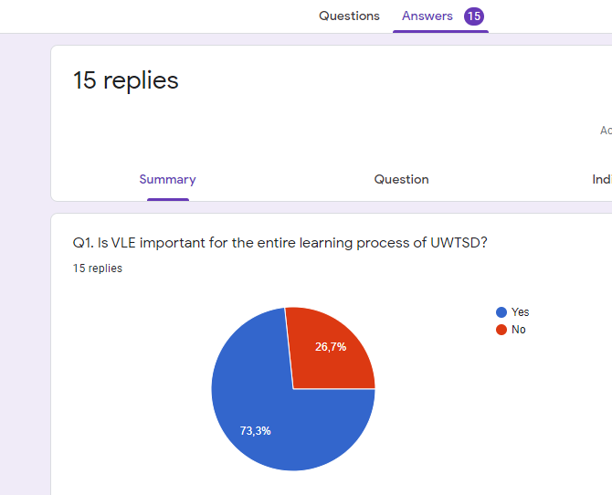

Questions | Responses (Yes) | Responses (No)
Q1 | 11 | 4
Q2 | 10 | 5
Q3 | 8 | 7

Questions | Responses (Yes) | Responses (No) | Minimum | Maximum
Q1 | 11 | 4 | 4 | 11
Q2 | 10 | 5 | 5 | 10
Q3 | 8 | 7 | 7 | 8
Total Score | 29 | 16 | 16 | 29
Average Score | 14.5 | 8 | 8 | 14.5

Questions | Very Often | Often | Sometimes | Never
Q4 | 7 | 4 | 3 | 1
Q5 | 5 | 6 | 2 | 2
Q6 | 6 | 7 | 2 | 0
Q7 | 9 | 4 | 1 | 1

Questions | Very Often | Often | Sometimes | Never | Max Responses | Min Responses
Q4 | 7 | 4 | 3 | 1 | 7 | 1
Q5 | 5 | 6 | 2 | 2 | 6 | 2
Q6 | 6 | 7 | 2 | 0 | 7 | 0
Q7 | 9 | 4 | 1 | 1 | 9 | 1
Total Responses | 27 | 21 | 8 | 4 | 29 | 4
Average Responses | 10.8 | 8.4 | 3.2 | 1.6 | 11.6 | 1.6

Questions | Strongly Agree | Agree | Disagree | Strongly Disagree
Q8 | 5 | 5 | 3 | 2
Q9 | 6 | 7 | 2 | 0
Q10 | 8 | 5 | 1 | 1

Questions | Strongly Agree | Agree | Disagree | Strongly Disagree | Max Responses | Min Responses
Q8 | 5 | 5 | 3 | 2 | 5 | 2
Q9 | 6 | 7 | 2 | 0 | 7 | 0
Q10 | 8 | 5 | 1 | 1 | 8 | 1
Total Responses | 19 | 17 | 6 | 3 | 20 | 3
Average Responses | 9.5 | 8.5 | 3 | 1.5 | 10 | 1.5

Discussion
From the secondary research I have found that some of the students prefer "face to face" teaching sessions rather than online or VLE based teaching. 26.67% of respondents agreed that VLE technology provides seamless and advanced services by providing new experiences and facilities to both learners and professors as well.
VLE is most important that enhances the entire education process and provides a unique experience of learning for me learners. I support that VLE helps me by providing the required information, learning materials at the time of my exam. It also has some positive parts by which I can make interact with professors using chat options and the students get quick replies from the respective professor regarding my problems. It allows me to store entire learning courses and information in the cloud platform that can be accessed by the me easily. However, it has some negative sides that can create technical issues and require more technical knowledge to handle this technology. I also face difficulties to solve my queries through VLE. Therefore, proper education should be provided by teachers regarding the usability of VLE technology to mitigate the issues of students.
The recommendation for improving the VLE technology, the university can provide online training and supporting guidance to the users that makes this technology smooth and easy for them.

Conclusion
In conclusion, VLE technology and its impact are discussed in this entire research project by considering the learning technique of the UWTSD London Campus. It has been identified that this technology is beneficial as well as effective for the learning session during this COVID-19 pandemic situation. As the impact of this, the students are more willing to take online classes and showing their interest in the education process. Moreover, it sometimes negatively affects learning due to technical and internet-related issues. It is time-consuming as well as costly for the students to install and manage this technology. It is recommended to the UWTSD to give proper guidance to their teachers as well as learners about the application, importance, and accessibility of VLE technology to overcome the identified challenges of VLE.

Reference list:
Ahmad, M., Razak, H.A., Omar, M. and Mkpojiogu, E.O., 2019, March. Knowledge Transfer of VLE Frog in Secondary School. In Proceedings of the 2019 7th International Conference on Information and Education Technology (pp. 248-251).
Alves, P., Miranda, L. and Morais, C., 2017. The Influence of Virtual Learning Environments in Students' Performance. Universal Journal of Educational Research, 5(3), pp.517-527.

Awang, H., Aji, Z.M., Osman, W.R.S., Nasir, A.A., Deli, M.M. and Hamat, W.Y.W., 2019. Virtual Learning Environment (VLE) Implementation Strategy: An Analysis of Practicality for Google Classroom Implementation in Malaysian Schools.

Braun, S. and Slater, C., 2014. Populating a 3D virtual learning environment for interpreting students with bilingual dialogues to support situated learning in an institutional context. The Interpreter and Translator Trainer, 8(3), pp.469-485.

Herrera Mosquera, L., 2017. Impact of implementing a virtual learning environment (VLE) in the EFL classroom. Íkala, Revista de Lenguaje y Cultura, 22(3), pp.479-498..
Maaliw III, R.R. and Ballera, M.A., 2017. Classification of Learning Styles in Virtual Learning Environment Using J48 Decision Tree. International Association for Development of the Information Society.

Penjor, S. and Zander, P.O., 2015. Predicting Virtual Learning Environment adoption-A case study. arXiv preprint arXiv:1503.02408.

Power, J. and Kannara, V., 2016. Best-practice model for technology enhanced learning in the creative arts. Research in Learning Technology, 24, p.30231.
Rienties, B., Giesbers, B., Lygo-Baker, S., Ma, H.W.S. and Rees, R., 2016. Why some teachers easily learn to use a new virtual learning environment: A technology acceptance perspective. Interactive Learning Environments, 24(3), pp.539-552.

Varga-Atkins, T., 2016. A study of the role of a technology-enhanced learning implementation group in mediating an institutional VLE minimum standards policy. Research in Learning Technology, 24.

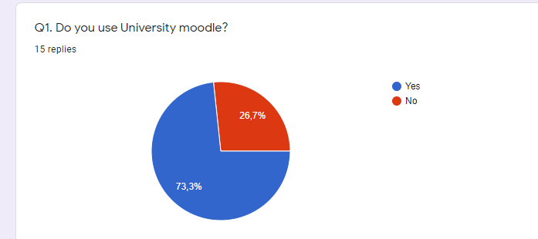
Appendix



