ELECTRICAL AND ELECTRONICS ENGINEERING
Electronics 1 Exam
ACDA5002

Kai Tang

Words words words words words words words words words words words words words words words words words words words words words words words words words words words words words words words words words words words words words words words words words words words words words words words words words words words words words words words words words words words words words words words words words words words words words words words words words words words words words words words words words words words words words words words words words words

17/01/2022

Q1

- IC1 is an integrator – resistor being parallel to capacitor allows it to behave like an inverting amplifier. Capacitor acts as an open circuit, blocking feedback voltage, using the switch it, resets the integrator shorting it to go through the switch and draining the capacitor
- IC2 is a Non-Inverting opamp allows amplification of a signal, LM385 – voltage reference , resistors are in a potential divider network to produce negative feedback
- Photodiode – A device that works when light shines on it – in this case light will induce current through photodiode, the UV filter is to allow only UV light in as the suntan monitor will be measuring amount of UV light instead of all light as UV light will be the one that produces a suntan.
- Disadvantage for analogue implementation would be how the device is user dependant, needs user to manually hit reset switch to reset the timer instead of just having the buzzer go off and reset automatically in a set amount of time later. This can be circumvented by having a digital suntan monitor operated by a microcontroller, this way, a code could be set to have the timing be automatic and can be hooked up to more things such as a led display showing progress or time remaining, a user input of intensity of tanning allowed by having it run a preset that has longer or shorter timings for each turn.

Q2

a. 6502 – cpu microprocessor main part of the circuit handling the calculations such as equations set within code to calculate C02 present and run tasks related to current C02 levels such as sounding the buzzer if detected C02 levels reach a given threshold
6464 8k RAM – volatile random memory access uses to read/write data by the cpu and run programs, data will be lost if system shuts down
27c256 32k eprom used as read only memory to store data and will not be erased when the system shuts off – designed for repeated use
D7002 4ch ADC – 4 channel analogue to digital converter used to convert data from analogue signal to digital so the system cpu can read it.
74590 8bit counter – binary counter counting clock pulses into binary numbers
6522 VIA – Versatile interface adaptor – has two bidirectional 8-bit parallel I/O ports, two 16-bit timers and 8-bit shift register for serial communications

b. 16bit

c. 8 pins
d. read co2 levels, refer to value for threshold if true sound buzzer if not return to count

e. memory storage such as ram to allow a basic os to be running along with all the other components and basic programs,
cost of micro
set number of pins and features available that the micro can handle to know if it can do the job well without much compromise such as any build in adc’s.

Q3
- Controlling the conduction angle of an AC signal which then controls the average AC voltage across a load
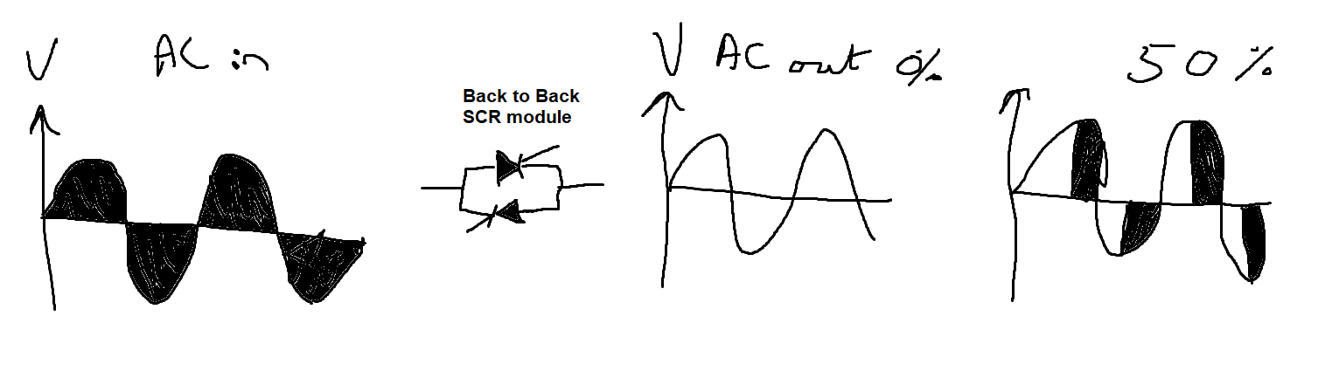
- Zero crossing point refers to point of which wave function changes occurs when wave intercepts x-axis

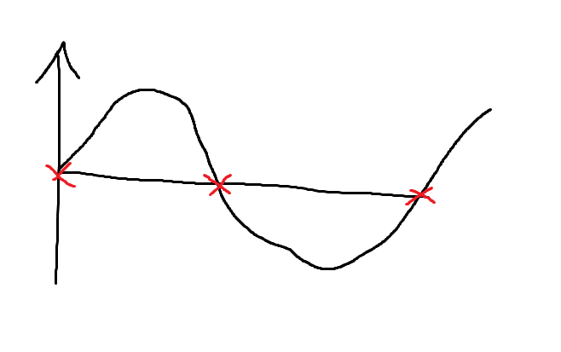

- resistors and capacitors, r1-r3 c1-c3 , fuse stop circuit from being damaged if too much currents draws in, fuse will blow.
Back to back diodes scr modules,
inductors generate mag field
resistors resist flow of electrons,
capacitors stores and discharges electricity via static

d.
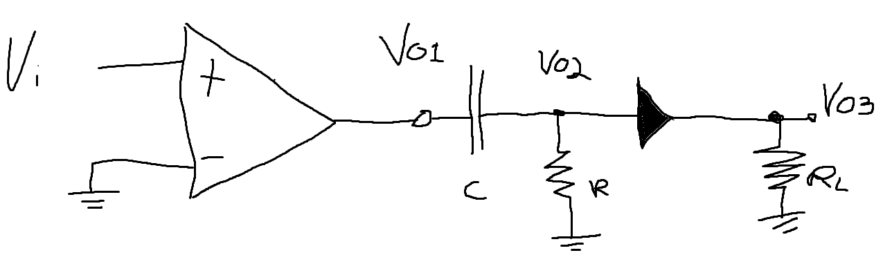

When comparator op amp switchs it drives through ac coupling capacitor, allowing a burst on transition and the diode, and RL will rectify.

