
Title: Feasibility Plan for an International
Meeting
in the Hospitality Industry
Subtitle: Event Theme
-

Sustainability
Presenter:

Mohammad

Shahidul

Islam

Chowdhury

Student

ID:2026960
Lecturer: Kathryn Flynn


Table of Contents

Slide 3: Introduction

Slide 4: Market Factors

Slide 5: Operational Factors

Slide 6: Costs

Slide 8: Predicted Revenues

Slide 9: Funding Sources

Slide 10: SWOT Analysis

Slide 11: PESTLE Analysis

Slide 12: Conclusion

Slide 13:
Reference

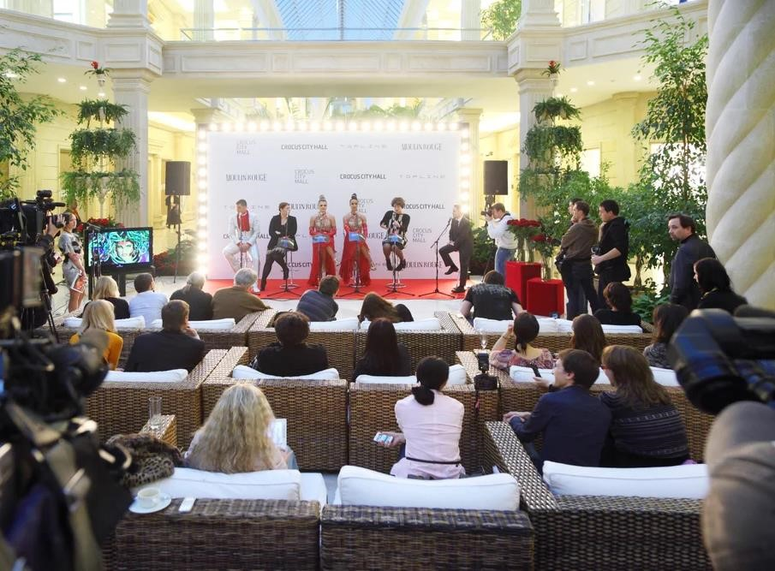
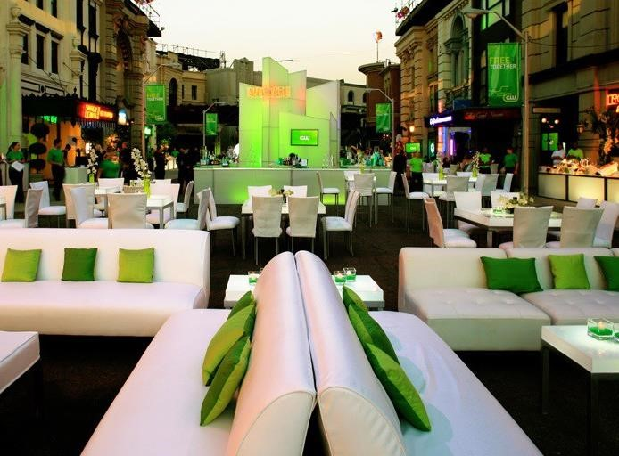
Introduction


Today, this assesses the feasibility of a pioneering event at the
intersection of fashion and sustainability: a garments exhibition
with a core focus on sustainability. This initiative aims to
showcase the latest sustainably and foster a dialogue on the
critical importance of sustainability in the garment industry. This
presentation will explore various facets, including market
dynamics, operational considerations, financial planning, and
strategic analyses, to determine the viability of bringing this
event to life.

Market Factors

Target Market: The primary audience includes fashion industry professionals, sustainability advocates, and environmentally conscious consumers.
Factors
Demand: There's a growing demand for events highlighting sustainability, reflecting the increasing consumer interest in ecofriendly products.
Supply: While there are several fashion events globally, those specifically focusing on sustainability are less common, presenting a unique opportunity.
Competition: Potential competitors include other sustainable fashion shows and exhibitions. However, our event's unique positioning could mitigate direct competition impacts.


Operational Factors
Venue Availability:
To have shortlisted
venues known for their sustainable
practices, with a preferred venue
available on our desired dates.
Venue Suitability:
The chosen venue
aligns with this event's sustainability
theme, offering necessary facilities like
eco
-
friendly lighting and recycling
services.
Skills Required:
Event staff will need
expertise in sustainable practices, event
management, and customer service.
Resources:
Essential resources include
eco
-
friendly catering options,
sustainable lighting solutions, parking
facilities, ample seating, and accessible
transportation options.

Costs

Table of Chart: Detailed Costs Breakdown
Cost Category | Amount (£)
Fixed Costs
Venue rental | 9,600
Costs of insurance | 2,400
Administration and general | 2,000
Marketing and promotion of the event | 4,800
Equipment rental charges | 3,200
Event permit and license | 1,600
Professional and legal fees | 1,200
Total Fixed Costs | 24,800

Variable Costs
Transport costs | 2,400
Disinfection and cleaning expenses | 1600
Documentation costs | 800
Stall arrangement | 4,000
Setting up and Venu decorating | 3,200
Salaries for staff | 5,600
Voluntary contributions | 1,600
Various other expenses | 1,200
Contingencies | 2,000
Total Variable Costs | 22,400
Total Costs | 47,200

Predicted Revenues

Table of Chart: Revenue Prediction
Revenue Source | Unit Prices (£) | Unit Sales | Sales Revenues (£)
Entry fee for guests | 80 | 600 | 48,000
Charges for stalls | 400 | 40 | 16,000
Commission from the sale of products | 10% of sales | N/A | 2,400
Total Sales Revenue |  |  | 66,400



Funding Sources

To ensure the financial viability of the event, funding will be
sought through various channels, including donations, sponsorships,
charges for stall rentals, and contributions from the event
organisers

themselves. This diversified funding strategy aims to secure the
necessary capital while
minimising

financial risk.
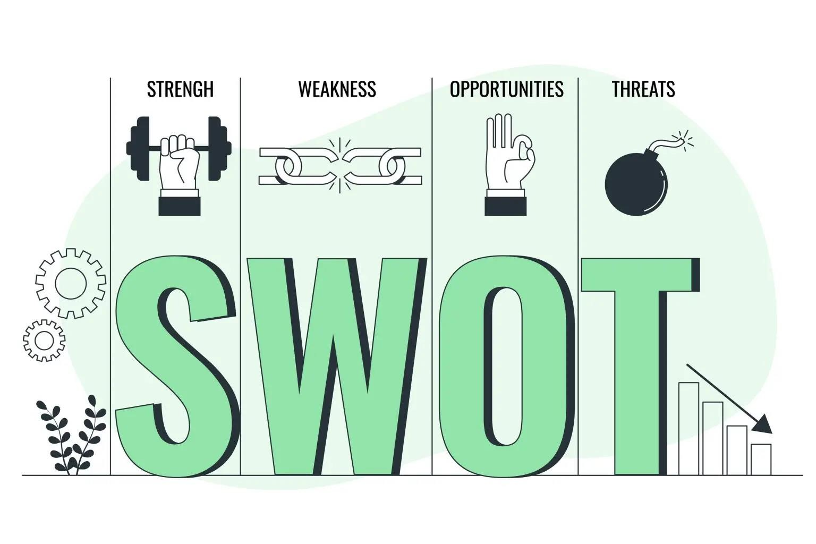
Strengths:
Unique focus on sustainability, strong
interest among
t
he target audience, and the potential
for high media interest.
Weaknesses:
High dependency on sponsorships,
potential challenges in attracting international
attendees.
Opportunities:
There is a gap in the market for
sustainability
-
focused garment events and potential
partnerships with eco
-
friendly brands.
Threats:
Economic downturns affecting sponsorships
and attendance, competition from virtual events.
SWOT

Analysis
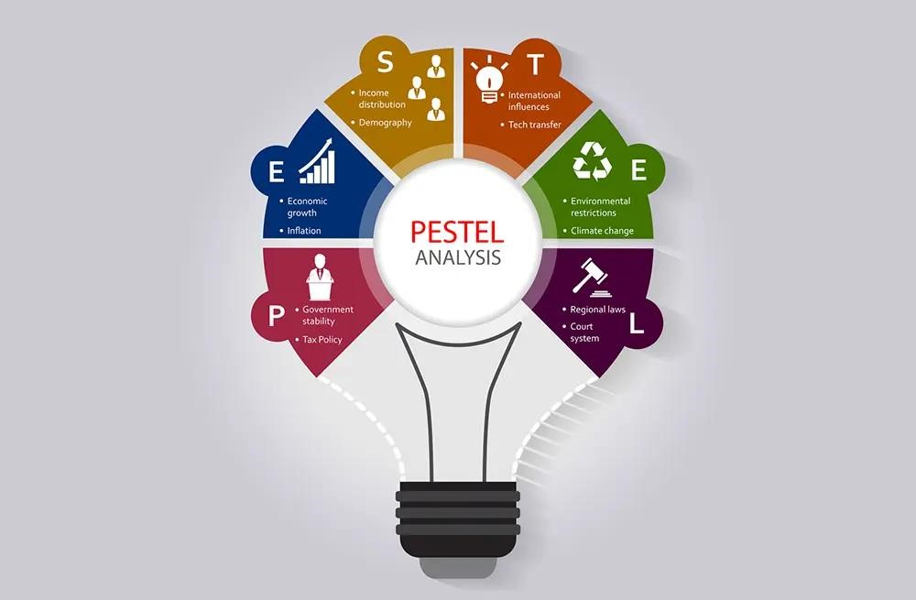
PESTLE
Analysis
Political:

Potential impact of trade policies on international
participants.
Economic:

Economic trends influencing consumer spending and
sponsorship availability.
Social:

Increasing consumer demand for sustainable products.
Technological:

Advances in sustainable fashion technologies.
Legal:

Compliance with local and international event regulations.
Environmental:

Commitment to minimising the event's carbon
footprint and promoting sustainability.

Conclusion
The feasibility analysis indicates that, with strategic planning and a focus on sustainability, the proposed garments exhibition event holds significant potential. Key findings suggest a strong market demand, viable operational plans, and a solid financial strategy underscored by a diverse funding approach. The SWOT and PESTLE analyses further validate the event's relevance and potential success in today's environmentally conscious and rapidly evolving global landscape. By emphasising sustainability, this event aligns with current social and environmental trends and sets a precedent for future industry standards.

References
- Baumann, B. (2017). Event Budget Basics: Everything You Need to Know – EventMobi. [online] EventMobi. Available at: https://www.eventmobi.com/blog/event-budget-basics/.
- Consultancy, M. (2023). The importance of market feasibility analysis in market expansion. [online] Medium. Available at: https://metheus.medium.com/the-importance-of-market-feasibility-analysis-in-market-expansion9ec27f0a689f.
- Coursera. (2023). What Is a Target Market? And How to Define Yours. [online] Available at:
https://www.coursera.org/gb/articles/target-market.
- Default. (n.d.). Chapter 14: Question & Answers. [online] Available at:
https://kfknowledgebank.kaplan.co.uk/acca/chapter-14-question-answersv2.
- Eventbrite UK. (2019). How to Get Funding For an Event (8 Ideas) | Eventbrite UK. [online] Available at:
https://www.eventbrite.co.uk/blog/8-ways-to-finance-your-event-idea-ds00/.
- How to Write a Funding Strategy. (n.d.). Available at: https://www.funding4sport.co.uk/wpcontent/uploads/2013/03/How-to-Write-a-Funding-Strategy1.pdf.
- James, M. (2022). Target Markets: What Everyone Should Know. [online] Investopedia. Available at:
https://www.investopedia.com/terms/t/target-market.asp.
- Macdonald, M. (2022). Calculating Market Demand: How to Find Product Ideas Your Customers Want. [online] Shopify. Available at: https://www.shopify.com/blog/market-demand.
- Nav (2021). Ultimate Restaurant Costs Breakdown Guide. [online] YES Group UK. Available at:
https://yesgroupuk.com/blog/ultimate-restaurant-costs-breakdown-guide/.
- Sweap. (n.d.). SWOT Analysis for Events 2023 | Sweap Blog. [online] Available at:
https://www.sweap.io/en/blog/swot-analysis-for-events#:~:text=SWOT%20helps%20you%20analyse%20the.
- Team, E. (2022). Event Budget Basics: Everything You Need to Know. [online] EventMobi. Available at: https://www.eventmobi.com/blog/event-budgetbasics/#:~:text=Fixed%20costs%20are%20costs%20that.
- UKEssays.com. (2010). Study On The Environment And The Event Industry Tourism Essay. [online] Available at: https://www.ukessays.com/essays/tourism/study-on-the-environment-and-the-eventindustry-tourism-essay.php.
- Visit Monmouthshire. (n.d.). Introduction to events management. [online] Available at: https://www.visitmonmouthshire.com/information/events-management/introduction.
- vistourism1976 (2014). Events venue feasibility study and events venue options appraisal. [online] Welcome to PSC - Tourism Consultants. Available at: https://www.pslplan.co.uk/events-venuefeasibility-study/.
- www.carmarthenshire.gov.wales. (n.d.). How feasible is the event? [online] Available at: https://www.carmarthenshire.gov.wales/home/business/organising-events/community-toolkit/howfeasible-is-the-event/.
- www.gevme.com. (n.d.). Event planning competition analysis. [online] Available at: https://www.gevme.com/en/blog/event-planning-competition-analysis/.
- www.leoisaac.com. (n.d.). Event Management: How to assess the feasibility of an event. [online] Available at: http://www.leoisaac.com/evt/top072.htm.
- www.leoisaac.com. (n.d.). Event Management: Six steps to selecting the venue. [online] Available at: http://www.leoisaac.com/evt/top086.htm.
- www.visitmonmouthshire.com. (n.d.). Event feasibility study - Visit Monmouthshire. [online] Available at: https://www.visitmonmouthshire.com/information/events-management/feasibility.

Video Link:
https://uowtsd-my.sharepoint.com/:v:/g/personal/2026960_student_uwtsd_ac_uk/EQep3CeRa9ZGth8zMNt9lDoBkgGZtpxvSJlw1zyt_vZ-Dw?referrer=Teams.TEAMS-ELECTRON&referrerScenario=MeetingChicletGetLink.view.view


