UWTSD
WISA



Tensile Test
Engineering Science – ACHA4002

Luca Gray
2304962
8th December 2024
Contents
1 Introduction 1
2 Experimental Procedure 2
3 Results 4
4 Analysis 5
5 Conclusion 9
6 Evaluation 10
7 Further Work 11
8 References 12

Figure 1 – The equipment used during the experiment …………………………………………………………………………. 3
Figure 2 – The materials before the experiment ……………………………………………………………………………………. 3
Figure 3 – The nominal values of the materials (TecQuipment, 2012) ………..…………………………………………. 3
Figure 4 – A typical stress-strain graph (Figari, P.) …………………………………………………………………………………. 3
Figure 5 – Raw results for steel ………………………..……………………………………………………………………………………. 4
Figure 6 – Raw results for duralumin ……………….……………………………………………………………………………………. 4
Figure 7 – Raw results for aluminium ……………………………………………………………………………………………………. 4
Figure 8 – Raw results for PVC ………………………………………………………………………………………………………………. 4
Figure 9 – A graph showing the stress-strain curve for steel …………………………………………………….……………. 5
Figure 10 – A graph showing the elastic region of steel …………………………………………………………………………. 5
Figure 11 – A graph showing the stress-strain curve for duralumin ……………………………………………………….. 6
Figure 12 – A graph showing the elastic region of duralumin …………………………………………..……………………. 6
Figure 13 – A graph showing the stress-strain curve for aluminium …………………………….…..……………………. 7
Figure 14 – A graph showing the elastic region of aluminium ……………………..…………………..……………………. 7
Figure 15 – A graph showing the stress-strain curve for PVC .……………………..…………………..……………………. 8
Figure 16 – A graph showing the elastic region of PVC ……………………..…………………..………………………………. 8

Table 1 - The results table for steel 5
Table 2 - The results table for duralumin 6
Table 3 - The results table for aluminium 7
Table 4 - The results table for PVC 8

Introduction
In this assignment, students were tasked with carrying out an experiment to test the tensile strength of various materials. Using the equipment provided, they can obtain data and use this to build tables of results, graphs and then compare the results of each different material. It is crucial for engineers to understand the strength of materials and how they react to applied loads (TecQuipment, 2012), and this experiment is a valuable introduction into learning this.

Experimental Procedure
1. Check that equipment is set up correctly and ready to be used. If so, choose a material to test and measure its gauge length (shown in Figure 1). Also measure the thickness of this length. This allows you to calculate the area of the material.
2. Fasten the material into the two chucks, which are shown in Figure 1. Set the dial indicator to zero.
3. Turn the Load Nut clockwise in 0.2mm steps up to 5mm, noting the dial indicator reading every 0.2mm. From 5mm to 10mm, turn and measure in 1mm steps, and then in 10mm steps.
4. Once the material has broken, remove it from the chucks. Carefully put the broken ends together and then measure the new gauge length. Subtract the original gauge length from this, and then note down your elongation.
5. Create an excel table which includes columns for all needed measurements. To find the force values, multiply the dial indicator reading at each point by 100. To find the extension of the material, subtract the dial indicator reading to each corresponding Load Nut movement.
6. To find the stress of the material, take each force value and divide by the area which was previously measured.
7. To find the nominal strain at any given measurement, take change in length (extension) and divide by the original length measured.
8. Plot a stress-strain curve graph, similar to the one shown in Figure 4 using your values found for stress strain.
9. Repeat all steps for each material or until satisfied with the number of results.

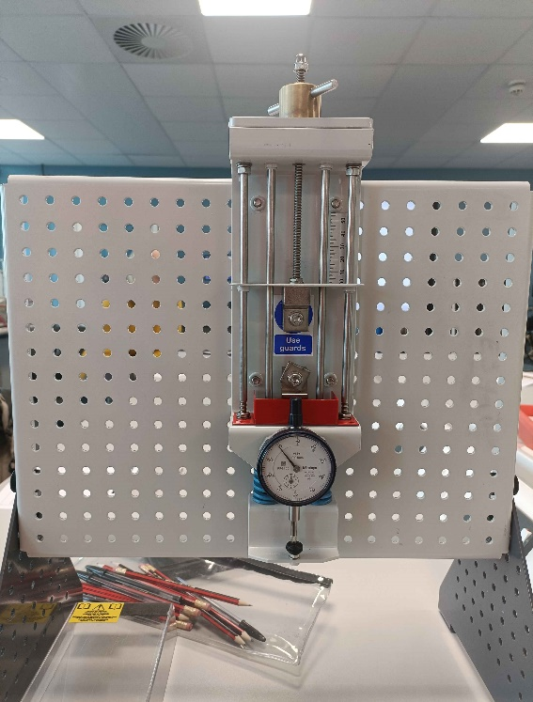
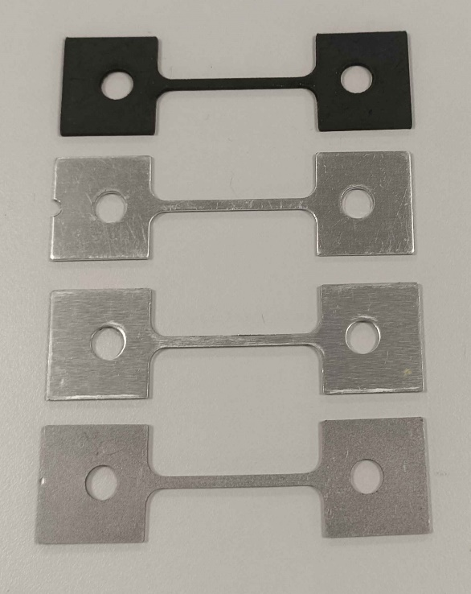

Figure 2 – The materials before the experiment
Figure 1 – The equipment used during the experiment
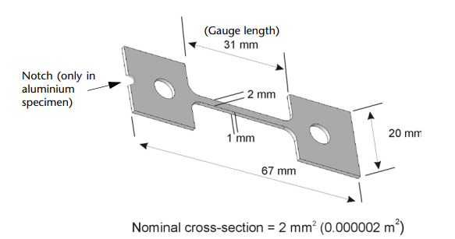

Figure 3 – The nominal values of the materials (TecQuipment, 2012)

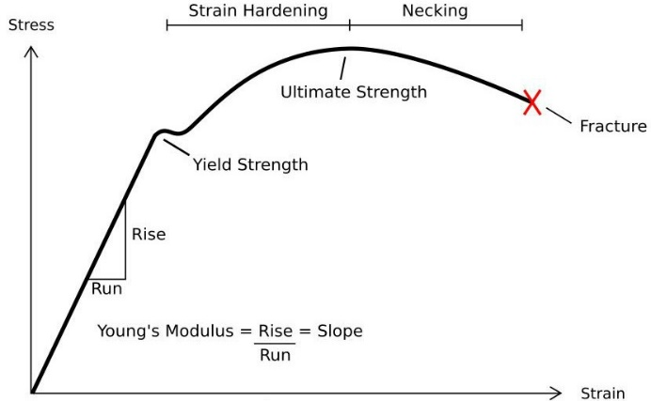

Figure 4 – A typical stress-strain graph (Figari, P.)

Results
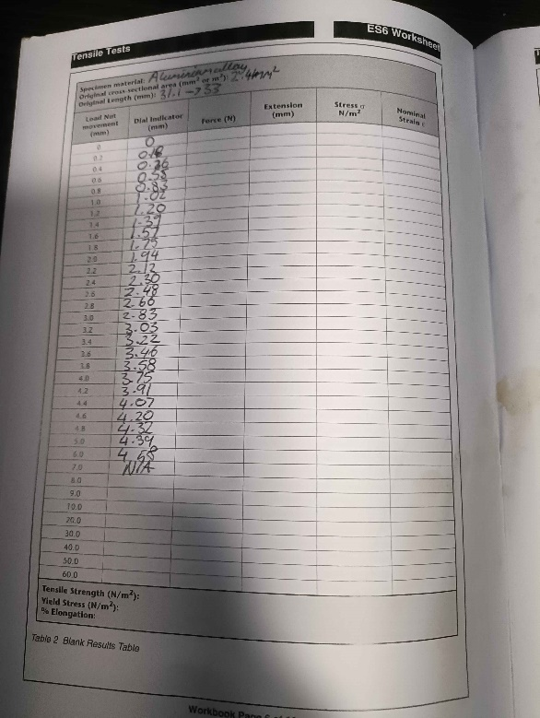
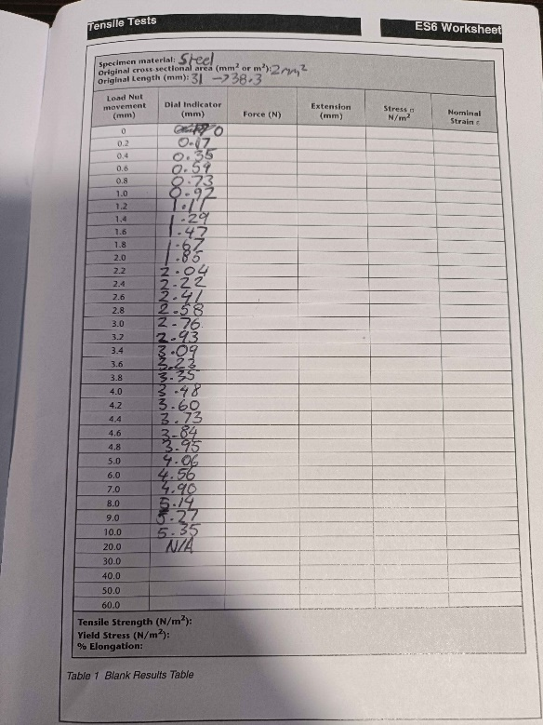

Figure 5 – Raw results for steel
Figure 6 – Raw results for duralumin

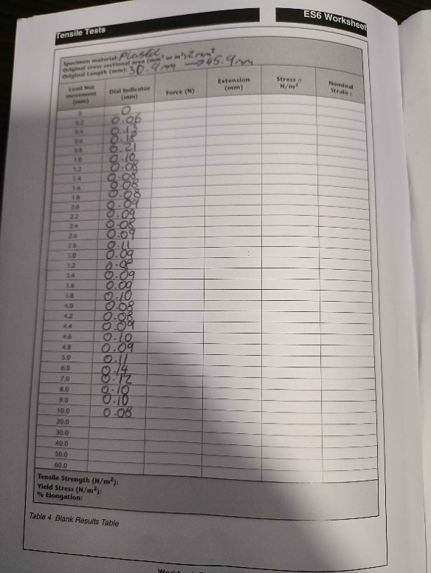
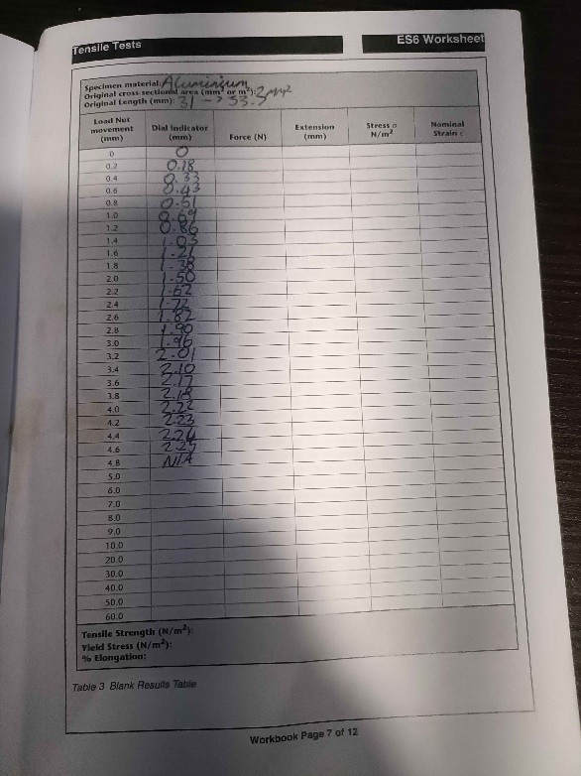

Figure 8 – Raw results for PVC
Figure 7 – Raw results for aluminium

Analysis
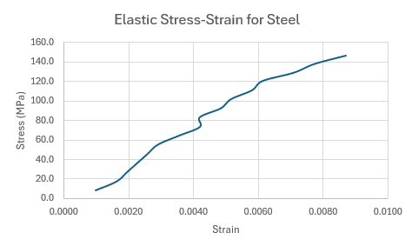
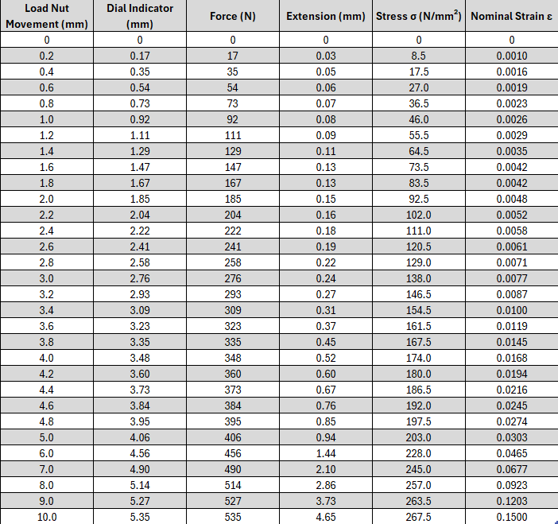
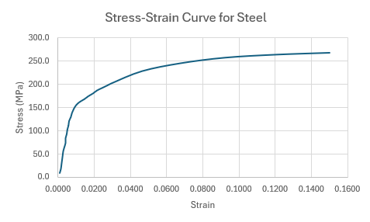
Figure 10 – A graph showing the elastic region of steel
Figure 9 – A graph showing the stress-strain curve for steel
Table 1 - The results table for steel
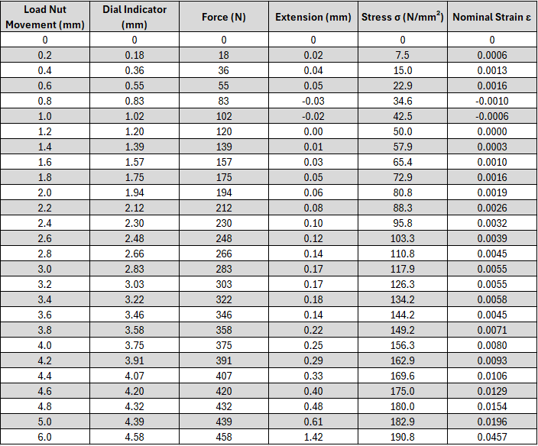
Table 2 - The results table for duralumin

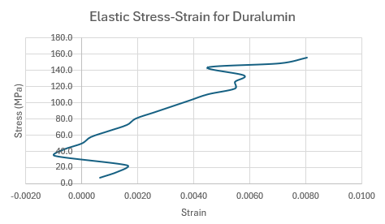
Figure 12 – A graph showing the elastic region of duralumin
Figure 11 – A graph showing the stress-strain curve for duralumin
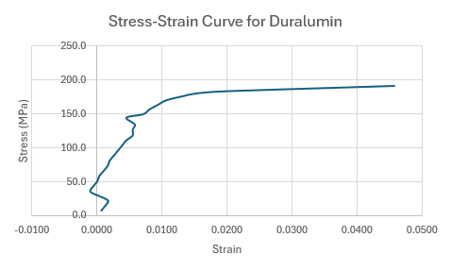

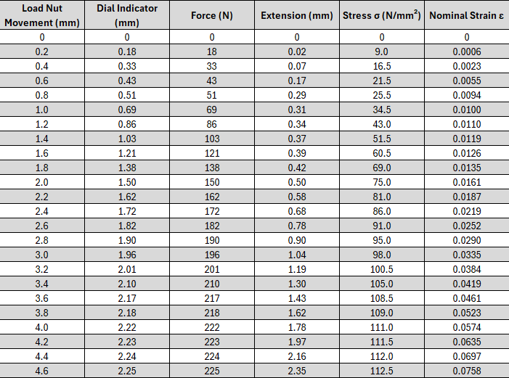
Table 3 - The results table for aluminium
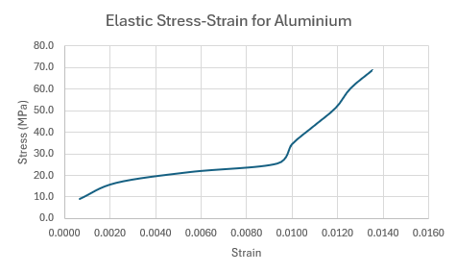
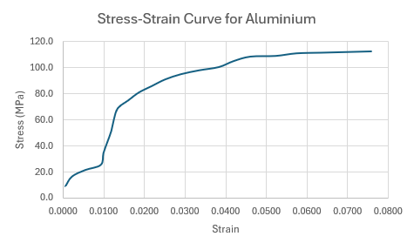
Figure 14 – A graph showing the elastic region of aluminium
Figure 13 – A graph showing the stress-strain curve for aluminium

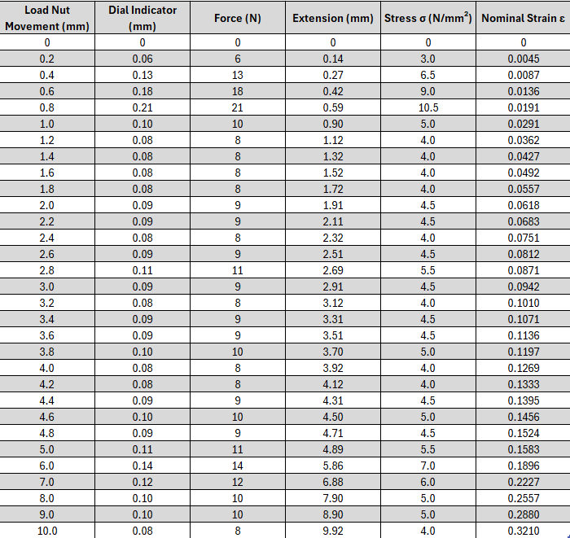
Table 4 - The results table for PVC

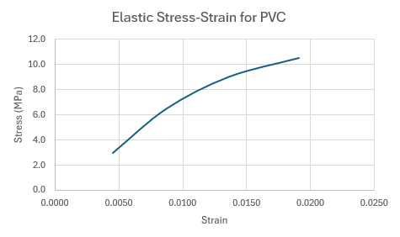
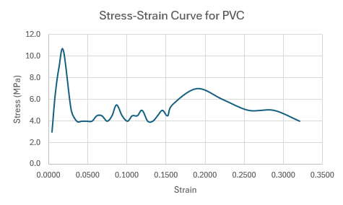
Figure 16 – A graph showing the elastic region of PVC
Figure 15 – A graph showing the stress-strain curve for PVC

Conclusion
In this experiment, four different materials were tested: Steel, Duralumin (an aluminium alloy), Aluminium, and PVC (Polyvinyl Chloride). The results for steel are largely what is expected, with a clear yield point and an elastic graph which has no obvious outliers. For duralumin, there are two outliers. One is towards the beginning, with the strain becoming negative, however it does continue in a linear manner afterwards. The other outlier is just before the yield point, where the strain again decreases, before continuing as expected. The results for aluminium are largely as expected, with a clear yield point. However, at a stress of roughly 15 MPa, the strain sharply increases, before again continuing as expected. For PVC, the results are very inconsistent, with the stress constantly fluctuating after the strain reaches 0.02, until which the stress-strain ratio is largely linear.

Evaluation
During the experiment, there were several measures taken to ensure that the results were as accurate and reliable as possible. One of these measures was ensuring that each person was focusing on only one task. One person was turning the load nut, another was stating the dial indicator readings, and a third person was recording the readings. This was to reduce the chance of human error as much as possible, as with each person being able to focus solely on performing one task,
Another measure that was taken to ensure that the experiment was as accurate as possible was applying a consistent rate of force to the load nut. This was done in an effort to maintain a constant extension of a given material, and ensured that no harsh forces were exerted that could make a material lose its strength. This then meant that there was less chance of an outlier coming up when analysing the results.

Further Work
Even though there were measures put in place to reduce the risk of errors in this experiment, there were still quite a few that occurred. There are many ways to improve the precision of the experiment however, which would lead to less mistakes and more accuracy.
One of these would be to use specialized equipment, which would be able to turn the load nut at a constant rate. This would ensure that there would be almost zero chance of any harsh movements on the material, as a computer is able to calculate its own speed and maintain a constant one far better than a human can. This would significantly increase the accuracy of the experiment, as this is the main source of outliers and eliminating the human element of this would remove that source.
Another piece of specialized equipment that can be used to increase the accuracy of the experiment is a computer which is able to measure the dial indicator at each specified load nut point. By being able to take exact measurements, there is a much-reduced risk of any outliers appearing in results. This is also another measure that reduces the human error risk, as a computer is much less likely to make a mistake reading measurements than a human is.
Additionally, the temperature within the room in which the experiment is conducted can also play a large factor in its results. If it is colder, some materials become more brittle, and if it is hotter, some materials become weaker. By conducting the experiment in a temperature-regulated room, the conditions under which each material is tested are the same, which means that the results are more likely to be accurate.
Finally, increasing the number of repeats to the test is a good way of ensuring accuracy. The main reason for this is that it greatly reduces the chances of having an outlier in the results, and for example in this experiment could show that what are thought to be outliers in fact are not. You can also do repeats at different temperatures to test each material and compare how they perform in a range of temperatures.

References
Figari, P. (n.d.) Steps to Analyzing a Material’s Properties From Its Stress/Strain Curve Available at: https://www.instructables.com/Steps-to-Analyzing-a-Materials-Properties-from-its/ (Accessed: 4th December 2024)
TecQuipment Ltd (2012) Engineering Science Guidance Notes; Tensile Tester Kit (Accessed: 13th November 2024)

