

Research on gas pipeline leakage detection and location based method on UWFBG
by
Yinjie Zhang

Supervisor: Gary

Project submitted as part of the requirements for the award of MSC Software Engineering

September 2023

DECLARATION

I, Yinjie Zhang declare that I am the sole author of this Project; that all references cited have been consulted; that I have conducted all work of which this is a record, and that the finished work lies within the prescribed word limits.

This work has not previously been accepted as part of any other degree submission.

Signed : .............................................

Date : ...............................................

FORM OF CONSENT

I, Yinjie Zhang hereby consent that my Project, submitted in candidature for the M.Sc. Software Engineering degree, if successful, may be made available for inter-library loan or photocopying (subject to the law of copyright), and that the title and abstract may be made available to outside organisations.

Signed : .............................................

Date : ...............................................

Abstract
There are great security risks in the process of natural gas transportation, especially for some pipelines that have been used for a long time and are in a complex environment, it is easy to cause pipe body damage and leakage due to material aging and corrosion of transportation medium. Once the pipe body damage leakage, if not found in time, will lead to unimaginable consequences. Therefore, the detection and location of pipeline leakage is particularly important. Traditional pipeline leakage detection methods such as manual detection method, infrared thermal imaging method, negative pressure wave method, acoustic detection method and model establishment method have the problems of poor real-time performance, low sensitivity, weak anti-interference ability and high difficulty in implementation. weak-reflectivity Fiber Bragg Grating (FBG) sensing technology has the characteristics of fast response, high sensitivity, strong anti-interference ability, simple installation and long detection distance. In this paper, a pipeline leak detection and precise location method based on low-reflection grating array technology is proposed. The vibration signal generated by pipeline leakage is perceived through grating array sensing optical fiber cable, and signal processing methods such as signal noise reduction and time delay estimation method are combined to realize the identification and accurate positioning of pipeline leakage characteristics. The main work is as follows:
- Through the analysis and comparison of several commonly used pipeline leakage detection technologies at home and abroad, combined with the advantages and characteristics of optical fiber sensing technology, a pipeline leakage detection technology based on large capacity, high density and low reflection grating array is proposed.
- This paper discusses the influence of environmental noise on the analysis of leakage signal, and proposes a noise reduction method based on Variational Mode Decomposition (VMD). Combined with the Finite Impulse Response digital low-pass filter, the vibration signal is deeply denoised. Firstly, the original signal is decomposed into several modal components. Then, according to the Pearson correlation coefficient between the different modal components and the original signal, the effective components were selected for reconstruction. Finally, a low-pass filter was used to reduce the noise of the reconstructed signal. The effectiveness of the proposed denoising method is demonstrated by comparing the SNR indices of different methods.
- Aiming at the problems of poor adaptability and high implementation difficulty in pipeline detection and location methods such as traditional machine learning and model building methods, a pipeline leakage detection and location method based on time delay estimation method is proposed. Firstly, whether the pipeline leakage occurs is determined by short-term energy analysis combined with frequency domain signal characteristics. Then, the peak value of the vibration signal in the rising stage of the amplitude was fitted by the least square polynomial, and the intersection point between the extension line of the fitting curve and the time axis was the time when the vibration signal arrived at the vibration sensing area. The leakage point was located by calculating the time difference between the vibration signal and the vibration sensing area on both sides of the leakage point.
- The pipeline leakage experiment scene is set up, and the working conditions of different distances, different initial pressures and different leakage aperture are simulated. The collected vibration signals are analyzed and processed, and the time domain and frequency domain characteristics of the pipeline leakage signal are obtained. The experimental results are consistent with the theoretical analysis and fluid simulation results mentioned above. The pipeline leakage experiment is simulated to verify the pipeline leakage detection and location method proposed in this paper. The experimental results show that the method can accurately identify the pipeline leakage event and accurately locate the leakage point, and the positioning error is about 1 m.

Chapter 1: Introduction

Source of topic
This topic comes from the key R&D project of Hubei Province "Research on Key Technologies of Leakage and Explosion Risk Prevention and Emergency Disposal of Urban Gas Pipeline Network" (2021BCA218).

Research background, purpose and significance
As a kind of clean and efficient green energy, natural gas has been widely used all over the world, and it strongly occupies the head of the proportion of combustible resources. Natural gas is frequently used in both people's livelihood and industrial production. Therefore, natural gas transportation is an extremely important step. At present, the main ways of natural gas transportation in our country include liquefied natural gas transportation, compressed natural gas transportation and long-distance gas transmission pipeline, among which long-distance pipeline transportation is the most frequently used and is the main way of natural gas transportation in the world [1,2]. In the process of natural gas transportation, it is inevitable that due to natural environmental factors, such as pipeline corrosion, pipeline deformation caused by heavy rain and flood, etc. There are also social and environmental factors, such as artificial theft, third-party construction, etc., as well as safety risks of the pipeline itself, such as pipe defects and pipe welding defects, which lead to pipeline leakage [3]. As a kind of flammable gas, if leakage occurs during transportation, the gas will spread rapidly [4,5], which is highly likely to cause combustion and explosion accidents [6,7]. It will not only cause economic losses, waste of resources, but also cause great pollution and damage to the environment. Figure 1-1 is the scene of two pipeline leakage and explosion accidents.
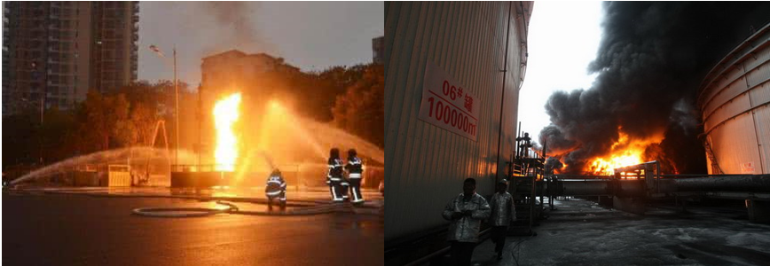
Fig 1-1. Scene of gas leak accident
Gas explosions are not uncommon. In 2011, a large area of gas leakage occurred in a street residential area in Jilin City, Jilin Province, resulting in an explosion; On July 20, 2016, a bank in Xingtai City caused an explosion due to a gas pipeline leak, causing varying degrees of damage to surrounding vehicles and houses. On the morning of February 17, 2017, a pipeline leakage explosion occurred near an intersection in Hebei province. The window of a bus passing by the explosion site was smashed, and two KTV employees were injured. On August 23, 2020, a gas pipeline explosion occurred in a suburb of Syria, directly interrupting the electricity supply throughout the country; On June 13, 2021, a trade market in Shiyan City, Hubei Province, ruptured due to severe corrosion of the steel pipe transporting natural gas. The leaked natural gas accumulated in a closed space and finally exploded when it met with the spark discharged from the oil fusing pipeline [8], resulting in many casualties. On Oct 21, 2021, a gas pipeline leak and explosion occurred at a barbecue restaurant in Liaoning province, causing many casualties and direct economic losses of about 44.25 million yuan. From the above many safety accidents, there is a huge potential safety hazard of gas pipeline leakage. Once an explosion occurs, it will cause unpredictable losses to the surrounding area. If the situation is light, it will cause economic losses, and if it is serious, it will threaten people's lives. If the post-fire treatment is not timely, the heat radiation conduction of the flame is likely to endanger the surrounding pipelines, resulting in catastrophic consequences. Therefore, real-time monitoring of pipeline leakage is very important. It is an important goal to stop the pipeline leakage in time or detect the leakage in the early stage of the pipeline leakage, and prevent the pipeline leakage from deteriorating continuously.
Due to the frequent occurrence of pipeline leakage accidents, researchers pay more and more attention to this kind of incidents, and the research on pipeline leakage detection and location is also more and more in-depth. This topic combines the low-reflection grating array technology with the pipeline leakage detection and location method. Through the combination of finite element simulation and field experiment, the influence of different factors on the pipeline leakage process is explored, so as to extract the characteristics of pipeline leakage. Finally, the detection and location of pipeline leakage are realized through the method proposed in this paper.

1.3 Research Status at home and abroad
At present, the technical means used in the field of pipeline leakage at home and abroad are the combination of pipeline leakage detection technology and signal processing methods to realize the detection and location of pipeline leakage.

1.3.1 Research status of pipeline leak detection technology
With people's attention to pipeline leakage accidents, many researchers have been exploring for decades, and pipeline leakage detection technology has made rapid progress. At present, the widely used pipeline leakage detection technology includes infrared thermal imaging detection method, negative pressure wave method, acoustic wave detection method, model building method and optical fiber detection method. The specific description of the above detection technology is as follows:
- Infrared thermal imaging detection method [9,10] : The infrared thermal imaging detection method is based on the thermal radiation effect. The infrared radiation information around the pipeline is collected by professional instruments, and the thermal imaging map is formed through data analysis and processing. When the pipeline leakage occurs, the temperature field around the pipeline changes, and the infrared radiation information will change accordingly, which is finally reflected in the thermal imaging map to realize the detection and location of pipeline leakage.
Safitr et al. [11] simulated the release and diffusion of gas in the leakage process of natural gas system by detecting the emission rate of leakage gas based on infrared thermal imaging, and gave the calculation results. Xiong et al. [12] combined infrared thermal imaging and deep learning technology to apply in gas pipeline leakage. The experimental results show that pipeline leakage can be detected when the data set is sufficient. Infrared thermal imaging detection method combined with robot or UAV can improve the detection efficiency to a certain extent, but when the pipeline is covered with soil and the leakage is small, the leakage cannot be effectively detected due to the weak thermal radiation around the leakage point [13].
- Negative pressure wave method [14] : The basic principle of the negative pressure wave method is that due to the pressure difference between the inside and outside of the pipe when the pipeline leaks, the fluid medium near the leakage hole flows out rapidly, and the fluid density at the leakage hole decreases rapidly, so that the instantaneous pressure difference between the leakage point and its adjacent position is formed, and the fluid on both sides of the leakage point quickly flows to the leakage hole, thus causing the fluid density and pressure in the adjacent area to decrease. As a result, the pressure on the whole pipeline gradually decreases with the leakage of the pipeline. This phenomenon gradually diffuses from the leakage point to the upstream and downstream of the pipeline, which is equivalent to generating a negative pressure wave propagating at a certain wave speed at the leakage point. It is called negative pressure wave in hydraulics. The principle of negative pressure wave detection is shown in Figure 1-2.
Sekhavat et al. [15] studied the theory of negative pressure waves and tested the method in a pipeline case study, which was validated. Chen et al. [16] used the negative pressure wave method to obtain the pressure wave velocity in the pipeline leakage experiment, and established a correction model to fully correct the propagation velocity of the negative pressure wave and improve the leakage positioning accuracy. The negative pressure wave method has low operation difficulty and high sensitivity, and can also quickly sense the leakage for long-distance transportation pipelines. However, for the case of small pipeline leakage, the recognition rate is low [17,18].
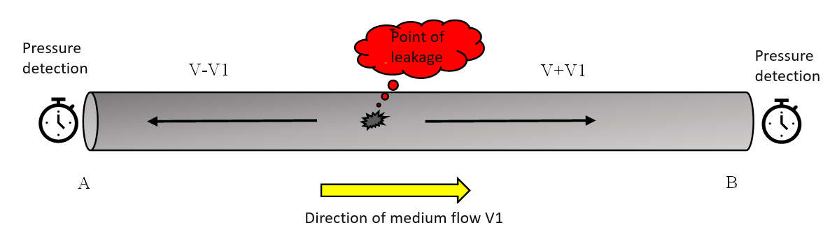
Fig 1-2 negative pressure wave detection method
- Real-time model checking method [19] : The working principle of the real-time model method is to establish a real-time model of the pipeline [20] by computer according to the relationship between the flow rate, density and pressure of the fluid medium in the pipeline, and simulate the fluid motion process in the pipeline [21]. The leakage threshold calculated by the simultaneous equations is compared with the actual pipeline monitoring data. If the actual value exceeds the set threshold, the pipeline leakage is determined.
Based on the Autoregressive exogenous (ARX) model, Mujtaba et al. [22] used flow quality measurements to estimate the pipeline model and tested the model at different locations. The results show that the method can identify the characteristics of different leakage sections in the pipeline in a specific environment. Zandi et al. [23] used three-dimensional simulation method to study gas leakage caused by pipeline failure in air environment and porous environment respectively, and the results showed that the simulation results were consistent with the field experimental results. The real-time model method is applied on the premise of the ideal working condition of the pipeline. Under the ideal condition, the monitoring effect of this method is good. However, in the actual work process of pipelines, due to the interference of many factors such as the external environment, there may be large differences between the actual pipeline model and the pipeline model established by the real-time model method, resulting in a high false alarm rate [24].
- Acoustic detection method: Acoustic detection method is based on the principle of pressure difference in the tube. Due to the pressure difference between the inside and outside of the pipe during leakage, the fluid in the pipe is rapidly ejected from the leakage hole, and the sound wave generated by the high-speed movement of the fluid and the friction of the leakage hole rapidly propagates and diffuses up and down the pipe wall. The principle is illustrated in Figure 1-3.
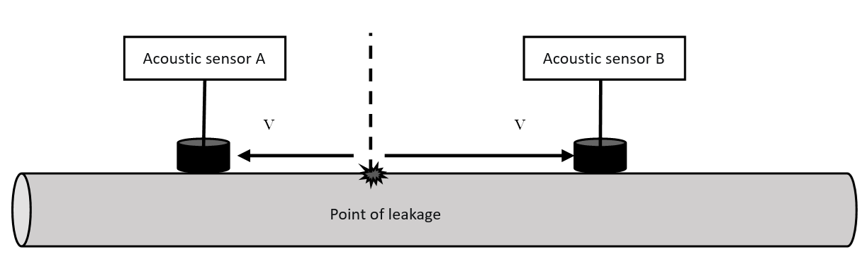
Fig 1-3 Acoustic detection method
Lukonge et al. [25] comprehensively expounded the application of AE technology in gas pipeline detection, and used this technology to simulate pipeline leakage experiments. Experimental results show that AE technology can detect leakage sound waves. Cao et al. [26] combined acoustic sensing technology with Hilbert-Huang Transform (HHT) processing algorithm to conduct experimental and numerical simulation research, and the results showed that the method could detect leakage in a specific environment. Through the acquisition, analysis and processing of sensor data [27], acoustic emission can quickly and accurately locate pipeline leakage, and it overcomes the disadvantage that negative pressure wave is not sensitive to small leakage. However, when the environmental noise is large, the acoustic signal will be disturbed in the propagation process, which will reduce the accuracy of pipeline leak detection and positioning. Traditional pipeline leak detection methods are compared in Table 1-1.

Table 1.1 Traditional pipeline leak detection methods are insufficient
Pipeline leak detection technology | deficiency
Infrared thermal imaging method | The monitoring effect is poor when the pipeline is covered with soil or the leakage per unit time is small
Negative pressure wave method | The monitoring effect of small leakage of pipeline is poor
Real-time Model checking | The false positive rate is higher when there is a large difference between the actual pipeline environment and the ideal model
Acoustic detection method | The signal is easily affected by environmental noise, and when the noise is large, the error is large
- Optical fiber detection method: optical fiber detection method is to use the special properties of optical fiber to sense the change of external temperature, strain and vibration and other physical quantities. When the pipeline leakage occurs, the change of external related physical quantities caused by pipeline leakage is sensed by optical fiber sensing technology. Optical fiber detection method is widely used in the field of pipeline leakage with complex environmental conditions because of its strong anti-interference ability, anti-corrosion, high precision and high response speed. The principle of its leakage detection is shown in Figures 1-4.
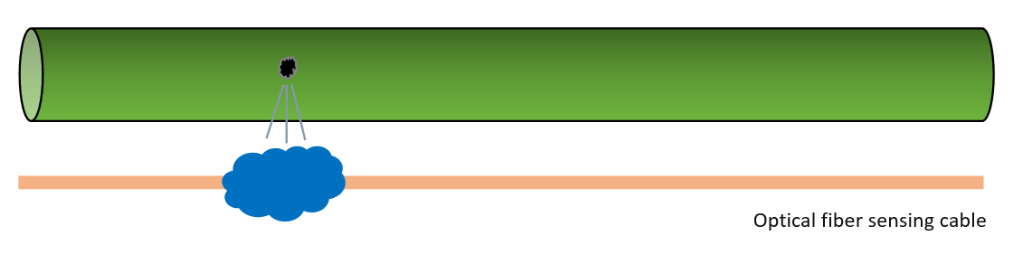
Fig. 1-4 Optical fiber detection method
Fiber sensing can be divided into fiber Bragg grating sensing technology [28] and distributed fiber Bragg sensing technology [29]. In fiber Bragg grating sensing technology, the fiber Bragg grating is used as the sensing unit to obtain the change of physical quantities of monitoring points through the reflected light wavelength. Distributed optical fiber sensing technology uses the frequency, phase and intensity information of scattered light inside the fiber to sense the external changes caused by leakage.

Ukil et al. [30] applied the commercial distributed temperature Sensor (DTS) in the gas pipeline experiment. The experimental results show that when the pipeline gauge pressure is 2 kPa, DTS can detect the temperature drop during the leakage process. Madabhushi et al. [31] established a pipeline leakage temperature model and obtained the calculation results. In the pipeline leakage experiment, DTS was used to sense the change of temperature, and finally the experimental results were compared with the theoretical model results. Zhou et al. [32] used DTS to monitor pipeline leakage and explored the change law of pipeline leakage temperature through finite element analysis combined with field experiments. Wang et al. [33] used DTS detection method based on Raman scattering, and DTS performed well in multi-point leakage detection. Experimental results show that DTS can detect the temperature change caused by pipeline leakage when the pressure difference between inside and outside the pipe is large. The disadvantage of DTS is that it is difficult for DTS to detect the temperature change for small leakage and small temperature difference between inside and outside the tube.
Due to the popularity of the negative pressure wave theory, the FBG pressure sensor is more and more widely used in the field of pipeline leakage. Hou et al. [34] used a fiber Bragg Grating (FBG) strain sensor to detect the negative pressure wave generated by pipeline leakage, and the experimental results showed that when the pipeline was 14 m long, the FBG could detect the leakage to the generated signal characteristics. Ren Liang et al. [35] installed FBG on the pipeline to measure the annular strain of the pipeline, and simulated various working conditions such as different leakage points and the number of leakage points to explore the leakage detection ability of FBG. The experimental results proved that for the 14-m long pipeline, the annular strain sensing could detect the leakage characteristics of the pipeline. Jiang et al. [36] developed an FBG ring strain sensor to capture the knee point based on the characteristics of the ring strain and combined with the relevant algorithm, so as to realize the leak location. Ren et al. [37] laid sensors on the pipeline at equal intervals, and detected pipeline leakage in the form of sensor array combined with the ring strain theory. Combined with the theoretical support of simulation and experimental results, the feasibility of ring strain for leakage detection in the case of limited pipeline length was verified. The disadvantage of FBG pressure sensor is that for small pipeline leakage and long-distance pipeline monitoring, the characteristic change of axial strain is not obvious, which may cause false alarm.
In view of the above shortcomings of DTS and strain sensors, distributed optical fiber vibration sensing (DVS) comes into being. DVS can sensitively capture perturbations caused by small leaks. Wang Shuo [38] used finite element simulation of flow field to simulate the pressure and fluid medium rate at the leakage hole during pipeline leakage, and used DVS to explore the influence of different factors on pipeline leakage. The results proved that DVS could detect the pipeline leakage characteristics with the diameter of leakage hole of 2 mm. Based on Mach-Zehnder/Sagnac hybrid interference principle, Zhao Ya et al. [39] applied distributed optical fiber detection technology to gas pipelines, and used signal processing method based on wavelet energy spectrum to diagnose leakage. Experimental results show that the false alarm rate of this method is 4.76%. Based on Mach-Zehnder/Zehnder hybrid interference principle, Wang et al. [40] established the optical polarization fading transmission model based on Jones matrix, designed a distributed optical fiber vibration sensor and applied it in pipeline leakage. Experimental results show that when the length of optical fiber increases from 1.5km to 9.5km, The relative error of leakage location decreases from 2.3% to 5.3%. Han et al. [41] applied DVS to gas pipeline leakage detection, combined empirical mode decomposition and approximate entropy to the optical fiber interference signal, and finally located the leakage point through the zero spectrum. The experimental results verify that DVS can be used for leak detection localization. YI et al. [42] used DVS detection technology in order to detect small pipeline leakage. After noise reduction processing of vibration signals collected in the experiment, they used correlation analysis method to locate the leakage. Liu Zhiwei [43] built a DVS pipeline leakage detection system, which can detect single-point and multi-point leakage with a resolution of 10 m. Although DVS has the advantages of long-distance monitoring and strong vibration perception ability, its disadvantage is low signal consistency and low signal to noise ratio under the interference of environmental noise [44]. The comparison of DTS, traditional point FBGS, and DVS in the field of pipeline leak monitoring is shown in Tables 1-2.
Table 1-2 Shortcomings of DTS, point FBG and DVS in pipeline leak monitoring
Optical fiber leakage monitoring technology |  | deficiency
DTS | The temperature change before and after the medium leakage in the tube cannot be monitored
Traditional point FBG | Long-distance distributed monitoring cannot be achieved
DVS | The signal consistency is low, and the signal SNR is low when the environmental noise is high

In recent years, optical fiber sensing technology based on low-reflectivity grating array has attracted much attention. Compared with the low reuse rate of traditional strong reflectivity fiber grating sensing technology, the grating array can reuse thousands of gratings on a fiber. Its high complex rate, high resolution, high sensitivity and its high signal-to-noise ratio in complex environments make it widely used in subway, pipeline and security and other fields.

1.3.2 Research status of pipeline leakage signal processing methods
Whether it is a pressure sensor or a vibration sensor, the original signal collected by it must contain environmental noise information, which will reduce the signal to noise ratio to a certain extent. If the noise is large enough to swamp the effective signal, the subsequent signal analysis and processing will be meaningless. For example, in the case of small pipeline leakage, noise is easy to cover up the leakage information, so it is necessary to preprocess the original signal.
- Filter denoising: Filter denoising is a traditional signal preprocessing method, which is based on the frequency domain characteristics of the noise, by suppressing the noise frequency band of the signal environment to achieve noise reduction. However, this method is difficult to separate the effective signal and noise signal in the same frequency band.
- Wavelet de-noising: The basic idea of wavelet de-noising is to pass the collected signal through wavelet transform, wavelet will disassemble the original signal from the frequency domain into components containing different frequencies, filter out the specific components according to the frequency domain characteristics of the noise, and retain the useful signal for reconstruction.
Urbanek et al. [45] used wavelet theory combined with kurtosis maximum value optimization to reduce the noise of pipeline leakage signal, and the results show that the noise reduction method can eliminate certain environmental noise and estimate the leakage degree of the pipeline. Cao Xuewei et al. [46] analyzed the mathematical characteristics of five commonly used wavelet bases, and used the root mean square error based on signal-to-noise ratio as the index to select the appropriate wavelet basis for noise reduction of pipeline leakage signals. The optimal noise reduction method is obtained through comparative experiments. The disadvantage of wavelet denoising is that the wavelet basis, the number of decomposition levels and the threshold need to be manually determined through experience, and different scenes may give different results.
- Noise reduction by Empirical Mode Decomposition (EMD) : EMD is a concept based on Intrinsic Mode Function (IMF), which can decompose the mixed signal into several IMF components according to the time scale. Finally, according to the time-frequency characteristics of the noise signal, the corresponding IMF is filtered and the signal is reconstructed, which is an adaptive signal decomposition method [47].
Jaafar et al. [48] used EMD to decompose the collected leakage signal, and adopted two indicators of standard deviation and variance in the selection of IMF. The results prove that this method has certain frequency domain analysis effect. Pan et al. [49] used the acoustic emission sensor to receive signals, denoised the original signals through EMD and wavelet decomposition, and then located the leakage source. The experimental results show that the noise reduction method can remove the environmental noise while retaining the leakage characteristics. However, EMD has the shortcomings of mode aliasing and end effects.
- VMD denoising: VMD is a signal decomposition method based on non-recursion proposed by Dragomiretskiy and Zosso[50] in 2014. It is formulated as a variational problem by iteratively searching for the variational modal optimal solution. VMD overcomes the mode aliasing problem of EMD to a large extent.
Xiao et al. [51] proposed an adaptive noise reduction method based on VMD and applied it to leakage signals under different working conditions. The experimental results show that the characteristics of leakage signals can be extracted from the denoised signals. Liu et al. [52] proposed a noise reduction method based on ANR-VMD applied to the negative pressure wave signal, and used the denoised signal to locate the pipeline leakage point. The results show that the positioning effect is better than that of using wavelet denoising and EMD denoising. The limitation of VMD lies in the determination of the number of modes K and the quadratic penalty term α before signal decomposition. If improperly selected, the signal decomposition effect will be counterproductive. And in the actual process of signal decomposition, there will be the problem of signal component bandwidth over-wide.
After denoising the original signal, the method of signal analysis and processing directly determines the accuracy of pipeline leak detection and location. Ferrante et al. [53] explored the change characteristics of the pressure at the leakage point when the pipeline leaked, and used the wavelet singular value analysis method to locate the leakage point. The experimental results show that the method can detect the singular value point generated by the leakage. Liang et al. [54] built a pipeline leakage detection platform based on FBG pressure sensors, and obtained the time difference between negative pressure waves arriving at different sensors by detecting singular values based on wavelet decomposition, and finally realized leakage detection and positioning. Experimental results show that the average positioning error is 14.17% when the pipeline length is 3.92 m. Singular value detection methods based on wavelet decomposition are widely used at present, but their shortcomings lie in the lack of adaptability in the selection of wavelet basis and decomposition level.
Li et al. [55] proposed a pipeline leak detection method based on sparrow search and Convolutional Neural Network (SSA-CNN), which optimized the parameters of CNN through SSA algorithm. Experimental results show that the proposed method can accurately classify 148 sample points in 150 test sets under the premise of 1500 data sets. Ning et al. [56] proposed a neural network structure combining spectrum enhancement and Convolutional Neural Network (SE-CNN) to detect gas pipeline leakage. The experimental results show that SE-CNN has an average recognition accuracy of 94.3% for six different types of leakage conditions under the premise of a data set of 3840 in a strong noise environment. Singh et al. [57] proposed a fingerprint positioning method based on the Nearest Neighbor node algorithm (KNN) to locate the leakage point. Experimental results show that the positioning error obtained by this method is less than 200m for a 10km pipeline. However, the pipeline leak detection method based on machine learning is complex in theoretical calculation, requires a large number of data samples for different environments of pipelines, and is difficult to apply to the actual pipeline.
Mostafapour et al. [58] used acoustic emission technology to detect pipeline leakage, and used the filtered signal to locate the leakage point through cross-correlation operation. The results of many experiments show that the positioning error of this method is about 5% when the pipeline length is 5.6 m. Lee et al. [59] used the cross-correlation technology to obtain the time delay of acoustic waves arriving at different sensors, and used the wave speed selection method based on VMD to locate. Finally, according to the leakage simulation experiment, it was verified that this method could be used for pipeline leakage location. Fang et al. [60] proposed a cross-correlation localization method based on MVMD. MVMD method was used to reduce the noise of the leakage signal, so that the signals received by different sensors retained the same leakage frequency component, and then the generalized cross-correlation method was used to determine the time difference between the leakage signal arriving at different sensors for positioning. For pipelines within 10 m, the average positioning error of the proposed method is less than 2.2%. The positioning method based on cross-correlation has a high requirement on the consistency of sensor signals at both ends of the leakage hole. If the environmental noise is large, the signal consistency will be affected to a certain extent.

1.4 Main research content and structure arrangement of this paper
In this paper, the vibration signal generated by pipeline leakage is taken as the main research object, and the characteristics of vibration signal under different leakage distance, leakage aperture and initial pressure are studied by means of finite element simulation and field experiments. In the simulation leakage experiment, combined with the characteristics of optical fiber sensing technology, the low-reflection grating array is used as the signal sensing unit of pipeline leakage, and a signal denoising method based on VMD is proposed. The effectiveness of the method is verified by actual collected signals. A pipeline leak detection and location method based on low reflection grating array with time delay estimation is proposed. The main contents are as follows:
Chapter 1 is the introduction. This paper mainly introduces the research background, purpose and significance of gas pipeline leakage and location. By introducing some safety accidents caused by pipeline leakage, this paper analyzes the current research situation of pipeline leakage at home and abroad, and puts forward the main research content of this paper.
Chapter 2 is the theoretical research of pipeline leak detection and location. The vibration sensing principle of low reflection grating array and the vibration detection and location principle of pipeline leakage are studied.
In Chapter 3, a signal noise reduction method based on VMD is proposed, and the comparative analysis of different noise reduction methods is used for the collected original signal, and the effectiveness of the method is verified by experiments. This paper introduces the time delay estimation method in pipeline leakage location, and proposes a pipeline leakage detection and location method based on time delay estimation method according to the characteristics of leakage signal, and introduces the method process in detail.
Chapter 4 introduces the experimental site, simulates the leakage process of different leakage distance, initial pressure and leakage aperture, and compares and analyzes the experimental exploration results with the fluid simulation results to obtain the signal characteristics. In order to verify the effectiveness of the proposed method, the proposed method is used to detect and locate the pipeline leakage point. The experimental results show the effectiveness of the proposed method.
Chapter 5 summarizes the main work of this paper and gives a further outlook on this research.

Chapter 2: Sensing principle of Ultra-weak fiber Bragg grating and pipeline leakage mechanism

2.1 Principles of Ultra-weak fiber Bragg grating
In 1978, a communications research center in Canada found the photosensitive phenomenon in quartz fiber, and on this basis, the use of argon ion laser to the standing wave method developed the world's first fiber grating; In 1989, with the joint efforts of some researchers in the United States, Fiber Bragg Grating (Fiber Bragg Grating) was made, which was a milestone in the history of fiber sensing technology. Since then, researchers started to study fiber Bragg grating in depth, and the development of fiber sensing technology began to advance rapidly. Because of the unique advantages of fiber Bragg grating sensor: anti-electromagnetic interference, anti-high temperature, anti-corrosion, light weight, low cost and multi-point multiplexing, so that it can be flexibly applied in various fields, it has become a popular choice in the sensor. Traditional fiber gratings are manually written in the fiber. This method has low multiplexing ability and is difficult to realize for long distance and large scale networking. The low reflection grating array can reuse thousands of gratings on a single fiber, which overcomes the shortage of low reuse rate of traditional fiber grating sensor and easily realizes large-scale networking. The low-reflection grating array is fabricated by the online preparation technology of pull-tower fiber Bragg grating. At present, only the National Engineering Research Center of Fiber Sensing and Network of Wuhan University of Technology and IPHT and FBGS company of Germany have grasped this technology and quantized production. In the production process, the spacing of the grating can be set in advance by the machine program. Its consistency is well guaranteed.

2.1.1 Vibration sensing system
According to the difference of signal modulation, fiber optic sensors can be divided into phase demodulation, intensity demodulation and wavelength demodulation. Its working principle is: when the pipeline leaks, the vibration signal generated by the leakage point propagates along the pipe wall to both ends, when the leakage vibration signal passes through the grating, the vibration information will act on the sensing arm, resulting in a change in the fiber refractive index, so that the optical phase changes. At this time, the optical signal in the reference arm will interfere with it, and the external disturbance will change the light intensity of the beam after interference. Finally, the change of the interference signal can be detected by the photodetector, and the leakage vibration signal can be demodulated. The Ultra-weak fiber Bragg grating(UWFBG) system is shown in Figure 2-1.
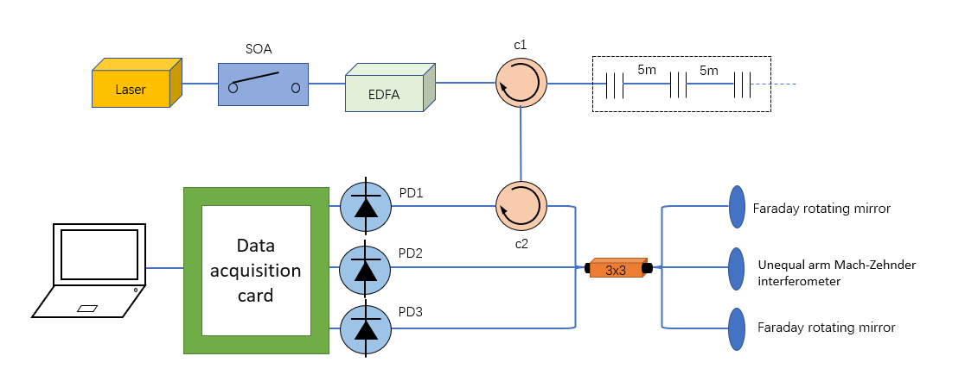
Fig. 2-1 General framework of UWFBG sensing system
Firstly, the laser will emit a light source, the laser source will be modulated by the pulse modulator, and the modulated optical signal will become a pulse optical signal to continue to propagate forward, and continue to be enhanced by the Erbium-doped fiber amplifier (EDFA). The enhanced pulse optical signal will first enter port 1 of the optical circulator No. 1, and then come out of port 2 of the optical circulator. According to the principle of time division multiplexing sensing technology, different gratings will reflect the reflected light back at different times. The reflected light signal of adjacent gratings will enter from the second port of the optical circulator, come out from the third port, and then pass through the second optical circulator to the coupler. After passing through the long and short arms of the Michelson interferometer, the optical signal will be reflected by the Faraday rotating mirror into four optical signals. When the adjacent grating spacing is equal to the difference between the long and short walls of the interferometer, the two beams of light will meet in the coupler, and then the light interference will occur. The interference signal is converted into electrical signal by photoelectric converter, and the high-speed data acquisition card will collect the electrical signal, and finally upload it to the upper system for signal analysis and processing. The FPGA module generates pulse signals for the pulse modulator to drive the optical signal forward, and generates pulse signals for the high-speed data acquisition card to drive signal acquisition.

2.1.2 Principle of phase demodulation
When the part between two adjacent gratings is disturbed due to external vibration, the refractive index at this position will change. This phenomenon of changing the refractive index caused by elastic deformation due to external force is called photoelastic effect. According to the optical theory, if the light enters the fiber and the moving distance is, the phase delay of the light will be obtained:
(2-1)
In the above equation β represents the fiber propagation coefficient, which is a constant. It is obvious that when the fiber propagation coefficient β and the fiber movement distance L change, the phase of the light will also change accordingly, and the specific change is as follows:
（2-2）
According to the fiber material characteristics, when the fiber is subjected to external stress, deformation will occur. According to the decomposition of force in mechanics, the external force can be decomposed into the force perpendicular to the fiber axis and the force along the fiber axis. The force along the fiber axis will change the length, diameter and refractive index of the fiber, and the force perpendicular to the fiber axis will not cause obvious influence on the fiber. The $∆β$in Equation (2-2) can be obtained as follows:
(2-3)
In Equation (2-3), D and n respectively represent the diameter of the fiber core and the refractive index of the fiber core. The left side of the right side of the equation represents the phase change due to changes in diameter and refractive index of the fiber core, and the right side represents the phase change due to the amount of change in fiber length. In fact, the fiber diameter changes hardly change the phase. Therefore, Equation (2-2) can be simplified as follows:
(2-4)
The phase change of light can be expressed as follows:
(2-5)
In Equations (2-5), $P_{11}$ and $P_{12}$ both represent the elasto-optic coefficients of the single-mode fiber, $μ$ and $λ_{0}$represent the Poisson coefficient of the fiber and the wavelength of the fiber in vacuum, E represents the Young's modulus of the fiber, and F represents the transverse force and strain tensor of the fiber. According to the formula, it can be obtained that the phase difference between the interfering lights can be calculated to obtain the externally imposed stress variable.

2.1.3 Reuse technique
By 2022, the total length of urban gas pipelines in China will exceed 900,000 kilometers, so the monitoring length must match it to achieve effective monitoring. Fiber grating multiplexing technology includes time division multiplexing (TDM) technology, Wave division multiplexing (WDM) technology, space division multiplexing (SDM) technology [61] and hybrid multiplexing technology. Traditional FBG sensors usually have weak reuse ability, and can not meet the long-distance monitoring, so UWFBG sensing technology with high reuse rate must be used to meet the needs of long-distance practical engineering. UWFBG achieves the long-distance and large-capacity requirements in practical engineering applications through time division multiplexing grating sensing technology [62]. The UWFBG TDM grating sensing system is shown in Figure 2-2.
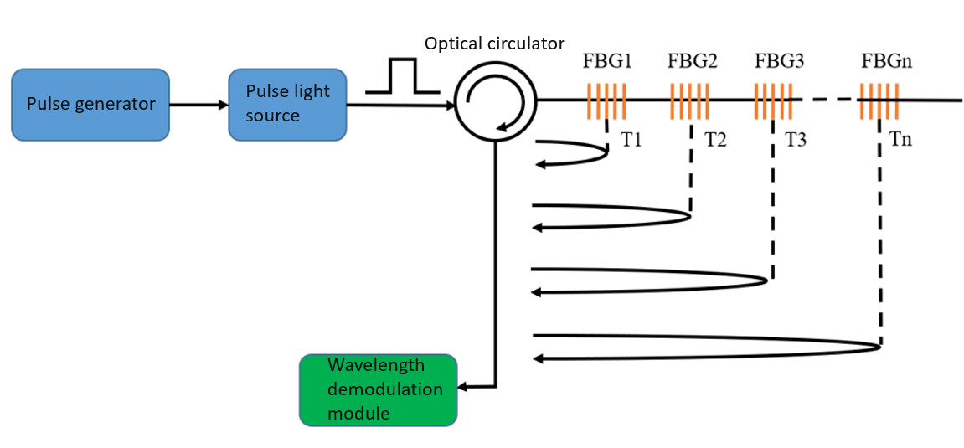
Fig 2-2 UWFBG TDM grating sensing system
Time division multiplexing (TDM) grating sensing technology performs grating expansion in the form of series topology. A large number of uniformly spaced low-reflection gratings with the same central wavelength are multiplexed on a sensing fiber. The broadband light source is passed through the pulse generator to form a broadband pulse light source. The pulse light source first arrives at the optical circulator, and then enters the low reflection grating array. Because the gratings are connected in series and the spacing between the gratings is certain, the time for the light signal to arrive at different gratings is different, and the time for the reflected light signal to return is also different. The wavelength information of different gratings can be demodulated by the time difference of the reflected light back. Assuming $L_{i}$ is the distance between the optical circulator and the ith FBG, the return time satisfies the following equation:
(2-6)
In the above equation, c represents the propagation speed of light and $n_{eff}$ represents the effective refractive index of the fiber core of the optical fiber.

2.2 Generation mechanism and propagation characteristics of pipeline leakage vibration signal

2.2.1 Mechanism of production
Most of the pipelines used for natural gas transportation in our country are steel. In the process of gas transportation, due to a small amount of moisture in the environment, as time goes by, chemical reaction between iron and oxygen in the water causes rust. From other points of view, due to the poor geological environment of the pipeline, the influence of temperature, internal pressure, and external load, pipeline leakage accidents occur frequently. The main leakage reasons are as follows [63] :
- Cracking of the pipe weld leads to leakage. The pipe welded by various steels is prone to connection problems at the welding point. For example, there are many welds at the welding point. If it is subjected to large gas pressure for a long time, the welding place is prone to cracking, resulting in leakage. Secondly, the possibility of misalignment at the weld will cause the weld to be weak, and once the pressure exceeds its capacity, the pipeline will leak.
- A perforated pipe resulted in a leak. If the pipeline is placed in a strong corrosive or wet harsh environment for a long time, under the action of chemical reactions between various elements, the outer surface of the gas transmission pipeline will slowly be corroded, and with the growth of time, the corrosion speed will be faster and faster, thus the pipeline perforation occurs, causing pipeline leakage and reducing the life of the pipeline.
- The rupture of the pipe caused the leak. Because most natural gas pipelines are very long, and there are a lot of gas in the pipeline, in the process of gas transportation, if there is unreasonable pressure distribution at different positions in the pipeline, it may lead to local pressure overload of the pipeline and pipeline fracture accidents. Due to the pipeline manufacturing process and pipeline quality problems, the pipeline was broken. For buried gas transmission pipeline, if the location of the pipeline collapses, or serious corrosion of the pipeline, it may lead to the fracture of the pipeline. Pipeline leakage caused by pipeline fracture is much more harmful than the above two cases of pipeline perforation and pipeline welding crack.

2.2.2 Propagation characteristic
When the pipe is damaged and leakage occurs, the huge pressure difference between the inside and outside of the pipe will cause the fluid medium in the pipe to spray quickly from the leakage hole to the outside of the pipe, forming a multiphase turbulent jet at the leakage. This phenomenon will suddenly change the normal movement of the fluid medium in the pipe, and due to the friction between the fluid and the crack of the leakage hole, the interaction will radiate certain energy. The turbulence generated by leakage is a complex process, and its boundary change law is random. The change will be along with the generation of pulsating pressure, which will lead to the generation of vibration. Related studies have mentioned that the degree of pulsating pressure is related to the velocity of the fluid medium in the tube, and the sound pressure generated by the change of the fluid velocity field in turbulence is a random function. Mani et al. [64] have studied that the sound pressure generated by the turbulent region can be approximately expressed as follows:
(2-7)
In the above equation, C is proportional to the volume of the turbulent region, L represents the characteristic length of the vortex, and v represents the fluid flow velocity in the tube. Therefore, we can obtain that the sound pressure generated in the turbulent region is positively correlated with the fluid flow velocity in the tube as well as the eddy characteristic length.
The vibration signal collected on the pipe wall through the UWFBG is essentially the vibration source response and transmission generated by the leakage. The sound pressure generated by turbulence can cause the vibration of the tube wall, and the amplitude of the vibration is positively correlated with the sound pressure. The vibration signal of a point on the pipe wall is expressed by Fourier series:
(2-8)
In the above equation, $f_{i}$ represents the vibration frequency of the pipe wall, $α_{i}$ is the amplitude of the pipe wall, and $θ_{i}$ represents the initial phase of the vibration. Because leakage will produce different types of waves, there are many factors affecting the frequency generated in turbulence, and the specific frequency range cannot be determined. If the frequency is between (tl,tg), the following equation can be obtained:
(2-9)
In the formula, y(t) represents the pipeline vibration caused by other unknown factors, and the pipeline vibration is positively correlated with the sound pressure, that is, $a_{ti}$ is positively correlated with the sound pressure p. The vibration amplitude of the pipeline caused by turbulence can be obtained by the above equation simultaneously:
(2-10)
In the above equation, $C_{t}$ represents a constant, which is linked to the physical properties of the fluid in the tube. $b_{ti}$ represents the coupling relationship between pipe and sound pressure, which depends on pipe material and size. $d_{i}$ denotes the relevant quantity in the turbulent region of the tube. Therefore, it can be finally obtained that when the pipeline leaks, the pipe wall will vibrate due to the sound pressure generated by the leakage, and they are positively correlated. The sound pressure is positively correlated with the flow velocity of the fluid inside the pipe, so the amplitude of the pipe wall is positively correlated with the flow velocity of the fluid inside the pipe.
The negative pressure wave, stress wave, infrasonic wave and ultrasonic wave [65] generated by the leakage will propagate along both ends of the leakage hole, and the frequency range of the above waves is from 0.01Hz to 10¹²Hz. These waves generated because of leakage will carry information related to the leakage, such as leakage aperture, leakage amount, leakage location and other information. When the pipe leaks, the fluid movement process in the pipe is shown in Figure 2-3.
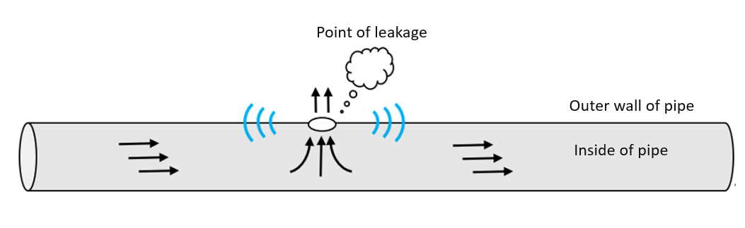
Figure 2-3 Schematic diagram of the pipeline leakage process
The sound wave is divided into horizontal and vertical waves, longitudinal waves and surface waves. The wave whose propagation direction is consistent with the vibration direction is called shear wave, which can only propagate in solid. The wave whose transmission direction is parallel to the vibration direction is called longitudinal wave, and it can propagate in different media. The surface wave is the wave transmitted along the surface of the pipe wall to the two ends, in which shear wave and surface wave are the main propagation modes. Sound wave is divided into infrasonic wave, acoustic wave and ultrasonic wave according to the different generation frequency. The propagation speed of sound wave will change with the change of medium, and its propagation speed in natural gas is about 300 m/s. Negative pressure waves can usually be detected using pressure sensors, and in gas pipelines, the propagation speed of negative pressure waves is usually of the same order of magnitude as the speed of sound. Stress wave is a kind of mechanical wave generated by the friction between the leakage medium and the pipe wall. Its propagation speed from the pipe wall to both ends of the pipe is greater than the speed of sound. The propagation speed of the stress wave in the steel pipe is about 5000m/s. In the process of transmission, the above wave will be accompanied by the vibration of the medium, that is, the leakage vibration signal will be transmitted from the leakage point along the pipeline to different UWFBG, and this vibration signal is a continuous and non-stationary signal, and the vibration signal will be attenuated by environmental factors such as reflection, refraction and the blocking effect of the medium on the propagation. Therefore, the pipeline leakage can be detected and located by analyzing and processing the vibration signal collected by UWFBG.

2.3 Principle of pipeline leak location
When the gas pipeline leaks, various waves generated by the interaction between the fluid and the pipe wall will propagate from the leakage point along the pipeline to both ends, and carry the vibration information of the propagation medium to the vibration sensing area between different gratings. The vibration signal is immediately reflected in the collected signal after the vibration signal is sensed in the area, as shown in Figure 2-4.
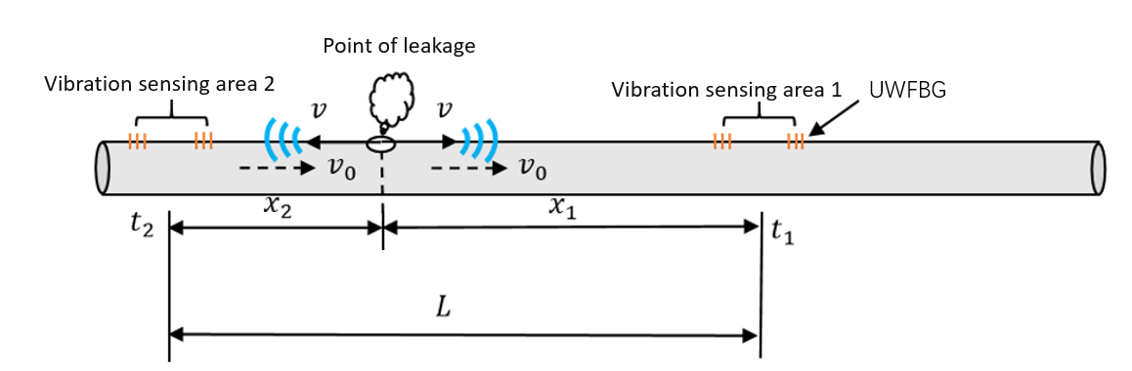Fig 2-4 Principle of pipeline leak location
The time difference $∆t$ of vibration signal transmission can be calculated by determining the time when the leakage vibration signal arrives at different vibration sensing zones, and the wave speed is known as v, the fluid speed in the tube is$v_{o}$, the distance between the two closest vibration sensing zones on both sides of the leakage point is L, and the distance between the leakage point and vibration sensing zone 1 is set as $x_{1}$. The distance from vibration sensing area 2 is $x_{2}$($x_{1}>x_{2}$), the time when the leakage vibration signal reaches the vibration sensing zone 1 and 2 is $t_{1}$ and $t_{2}$, respectively. According to the above conditions, Equations (2-11) to (2-13) can be obtained:
(2-11)
(2-12)
(2-13)
Simultaneously, the distance $x_{1}$ from the leakage point to the vibration sensing zone 1 can be calculated as follows:
(2-14)
The medium flow speed in the city gas pipeline is usually 1m/s, which means that $v_{o}$ is far less than v. Equation (2-14) can be simplified as follows:
(2-15)
According to Equation (2-15), since the distance between the vibration sensing zones on both sides of the leakage point and the propagation speed of the leakage vibration information are known, the location of the leakage point only depends on the $∆t$ difference between the vibration signals arriving at different vibration sensing zones.

2.4 Summary of this chapter
This chapter first introduces the basic vibration sensing principle of low reflection grating array, combined with the characteristics of gas pipeline requiring long-distance monitoring, the multiplexing mode of UWFBG is introduced in detail. In order to sense the disturbance caused by pipeline leakage, the UWFBG vibration sensing system and the principle of phase demodulation are described. When the pipeline leaks, the fluid medium in the pipeline will rub with the leakage wall to generate various waves. The wave propagation is accompanied by the vibration of the medium. The vibration sensing area on both sides of the leakage point can sense the change of vibration information to obtain the time difference of the arrival of the leakage vibration information, so as to realize the positioning of the leakage point. This chapter provides a theoretical basis for the detection and location of pipeline leakage.

Chapter 3: Research on pipeline leak detection and location method
As described above, in the process of gas transportation, the gas pipeline may leak due to some reasons. In order to accurately detect and locate the leakage point, the perception unit needs to obtain the leakage signal by collecting signals, and use the relevant signal analysis method to process the collected vibration signal. In the process of signal acquisition, due to the interference of environmental factors such as the environment of the pipeline, the signal will inevitably be aliased by various environmental noise signals. If the environmental noise signal interference is too large, it may interfere with the leakage information in the signal, which will affect the accuracy of leakage detection and positioning. In order to reduce the difficulty of extracting the leakage information in the signal, signal de-noising is very necessary. This chapter first introduces the classification of pipeline environmental noise, proposes a noise reduction method, and verifies the effectiveness of the noise reduction method through experimental comparison. Secondly, the pipeline leak detection and location method based on time delay estimation proposed in this paper is introduced in detail.

3.1 Vibration signal preprocessing method
In the actual pipeline laying, it will be disturbed by various environmental noises, which will cause a certain degree of interference to the signal analysis and processing. If the noise is too large, it will even drown the effective signal features. So, the understanding of the noise source will play a certain role in signal analysis and processing. According to the nature of the classification, noise can be divided into two main categories:
The first category is the environmental noise of the pipeline, which can be divided into four types according to the noise source: (1) noise generated inside the pipeline. Natural gas pipeline is generally composed of multiple pipe sections of the same material. In the process of gas transmission, due to the flow of gas inside the pipeline, the gas will rub and interact with the welding site, resulting in noise. (2) A variety of environmental noises outside the pipeline. For example, pedestrians walking around the pipeline, vehicles honking, driving, wind and grass moving and other movements will generate noise, which will affect the collected signal. (3) Unknown source noise. Some gas pipelines are laid in the suburbs outside the city, the environment is complex, and the unknown strong noise will mix with the collected vibration signal.
The second category is in the terminal equipment that collects the signal, which in this experiment refers to the FBG demodulator. In the process of signal transmission and processing, there will be a certain circuit interference noise, which mainly includes four kinds: (1) noise generated by power supply equipment. When the power is supplied to the fiber Bragg grating demodulator through the power line, there will be some interference due to the transmission of current. (2) end surface reflection and crosstalk noise. There are many signal transmission circuits in the fiber Bragg grating demodulator, and electrical crosstalk noise will be generated due to electromagnetic induction during the transmission of electrical signals. If the fiber and the demodulation instrument joint is not cleaned with alcohol, it will cause interference to the signal transmission, resulting in the end reflection phenomenon, so that the output vibration signal is unstable and fluctuates greatly; (3) There are a variety of different electrical hardware modules in the fiber Bragg grating demodulator. When the circuit is connected, it will produce noise into the signal, such as amplifier, filter and other electrical modules will produce noise; (4) the noise generated by the ground line. A large number of circuits in the fiber Bragg grating demodulator will have multiple ground lines, which will produce some interference noise due to the existence of potential difference. This kind of noise is mainly due to the production of terminal equipment in the manufacturing process.
Because the noise generated inside the fiber Bragg grating demodulation equipment can only be removed by relevant technical means in the process of instrument production, and cannot be solved by post-signal processing, this paper only studies the noise reduction of the first type of pipeline environmental noise.

3.1.1 The VMD-Pearson-FIR signal denoising method
(1) Principle of VMD
EMD decomposition algorithm is a signal decomposition algorithm for non-stationary signals proposed in 1998. It is an adaptive algorithm, which can decompose mixed signals into multiple signals on different time scales. However, there are some related problems such as end effect and mode mixing, which may lead to the loss of effective information in the signal decomposition process. In 2014, Konstantin Dragomiretskiy proposed VMD algorithm to overcome the problems of mode aliasing and end effects. VMD is based on a completely non-recursive signal decomposition model, which searches for the optimal solution of the variational model through an adaptive iterative way. The optimal bandwidth and center frequency of different Modal components (IMF) were obtained, and the effective decomposition of different IMF components was realized. VMD method has been widely used in the field of signal noise reduction. Each IMF will be defined as the corresponding AM and FM signal [67] :
(3-1)
Hillbert transform is applied to different IMFs to obtain different one-sided spectra:
(3-2)
In different IMFs, the corresponding center frequency is adjusted by adding different index terms, and different IM is modulated to the corresponding baseband by frequency shift:
(3-3)
The bandwidth of different IMFs is obtained by Gaussian smoothing:
(3-4)
Then the constrained variational problem model can be obtained as follows:
(3-5)
(3-6)
In the above equation, a represents the different K IMF components of the signal obtained after VMD decomposition, and $ω_{k}(k=1,⋯,K)$ represents the corresponding center frequencies of different IMF components.
In order to solve the constrained variational model, it is necessary to combine the Lagrange multiplier method and the quadratic penalty term to transform the constrained problem model into an unconstrained variational problem. The quadratic penalty term can ensure the accuracy of the reconstructed signal in the case of external interference. The constraint condition of the Lagrange multiplier method is certain strict, and the following augmented function can be obtained:
(3-7)
In the above formula, $α$ and λ represent the quadratic penalty function term and Lagrange multiplier respectively, and then the alternating direction method of multipliers is used to find the optimal solution. In the above formula, $u_{K}^{n+1}$ can be expressed as:
（3-8）
Where $ω_{k}$ and $\sum_{i}{u_{i}}(t)$ are equivalent to $ω_{k}^{n+1}$ and $\sum_{i}{u_{i}}{(t)}^{n+1}$ respectively, and the signal frequency domain information can be obtained by Fourier transform:
(3-9)
Replacing $ω-ω_{k}$ in the formula with $ω$, the update expressions of different IMF components can be obtained through quadratic optimization:
(3-10)
Meanwhile, the update expression of the center frequency $ω_{k}$ is as follows:
(3-11)
According to the above process description of the VMD algorithm, the steps of obtaining different IMFs through VMD are as follows:
- Set the initial value 0 for $μ_{k}$, $ω_{k}$, λ and n, and determine the number of mode decomposition K and the maximum number of iterations.
- The number of loops is determined according to the set K value, and ${\hat{μ}}_{k}$ and $ω_{k}$ are continuously updated by iteration in (3-10) and (3-11).
- Then update continuously according to Equation (4-12), where $τ$ is usually 0.
(3-12)
- Equation (3-13) is the judgment of accuracy threshold, which is responsible for determining whether the accuracy meets the expected requirements. If the accuracy is not enough, the above steps will be repeated iteratively until the accuracy is satisfied, and K modal components that meet the conditions will be obtained.
(3-13)
Before using VMD for signal decomposition, the most important thing is to determine the decomposition level K. If the value of K is too small, the decomposed signal is relatively rough, and the reconstructed signals with different IMF components may not accurately represent part of the information in the original signal. If the value of K is chosen too large, the signal over-decomposition problem will be caused, and the gap between the different IMF components and the effective part of the original signal will be too large, which will mislead the later analysis of the signal. When using the VMD method to decompose the actual signal, there may be a problem that the frequency band of the mode component is too wide, which leads to the reconstructed signal still contains part of the noise.
(2) Principle of screening effective IMF components by Pearson correlation coefficient
Pearson correlation coefficient is used to measure the correlation between two variables in statistics, and the numerical range is between -1 and 1. In this paper, it is used to measure the correlation between different IMF components and the original signal. If the correlation is strong, the component is considered to contain the main information in the original signal, otherwise, the component is considered as noise. It is defined as [68] :
(3-14)
Where $\sqrt{Var(X)}$, $\sqrt{Var(Y)}$, and $Cov\left(X,Y\right)$are the variance of X, the variance of Y, and the covariance of X and Y, respectively, and $ρ_{XY}$ is the correlation coefficient. Transforming Equation (3-14) yields:
(3-15)
Where, n and R are the calculated signal length and Pearson correlation coefficient, and $\overline{X}$ and $\overline{Y}$ represent the average value of n data in the two signals.
(3-16)
(3-17)
When Equations (3-16) are satisfied, the equality (3-17) holds.
In summary, the closer $\left|R_{XY}\right|$ is to 1, the more correlated the variable is with Y of X. When $\left|R_{XY}\right|$ is positive, the variables X and Y are positively correlated. Conversely, the variables X and Y are negatively correlated. When $\left|R_{XY}\right|$ is 0, it means that the variables X and Y are completely independent of each other, and the signals are orthogonal to each other. In the process of correlation analysis between signals, it is generally believed that if $0<\left|R_{XY}\right|<0.3$, the correlation between variables is extremely weak. If $0.3<\left|R_{XY}\right|<0.5$, there is a certain correlation between the variables, but not high; If $0.5<\left|R_{XY}\right|<0.8$, the correlation between the variables is moderate. If $0.8<\left|R_{XY}\right|$, the variables are strongly correlated. In the text, 0.3 is taken as the critical point to measure the correlation between the IMF component and the original signal. If $0.3<\left|R_{XY}\right|$, the IMF component obtained after screening is taken as one of the effective components of the signal.
(3) The principle of FIR digital filter
FIR digital filter is a finite-length impulse response filter, which is a non-recursive structure. It ensures arbitrary amplitude-frequency characteristics, and on this basis has a very strict linear phase, which means that there are multiple frequency components of the signal after the FIR filter time difference between frequencies remains unchanged, to ensure that the signal will not occur distortion phenomenon. At the same time, the FIR filter is a stable system because of its finite-length unit sampling response. It is widely used in the field of signal processing.
The FIR filter works as shown in Figure 4-1. Firstly, the input signal that needs to be filtered is passed through the analog to digital (A/D) converter to convert the original signal into a digital signal before filtering. The signal sampling frequency must meet Shannon's theorem, that is, the sampling frequency must be at least greater than or equal to twice the upper limit of the signal acquisition frequency. Then through the middle of the various operation controller to calculate the signal to get the final output sequence, in order to maintain consistency with the input signal, the output sequence is converted into output analog signal through the digital to analog converter, that is, the filtered signal.
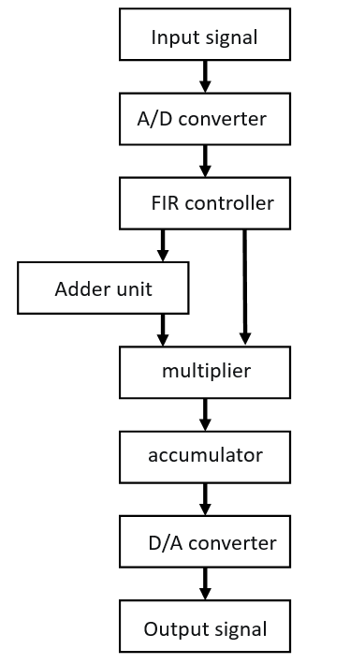
Fig 3.1 Working principle of FIR filter
Due to the complex composition of pipeline environmental noise sources, and the IMF components obtained by VMD decomposition of the original signal are limited and have a wide frequency band, some IMF components will contain both effective signal and noise signal, and the environmental noise in some frequency bands may not be effectively separated from the original signal. In this paper, the secondary noise reduction of pipeline leakage signal will be realized by FIR digital filter, and the effective IMF obtained after VMD decomposition will be reconstructed. After the secondary noise reduction of the reconstructed signal through the FIR filter, the subsequent signal processing work of pipeline leakage detection and location will be carried out.
Through the description of the above signal analysis and processing methods, the specific signal noise reduction process of the signal noise reduction method based on VMD is shown in Figure 3-2.
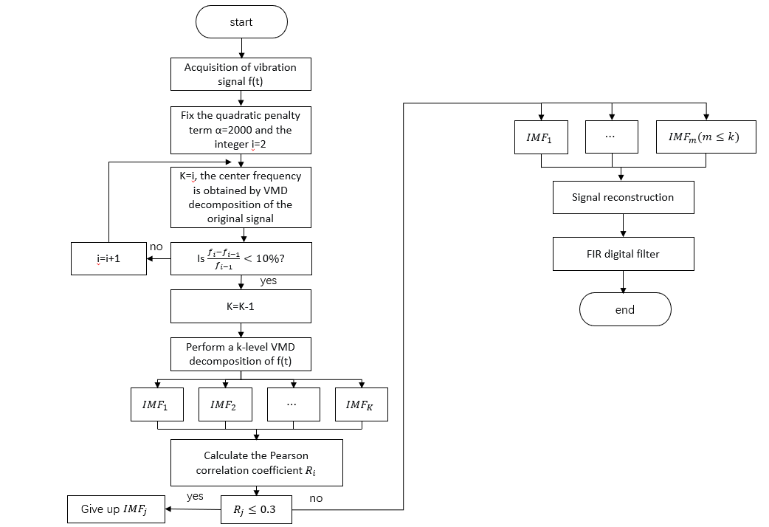
Fig 3.2 Flowchart of signal denoising method based on VMD
The steps of the noise reduction method are as follows:
- The vibration signal was obtained by UWFBG.
- The value of penalty term $α$ and the number of mode decomposition K in VMD algorithm were determined.
- The original signal was decomposed by VMD to obtain K IMF components.
- Pearson correlation coefficients were calculated between the K IMF components and the original signal, and K Pearson correlation coefficients were obtained.
- The IMF components whose correlation coefficients satisfy the condition greater than 0.3 are reconstructed.
- The reconstructed time domain signal is low-pass filtered by FIR digital filter to complete noise reduction.

3.1.2 Different signal noise reduction methods
Figure 3-3 shows the collected original signals of a leakage stage and the environmental noise in time domain and frequency domain. It can be seen that in the time domain, after the leakage occurs, the amplitude of the vibration signal in time domain will suddenly increase and reach the peak in a short time. With the loss of gas in the tube, the signal amplitude will gradually decrease. In the frequency domain, the frequency components generated by the leakage stage are mainly concentrated from 0 to 100Hz, and among them, the frequency components near 20 Hz have the largest amplitude. In order to explore the effect of the signal noise reduction method of VMD-Person-FIR proposed in this paper, the leakage signal is used as a test signal. For noisy signals, the amplitude fluctuates around 0 in the time domain and there is only a relatively weak frequency component around 100 Hz in the frequency domain.
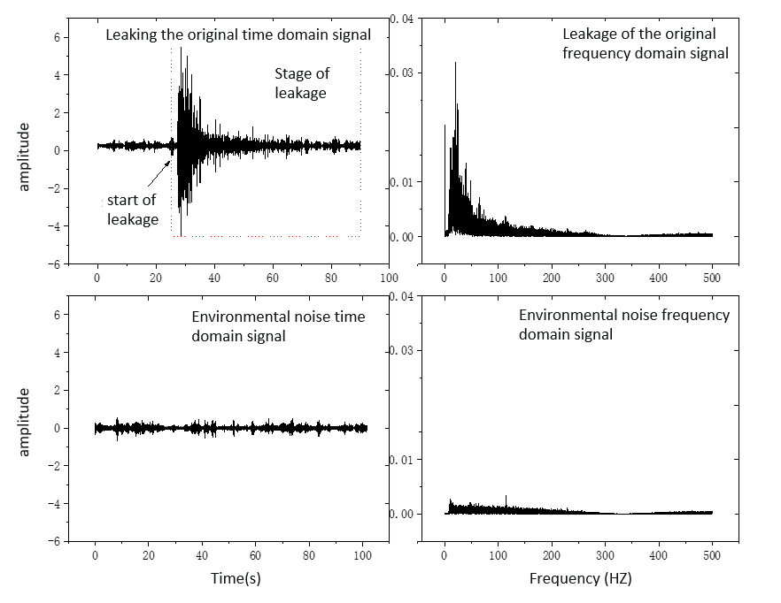
Fig 3-3 Original time domain signal and corresponding frequency domain signal of leakage and noise
Before using the VMD algorithm to decompose the signal, it is necessary to determine the number of modal components K and the quadratic multiplication penalty function term α. Only by selecting the appropriate parameters can the excellent signal decomposition effect be guaranteed. For the choice of the quadratic penalty term α, the general value range is between 500 and 3000. If the value is too large, the spectrum bandwidth will be too narrow. If the value is too small, the mode aliasing phenomenon will occur in different IMFs. In order to balance this phenomenon, α is set as the default value of 2000, and the signal decomposition under different K values is observed, as shown in Table 3-1. When K is 7, the difference between the center frequency of ${IFM}_{6}$ and ${IFM}_{7}$ is within 10%, and the decomposition is stopped. At this time, K is the number of decomposition modes, so the value of K is determined to be 6.
Table 3.1
Center frequencies of different IMF components after decomposition of the original signal
K | IMF1 | IMF2 | IMF3 | IMF4 | IMF5 | IMF6 | IMF7
2 | 0.48 | 20.35
3 | 1.13 | 20.56 | 38.77
4 | 2.14 | 20.78 | 38.55 | 65.56
5 | 0.79 | 20.45 | 38.37 | 66.54 | 101.23
6 | 0.48 | 20.66 | 38.79 | 65.56 | 102.56 | 456.56
7 | 1.67 | 20.45 | 39.65 | 68.24 | 105.23 | 418.35 | 456.26
Figure 3-4 shows the six components of the signal and the corresponding spectrum after decomposition when K=6.
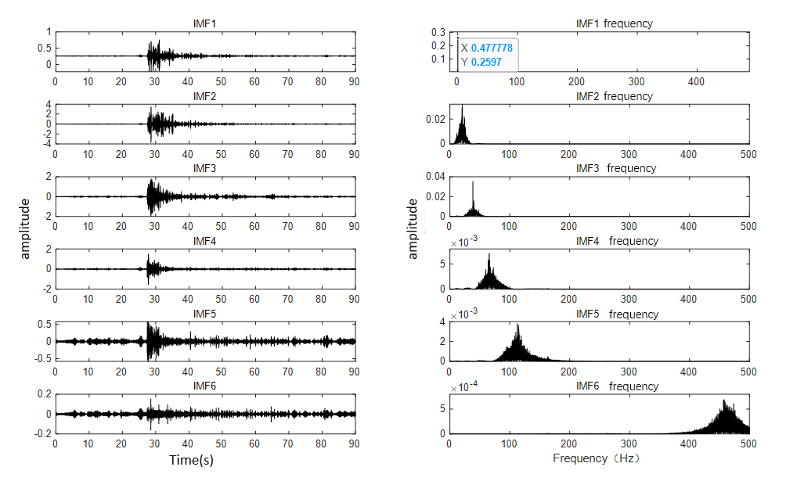
Figure 3-4.Different IMF components for K=6
Pearson correlation coefficients were calculated between the decomposed six IMF components and the original signal respectively. Figure 3-5 shows the Pearson correlation coefficients between different components and the original signal, and the results are shown in Table 3-2. It can be seen from the table that ${IFM}_{2}$, ${IFM}_{3}$ and ${IFM}_{4}$ meet the correlation coefficients greater than 0.3. Then ${IFM}_{2}$, ${IFM}_{3}$ and ${IFM}_{4}$ components are reconstructed.
Table 3.2
Pearson correlation coefficients between different IMF components and the original signal
Coefficient of correlation | 0.18 | 0.52 | 0.42 | 0.32 | 0.24 | 0.12
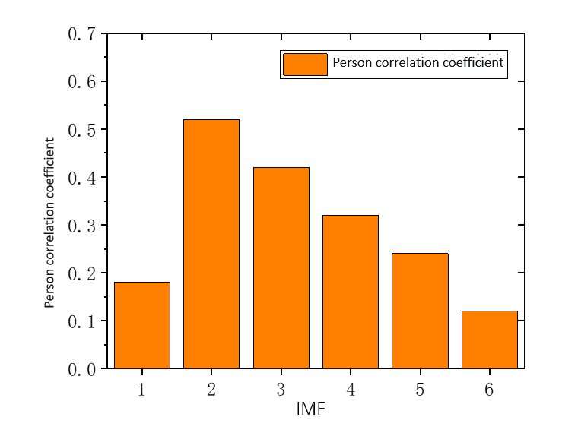
Figure 3-5 Pearson correlation coefficient between IMF component and original signal
From the leakage raw frequency domain signal, it can be seen that the frequency components generated by the leakage are concentrated in the frequency band from 0 to 100Hz. In this paper, a Butterworth low-pass filter with a sampling frequency of 1000Hz, a passband frequency of 100Hz and a stopband frequency of 150Hz, and a filter order of 60 is designed. The ampliture-frequency response and phase response curves are shown in Figure 3-6. The reconstructed signal is low-pass filtered by the filter to complete the noise reduction of the original signal.
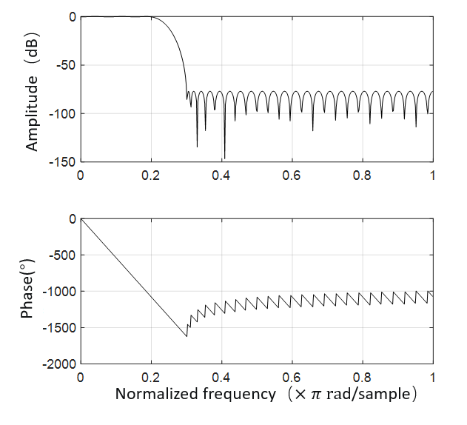
Fig.3-6 amplitude-frequency response and phase-frequency response curve of FIR digital filter
As shown in Figure 3-7, the figure contains the comparison of time domain and frequency domain signal before and after noise reduction.
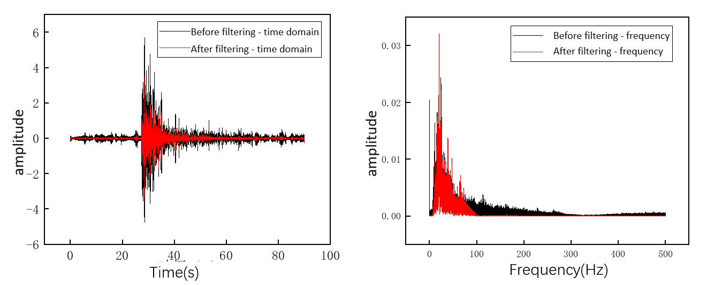
Fig. 3-7 Comparison of signals before and after noise reduction
In the field of Signal processing, the quality of a Noise reduction method usually needs some specific indicators to judge. In this paper, Signal-to-noise Ratio (SNR) is used to evaluate the noise reduction effect of different noise reduction methods, which evaluates the quality of the method from the similarity between the noise reduction signal and the clean signal. The larger the SNR, the better the denoising effect of the signal. The SNR is calculated as follows:
(3-18)
In the above equation, A and A represent the original signal and the denoised signal, respectively, and N represents the length of the time domain signal. This section compares the noise reduction using FIR digital filter, the noise reduction using VMD combined with correlation coefficient method, and the noise reduction method introduced in this paper, respectively. The comparison results are shown in Table 3-3:
Table 4-3
Comparison of noise reduction effect of leakage signal
 | FIR filter | VMD-Pearson | VMD-Pearson-FIR
SNR | 6.075 | 6.531 | 8.206
It can be seen from the table that the above three noise reduction methods can eliminate the noise in the original signal to a certain extent. From the results, The SNR calculated by the noise reduction methods of VMD-Pearse-FIR, VMD-Pearson and FIR digital filter noise reduction used in this paper is 8.206 dB, 6.531 dB and 6.075 dB, respectively, and the SNR of the noise reduction method used in this paper is the largest. Noise reduction using a filter only on the original signal has the worst effect among the three methods. It is proved that the noise reduction method can effectively remove the noise in the vibration signal.

3.2 Pipeline leak detection and location method based on time delay estimation

3.2.1 Time delay estimation method
Combined with pipeline leakage simulation and vibration signal characteristics, this chapter proposes a time delay estimation detection and location method based on short-time energy analysis and polynomial fitting. By determining the time when the leakage is transmitted to different vibration sensing areas, the corresponding time delay is obtained, and finally the leakage point is located according to the time difference.
Compared with the traditional gas pipeline detection technology, such as infrared thermal imaging method, flow balance method and negative pressure wave method, low reflection grating array has been favored by many researchers because of its high response speed, high sensitivity, high positioning accuracy and long distance and large scale advantages. As a commonly used pipeline leak location method, time delay estimation method is mainly used in the field of pipeline leak detection to locate the leak point. According to the different signal transmission direction, the time delay estimation method is divided into two kinds, which are active time delay estimation method and passive time delay estimation method. Among them, the active time delay estimation method refers to that the sensors laid on the pipeline can actively send signals to the leakage hole, and calculate the time difference between the time when the sensor obtains its own transmitted signal and the time when the sensor receives the signal reflected back from the leakage hole to obtain the position of the leakage hole and achieve the positioning effect. Passive time delay estimation method refers to that sensors laid on the pipeline passively receive signals from the leakage hole. It is only responsible for signal acquisition, but not for signal transmission. The location of the leakage hole is calculated by the time difference between the signals received by sensors laid on both sides of the pipeline. In this paper, the pipe is only responsible for collecting signals, and cannot send signals. Therefore, the passive time delay estimation method is used in this paper to calculate the time difference and locate the leakage point.
The principle of locating the leakage point based on time delay mainly includes two parts. The first part is to collect the signals of the sensors at both ends of the leakage point, obtain the time difference when the leakage signal arrives at the sensors at both ends, and calculate the time difference. The second part is to obtain the velocity of the wave transmitted along the pipeline when the leakage occurs, and calculate the location of the leakage point according to the positioning principle in the previous paragraph.

3.2.2 Detection and localization algorithms
The proposed leak detection and localization method is based on short-time energy analysis combined with least squares polynomial fitting. Before locating the leakage point, it is necessary to determine that the pipeline is leaking. Endpoint detection is often used to detect the starting point and the end point of the signal. The purpose of endpoint detection is to detect the starting point of the event and only retain the effective part of the signal. For the signal that has been denoised, the difference between the noise and the effective part of the signal is larger, so the endpoint detection will be more effective. The short-time energy analysis method is very suitable for the case that the pipeline leakage has abrupt changes in the signal time domain.
The least squares method can find the best function pairing between data by minimizing the square error. It is a simple method to solve unknown data and minimize the error between the unknown data and the actual data. The least square method can be used for polynomial fitting, it will fit a polynomial curve according to the actual given multiple discrete points, and make the data points on the curve as close as possible to the corresponding actual data points.
In response to the introduction of the above methods, this paper proposes a pipeline leak detection and localization method based on short-time energy analysis and least squares polynomial fitting with time delay estimation. Figure 3-8 shows the flow of the method:
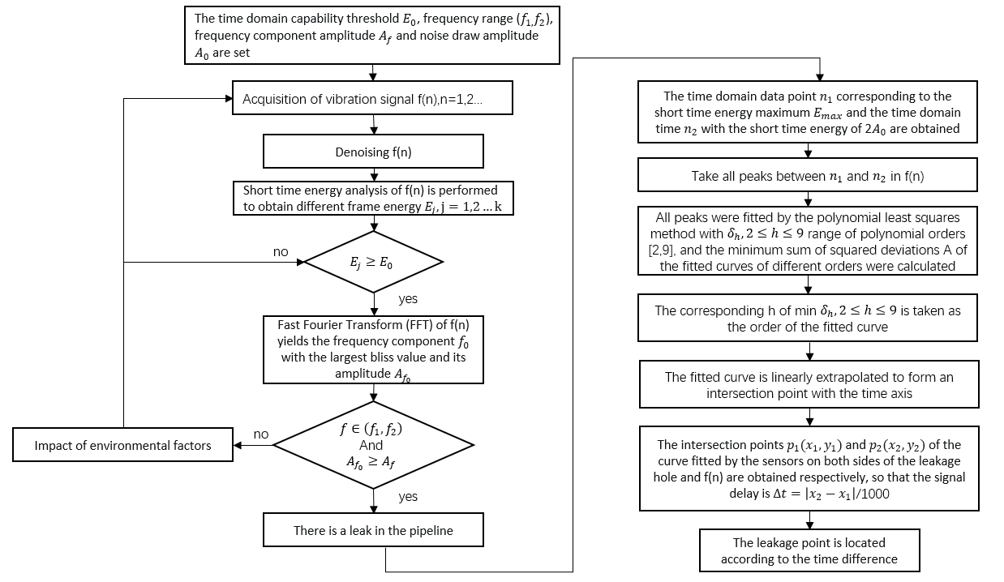
Fig 3-8 Pipeline leak detection and location method
A time-domain vibration signal generated in the actual pipeline leakage experiment scene is taken as an example to illustrate the leakage detection and location method proposed in this paper:
- Firstly, the relevant data threshold is set in advance, including the short-time energy threshold $E_{0}$. Since the short-time energy of the noise signal is close to 0, $E_{0}$ is set to 1 and the frequency range ($f_{1}$,$f_{2}$). Since the frequency corresponding to the maximum frequency component generated by the leakage signal is about 20Hz, the range is set to (15Hz, 25Hz), the frequency component amplitude $A_{f_{0}}$ is set to 0.1 and the average noise amplitude $A_{0}$ in the positive direction of the X-axis. The average noise amplitude in the signal is set according to the signals collected in different vibration sensing areas. As a subsequent condition to determine whether leakage occurs.
- The time domain signal is collected at a certain interval, and the noise reduction method introduced in the previous three chapters is collected every 1s in this experiment to denoise this data segment.
- The vibration signal after noise reduction is processed by framing, because when the pipeline leakage occurs, the amplitude will reach the maximum value of leakage amplitude at about 1s. Therefore, in this paper, 0.1s data is taken as a frame, and the frame shift is 0.05s. After framing, the short-time energy of different frames is calculated, and the short-time energy spectrum shown in Figs. 3-9 is obtained.
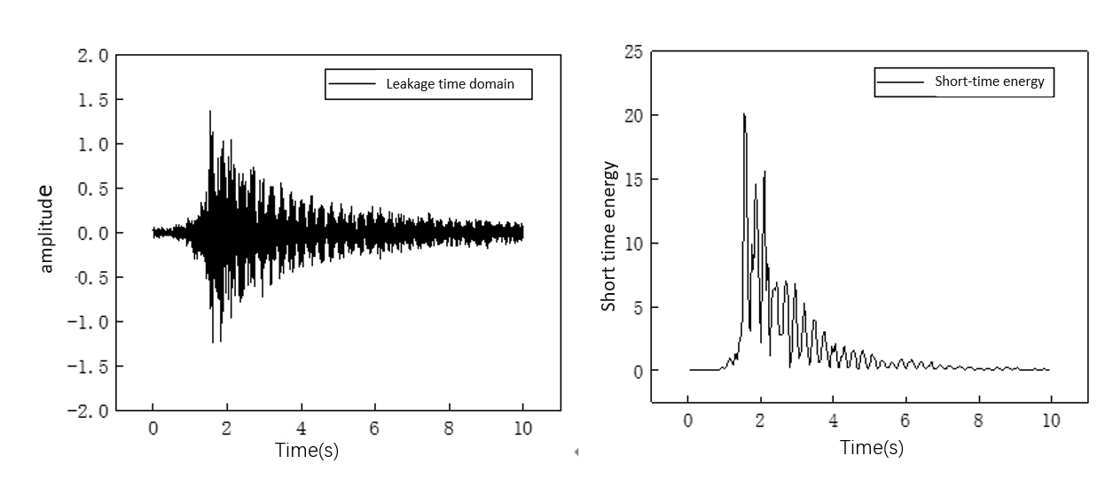
- If there is an energy greater than or equal to $E_{0}$ in the short-time energy spectrum, the fast Fourier transform is performed to observe the frequency domain information of the signal. Otherwise, no leakage occurs and the signal is collected continuously. There are multiple frame energies larger than $E_{0}$ in the short-time energy spectrum of this leakage signal and proceed to the next step.
- If the condition of the previous step is satisfied, the frequency corresponding to the maximum amplitude in the frequency domain is found. If the frequency is within the set frequency range, it is continued to determine whether the amplitude of the frequency component is greater than or equal to A, if so, it is determined that the pipeline has leaked. Otherwise, it is determined that the time domain amplitude disturbance may be caused by environmental factors. Figure 3-10 shows the frequency domain information obtained by FFT of the time-domain signal, whose maximum frequency component is 3.629, corresponding frequency is 20.1Hz, which meets the condition of leakage frequency range and amplitude, so it is determined that the pipeline leakage occurs.
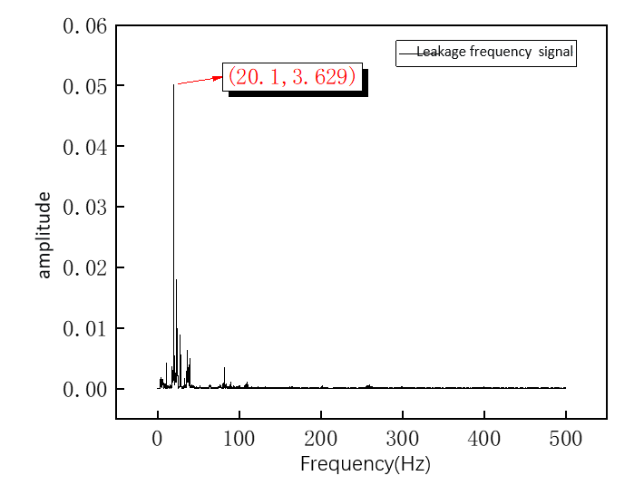
Fig 3-10 Leakage frequency domain signal
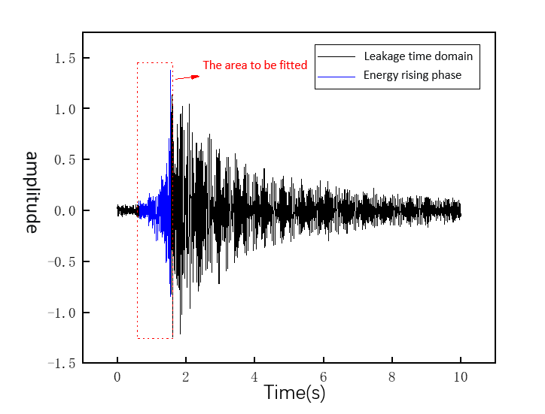
Fig 3-11 Energy rise stage of leakage signal
- After the pipeline leak is detected, the subsequent step is the leak location method based on the time delay estimation method. The time domain data point corresponding to the maximum energy in the short-time energy spectrum of the leakage segment signal and the time domain data point with signal amplitude $2A_{0}$ are obtained. A segment of data between the two points is obtained, and all peaks in the segment of data are searched. Figures 3-11 represent a segment of the leakage signal to be fitted obtained by the short-time energy limitation condition.
- The polynomial order ranged from 2 to 9, and eight curves were fitted, and the minimum deviation square sum of the corresponding polynomial fitting curve with different order was calculated. If the order of the fitting curve was too low, the curve fitting effect was too poor. If the order of the fitting order is high, the stability of the fitting curve is poor and the oscillation phenomenon may occur. In order to measure the quality of the fitting effect, R-square, residual sum of squared error and mean square error are used to judge the specific values of three indicators.
In statistics, r-squared is a measure of how accurate a model is; the closer the r-squared is to 1, the better the model fits. Residual sum of squares is used to measure the degree of model fitting in statistics. It uses the form of fitting curve function to approximate the discrete point group on the coordinate plane. The smaller the residual sum, the better the curve fitting effect. Mean square error is a measure in statistics that reflects the degree of fit between the fitted data value and the fitted quantity. The smaller the value is, the better the data fit is. The formulas are as follows:
(3-19)
(3-20)
(3-21)
Here, $y_{i}$, $\overline{y}$ and $\hat{y_{i}}$ represent the actual data value, the average value of the actual data and the fitted data value, respectively. The above three indexes corresponding to fitting curves of different orders are calculated, and the results are shown in Figure 3-12:
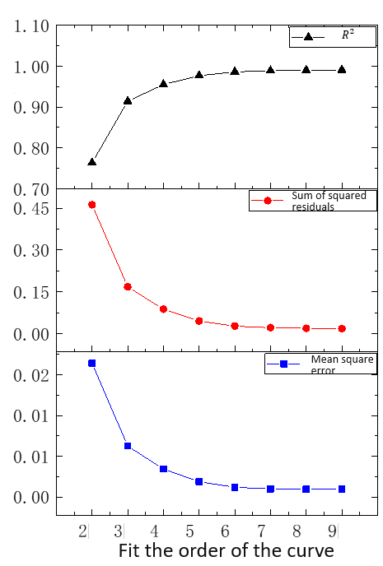
Fig. 3-12 Comparison of curve indexes of different orders of fitting
It can be seen from the comparison results of the three indicators that when the order of the fitting curve is less than or equal to 5, the quality of the fitting curve will be improved more when the order of the fitting curve is greater than 5. When the order of the fitting curve is greater than 5, the improvement of the quality of the curve is not obvious, so the order of the fitting curve is set to 5. Figures 3-13 show the results of polynomial curve fitting with order 5.
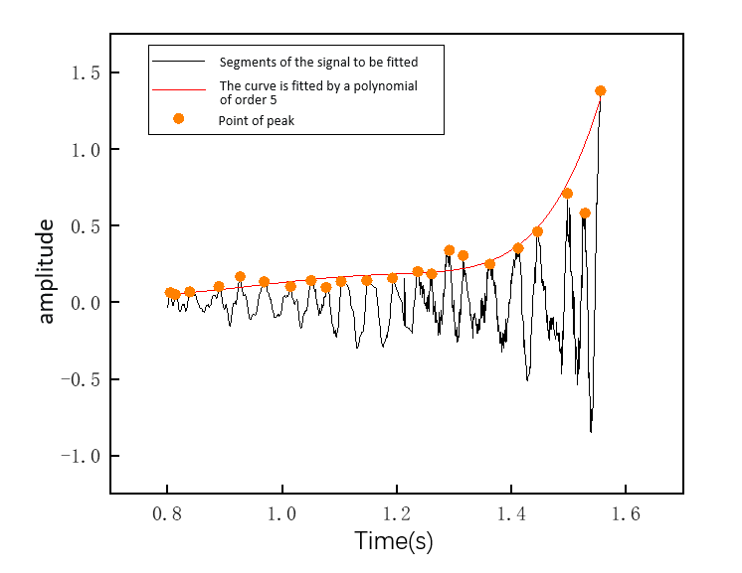
Fig 3.13.least squares polynomial fit between peaks
- Linear extrapolation is a method of linear extension according to the trend of the fitting curve. It is a mathematical method of data prediction. The intersection point of the extension line and the time axis is regarded as the arrival time of the leakage signal, and then the time difference is calculated by the difference calculated by the vibration sensing area on both sides of the leakage point. Finally, the position of the leakage point is calculated according to the formula, so as to achieve the purpose of positioning. Figures 4-14 represent the moment when the leakage signal obtained by the method described in this paper arrives at the vibration sensing area. It can be seen from the figure that there is an intersection point between the curve obtained by the proposed method and the time axis, which is the time when the leakage is transmitted to the sensing area when the pipeline leaks.
The proposed pipeline leak detection and localization algorithm based on time delay estimation method is shown in Algorithm 3.1.
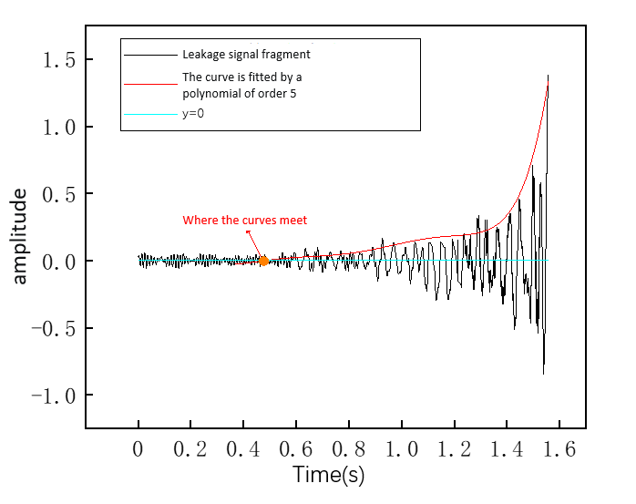
Fig. 3-14 The moment when the leakage vibration signal reaches the vibration sensing area
Algorithm 3.1 Leakage identification algorithm
Input：At this moment, 10 s vibration data vib of all sensing areas are stored, as well as sensing area number, sensor, short-time energy threshold E, frequency range threshold (fa,fb), frequency component amplitude threshold F, fitting order lifting rate threshold T
Output：Early warning results
1: Emax = getEnerge(vib) // The maximum short-time energy Emax corresponding to 10 s vibration signals in all sensing areas was obtained in real time
2: if Emax ≥ E then
3: (f1,fA) = fft(vib) // The fast Fourier transform of vib is applied to obtain the frequency component f1 and the corresponding amplitude fA
4: if f1 ϵ (fa,fb) and fA ≥ F then // Determine a pipeline leak
5: (n1,n2) = getData(Emax) // The time domain time n1 in the corresponding sensing area and the time n2 when the short-time energy is 2E are obtained by Emax
6: peak[n][2] = getPeak(vib,n1,n2) // At time n1 and n2, all n peak values of the signal in the sensing area at both ends of the pipeline in this time period are obtained
7: (resCur1,resCur2)=getFit(peak[n][2])// Fitting curves resCur1 and resCur2 were calculated by least squares polynomial fitting of all peak points according to their coordinates
8: (t1,t2)=extra(resCur2,resCur2)// The intersection points t1,t2 of the fitting curves on both sides of the pipeline and the time axis are calculated by interpolation extrapolation.
9: Xres=getRes(t1,t2)// The leakage is located according to the time difference of the signals in the sensing area at both ends
10: alarm()//An alarm occurs, notifies the administrator, and marks the sensing area
11: else
12: normal() // No leakage occurred
13: else if
14: else
15: normal() // No leakage occurred
16: else if

3.3 Summary of this chapter
This chapter introduces the possible noise types and noise characteristics in the environment of the pipeline, and explains the necessity of noise reduction of the vibration signal. Combined with variational mode decomposition, Pearson correlation coefficient and digital filter, a vibration signal noise reduction method is proposed. By analyzing the actual signal, the effectiveness of the noise reduction method is verified by comparing and using different noise reduction methods. A pipeline leakage detection and location method based on time delay estimation is proposed, and the process of the method is introduced in detail by the actual leakage signal.

Chapter 4 analyzes experimental data of pipeline leak detection and localization
This chapter introduces the construction of the pipeline leakage experiment site, simulates the pipeline leakage experiment under the influence of different factors, and explores the signal characteristics under the influence of different factors when leakage. According to the pipeline leakage detection and location method proposed in this paper, the effectiveness of the method for pipeline leakage detection and location is verified by simulating pipeline leakage experiments.

4.1 System Environment Construction
This chapter simulates the leakage experiment by establishing a physical pipeline platform, which is located on the negative first floor of the office building of the College of Resources and Environment, Nanhu Campus of Wuhan University of Technology. The actual pipeline system is shown in Figure 4-1. The pipeline system consists of an inflatable device and a pipeline. The inflatable device includes an air compressor and a gas storage tank. The pipe is 48 m long, and its inner and outer diameters are 95 mm and 114 mm, respectively. The pipe head is equipped with a pressure gauge to measure the pressure in the pipe. The gauge pressure indicates the pressure in the pipe measured on the basis of the air pressure (0.1 MPa). The head of the pipeline is connected with the gas storage tank through the black hose, and a switch valve is arranged in the middle to control the connection and partition of the gas between the pipeline and the gas storage tank; The gas storage tank is connected to the air compressor to store part of the gas that does not enter the pipeline. The second half of the pipeline is equipped with a leakage column of about 1 m in length and a leakage aperture of 20 mm, which can be changed by installing different types of nuts. An on-off valve is installed on the leakage column. In the simulation of leakage experiment, the internal pipe is connected to the atmosphere by unscrewed the valve on the leakage column to simulate the leakage state.
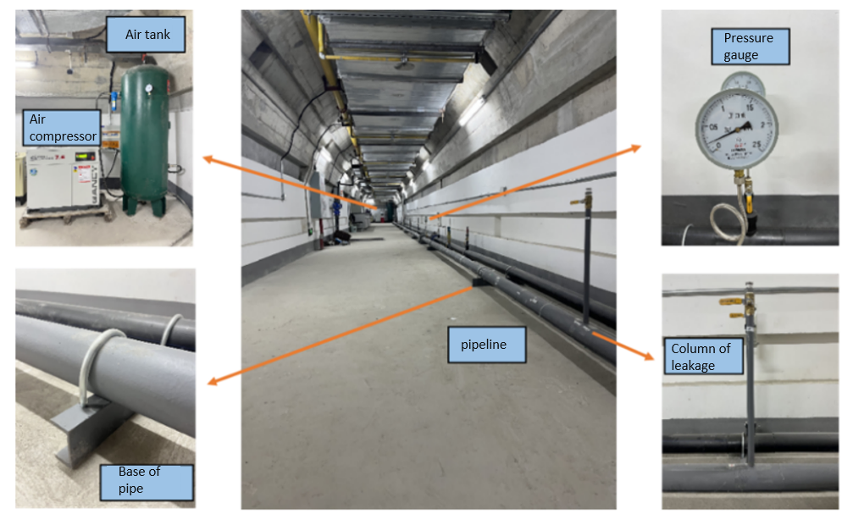
Fig 4-1 Physical drawing of the pipeline system
In this paper, a low-reflection grating array is used as the sensing unit for pipeline leak monitoring. The UWFBG was laid parallel to the axial direction of the pipeline and directly above the pipeline. In order to make the collected leakage signal more real and effective, the optical fiber was close to the surface of the pipeline and reinforced with glue at every interval. The spacing of the UWFBG grating used in the experiment is 5 "m", which is laid from the tail of the pipeline forward, and every 5 m is a vibration sensing area. The whole pipeline contains a total of 9 areas. After the optical fiber is laid, the tail end is knoted to prevent the signal instability caused by the reflection of the end face. The UWFBG head is connected to an FBG demodulator, which is responsible for demodulating the vibration information sensed by the UWFBG. The demodulator is connected to the host computer through the network cable, and the host computer communicates with the demodulator through the TCP protocol. The vibration data uploaded by the demodulator is displayed in the host computer system. Because there is a distance between the tail end of the pipeline and the demodulation instrument, the length of the optical fiber read in the system is slightly larger than the length of the pipeline. The area between the first two gratings laid at the head of the pipeline is taken as zone 1, and there are two leakage columns. One is located at the midpoint of zone 4, and the two leakage columns are separated by 4 m. The acquisition frequency of the system is 1000 Hz.
In order to ensure the safety of the experiment, this experiment uses air instead of natural gas to simulate pipeline leakage experiment. The experimental process of each leakage simulation mainly includes three steps: (1) Inflation stage: When the pressure in the pipe is 0 and all valves are closed, start the air compressor and open the switch valve between the gas storage tank and the pipeline, inflate the pipeline, observe the pressure gauge on the pipeline at the same time, when the pressure in the pipe reaches the expected pressure, close the air compressor and the switch valve between the gas storage tank and the pipeline; (2) Stable stage: keep the gas in the tube in a stable state and last for a period of time after the completion of inflation; (3) Leakage stage: When simulating leakage, quickly and completely unscrew the valve on the leakage column by hand (the valve is parallel to the leakage column), observe the pressure gauge, and when the gauge pressure value is 0, the leakage stage ends. The system architecture is shown in Figure 4-2.
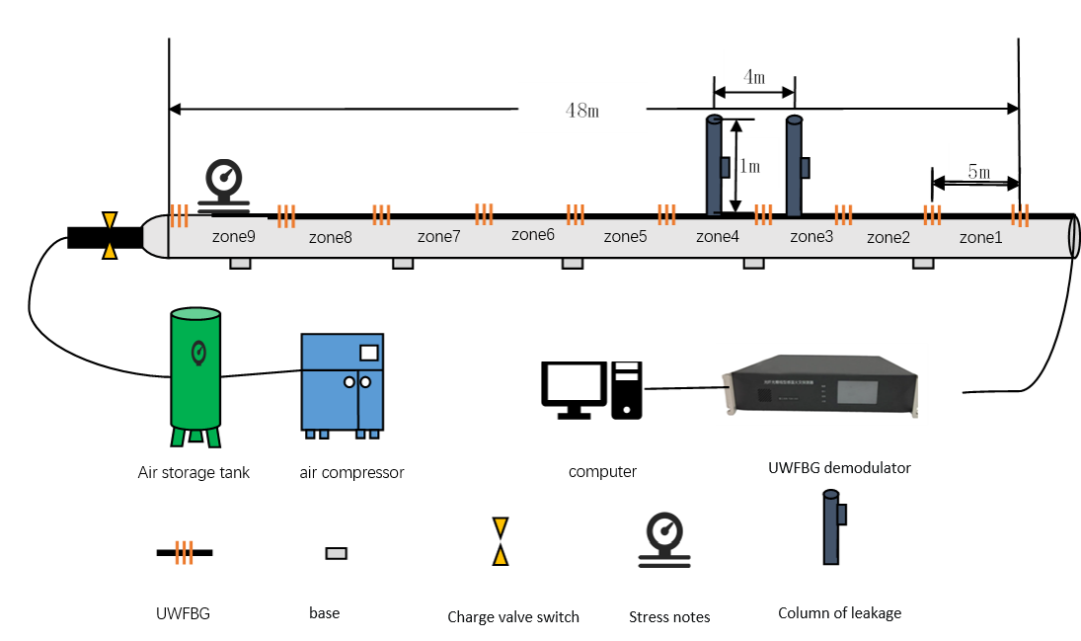
Fig 4-2 Piping system structure

4.2 Analysis of leakage signal characteristics under different influencing factors
Field experiments In order to explore the influence of different distance, pressure and leakage aperture on pipeline leakage characteristics, several pipeline leakage experiments were simulated. The signals analyzed and processed were denoised by the noise reduction method based on in Chapter 3.
- Different leakage distance
In order to explore the extent to which different distances on the pipe wall are affected by pipeline leakage, the leakage column in No.4 area is selected as the leakage point when the leakage signal characteristics are explored in the simulation of pipeline leakage experiment. The expected pressure is set to 0.4 MPa and the leakage aperture is 10 mm in the inflation stage, and the stability time is 2 minutes in the stabilization stage. The vibration signal characteristics in time domain and frequency domain of three continuous regions on the right side of the leakage hole were observed respectively. Figures 4-3 represent the time domain and frequency domain signals in zones 1, 2, and 3. It can be seen from the pipeline system structure diagram that the center of area 3, 2 and 1 is 5 m, 10 m and 15 m away from the leakage hole, respectively.
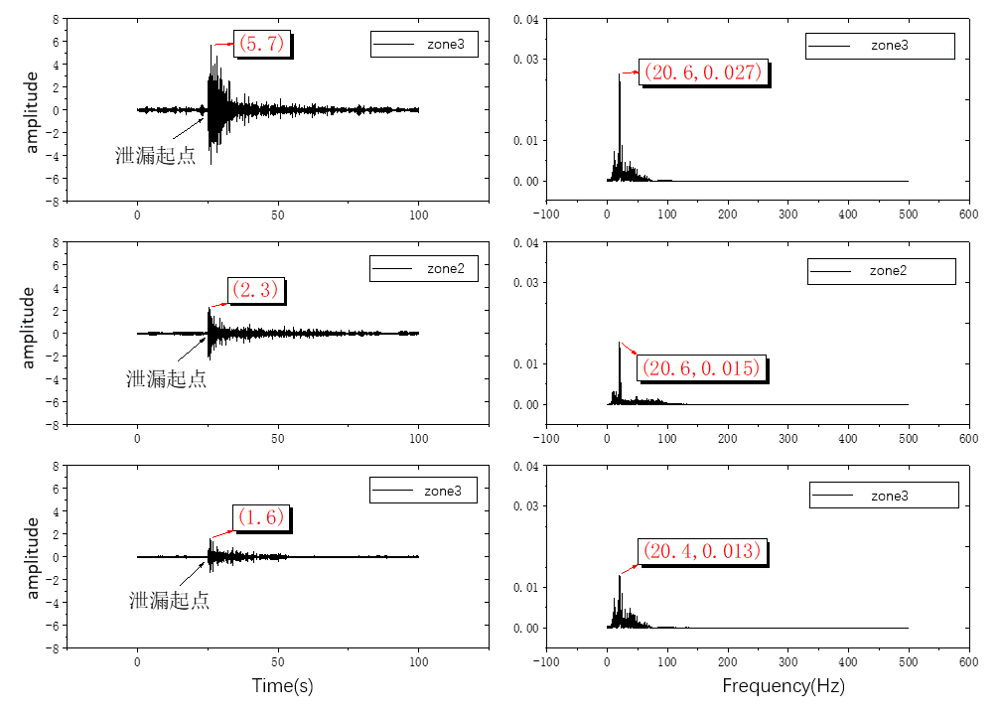
Fig. 4-3 Leakage signals in different regions
From the collected leakage signal, it can be seen that in the time domain, the signal amplitude will rise suddenly after the leakage occurs, and then decrease slowly after reaching the peak value of the signal. When the gas is drained out, the amplitude will be reduced to the same level as the noise. The maximum amplitude of area 1, 2 and 3 are 1.6, 2.3 and 5.7, respectively. The signal amplitude of area 3 closest to the leakage hole is the largest, and the signal amplitude of area 1 farthest from the leakage hole is the smallest, which decreases from near to far. In the frequency domain, the frequency components in the range of 0 to 100Hz are generated in zone 1 to 3, among which the frequency component near 20Hz has the largest amplitude, which is divided into 0.013, 0.015 and 0.027. The amplitude is the same as the law in the time domain, and the distance from the leakage point decreases in turn from near to far.
- Different leakage pressure
The leakage aperture was fixed to 10 mm, and the signal in area 3 was selected as the vibration signal sensing observation area. Three groups of experiments were simulated under the conditions of initial pressure of 0.2 MPa, 0.4 MPa and 0.6 MPa in the tube. Different groups of simulation experiments were inflated to 0.2 MPa, 0.4 MPa and 0.6 MPa respectively in the inflation stage. The stability stage lasted for 2 minutes, and all valves were closed after the end of the leakage stage. Figure 4-4 shows the time and frequency domain diagram of the vibration signal collected in zone 3 under different initial pressure in the tube.
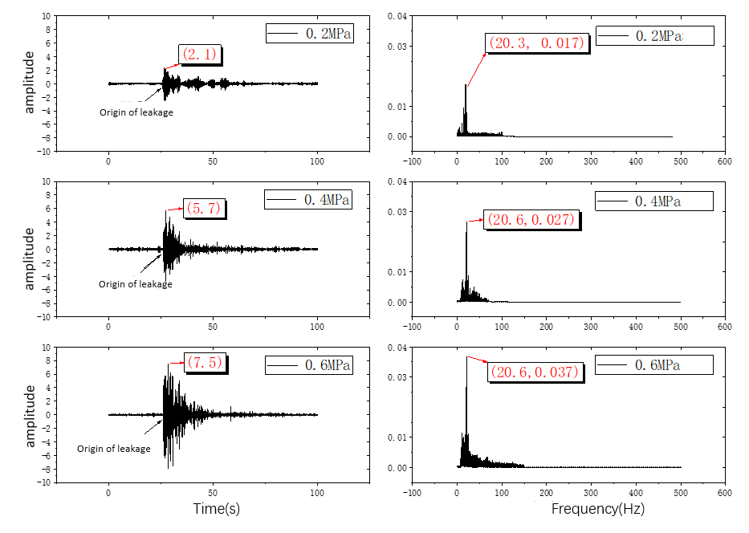
Fig. 4-4 Leakage signals at different initial pressures
It can be seen from the above figure that, from the perspective of time domain, when the initial pressure in the tube is 0.2MPa, 0.4MPa and 0.6MPa respectively, the maximum amplitude of the signal in the time domain is 2.1, 5.7 and 7.5 respectively. It can be deduced that with the increase of the initial pressure, the signal amplitude also increases. From the perspective of frequency domain, the leakage produces frequency components in the range of 0 to 100, and the frequency component around 20 has the largest amplitude, which is 0.017, 0.027 and 0.037 respectively. As the initial pressure increases, the maximum frequency component does not change and its amplitude increases.
- Different leakage aperture
The initial pressure of the fixed pipeline was 0.4 MPa, and area 3 was used as the vibration signal sensing observation area. Three groups of experiments were simulated under the conditions of leakage aperture of 5 mm, 10 mm, and 15 mm, respectively. In each simulation experiment, the inflating phase stopped when the pressure in the tube reached 0.4 MPa, and the stable phase lasted for 2 minutes. The switch is turned off after the leakage phase. Figures 4-5 represent the vibration signals collected from three sets of experiments with different leakage apertures.
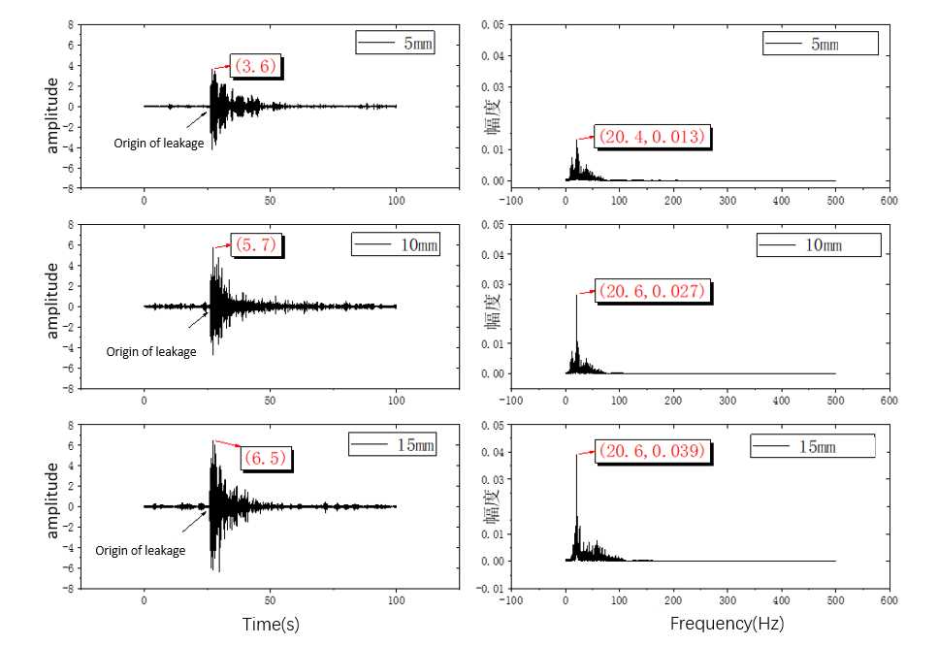
Fig. 4-5 Leakage signals under different leakage apertures
The maximum amplitude in the time domain corresponding to 5mm, 10mm and 15mm is 3.6, 5.7 and 6.5, respectively. With the increase of the leakage aperture, the signal amplitude also increases. In the frequency domain, the leakage produces frequency components in the range of 0 to 100 Hz, with the amplitudes of 0.013, 0.027 and 0.039, respectively. The frequency component near 20Hz has the largest amplitude, and the frequency amplitude becomes larger with the increase of the leakage aperture.
This experiment explores the influence of the change of different factors on the vibration signal generated by the leakage. The experimental results show that when the pipeline leakage occurs, the vibration signal can respond quickly. In the time domain, the amplitude of the vibration signal will reach the peak within a short time after the leakage occurs, and then with the loss of gas in the pipe and the decrease of pressure in the pipe, the signal amplitude will also decrease. In the frequency domain, frequency components in the range of 0 to 100Hz will be generated, with the largest amplitude of the frequency component near 20 Hz.
When other conditions are unchanged, only when the leakage aperture or the initial pressure in the tube become larger, the amplitude of the time domain signal will become larger after the leakage occurs. In the frequency domain, the frequency component in the range of 0 to 100Hz is generated, and the frequency component around 20Hz has the largest amplitude. The frequency component amplitude will also become larger with the increase of the leakage aperture and the initial pressure. The closer the area is to the leakage point, the larger the amplitude of the time domain signal will be after leakage, and the smaller it will be. In the frequency domain, a frequency component with a maximum amplitude of about 20 Hz is also generated, and the amplitude of the frequency component decreases as the distance increases. In summary, when the pipeline leakage occurs, the maximum amplitude of vibration signal is positively correlated with the leakage aperture and pressure, and negatively correlated with the distance, which is consistent with the fluid simulation results in Chapter III. In the frequency domain, a fixed frequency component with constant frequency magnitude will be generated, and its amplitude is positively correlated with the leakage aperture and pressure, and negatively correlated with the distance. The variation trends of time domain and frequency components with different influencing factors are shown in Figure 4-6:
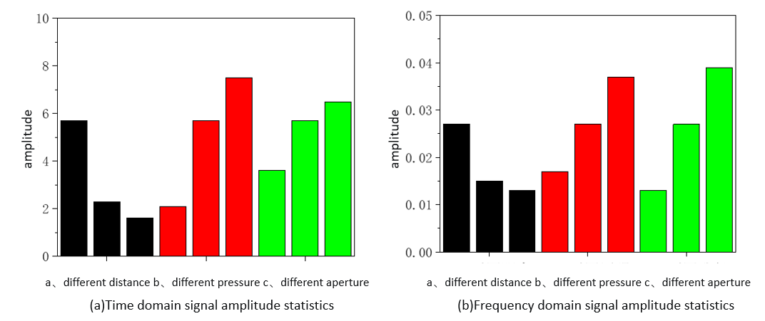
Fig 4-6 Variation trend of leakage signal amplitude with different influencing factors

4.3 Analysis of vibration signal propagation speed
Before the pipeline leak location study, the proposed localization method based on time delay estimation is used to calibrate the vibration propagation speed generated by the leak. In this experiment, three repeated experiments of pipeline leakage were simulated, and the conditions of each experiment were unified. The pressure in the pipe was controlled at 0.2 MPa before leakage, and the leakage hole was 5 mm. The leakage occurred in zone 4, and the completion of gas leakage in the pipe was the completion of a leakage experiment. According to the demodulation principle of low-reflection grating array, the obtained vibration information comes from the whole vibration sensing area. For convenience of calculation, the midpoint of the area is regarded as the vibration information sensing point of the current vibration sensing area.
If the distance and time difference between the vibration sensing area and the leakage point are known, the leakage vibration propagation speed is unknown. According to the theoretical formula in Chapter 2, the propagation velocity of leakage vibration can be calculated. In order to verify the effectiveness of the low-reflection grating array combined with the detection and localization algorithm proposed in this paper in the pipeline leak location, the vibration propagation speed at different vibration sensing areas is tested. In the speed test, the arrival time of the leakage vibration signal in zones 1, 4 and 9 is calculated by the proposed algorithm. Figure 4-7 shows the calculation result of one of the leakage experiments, and then the time difference between zones 1, 9 and 4 is calculated respectively. As the distance between zones is determined, the vibration transmission rate at different locations is calculated, and the results are shown in Table 4-1. Finally, the average propagation speed of the system vibration signal is 324.5 m/s.
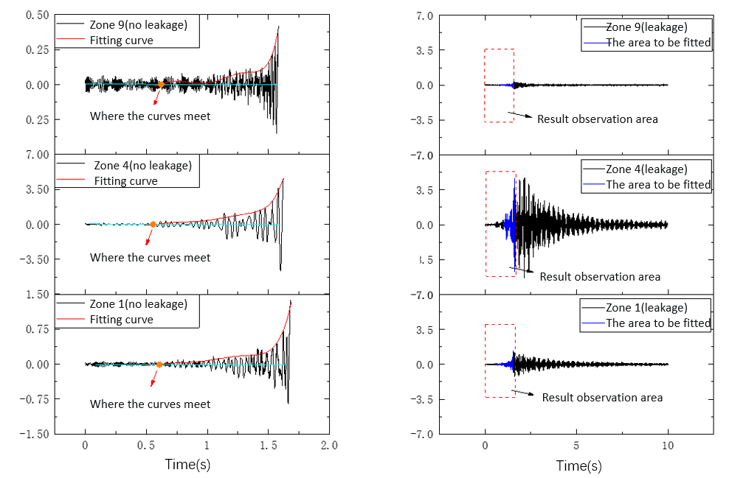
Fig. 4-7 The time when the vibration signal arrives at different measurement areas
Table 4-1 Vibration propagation rate in area 1 and 9
 | Time delay /s in zone 1 and 4 | Time delay /s in zone 9 and 4 | Leakage vibration speed in Zone 1 /(m/s) | Leakage vibration speed in Zone 9 /(m/s)
The first experiment | 0.046 | 0.074 | 326.1 | 337.8
The second experiment | 0.048 | 0.082 | 312.5 | 304.9
The Third experiment | 0.044 | 0.077 | 340.9 | 324.7

4.4 Analysis of leakage location error
This method was used to calibrate the vibration propagation speed of the system, and the speed of the leakage vibration signal propagation along the pipe wall was obtained to be 324.5 m/s. Five repeated leakage experiments were re-simulated with the same experimental conditions as above, the leakage occurred in zone 4, and the localization results were verified by collecting vibration signals in zone 1 and zone 9. Among them, the center distance between zone 1 and zone 9 is 40 m. In the table, the actual distance represents the actual distance between zone 9 and the leakage point, and the positioning distance represents the calculated distance. After calculation by the proposed method, the results are shown in Table 5-2. It can be seen that the maximum positioning error is 1.17m, the minimum positioning error is 0.36m, and the average positioning error is 0.77m, which fully meets the actual engineering needs. The localization error is the difference between the calculated distance between the leakage point and the different vibration sensing areas and the actual distance between the leakage point and the vibration sensing area.
In order to explore the positioning effect of different leakage points, the leakage column in area 3 was selected as the leakage point, and the experiment was repeated five times. After calculation by the proposed method, the results are shown in Table 4-3. The maximum positioning error is 1.06m, the minimum positioning error is 0.41m, and the average positioning error is 0.73m.
According to the above experimental analysis results, it can be concluded that the low-reflection grating array combined with the leakage localization method based on time delay estimation proposed in this paper has a good effect on vibration signal perception, and can accurately detect and locate the leakage location. The average positioning error is about 1 m when the vibration perception interval is 40 m.
Table 4-2 Location results of leakage experiment in Area 4
 | Time delay estimation (s) | Actual distance (m) | Positioning distance (m) | Positioning error (m)
Test 1 | 0.033 | 25 | 25.36 | 0.36
Test 2 | 0.027 | 25 | 24.39 | 0.61
Test 3 | 0.035 | 25 | 25.68 | 0.68
Test 4 | 0.038 | 25 | 26.17 | 1.17
Test 5 | 0.037 | 25 | 26.01 | 1.01
Table 4-3 Experimental positioning results of pipeline leakage in Area 3
 | Time delay estimation (s) | Actual distance (m) | Positioning distance (m) | Positioning error (m)
Test 1 | 0.051 | 29 | 28.27 | 0.73
Test 2 | 0.062 | 29 | 30.06 | 1.06
Test 3 | 0.052 | 29 | 28.44 | 0.56
Test 4 | 0.061 | 29 | 29.90 | 0.90
Test 5 | 0.058 | 29 | 29.41 | 0.41

4.5.Summary
Firstly, this chapter introduces the experimental scene of simulated leakage, and explores the influence of different factors such as leakage distance, leakage pressure and leakage aperture on leakage signal characteristics through field simulation pipeline leakage experiments, and verifies the results with the fluid simulation results in Chapter 3. According to the pipeline leakage detection and location method based on time delay estimation proposed in this paper, the propagation velocity of the leakage vibration signal is analyzed and the velocity value is obtained. On the premise of knowing the leakage propagation velocity, the pipeline leakage experiment is simulated to locate, and the effectiveness of the method for pipeline leakage location is proved. The positioning error is about 1 m.

Chapter 5 summarizes and prospects

5.1 Summary of work in this paper
As an indispensable fuel for people's livelihood and industrial production, natural gas needs to be transported between cities over long distances. Pipeline transportation is the most common mode of gas transportation, and the safety of the transportation process must be guaranteed. In order to prevent the serious caused by pipeline leakage, it is necessary to monitor the safety of pipeline transportation through relevant technical means. Traditional pipeline leakage monitoring technology has the problems of poor real-time performance, inability to detect small leaks, easy to be disturbed by the environment, and poor positioning effect. According to the characteristics of low reflection grating array, such as fast response, large capacity, strong anti-interference ability and high stability, this paper combines the low reflection grating array with the relevant signal processing method to realize the detection and location of pipeline leakage, and proves the feasibility of the method through the combination of theory and practical experiments.
The main research work of this paper is as follows:
- The multiplexing principle, vibration sensing principle and demodulation principle of low-reflection grating array are explored. The generation mechanism and propagation law of pipeline leakage vibration signal are studied, and the principle of pipeline location is introduced, which provides a theoretical basis for pipeline leakage detection and location.
- This paper introduces the noise classification contained in the signal collected by the grating array in the pipeline environment, and explains the interference of noise on the analysis and processing of the leakage signal. According to the problem that the mode component is too wide in the actual signal decomposition process, a signal noise reduction method based on is proposed. By comparing different noise reduction methods, the results show that, The signal to noise ratio of the signal after noise reduction based on the signal noise reduction method introduced in this paper is relatively higher, which can effectively reduce the signal noise.
- The time delay estimation method used to locate the leakage point is introduced. Based on the characteristics of the vibration signal after leakage and the shortcomings of some methods in the time delay estimation method, a method of pipeline leakage detection and location based on short-time energy analysis combined with least square polynomial fitting is proposed. Under the premise of pipeline leakage, the intersection point of the fitting curve and the original signal is obtained by the method of least square polynomial fitting, so as to sense the time when the vibration signal arrives at the vibration sensing area. The location of the leakage point is calculated by the time difference between the leakage signal and the vibration sensing area at the two ends of the leakage point.
- The pipeline leakage experiment was simulated by setting different distances, different initial pressures and different leakage apertures, and the influence of different external factors on the leakage signal characteristics was explored. The experimental results obtained by data analysis were consistent with the fluid simulation results. The pipeline leakage detection and location method proposed in this paper is applied to the leakage experiment. The experimental results show that the positioning error of the method is about 1 m when the pipeline detection length is 40 m.
The main work and achievements of this paper are as follows:
- Aiming at the problem that the central frequency band is too wide in the actual signal decomposition process of VMD algorithm, a signal denoising method combining VMD, Pearson correlation coefficient and FIR low-pass filter is proposed. The effectiveness of the noise reduction method is proved by experiments.
- Aiming at the problems of poor adaptability and high implementation difficulty of traditional pipeline leakage location methods, a pipeline leakage detection and location method combining low reflection grating array and time delay estimation method is proposed. The experimental results show that the method can effectively realize the detection and location of pipeline leakage, and the positioning error is about 1 m.

5.2 Future work prospects
(1) Limited by the experimental conditions, the pressure inside the pipe is not guaranteed to remain unchanged during the pipeline leakage experiment in the field simulation in this paper. In the next step, the experimental scenario can be optimized to simulate a more realistic pipeline leakage experiment.
(2) The proposed pipeline leak detection and localization method is optimized to improve its adaptability in different environments.

References
- Zhang Yangyang. Transportation mode and characteristics of natural gas [J]. Petrochemical Technology, 2021.[In China]
- Aseel S, Al-Yafei H, Kucukvar M, et al. Life Cycle Air Emissions and Social Human Health Impact Assessment of Liquified Natural Gas Maritime Transport[J]. Energies,2021, 14 (19): 6208.
- Ma Hongtao, Wei Tao. Hazard factors and countermeasures of long-distance natural gas transmission pipeline operation [J]. Cleaning World, 2022, 38 (06): 196-198. [In China]
- Kan Yi-wei, GU Hao-wen. Numerical simulation of leakage diffusion in natural gas pipeline [J]. Value Engineering, 2022, 41 (36): 124-126. [In China]
- Chen Ye, ZHAO Jian-hui, ZHANG Zhidan. Study on leakage diffusion characteristics of natural gas pipeline [J]. Petroleum and Chemical Equipment, 2022, 25 (10): 8-10. [In China]
- Yu Qiao-yan, HOU Lei, Chai Chong, et al. Research on the length and damage range of jet flame in high pressure natural gas pipeline [J]. Bulletin of Petroleum Science, 2022, 7 (04): 593-603. [In China]
- Zhou Xing, Hao Yong-mei, Yang Jian, et al. Review on explosion characteristics and explosion relief technology of natural gas pipe gallery [J]. Industrial Safety and Environmental Protection, 2022, 48 (11): 1-4, 8. [In China]
- Sun Yilin, Zheng Xiaoqiang, Liu Xianfeng, et al. Research on quantitative analysis method of major urban gas pipeline leakage and explosion accident -- A case study of "6·13" accident in Shiyan, Hubei Province [J]. Journal of Safety and Environment, 2022, 22 (06): 3312-3320. [In China]
- Wang X, Liu L, Duan R, et al. A Method for Leak Detection in Buried Pipelines Based on Soil Heat and Moisture[J]. International Communications in Heat and Mass Transfer, 2022, 135: 106123.
- Lu Q, Li Q, Hu L, et al. An Effective Low-Contrast SF₆ Gas Leakage Detection Method for Infrared Imaging[J]. IEEE Transactions on Instrumentation and Measurement, 2021, 70: 1-9.
- Safitri A, Gao X, Mannan M S. Dispersion Modeling Approach for Quantification of Methane Emission Rates from Natural Gas Fugitive Leaks Detected by Infrared Imaging Technique[J]. Journal of Loss Prevention in the Process Industries, 2011, 24 (2): 138-145.
- Xiong K, Jiang J, Pan Y, et al. Deep Learning Approach for Detection of Underground Natural Gas Micro-Leakage Using Infrared Thermal Images[J]. Sensors, 2022, 22 (14): 5322.
- Yan Rongsong, Zhao Zijun, Gao Wenxue, et al. Current situation and prospect of leakage detection technology for urban gas pipelines [J]. Gas & Heat, 2021, 41 (10): 27-29, 37-46. [In China]
- Hou Q. An FBG Strain Sensor-based NPW Method for Natural Gas Pipeline Leakage Detection[J]. Mathematical Problems in Engineering, 2021, 2021: 1-8.
- Sekhavati J, Hashemabadi S H, Soroush M. Computational Methods for Pipeline Leakage Detection and Localization: A Review and Comparative Study[J]. Journal of Loss Prevention in the Process Industries, 2022, 77: 104771.
- Chen Q, Shen G, Jiang J, et al. Effect of Rubber Washers on Leak Location for Assembled Pressurized Liquid Pipeline Based on Negative Pressure Wave Method[J]. Process Safety and Environmental Protection, 2018, 119: 181-190.
- Wu Ximing, Li Jiangfeng, Yan Yan, et al. Research progress on leakage detection and location technology of submarine oil and gas pipelines [J]. Petroleum Engineering Construction, 2022, 48 (3): 1-7. [In China]
- Li Jian, Chen Shili, Huang Xin-jing, et al. Review on leakage monitoring and near-real-time detection technology of long distance oil and gas transportation pipeline [J]. Chinese Journal of Scientific Instrument, 2016, 37 (8): 1747-1760. [In China]
- Li H J, Zhu H H, Tan D Y, et al. Detecting Pipeline Leakage Using Active Distributed Temperature Sensing: Theoretical Modeling and Experimental Verification[J]. Tunnelling and Underground Space Technology, 2023, 135: 105065.
- Thiberville C, Wang Y, Waltrich P, et al. Modeling of Smart Pigging for Pipeline Leak Detection[J]. SPE Production & Operations, 2020, 35 (03): 610-627.
- Bohorquez J, Alexander B, Simpson A R, et al. Leak Detection and Topology Identification in Pipelines Using Fluid Transients and Artificial Neural Networks[J]. Journal of Water Resources Planning and Management, 2020, 146 (6): 04020040.
- Mujtaba S M, Lemma T A, Vandrangi S K. Leak Diagnostics in Natural Gas Pipelines Using fault signatures[J]. International Journal of Pressure Vessels and Piping, 2022, 199: 104698.
- Zandi E, Alemrajabi A A, Emami M D, et al. Numerical Study of Gas Leakage From a Pipeline and Its Concentration Evaluation Based on Modern and Practical Leak Detection Methods[J]. Journal of Loss Prevention in the Process Industries, 2022, 80: 104890.
- Alnwaimi G, Boujemaa H, Alfosail F, et al. Leak Detection and Localisation on a Gas Pipeline Using the Gradient of Squared Pressure[J]. International Journal of Sensor Networks, 2022, 39 (2): 75-82.
- Lukonge A B, Cao X. Leak Detection System for Long-distance Onshore and Offshore Gas Pipeline Using Acoustic Emission Technology. A review[J]. Transactions of the Indian Institute of Metals, 2020, 73 (7): 1715-1727.
- Lukonge A B, Cao X, Pan Z. Experimental Study on Leak Detection and Location for Gas Pipelines Based on Acoustic Waves Using Improved Hilbert–Huang transform[J]. Journal of Pipeline Systems Engineering and Practice, 2021, 12 (1): 04020072.
- Wang C, Wang Z, Zhang J, et al. Study on Acoustic Source Characteristics of Distributed Optical Fiber Acoustic Wave Monitoring Buried Natural Gas Pipeline Leakage[C]. E3S web of conferences, 2021: 03043.
- Gao Wen-ao, LIU Yang, Li Deng-ke, et al. Research on Gas Pipeline Leakage Based on Optical Fiber Monitoring Technology [J]. China Safety Science Journal, 2019, 29 (8): 67. [In China]
- Liu Zhiwei, Shang Ying, Wang Chen, et al. Distributed leakage monitoring technology of optical fiber vibration pipeline based on multi-dimensional spatial data fusion Algorithm [J]. Advances in laser and Optoelectronics.Ukil A, Libo W, Ai G. Leak Detection in Natural Gas Distribution Pipeline Using Distributed Temperature Sensing[C]. IECON 2016-42nd Annual Conference of the IEEE Industrial Electronics Society, 2016: 417-422. [In China]
- Madabhushi S, Elshafie M, Haigh S. Accuracy of Distributed Optical Fiber Temperature Sensing for Use In Leak Detection of Subsea Pipelines[J]. Journal of Pipeline Systems Engineering and Practice, 2015, 6 (2): 04014014.
- Zhou Z, Tan J, Zhang J, et al. High Pressure Buried Gas Pipeline Leakage Temperature Drop Testing and TheoryAnalysis[J]. Numerical Heat Transfer, Part A: Applications, 2020, 78 (1): 18-28.
- Wang Q, Gu X, Zhang Z, et al. On-Line Leakage Detection in Buried Tap Water Distribution Pipes Using Distributed Temperature Sensing[J].Journal of Pipeline Systems Engineering and Practice, 2022, 13 (2): 04022010.
- Qingmin H, Wenling J, Shuhui Z, et al. Natural Gas Pipeline Leakage Detection Based on FBG Strain Sensor[C]. 2013 Fifth International Conference on Measuring Technology and Mechatronics Automation, 2013: 712-715.
- Ren Liang, Xia Mengying, Jiang Tao, et al. Gas pipeline leakage monitoring test based on circumferential strain [J]. Vibration. Journal of Testing & Diagnosis, 2015, 35 (5): 820-825. [In China]
- Jiang T, Ren L, Wang J J, et al. Experimental Investigation of Fiber Bragg Grating Hoop Strain Sensor–based Method for Sudden Leakage Monitoring of Gas Pipeline[J]. Structural Health Monitoring, 2021, 20 (6): 3024-3035.
- Ren L, Jiang T, Jia Z-G, et al. Pipeline Corrosion and Leakage Monitoring Based on the Distributed Optical Fiber Sensing Technology[J]. Measurement, 2018, 122: 57-65.
- Wang Shuo. Research on Pipeline Leakage Monitoring Based on Distributed Vibration Optical Fiber Sensing [D]. Harbin Institute of Technology, 2019. [In China]
- Zhao Ya, Wang Qiang, Zhai Yong-jun, et al. Leakage monitoring and experimental analysis of distributed optical fiber Gas pipeline based on wavelet packet energy spectrum [J]. Applied Optics, 2018, 39 (2): 295-300. [In China]
- Wang Q, Han L, Fan X, et al. Distributed Fiber Optic Vibration Sensor Based on Polarization Fading Model for Gas Pipeline Leakage Testing Experiment[J]. Journal of Low Frequency Noise, Vibration and Active Control, 2018, 37 (3): 468-476.
- Wang Q, Han L, Liao X. Experiment on a Distributed Fiber Optic Interferometric Sensing System to Monitor and Locate Urban High-density Polyethylene Gas Pipe Leakage[J]. Journal of Optical Technology (A Translation of Opticheskii Zhurnal), 2021, 88 (9): 536-542.
- Yi K, Cai C, Liao R. Research on Distributed Optical Fiber Pipeline Micro Leakage Detection Technology Based on Recursive Least Square[C]. Journal of Physics: Conference Series, 2022: 012041.
- Liu Zhiwei. Research on pipeline leakage monitoring technology based on distributed optical fiber vibration sensing [D]. Qilu University of Technology, 2022. [In China]
- Niu Kunpeng, Xia Binyun, Lv Dajuan, et al. Research on pipeline leakage monitoring based on ultra-weak grating array [J]. Journal of Wuhan University of Technology (Information and Management Engineering Edition), 2022, 44 (6): 882-886, 916. [In China]
- Urbanek J, Barszcz T, Uhl T, et al. Leak Detection in Gas Pipelines Using Wavelet-based Filtering[J]. Structural Health Monitoring, 2012, 11 (4): 405-412.
- Cao Xuewei, Sun Shouqun, Xuan Liming, et al. Optimization Research of Wavelet Analysis in Pipeline Leakage Signal denoising [J]. Petrochemical Automation, 2019 (1): 29-34. [In China]
- Zhang Yuan, DU Shasha, Gu Chunwei, et al. Acoustic emission detection of leakage in horizontal two-phase flow pipeline of oil and gas drilling and production based on experimental research [J]. China Offshore Oil and Gas, 2021. [In China]
- Jaafar N S M, Aziz I A, Hasan M H B, et al. Parameter Calculation in Time Analysis for the Approach of Filtering to Select IMFs of EMD in AE Sensors for Leakage Signature[C]. Artificial Intelligence Methods in Intelligent Algorithms: Proceedings of 8th Computer Science On-line Conference 2019, 2 (8): 139-146.
- Pan S, Xu Z, Li D, et al. Research on Detection and Location of Fluid-filled Pipeline Leakage Based on Acoustic Emission Technology[J]. Sensors, 2018, 18 (11): 3628.
- Dragomiretskiy K, Zosso D. Variational mode decomposition[J]. IEEE transactions on signal processing, 2013, 62 (3): 531-544.
- Xiao Q, Li J, Bai Z, et al. A Small Leak Detection Method Based on VMD Adaptive De-noising and Ambiguity Correlation Classification Intended for Natural Gas Pipelines[J]. Sensors, 2016, 16 (12): 2116.
- Liu B, Jiang Z, Nie W. Negative Pressure Wave Denoising Based on VMD and Its Application in Pipeline Leak Location[J]. Journal of Mechanical Science and Technology, 2021, 35: 5023-5032.
- Ferrante M, Brunone B. Pipe System Diagnosis and Leak Detection by Unsteady-state Tests. 1. Harmonic Analysis[J]. Advances in Water resources, 2003, 26 (1): 95-105.
- Liang L, Feng K, Xu G, et al. Pipeline Leakage Test Based on FBG Pressure Sensor[C]. IOP Conference Series: Earth and Environmental Science, 2018: 022049.
- Li Q, Shi Y, Lin R, et al. A Novel Oil Pipeline Leakage Detection Method Based on the Sparrow Search Algorithm and CNN[J]. Measurement, 2022, 204: 112122.
- Ning F, Cheng Z, Meng D, et al. Enhanced Spectrum Convolutional Neural Architecture: An intelligent Leak Detection Method for Gas Pipeline[J]. Process Safety and Environmental Protection, 2021, 146: 726-735.
- Singh K, Kaushik M, Kumar M. Integrating α-cut Interval Based Fuzzy Fault Tree Analysis with Bayesian Network for Criticality Analysis of Submarine Pipeline Leakage: A Novel Approach[J]. Process Safety and Environmental Protection, 2022, 166: 189-201.
- Mostafapour A, Davoodi S. Leakage Locating In Underground High Pressure Gas Pipe by Acoustic Emission Method[J]. Journal of Nondestructive Evaluation, 2013, 32: 113-123.
- Lee W, Tan A, Tey J, et al. Wave Velocity Selection for Leakage Localization of Water Pipeline by Variational Mode Decomposition[C]. IOP Conference Series: Earth and Environmental Science, 2019: 012054.
- Fang Q S, Wang H J, Xie C L, et al. Research on Leak Location Method of Water Supply Pipeline Based on MVMD[J]. Computer Modeling In Engineering&Sciences, 2023 (2): 021131.
- Zhou Song. Application of multiplexing technology in railway safety monitoring sensor network based on FBG [J]. Information and Communication, 2019 (06): 202-203. [In China]
- Shang Fan, Qi Yue, Ma Lina, et al. Research on phase noise of time-division multiplexing sensor array based on fiber Bragg grating [J]. Acta Optik Sinica, 2021, 41 (13): 93-103. [In China]
- Dai Dabing. Research on the causes and Prevention Countermeasures of Gas Pipeline Leakage Accident [J]. Science Review (Science Engineering & Electric Power), 2019 (23): 25-26. [In China]
- Mani R. The Influence of Jet Flow on Jet Noise. Part 1. The Noise of Unheated Jets[J]. Journal of Fluid Mechanics, 1976, 73 (4): 753-778.
- Fan H, Tariq S, Zayed T. Acoustic Leak Detection Approaches for Water Pipelines[J]. Automation in Construction, 2022, 138: 104226.
- Sun Jianfei. Research on gas pipeline leakage process simulation and leakage amount measurement [D]. China University of Petroleum (Beijing), 2020. [In China]
- Ren Y, Zhang L, Chen J, et al. Noise Reduction Study of Pressure Pulsation in Pumped Storage Units Based on Sparrow Optimization VMD Combined with SVD[J]. Energies, 2022, 15 (6): 2073.
- Šverko Z, Vrankić M, Vlahinić S, et al. Complex Pearson Correlation Coefficient for EEG Connectivity Analysis[J]. Sensors, 2022, 22 (4): 1477.
- Zhu Y, Lang X, Zhang L, et al. Leak Localization Method of Jet Fuel Pipeline Based on Second-Generation Wavelet Transform and Short-Time Energy Time Delay Estimation[J]. IEEE Sensors Journal, 2023, 23 (3): 2823-2832.
- Rossi F, Robinson P M. Higher-order Least Squares Inference for Spatial Autoregressions[J]. J. Econometrics, 2023, 232 (1): 244-269.

