Nazish Shazady
2224320
LCHS7003
Component 1
Booklet of Long- term Condition Management
Raheela Shaikh

CONTENTS
Introduction ..............................................................................................Page 4
Understanding Asthma ............................................................................Page 4–5
Prevalence and Burden of Asthma ..........................................................Page 5
Causes and Risk Factors ........................................................................Page 5–6
Physical Impact of Asthma ......................................................................Page 6
Psychological Impact of Asthma .............................................................Page 7
Social and Family Impact ........................................................................Page 7
Evidence-Based Treatment and Management in the NHS (UK) ........... Page 7–9
Policy, Law and Legislation ....................................................................Page. 9
Theoretical Perspectives and Models of Care .......................................Page 9–10
Local and National Policy Context .........................................................Page 10
Person-Centred Care and Self-Management ........................................Page 10–11
End-of-Life Considerations ...................................................................Page 11
Recommendations for Improvement .................................................... Page11
Conclusion ............................................................................................Page11–12
Help and Support Information……………………………………………...Page 13
References ...........................................................................................Page 14- 19

Asthma Information Booklet
(Living well with asthma: understanding, Managing, and improving outcomes)

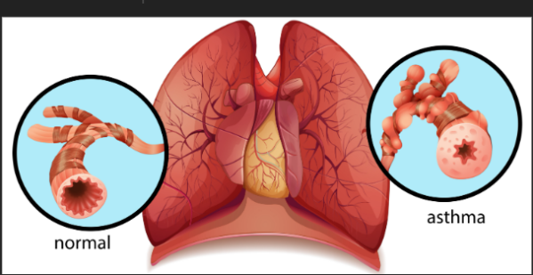
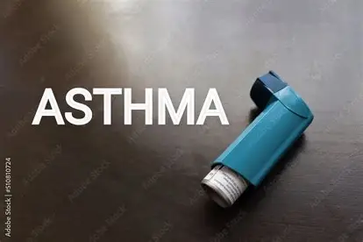
Images (Online images)

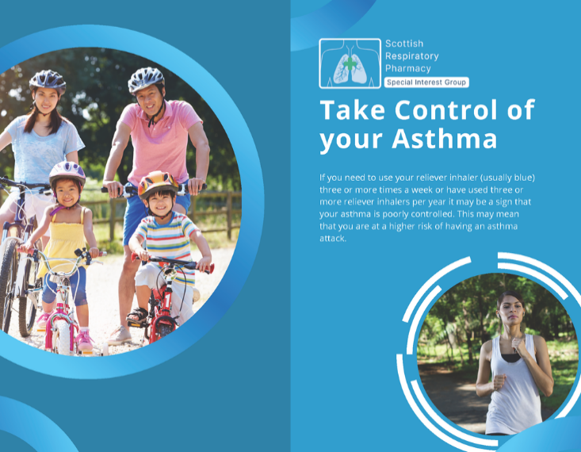(Community Pharmacy Scotland, 2024)

1. INTRODUCTION
Asthma is one of the most common long-term non-communicable diseases worldwide and remains a major cause of morbidity across the lifespan (Porsbjerg et al., 2023; GINA,2024) It is characterised by chronic airway inflammation, variable airflow limitation and recurrent symptoms such as wheeze, shortness of breath, chest tightness, and cough. Although effective treatments exist, many people continue to experience poorly controlled asthma, avoidable exacerbations, and reduced quality of life.
In the United Kingdom, asthma affects approximately 5.4 million people, including both adults and children, placing a substantial burden on individuals, families, and healthcare services (Asthma + Lung UK, 2023). Hospital admissions, emergency department attendances, and preventable deaths remain significant concerns, highlighting ongoing gaps between evidence-based asthma, alongside the wider implications for families and carers. Current theoretical models and frameworks for long-term condition management are examined, including UK and international perspectives, to illustrate how outcomes can be improved. National and local policies guiding asthma care are discussed, and practical recommendations are offered to support person-centred, self-management-focused approaches.
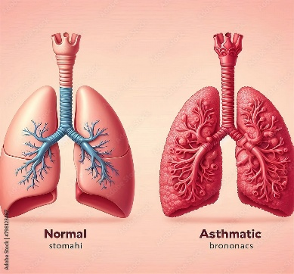
By presenting up-to-date evidence in a clear and supportive format, this booklet seeks to empower people living with asthma and those involved in their care, while also demonstrating critical engagement with contemporary research and policy.

2. UNDERSTANDING ASTHMA
Asthma is a heterogeneous disease, meaning it does not present in the same way for everyone. It is defined by chronic airway inflammation and variable airflow obstruction that is usually reversible, either spontaneously or with treatment (Porsbjerg et al., 2023). At a biological level, asthma is commonly associated with type 2 (T2) inflammation, driven by immune pathways involving interleukins such as IL-4, IL-5, and IL-13, although non-T2 phenotypes also exist (Fahy, 2015; Hammad & Lambrecht, 2021).
(Image) stock images
These inflammatory processes lead to:
- Narrowing of the airways
- Increased mucus production
- Swelling of airway walls
- Heightened airway sensitivity
Collectively, these changes cause the characteristic symptoms of asthma and explain why exposure to triggers such as allergens, infections or air pollutants can rapidly worsen breathing.
Research in immunology has shown that asthma involves complex interactions between innate and adaptive immune cells, including CD4+ T cells, eosinophils, and mast cells (Lambrecht & Hammad, 2015; Muehling et al., 2017). This complexity helps explain why some individuals respond well to standard inhaled therapies, while others require advanced biologic treatments.
Asthma severity exists along a spectrum. Many people achieve good control with low-dose inhaled corticosteroids, while others experience severe or difficult-to-treat asthma associated with frequent exacerbations, fixed airflow obstruction, and higher mortality risk (Brusselle & Koppelman, 2022). Recognising this variation is essential for tailoring care and avoiding a “one-size-fits-all” approach.
Importantly, asthma is now understood not simply as a respiratory condition, but as a long-term condition with multidimensional consequences affecting physical functioning, mental health, and social participation. This broader understanding underpins modern approaches to asthma management and long-term condition care.
3. PREVALENCE AND BURDEN OF ASTHMA
Asthma is a substantial global public health burden (GBD 2021 Diseases and Injuries collaborators, 2023). It is estimated that over 260 million people worldwide live with asthma, and the condition handles hundreds of thousands of deaths each year (Porsbjerg et al., 2023). Although mortality rates have declined in many high-income countries, asthma stays unevenly distributed, with higher burden seen in socioeconomically disadvantaged populations.
Within the UK, approximately one in twelve adults and one in eleven children are affected by asthma (Asthma + Lung UK, 2024). Despite the availability of effective therapies, outcomes are still suboptimal for most individuals. Emergency hospital admissions for asthma continue to occur at a rate that suggests inadequate long-term control, and a considerable proportion of asthma-related deaths are considered preventable.
Research shows that poor asthma outcomes are often linked to modifiable factors, including suboptimal inhaler technique, poor adherence to preventative medication, delayed access to specialist care and environmental exposures (GINA, 2023). However, structural issues such as health inequalities, housing quality and access to primary care also play a crucial role (Marmot et al.,2020).
Critically, the burden of asthma extends beyond clinical outcomes. People with uncontrolled asthma experience reduced quality of life, impaired sleep, limitations in physical activity and difficulties keeping employment or education. Families and carers may also experience emotional strain, financial pressure, and increased caregiving responsibilities. These broader consequences reinforce the need for comprehensive, person-centred, and preventative approaches to asthma care.

4. CAUSES AND RISK FACTORS
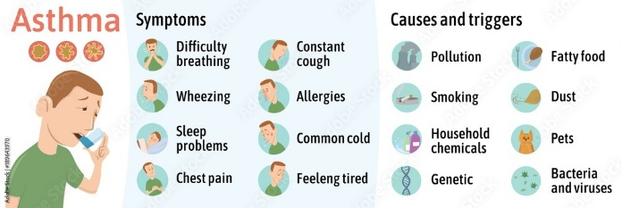
(Stock image, 2024)

Asthma develops through complex interactions between genetic susceptibility and environmental exposures. Family history is still one of the strongest predictors, with children of parents who have asthma being at significantly higher risk (Mirzakhani et al., 2019).

Environmental and lifestyle risk factors include:
- Exposure to tobacco smoke
- Indoor air pollutants (e.g., damp, mould, cleaning chemicals)
- Outdoor air pollution
- Respiratory viral infections in early life
- Obesity
Large-scale reviews have shown strong associations between indoor air pollutants and both new-onset asthma and worsening of existing disease (WHO,2021; Agache et al., 2025). This highlights the importance of housing quality and environmental health policies in asthma prevention.
Obesity is increasingly recognised as both a risk factor and disease modifier for asthma. Obese individuals with asthma often experience more severe symptoms, poorer control, and reduced response to standard inhaled therapies (Peters et al., 2018; Dixon & Poynter, 2016). This relationship is thought to involve mechanical, metabolic, and inflammatory mechanisms, illustrating the need for holistic management strategies (Forno & Celedon, 2017).
Importantly, risk factors do not act in isolation. Socioeconomic deprivation often clusters with higher exposure to pollutants, poorer housing conditions and reduced access to healthcare, amplifying asthma risk, and severity. Addressing asthma therefore requires interventions at both individual and population levels.

5. PHYSICAL IMPACT OF ASTHMA
Asthma is characterised by chronic airway inflammation, bronchoconstriction, and variable airflow limitation, leading to symptoms such as wheeze, breathlessness, chest tightness, and cough (Porsbjerg et al., 2023). These physiological changes reduce oxygen delivery and increase the work of breathing, which can significantly impair day-to-day functioning.
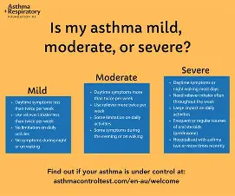
(Asthma Foundation, 2026)
For many individuals, asthma symptoms fluctuate over time. However, a subgroup of patients experiences persistent symptoms despite high-dose treatment, commonly referred to as severe or difficult-to-treat asthma. Severe asthma is associated with frequent exacerbations, emergency department attendance and hospitalisation, and increased risk of fixed airflow obstruction (Brusselle & Koppelman, 2022). This challenges the historical perception of asthma as a fully reversible condition.
Asthma can also disrupt sleep due to nocturnal symptoms, resulting in daytime fatigue, reduced concentration and impaired performance at work or school. Recurrent exacerbations further contribute to physical deconditioning, as individuals may avoid physical activity due to fear of symptom provocation.
From a critical perspective, many physical complications of asthma are preventable. Evidence indicates that inappropriate inhaler technique, poor adherence to inhaled corticosteroids and delayed escalation of therapy contribute to poor control (GINA, 2023). This suggests that biomedical treatment alone is insufficient; effective education, monitoring and follow-up are equally essential.

6. PSYCHOLOGICAL IMPACT OF ASTHMA
Living with asthma is associated with a significantly increased risk of anxiety and depression. Unpredictable symptoms and fear of severe attacks can generate chronic stress and hypervigilance, particularly in individuals who have previously experienced life-threatening exacerbations (Liu et al., 2023; Yan et al., 2024; Opolski and Wilson, 2005; Pickard-Michels et al., 2025).
Studies demonstrate that psychological distress is not merely a consequence of asthma but can also worsen disease control. Anxiety may amplify symptom perception, while depression is associated with poorer medication adherence and reduced self-management capacity. This creates a bidirectional relationship in which poor mental health and poor asthma control reinforce one another ( Freitas and Novais, 2025).
Children and adolescents with asthma may experience emotional difficulties linked to feeling “different” from peers, activity restriction, and school absence (Porsbjerg et al., 2023; Levy, 2015; Royal College of Physicians, 2014). Adults may experience frustration, loss of independence and reduced self-efficacy, particularly when symptoms persist despite treatment.
Critically, mental health support is not consistently embedded within routine asthma care pathways. This represents a significant gap in service provision. Integrating psychological screening and support into long-term condition management could improve both mental wellbeing and clinical outcomes.
7. SOCIAL AND FAMILY IMPACT
Asthma has substantial social consequences that extend beyond the individual. Poorly controlled asthma can limit participation in education, employment, and social activities. Repeated absences from school or work may affect academic attainment, career progression, and financial stability (Royal College of Physicians, 2014; Levy, 2015; Porsbjerg et al., 2023).
Families often assume caregiving roles, particularly for c(Royal College of Physicians, 2014; Carers UK, n.d.). Children or individuals with severe asthma his may involve monitoring symptoms, administering medication, attending appointments, and responding to emergencies. Such responsibilities can contribute to caregiver burden, emotional stress, and disruption to family routines.
Social determinants of health play a key role in shaping asthma outcomes. Individuals living in deprived areas are more likely to be exposed to air pollution, poor housing, and limited access to healthcare, all of which increase asthma morbidity (Defra, 2025; UK Government, 2021; Porsbjerg et al., 2023). These inequalities highlight that asthma management must extend beyond individual behaviour change to include broader policy and environmental interventions.

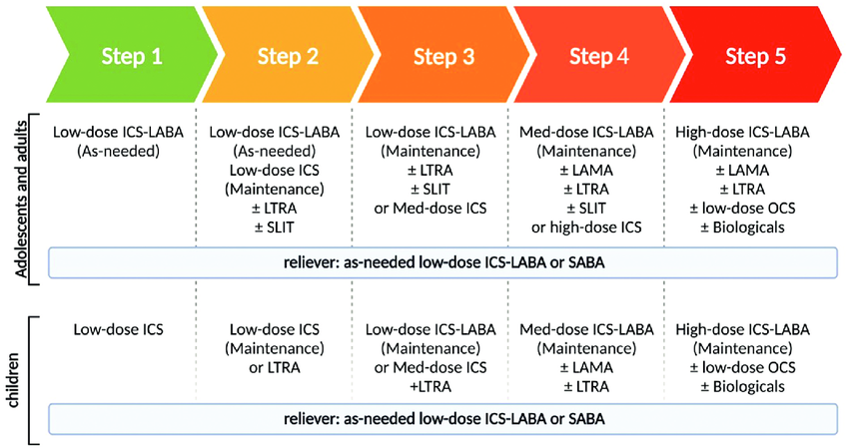
8. EVIDENCE-BASED TREATMENTS AVAILABLE IN THE NHS
(Gruffydd-Jones et al., 2025).
Asthma management within the NHS is guided by national and international evidence-based recommendations, including those from the Global Initiative for Asthma (GINA) and the British Thoracic Society/Scottish Intercollegiate Guidelines Network (BTS/SIGN). The primary aim of treatment is to achieve good symptom control, prevent exacerbations and minimise future risk.
Short Case Example (Real-world application)
A 34-year-old woman with “mild asthma” collects three salbutamol inhalers in four months but rarely uses her preventer. She works in cleaning with frequent chemical exposure and avoids asking for workplace adjustments due to fear of losing shifts. She has regular night symptoms and anxiety following a previous A&E admission. At review, she demonstrates incorrect inhaler technique and has no written asthma action plan. Her asthma is therefore poorly controlled due to a combination of clinical, occupational, and psychosocial factors rather than lack of medication alone (Pinnock, 2015; NICE,2024a; Hodkinson et al.,2020).
Person-centred management should include inhaler retraining, optimised therapy, a written action plan, mental health screening, and advice on reasonable workplace adjustments under the Equality Act 2010.

Pharmacological Treatments
Inhaled corticosteroids (ICS) remain the cornerstone of asthma management. They reduce airway inflammation and significantly decrease the frequency of exacerbations and asthma-related mortality. For many patients, ICS are combined with long-acting beta-agonists (LABA) to improve bronchodilation and symptom control (GINA, 2024a; BTS, 2025; NICE, 2024a).
More recently, Maintenance and Reliever Therapy (MART), using low-dose ICS-formoterol as both preventer and reliever, has been shown to reduce exacerbation risk compared with traditional short-acting beta-agonist (SABA)-based regimens. This approach simplifies treatment and improves adherence (GINA, 2024a; Porsbjerg et al., 2023)
For individuals with severe asthma, biologic therapies targeting specific inflammatory pathways (e.g., anti-IgE, anti-IL-5, anti-IL-4 receptor agents) have transformed outcomes. These treatments can reduce exacerbation frequency, oral corticosteroid dependence and improve quality of life (Brusselle & Koppelman, 2022).
Critical Evaluation
Although highly effective therapies exist, real-world outcomes remain inconsistent. Many patients do not receive optimal treatment due to underdiagnosis, delayed referral or inadequate review. Overreliance on SABA inhalers persists despite unmistakable evidence of associated risks.
Furthermore, biologic therapies are expensive and available only through specialist services, raising concerns about equity of access. This highlights the importance of robust primary care management to prevent progression to severe disease ( Brusselle & Koppelman, 2022; NICE, 2024a.
Non-Pharmacological Interventions
Non-pharmacological strategies are essential components of asthma care and include:

- Personalised asthma action plans
- Inhaler technique training
- Smoking cessation support
- Weight management
- Trigger identification and avoidance (GINA, 2024a; Pinnock et al., 2017; Peters et al., 2018; NICE, 2024a).
Evidence shows that patients with written asthma action plans experience fewer hospital admissions and improved self-management confidence. However, implementation remains inconsistent across NHS services (Pinnock et al., 2017; Hodkinson et al., 2020).
Environmental interventions, such as improving housing conditions and reducing indoor pollutants, can significantly improve symptoms, yet these are often beyond the control of individual patients. This underscores the need for cross-sector collaboration between health, housing, and environmental agencies (Agache et al., 2024; Defra, 2025; Environment Act 2021).
9. Policy, law, and legislation
Asthma outcomes in the UK are shaped not only by clinical treatment but by policy implementation and legal duties. Current UK clinical expectations are set through the NICE/BTS/SIGN asthma guidance pathway, which emphasises accurate diagnosis, regular review, optimised inhaled corticosteroid use, and supported self-management (NICE, 2024a; SIGN, 2024).
However, evidence from the UK National Review of Asthma Deaths (NRAD) highlighted persistent system failures including poor follow-up, inadequate personal asthma action plan provision, and preventable risk factors in a substantial proportion of cases (RCP, 2014; Levy, 2015). This exposes an implementation gap: guidance exists, yet safety-critical elements are not consistently delivered in routine practice ( UK Parliament 2015).
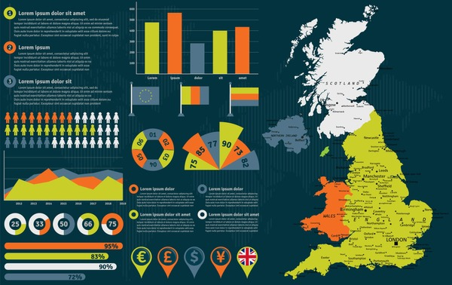

Legal frameworks strengthen the argument that suboptimal asthma care is not simply an individual “adherence” issue. Under the Equality Act 2010, asthma may constitute a disability where it has a substantial, long-term effect on normal activities, creating duties for employers and education providers to make reasonable adjustments (UK Government, 2013; ACAS, 2025). This is directly relevant to asthma-related work limitation, occupational triggers, and attendance issues.
Additionally, family burden can be framed through the Care Act 2014 wellbeing principle and duties around information/advice and support for carers, reinforcing that long-term condition management affects households as well as individuals (UK Government, 2025; SCIE, 2024).
10. THEORETICAL PERSPECTIVES AND MODELS OF CARE
UK Model: The Chronic Care Model (CCM)
The Chronic Care Model emphasises initiative-taking, structured, and patient-centred management of long-term conditions. It focuses on:
- Informed and activated patients.
- Prepared and initiative-taking healthcare teams.
- Integrated information systems
- Community support
In asthma care, this model supports regular reviews, personalised care planning, and shared decision-making. Evidence suggests that CCM-aligned services improve clinical outcomes and patient satisfaction.

International Model: WHO Innovative Care for Chronic Conditions (ICCC)
The ICCC framework extends the CCM by incorporating policy-level and community-level influences. It emphasises supportive environments, continuity of care and partnership between patients, families, and professionals (Wagner et al., 1998; Bodenheimer et al; 2002)
Critical Comparison
Both models promote person-centred care and self-management. However, implementation in practice is variable. Time constraints in primary care, workforce shortages and fragmented services limit consistent application. This suggests that structural reform is necessary alongside clinical guideline development.
11. LOCAL AND NATIONAL POLICY CONTEXT
Asthma care in the UK is shaped by a range of national strategies aimed at improving outcomes for people living with long-term conditions. The NHS Long Term Plan prioritises prevention, early diagnosis, and personalised care planning for chronic disease management. Asthma is explicitly recognised as a condition where avoidable harm remains unacceptably high (King’s Fund, 2013; British Heart Foundation, n.d.; NHS England, n.d.).
National audits repeatedly prove variation in asthma outcomes across regions, with higher hospital admission and mortality rates in deprived areas. This indicates that policy intentions are not consistently translated into practice. While clinical guidelines are robust, their implementation is uneven (Royal College of Physicians,2014; NICE 2024a).
Locally, Integrated Care Systems (ICSs) handle commissioning services that meet population needs. This provides opportunities for targeted interventions such as community respiratory teams, specialist nurse-led clinics, and school-based asthma education programmes. However, variability in funding and service design leads to a postcode lottery in access to high-quality asthma care NHS England, 2019).
From a critical standpoint, current policy frameworks emphasise individual self-management but often fail to adequately address structural determinants such as poor housing, air quality, and poverty. Without tackling these upstream factors, long-term reductions in asthma burden are unlikely.
12. PERSON-CENTRED CARE AND SELF-MANAGEMENT
Person-centred care recognises individuals as active partners in managing their condition rather than passive recipients of treatment. In asthma, this involves shared decision-making, personalised treatment plans and recognition of individual priorities and circumstances.
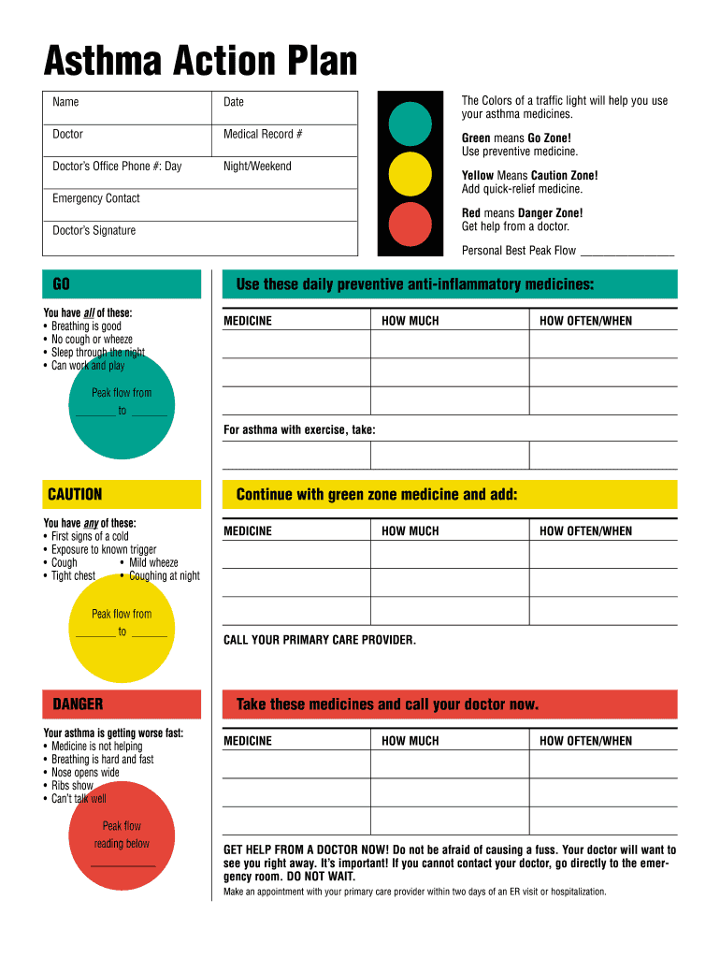 Image (online images)
- Effective self-management includes:
- Understanding symptoms and triggers
- Correct inhaler use
- Adherence to preventer medication
- Knowing when and how to seek help

Evidence indicates that patients who receive structured education and personalised asthma action plans have better symptom control and fewer exacerbations (Pinnock, 2015; Pinnock et al., 2017; NICE, 2024a; GINA, 2024a). However, many patients report never receiving a written plan or adequate inhaler training.
Cultural, linguistic and health literacy barriers further influence self-management capacity. A one-size-fits-all approach is therefore inadequate. Services must be tailored to reflect diversity and individual needs.
Critically, self-management should not be interpreted as shifting responsibility entirely onto patients. Healthcare systems retain a duty to provide accessible, continuous, and supportive care (Wagner et al., 1998; Bodenheimer et al., 2002; King’s Fund, 2013).

12. END-OF-LIFE CONSIDERATIONS (WHERE RELEVANT)
Although asthma is not commonly associated with palliative care, individuals with severe, treatment-refractory asthma may experience progressive decline and repeated life-threatening exacerbations (Brusselle & Koppelman, 2022; Levy, 2015). In such cases, early integration of palliative principles can improve symptom control, psychological wellbeing, and advance care planning
This aspect of care is often overlooked, reflecting broader discomfort within healthcare systems regarding end-of-life discussions for non-malignant disease. Addressing this gap represents a key area for service development (Royal College of Physicians, 2014; Levy, 2015).

14. RECOMMENDATIONS FOR IMPROVEMENT
Based on the evidence presented, the following recommendations are proposed:
- Mandatory provision of personalised asthma action plans for all patients
- Routine inhaler technique assessment at every review
- Expansion of specialist asthma nurse services
- Improved access to biologic therapies through streamlined referral pathways
- Integration of mental health screening into asthma reviews
- Stronger collaboration between healthcare, housing, and environmental services
- Mandatory annual asthma reviews that include inhaler technique assessment, adherence discussion, and mental health screening.
- Integrated asthma pathways linking primary care, community respiratory teams, schools, housing services, and environmental health departments.
(NICE, 2024a; BTS, 2025; GINA, 2024a; Pinnock et al., 2017; HQIP, 2014).

These recommendations are informed by evidence proving persistent gaps between clinical guidelines and real-world asthma care. They focus on strengthening prevention, reducing health inequalities and improving implementation of supported self-management across the care pathway.
15. CONCLUSION
Asthma remains a major long-term condition with significant physical, psychological, and social consequences. Despite the availability of effective treatments, preventable morbidity and mortality persist. Improving outcomes requires not only evidence-based pharmacological therapy but also person-centred care, robust self-management support, and action on wider social determinants of health.
Future progress in asthma care depends on shifting from a reactive, crisis-driven model towards proactive, preventative, and integrated long-term condition management. Bridging the gap between policy ambition and frontline practice is essential if avoidable harm is to be reduced.
By embedding person-centred approaches, strengthening self-management support, and addressing wider social and environmental determinants, asthma care can become more equitable, effective, and sustainable (GINA, 2024a; NICE, 2024a; BTS, 2025; Wagner et al., 1998).

WHERE TO GET FURTHER SUPPORT AND INFORMATION
If you need advice or support with asthma, the services below provide trusted information and help.
Asthma + Lung UK
Website: https://www.asthmaandlung.org.uk
Helpline: 0300 222 5800
NHS 111 (urgent advice, 24 hours)
Telephone: 111
Emergency
Call 999 if someone is having a severe asthma attack and struggling to breathe.
INFORMATION IN OTHER LANGUAGES
Asthma information is available in multiple languages and easy-read formats.
NHS: https://www.nhs.uk
Asthma + Lung UK: https://www.asthmaandlung.org.uk
Scan the QR code for trusted asthma information, inhaler videos, and asthma action plan.
👉 https://www.asthmaandlung.org.uk/conditions/asthma
Arabic (العربية)
امسح رمز الاستجابة السريعة للحصول على معلومات موثوقة عن الربو وخطط العلاج واستخدام البخاخات.
Urdu (اردو)

قابلِ اعتماد دمہ کی معلومات، انہیلر ویڈیوز اور ایکشن پلانز کے لیے کیو آر کوڈ اسکین کریں۔
Polish (Polski)
Zeskanuj kod QR, aby uzyskać rzetelne informacje o astmie, filmy o inhalatorach i plany leczenia.
Punjabi (ਪੰਜਾਬੀ)
ਦਮਾ ਬਾਰੇ ਭਰੋਸੇਯੋਗ ਜਾਣਕਾਰੀ, ਇਨਹੇਲਰ ਵੀਡੀਓ ਅਤੇ ਐਕਸ਼ਨ ਪਲਾਨ ਲਈ QR ਕੋਡ ਸਕੈਨ ਕਰੋ।
Bengali (বাংলা)
বিশ্বাসযোগ্য হাঁপানি তথ্য, ইনহেলার ভিডিও এবং অ্যাকশন প্ল্যানের জন্য QR কোড স্ক্যান করুন।
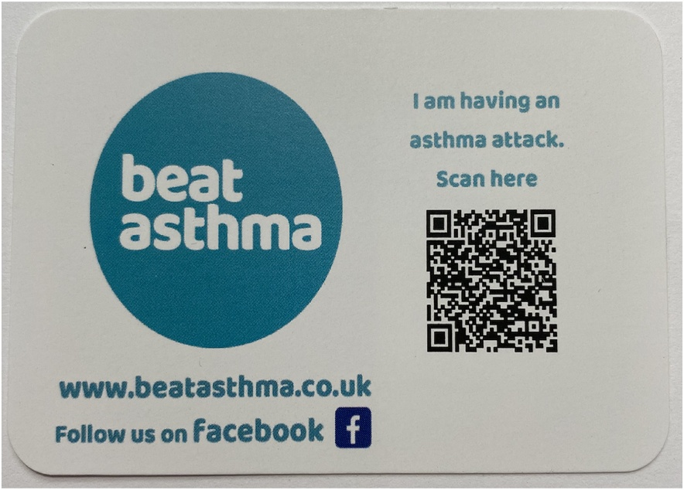

References:

ACAS (2025) Reasonable adjustments at work. Available at: https://www.acas.org.uk/reasonable-adjustments
(Accessed: 23 February 2026).

Agache, I. et al. (2024) ‘EAACI Guidelines on Environmental Science for Allergy and Asthma—Recommendations on the impact of indoor air pollutants on asthma-related outcomes’, Allergy. Available at: https://onlinelibrary.wiley.com/journal/13989995
(Accessed: 20 February 2026).

Ash, S.Y. et al. (2018) ‘Pruning of the pulmonary vasculature in asthma: The Severe Asthma Research Program (SARP) cohort’, American Journal of Respiratory and Critical Care Medicine, 198(1), pp. 39–50. doi:10.1164/rccm.201712-2426OC.

Bodenheimer, T., Wagner, E.H. and Grumbach, K. (2002) ‘Improving primary care for patients with chronic illness’, JAMA, 288(14), pp. 1775–1779. Available at: https://jamanetwork.com
(Accessed: 20 February 2026).

British Heart Foundation (n.d.) Person-centred care and the House of Care. Available at: https://www.bhf.org.uk
(Accessed: 20 February 2026).

British Thoracic Society (2024) BTS/SIGN asthma guideline update. Available at: https://www.brit-thoracic.org.uk
(Accessed: 23 February 2026).

British Thoracic Society (2025) ‘BTS/NICE/SIGN joint guideline on asthma: diagnosis, monitoring and management’, Thorax, 80(7), pp. 416–423. Available at: https://thorax.bmj.com
(Accessed: 23 February 2026).

Brusselle, G.G. and Koppelman, G.H. (2022) ‘Biologic therapies for severe asthma’, New England Journal of Medicine, 386(2), pp. 157–171. doi:10.1056/NEJMra2032506.

Bullone, M. and Lavoie, J-P. (2015) ‘Asthma “of horses and men”’, Molecular Immunology, 66(1), pp. 97–105. doi:10.1016/j.molimm.2014.12.005.

Carers UK (n.d.) Your guide to the Care Act (England). Available at: https://www.carersuk.org
(Accessed: 20 February 2026).

Daines, L. et al. (2020) ‘Understanding how patients establish strategies for living with asthma’, British Journal of General Practice, 70(694), e303–e311. Available at: https://bjgp.org
(Accessed: 20 February 2026).

Department for Environment, Food & Rural Affairs (Defra) (2025) Air quality: Environment Act target delivery plan. Available at: https://www.gov.uk/government/collections/air-quality-environment-act-target-delivery-plan
(Accessed: 20 February 2026).

Fahy, J.V. (2015) ‘Type 2 inflammation in asthma’, Nature Reviews Immunology, 15(1), pp. 57–65. doi:10.1038/nri3786.

Feldman, A.S. et al. (2015) ‘Toward primary prevention of asthma’, American Journal of Respiratory and Critical Care Medicine, 191(1), pp. 34–44. doi:10.1164/rccm.201405-0901PP.

Freitas, J. and Novais, F. (2025) ‘Review on the relationship of asthma and mental disorders’, Personalized Medicine in Psychiatry, 51–52, 100157. doi:10.1016/j.pmip.2025.100157. Available at: https://www.sciencedirect.com
(Accessed: 20 February 2026).

Global Initiative for Asthma (GINA) (2024a) Global Strategy for Asthma Management and Prevention. Available at: https://ginasthma.org
(Accessed: 20 February 2026).

Global Initiative for Asthma (GINA) (2024b) 2024 Summary Guide for Asthma Management and Prevention. Available at: https://ginasthma.org
(Accessed: 18 February 2026).

Gruffydd-Jones, K. (2025) ‘BTS/NICE/SIGN guideline for asthma 2024’, npj Primary Care Respiratory Medicine, 35, 22. doi:10.1038/s41533-025-00425-x. Available at: https://pmc.ncbi.nlm.nih.gov/articles/PMC11992161/
(Accessed: 23 February 2026).

Hammad, H. and Lambrecht, B.N. (2021) ‘The basic immunology of asthma’, Cell, 184(6), pp. 1469–1485. Available at: https://www.cell.com
(Accessed: 20 February 2026).

Hodkinson, A. et al. (2020) ‘Self-management interventions to reduce healthcare use’, BMJ, 370, m2521. Available at: https://www.bmj.com
(Accessed: 20 February 2026).

Healthcare Quality Improvement Partnership (HQIP) (2014) National Review of Asthma Deaths (NRAD). Available at: https://www.hqip.org.uk/resource/national-review-of-asthma-deaths-nrad/
(Accessed: 18 February 2026).

Jutel, M. et al. (2024) ‘House dust mite SCIT reduces asthma risk’, Allergy, 79(4), pp. 1042–1051. doi:10.1111/all.16052.

King’s Fund (2013) Delivering better services for people with long-term conditions: the House of Care model. Available at: https://www.kingsfund.org.uk
(Accessed: 20 February 2026).

Kuruvilla, M.E. et al. (2019) ‘Understanding asthma phenotypes’, Clinical Reviews in Allergy & Immunology, 56, pp. 219–233.

Lambrecht, B.N. and Hammad, H. (2015) ‘The immunology of asthma’, Nature Immunology, 16(1), pp. 45–56.

Levy, M.L. (2015) ‘The national review of asthma deaths’, Breathe, 11(1), pp. 14–24. Available at: https://breathe.ersjournals.com
(Accessed: 20 February 2026).

Liu, X. et al. (2023) ‘Bidirectional associations between asthma and mental disorders’, JACI: In Practice. Available at: https://www.jaci-inpractice.org
(Accessed: 20 February 2026).

National Institute for Health and Care Excellence (NICE) (2024a) Asthma: diagnosis, monitoring and management (NG245). Available at: https://www.nice.org.uk/guidance/ng245
(Accessed: 20 February 2026).

National Institute for Health and Care Excellence (NICE) (2024b) Asthma pathway (NG244). Available at: https://www.nice.org.uk
(Accessed: 18 February 2026).

NHS England (n.d.) Comprehensive model of personalised care. Available at: https://www.england.nhs.uk/personalisedcare
(Accessed: 23 February 2026).

Opolski, M. and Wilson, I. (2005) ‘Asthma and depression’, Clinical Practice and Epidemiology in Mental Health, 1, 18. doi:10.1186/1745-0179-1-18.

Peters, U., Dixon, A.E. and Forno, E. (2018) ‘Obesity and asthma’, Journal of Allergy and Clinical Immunology, 141(4), pp. 1169–1179.

Pickard-Michels, T. et al. (2025) ‘Association between mental health disorders and asthma exacerbations’, BMJ Open Respiratory Research, 12(1), e003244.

Pinnock, H. (2015) ‘Supported self-management for asthma’, Breathe, 11(2), pp. 98–109.

Pinnock, H. et al. (2017) ‘Systematic meta-review of supported self-management for asthma’, BMC Medicine, 15, 64.

Porsbjerg, C. et al. (2023) ‘Asthma’, The Lancet, 401(10379), pp. 858–873. doi:10.1016/S0140-6736(22)02125-0.

Royal College of Physicians (RCP) (2014) Why asthma still kills: The National Review of Asthma Deaths (NRAD). Available at: https://www.rcplondon.ac.uk/projects/outputs/why-asthma-still-kills
(Accessed: 18 February 2026).

Scottish Intercollegiate Guidelines Network (SIGN) (2024) British guideline on the management of asthma. Available at: https://www.sign.ac.uk
(Accessed: 20 February 2026).

Social Care Institute for Excellence (SCIE) (2024) Key Care Act duties for assessment and eligibility. Available at: https://www.scie.org.uk
(Accessed: 23 February 2026).

UK Government (2012) Health and Social Care Act 2012. Available at: https://www.legislation.gov.uk/ukpga/2012/7
(Accessed: 18 February 2026).

UK Government (2013) Equality Act 2010 guidance on definition of disability. Available at: https://www.gov.uk/definition-of-disability-under-equality-act-2010
(Accessed: 20 February 2026).

UK Government (2014) Care Act 2014. Available at: https://www.legislation.gov.uk/ukpga/2014/23
(Accessed: 20 February 2026).

UK Government (2021) Environment Act 2021. Available at: https://www.legislation.gov.uk/ukpga/2021/30
(Accessed: 20 February 2026).

UK Parliament (2015) ‘Asthma: Written question – UIN 223620’. Available at: https://questions-statements.parliament.uk/written-questions/detail/2015-02-05/223620
(Accessed: 23 February 2026).

Wagner, E.H. et al. (1998) ‘Improving chronic illness care’, Health Affairs, 20(6), pp. 64–78.

Yan, Z. et al. (2024) ‘Genetic analyses of bidirectional associations between anxiety, depression and asthma’, Frontiers in Psychiatry. Available at: https://www.frontiersin.org
(Accessed: 20 February 2026).

