Thomas Pritchard
1809125

ACCA4018
Internet Technology and Security
Assignment 1
BYOT – Synthesize a solution to a potential real life scenario

Contents
- Introduction
- BYOT: Advantages and Disadvantages
  - Advantages
  - Disadvantages
- Hyper-Fort
- Network Configuration
- Data Flow Diagram
- MDM Software
- Policies
- Conclusion
- References
- Further Reading

- Introduction
The below report looks into advantage and disadvantages of implementing a BYOT framework into a business. The report looks at an example company, Hyper-Fort, and includes a layout of their network, as well as a proposed MDM solution to best meet their needs.

- BYOT: Advantages and Disadvantages
Successful implementation of BYOT into an organisation involves finding the right balance between security and accessibility. Each companies’ requirements, and thus solution, will be unique, however below are detailed some common advantages and disadvantages to a BYOT framework.
  - Advantages
Increased staff satisfaction [1]
Staff who are able to work and access company data using their own devices are more satisfied in work; they are able to use devices they are already comfortable with and are able to work more flexibly.
Cost savings [2]
Companies do not need to purchase and supply devices to each user.
Increased productivity
With mobile employees working on average 240 hours more per year [3] than their office based counterparts it is evident that a BYOT implementation provides business benefits.
Out-of-office flexibility [4]
BYOD provides companies with the opportunity to allow employees to work at times and locations most convenient for them, including utilising time that may have otherwise gone to waste such as between off-site meetings or as part of a commute.
Training
As employees will be using devices they are already comfortable with, there will be a lower requirement for time devoted to training. [5]
2.2 Disadvantages
Less control over device security features
Without a strong policy and MDM in place, many users may not fully utilise the security features of their device, a 2017 study found that 28% of smartphone users have no lock screen on their phone [6]. Of the 25% that use a pin code [6] many do not choose a unique number; the same 20 most popular pin codes are used in 26.83% of cases [7].
Support complexity
Due to the larger scope of devices that employees may bring to work, there is a requirement for an increased level of support that I trained and able to cope with each of these individual requirements. [8]
Always online
As opposed to work devices, personal devices are generally left switched on and internet connected at all times [5], increasing the opportunity for an attacker to exploit a vulnerability.
Employees may not wish to provide their employer with access to their personal device [4]
Employees may not be comfortable providing a company access to their device which stores a large amount of personal data, with the worry that the company will have access.

- Hyper-Fort
Hyper-Fort act as a global consultancy company operating within the energy sector. Due to the nature of this work, it is assumed that the company will be handling sensitive data such as payment records, customer PII and information on future company plans which may be required to be kept confidential.
With security of personal staff and client data, as well as Hyper-fort’s intellectual properties, forming a major concern for the company, it is evident that their BYOT plan must provide increased service accessibility without negatively compromising security to a level beyond the company’s risk appetite.

- Network Configuration
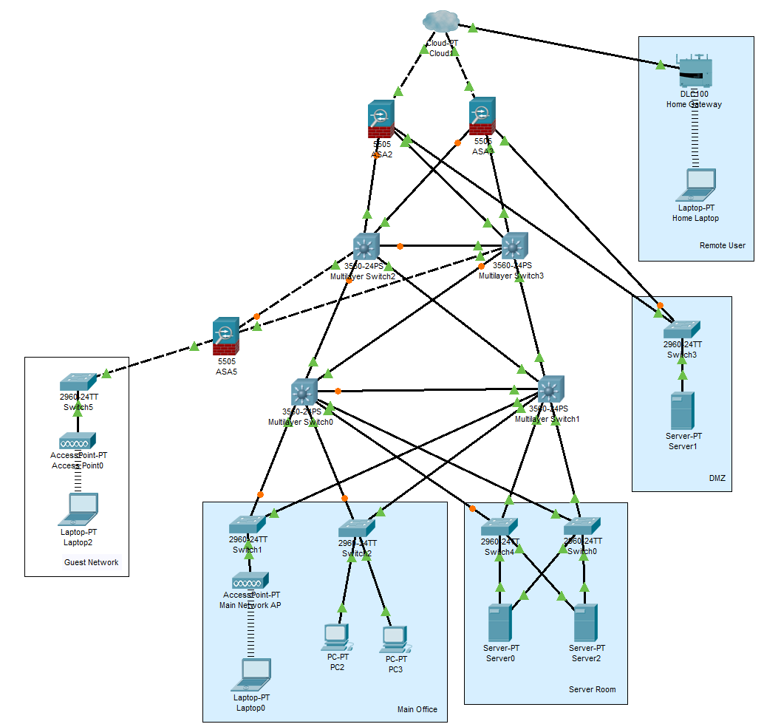
Above is a network diagram showing the layout of the Hyper-Fort network and external device connections. The above diagram makes the assumption that the majority of Hyper-Fort staff work in one head-office location with no satellite branches, with other’s working remotely from locations including their homes, this may be anywhere across the globe.
For connections on site, the network is laid out in a three-layer hierarchy. Each item on each layer is connected to all the resources above and below in order to provide high resiliency should a hardware failure occur. Due to the nature of the company, both staff and clients need access to company resources, for this reason I have created a DMZ connected to the outer firewall pair which allows access to shared resources required by both staff and clients, negating the need for clients to access the rest of the network. Traffic is filtered on the firewall pair both into and out of this DMZ.
Two Layer 3 switches operate at the core layer, connected to these is another firewall through which guest devices are able to connect to the network for internet access. The firewall rules are set to limit the direction of data to provide internet access only, mimicking an outside connection.
A further two layer 3 switches are installed within the distribution layer, which then connect to the application layer below. At this layer, company resources are found and accessed within the server room, and standard PCs have ethernet connections. As 95% of Hyper-Fort workers use wifi, the diagram shows a device connected via a wireless access point – this is representative of a full wireless network covering all necessary areas of the company’s site, depending on its size.
Remote users are able to access company assets via a VPN solution.

- Data Flow Diagram
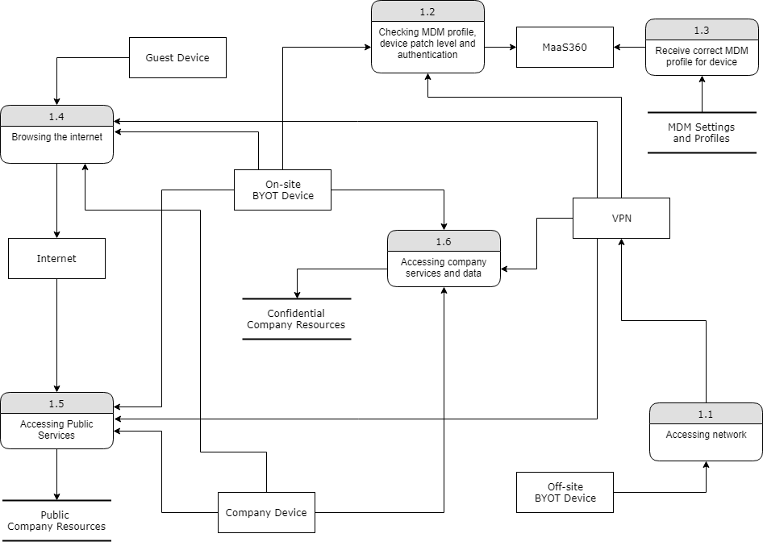

It is assumed that a VPN solution is in place for existing remote access, otherwise access to the company network for remote users must only be possible via a company provisioned VPN, this ensures that all company data is encrypted whilst in transit. This reduces the risk of data leakage whilst an employee is outside of the office environment, as the only attack surface would be the end device which is locked down as part of the BYOT framework detailed in sections 6 and 7.

- MDM Software
The recommended MDM implementation for Hyper-fort would be MaaS360, which offers key features that prove are likely to prove the most useful in the Hyper-Fort environment.
Hyper-Fort already utilise cloud services to deliver IT services to its staff and clients, therefore it is assumed that a full risk assessment has been completed surrounding their corporate data being stored with third party cloud providers. Based on this, as strong recommendation for an MDM solution would be the cloud-based [9] MaaS360. Considering a SaaS solution for a company already bought into the cloud eco-system offers a number of benefits including no need to purchase additional on-premise hardware, and increased ease of availability. With the ‘five nines’ of availability [10] often being a target, it is estimated that cloud solutions become the most economical option for availability over approximately 99.95% [11].
MaaS360 offers containerisation [12] for supported devices (see section 7 for more information on supported devices), any business data retained on the device is placed in a separate encrypted environment, keeping both sensitive data from leaving the container as well as preventing access to malicious content [13]. This also provides the added benefit of allowing a selective wipe, ensuring that if a wipe of corporate data from the device needs to be completed, this can be done without affecting the employee’s personal data. Access control can be applied [12] to containerised apps requiring the employee to provide authentication information before access to the information or service. This ensures that data kept on a company device remains secure even when outside the office environment.
MaaS360 offers the facility to implement a per-device policy framework, the use of this is recommended to enforce the policies detailed within the next section to maximise security.

- Policies
A number of policies should be considered for users of mobile devices as part of the BYOT framework.
Firstly, device support should be considered. With an expectation that users will be utilising their own personal devices to access corporate data and services, this brings forward the issue that IT staff must now offer support for a multitude of devices. In order to best utilise resources, it would be recommended that hardware is limited to those that are 1) supported by the chosen MDM tool, MaaS360 (a full list is linked in Further Reading below); and 2) most widely used by staff. According to Statcounter [14][15] the OS’s with the largest market share are:

Therefore, to operate the MDM successfully at a basic level, the Hyper-Fort should be equipped with the resources and staff training required to support Windows, OS X, Android and iOS. In order to incorporate more of its users for optimal operation, a business should strive to support as many devices as possible, however assuming that Hyper-Fort only has the resources to support these 4 devices, a further process should be considered. A process should be implemented to provide users with these devices if they do not already have their own or do not wish to use their personal device for work under the BYOD scheme, such as COPE [16] (Corporately Owned, Personally Enabled) devices.
A security policy should be created and distributed which, as a minimum, covers the following areas in relation to BYOD:
Declaration:
A security declaration should be signed by all BYOD users which confirms that they have read and understood the security policy, as well as the employee making a declaration that they will be following the security guidance.
Remote wipe:
In order to ensure data security when a company device leaves the office, remote wipe should be enabled as detailed in section 6. The declaration above should also include a statement that this facility is in operation.
Patching and updates:
Where possible, automatic updates should be enabled for the OS, applications and anti-virus. Otherwise, users should be required to update their device on a frequent basis to ensure security updates are installed promptly. Compliance Rules should be set within MaaS360 [16] to ensure connections are only possible with devices on recent operating system versions.
Screen lock:
Employees should be required to utilise a password or pin protected lock screen on their device; this secret authentication information must be known solely by the user. If the employee believes this information has been shared or compromised, they should be instructed to change it immediately and notify their Service Desk.
Leaving the company, Loss or Theft:
Should an employee lose their device, they must notify the Service Desk immediately for a remote wipe of company information to be arranged. This process, and relevant contact information, should be regularly distributed to ensure employees hold a consistent level of process awareness should a loss or theft incident occur.
When an employee leaves the company, Service Desk must be notified immediately so that the device can be provided to the IT Department for company data to be removed, the responsibility for notification should lie with the employee’s line manager. Where a user leaves the company unexpectedly, or the device is not available to the IT department, a remote wipe should be initiated.
Elements of this policy which can be enforced via the MDM should be put into place, such as enforcing the use of remote wipe, screen locks or frequent updates.
Allowing the use of personally owned devices may encourage some users to blend personal and business device use on company time. The level as to which this would be acceptable, and how it would be monitored will differ depending on business areas, for example the PR team may utilise the camera function to post images to Social Media, whereas an employee within the finance department is unlikely to need the camera for work purposes. For this reason, heads of group for each area should define acceptable usage to meet their business needs, and this should be shared amongst all managers in the area, with responsibility for compliance resting with each individual’s line manager.

- Conclusion
In conclusion, the recommendation for a BYOT solution for Hyper-Fort includes utilisation of MaaS360, a cloud-based MDM solution which meets the requirements of the business, offers containerisation for protection of company information both inside and outside of the office environment, and supports a multitude of devices that may be required as part of the BYOT framework.
The solution also includes a VPN for remote connections, an a multitude of policies which support the technical solution, with various responsibilities split between administrators, managers and employees.

- References
[1] P. K. Gajar, A. Ghosh, and S. Rai, “Bring Your Own Device (Byod): Security Risks And Mitigating Strategies,” J. Glob. Res. Comput. Sci., 2013.
[2] D. Evans, “What is BYOD and why is it important?,” 2013.
[3] “The iPass Global Mobile Workforce Report The iPass Global Mobile Workforce Report Understanding Enterprise Mobility Trends and Mobile Usage,” 2011.
[4] S. Blizzard, “Coming full circle: are there benefits to BYOD?,” Comput. Fraud Secur., vol. 2015, no. 2, pp. 18–20, Feb. 2015.
[5] N. Singh, “B.Y.O.D. Genie Is Out Of the Bottle – ‘Devil Or Angel,’” J. Bus. Manag. Soc. Sci. Res., vol. 1, no. 3, 2012.
[6] M. Anderson, “Many smartphone owners don’t take steps to secure device,” 2017.
[7] “PIN number analysis,” Data Genetics, 2012. [Online]. Available: http://datagenetics.com/blog/september32012/index.html. [Accessed: 17-Dec-2018].
[8] G. Disterer and C. Kleiner, “BYOD Bring Your Own Device,” Procedia Technol., vol. 9, pp. 43–53, Jan. 2013.
[9] “IBM Knowledge Center - IBM MaaS360 Mobile Device Management (SaaS) documentation.” [Online]. Available: https://www.ibm.com/support/knowledgecenter/en/SS8H2S/com.ibm.mc.doc/mc_collateral/mc_landing.htm?origURL=SS8H2S. [Accessed: 17-Dec-2018].
[10] T. Chumash, “Obtaining Five ‘Nines’ of Availability for Internet Services,” 2006.
[11] J. Beswick, “If you’re serious about availability, cloud is the only option,” IT Next, 2017. [Online]. Available: https://itnext.io/if-youre-serious-about-availability-cloud-is-the-only-option-f8cb142fecda. [Accessed: 17-Dec-2018].
[12] “Securing your mobile apps with MaaS360 (IBM MaaS360).” [Online]. Available: https://www.ibm.com/developerworks/community/blogs/4d57676c-a8cd-4907-9910-b21f35a1e5c6/entry/Securing_your_mobile_apps_with_MaaS360?lang=en. [Accessed: 17-Dec-2018].
[13] “What is Mobile Application Webopedia.” [Online]. Available: https://dm.comodo.com/solutions/application-containerization/. [Accessed: 17-Dec-2018].
[14] “Desktop Operating System Market Share Worldwide | StatCounter Global Stats,” 2019. [Online]. Available: http://gs.statcounter.com/os-market-share/desktop/worldwide. [Accessed: 02-Jan-2019].
[15] “Mobile Operating System Market Share Worldwide | StatCounter Global Stats,” 2019. [Online]. Available: http://gs.statcounter.com/os-market-share/mobile/worldwide. [Accessed: 02-Jan-2019].
[16] J. Holleran, “Building a Better BYOD Strategy,” Risk Manag. New York, vol. 61, no. 7, p. 12, 2014.

- Further Reading
Full list of devices/operating systems supported by MaaaS360
https://www.ibm.com/support/knowledgecenter/en/SS8H2S/com.ibm.mc.doc/pag_source/concepts/devices_supported_sps_mdm.htm

