DS 1 Template

My Screenshots/Photos
- Please add 4–6 screenshots or photos of your digital life.
- You can use your phone or laptop.
- For each screenshot, write one or two sentences explaining what it shows.

Screenshot/Photo 1

I use the stock app to check the market

Screenshot/Photo 2
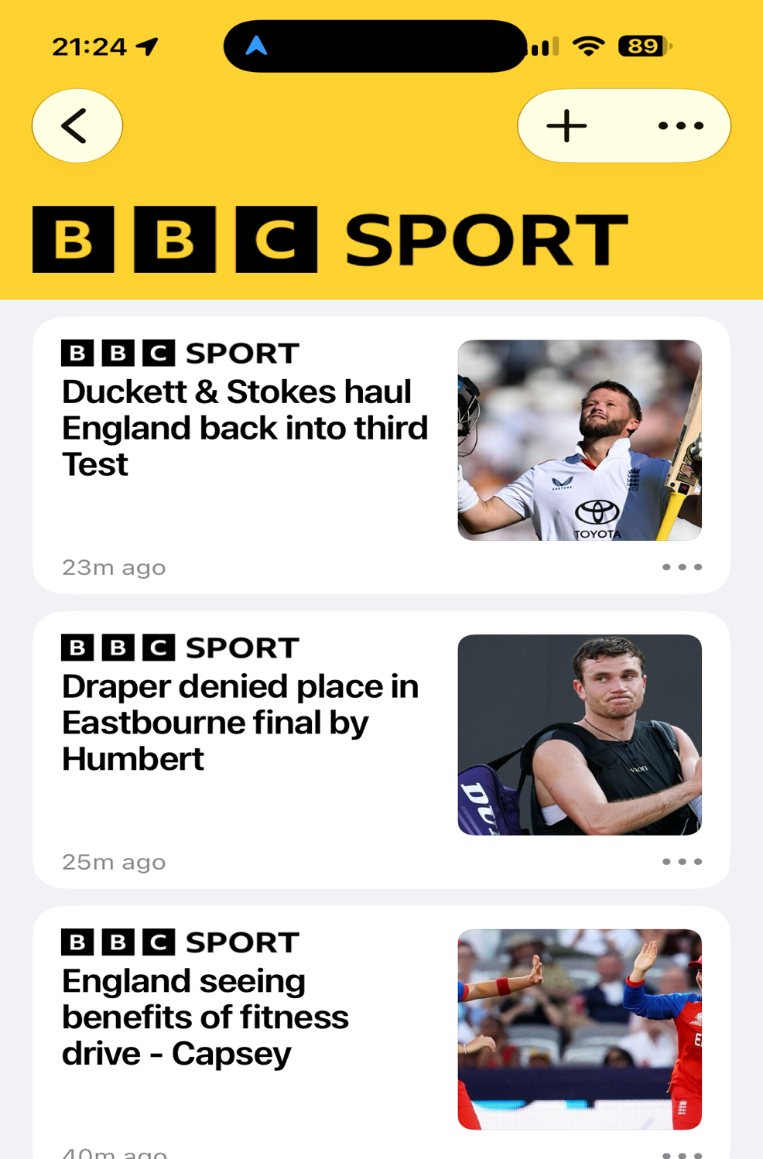
I use the bbc sport app to get my daily sports reports

Screenshot/Photo 3
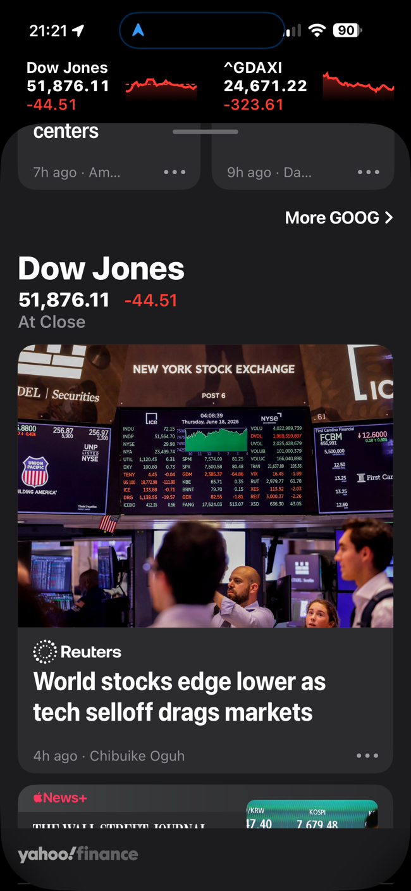
I specially use this app on my iPhone to watch the world stocks

Screenshot/Photo 4
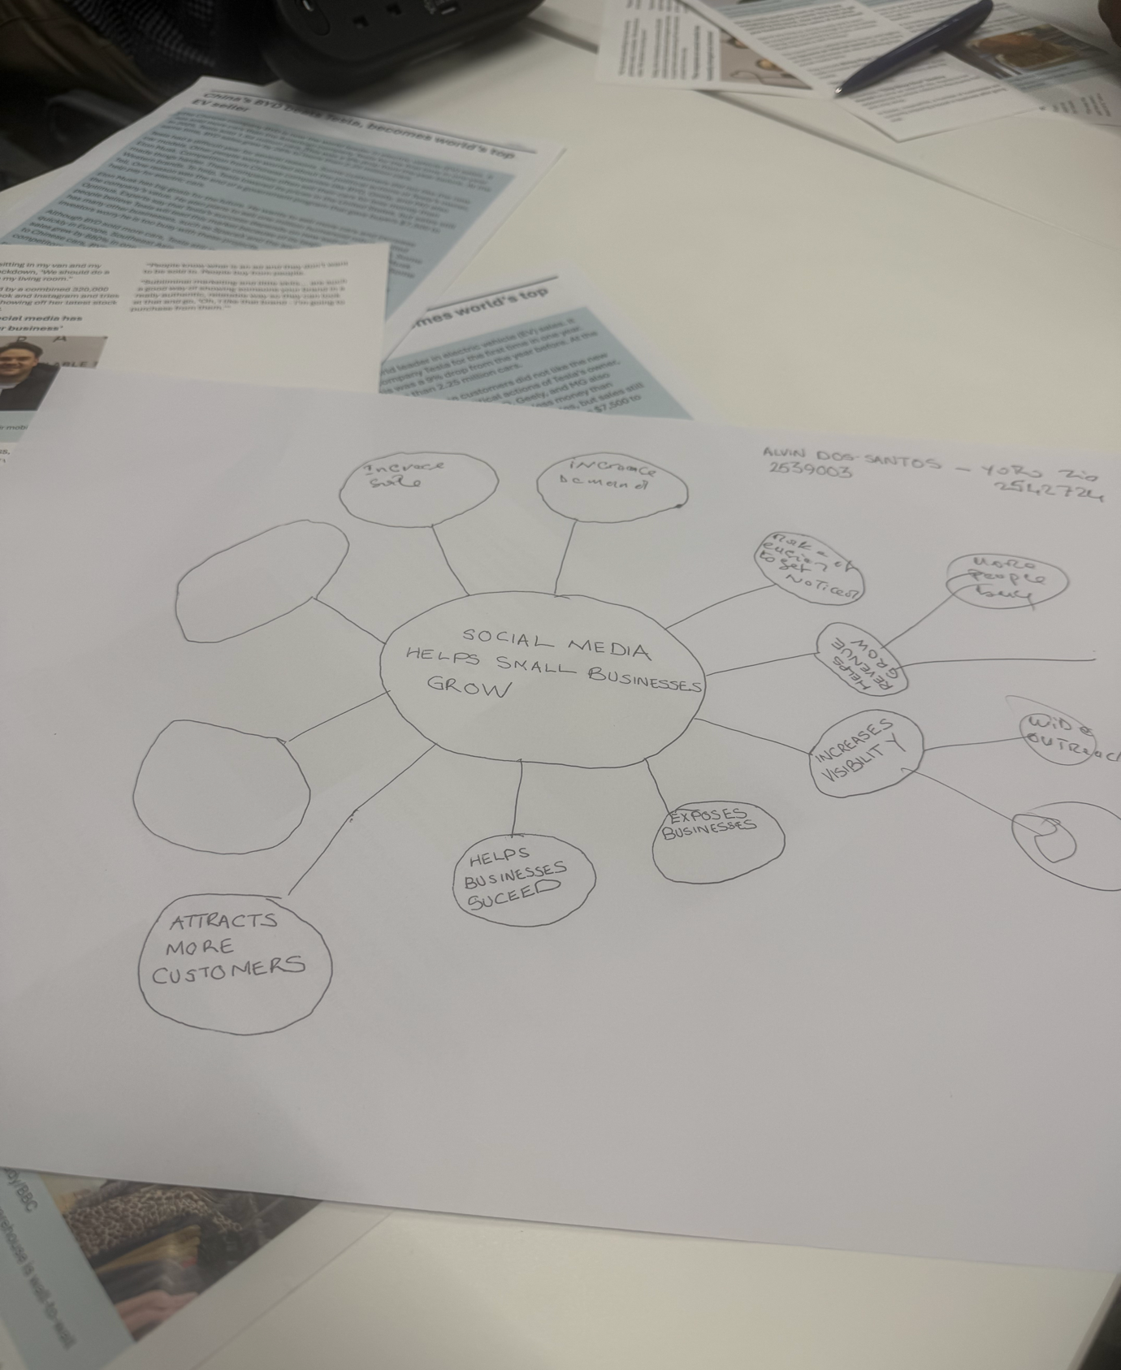
This is a class workshop on how social media can help small businesses grow

Screenshot/Photo 5
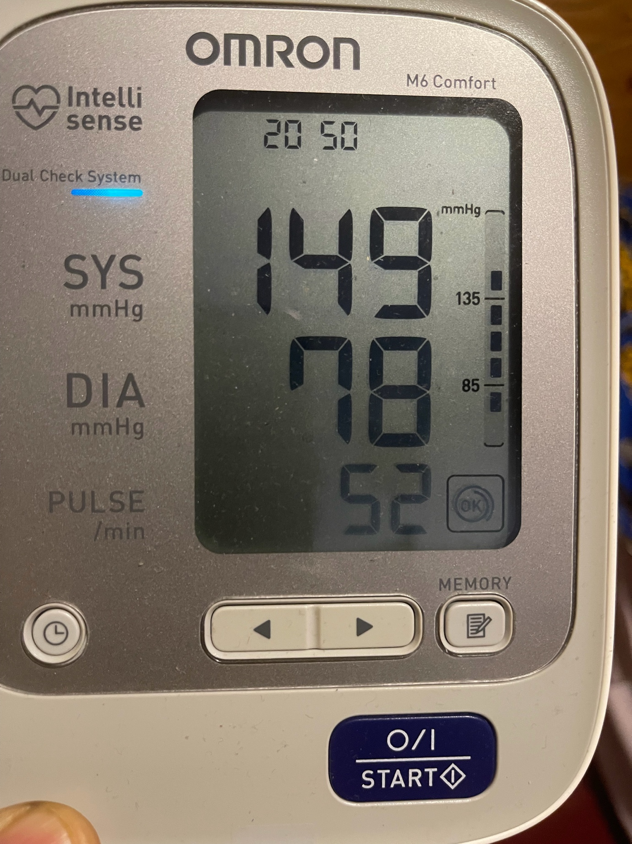
I use my phone to record my daily high blood pressure reading

Screenshot/Photo 6
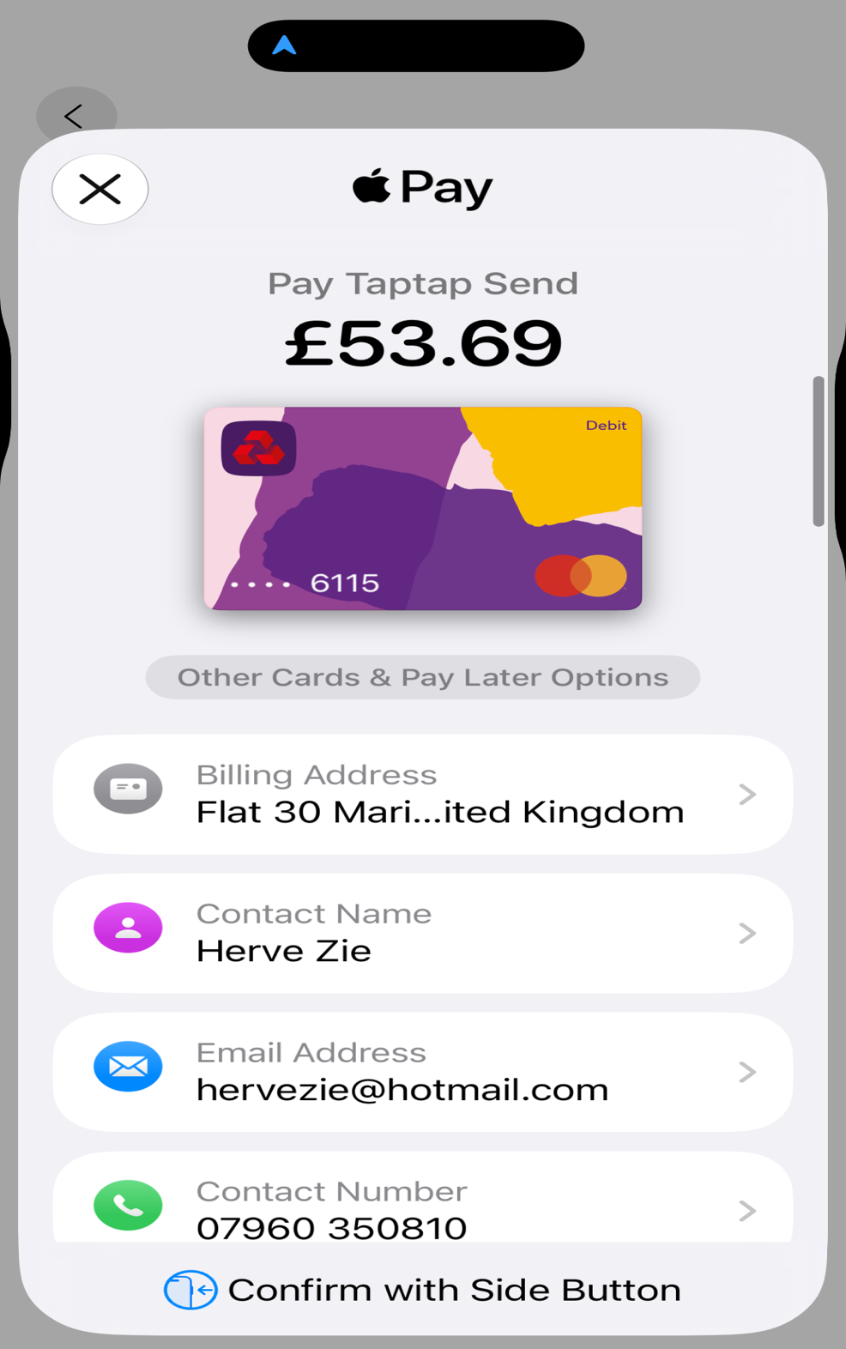
I use my phone to take a screenshot of my purchases

My Short Reflection
- Write 5–8 simple sentences about your digital life.
- You can use the sentence starters below if helpful.
I use digital tools such as my phone , laptop or tablet and my computer to write, record and research everything. I also use them to communicate through apps like Facebook WhatsApp and many more.
Although I feel sometimes not confident enough about using certain apps, I know that I can improve because digital skills are increasingly important to my business and daily life.

Sentence starters
- I use digital tools to …
- I feel confident when I …
- I want to improve …
- I often use these tools: …
- I sometimes feel nervous about …
- I hope this module will help me …
- Digital skills are important for me because …
You can write more if you want.

Submission Checklist
Before you submit, please check:
​​​ ☐ I added 4–6 screenshots
☐ I wrote short sentences for each screenshot
☐ I wrote my short reflection
☐ My work is my own
☐ My file opens correctly
​​☐ My file opens correctly

