Financial management

Student name: Iva Pavlova-Minkova
Student Number: 1919329
Lecturer: Jia Miao
Re-Submission Date: 10/05/2021

Table of Contents
Part A. 4
Part B. A critical review of the financial performance of the company 5
Calculation and evaluation of Financial Ratio Analysis of Tesco Plc for the Last Five Years 5
Profitability Ratio 5
Liquidity Ratio 7
Gearing Ratio 8
Efficiency Ratio 9
Comparison of the financial performance with the competitor 10
Calculation of Financial Ratio Analysis of J Sainsbury Plc for the Last Five Years 10
Profitability Ratio 10
Liquidity Ratio 11
Gearing Ratio 12
Efficiency Ratio 12
Comparison between the financial performance of Tesco Plc and J Sainsbury Plc of the last 5 years 13
Profitability Ratio 13
Liquidity Ratio 14
Gearing Ratio 14
Efficiency Ratio 15
Recommendations to Improve Financial Management 15
Part C. 17
Task 1. 17
Payback Period (PBP) 17
Accounting Rate of Return (ARR) 17
Net Present Value (NPV) 18
Internal Rate of Return (IRR) 19
Task 2. 21
PBP 21
ARR 22
NPV 23
IRR 23
Reference 25
Appendix 28
Appendix 1 – Statement of Income of Tesco Plc for Last 5 Years (2016 – 2020) 28
Appendix 2 – Statement of Financial Position of Tesco Plc for Last 5 Years (2016 – 2020) 29
Appendix 3 – Statement of Income of J Sainsbury Plc for Last 5 Years (2016 – 2020) 30
Appendix 4 – Statement of Financial Position of J Sainsbury Plc for Last 5 Years (2016 – 2020) 31

Part A.
The history of Tesco Plc begins from 1919 when Jack Cohen started selling surplus groceries from a stall in the East End of London. In 1924, the first product owned by the brand was sold. In 1929, the first Tesco store was opened in Burnt Oak, Edgware, North London and it sold great value dry goods and the first branded product which was Tesco Tea. Further, in 1930s the store was expanded and the headquarters of Tesco was built with a new warehouse. It was in 1940s that Tesco brought about a revolution in the shopping scenario of Britain with initiation of self-service in 1946 (Our history, 2020). In 1947, Tesco was listed in the stock exchange. Later, in 1950s Tesco started its expansion and in 1955, 19 Burnards stores were bought by the brand. Over the next 5 years, 500 new stores were bought and there was a rapid expansion of Tesco resulting in the present-day success of the brand (Our history, 2020).
The business model of Tesco is dynamic as it can be seen from the history of its rapid expansion. Considering the different aspects of Tesco’s business model, few insights have been provided below:
- The company purchases its supplies from vendors over 44 countries. Tesco purchases its supplies in bulks which is the reason behind selling them at a cheaper price. The buying in lot ensures customer affordability and maintaining of competitive prices.
- Tesco’s business model also includes production of own-brand products. The groceries that are self-manufactured are sold at comparatively lower prices than its competitors. Further, the company also sells premium quality products under Tesco Finest brand name (An Insight into The Tesco Business Model, 2017).
- Tesco also has an online shopping system which has been a massive success and it is a profitable wing of the company.
- In the current times, Tesco has diversified its business model to serve a wider number of people. Tesco Express and Tesco Metro were launched by the company for people to have the convenience to purchase from nearby metro or bus stations. The consumers no longer needed to travel to larger cities to shop at Tesco. This increased the brand’s reach. Similarly, Tesco Superstore was launched which are like hypermarkets, often a part of a shopping mall and the product availability is larger (An Insight into The Tesco Business Model, 2017).
The supermarket industry in UK is one of the largest with stiff competition among a few giant brands. The marketplace is highly competitive for Tesco and its main competitors include Sainsburys, Asda and Morrisons. These brands have been racing to lead the market. As of 2019-2020, the big four- Tesco, Sainsburys, Asda and Morrisons accounted for around 65% market share. As of May 2020, Tesco and Sainsburys had the largest market share together, around 42% (Where to next for the UK supermarket industry? 2019).
In the past 5 years, Tesco changed several strategies and considered new launches and mergers. The method of marketing by Tesco had changed after the 2014 accounting scandal. The company started focusing on resolving the daily customer issues. The company directed its marketing towards customer entirely and launched its new marketing campaign, ‘Food Love Stories’, keeping in mind the customer perspective (Starkie, 2015). Further, 2017, Tesco took over the cash-and-carry group Booker at a price of £3.7bn. The acquisition of Booker Wholesale was estimated to reduce Tesco’s running cost by £200m annually (Monaghan and Wood, 2017). In 2018, the company also launched Jack’s Discount Stores to take on Lidl and Aldi. These stores promised groceries at cheapest prices (Butler and Wood, 2018).

Part B. A critical review of the financial performance of the company

Calculation and evaluation of Financial Ratio Analysis of Tesco Plc for the Last Five Years

Profitability Ratio

Gross Profit Margin Ratio
Gross Profit Margin Ratio = (Gross Profit / Total Revenue) *100 %
Now, Gross Profit = (Total Revenue – Cost of Goods Sold)
So, Gross Profit Margin Ratio = [(Total Revenue – Cost of Goods Sold) / Total Revenue] *100 %
 | 2020 | 2019 | 2018 | 2017 | 2016
 | (’£ 000) | (’£ 000) | (’£ 000) | (’£ 000) | (’£ 000)
Gross Profit (£) | 5854.156 | 5468.016 | 4398.883 | 3841.086 | 4322.578
Total Revenue (£) | 82776.23 | 84330.56 | 75491.43 | 74011.74 | 82442.59
Gross Profit Margin Ratio (%) | 7.07 % | 6.48 % | 5.83 % | 5.19 % | 5.24 %

Evaluation
The gross profit margin ratio is one of the most important and common profitability ratio which is used by the investors, shareholders and the management of the business organisation. The gross profit margin ratio can help information regarding the ability of the organisation to earn profit from market (Gross Profit Margin Ratio Analysis | Gross Profit Margin Ratio Formula, 2020). As per the above calculation it is clearly understandable that the business organisation Tesco Plc has increased the gross profit over the years. But the overall gross profit earning ability of this organisation is very low. As a profitability it is expected that the business organisation will be able to earn more profit by maintaining a higher profitability ratio.

Net Profit Margin Ratio
Net Profit Margin Ratio = (Net Profit / Total Revenue) * 100 %
Or, Net Profit Margin Ratio = [Total Revenue – (Operating Expenses + Interest Expenses + Income Taxes) / Total Revenue] * 100 %
 | 2020 | 2019 | 2018 | 2017 | 2016
 | (’£ 000) | (’£ 000) | (’£ 000) | (’£ 000) | (’£ 000)
Net Profit (£) | 12141.132 | 1744.379 | 1583.599 | -52.944 | 209.011
Total Revenue (£) | 82776.23 | 84330.56 | 75491.43 | 74011.74 | 82442.59
Net Profit Margin Ratio (%) | 14.67 % | 2.07 % | 2. 10 % | -0.07 % | 0.25 %

Evaluation
The net profit margin ratio is also another profitability ratio who is provide the details regarding the net profit earned by the business organisation (How to Calculate Net Profit Margin, 2020). As per the ratio it is clearly understandable that the ability of the business organisation to earn the net profit has increased significantly. Especially in the last year (2020), the net profit of the business organisation have suddenly increased.

Liquidity Ratio

Current Ratio
Current Ratio = Total Current Assets / Total Current Liability
 | 2020 | 2019 | 2018 | 2017 | 2016
 | (’£ 000) | (’£ 000) | (’£ 000) | (’£ 000) | (’£ 000)
Total Current Assets (£) | 16826.22 | 16715.43 | 18023.61 | 20405.94 | 22458.04
Total Current Liability (£) | 22914.29 | 27287.26 | 25261.42 | 25684.46 | 29858.23
Current Ratio (times) | 0.73 times | 0.61 times | 0.71 times | 0.79 times | 0.75 times

Evaluation
The current ratio is a liquidity ratio which measure the liquidity position of the business organisation. It is important to remember that the current ratio should be above 1 (Current Ratio Formula - Examples, How to Calculate Current Ratio, 2020). From the above calculation it is clearly understandable that of the business organisation Tesco Plc has a high current liability over the current assets. So in case of any emergency the business organisation will not be able to meet all the demand of the current liability by using the current assets of the organisation.

Quick Ratio
Quick Ratio = [(Cash + Cash Equivalents + Short Term Investments + Current Receivables) / Current Liabilities] * 100 %
 | 2020 | 2019 | 2018 | 2017 | 2016
 | (’£ 000) | (’£ 000) | (’£ 000) | (’£ 000) | (’£ 000)
Cash & Cash Equivalents | 6070.172 | 4519.288 | 6805.797 | 9421.385 | 10179.43
Short Term Investments | 391.129 | 137.228 | 211.409 | 472.525 | 380.157
Current Receivables | 1784.367 | 2163.98 | 1946.014 | 1952.31 | 2433.914
Total | 8,245.668 | 6,820.496 | 8,963.22 | 11,846.22 | 12,993.501

 | 2020 | 2019 | 2018 | 2017 | 2016
 | (’£ 000) | (’£ 000) | (’£ 000) | (’£ 000) | (’£ 000)
Cash + Cash Equivalents + Short Term Investments + Current Receivables (£) | 8,245.668 | 6,820.496 | 8,963.22 | 11,846.22 | 12,993.501
Current Liabilities (£) | 22914.29 | 27287.26 | 25261.42 | 25684.46 | 29858.23
Quick Ratio (times) | 0.3598 times | 0.2499 times | 0.3548 times | 0.4612 times | 0.4352 times

Evaluation
The quick ratio of the business organisation is also another liquidity ratio with help the investors finding out about the ability of the business organisation to pay of the current liability by using the quick assets (Quick Ratio, 2020). In order to attract the investors, it is important for any business organisation to maintain the quick ratio above 1. But Tesco Plc a very low quick ratio.

Gearing Ratio
Gearing Ratio = (Long Term Liabilities / Capital Employed) *100 %
 | 2020 | 2019 | 2018 | 2017 | 2016
 | (’£ 000) | (’£ 000) | (’£ 000) | (’£ 000) | (’£ 000)
Long Term Liabilities (£) | 26998.14 | 17856.79 | 19914.47 | 26517.00 | 23587.91
Capital Employed (£) | 16939.98 | 19573.46 | 13732.40 | 8489.57 | 13049.54
Gearing Ratio (%) | 159.37 % | 91.22 % | 145.02 % | 312.35 % | 180.75 %

Evaluation
The gearing ratio help the business organisation and the shareholders about the dependency of the business organisation on the debt capital and equity capital (guides, account, account and account, 2020). It is important for the business organisation to reduce the amount of debt capital and increase the equity capital in order to reduce the impact of high liability. As per the calculation above it is clearly understandable that to the business organisation Tesco Plc has a higher amount of debt capital and long term liability rather than the equity capital.

Efficiency Ratio

Inventory Turnover Ratio
Inventory Turnover Ratio = Cost of Goods Sold / Average Inventory
Now, Average Inventory = (Opening Inventory + Closing Inventory) / 2
 | 2020 | 2019 | 2018 | 2017 | 2016
 | (’£ 000) | (’£ 000) | (’£ 000) | (’£ 000) | (’£ 000)
Opening Inventory (£) | 3453.132 | 2971.545 | 3045.604 | 3680.405 | 4813.10
Closing Inventory (£) | 3109.861 | 3453.132 | 2971.545 | 3045.604 | 3680.405
Average Inventory (£) | 3,281.49 | 3,212.33 | 3,008.57 | 3,363.00 | 4,246.75

 | 2020 | 2019 | 2018 | 2017 | 2016
 | (’£ 000) | (’£ 000) | (’£ 000) | (’£ 000) | (’£ 000)
Cost of Goods Sold (£) | 76922.08 | 78862.55 | 71092.55 | 70170.66 | 78120.01
Average Inventory (£) | 3,281.49 | 3,212.33 | 3,008.57 | 3,363.00 | 4,246.75
Inventory Turnover Ratio (times) | 23.44 times | 24.55 times | 23.63 times | 20.86 times | 18.39 times

Evaluation
The inventory turnover ratio is an example of efficiency ratio which help the management of the business organisation in finding out about the efficiency of the business to earn the profit and revenue by using the inventory of the organisation (Inventory Turnover - How to Calculate Inventory Turns, 2020). As per the calculation it can we say that Tesco Plc has a high inventory turnover ratio. Also it is noticeable that the business organisation has increased efficiency to earn the profit by using the inventory over the years.

Asset Turnover Ratio
Asset Turnover Ratio = Net Revenue / Total Assets
 | 2020 | 2019 | 2018 | 2017 | 2016
 | (’£ 000) | (’£ 000) | (’£ 000) | (’£ 000) | (’£ 000)
Net Revenue (£) | 12141.132 | 1744.379 | 1583.599 | -52.944 | 209.011
Total Assets (£) | 66852.41 | 64717.52 | 58908.29 | 60691.03 | 66495.68
Asset Turnover Ratio (times) | 0.18 times | 0.03 times | 0.03 times | -8.72 times | 0.003 times

Evaluation
The asset turnover ratio is another example of efficiency ratio which provide the information regarding the ability of the business organisation to use the assets for earning the revenue. As per the calculation Tesco Plc has a very low asset turnover ratio. It is important for the business organisation to improve the same in order to impress and attract more investment in the business (Asset Turnover Ratio | Analysis | Formula | Example, 2020). The asset turnover ratio of these business organisation implies that the business organisation is not efficient to use the existing asset for earning the revenue.

Comparison of the financial performance with the competitor
The business organisation Tesco Plc operate in the supermarket and retail industry. In the United Kingdom the competition in this industry is extremely high and fierce. There are various competitors and rivals are found in this field and industry. The closest competitor of Tesco Plc is J Sainsbury's Plc. This business organisation is also operating in the same industry. The comparison about the financial performance of both of the company has been conducted below with the help of ratio analysis.

Calculation of Financial Ratio Analysis of J Sainsbury Plc for the Last Five Years

Profitability Ratio

Gross Profit Margin Ratio
Gross Profit Margin Ratio = (Gross Profit / Total Revenue) *100 %
Now, Gross Profit = (Total Revenue – Cost of Goods Sold)
So, Gross Profit Margin Ratio = [(Total Revenue – Cost of Goods Sold) / Total Revenue] *100 %
 | 2020 | 2019 | 2018 | 2017 | 2016
 | (’£ 000) | (’£ 000) | (’£ 000) | (’£ 000) | (’£ 000)
Gross Profit (£) | 2563.141 | 2634.789 | 2496.848 | 2136.129 | 2195.941
Total Revenue (£) | 36861.7 | 38080.39 | 37752.57 | 34282.64 | 35451.75
Gross Profit Margin Ratio (%) | 6.95 % | 6.92 % | 6.61 % | 6.23 % | 6.19 %

Net Profit Margin Ratio
Net Profit Margin Ratio = (Net Profit / Total Revenue) * 100 %
Or, Net Profit Margin Ratio = [Total Revenue – (Operating Expenses + Interest Expenses + Income Taxes) / Total Revenue] * 100 %
 | 2020 | 2019 | 2018 | 2017 | 2016
 | (’£ 000) | (’£ 000) | (’£ 000) | (’£ 000) | (’£ 000)
Net Profit (£) | 193.253 | 287.503 | 409.95 | 492.852 | 710.362
Total Revenue (£) | 36861.7 | 38080.39 | 37752.57 | 34282.64 | 35451.75
Net Profit Margin Ratio (%) | 0.52 % | 0.75 % | 1.08 % | 1.44 % | 2.00 %

Liquidity Ratio

Current Ratio
Current Ratio = Total Current Assets / Total Current Liability
 | 2020 | 2019 | 2018 | 2017 | 2016
 | (’£ 000) | (’£ 000) | (’£ 000) | (’£ 000) | (’£ 000)
Total Current Assets (£) | 9644.841 | 9962.839 | 10435.82 | 8264.751 | 6655.687
Total Current Liability (£) | 15316.56 | 14988.24 | 13667.66 | 11207.48 | 10135.1
Current Ratio (times) | 0.6297 times | 0.6647 times | 0.7635 times | 0.7374 times | 0.6567 times

Quick Ratio
Quick Ratio = [(Cash + Cash Equivalents + Short Term Investments + Current Receivables) / Current Liabilities] * 100 %
 | 2020 | 2019 | 2018 | 2017 | 2016
 | (’£ 000) | (’£ 000) | (’£ 000) | (’£ 000) | (’£ 000)
Cash & Cash Equivalents | 1383.283 | 1776.218 | 2577.778 | 1669.422 | 1873.184
Short Term Investments | 0 | 0 | 0 | 0 | 0
Current Receivables | 6054.407 | 5643.727 | 5444.777 | 4261.798 | 3322.564
Total | 7,437.69 | 7419.945 | 8,022.555 | 5,931.22 | 5,195.748

 | 2020 | 2019 | 2018 | 2017 | 2016
 | (’£ 000) | (’£ 000) | (’£ 000) | (’£ 000) | (’£ 000)
Cash + Cash Equivalents + Short Term Investments + Current Receivables (£) | 7,437.69 | 7419.945 | 8,022.555 | 5,931.22 | 5,195.748
Current Liabilities (£) | 15316.56 | 14988.24 | 13667.66 | 11207.48 | 10135.1
Quick Ratio (times) | 0.4856 times | 0.4950 times | 0.5870 times | 0.5292 times | 0.5126 times
Quick Ratio (%) | 48.56 % | 49.50 % | 58.70 % | 52.92 % | 51.26 %

Gearing Ratio
Gearing Ratio = (Long Term Liabilities / Capital Employed) * 100 %
 | 2020 | 2019 | 2018 | 2017 | 2016
 | (’£ 000) | (’£ 000) | (’£ 000) | (’£ 000) | (’£ 000)
Long Term Liabilities (£) | 10319.95 | 4815.351 | 5688.89 | 5610.932 | 5863.882
Capital Employed (£) | 9882.592 | 11101.04 | 9832.174 | 8983.766 | 9599.693
Gearing Ratio (%) | 104.42 % | 43.38 % | 57.86 % | 62.46 % | 93.58 %

Efficiency Ratio

Inventory Turnover Ratio
Inventory Turnover Ratio = Cost of Goods Sold / Average Inventory
Now, Average Inventory = (Opening Inventory + Closing Inventory) / 2
 | 2020 | 2019 | 2018 | 2017 | 2016
 | (’£ 000) | (’£ 000) | (’£ 000) | (’£ 000) | (’£ 000)
Opening Inventory (£) | 2532.391 | 2401.327 | 2320.458 | 1459.938 | 1608.46
Closing Inventory (£) | 2202.065 | 2532.391 | 2401.327 | 2320.458 | 1459.938
Average Inventory (£) | 2367.228 | 2,466.859 | 2,360.892 | 1,890.198 | 1534.199

 | 2020 | 2019 | 2018 | 2017 | 2016
 | (’£ 000) | (’£ 000) | (’£ 000) | (’£ 000) | (’£ 000)
Cost of Goods Sold (£) | 34298.56 | 35445.6 | 35255.73 | 32146.51 | 33255.81
Average Inventory (£) | 2367.228 | 2,466.859 | 2,360.892 | 1,890.198 | 1534.199
Inventory Turnover Ratio (times) | 14.49 times | 14.37 times | 14.93 times | 17.01 times | 21.68 times

Asset Turnover Ratio
Asset Turnover Ratio = Net Revenue / Total Assets
 | 2020 | 2019 | 2018 | 2017 | 2016
 | (’£ 000) | (’£ 000) | (’£ 000) | (’£ 000) | (’£ 000)
Net Revenue (£) | 193.253 | 287.503 | 409.95 | 492.852 | 710.362
Total Assets (£) | 35519.1 | 30904.63 | 29188.73 | 25802.18 | 25598.68
Asset Turnover Ratio (times) | 0.005 times | 0.009 times | 0.014 times | 0.019 times | 0.028 times

Comparison between the financial performance of Tesco Plc and J Sainsbury Plc of the last 5 years

Profitability Ratio
 | 2020 | 2019 | 2018 | 2017 | 2016
Gross Profit Margin Ratio
Tesco Plc | 7.07 % | 6.48 % | 5.83 % | 5.19 % | 5.24 %
J Sainsbury Plc | 6.95 % | 6.92 % | 6.61 % | 6.23 % | 6.19 %
Net Profit Margin Ratio
Tesco Plc | 14.67 % | 2.07 % | 2. 10 % | -0.07 % | 0.25 %
J Sainsbury Plc | 0.52 % | 0.75 % | 1.08 % | 1.44 % | 2.00 %

Discussion on comparison
From the above table it is really understandable that the business organisation Tesco Plc has a higher profitability in the market. From the net profit margin ratio, it is clearly understandable that the business organisation Sainsbury's has a better stability and consistency. It is important for the business organisation Tesco Plc to improve the profitability ratio in order to attract the investors for investing. Also it is noticeable that to Tesco Plc has improved their situation over the last few years significantly.

Liquidity Ratio
 | 2020 | 2019 | 2018 | 2017 | 2016
Current Ratio
Tesco Plc | 0.73 times | 0.61 times | 0.71 times | 0.79 times | 0.75 times
J Sainsbury Plc | 0.6297 times | 0.6647 times | 0.7635 times | 0.7374 times | 0.6567 times
Quick Ratio
Tesco Plc | 0.3598 times | 0.2499 times | 0.3548 times | 0.4612 times | 0.4352 times
J Sainsbury Plc | 0.4856 times | 0.4950 times | 0.5870 times | 0.5292 times | 0.5126 times

Discussion on comparison
In the comparison table of liquidity ratio, it is clearly understandable that both of the business organisation does not maintain an ideal liquidity position. But for the current ratio it is clearly understandable that the business organisation Tesco Plc has more advantage. On the other hand, as per the calculation of quick ratio, Sainsbury's has higher advantage in the market. This implies that both of the business organisation will not be able to repay the current liability of the organisation in case of any emergency situation with the help of current asset.

Gearing Ratio
 | 2020 | 2019 | 2018 | 2017 | 2016
Inventory Turnover Ratio
Tesco Plc | 159.37 % | 91.22 % | 145.02 % | 312.35 % | 180.75 %
J Sainsbury Plc | 104.42 % | 43.38 % | 57.86 % | 62.46 % | 93.58 %

Discussion on comparison
As per the comparison of gearing ratio the business organisation Tesco Plc has a higher dependency on the debt capital over equity capital of the organisation. The dependency on the debt capital of the business should be minimised. It has been found that in the year of 2020, both of the business organisation has significantly increased the dependency on the debt capital then the previous years.

Efficiency Ratio
 | 2020 | 2019 | 2018 | 2017 | 2016
Inventory Turnover Ratio
Tesco Plc | 23.44 times | 24.55 times | 23.63 times | 20.86 times | 18.39 times
J Sainsbury Plc | 14.49 times | 14.37 times | 14.93 times | 17.01 times | 21.68 times
Asset Turnover Ratio
Tesco Plc | 0.18 times | 0.03 times | 0.03 times | -8.72 times | 0.003 times
J Sainsbury Plc | 0.005 times | 0.009 times | 0.014 times | 0.019 times | 0.028 times

Discussion on comparison
As per the comparison it is clearly understandable that to the business organisation tesco plc has a better efficiency than its competitor Sainsbury's. But it is also important to remember that even though the efficiency of Tesco Plc is higher than Sainsbury's, still, the efficiency ratio of Tesco Plc is very low. So it is important to improve the ratio.

Recommendations to Improve Financial Management
In context of improving the financial management of a company it is necessary that the strategies and method related to financial management are taken care of and focused upon. Tesco Plc, in order to improve its financial management can adopt the following recommendations:
- The first recommendation is to ensure that a clear plan is chalked out. This will improve the management of finances as the execution of the strategies will improve with a fool- proof plan of execution.
- Secondly, monitoring of financial position is an essentiality in context of Tesco plc. Being a large multinational organisation with several processes and business operations, monitoring is one of the most difficult aspects (Van Horne and Wachowicz, 2005). However, monitoring the business finances is important in order to ensure proper utilisation of funds and efficient management of revenues and costs.
- Another aspect that Tesco Plc has to look after in order to improve financial management is that it has to ensure that customers pay on time (Van Horne and Wachowicz, 2005). The receivables of the company need effective monitoring and a strategic approach for management. If receivables are not paid by customers on time, there will be liquidity issues with the organisation. Hence, effective strategies are required to be employed in this context.
- Monitoring of costs through budgets and variance analysis is another recommendation that the company can adopt. The regular expenses and activities of Tesco must be monitored efficiently to identify additional activities and costs as well as to control the costs incurred (Brigham and Houston, 2012).
- The accounting records of the company must be monitored and updated at regular intervals. The implementation of financial governance policies and proper maintenance of these policies will ensure that the funds and transactions are proper recorded and controlled within the organisation (Brigham and Ehrhardt, 2013).
- Inventory management system is essential in context of Tesco plc as the organisation holds a large amount of stock. For proper financial management, effective and efficient handling of stock is necessary. Hence, the organisation must adopt a suitable inventory management system to improve its financial management (Brigham and Ehrhardt, 2013).

Part C.

Task 1.

Payback Period (PBP)
Year | A (£m) | Cumulative Cashflows (£m) for A | B (£m) | Cumulative Cashflows (£m) for B
0 | -30 | -30 | -50 | -50
1 | 0 | -30 | 15 | -35
2 | 15 | -15 | 15 | -20
3 | 20 | 5 | 15 | -5
4 | 10 | 15 | 27 | 22

Payback Period for Project A = 2 years + (15/20)
= 2 + 0.75 years or 2.75 years
Payback Period for Project B = 4 years + (5/27)
= 4 + 0.19 years or 4.19 years

Accounting Rate of Return (ARR)
Project A
Year | Cash inflow (£m)
1 | 0
2 | 15
3 | 20
4 | 10
Total inflows | 45
Less: Depreciation (30 – salvage value) /4 years | -7.5
Total Profit | 37.5
Average annual profit (Profit/ number of years) (37.5/4) | 9.375
Average investment (Investment + salvage value)/2 | 15
ARR (Average profit/ Average investment) | 62.5 %

Project B
Inflows (Year 1 to 3) (15 * 3) | 45
Inflow in Year 5 | 27
Total inflows | 72
Less: Depreciation (50 – salvage value) /4 years | -12.5
Total profit | 59.5
Average annual profit (Profit/ number of years) (59.5/4) | 14.875
Average investment (Investment + salvage value)/2 | 25
ARR (Average profit/ Average investment) | 59.5%

Net Present Value (NPV)
Project A
Year | A (£m) | Discount rate (12%) | PV of cashflows
1 | 0 | 0.893 | 0
2 | 15 | 0.797 | 11.955
3 | 20 | 0.712 | 14.24
4 | 10 | 0.636 | 6.36
Present value of inflows |  |  | 32.555
Less: Present value of outflows |  |  | -30
NPV |  |  | 2.555

Project B
Year | B (£m) | Discount rate (12%) | PV of cashflows
1 | 15 | 0.893 | 13.395
2 | 15 | 0.797 | 11.955
3 | 15 | 0.712 | 10.68
4 | 27 | 0.636 | 17.172
Present value of inflows |  |  | 53.202
Less: Present value of outflows |  |  | -50
NPV |  |  | 3.202

Internal Rate of Return (IRR)
Since the cost of capital is 11.8% and has been considered as 12% for the purpose of calculation, the estimated IRR for both projects A and B is considered as 15% for trial. Therefore, NPV at 15% for A and B are:
Project A
Year | A (£m) | Discounting rate (15%) | PV of cashflows
1 | 0 | 0.87 | 0
2 | 15 | 0.756 | 11.34
3 | 20 | 0.658 | 13.16
4 | 10 | 0.572 | 5.72
Present value of inflows |  |  | 30.22
Less: Present value of outflows |  |  | -30
NPV |  |  | 0.22

Using the method of interpolation for A (cost of capital 12% and IRR 15%),
12% + {2.555 (15-12)} / (2.555 – 0.22)
= 12% + (7.665/ 2.335)
= 12% + 3.283
= 15.283%
Project B
Year | B (£m) | Discounting rate (15%) | PV of cashflows
1 | 15 | 0.87 | 13.05
2 | 15 | 0.756 | 11.34
3 | 15 | 0.658 | 9.87
4 | 27 | 0.572 | 15.444
Present value of inflows |  |  | 49.704
Less: Present value of outflows |  |  | -50
NPV |  |  | -0.296

Using the method of interpolation for B (cost of capital 12% and IRR 15%),
12% + {3.202 (15-12)} / 3.202 – (- 0.296)
= 12% + (1.067/ 3.471)
= 12% + 0.31
= 12.31%
Above, considering the two investment proposals A and B, the PBP, ARR, NPV and IRR have been calculated. Below, a summary of the results have been provided to evaluate the best proposal for the chosen company.
 | A | B
PBP | 2.75 years | 4.19 years
ARR | 62.50% | 59.50%
NPV | 2.555 | 3.202
IRR | 15.28% | 12.31%

Considering the method of PBP, it can be seen that B has a longer payback period than A. According to the evaluation criterion for PBP, the project with shorter duration is selected and here project A has a shorter payback period. Hence, according to his method of investment appraisal, project A must be selected.
The ARR for both projects is higher than the cost of capital. In context of evaluation, the ARR is generally compared to the cost of capital and the project is accepted if the ARR is higher. In the present case, since ARR for both A and B are positive and higher than the cost of capital, the project with higher ARR must be selected. Hence, Project A must be selected by the company.
Considering the method of NPV, the selection criterion is that the project with positive NPV must be selected. In this case, both A and B has positive NPV. Hence, the project with higher NPV must be selected, that is, Project B will be feasible according to this method.
The IRR method of investment appraisal considers comparison between cost of capital and IRR. If the project has a higher IRR than cost of capital then it is selected. In this case, both projects have higher IRR than the cost of capital. Hence, comparing the two IRR, Project A has higher IRR hence, it must be selected.
The methods of appraisal suggest different projects to be adopted for the company. Though NPV suggests project B, all the other methods suggest project A. Hence, it is recommended to adopt project A.

Task 2.
In context of making an investment decision, the different methods of investment appraisal are considered for evaluation. Below, the pros and cons of each of these methods have been discussed:

PBP
This method provides the time period within which the initial investment of the project can be recovered.
The main advantages of this investment appraisal method are as follows:
- PBP is simple to calculate and easy to understand as well as interpret.
- The inputs and information required for calculation is minimum
- This method is useful for industries that are uncertain in context of information like estimation of annual cashflows (Bulaki Borad, 2020).
- This is the only method that provides the estimation of time required to recover the investment. This information is crucial for small businesses as shorter payback period indicates lower risk of liquidity.
The disadvantages of PBP are:
- The method does not cover all cashflows. It considers the cashflows till the time the initial investment is recovered.
- The method is not realistic at times as many projects have irregular cashflows and capital investments are not just one-time.
- The method ignores profitability and time value of money (Bulaki Borad, 2020).

ARR
ARR is the average rate of return that is calculate by dividing the average net profit of the project by the annual average investment.
The main advantages of ARR are as follows:
- The method of ARR considers total profits over the life of the project which is an important aspect.
- The method recognises the concept of net earnings after tax and depreciation (Bierman Jr and Smidt, 2012).
- ARR provides a clear picture of profitability which is an essential aspect of investment appraisal.
The disadvantages of this investment appraisal method are as follows:
- The method of ARR ignores time value of money which is a crucial information for investment appraisal.
- The external factors are not considered in this method which also affect profitability.
- The cash inflows are not considered here which are more important than accounting profits (Peterson and Fabozzi, 2002).

NPV
NPV is the difference between the present value of cash inflows and the present value of cash outflows. This is a reliable method for investment appraisal as it considers time value of money (Gallant, 2020).
The main advantages of NPV are as follows:
- NPV considers the time value of money which is its main advantages. It is due to this advantage that the businesses rely on this method.
- The decision-making process is simple and easy to understand.
- The information or inputs for calculating NPV are useful for decision-making
The disadvantages of this method are:
- The method of NPV cannot be used to evaluate or compare projects of different sizes.
- The sunk costs, opportunity costs or any hidden costs are not taken into account in this method.
- Selecting discount rate in NPV is a disadvantage as an accurate rate cannot be estimated in accordance with the risks involved in the investment proposal (Gallant, 2020).

IRR
This is the estimated rate of growth that the investment is expected to generate.
The advantages of IRR are:
- The method considers time value of money
- The required rate or hurdle rate is not required in this method.
- The interpretation and selection criterion are simple and easy to understand.
The disadvantages of IRR are:
- The economies of scale is ignored in this method of investment appraisal.
- The calculation of IRR is based on trial and error method as a result of which the IRR is a rough estimate and not the accurate rate.
- Using IRR method has the disadvantage that it does not take into account the size of the project when they are compared (Peterson and Fabozzi, 2002).
There are several non-financial factors that are considered for investment decision-making. Few of these factors are:
Availability of funds and resources – This is an important factor as the company needs to be aware of its resources before selecting an investment proposal. The available of resources will impact the decision-making.
Impact on business and employees – The impact of the project on business operations, processes and the employees must also be estimated. The project must impact the employees and management positively and facilitate growth and development.
Hence, these factors are also important while making investment decisions.

Reference
Bierman Jr, H. and Smidt, S., 2012. The capital budgeting decision: economic analysis of investment projects. Routledge.
Bulaki Borad, S., 2020. Disadvantages And Advantages Of Payback Period | Efinancemanagement. [online] eFinanceManagement.com. Available at: <https://efinancemanagement.com/investment-decisions/advantages-and-disadvantages-of-payback-period> [Accessed 29 September 2020].
Butler, S. and Wood, Z., 2018. Tesco Opens Discount Store Jack's To Take On Lidl And Aldi. [online] the Guardian. Available at: <https://www.theguardian.com/business/2018/sep/19/tesco-opens-jacks-first-discount-store-battle-lidl-aldi> [Accessed 29 September 2020].
Corporate Finance Institute. 2020. Current Ratio Formula - Examples, How To Calculate Current Ratio. [online] Available at: <https://corporatefinanceinstitute.com/resources/knowledge/finance/current-ratio-formula/> [Accessed 29 September 2020].
Corporate Finance Institute. 2020. Inventory Turnover - How To Calculate Inventory Turns. [online] Available at: <https://corporatefinanceinstitute.com/resources/knowledge/finance/inventory-turnover/> [Accessed 29 September 2020].
Eeph.org.uk. 2017. An Insight Into The Tesco Business Model. [online] Available at: <https://www.eeph.org.uk/business-model.php> [Accessed 29 September 2020].
Gallant, C., 2020. Disadvantages Of Net Present Value (NPV) For Investments. [online] Investopedia. Available at: <https://www.investopedia.com/ask/answers/06/npvdisadvantages.asp> [Accessed 29 September 2020].
guides, T., account, O., account, F. and account, T., 2020. Gearing Ratio: Definition, Formula And Examples | CMC Markets. [online] Cmcmarkets.com. Available at: <https://www.cmcmarkets.com/en/trading-guides/gearing-ratio-explained> [Accessed 29 September 2020].
IG. 2019. Where To Next For The UK Supermarket Industry?. [online] Available at: <https://www.ig.com/uk/news-and-trade-ideas/shares-news/where-next-for-the-uk-supermarket-industry--190307> [Accessed 29 September 2020].
Investopedia. 2020. How To Calculate Net Profit Margin. [online] Available at: <https://www.investopedia.com/terms/n/net_margin.asp#:~:text=The%20net%20profit%20margin%20is,be%20represented%20in%20decimal%20form.> [Accessed 29 September 2020].
Investopedia. 2020. Quick Ratio. [online] Available at: <https://www.investopedia.com/terms/q/quickratio.asp> [Accessed 29 September 2020].
Macrotrends.net. 2020. J Sainsbury Balance Sheet 2005-2020 | JSAIY. [online] Available at: <https://www.macrotrends.net/stocks/charts/JSAIY/j-sainsbury/balance-sheet> [Accessed 29 September 2020].
Macrotrends.net. 2020. Tesco Balance Sheet 2005-2020 | TSCDY. [online] Available at: <https://www.macrotrends.net/stocks/charts/TSCDY/tesco/balance-sheet> [Accessed 29 September 2020].
Monaghan, A. and Wood, Z., 2017. Tesco's £3.7Bn Takeover Of Booker Given Green Light. [online] the Guardian. Available at: <https://www.theguardian.com/business/2017/nov/14/tescos-37bn-takeover-of-booker-given-green-light> [Accessed 29 September 2020].
My Accounting Course. 2020. Asset Turnover Ratio | Analysis | Formula | Example. [online] Available at: <https://www.myaccountingcourse.com/financial-ratios/asset-turnover-ratio> [Accessed 29 September 2020].
Peterson, P.P. and Fabozzi, F.J., 2002. Capital budgeting: theory and practice (Vol. 10). John Wiley & Sons.
Starkie, K., 2015. What Can Your Business Learn From Tesco’S Change In Its Approach To Marketing? - Purpose Media. [online] Purpose Media. Available at: <https://www.purposemedia.co.uk/blog/tescos-change-approach-marketing> [Accessed 29 September 2020].
Tesco PLC. 2020. Our History. [online] Available at: <https://www.tescoplc.com/about/our-history/> [Accessed 29 September 2020].
The Strategic CFO. 2020. Gross Profit Margin Ratio Analysis | Gross Profit Margin Ratio Formula. [online] Available at: <https://strategiccfo.com/gross-profit-margin-ratio-analysis/#:~:text=The%20gross%20profit%20margin%20ratio%20analysis%20is%20an%20indicator%20of,revenue%20a%20company%20is%20earning.&text=A%20higher%20gross%20profit%20margin,keeps%20overhead%20costs%20in%20control.> [Accessed 29 September 2020].

Appendix

Appendix 1 – Statement of Income of Tesco Plc for Last 5 Years (2016 – 2020)
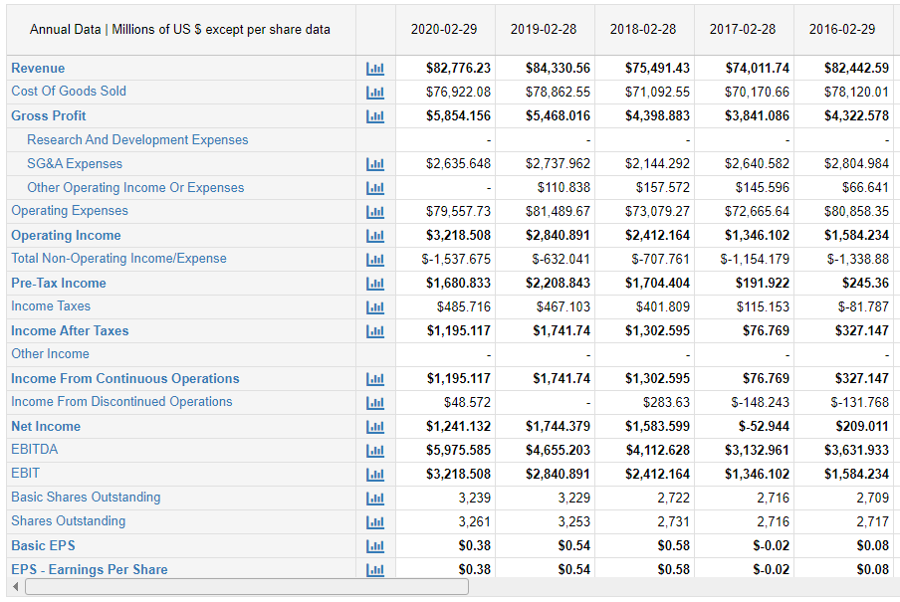

Appendix 2 – Statement of Financial Position of Tesco Plc for Last 5 Years (2016 – 2020)
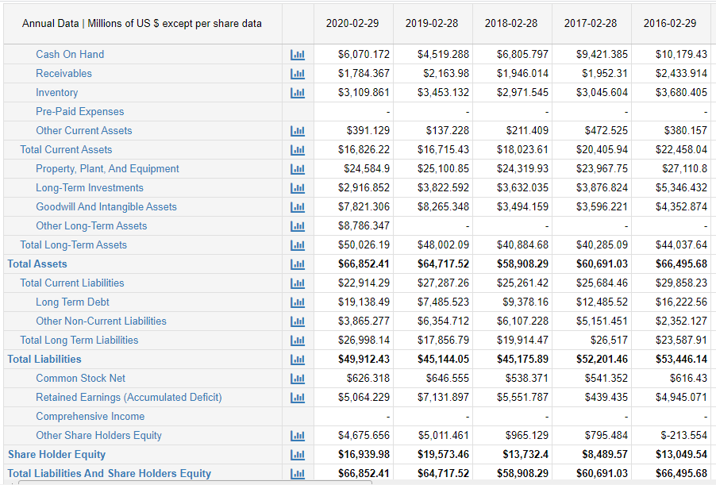

Appendix 3 – Statement of Income of J Sainsbury Plc for Last 5 Years (2016 – 2020)
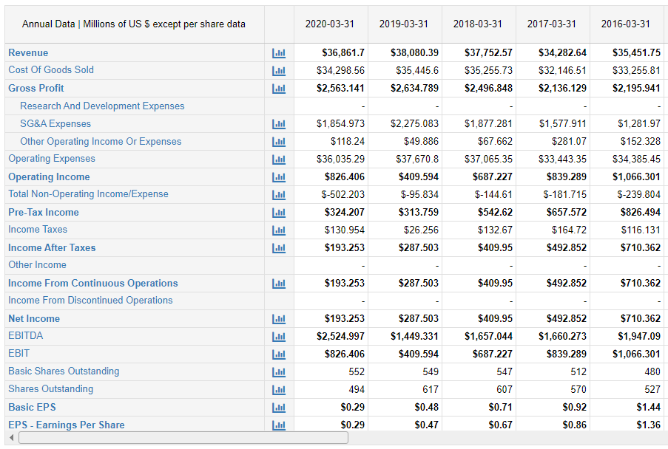

Appendix 4 – Statement of Financial Position of J Sainsbury Plc for Last 5 Years (2016 – 2020)


