

Module Name: Academic Skills for the Digital Era
Module Code: BMSW4013
Evidence of Learning (E-Portfolio)

Component 3 – Presentation
Contents
Introduction 3
The Importance of Time Management 4
Challenges Students Face in Time Management 5
The Benefits of Effective Time Management 6
Time Management Strategies for Students 7
The Pomodoro Technique 8
Overcoming Digital Distractions 9
Using Digital Tools to Improve Time Management 10
Conclusion 11
References 12

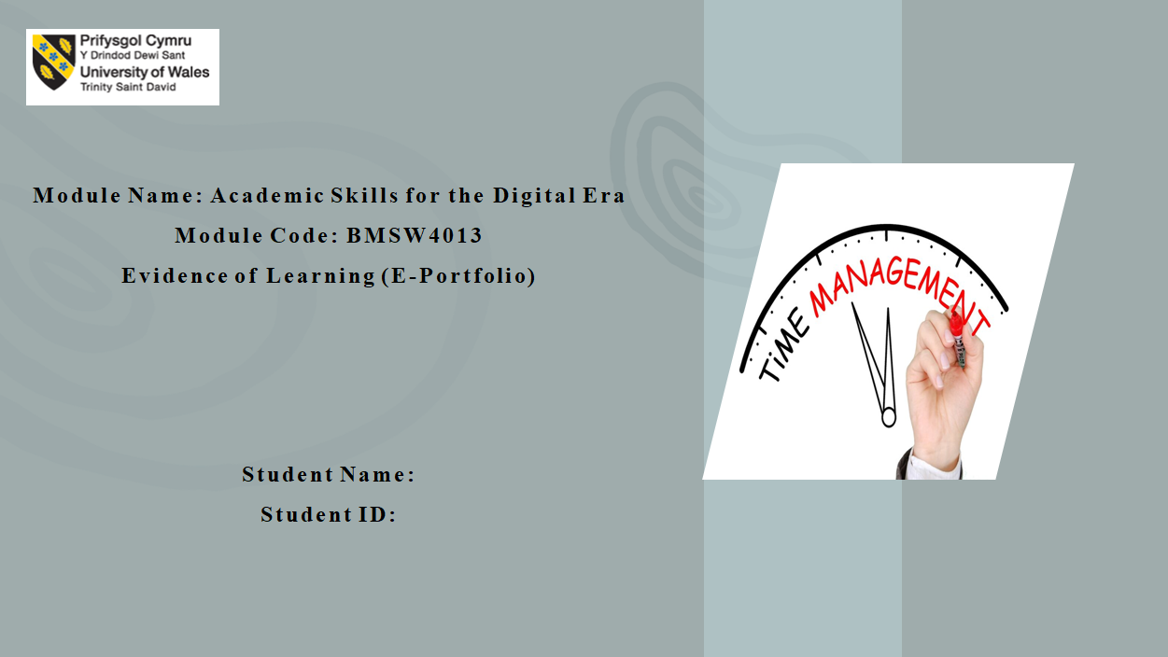

Introduction
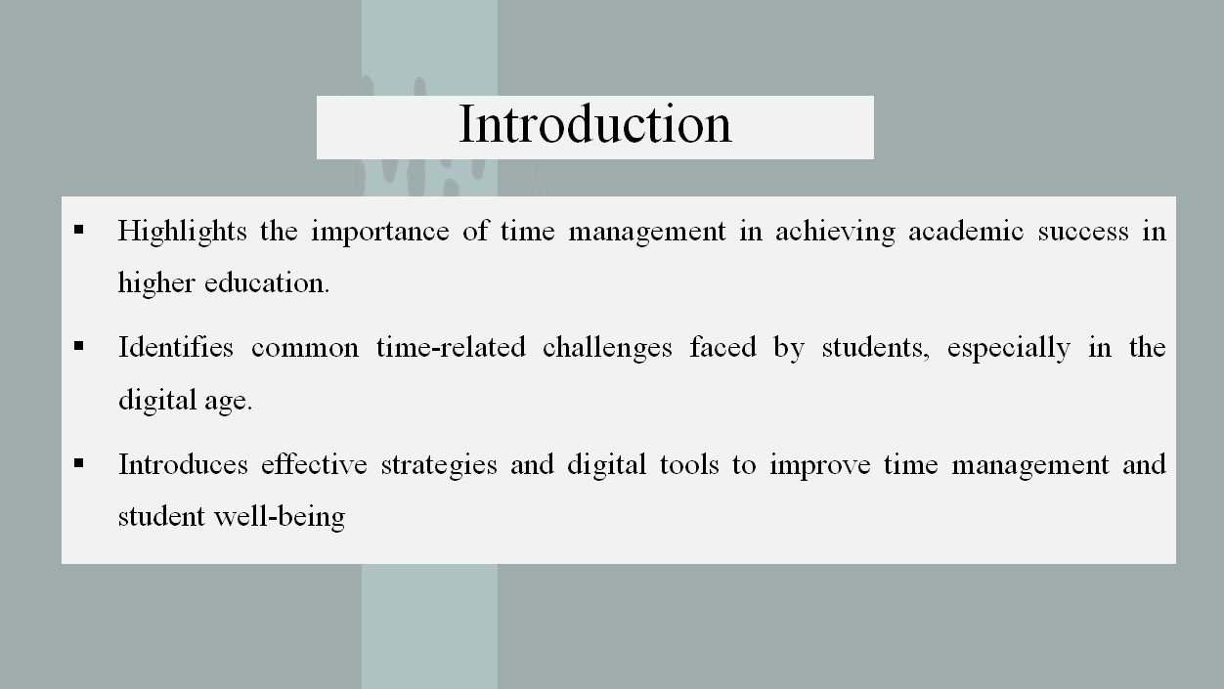
Time management is an essential credit to academic achievement in higher education. As students acquire more academic and personal tasks, they also note that they are unable to manage their time properly. Time management is even more essential in the age of technology, which provides certain opportunities or distractions. The following presentation will reveal the significance of time management, address the most frequent issues the students have to deal with, and mention strategies and tools that would help students manage their time more efficiently to guarantee academic success and their well-being.

The Importance of Time Management
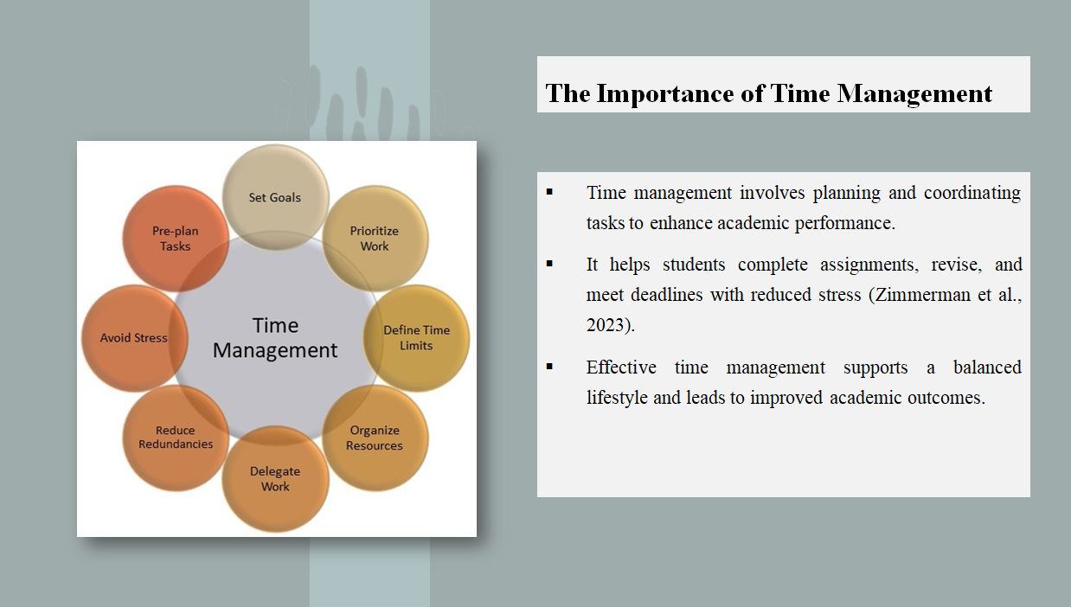
Time management entails the coordination and planning of different activities. It is an important factor of academic success at the higher education level. Time management is of great benefit as it enables the learner to do assignments, revise, and meet deadlines without undue anxiety (Zimmerman et al., 2023). Proper time management also promotes a healthy lifestyle in terms of enabling people to take things other than studies and the allocation of time to relax and enjoy themselves. Studies indicate that a student who manages his or her time well will have less stress and better academic results.

Challenges Students Face in Time Management
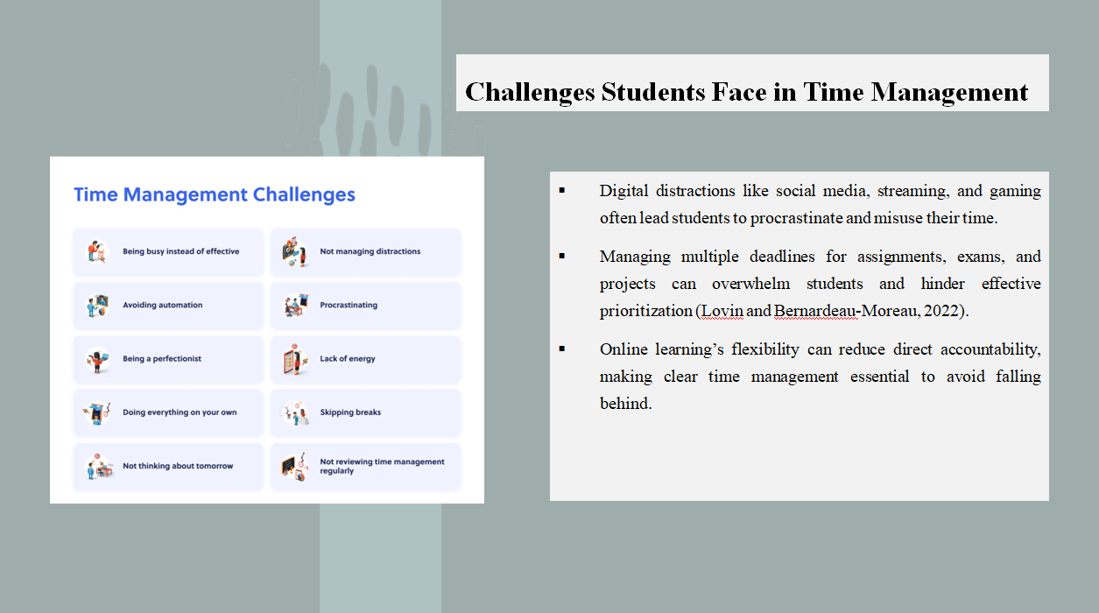
Although time management is a powerful aspect, most students are faced with great difficulties. Among the greatest barriers, one can focus on digital media distraction. Social media, video streaming on the internet, and gaming are some of the best distractors of students that can easily lure students off their current coursework, leading to procrastination and improper use of time. The second biggest issue is the pressure of several deadlines. Having different assignments, exams, and projects piled together, students might not manage them efficiently and set their priorities (Lovin and Bernardeau-Moreau, 2022). Also, online learning settings may be disorderly because learners may be flexible and have less direct responsibility and hence, by not having a clear time management process, it is easy to miss out.

The Benefits of Effective Time Management
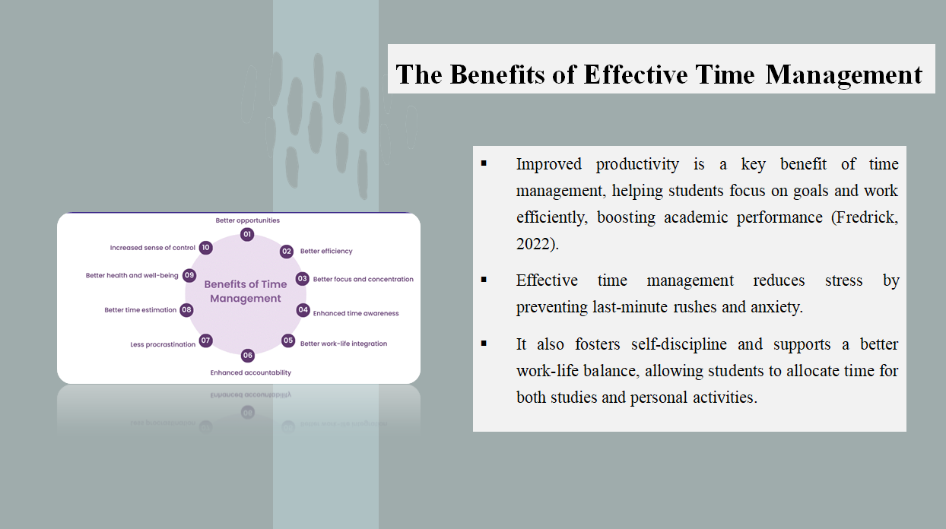
There are many advantages of time management among students. Included, as one of its primary benefits, is improved productivity. Improved planning and establishment of goals enable students to channel their working time by making more and doing less. This, in its turn, enhances their academic performance (Fredrick, 2022). The other advantage is less stress. Effective time management leads students to avoid a last-minute rush, which is one of the most significant reasons for mild anxiety. In addition, time keeping enables self-control because students learn how to always adhere to the time and also do things step by step. Students are also able to have a better work-life balance with better time management, as they are able to devote some time to their studies as well as to their personal life.

Time Management Strategies for Students
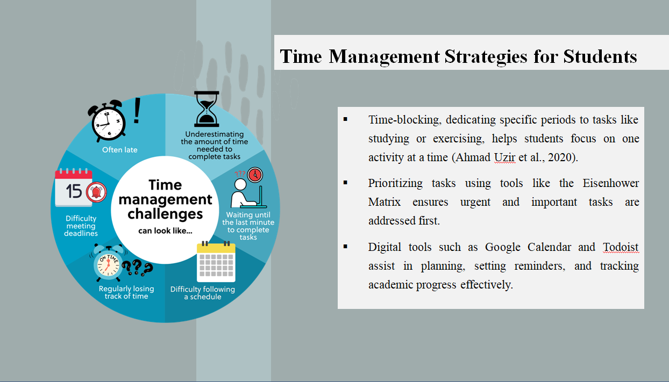
Several time management tips can help students to be more productive. One of the helpful ways is time-blocking, the process when certain periods are devoted to particular activities, say, studying in the morning and exercising in the afternoon. This assists students in concentrating on one thing at a time (Ahmad Uzir et al., 2020). The next strategy is to prioritise tasks with the use of instruments such as the Eisenhower Matrix, which orders the tasks according to their urgency and importance. Planning, alerts and monitoring of the academic progress can also be organised successfully with the help of digital tools like Google Calendar or Todoist.

The Pomodoro Technique
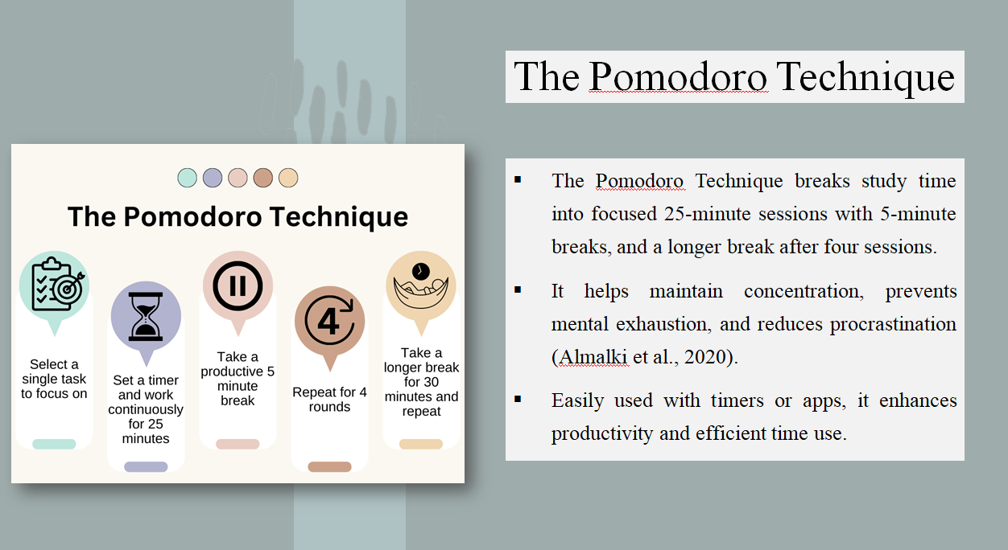
The Pomodoro Technique is one of the famous procedures of time management that divides the studying session into a number of concentrated periods, no more than 25 minutes each, and takes 5-minute breaks between them. In the fourth pomodoro, the students will get an extended break (15-30 min). This technique also keeps the students focused and therefore productive because one can avoid the case of tiredness of mind, and there is always a break. Studies have shown that this method can assist in being less prone to distraction and more focused (Almalki et al., 2020). Students can use this technique easily, with a timer or an app using Pomodoro, which means this technique is associated with a lot of productivity and time usage.

Overcoming Digital Distractions
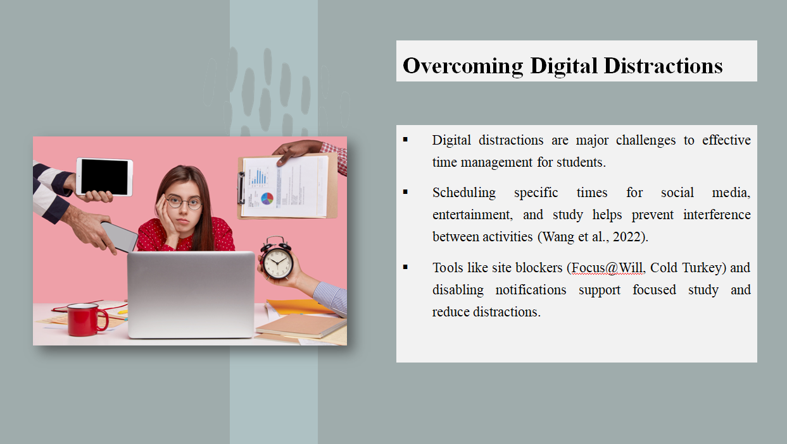
Distractions in the age of the digital revolution have become one of the biggest opponents to efficient time management. Students will be able to reduce such distractions by establishing clear limits on the time when they are active to participate in non-academic activities. Scheduling social media, entertainment, and study sessions would do the trick, making sure that studying would not be impaired by the other two activities (Wang et al., 2022). To avoid study-destroying websites during the studying process, it is possible to use site blockers like Focus@Will or Cold Turkey. Also, disabling the option of notifications when studying could enable the students to concentrate on what they are doing without too many distractions. Digital distraction can be mitigated by students being conscious about these issues, thus managing their time in Hong Kong.

Using Digital Tools to Improve Time Management
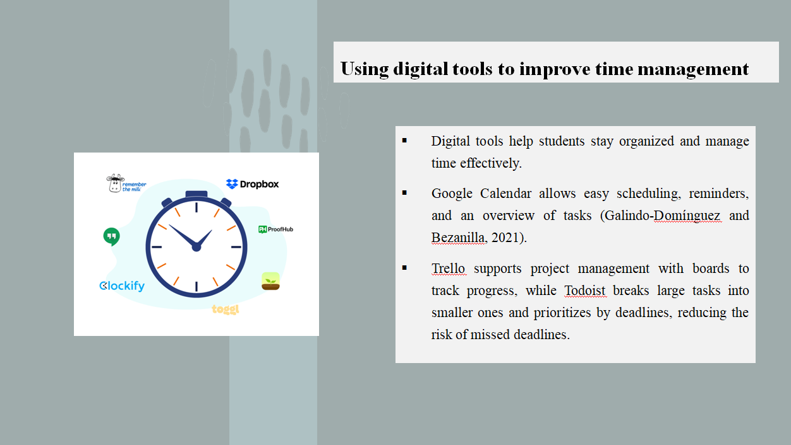
Digital tools are effective tools that can help students stay organised and manage their time. Google Calendar is an easy and convenient tool to organise studying sessions, creates reminders and keeps a clear overview of what to do (Galindo-Domínguez and Bezanilla, 2021). Trello also facilitates project management, giving a person a chance to come up with boards that will help them monitor the progress of different assignments. Todoist is useful to deconstruct huge tasks into small ones and categorise them using deadlines. They help to become organised and better manage time, and thus, the chances of missing deadlines are minimal.

Conclusion
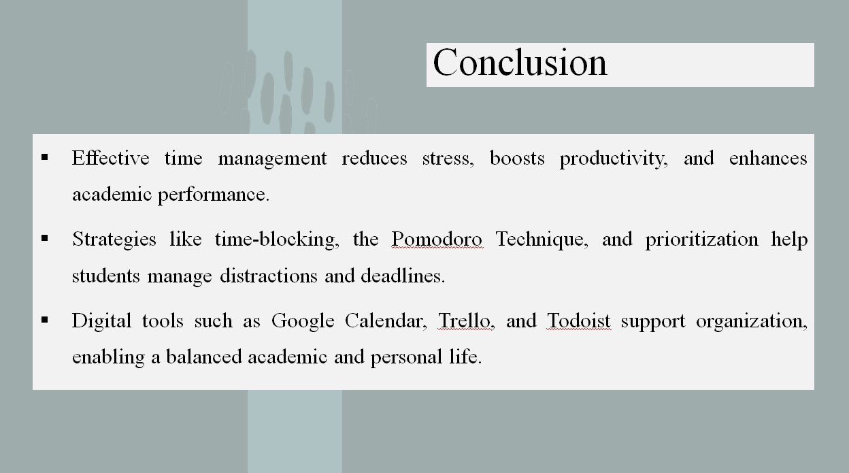
Effective time management is an extremely important academic attainment and for human health. Proper time management allows a student to be less stressed, more productive, and have improved academic performance. Though the problem of digital distractions and having multiple deadlines comes up, the students may address it by adopting various strategies, such as time-blocking, the Pomodoro Technique, and prioritisation strategies. Digital tools such as Google Calendar, Trello, and Todoist can also contribute to helping students stay organised and keep up their work. The potential to balance the life of the students is that once they develop skills in time management, the students are not only able to perform well academically, but they also have the time to maintain good health as well.

References
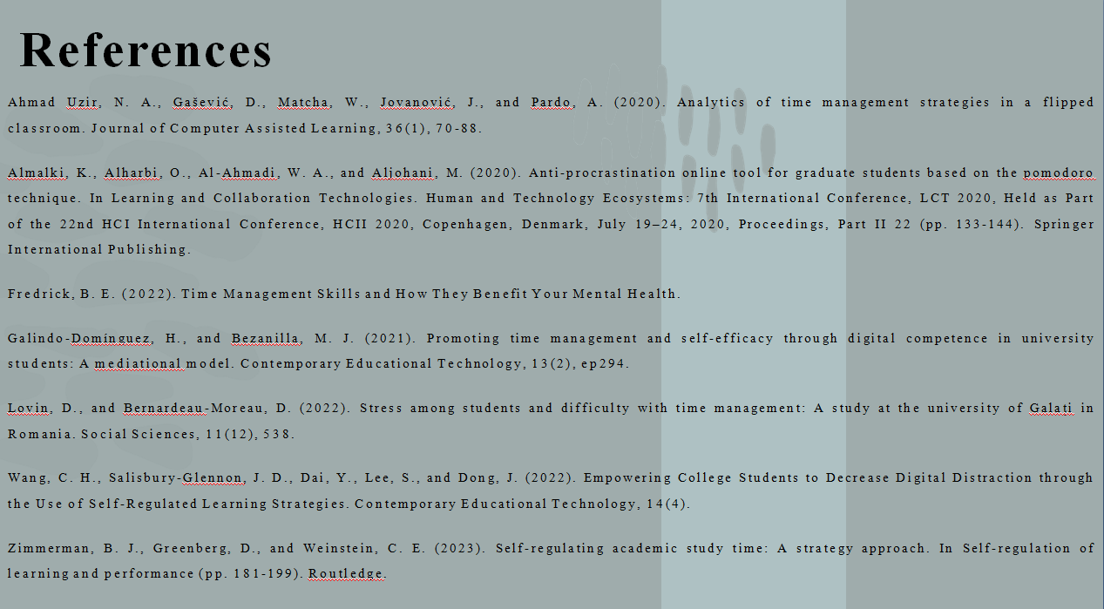
Ahmad Uzir, N. A., Gašević, D., Matcha, W., Jovanović, J., and Pardo, A. (2020). Analytics of time management strategies in a flipped classroom. Journal of Computer Assisted Learning, 36(1), 70-88.
Almalki, K., Alharbi, O., Al-Ahmadi, W. A., and Aljohani, M. (2020). Anti-procrastination online tool for graduate students based on the pomodoro technique. In Learning and Collaboration Technologies. Human and Technology Ecosystems: 7th International Conference, LCT 2020, Held as Part of the 22nd HCI International Conference, HCII 2020, Copenhagen, Denmark, July 19–24, 2020, Proceedings, Part II 22 (pp. 133-144). Springer International Publishing.
Fredrick, B. E. (2022). Time Management Skills and How They Benefit Your Mental Health.
Galindo-Domínguez, H., and Bezanilla, M. J. (2021). Promoting time management and self-efficacy through digital competence in university students: A mediational model. Contemporary Educational Technology, 13(2), ep294.
Lovin, D., and Bernardeau-Moreau, D. (2022). Stress among students and difficulty with time management: A study at the university of Galați in Romania. Social Sciences, 11(12), 538.
Wang, C. H., Salisbury-Glennon, J. D., Dai, Y., Lee, S., and Dong, J. (2022). Empowering College Students to Decrease Digital Distraction through the Use of Self-Regulated Learning Strategies. Contemporary Educational Technology, 14(4).
Zimmerman, B. J., Greenberg, D., and Weinstein, C. E. (2023). Self-regulating academic study time: A strategy approach. In Self-regulation of learning and performance (pp. 181-199). Routledge.

