Improving the Quality of Emergency Echocardiography and Echo Training for Specialist Registrars at the University Hospital of Wales
Dr. Richard Wheeler
Student number 1709490
Module code DSAW7058
Leading Service Improvement
University of Wales Trinity Saint David
Contents

Glossary of terms and abbreviations 2

Project Proposal 3

Introduction and Context 6

Solutions and methods 8

Results 10

Discussion 14

Future Directions 17

References 20

Appendices 21

Glossary of terms

Cardiac Physiologist A non-medical practitioner who specialises in the assessment and management of cardiac patients. Echocardiography is one of the many areas that such an individual will be expert. Other examples include pacemaker programming

Specialist Registrar This is a junior doctor grade trainee who is sub-specialising in a particular medical area. This post is normally 6 to 8 years in length

Specialist Trainee This is the modern terminology for Specialist Registrar with posts labelled according to year of seniority e.g. ST3

Tertiary Services Specialised healthcare dealing with referrals from a primary or secondary healthcare professional

Xcelera The electronic reporting and archiving system for all forms of echocardiography manufactured by Philips

Abbreviations

BCS British Cardiovascular Society
BSE British Society of Echocardiography
CP Cardiac Physiologist
CT Computed Tomography
MRI Magnetic Resonance Imaging
SpR Specialist Registrar
ST Specialty Trainee
TTE Transthoracic Echocardiography
UHW University Hospital of Wales

Improving the Quality of Emergency Echocardiography and Echo Training for Specialist Registrars at the University Hospital of Wales

Aims
To achieve >80% cross checking of all emergency and urgent transthoracic echo (TTE) scans performed at the University Hospital of Wales (UHW).
To improve the quality and standard of echo training for cardiology specialist registrars.

Background and Customer Impact

TTE is a well established diagnostic investigation performed worldwide which allows rapid assessment of the heart with a technique that is safe, low cost and can be completed at the bedside even in critically ill patients. TTE is an essential test used in the management of almost all cardiology/cardiac surgical patients but also has a prominent role in most hospital specialties including the emergency department. As a result there is a high demand for this test which will often be requested out of hours when the main echo department is closed.

Most routine TTE is done by highly trained cardiac physiologists who all achieve formal accreditation in echocardiography and produce standardised reports (Wharton, 2015) on an electronic database (Xcelera by Philips) which is readily accessible online. The vast majority of urgent/emergency TTEs done at UHW are performed by cardiology specialist registrars (SpRs) who have no formal accreditation in echo. Most reports take the format of a handwritten entry in the medical notes to ensure rapid communication of findings. There is therefore no electronic record on the Xcelera system. This arrangement is fundamentally inadequate as we are not routinely cross checking reports on patients who may have life threatening and complex cardiac diagnoses.

TTE training at UHW is based around our Wednesday morning academic meeting which is theoretical teaching using case studies. There is limited access to hands on supervised echo scanning sessions. The current echo training curriculum for cardiology SpRs in their first three years (referred to as ST3, ST4 and ST5) mandates supervised echo training lists and completion of a log book for formal accreditation. The lack of supervision during hands on scanning is proving difficult for cardiologists in training to reach the required standards.

This project therefore has multiple primary drivers - namely improving standards around accuracy and clinical governance of emergency TTE scans in conjunction with an uplift in the quality of training for our cardiology registrars.

Methods

Cardiologists and cardiac physiologists need to work together as a team to understand the problem in more detail and to collect data in order to accurately describe our starting position. A number of key questions arise in this context –

- How many emergency scans are performed by registrars each month ?
- What is the case mix and from which specialty within the hospital ?
- What proportion of scans are performed out of hours ?
- What proportion of the scans do not produce a formal electronic report ?

This data will allow us to enter a second phase within the project to decide on the optimal way of cross checking the TTEs. This will take the form of several PDSA cycles to trial the different options that we have available to achieve the desired aims. We are fortunate at the moment to have a cardiac physiologist who is available for a significant portion of the week in a supervisory/educational role. This individual can work with the Consultant cardiologists and registrars to trial the most effective practical system of achieving cross checking of scans.

Within this second phase of the project we can bolster the ‘hands on’ training component for the registrars by providing three supervised echo sessions per week - Monday am, Wednesday am and Thursday pm. This will be mostly ward based echoes with the aim to perform three studies (depending on the experience of the SpR). Each of these studies will be fully reported on Xcelera in conjunction with our dedicated cardiac physiologist.

The third phase of the project will then require a review of our new systems of reporting and checking scans to see how comprehensive this has been and to then consider an options appraisal going forwards to decide on the most sustainable long term system. Part of this third phase should also include data collection in relation to demonstrating the efficacy and merit of this cross checking system. That is to say – can we demonstrate an improved clinical outcome by adopting this fastidious new proposal ? This may be important in terms of writing a future business case which covers adequate work force planning within the team of cardiac physiologists. My vision is to develop the educational role of several interested and enthusiastic cardiac physiologists such that this system is embedded alongside the service delivery of the echo department.

Introduction and context

Transthoracic echocardiography (TTE) is an ultrasound based diagnostic technique which has been in clinical use since the late 1970s (Edler I, 2004) but whose growth has been enormous through the last 20 years on account of technological improvements but also a realisation of its utility in modern medicine. TTE allows the real time visualisation of the heart (Appendix 1) to obtain comprehensive anatomical data. However, all contemporary machines are now able to assess function and haemodynamics via an associated ultrasound technique referred to as doppler (Appendix 2). An excellent example would be a patient with severe valve disease (aortic stenosis) where TTE can define both the structure of the valve but also determine the precise degree of narrowing. This technology provides highly accurate diagnostics without the need for invasive tests, and can be performed at the patient’s bedside (Appendix 3). One other notable benefit is that ultrasound of course does not use ionising radiation and is therefore completely safe.
There are a multitude of cardiac pathologies that are regularly interrogated by TTE e.g. heart attacks, valve disease, cardiomyopathy. These conditions are usually the remit of cardiologists and cardiac surgeons. However, TTE is used by many other specialties particularly those that deal with acutely unwell patients e.g. emergency medicine and intensive care units. Alongside this primary cohort of patients there is a huge demand for TTE from a range of specialties who require some information regarding cardiac status. Two examples might be anaesthetic preassessment clinics in patients undergoing high risk non-cardiac surgery or oncology services prior to consideration of cardiotoxic chemotherapy.
It is therefore immediately apparent that there is a huge demand for TTE within the University Hospital of Wales (UHW), especially as we are a cardiac surgical centre (Tertiary Services).
TTE is the responsibility of cardiology services in most hospitals (rather than radiology) and the majority of studies are performed by cardiac physiologists who are highly trained and accredited in this area. Approximately 10000 TTE studies are performed each year at UHW. There are four Consultant Cardiologists who subspecialise within cardiac imaging (which includes all forms of echocardiography but also other investigations such as nuclear cardiology, CT and MRI.). The clinical lead for echocardiography within UHW is Dr. Masani and between the four Consultants we have responsibility for supervising the cardiac physiologist but also approximately 12 Specialist Registrars (SpRs) within cardiology who need to learn and become proficient in TTE.

All of the outpatient TTE work is performed by cardiac physiologists with pre-booked lists during the working week. Most of the inpatient requests are also tackled by cardiac physiology but this tends to be the more routine non-urgent type of patient. The majority of urgent and emergency inpatient TTE requests are performed by cardiology SpRs for three main reasons –
- These patients are often acutely unwell and it may not be safe to transport them to the echo department.
- Many of these requests are out of hours when there are no cardiac physiologists on duty.
- The pressure on outpatient TTE waiting times is such that cardiac physiologists are mainly allocated to this particular patient group.

The problem
The majority of urgent and emergency TTE are performed by SpRs who have no formal accreditation in echocardiography. Many of these studies will result in a handwritten report in the medical notes (rather than an electronic archived report on Xcelera) with no opportunity for senior review and cross check. This represents the potential for significant clinical risk if a misdiagnosis is made. This situation is also a huge wasted opportunity in terms of teaching and education for the SpRs. Therein lies the second part of the problem – how to improve the teaching and supervision of cardiology SpRs in training.

A recent working group report from the British Cardiovascular Society provided a number of recommendations related to out of hours emergency care and in specific relation to echocardiography stated:

‘Emergency echocardiography should ideally be provided by a cardiac physiologist or clinician who has British Society of Echocardiography (BSE) accreditation or equivalent and who demonstrates their continuing experience through revalidation in echocardiography.’ (BCS 2016)

Solutions and methods
I brought this problem to the team within our department which included the Imaging cardiology consultants, senior cardiac physiologists (including one nominated lead - CP1) and also a representative from the registrar group – SpR1. I also involved our management team (directorate manager) as it was clear to me that the implications of this study would impact on work force planning in the future.
We met in order to look at the problem and all agreed that the current situation was suboptimal with huge potential for clinical risk. We set out to obtain data on our current practice and then looked at the various drivers that would contribute to the ultimate aims of the project.
I did not need to seek ethical approval for this project as there was no upfront intention to change clinical management or the pathway for any patient that we looked at. It is easy to recognise that the core themes of the study were to improve patient care – beneficence, and to put in place systems to avoid harm - non-maleficence (Gillon, 1994).

Driver Diagram

Data collection phase 1
SpR1/RW were tasked with collecting data on the number of scans performed each month starting from August 2017. These data were obtained from the Xcelera database and allowed us to look at the numbers for each individual SpR but more importantly to look at how many scans had any report logged on the system. We also looked at the timing of when the scans were performed as this was a key piece of information with regards to understanding the work flow. During January 2018 we also collected data for the total number of inpatient TTE performed at UHW in order to compare the distribution of workload between the cardiac physiologists and the cardiology SpRs. These data were obtained from a handwritten folder/log within the echo department. This also allowed us to study clinical case mix and the referring specialty.

Data collection phase 2
The second part of the project required us to institute a system for checking TTE reports on the Xcelera system and to review the actual images in all cases. Myself and CP1 met in order to plan the method and then attempt to carry this out over the course of the following week. We then reviewed the data to decide on whether changes needed to be made for the susbsequent week of work. This effectively formed our Plan Do Study Act (PDSA) for two cycles.
The first proposal (Cycle 1) was a week where CP1 would allocate time through each working day Monday to Friday to keep up to date with scans. RW would try to assist this process but with no specific allocated sessions.
The second proposal (Cycle 2) was a week where CP1 would again allocate time each day but RW would also put aside dedicated specific reporting sessions during the week.

Implementation of supervised echo lists
Starting from approximately March 2018 we have established three supervised echo lists for the SpRs. These are scheduled for Monday, Wednesday and Thursday morning and accommodate one SpR to spend the session with a cardiac physiologist, scanning patients either in the department or on the ward. Some of these scans may be emergency scans which has the added benefit of sharing the workload for this specific group of patient who are the main focus of this project. At the end of the session all scans are reported and signed off.

Results
Phase 1
The number of scans performed by SpRs per month between August 2017 and July 2018 varied from 93 to 183 (figure 1). Approximately 60% of these scans were performed ‘out of office’ hours i.e. after 5pm on a weekday or at nights and weekends (figure 2).

Figure 1 – total number of TTE performed by SpRs from August 2017 to July 2018

Figure 2 – the timing of TTE performed by SpRs between August 2017 and May 2018

The number of inpatient scans performed by cardiac physiologists within the department was assessed for January 2018 – figure 3. This shows a total of approximately 350 scans which represents the majority of the inpatient workload when compared to the SpR data. The case mix (figure 4) shows that the vast majority of the request are to assess left ventricular function which is consistent with the known literature on this subject. Cardiology and general/acute medicine are the largest users of the service but with significant contributions from several other specialties. We also collected data for case mix in relation to the TTE referrals going directly to the cardiology SpR. This data collection period was in April 2018. Figure 5 illustrates these data with a high proportion of requests needed to assess LV function but also a large number to assess pericardial effusions which can be a life-threatening diagnosis if present hence the urgent categorisation.

Figure 3 – Referring specialties for inpatient TTE performed by cardiac physiologists within the department

Figure 4 – Clinical Indication for inpatient TTE January 2018 – referrals going to cardiac physiologists within the department

Figure 5 - Clinical Indication for inpatient TTE January 2018 – referrals going to cardiology SpRs

Phase 2
The following results show the data from two planned PDSA cycles in which we tried to determine the most efficient and sustainable strategy for cross checking of scans.
PDSA cycle 1 ran from 4/4/18 to 11/4/18 - 8 day period.
PDSA cycle 2 ran from 13/4/18 to 22/4/18 – 10 day period.

 | Cycle 1 | Cycle 2
Number of scans | 45 | 55
Number checked by CP1 | 39 | 28
Number checked by RW | 6 | 27

These data show that the most equitable way of sharing the burden of this work is by making sure that allocated consultant time is scheduled for this work.

Subsequent data collection from the rest of the study period showed the following results within a run chart – figure 6.

Figure 6 – Run chart to show the change in categorisation of TTE scans during the study period August 2017 to July 2018.

Discussion
In this project I am confident that I have chosen an important and worthwhile topic and have laid out specific measurable aims in a particular patient group (Langley, 1996). One of the main challenges of this project from the beginning has been the considerable personal unease as to why we have had this long standing ‘gap’ in formalised echo reports, leading to a vulnerable position for the department in terms of clinical risk and governance. The obvious parallel with radiology services within most hospitals only serves to highlight this unease as it would be completely unacceptable for any radiological investigation e.g. CT scan of the brain, to have a hand written unchecked report in the notes from a doctor in training. Why should emergency echocardiography from cardiology services be any different ? This starting point illustrates the concept and necessity of a paradigm shift within the department which was one of my primary goals (Covey, 2008).
During this study period I took the opportunity to consult colleagues in a number of other large tertiary cardiac centres in England. It was fascinating to share remarkably similar logistical problems amongst senior and highly respected national colleagues. This information gave me added encouragement to tackle this problem in an open and determined way.
Analysing all of this preliminary information and outlining the problem helped me create a real sense of urgency within the department about wanting to take on and solve this issue (Kotter, 1996). This was an excellent starting point for the project but I was cautious in my own style of presentation so that this feeling of ‘an inadequate situation’ was not conveyed as an open criticism to others within the echo department.
The next step was to assemble an appropriate team in order to help deliver the project but it was very important to choose individuals who understood the urgency of the task and who believed in improving the service as a long term measure. CP1 was an obvious choice for the team having worked in the department for a long time as a senior physiologist. Due to recent ill health CP1 was working less than full time in the clinical area and therefore was ideally placed to help out with an academic project. SpR1 had been in the department only a few months but was a highly motivated organised doctor with a passion for quality improvement initiatives. My other cardiology consultant colleagues involved in cardiac imaging were kept involved as much as possible with our directorate management team aware from the outset regarding the aims and intentions of the work.
My observation of team roles during this work has been interesting and of personal use in future work and personal development. My own team role preference tends to be as a ‘Teamworker’ and ‘Coordinator’ and whilst these have been helpful during the study I have had to work on elements of being a ‘Shaper’ in order to drive the project forwards (Belbin, 2012). I would consider CP1 an excellent ‘Teamworker’ but the ‘Completer Finisher’ aspects of SpR1 have been invaluable in generating outcome data and deciding on further directions.
Assembling this small team and working in a collaborative manner has been a very rewarding experience and I would like to think we each brought a shared purpose to this project. I am aware from feedback in my recent ‘360° report’ that I am perceived as someone who leads by example but can often take on too much individually and could delegate more effectively. I have tried to follow this advice but this is always a challenge for me. My leadership style has also been described as a ‘benign dictatorship’, which I construe as a complement but tells me that I need to foster more autonomy in my team members.

One of the discussions that could have taken place at the beginning of this project relates to the very simple concept of ‘Five Whys’ (Ohno, 1988). This is an elegant tool which helps to identify the root of a problem and can aid in identifying the most appropriate solutions. This process of critical thinking can avoid a misjudgement or misinterpretation of the required solutions. The Jefferson Memorial is perhaps the most widely quoted example but in relation to my project I would lay out the following –

Problem – emergency/urgent TTE scans are performed without a formal electronic and checked report by an accredited individual.
Five whys -
- There is no allocated time for physiologists or consultants to check reports.
- It is difficult to bring ill patients to the echo department due to their instability but also a lack of portering availability.
- Cardiac physiologists do not routinely go to the ward with a portable machine.
- Many cardiology SpRs do not have a formal accreditation in echo.
- There are a large number of requests out of hours including real emergency scans that have to be done straight away.

These five points are interesting in that they highlight several different areas of the service which require review and brainstorming in order to produce workable solutions that will then come together to achieve the primary aim. It would be perfectly possible in this clinical dilemma to head straight for the obvious statement – ‘we don’t have enough cardiac physiologists’. Whilst I recognise that this is an undeniable truth, the process that I have laid out in this project has allowed me to look at alternative solutions which are within the remit of the department to influence. This may be akin to looking at areas that are within one’s circle of influence (Covey, 2008).

The results from the basic data collection in phase 1 of this project were as I had expected but it was very useful to clearly define the scale of the workload involved with emergency/urgent TTE. We also compared the number of scans performed by the SpRs with the inpatients being scanned within the department by cardiac physiologists. It would have been desirable to have studied this over a longer period than just January 2018 but I feel that the data is still of note. The case mix of emergency scans was also predictable with a higher proportion of indications for the assessment of pericardial effusion which tends to be an emergency clinical scenario.

Phase 2 data collection was the core part of the project to look at the feasibility of cross checking scans each week and exploring different models of working. The run chart data shown in the results section provides a powerful display of what can be achieved by setting in motion a relatively simple strategy to change the way that we manage emergency and urgent inpatient TTE scans. One can see that from March 2018 when CP1 started to look at SpR scans the number of finalised reports starts to increase significantly. From April 2018 when we started the first PDSA cycle that the changes were dramatic. Thereafter with the dedication of CP1 we have achieved virtually a 100% finalised and checked system. It was clear that with the combination of allocated time for both cardiac physiologists and consultants that this led to a more equitable sharing of the workload. This is much more likely to be a sustainable long term solution and without this system of shared workload I remain anxious that problems may lie ahead.

A number of very important issues arose when we evaluated this basic data from phase 2 as a team. I presented this data in order to look at our progress but I also felt that the positive results would generate enthusiasm within the group in order to encourage and motivate further work – ‘creating short term wins’.
Key problems identified –
- Most TTE studies did not have a preliminary Xcelera report available to review i.e. the presumption being that the SpR had simply written a report in the medical notes immediately after the scan. As a result there were no clinical details and frequently no record of which SpR had performed the study. This makes the cross checking of scans much more time consuming. The lack of clinical information also makes it more difficult to know where to focus attention in relation to specific pathology e.g. if the patient had a potential aortic dissection then one would look extra carefully in these specific aortic views. The lack of the preliminary report made it impossible to check what had actually been concluded within the handwritten report in the notes. This is potentially a significant area of clinical risk and confusion if discrepant reports are produced.

- We looked at one week of data in May to record the time delay between a TTE performed by an SpR and then the finalised checked scan being generated. Unfortunately, there was a mean delay of 4 days, median 4 days with a maximum up to 12 days. This time delay is not an efficient way of generating finalised reports and emphasises the importance of regular review sessions during the week and avoiding backlogs of scans.

- There was inadequate feedback of the checked scan to the SpRs in order to allow education and development of echo interpretation skills. We all highlighted this as a waisted learning opportunity.

- SpRs wanting to collect logbook cases for their accreditation with the BSE have encountered problems with scans that they have performed but where a brief cross-checked report has been written and finalised by RW or CP1. This has led to the logistical question of how SpRs utilise these scans in order to appropriately collect cases and document that they have completed the study themselves.

Future directions

Going through these problems listed above has allowed the team to understand the priorities and possible solutions going forwards. This is an absolute key step for this quality improvement project and one of my personal criticisms here is that having obtained some preliminary encouraging data in May with a dramatic uplift in cross checked scans, I fell into a trap of declaring ‘project victory’ rather too early. The phase 2 data is in fact an opportunity to continue building on this work and making improvements in small discrete areas that will effect longer term change.

There is no doubt that the two key areas going forwards are 1. Allocation of scheduled cross reporting sessions for nominated cardiac physiologists and consultant cardiologists within cardiac imaging. 2. SpRs to generate preliminary Xcelera reports on all cases that they scan. Both of these areas involve practical steps in order to facilitate change and I am pleased that from September 2018 we have tried to formalise this with ongoing allocated sessions for CP1 but also from two consultant cardiologists – RW and AZ during their routine scanning lists. We have also made improvements in access to reporting work stations for the SpRs. There are also plans to improve electronic download of images moving to wireless technology as soon as possible.

The title of this project refers to two distinct areas for improvement – the first is the quality of emergency echocardiography and the second is the quality of echo training for cardiology SpRs. I am satisfied that those goals and specific measurable targets have been achieved. However, during one of our data review meetings within the department where we reviewed some of the data, it was felt that the specific measurement aim of achieving >80% cross checking of scans was not necessarily a robust marker of quality improvement. This concept caused considerable unrest within the group as we had all felt that achieving any form of review of echo studies was a highly desirable end product. On more careful analysis we confronted this question as to whether a signed off study was in fact more accurate than a preliminary study report generated from an SpR. We have a number of experienced cardiology trainees who have a wide knowledge of clinical echocardiography, despite no formal accreditation, and it is quite likely that many of their reports will be accurate and of high quality. Whilst we all acknowledged that having complete electronic finalised reports on all patients was a shared common aim this is likely to require a restructuring of the physiology service with a significant implication to the budget allocation. It was therefore proposed that a further piece of work was required to try and demonstrate and if possible measure the uplift in ‘quality’ and accuracy of a cross checked report. The precise format of this measurement is being developed within the department and is likely to serve as a useful document to support additional funding for this specialist physiology role. In my opinion it will also have utility as an additional teaching tool in terms of feedback of adjusted and corrected reports. These aspects of quality control are vital in modern echo departments to assist in departmental accreditation from our national body – the British Society of Echocardiography (BSE).

This project has definitely enhanced the quality of SpR echo training at UHW through two main areas – the closer scrutiny of scans via the cross-checking system and also the delivery of supervised scanning lists on a regular basis. However, this project has had other desirable effects in terms of lifting the whole profile of echo training within the cardiology service.

All of these solutions and ideas for future improvements actually revolve around a key principle which has evolved during this study which is the cultural change within the department which I have been trying to drive from the very beginning. That is to say the culture within the department of always insisting on finalised checked TTE scans by an accredited individual and likewise the SpRs working within a culture where they always generate an electronic report. These specific developments then naturally feed into the corporate culture that we are a department with the highest standards of echocardiography and can demonstrate robust clinical governance systems even for our out of hours emergency work. Having explored and investigated this problem with the data that we have obtained during the study I am more confident that this can help us to support a business case for staffing of cardiac physiologists with a focus on developing individuals who will take on educational and teaching responsibilities as a significant part of their role rather than as an ‘optional extra’ when financial circumstances within the directorate allow. My vision is that these specialist roles will involve at least 3 cardiac physiologists to allow a flexible and durable system that will cope with the logistical problems of annual leave and staff absences. The failure to develop these roles in future will only have a negative impact on standards of clinical care but also of teaching for our SpRs in the years ahead. The involvement of consultant cardiologists is also pivotal in this process so that collaborative working helps to improve standards but also develops and nurtures working relationships between all members of the team. This will serve as an exemplary model of contemporary practice in cardiology units around the UK.

References

Belbin, R.M. (2012) Available from: http://www.belbin.com.

British Cardiovascular Society. (2016) Out-Of-Hours Cardiovascular Care: Management of Cardiac Emergencies and Hospital In-Patients. Available from: www.bcs.com/documents/BCSOOHWP_Final_Report_05092016.pdf.

Covey, S.R. (2008) The 7 Habits of Highly Effective People:Powerful Lessons for Personal Change. Concordville, Soundview Executive Book Summaries.

Edler, I., Lindstrom, K. (2004) The history of echocardiography. Ultrasound Medical Biology, 30(12), pp. 1565-644.

Gillon, R. (1994) Medical ethics: four priciples plus attention to scope. British Medical Journal, 309, pp. 184.

Kotter, J. (1996) Leading Change. Harvard Business Review Press.

Langley, G.J., Nolan, K.M., Nolan, T.W., Norman C.L., Provost L.P. (1996) The Improvement Guide - A Practical Approach to Enhancing Organisation Performance. San Francisco: Jossey-Bass.

Ohno, T. (1988) Toyota Production System: beyond large scale production. Portland: Productivity Press.

Wharton, G., Steeds, R., Allen, J., Phillips, H., Jones, R., Kanagala, P., Lloyd, G., Masani, N., Thomas, M., Oxborough, D., Rana, B., Sandoval, J., Wheeler, R., O'Gallagher, K., Sharma, V. (2015) A minimum dataset for a standard adult transthoracic echocardiogram: a guideline protocol from the British Society of Echocardiography. Echo Research Practice, 2(1), pp. G9-G24.

Appendix 1 – Transthoracic echo images

Image 1 – still image of a bedside TTE showing the four chambers of the heart

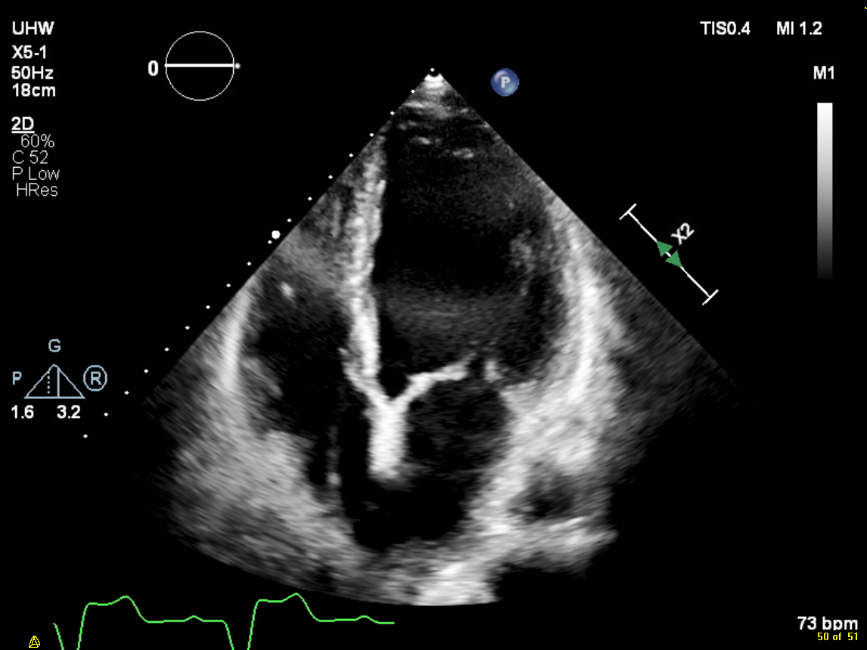

Image 2 – an example of a doppler examination showing severe aortic stenosis. Note the high velocity measured - >400cm/s. Normal flow would be closer to 100cm/s. Doppler allows the measurement of blood velocity and this can then be correlated with pressure differences across valves. This provides the basis for the non-invasive assessment of valve disease which has revolutionised modern cardiology. Patients rarely now require detailed invasive cardiac catheter measurements to obtain this data.

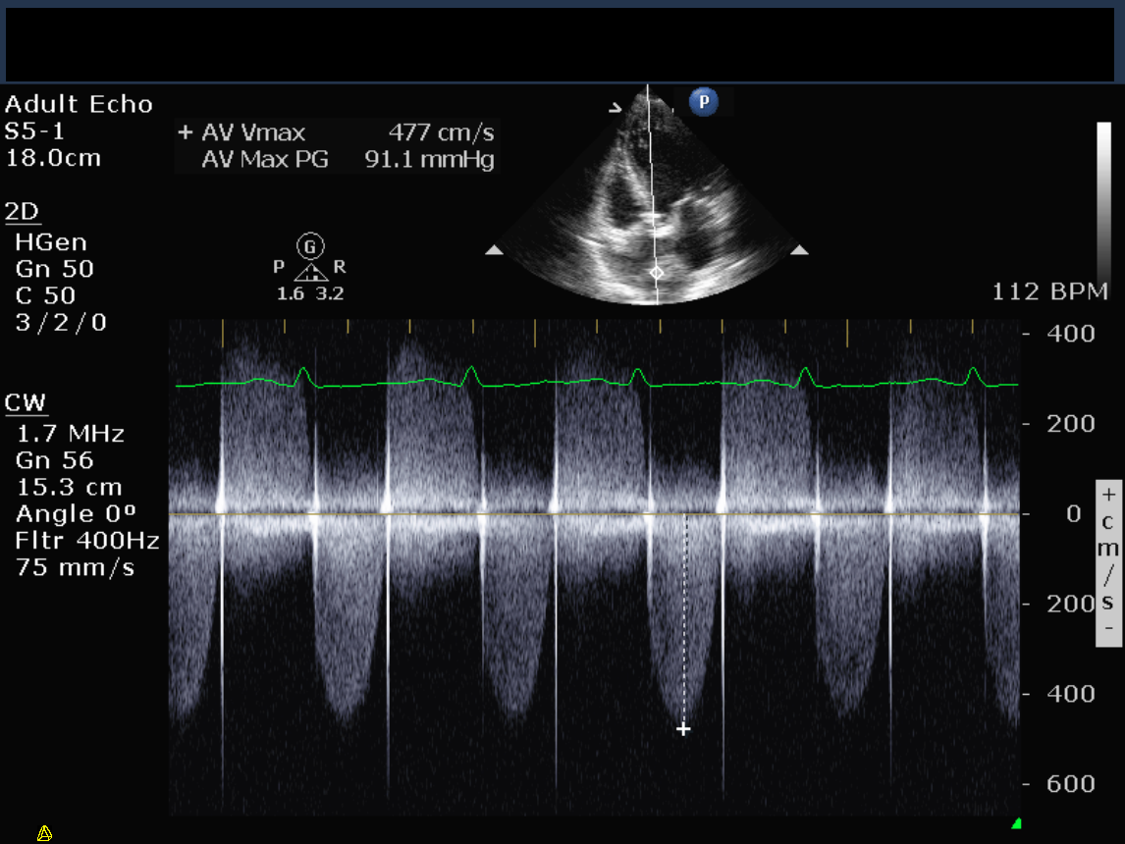

Appendix 2 – modern echo equipment

A typical modern echo machine which is positioned alongside a patient in order to acquire images using a small probe which is placed on the patient’s chest in a number of different locations. The echo machine is able to be transported anywhere in the hospital which adds enormously to the ease of assessing critically ill patients at the bedside.



