Marketing plan

Name of the hotel: JW Marriott from Bucharest
Student Name
________________________ Nerea Juaristi __________________________

Student ID number
_________2212615__________

Marketing Essentials BMIH4005

Lecturer:
________________Luciana Suardi__________________

Table of Contents
1 Introduction 3
2 Situation Analysis 3
2.1 Company: SWOT Analysis 3
2.2 Customers: Segmentation and Targeting 4
2.3 Competitors: Porter's five forces 4
2.4 Collaborators 5
2.5 Climate: PESTLE 5
3 Objectives 6
4 Strategy 6
5 Tactics 7
5.1 Product 7
5.2 Place 7
5.3 Price 7
5.4 Promotion 7
6 Action 7
7 Control 8
8 Conclusion 8
9 References 9

Introduction
A marketing plan is an effective way to track business success and attract customers. The aim of this marketing plan is to attract new customers from the perspective of the chosen hotel. For this purpose, JW Marriott Hotel is selected. The 5-star luxury hotel JW Marriott is located in Bucharest, Romania (JW Marriott, 2022). The marketing plan will underline the SOSTAC model that assists in evaluating critical aspects of the hotel. Moreover, a strategy that will help hotel management to attract customers will also discuss in the marketing plan. Also, the SMART target for the marketing plan will highlight in the plan. Despite this, there will be a marketing mix present for the selected hotel.

Situation Analysis

Company: SWOT Analysis
SWOT analysis for JW Marriott is well-defined in the table below;
Strengths | Weaknesses
- Worldwide presence  - Excellent reputation in the hospitality industry  - Leading brand  - High acquisition  - Excellent customer loyalty  - Strategic Partnership  - Highly Innovative strategies | - Lack of data protection  - The Code of conduct are way too strict  - Negative publicity rate  - Some issues with the law  - Inappropriate positioning
Opportunities | Threats
- Entrance into emerging economies  - Demographics shifts  - Expansion  - Diversification  - Personalized services | - High market competition  - Effects of a pandemic on travelling  - Global recession  - Banned on terrorist activities  - Threats of new entrants

Customers: Segmentation and Targeting
Segmentation | - The hotel offers premium luxury services  - For first-class services, the main target of JW Marriott Bucharest Grand Hotel is business-class and upper-class people (JW Marriott, 2022 a).
Targeting | - Luxury service lovers  - Travellers  - Businessman and families
Positioning | - JW Marriott Bucharest Grand Hotel has positioned itself by offering a premier luxury destination for business and a smooth assortment of fresh, luxury, as well as authentic appeal improvements (JW Marriott, 2022 a).

Competitors: Porter's five forces
Threats of New Entrants | - The threat of new entrants in the hotel industry of Bucharest is moderate.  - New entrants invest in innovations and put pressure on 5-star luxury hotel brands.
Threats of Substitutes | - Substitute power is high in Bucharest.  - With the emergence of the pandemic, the biggest substitute is home.  - Most people do business activities from home, which has a negative impact on the hotel industry in Bucharest (Nedelcu and Bușu, 2022).
Bargaining Power of Customers | - The bargaining power of customers is moderate.  - For 5-star luxury hotel brands, the power is low for those people who visit the hotel to spend their vacation.  - Also, for businessmen, the environment of 5-star luxury hotel brands is comfortable enough which minimize their bargaining power.
Bargaining Power of Suppliers | - The bargaining power of suppliers is low in the Bucharest hotel industry  - In the hotel industry, there is a strong relationship with suppliers, for which sticking with the specific supplier is essential, which reduces the bargaining power of the suppliers (Rangone, 2022).
Competitive Rivalry | - Competitive rivalry is high in the hotel industry.  - There are different brands in Bucharest present that offer excellent luxurious services to the customers.

Collaborators
JW Marriott is associated with part of Marriott International's luxury portfolio. The eye-catching and beautiful resorts and hotels of JW Marriott announced its collaborations with different brands like Alo, which is famous for its mindfulness programs (Bethesda, 2019).

Climate: PESTLE
Political | - The political condition of Bucharest is stable.  - In Bucharest, there are low costs tax policies for businesses that have positively impacted the hotel industry (Silvestru et al., 2021).
Economic | - According to a European Union report, Bucharest is ranked the 13th number that has a stable economic condition.  - The inflation rate in Bucharest is recorded to slow down in the year 2022 (Anghelache et al., 2022).
Social | - Customers are more attracted towards luxurious services that beneficiate the hotel business.  - Business-class people are more likely to spend money on 5-star hotels.
Technological | - Bucharest is considered one of the fastest-growing cities in central Europe.  - There is a significant increase in the usage of technology that makes it interesting for hotel brands to innovate.
Legal | - In Bucharest, all businesses must have to follow legal laws and restrictions (Stătică, 2021).  - Health and safety law are essential to follow in the hotel industry in Bucharest.
Environmental | - In Bucharest, there are issues of suspension particles that also impact the operations of the hotel industry.

Objectives
The key objectives on which the marketing plan is based are;
- To increase the sales of the hotel by 20% by the mid of 2023.
- To enhance marketing strategies by 30% by the end of 2023.
- To boost consumer engagement by 5% by the end of 2022.

Strategy
JW Marriott Bucharest Grand Hotel serves as a luxurious hotel and operates within the property of the historic district. To create value, the approach of JW Marriott is to focus on accessibility, the high status of the brand, customization, and premium services to customers. The brand offers excellent services, like A Longer, Stay for Less, Stay Longer on Us, Authentic Romanian Character, A Home Away From Home, etc. In order to attract customers, the hotel invests in a luxury lobby that contains warm colours, ample spaces, fancy daylight, excellent marble staircases, as well as imposing cupolas (JW Marriott, 2022). With reference to Bowman’s strategy clock, it is noted that it helps in understanding the value of the company in the market. In regards to JW Marriott, the brand focuses on high-quality services along with high prices, as it is a luxury hotel. For this, a differentiation strategy will be best for JW Marriott. The strategy will help in focusing on unique services and remain competitive in the market.

Tactics

Product
The product offered is hotel services to its customers after the pandemic. Hence, JW Marriott Bucharest Grand Hotel provides a five-star hotel with spacious accommodations for its customers. It also offers an executive lounge in executive rooms which is remodelled. It also has business suites for all different people. It has dining rooms also for customers to have food. It also provides a deluxe room with 1 and 2 rooms. Also, it has a grand superior room with a guest room for its people. Further, it also has presidential, senator, family and business suites for a different number of people accommodation (JW Marriott Bucharest Grand Hotel).

Place
JW Marriott Bucharest Grand Hotel is located in Romania. It is located in a historical and national interest location close to the Palace of Parliament and People’s Salvation Cathedral. It also provides wealthy and status culturally. Hence, it also offers represents grandeur in Romania. It is situated 30 minutes’ drive from Henri Coandă International airport and within walking distance of Old Town (JW Marriott Bucharest Grand Hotel).

Price
The price of JW Marriott Bucharest Grand Hotel is mainly luxurious as it gives different prices for a different rooms. Hence, it is a 5-star business hotel in Romania. The prices are also high for different clients and customers (JW Marriott Bucharest Grand Hotel).

Promotion
Hence, the main promotion used by the hotel is its own website for booking. Further it also uses online platform to market its hotel. But, the hotel will offer high pricing but with continuing bonus point schemes to attract people. Through online social media platforms including Facebook, YouTube, Snapchat, and TikTok (Ibrahim &amp; Aljarah, 2021). However, the marketing will be done on Instagram as people are more attracted nowadays towards it.

Action
The main USP of JW Marriott Bucharest Grand Hotel is to attract old customers and build new ones in Romania. It is also located near a place where the crowd is more. Hence, the pricing strategy is high, but people will get good services and invest in the product. The marketing strategies used with help gain new customers after the pandemic, which will help businesses to grow and earn from the loss that happened during the pandemic. Also, if services are suitable and better, the customers will have positive attitudes towards the brand.

Control
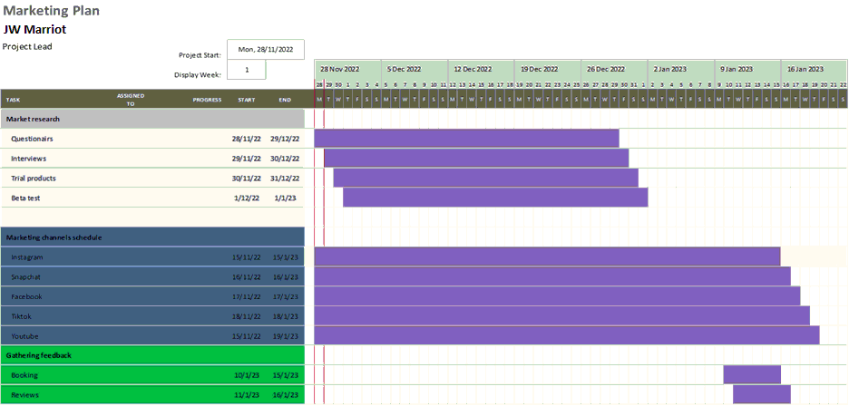
Preparation for the marketing strategies will be done beforehand 28th November. For market research and marketing schedule channels with approximately will take to make, photograph, and order with also posting timely on social media (like YouTube, Instagram, Facebook, Snapchat). Hence, one month is needed to properly research. Further, to attract and market the schemes of the hotel as planned. Lastly, gathering feedback will not need many days as people will come (in crowd) and it will provide reviews by the customers. And, then word-of-mouth about the hotel will spread gradually.

Conclusion
The marketing plan is about attracting new customers with slight amendments in operational strategies and activities. It has been concluded that JW Marriott is operating as a luxury hotel in Bucharest. The hotel invests heavily in digital marketing and other technological designs.

References
Anghelache, C., Anghel, M.G., Iacob, S.V., Rădut, C.M. and Strijek, D.A., 2022. Inflation seriously affects the standard of living of the population. Theoretical & Applied Economics, 29(3).
Bethesda, 2019. JW Marriott Announces Collaborations With Leading Brands Including Alo to Offer Full Program of Inspiring Mindfulness Experiences at Gather by JW. [Online] Available at https://news.marriott.com/news/2019/09/12/jw-marriott-announces-collaborations-with-leading-brands-including-alo-to-offer-full-program-of-inspiring-mindfulness-experiences-at-gather-by-jw [Accessed on 29th November 2022].
Ibrahim, B. and Aljarah, A., 2021. The era of Instagram expansion: matching social media marketing activities and brand loyalty through customer relationship quality. Journal of Marketing Communications, pp.1-25.
JW Marriott, 2022 a. JW Marriott Bucharest Grand Hotel [Online] Available at https://jwmarriottbucharestgrand.h-rez.com/contact.htm [Accessed on 29th November 2022].
JW Marriott, 2022. About us. [Online] Available at < https://www.marriott.com/en-us/hotels/buhro-jw-marriott-bucharest-grand-hotel/overview/> [Accessed on 29th November 2022].
Nedelcu, C. and Bușu, M., 2022. An Analysis of the Liberalization Process of Gas Market for Household Consumers in Romania. Management and Economics Review, 7(2), pp.228-237.
Rangone, A., 2022. Sustainability and Innovation Against the Techno-Corporate Gap: Evidence and Perspectives from the Italian-Romanian Partnership. In IOP Conference Series: Materials Science and Engineering (Vol. 1256, No. 1, p. 012034).
Silvestru, O.O., 2021. ‘Capital Politics’ through Railways: The Opening Ceremonies of Railway Stations in Nineteenth-Century Bucharest. In The City and the Railway in the World from the Nineteenth Century to the Present (pp. 214-228).
Stătică, I., 2021. Overlapping Nostalgias: Negotiating space and labor in the (post) communist city of Bucharest. Space and Culture, 24(4), pp.650-663.

Appendix:


