MODULE CODE: LCBB6000
Dissertation
On
The experience of the move from face-to-face to online delivery in response to Covid-19 for students from UWTSD

Abstract
This research paper has been prepared on “The experience of the move from face-to-face to online delivery in response to Covid-19 for students from UWTSD”. By issuing questionnaires to 10 students of UWTSD and collecting relevant data from them, their overall experience regarding online delivery of education has been analysed. The collected data was mostly quantitative. The study found that online the transformation of the educational platform was not effective for the institution as many students found the platform not suitable for receiving permanent learning. Families of 40% of the students were burdened with financial distress, mental breakdown and other social problems amid the pandemic. 60% of the students found the platform difficult to continue. 20% of students could not maintain effective teamwork due to the absence of face-to-face interaction among their classmates and teachers. Even some students experienced problems while attending examinations. These hindrances caused mental suffering among the students. The online class structure did come with some advantages having permanent storage of reading materials in digital form etc. But the challenges should be dealt with effectively so that students can receive a better education in the most effective, productive and adaptive way.

Table of Contents
Abstract 2
Chapter 01: Introduction 5
1.1 Title of the research 5
1.2 Background of the research 5
1.3 Rationale of the research 5
1.4 Aims and objectives of the research 6
1.5 Research questions 7
1.6 Research hypothesis 7
Chapter 02: Literature review 8
2.1 Impact of covid-19 on education 8
2.2 Resource requirements in the online education system 8
2.3 Challenges students face in embracing online education 9
2.4 Advantages and disadvantages of online delivery of education 9
2.5 Future of online education 10
2.6 Factors affecting the online education experience of students 10
2.7 Research gap 11
Chapter 03: Methodology 12
3.1 Research philosophy 12
3.2 Research paradigm 12
3.3 Research approach 13
3.4 Research methods 13
3.5 Sampling techniques 13
3.6 Data collection methods 13
3.7 Tools for data analysis 14
3.8 Ethical consideration 14
Chapter 04: Data analysis, findings and discussion 15
4.1 Data analysis and findings 15
4.1.1 Descriptive statistics of dataset 15
4.1.2 Demographic characteristics of sample 16
4.1.3 Internet connectivity during online class 18
4.1.4 Attentiveness in the online class 19
4.1.5 Online class experience compared to offline class 20
4.1.6 Challenges in online classes 21
4.1.7 Impact of covid-19 on global education 22
4.1.8 Preferred class structure for learners 23
4.1.9 Expected factors for a better online learning platform 24
4.1.10 Impact of covid-19 on the learning ability of students 25
4.1.11 Factors affecting the effectiveness of the online platform 26
4.1.12 Positive and negative experiences from the online platform 27
4.1.13 Perceived benefits and limitations in the new learning mechanism 29
4.2 Discussion 30
Chapter 05: Conclusion and recommendation 32
5.1 Conclusion 32
5.2 Recommendation 32
References 34
Appendix 37

Chapter 01: Introduction

1.1 Title of the research
“The experience of the move from face-to-face to online delivery in response to Covid-19 for students from UWTSD” is the title of this research paper.

1.2 Background of the research
Online education has been the only means of learning system at the onset of the covid-19 pandemic. All of the educational institutions in the UK were shut down in March 2020. 21% of the total population is connected to some sort of online learning in the country right now with a 60% rise in the information retention ratio that was near 10% during the offline education distribution system (Crane, 2021). 49% of students participating the online education thought the presence of virtual reality-based technologies in the learning system would have made the information retention ability rise more. The UK educational industry experienced a 72% growth rate in 2020 with students between the age range 18-24 having more concentration in online education penetration amid the closure of all forms of economic and social activities (Holt and Murray, 2021). Currently, the industry is valued at approximately £3,200 million.

1.3 Rationale of the research
Online learning has come to different people in different forms. In a survey, almost 37% of students claimed online learning to be more effective than offline learning systems whereas 34% voted for the offline learning model to be the most effective learning mechanism (Osterrieder, 2021). To some groups of students, it came as a blessing. The essence of globalization can be reflected in this distant learning mode. The quality of education irrespective of geographical differences is ensured as on the same platform students from different locations are gathered. However, the shift from an in-person to an online platform has brought about a revolutionary change in the routine and concentration of the students. Many learners went through learning loss. The economic, financial and social toll caused great suffering to people of all levels and students were not exceptional from this situation (Newlove-Delgado, 2021).
In this research, the experience of students of UWTSD in transforming from in-person to online educational platforms has been analysed. It is significant to devise the future learning system and decide on the platform that best fits the students of UWTSD. The main inspiration to choose this topic was to identify whether the utilities students were receiving under the offline education delivery system were better than the online delivery system of education. Transformation to online learning had bring about different experiences for students with different backgrounds according to the results of the literature review. In which category UWTSD’s students’ experience falls is a matter of great concern for both the program designers of the institution and the existing students. By looking at the problems students experienced, the concerned authority can take necessary measures in devising a learning platform that will maximize the benefits students of UWTSD receive by choosing the organization as their educational institution.
One of the most common complexities students all over the world faced while embracing online education was disrupted internet connection, lack of technological resources, and lack of experience and knowledge on how to operate different audio and video apps as well as other online learning platforms. The same problems were faced by educators at the same time. Whether the students of UWTSD experienced the same problems and to what extent they suffered and were able to go through the complexities were also the motivation for choosing this topic. The topic can also be regarded as important for the institution to figure out whether the students require help to get access to smooth internet connection and technological resources and by ensuring all students are ready to embrace the online platform, they can make the learning system more effective.

1.4 Aims and objectives of the research
This research aims to analyse and evaluate the ultimate experience of students from UWTSD regarding the experience of online classes in the state of face-to-face classes during the COVID-19 pandemic.
Other objectives that would be fulfilled from this study are as follows.
- To analyse the impact of Covid-19 on education around the world.
- To understand the current condition of Covid-19 and its potential for future education.
- To evaluate the experiences that students are observing right now for the strategic shift from offline to online classes.
- To analyse the advantages and disadvantages of online classes along with the experience of students in COVID-19.

1.5 Research questions
The research will provide answers to the following questions.
- How was the experience of UWTSD’s students in embracing online education during the pandemic instead of traditional face-to-face education?
- How did the covid-19 change the traditional education delivery process around the world?
- What were the challenges UWTSD’s students faced in adopting the e-learning model?
- What were the structural and other resources students required to ensure a smooth educational platform?
- What were the advantages and disadvantages students faced in the transmission and acceptance of e-learning throughout the pandemic?
- What might be the possible influence of covid-19 in shaping the future of the educational system?

1.6 Research hypothesis
The null hypothesis, H₀: There are no significant differences in experience between face-to-face and online education for the students of UWTSD.
The alternate hypothesis, H₁: There are significant differences in experience between face-to-face and online education for the students of UWTSD.

Chapter 02: Literature review

2.1 Impact of covid-19 on education
Schleicher (2020) stated that in a report by UNESCO, 800,000,000 students were claimed to have been deprived of proper education to some extent during the pandemic with 20% of the students failing to attend educational institutions at all. More than 102 countries including the UK declared to shut down all educational institutions from schools to universities. According to Reimers (2022), learners around the globe were suffering from learning losses with a lower information retention ratio. To prevent the possible catastrophe of depriving students of their basic right to education, the digital learning system was taken into consideration by 90% of the countries. But only 60% of the nations took measures to open up online platforms for elementary schools. In a research paper, Zawacki‐Richter (2021) mentioned that out of 800 million students who were impacted by the pandemic, 463 million learners were irregular or dropped out while educational institutions started delivering teaching services online. He also mentioned that 80% of countries were able to retain only 20% of students properly through transmitting to digital learning systems. Students found it difficult to attend classes with proper attention. Also, communication between scholars and the learners was not smooth and spontaneous like the face-to-face delivery of education due to several constraints (Blundell, 2021).

2.2 Resource requirements in the online education system
Doyumgaç, Tanhan and Kiymaz (2021) cited IT and structural infrastructure-related resource constraints to be the single most common reason for the failure of countries in ensuring access to education for students of all levels. Research conducted by Doyumgaç, Tanhan and Kiymaz (2021) concluded that out of the students who could not be brought into digital learning platform, 75% was from rural or unprivileged families who did not have adequate IT resources or smoother as well as undisrupted internet connectivity. Budur, Demir and Cura (2021) emphasized a report made by Sutton Trust. The report claimed that 33% of students could not join online classes either because they had no smartphones or laptops or because they did not have an internet connection according to the statement of 15% of the scholars whom they reached. According to Imran, Hina and Baig (2022), people’s reduced disposable income that was induced by covid-19 generated adverse economic conditions was responsible for the rising population in the new poor social status that directly affected how children and youths of the affected families would enjoy educational facilities they enjoyed before the pandemic. At the beginning of the pandemic, the UK people’s income declined by 34% and the declining rate was 28% in March 2021.

2.3 Challenges students face in embracing online education
Akpınar (2021) conducted a survey on some students regarding their mental soundness during the pandemic in the UK and found that more than 50% of the students were in mentally volatile conditions with a rising tendency toward laziness, depression and abjectness. 32% were reported to have no change in their mental health. Depression among students increased by 15% more in Chinese students according to another survey. Mental instability caused a lack of interest and passion among students for learning. Kaisara and Bwalya (2021) cited lack of educational technology, the poor financial condition of students and their family members, and infection of family members by covid-19 to be the hindrances against students’ smooth journey in online education. The UK government provided £20 million in December 2020 and £50 million in February 2021 to support students financially but this was not adequate to ensure real support to all of the impacted students. According to Heng and Sol (2021), students found it challenging to maintain a daily routine as they maintained before the pandemic. The face-to-face interaction between peer students and teachers helped them nurture and boost the mental health that they did not find while attending online classes. It caused a significant communication gap with one another.

2.4 Advantages and disadvantages of online delivery of education
Al Rawashdeh (2021) considered online education as the saviour for students to prevent their year loss due to the lockdown. When educational institutions were shut down, students were able to continue their studies online. As a result, they could not have to go through severe learning loss. The time required for travelling to schools or universities from home was saved and students got more time for studies and other daily chores. Peimani and Kamalipour (2021) stated that learners had been able to see a recording of online classes as many times as they wanted that were not possible in a face-to-face educational platform. Besides, students were being efficient in using the internet and IT for educational purposes. It enhanced the IT literacy of learners. It could be reflected in the fact that in the USA, more than 59% of the earnings of IT companies are generated from the creation of different content by educational institutions. Firmansyah (2021) highlighted the problems covid-19 created by imposing the obliged use of technology by learners of all ages even children. Students were seen to use technology and smartphones for detrimental purposes more. They were hardly found attentive and responsive during an online class. Even there was scope for partaking in unfair means during the online quiz. It made the fair evaluation of students’ academic performance challenging. In some cases, the teachers were not well-equipped or knowledgeable enough to deal with the technology-based learning platform which hampered their teaching quality.

2.5 Future of online education
Thomas and Dello Stritto (2021) surveyed to find out the experiences of students in online and remote learning so that their experience could be adjusted in designing future hybrid learning platforms. Only 8% of students were found who did not face any internet connectivity problem during the period. But 33% of students experienced inappropriate and noisy environments while doing online classes. The hybrid learning model should consider these things before finalizing what should be added in the online portion and what in the face-to-face learning system. Cope and Kalantzis (2022) highlighted the technical issues that could be addressed by the school authorities to ensure a better online learning experience for their students. 11% of students in the UK found their laptop or smartphone slow or hanging which hindered their activities. 53% of students reported that turning on a video camera during class or an exam was uncomfortable. Hu (2021) reported that more than 48 educational institutions did not reopen classes after the wave of covid-19 came at a bearable rate. The lives of children and youth should not be put at risk. Therefore, some educational institutions mostly went for online education. Hu (2021) recommended a learning system where classes and examinations could be taken face-to-face whereas distributing and collecting assignments as well as other activities like presentation, report submission and feedback could be completed online. What would be the perfect blending of offline and online activities was considered to be a matter of customization that differed from institution to institution. As the students were brought into the world of online education, educational institutions in the future might offer different IT literacy courses.

2.6 Factors affecting the online education experience of students
Maheshwari (2021) considered students’ family and social and economic conditions to be the most influencing elements in determining their online education experience. 64% of undergraduates and 40% of graduates in the UK were reported of having poor financial conditions that made it difficult to access online classes using proper educational technology. 67% of students were found participating in online classes using smartphones and did not have access to a computer or laptop required for high-quality presentation and homework preparation. Esra and Sevilen (2021) stated that the characterization of online programs and the quality of the teachers and the institutions were reasonable factors that influenced learners’ decision of being part of any particular online program. In 39% of the cases, the reputation of the schools was the influencing factor. 34% of graduates were concerned about the quality of scholars whereas 20% of undergraduates cared about teachers’ teaching quality. In one-fourth of the cases, students demanded a hybrid learning platform. According to Lei and So (2021), the atmosphere of students and internet connectivity determined whether the experience would be favourable for them or not. With a disrupted internet connection, students found it irritating and disturbing to continue exams or classes online. Besides, many youths and children were mentally disturbed due to the external pressure covid-19 brought about in their lives. It directly affected their academic performance.

2.7 Research gap
Numerous studies and research papers have been developed to observe the experiences of students in online education. But these studies were conducted in different educational institutions and different countries. As experience is involved with students’ external and internal environments, the result would be different in different scenarios. No research paper has been developed yet on the experience of UWTSD’s students regarding the transmission from offline to online learning platforms. In this study, the students of UWTSD would be the main focus and their experience would be the main issue that would devise the results and recommendations.

Chapter 03: Methodology

3.1 Research philosophy
From research philosophy, researchers’ views and assumptions regarding the study can be known. Philosophies may range into three categories- ontology, epistemology and axiology. Ontology philosophy represents the belief system of a researcher in interpreting the nature of a fact. It may consist of both subjective and objective interpretations of the facts. Sources from which knowledge is gathered, characteristics and nature of the knowledge, constraints of the knowledge in a particular field of research etc. are the branches considered in epistemology research philosophy (Saunders, Lewis and Thornhill 2019). Under this category, researchers analyse the predetermined criteria to decide whether they are related to the knowledge or not. Axiology refers to the term “value or worth”. Therefore, axiology philosophy deals with the theory of value. It refers to the study of the value of a particular research area and analyses the role of the researcher in value judgement. Of these three different philosophies, this particular research followed the ontology research philosophy as the nature of students’ experience regarding online education was the main concern here and to do so, subjective and objective observations were applied here.

3.2 Research paradigm
The standard research model recognized by researchers through verification and years of practice is regarded as a research paradigm. Four common research paradigms are interpretivism, positivism, critical paradigm and social constructionism. Interpretivism deals with describing the features and nature of a particular research area using descriptive or theoretical data. According to the positivism paradigm, ideas regarding any research area can be identified through observation and analysis of reality targeting some variables that might have an impact on the research area (Adams, Khan and Raeside, 2014). The critical paradigm deals with the current condition of a research area and comes up with an alternative based on analysis to change the status quo prevalent now. How people have turned a social activity into practice is analysed under the social constructionism paradigm. Researchers explain people’s behaviour ad knowledge regarding the research topic in this case. As this research paper looked into the experience of students from UWTSD regarding the transformation from offline to online education where some factors were supposed to have a significant impact on their experience, the positivism research paradigm fitted the research method most appropriately.

3.3 Research approach
The inductive research approach refers to the proposition of a new concept that has more relevance and application in the scientific research area. But in the case of the business research field, the deductive approach is mostly observed to use by researchers as it deals with the impact of an existing phenomenon on some other variables (D O'Gorman and MacIntosh, 2015). The deductive approach does not offer any innovation. Though Covid-19 was a two thing 2 years ago, it is now a new normal for everyone. That’s why analysing the impact of covid-19 on students’ experience regarding online education was nothing new. So, the deductive research approach best fitted the research work.

3.4 Research methods
Of the three different research methods including qualitative, quantitative and mixed, the mixed research method was applied for this study. The quantitative research method was given more concentration in this work given the data collected from the students were mostly quantitative. The way by which data were collected indicated that the study followed the numerical research method. The causal effect between students’ experience and factors affecting their experience was the main essence of the study and it would be best expressed using the mixed research method. The mixed method is the blending of qualitative and quantitative methods (Duignan, 2016).

3.5 Sampling techniques
The research work was conducted by collecting data from a sample of students. If all of the students of UWTSD were used for the study, it would be considered as the population. But from them, only 10 students were selected for the study and they were selected using random sampling techniques. This sampling technique was used to free the research work from any intentional sample bias. Making the sample units representative of the population units was also the purpose of using a random sampling technique.

3.6 Data collection methods
Data can be collected from either primary sources or secondary sources. The primary data refers to the data collected by a researcher through interviews, observation, questionnaires or focus group discussions from the target sampling units. Secondary data refers to the data collected from other researchers’ works, websites, libraries or different articles and publications (Denscombe, 2012). Primary data is more reliable than secondary data as the latter might have the possibility of being distorted by the researchers who collected the data first-hand. For this particular research work, primary data was used and the data were collected using a questionnaire. The designed questionnaire was sent to the 10 selected students through the mail and after they were done with the response, they returned the feedback as a reply of the same mail.

3.7 Tools for data analysis
Data collected for analysis can be interpreted and processed using several statistical and numerical measures. Analysis tools may also vary depending on the nature of the data. Numerical data are mostly analysed using different functions of MS Excel and other statistical software (Oliver, 2012). The data that was collected through questionnaires were processed for this research work using MS Excel and SPSS software. In presenting data, different tables, line charts, pie charts, histograms, clustered columns and bar charts were used. This made the result more understandable for any reader irrespective of their background.

3.8 Ethical consideration
Ethics should be given utmost importance while conducting any research as a violation of ethics by the researcher is a characteristic of a bad researcher and this sort of practice is not sustainable at all in this field (Curwin, Slater and Eadson, 2013). As this particular study involved data collection from students directly, the students might fear that their privacy may be disrupted. While collecting data, students communicated the purpose of this study. It has been made clear that their given information would not be shared with any third party and after the course is over, the data will be destroyed from the electronic device where data has been restored for research work. Besides, the final research paper will be communicated to them so that they can see whether their privacy has been breached. If they find anything inappropriate, that portion will be removed from the report. Besides, from the very beginning, the anonymity of selected students was followed.

Chapter 04: Data analysis, findings and discussion

4.1 Data analysis and findings

4.1.1 Descriptive statistics of the dataset
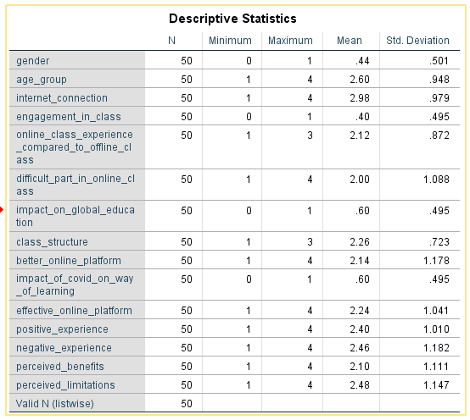
Figure 01: Descriptive statistics
Source: Self-made
Descriptive statistics present the statistical characteristics of the variables. There are some categorical variables presented here like the age group and gender. The average value of these variables does not signify any meaning. The mean value of engagement in class is 0.40 which means that most of the students did not find online classes attentive. The online class experience was worse for them as the mean value of their experience is 2.12 where 2 was labelled as the same experience as their experience in offline class and 3 was labelled as a worse experience. Many students preferred offline class structure while a reasonable portion of them prefer hybrid class structure.

4.1.2 Demographic characteristics of the sample
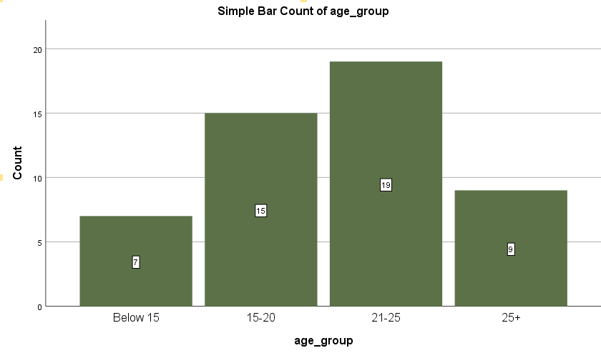
Figure 02: Respondents’ age-group
Source: Self-made
Of the 50 students from whom data has been collected, 56% of the sample were from the 21-25 and above 25 age group. 30% of the students are in the age range of 15-20 and 14% are from the “below 15” range.
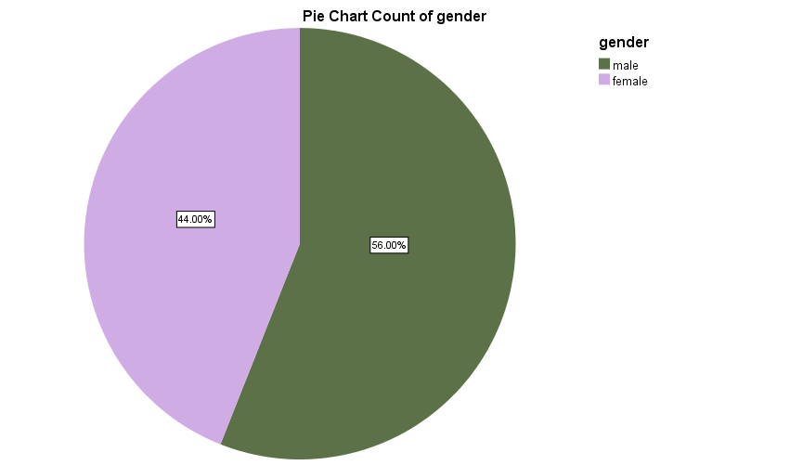

Figure 03: Gender of the respondents
Source: Self-made
Data were collected from both male and female students. The male respondents dominated the sample. 56% of the respondents were male students of UWTSD and the rest of the students, that is, 44% of them are female.

4.1.3 Internet connectivity during online class
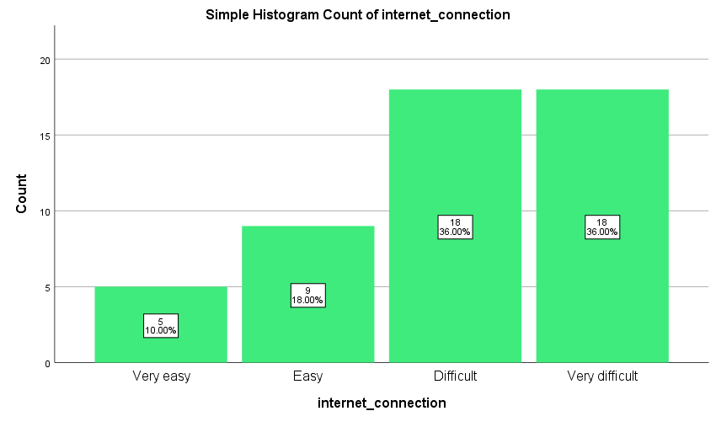
Figure 04: Internet connection during the class
Source: Self-made
Students were asked whether they had smooth internet connectivity when the classes were moved from offline to online. They were instructed to comment whether they found it easy or difficult in finding an undisrupted internet connection. 36% of the respondents had experienced difficulty in accessing classes and exams. For another 36% of the students, getting an undisrupted internet connection was more difficult. Only 28% of the students enjoyed smoother connectivity and did not become disconnected in the mid of examinations of online classes. If the class was conducted on a face-to-face platform, then the majority of the students would not have to be enlisted in the disadvantageous condition.

4.1.4 Attentiveness in the online class
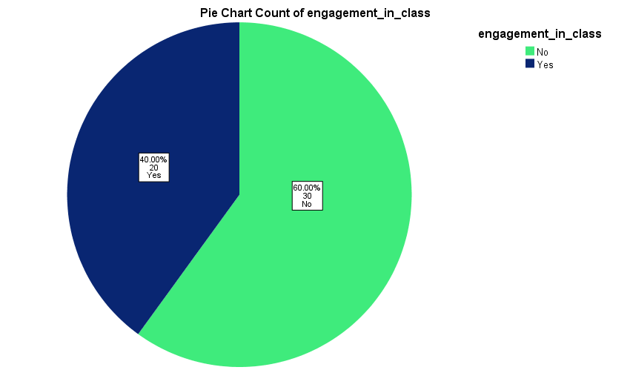
Figure 05: Level of students’ engagement in class
Source: Self-made
Only 40% of the respondents reported that they were able to attend classes with full attention and the classes were engaging at the same time. But 30 out of 50 students discovered the classes to be boring and the course content to be not-engaging. For some external and internal problems, they did not get the appropriate environment to invest uninterrupted attention in the classes. To them, an offline class environment was better as an effective learning platform. The higher absence rate and rising tendency of dropout during the pandemic can be attributed to the disengaging nature of the class.

4.1.5 Online class experience compared to offline class
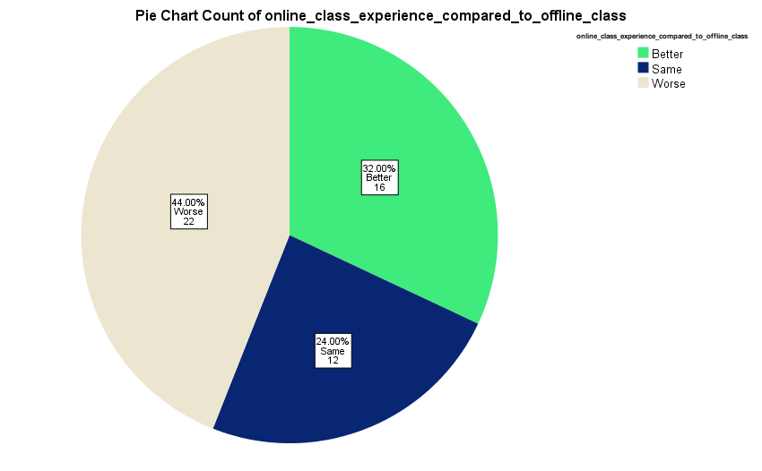
Figure 06: Students’ experience regarding online class
Source: Self-made
To compare the desires of students to go with online classes over offline classes, students were asked what their experience was regarding the strategic move of the class structure. Most of the students did not take the change positively. Attending classes online seemed to be a challenge for them. They were obliged to embrace the change due to survival and to prevent dropout. 32% of the respondents reported that their experience in online classes and learning systems was better than the facilities they got in offline classes. Another 24% of the respondents cited the experience in both of the cases as almost the same.

4.1.6 Challenges in online classes
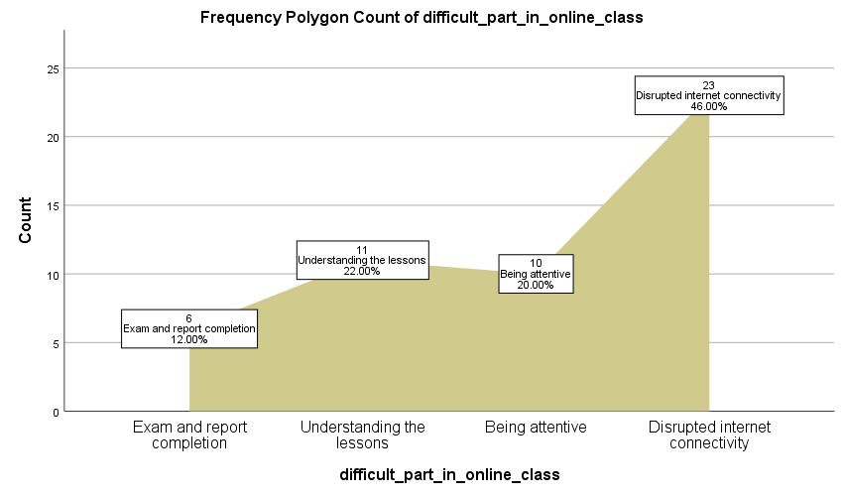
Figure 07: Challenges in online classes
Source: Self-made
To conclude how the students went through to adjust with the transformation of the learning platform from offline to online, the sample respondents were asked what the most difficult part was on their part to continue education during the lockdown. 46% of them complained about the weaker status of internet connection that was a must to remain connected in the classroom. 20% of the students could not concentrate in class. 11 of the 50 students could not understand the topic and another 6 of the 50 students failed to keep connected with the exam and report submission.

4.1.7 Impact of covid-19 on global education
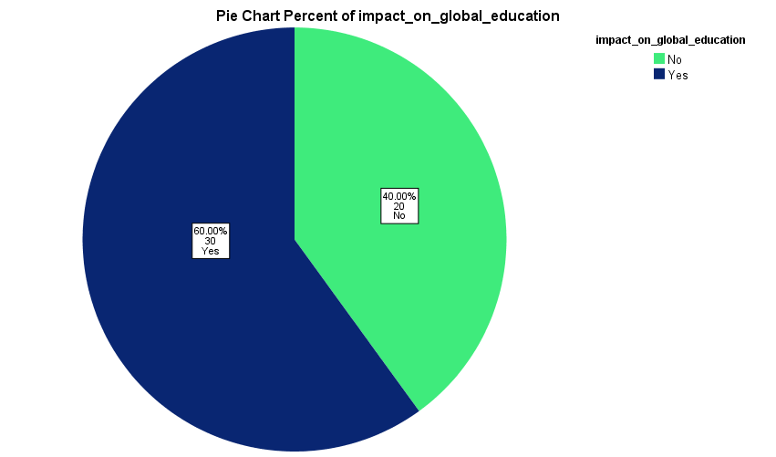
Figure 08: Impact of covid-19 on global education
Source: Self-made
To 60% of the students, the global pandemic brought about significant changes in how the educational industry around the world operates. It has destabilized the basic foundation of this industry. The impact was not restricted to any particular geographical location. Only 40% of the student felt that the pandemic did not result in any significant alternation in the way they received an education. Though the method of learning and teaching was different, they did not cause any substantial change in their outcome.

4.1.8 Preferred class structure for learners
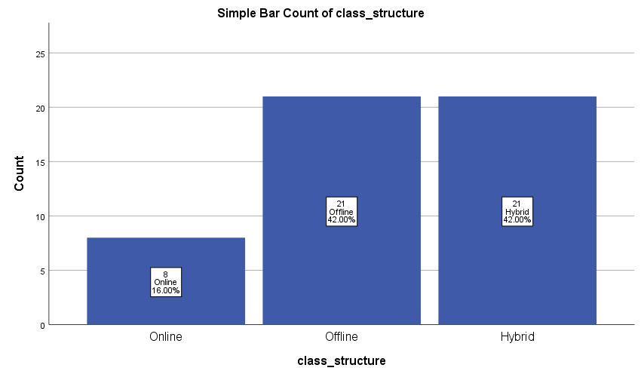
Figure 09: Expected class structure
Source: Self-made
To predict what could be the potential shape of online education, students were asked about their preferred platform that they think would be the best fit for effective learning in the future. 21 out of the 50 students stated that it would be better if teaching services is delivered using both online and offline platforms. According to them, classes and examinations might be conducted offline whereas other things like study material disbursement, assignment submission etc. might be made using the online portal. Only 16% of the students said that they would be more comfortable if all of the learning procedures were conducted online.

4.1.9 Expected factors for a better online learning platform
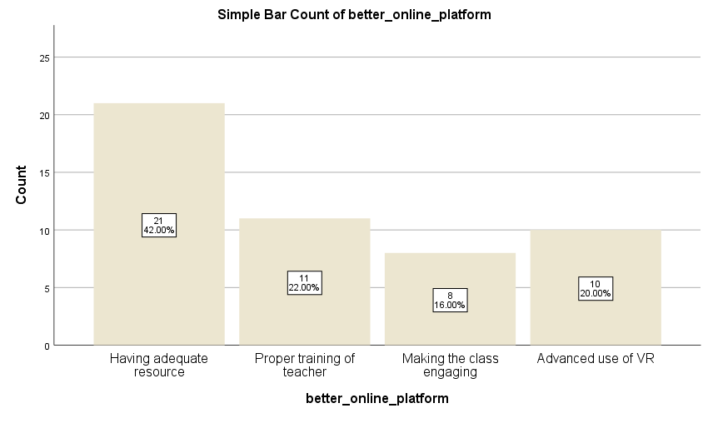
Figure 10: Criteria for the better online class platform
Source: Self-made
Factors that would be appropriate for making the online learning experience better for the students differ based on several diverse factors some of which are associated with the economic condition and other external environments and some of which are with the personal issues of the students. 42% of the students thought if they had adequate resources to conduct the classes, their experience would be better. By resources, they mean effective and appropriate smartphones, computers, laptops etc. Some students felt that the teaching style of tutors needed to be changed. They needed to take proper training on how to conduct learning sessions and make the process interesting to the students. 16% of the students sensed the urge for designing the course and planning the teaching session in a way that would ensure the engagement of students in the class. 20% of students stated that the authority should provide VR-based learning.

4.1.10 Impact of covid-19 on the learning ability of students

Figure 11: Impact of the pandemic on the learning experience
Source: Self-made
60% of the students experienced more obstacles in consummating lessons. They failed to retain information for longer periods. This might be the side effects of the adverse environment which they had to go through amid the global pandemic. 40% of students did not experience major hindrances.

4.1.11 Factors affecting the effectiveness of the online platform
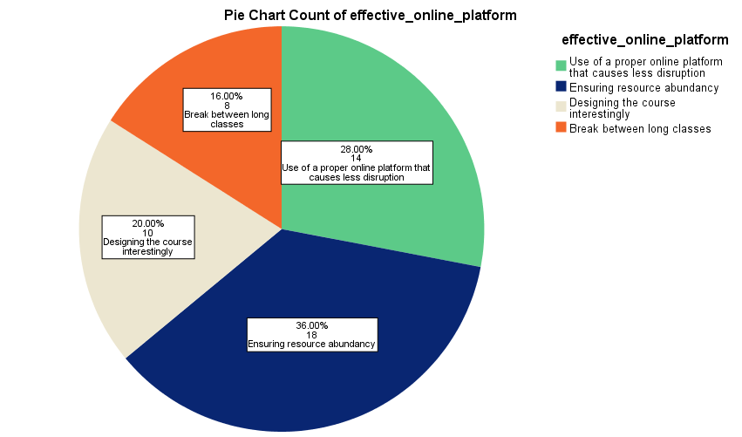
Figure 12: Factors affecting the effectiveness of online class
Source: Self-made
18 out of 50 students stated that the productivity and success of the online platform in disbursing education could be ensured by availing adequate resources to all of the students equally. For this, government and school authorities should work hand in hand. 16% of the students suggested frequent breaks within a class so that students could get refreshments and join the class with more concentration. 20% of students focused on the course design and 28% on the need to accept an appropriate online platform.

4.1.12 Positive and negative experiences from the online platform
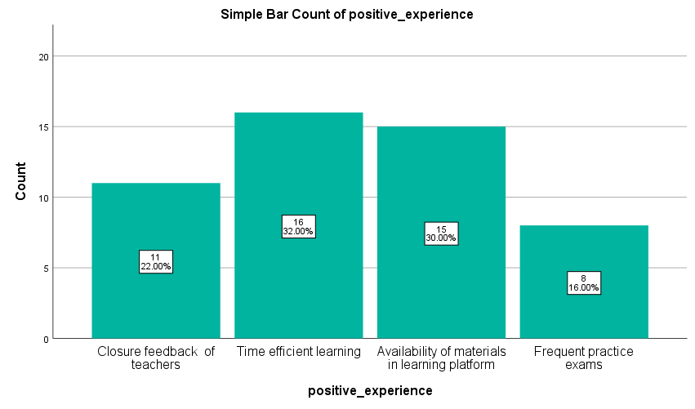

Figure 13: Positive experience regarding online education
Source: Self-made
The online platform proposed an effective learning process as students could save the times they required to travel to school. 32% of the students reported that due to online classes, they got more time to study. They found recorded classes on a particular online platform. So, if they accidentally missed a class, they would find the recorded class on the website. Besides class recording, learning materials were also available in an arranged way. Other positive experiences include more direct feedback from teachers and frequent quizzes conducted by the course teacher.
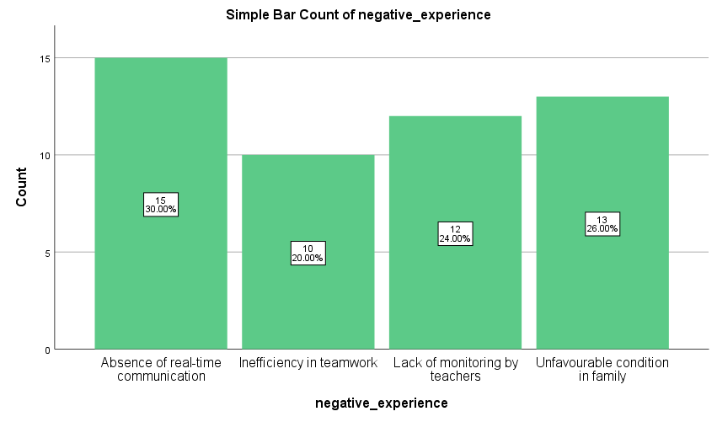
Figure 14: Negative experience regarding online education
Source: Self-made
26% of students had to go through terrible situations due to unfavourable family conditions. Some lost their family members in covid, some had to face a sudden fall in income. All of these affected students’ attention levels. 30% of students felt that they could not communicate with their teachers and classmates online as they did in the face-to-face classroom.

4.1.13 Perceived benefits and limitations in the new learning mechanism
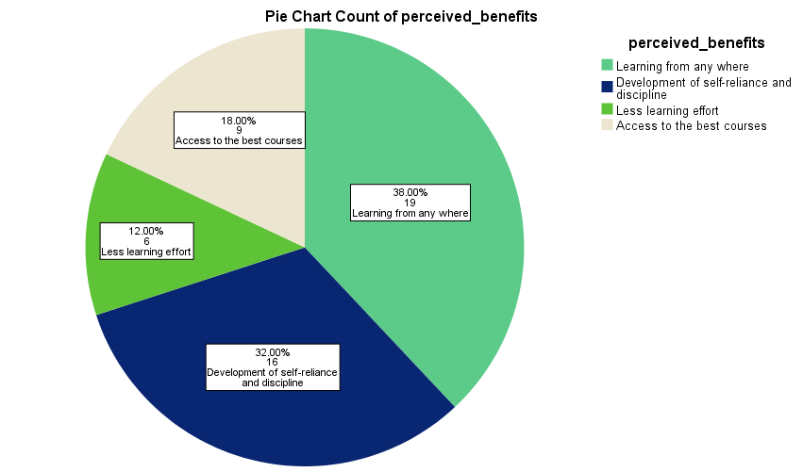
Figure 15: Perceived benefits in online class structure
Source: Self-made
In general, the transformation of the learning system during the pandemic has brought about some benefits for students of all levels. The perceived benefits include access to the best classes conducted by the best teachers. It increased demand for some courses. Students irrespective of their geographical locations can attend the classes. But online learning systems vested more responsibility on students regarding their performance and success.
32% of the students thought that their sense of self-efficacy improved within themselves as teachers were no longer able to monitor the students closely and it was the student’s responsibility to ensure good performance. They needed to maintain a regular study routine amid all forms of adversities. It also helped students in being responsible and multiple task managers. Besides being careful about their studies, students were also required to take care of their family members. 38% of the students cited no requirement for physically present in the classroom as a blessing as they had to move out from their present residents either due to decreased income or other reasons.
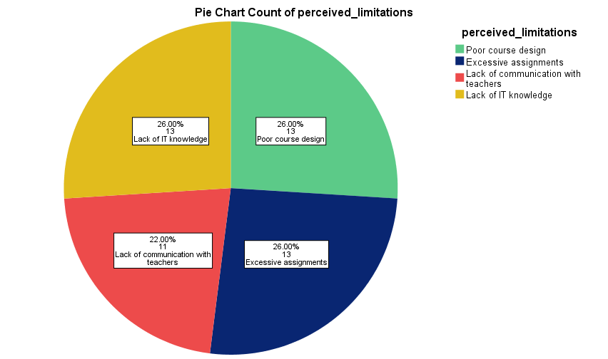
Figure 16: Perceived limitations in online class structure
Source: Self-made
Perceived limitations that arose from the learning platforms’ transformation included students’ lack of knowledge in information technology, communication gap between teachers and students, piles of homework and assignments, poor design of course content etc.
Most acute problems were seen in communication. 22% of students stated that they could not communicate with the tutors whenever they needed help. Consequently, they could not solve their problems in time resulting in long-term damage to their studies. During the pandemic, to keep students busy and to compensate for the damage made from the learning loss at the onset of the deadly pandemic.

4.2 Discussion
Schleicher (2020) stated that one out of every 5 students dropped out of school in the face of covid-19. The reasons for dropping out might vary from person to person but all of the reasons were induced by the covid-19 pandemic. A similar situation was observed in UWTSD where 60% of the students faced difficulty in continuing their education. Richter (2021) found out that only 20% of the students who joined online classes remained till the last time. This statement can be rationalized by the findings of the study conducted on the students of UWTSD. They were burdened with financial, social and family problems that caused them to take a break from studying.
Doyumgaç, Tanhan and Kiymaz (2021) considered students’ lack of experience in IT and inability to afford electronic devices to be the most common problems. This was also true for the students of UWTSD where 46% of students could not afford undisrupted net-connected, 26% of students had severe conditions in their families and 42% of students did not have adequate resources for the smoother continuation of online classes. Budur, Demir and Cura (2021) reported a 33% absence rate overall in class due to students’ inability to afford required devices which was greater than the statistics found in this study. Hina and Baig (2022) observed a 28% decline in people’s financial condition. The situation was almost similar for the respondents of this study. 26% of the students were financially impacted during the pandemic.
Heng and Sol (2021) cited weaker mental conditions and resource inadequacy to be the challenges most frequently faced by learners. But for the students of UWTSD, the most challenging issues included poor course design, boringness in class, lack of training of teachers, and too many assignments and exams. The findings of Peimani and Kamalipour (2021) were similar to that of this study as in both of these research papers, students’ family conditions, poor course plans etc. were responsible for bitter experiences in the transformed platform for delivery of education.

Chapter 05: Conclusion and recommendation

5.1 Conclusion
On average, students of UWTSD’s experience on the online platform was not satisfactory at all. 72% of the total students to some extent faced problems in doing classes due to poor internet connection. Only 20 out of 50 students could keep attention in their classes. 16% of students found the online platform better than the offline platform whereas 42% of students found the offline platform better than the online one. 42% out of the total 50 students recommended the authority to design a hybrid class structure. 46% of students found internet connectivity to be the most crucial but challenging factor in the new normal way of receiving education. 22% could not understand the topics taught in class and for the rest of the students, pressure for frequent examinations, assignments and quizzes was intense on this platform. Given the experience of students in access to education, 60% of students thought that the new experience would bring about significant structural changes in global education. The change is apparent as 42% of students wanted to maintain a hybrid class structure even after infection by covid-19 came under control. The good things concluded by the students from this transformation of the learning platform included savings of time and money, storage of reading materials on the web portal, frequent practice exams etc. Students are also expected to have developed self-discipline and self-reliance during the pandemic.

5.2 Recommendation
It is possible that the world would not be exactly like before the pandemic as the covid-19 has shown people the benefits of digitalization in every aspect. In the field of education, the same effects have also been experienced in some cases that might bring about permanent change in the way education is delivered to students around the world. Many institutions are not embracing a hybrid class structure and in doing so, special focus should be imposed o marginalized students. If there are learners who cannot afford a net connection and adequate devices to attend classes, the institutions should not adopt an online learning structure (Selvaraj, 2021). Also, teachers are required to go through training and development sessions on how they can make the classes engaging and effective. Two-way interaction from time to time is the best solution for making classes interesting for students. As the pandemic has caused mental suffering in students, each teacher should counsel some students and monitor them on daily basis. By doing so, the communication gap between teachers and students can be minimized properly, the need of students can be identified clearly and the most appropriate solutions for meeting up their needs can be adopted successfully.

References
Adams, J., Khan, H.T. and Raeside, R., 2014. Research methods for business and social science students. SAGE Publications India.
Akpınar, E., 2021. The effect of online learning on tertiary level students’ mental health during the COVID-19 lockdown. The European Journal of Social & Behavioural Sciences.
Al Rawashdeh, A.Z., Mohammed, E.Y., Al Arab, A.R., Alara, M. and Al-Rawashdeh, B., 2021. Advantages and disadvantages of using e-learning in university education: Analyzing students’ perspectives. Electronic Journal of e-Learning, 19(3), pp.107-117.
Blundell, R., Cribb, J., McNally, S., Warwick, R. and Xu, X., 2021. Inequalities in education, skills, and incomes in the UK: The implications of the COVID-19 pandemic. Institute for Fiscal Studies.
Budur, T., Demir, A. and Cura, F., 2021. University readiness for online education during the Covid-19 pandemic. International Journal of Social Sciences & Educational Studies, 8(1), pp.180-200.
Cope, B. and Kalantzis, M., 2022. The changing dynamics of online education: Five theses on the future of learning1. In Foreign Language Learning in the Digital Age (pp. 9-33). Routledge.
Crane, L., Adu, F., Arocas, F., Carli, R., Eccles, S., Harris, S., Jardine, J., Phillips, C., Piper, S., Santi, L. and Sartin, M., 2021, May. Vulnerable and forgotten: The impact of the COVID-19 pandemic on autism special schools in England. In Frontiers in Education (Vol. 6, p. 629203). Frontiers Media SA.
Curwin, J., Slater, R.H. and Eadson, D., 2013. Quantitative methods for business decisions. Cengage Learning.
D O'Gorman, K. and MacIntosh, R., 2015. Research methods for business and management: A guide to writing your dissertation. Goodfellow Publishers Ltd.
Denscombe, M., 2012. Research proposals: A practical guide: A practical guide. McGraw-Hill Education (UK).
Doyumgaç, I., Tanhan, A. and Kiymaz, M.S., 2021. Understanding the most important facilitators and barriers for online education during COVID-19 through online photovoice methodology. International Journal of Higher Education, 10(1), pp.166-190.
Duignan, J., 2016. A dictionary of business research methods. Oxford University Press.
Esra, M.E.Ş.E. and Sevilen, Ç., 2021. Factors influencing EFL students’ motivation in online learning: A qualitative case study. Journal of Educational Technology and Online Learning, 4(1), pp.11-22.
Firmansyah, R., Putri, D., Wicaksono, M., Putri, S., Widianto, A. and Palil, M., 2021. Educational Transformation: An Evaluation of Online Learning Due to COVID-19. International Journal of Emerging Technologies in Learning (iJET), 16(7), pp.61-76.
Heng, K. and Sol, K., 2021. Online learning during COVID-19: Key challenges and suggestions to enhance effectiveness. Cambodian Journal of Educational Research, 1(1), pp.3-16.
Holt, L. and Murray, L., 2021. Children and Covid 19 in the UK. Children's Geographies, pp.1-8.
Hu, X., Chiu, M.M., Leung, W.M.V. and Yelland, N., 2021. Technology integration for young children during COVID‐19: Towards future online teaching. British Journal of Educational Technology, 52(4), pp.1513-1537.
Imran, M., Hina, S. and Baig, M.M., 2022. Analysis of Learner’s Sentiments to Evaluate Sustainability of Online Education System during COVID-19 Pandemic. Sustainability, 14(8), p.4529.
Kaisara, G. and Bwalya, K.J., 2021. Investigating the E-learning challenges faced by students during COVID-19 in Namibia. International Journal of Higher Education, 10(1), pp.308-318.
Lei, S.I. and So, A.S.I., 2021. Online teaching and learning experiences during the COVID-19 pandemic–A comparison of teacher and student perceptions. Journal of Hospitality & Tourism Education, 33(3), pp.148-162.
Maheshwari, G., 2021. Factors affecting students’ intentions to undertake online learning: an empirical study in Vietnam. Education and Information Technologies, 26(6), pp.6629-6649.
Newlove-Delgado, T., McManus, S., Sadler, K., Thandi, S., Vizard, T., Cartwright, C. and Ford, T., 2021. Child mental health in England before and during the COVID-19 lockdown. The Lancet Psychiatry, 8(5), pp.353-354.
Oliver, P., 2012. Succeeding with your literature review: A handbook for students.
Osterrieder, A., Cuman, G., Pan-Ngum, W., Cheah, P.K., Cheah, P.K., Peerawaranun, P., Silan, M., Orazem, M., Perkovic, K., Groselj, U. and Schneiders, M.L., 2021. Economic and social impacts of COVID-19 and public health measures: results from an anonymous online survey in Thailand, Malaysia, the UK, Italy and Slovenia. BMJ Open, 11(7), p.e046863.
Peimani, N. and Kamalipour, H., 2021. Online education and the COVID-19 outbreak: A case study of online teaching during the lockdown. Education Sciences, 11(2), p.72.
Reimers, F.M., 2022. Learning from a pandemic. The impact of COVID-19 on education around the world. In Primary and secondary education during COVID-19 (pp. 1-37). Springer, Cham.
Saunders, M.N.K., Lewis, P. and Thornhill, A., 2019. Research Methods for Business Students Eight Edition. QualitativeMarket Research: An International Journal.
Schleicher, A., 2020. The Impact of COVID-19 on Education: Insights from" Education at a Glance 2020". OECD Publishing.
Selvaraj, A., Radin, V., Nithin, K.A., Benson, N. and Mathew, A.J., 2021. Effect of pandemic-based online education on teaching and learning system. International Journal of Educational Development, 85, p.102444.
Thomas, R.A. and Dello Stritto, M.E., 2021. What is the future of online education? The perceptions of instructors with over a decade of online teaching experience. Online J Dist Learn Admin, 24(4), p.638470.
Zawacki‐Richter, O., 2021. The current state and impact of Covid‐19 on digital higher education in Germany. Human Behavior and Emerging Technologies, 3(1), pp.218-226.

Appendix
Questionnaire
1. Please tick on your gender.
- Male (0) - Female (1)
2. Please select the age group you are located at.
- Below 15 (1) - 15-20 (2) - 21-25 (3) - 25+ (4)
3. How was it for you to connect internet for access to classes and exams?
- Very easy (1) - Easy (2) - Difficult (3) - Very difficult (4)
4. Did you find the classes attentive and engaging?
- Yes (1) - No (0)
5. How was your online class experience compared to offline classes?
- Better (1) - Same (2) - Worse (3)
6. What was the difficult part for you while attending online classes?
- Disrupted internet connectivity (1) - Being attentive (2)
- Understanding the lessons (3) - Exam and report completion (4)
7. Do you think the pandemic changed the way students had the access to education?
- Yes (1) - No (0)
8. What class structure would you prefer?
- Online (1) - Offline (2) - Hybrid (3)
9. What will make your online class experience better in future?
- Having adequate resources (1) - Proper training of teacher (2) - Making the class engaging (3) - Advanced use of VR (4)
10. Did covid-19 make your way of learning difficult?
- Yes (1) - No (0)
11. What would you recommend for making the online platform effective?
- Use of a proper online platform that causes less disruption (1) - Ensuring resource abundancy (2) - Designing the course interestingly (3) - Break between long classes (4)
12. What are the positive experiences you got from a shift to an online platform?
- Closure feedback of teachers (1) - Time efficient learning (2) - Availability of materials in the learning platform (3) - Frequent practice exams (4)
13. What are the negative experiences you got from shifting to an online platform? - Absence of real-time communication (1) - Inefficiency in teamwork (2) - Lack of monitoring by teachers (3) - Unfavourable conditions in the family (4)
14. What are the perceived benefits of online learning?
- Learning from anywhere (1) - Development of self-reliance and discipline (2) - Less learning effort (3) - Access to the best courses (4)
15. What are the perceived limitations of online learning?
- Poor course design (1) - Excessive assignments (2) - Lack of communication with teachers (3) - Lack of IT knowledge (4)

