Enterprise Network Infrastructure Research Report: NOSS2027



Student’s Name: Adiba Shabbir (2513924)
Module Name: Network Operating Systems & Services
Module Code: ACCA 5023
Lecturer’s Name: Md Abrar Jahin Almazi Bipon
Table of Contents

Abstract 2
1.Introduction: 2
2. Enterprise Network Requirements and Future Growth 3
2.1 Current requirements 3
2.2 Scalability, resilience and maintainability 4
3. Server Operating Systems Comparison 5
3.1 Windows Server 2025 5
3.2 Debian Linux administered through CLI 6
3.3 Critical comparison 7
4. Network Services and Roles 8
4.1 Addressing, DNS and directory services 9
4.2 File sharing and web services 9
4.3 Routing, VPN and remote access 9
4.4 Certificates and monitoring 10
5. Basic Information Security Considerations 10
6. Conclusion and Recommendation 12
7. References 13

Date Submitted: 23/10/2026

Abstract
This report critically evaluates the operating systems and network services required to support NOSS2027, an organisation operating across Swansea and London. It compares Windows Server 2025 with Debian Linux administered through CLI, considering administration, licensing, automation, security and enterprise suitability. Windows Server is recommended for centralised domain management, while Debian provides a flexible platform for Linux-based services. The report also examines DHCP, DNS, directory services, file sharing, web hosting, remote access, routing, VPNs, certificates and monitoring. Basic security controls, including least privilege, firewall restrictions, patching and protected backups, are considered alongside future requirements for scalability and resilience. A virtualised mixed-platform network is recommended for Component 2, with service testing and documented configuration. Redundancy, secure inter-site connectivity and tested recovery remain priorities for future production deployment.

1.Introduction:
Enterprise networks must deliver reliable communication, secure access to information and sufficient capacity for organisational growth. NOSS2027 operates across Swansea and London, requiring an infrastructure that supports geographically separated users through interoperable Windows and Linux systems. The challenge is to select technologies that balance security, cost, performance and maintainability rather than simply installing available services.
This report evaluates the network requirements, compares Windows Server 2025 with Debian Linux administered through the command-line interface (CLI), and examines essential network services and security controls. Evidence from scholarly research, recognised standards and technical documentation informs recommendations for the simulated environment comprising Windows clients, one Windows Server and one Debian server.

2. Enterprise Network Requirements and Future Growth

2.1 Current requirements
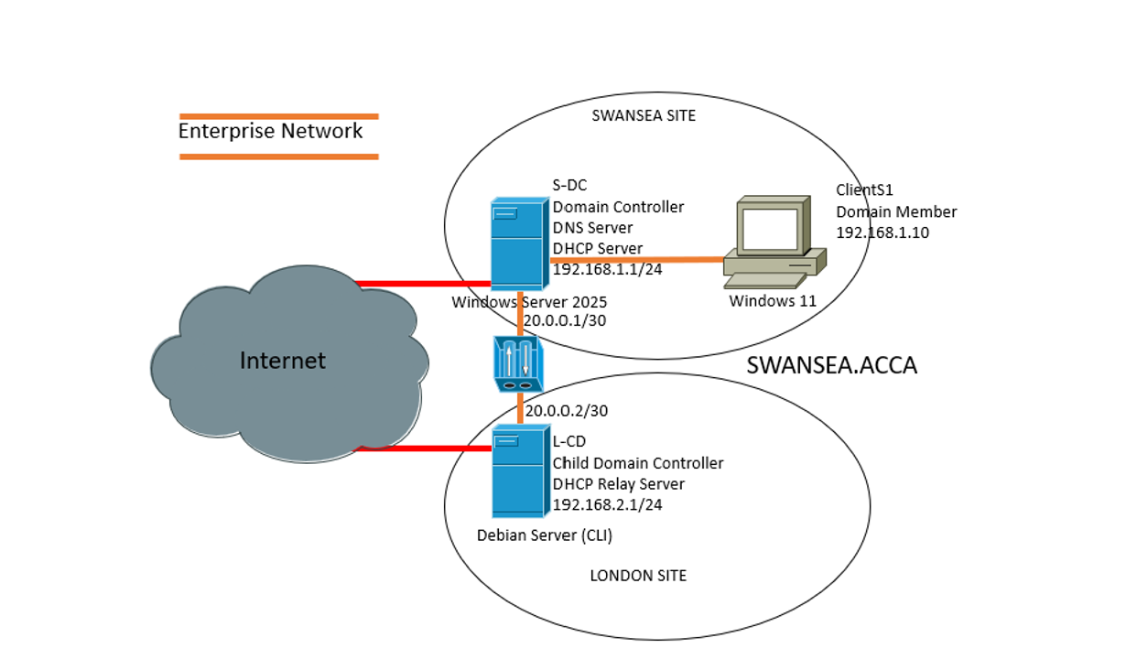
NOSS2027 requires reliable communication between its offices, centralised authentication, shared resources and controlled access to internal services. Each site should have a local area network (LAN), with inter-site communication represented by routed networks and, in production, protected through an appropriate wide area network (WAN) or site-to-site virtual private network (VPN). Subnetting and documented IP addressing simplify administration and help separate user devices, servers and management systems [1].
Figure 1. Proposed Two-Site Enterprise Network

Dynamic Host Configuration Protocol (DHCP) should allocate client IP addresses, gateways and DNS settings. Domain Name System (DNS) resolves hostnames and enables Windows clients to locate domain controllers. Since Active Directory Domain Services (AD DS) relies on correct DNS configuration, incorrect records can prevent domain discovery even when the server is operational [2]. Address allocation and name resolution must therefore be verified before domain joining.
Windows Server should provide centralised domain management, authentication and Group Policy. Debian should host a justified Linux service, such as web hosting. This division demonstrates interoperability without unnecessarily duplicating core roles.

2.2 Scalability, resilience and maintainability
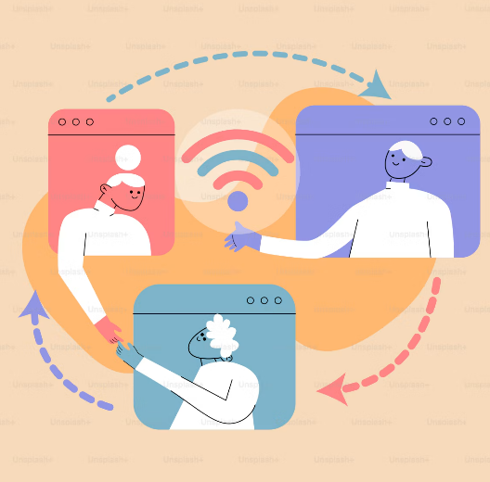
Future growth may introduce additional users, departments, applications and remote connections. Reserved address capacity, consistent naming, documented configurations and automation can reduce the effort required to expand. Virtualisation supports isolated workloads and repeatable testing, although performance remains dependent on host CPU, memory, storage and network resources.
Resilience requires understanding service dependencies. Failure of a domain controller could disrupt authentication, while loss of inter-site connectivity could isolate users from centrally hosted resources. Kurose and Ross explain how network protocols and layered dependencies influence communication across interconnected systems [1]. For NOSS2027, production planning should consider redundant domain controllers, alternative connectivity, protected backups and tested recovery procedures. These measures may exceed the simulation's scope, but their absence should be recorded as a design limitation.
Maintainability requires scheduled patching, monitoring, change documentation and repeatable configuration. PowerShell supports Windows automation, while Debian provides shell scripting and package-management tools. Automation improves consistency but can distribute errors when scripts are poorly tested. Changes should therefore be tested before deployment and accompanied by rollback procedures.
Longer-term requirements may include cloud integration, additional branches and increased remote working. A design based on documented dependencies and defined service roles will accommodate these changes more effectively than ad hoc configuration.

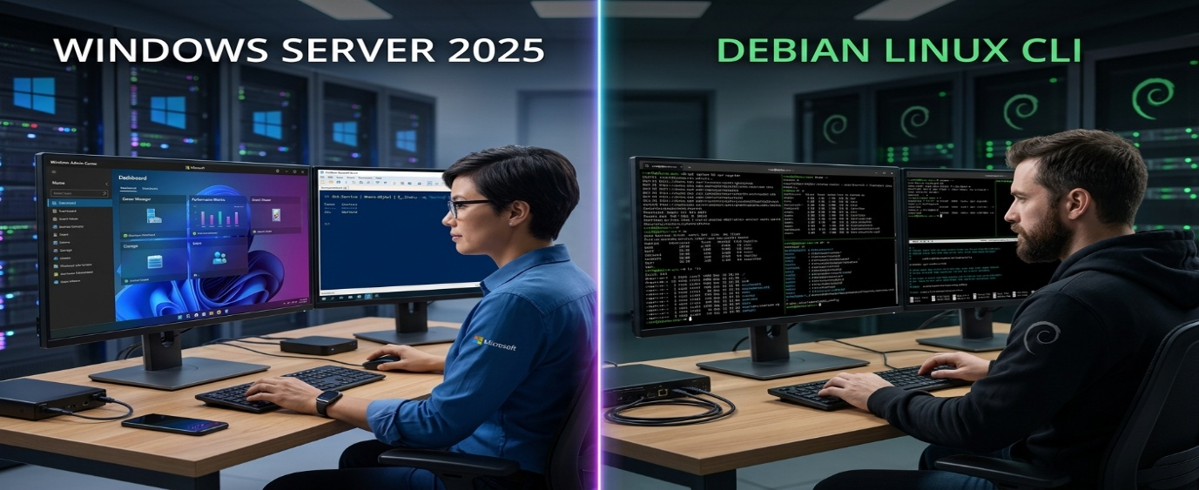
3. Server Operating Systems Comparison

3.1 Windows Server 2025
Windows Server 2025 supports enterprise services including AD DS, DNS, DHCP, Internet Information Services (IIS) and certificate services [3]. Its main advantage for NOSS2027 is integrated identity and policy management. Administrators can organise users and computers into domains, apply Group Policy and assign permissions through security groups.
PowerShell supports repeatable administration, reducing dependence on manual configuration. Microsoft also documents security enhancements in Windows Server 2025, including Credential Guard being enabled by default on supported devices [3]. However, these protections depend on compatible hardware and appropriate configuration; they do not eliminate the risks associated with excessive privileges or insecure applications.
Centralisation also creates concentration risk. Compromised privileged accounts or incorrectly applied domain policies may affect multiple systems. Separate administrative accounts, restricted permissions and tested recovery arrangements are consequently essential.
Windows Server introduces licensing costs. Edition, core-based licensing, virtualisation rights and applicable client access licences (CALs) influence total expenditure [4]. The decision should consider support, training and maintenance rather than software purchase alone.

3.2 Debian Linux administered through CLI
Debian is an open-source operating system suited to stable server workloads and scriptable administration. Debian 13, Codenamed Trixie, was released on 9 August 2025. Its published lifecycle provides full support until August 2028 and long-term support until June 2030, subject to the project's stated architecture and package conditions [5].
CLI administration uses apt for package management, systemctl for service control and journalctl for log inspection. SSH supports remote administration without requiring a graphical desktop. These tools allow efficient management of web services and system configuration.
A minimal installation can reduce resource overhead, but actual performance depends on workload and configuration. CLI operation also requires familiarity with permissions, networking and configuration syntax. Incorrect changes can interrupt services, particularly where administrators lack documentation or recovery procedures.
Debian generally avoids proprietary operating-system licensing fees, but training, support, monitoring and maintenance remain operational costs. Its suitability depends on whether flexibility and lower licensing expenditure outweigh the additional administration effort.

3.3 Critical comparison
 | Windows Server 2025 | Debian Linux CLI
Administration | PowerShell, graphical tools and integrated domain management | Shell commands, SSH and configuration files
Directory services | Native AD DS and Group Policy | Integration with AD or separate directory technologies
Licensing | Commercial licensing and applicable CAL costs | No mandatory OS licence fee; operational costs remain
Updates | Windows servicing and management tools | Repository-based package management and security updates
Automation | PowerShell | Shell scripting and configuration-management tools
Resource requirements | Depend on edition and enabled roles | Minimal CLI installation can be lightweight
Compatibility | Strong Windows enterprise integration | Strong Linux-native and cross-platform support
Main limitation | Licensing and ecosystem dependence | Greater requirement for CLI expertise

Windows Server is the stronger choice for centralised Windows domain management, whereas Debian is appropriate for Linux-native services and CLI administration. Neither platform is inherently secure simply because of its design. Both require supported software, secure configuration, controlled privileges and effective monitoring.
For Component 2, Windows Server should provide the primary domain environment, with DHCP hosted there if the practical specification permits. Debian should demonstrate a Linux service, preferably web hosting. This allocation provides a clear technical purpose for each server without unnecessary duplication.

4. Network Services and Roles
Enterprise services operate as an interdependent system. A service may be running correctly while the network remains unusable because another dependency is unavailable or incorrectly configured. Table 2 summarises the principal services and their trade-offs.
Service | Purpose and benefits | Limitations & considerations
DHCP | Automates IP configuration and reduces manual errors | Incorrect scopes or rogue servers can disrupt clients
DNS | Resolves hostnames and supports domain discovery | Incorrect records can disrupt authentication and applications
Directory/domain services | AD DS centralises identities, authentication and policy | Controller failure and privileged-account compromise create significant risks
File sharing | SMB supports collaboration through shared folders | Excessive permissions and ransomware threaten data
Web services/IIS | Hosts websites and applications; IIS supports Microsoft environments | Exposed applications require patching and secure TLS configuration
Remote access/RDS | Provides remote administration or hosted desktops and applications | Licensing, capacity and exposed access points require control
Routing | Connects subnets and networks | Incorrect routes or unrestricted traffic create connectivity and security risks
VPN | Protects traffic across untrusted networks | Weak authentication or configuration can expose resources
Certificates | Support server identity and encrypted TLS connections | Expiry or compromised private keys undermine trust
Logging/monitoring | Supports fault diagnosis and incident investigation | Unreviewed logs provide limited security value

4.1 Addressing, DNS and directory services
DHCP and DNS should be prioritised because other services depend on reliable addressing and name resolution [2]. The practical build should verify that clients receive valid network settings, resolve internal hostnames and reach the intended server. If DHCP is outside the simulation's scope, static addressing should be documented and checked for conflicts.
AD DS centralises user administration and authentication. Security groups and Group Policy support consistent permissions and Windows client settings. However, centralised administration increases the impact of mistakes, requiring restricted privileges and tested policy changes.

4.2 File sharing and web services
Server Message Block (SMB) supports file sharing between Windows systems and compatible servers. Debian can provide interoperability through Samba, but this should be introduced only if required by the practical specification. Access should be assigned through appropriate groups, considering both share and filesystem permissions.
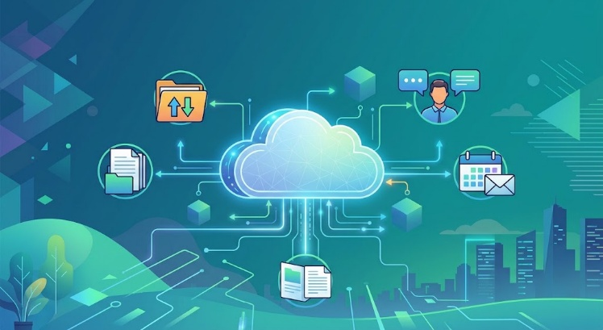
IIS is suitable for Microsoft-integrated applications, whereas Apache HTTP Server or Nginx may be preferable for Linux-native workloads. Selection should reflect compatibility, administrator skills and support requirements. For NOSS2027, Debian web hosting demonstrates Linux administration, provided the service can be tested within the simulation.

4.3 Routing, VPN and remote access
Routing enables communication between subnets, while a site-to-site VPN can protect traffic between Swansea and London. Remote Desktop Services (RDS) provides centrally hosted Windows desktops and applications, but adds capacity, configuration and licensing considerations [6].
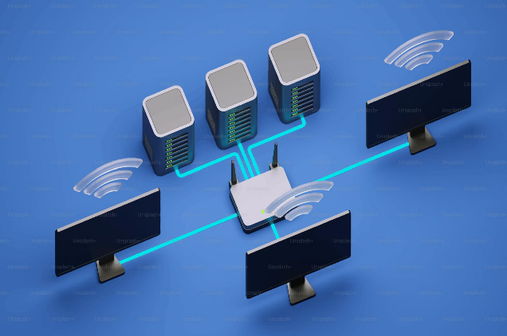
Remote access improves flexibility while expanding the attack surface. NOSS2027 should avoid exposing internal RDP services directly to the internet. A secured gateway or VPN, strong authentication and restricted permissions offer better-controlled access. Where VPN or inter-subnet routing cannot be demonstrated, the report should distinguish the recommended production design from the implemented simulation.

4.4 Certificates and monitoring
Certificates support server identity verification and encrypted communications. Windows certificate services can support internal certificate issuance, while Debian web services can use certificates from an appropriate certificate authority. Renewal, revocation and private-key protection should form part of routine maintenance.
Windows Event Viewer and Debian system logs can record authentication failures, service errors and administrative events. NIST security controls emphasise protecting audit information from unauthorised access and modification [7]. CISA likewise recommends enabling relevant logs, protecting them and reviewing unusual activity [8]. The practical build should verify service status, authentication, hostname resolution and connectivity. A production network should extend this to centralised logging, alerting and documented incident handling.

5. Basic Information Security Considerations
Security should protect confidentiality, integrity and availability without preventing legitimate work. It must apply to both operating systems rather than relying exclusively on perimeter protection.
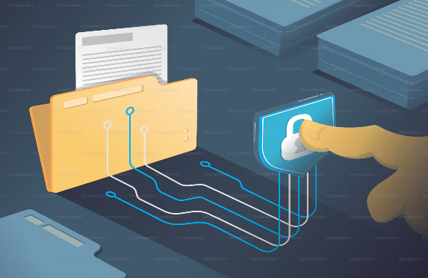
Authentication: Users should have individual accounts and strong, unique credentials. Multifactor authentication should be used for privileged or remote access where supported. Separate administrator accounts reduce the risk of everyday activities exposing elevated credentials.
Authorisation and least privilege: Access should reflect job responsibilities. Standard users should not receive unnecessary administrative rights, and service accounts should possess only the permissions required for their tasks. Syed et al. explain that zero-trust architectures emphasise explicit authentication, access control, encryption and segmentation rather than automatically trusting devices because of their network location [9]. This approach is relevant to a two-site organisation whose users access shared resources across different networks.

Firewalls and segmentation: Rules should permit only necessary traffic between defined sources and destinations. Management interfaces should be restricted, unnecessary services disabled and network segments separated where practical. Segmentation is not sufficient by itself; poorly configured routing rules can reintroduce unrestricted access.

Patching and safe operation: Windows, Debian and application updates should be reviewed, tested and installed through documented procedures. A systematic literature review by Alqahtani et al. identifies patch management as a socio-technical process involving prioritisation, dependencies, tools and organisational decisions [10]. NOSS2027 should therefore prioritise critical vulnerabilities, test updates where practical and verify service availability afterwards.
Backups and monitoring: Backups should be protected from ordinary user modification, with restoration tested periodically. Administrators should use trusted software sources and record significant configuration changes. The NIST zero-trust model and security-control guidance provide broader frameworks for managing access and protecting audit information [7], [11].
These measures establish an introductory baseline rather than a complete security architecture. The Component 2 security discussion should assess how controls are implemented, tested and improved.

6. Conclusion and Recommendation
NOSS2027 requires a maintainable network that supports two offices while allowing future expansion. A mixed Windows–Linux design is appropriate because it combines integrated Windows domain management with Debian's flexible CLI administration.

Windows Server 2025 should provide AD DS, Group Policy and required Windows-oriented services. Debian should host an appropriate Linux service, such as a web server. DHCP, DNS, routing, remote access and monitoring should be selected according to the practical specification and verified through service tests.
Component 2 should prioritise reliable addressing, DNS resolution, successful client authentication, controlled permissions and website availability. Firewall restrictions, patching, protected backups and log review should support these functions. Production deployment would additionally require redundancy, tested recovery procedures, secure inter-site connectivity and enhanced monitoring. The recommendation therefore provides an evidence-informed foundation while acknowledging the limitations of a simulated environment.

7. References
[1] J. F. Kurose and K. W. Ross, Computer Networking: A Top-Down Approach, 8th ed. Harlow, U.K.: Pearson, 2021.
[2] Microsoft, “DNS and AD DS,” Microsoft Learn. [Online]. Available: https://learn.microsoft.com/en-us/windows-server/identity/ad-ds/plan/dns-and-ad-ds. [Accessed: Oct. 23, 2026].
[3] Microsoft, “What’s new in Windows Server 2025,” Microsoft Learn. [Online]. Available: https://learn.microsoft.com/en-us/windows-server/get-started/whats-new-windows-server-2025. [Accessed: Oct. 23, 2026].
[4] Microsoft, “Windows Server licensing,” Microsoft Licensing. [Online]. Available: https://www.microsoft.com/en-us/licensing/product-licensing/windows-server. [Accessed: Oct. 23, 2026].
[5] Debian Project, “Debian ‘trixie’ release information.” [Online]. Available: https://www.debian.org/releases/trixie/. [Accessed: Oct. 23, 2026].
[6] Microsoft, “Remote Desktop Services overview,” Microsoft Learn. [Online]. Available: https://learn.microsoft.com/en-us/windows-server/remote/remote-desktop-services/remote-desktop-services-overview. [Accessed: Oct. 23, 2026].
[7] Joint Task Force, Security and Privacy Controls for Information Systems and Organizations, NIST Special Publication 800-53, Rev. 5, Sep. 2020, updated Dec. 2020, doi: 10.6028/NIST.SP.800-53r5.
[8] Cybersecurity and Infrastructure Security Agency, “Use logging on business systems.” [Online]. Available: https://www.cisa.gov/audiences/small-and-medium-businesses/secure-your-business/use-logging-on-business-systems. [Accessed: Oct. 23, 2026].
[9] N. F. Syed, S. W. Shah, A. Shaghaghi, A. Anwar, Z. A. Baig, and R. Doss, “Zero trust architecture (ZTA): A comprehensive survey,” IEEE Access, vol. 10, pp. 57143–57179, 2022, doi: 10.1109/ACCESS.2022.3174679.
[10] M. A. Alqahtani et al., “Software security patch management—A systematic literature review of challenges, approaches, tools and practices,” Information and Software Technology, vol. 144, Art. no. 106771, 2022, doi: 10.1016/j.infsof.2021.106771.
[11] S. Rose, O. Borchert, S. Mitchell, and S. Connelly, Zero Trust Architecture, NIST Special Publication 800-207, Aug. 2020, doi: 10.6028/NIST.SP.800-207.
[12] National Cyber Security Centre, “Network security fundamentals.” [Online]. Available: https://www.ncsc.gov.uk/guidance/network-security-fundamentals. [Accessed: Oct. 23, 2026].
[13] R. Hertzog and R. Mas, The Debian Administrator’s Handbook. [Online]. Available: https://www.debian.org/doc/manuals/debian-handbook/. [Accessed: Oct. 23, 2026].
[14] Center for Internet Security, “CIS Critical Security Controls v8.” [Online]. Available: https://www.cisecurity.org/controls/v8. [Accessed: Oct. 23, 2026].
[15] Cybersecurity and Infrastructure Security Agency, #StopRansomware Guide. [Online]. Available: https://www.cisa.gov/stopransomware/ransomware-guide. [Accessed: Oct. 23, 2026].

