

University of Wales Trinity Saint David
School of Engineering
Real World Powertrain Analysis
Yan Li
1904638
Level 6
23/03/2020
Powertrain and Sustainability
M6X01206
Owen Williams

Contents
1 Introduction 1
2 Basic Data Processing 2
3 Comparation 5
3.1 Engine and Vehicle Performance 5
3.2 CO₂ and Fuel Consumption 9
4 Ideal Vehicle 12
4.1 Hybrid/Electric/Hydrogen Vehicles 12
4.2 Stop-stars 15
4.3 KERS 16
4.4 Self-Driving 16
4.5 ABS/EBD 17
5 Specifications 18
6 Conclusion 21
7 Reference 22

Introduction
In this report, study is carried out about the vehicle test data of a typical ‘Drive Circle’ output from vehicle’s OBDII port. Based on 3 vehicles of different types: 2016 Toyota Aygo 1.0 VVT-i X-Pression 5dr Hatchback, 2016 Volvo V40 Cross-Country D2, 2011 Triumph Tiger 800 XC, several road types are involved in the circle over 30km length, including Motorway, Extra Urban, City Driving, B-road and Unclassified road.
Raw data output from the application software need to be processed into a suitable form, which is more convenient to analysis. In addition, there are vehicle setting parameters and 25682 x 119 data in EXCEL for Tiger 800XC, 24264x119 data of Volvo and 23345x119 data for AYGO. Obviously, not every data useful, author should choose the necessary one in terms of task targets.
Based on the testing and setting data, author will analysis the engine load, performance, transmissions, emissions and fuel consumption. Raw data can be plot in diagrams and converted into other forms to analysis vehicles’ plenty of performance by the evaluation standards. At same time, the veracity of the data can be determined. Through the analysing process, data processing work can also be finished.
After comparing 3 vehicles’ characteristics, there must be some shortages of modern vehicles. Author will try to build an ideal vehicle for the 60km daily commute by applying several new technologies like hydrogen/hybrid/electric, stop-starts, KERS and self-driving. Under nowadays technology circumstance, there are many suitable processes that can improve the vehicles properties. Technique supports can found from some advanced vehicle companies.
Next, set suitable specifications for this driving circle from the aspect of a company engineer. What’s more, the specification should be economically and politically for the 2028 production and realistic and reasonable.

Basic Data Processing
Not only the test data is provided, but also the vehicle setting parameters are provided. Vehicle parameters also play an important role in the analysis process, there are 3 vehicles in the test: 2016 Toyota Aygo 1.0 VVT-i X-Pression 5dr Hatchback, 2011 Triumph Tiger 800 XC, 2016 Volvo V40 Cross-Country D2. However, author decides to choose the vehicle data according to study needs. Hence, this work is delay to the next part.
There are two types test files provided, one CSV file and one .lfg log file. What’s more, the latter file can be processed in Scan XL professional software when the vehicle is running. Author tries to use the software, but there is no vehicle available. Hence, he has to use the CSV file to work on the study.
CSV file can be processed in EXCEL (EXCEL2016, 2016). After observing all data, author finds that different data are record in different forms and units. For example, there are three columns data for frame time as shown in Figure 2-1. And all data are numbered along the frame time, which is helpful to the further plot analysis. Firstly, author sorts out the data in CSV file, shown in Table 2-1.
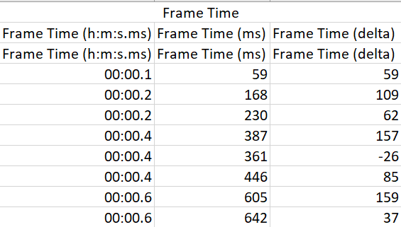
Figure 2-1 Data Sample
Table 2-1 Test Data Types
Data Number | Data Name | Data Number | Data Name
1 | Frame Number | 2 | Forward Acceleration
3 | Lateral Acceleration | 4 | Vehicle Roll
5 | Vehicle Pitch | 6 | GPS Latitude
7 | GPS Longitude | 8 | GPS Altitude
9 | Horizontal Accuracy | 10 | Vertical Accuracy
11 | GPS Course | 12 | GPS Vehicle Speed
13 | Intake Pressure | 14 | Engine RPM
15 | Vehicle Speed Sensor | 16 | Intake Air Temperature
17 | Setting Min Engine Speed | 18 | Setting Drive Ratio
19 | System Lambda PID | 20 | Setting Max Engine Speed
21 | Setting Fuel Density | 22 | Setting Volumetric Efficiency
23 | Setting Fuel Tank Capacity | 24 | Trip Computer Calculations
25 | Setting Wheel Circumference | 26 | Setting Engine Displacement
27 | Setting Shift Point | 28 | Setting Speed Correction Coefficient
29 | System Pressure PID | 30 | Setting Stoichiometric AFR
31 | Setting CO₂ Content | 32 | Fuel Economy/Consumption
33 | System Mass Air Flow PID | 34 | Shifting Speed Zones
35 | Returns True | 36 | Using Lambda
37 | Using Mass Air Flow | 38 | Using Manifold Absolute Pressure
39 | Corrected Vehicle Speed | 40 | Calculated Fuel Flow
41 | Instantaneous Fuel Consumption | 42 | Fuel Consumed per Trip
43 | Distance Travelled for per Trip | 44 | Trip Time Stats per Trip
45 | Number of fill-ups per trip | 46 | Max and Average Trip Fuel Flow
47 | Max and Average Trip speeds | 48 | Max and Average Trip Boost and Vacuum
49 | Max and Average Trip RPMs | 50 | Number of Stops per Trip
51 | Distance Travelled per Trip | 52 | Volume of fuel consumed per trip
53 | Average fuel economy and consumption for past periods | 54 | Boost Pressure Estimation
55 | Current and Suggest Shift | 56 | Current Acceleration Based on the Last Two Speeds
57 | Average Fuel Consumption per Trip | 58 | Calculated Engine Power
59 | Acceleration Expressed as g (gravity) | 60 | Average Fuel Economy and Consumption per Trip
61 | Trip Gear Statistic | 62 | CO2 Emission Calculations per Trip
63 | Manage Values Displayed on Fill-up Dashboard | 64 | Calculated Engine Torque
65 | Fuel Cost per Trip | 66 | Fuel Price
67 | Fuel Consumption Correction Factor | 68 | Max Trip Power
69 | Max Forward and Braking Trip Acceleration | 70 | Max Trip Torque
From Table 2-1, there are 70 types data output from the software. The data with IS unit about acceleration, time, speed, GPS, fuel, torque is the one that can be used in analysis work. Honestly, for the data recorded according to the timestamp, author doesn’t know and find how to use it, but it seems like useless. Vehicles’ parameters are shown in Table 2-2, just useful data are shown .
Table 2-2 Vehicles Parameters
Parameter | TOYOTA AYGO (TOYOTA) | Triumph Tiger 800XC (Triumph) | V40 Cross Country (Volvo, 2019)
ENGINE
Type | 1.0-litre VVT-i | - | Turbodiesel
Configuration | 3-cylinder, in-line | Transverse 3-cylinder | 4-cylinder, in-line
Displacement (cc) | 998 | 799 | 1969
Bore x stroke (mm) | 71x84 | 74x61.9 | 82x93.2
Compression ratio | 11.5:1 | 12.0:1 | 16.0:1
Max power (kw) | 51@6000rpm | 69.1@9300rpm | 88@3750rpm
Max torque (Nm) | 95@4300rpm | 79@7850rpm | 280@2280rpm
CO₂ | 97g/km | - | 101g/km
Valves | 4/cylinder DOHC  Chain Drive | 4/cylinder DOHC | 4/cylinder DOHC
BRAKES | Front: Discs  Rear: Drums | Front & Rear: Discs (Switchable ABS) | ABS with EBD and EBA.  Distance (100-0km/h): 37m
TRANSMISSION | 5-speed/automated manual | 6-speed | M66F/AW TF-71SC
PERFORMANCE
Max speed | 99mph | 122/196.3 km/h | 190km/h
0-62mph acceleration (s) | 14.2 | Standing ¼ Mile: 12.2 | 0-100km/h: 10.6
Fuel CONSUMPTION
Combined (mpg) | 68.9/4.1L/100km | 44.2/5.3L/100km | 3.9L/100km
WEIGHT
Gross vehicle weight (kg) | 1240 | 214.5kg | 1970-2055kg
INTERIOR DIMENSIONS
Interior length | 1630mm | 2215mm | -
Interior width | 1250mm | 795mm | -
Interior height | 1205mm | 1350mm | -

Comparation
From 3 vehicles setting specifications, there are several differences between them. Pictures shown below also show the difference that the Tiger 800XC is motorcycle but rest are passenger vehicles. Therefore, only the comparation analysis of engine can be carried out between these 3 vehicles, obviously, others between TOYOTA AYGO and V40 Cross Country.
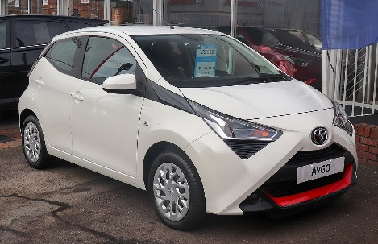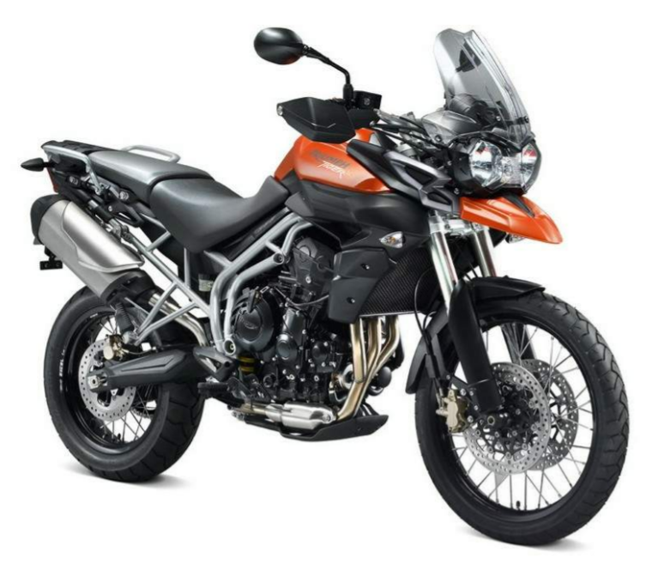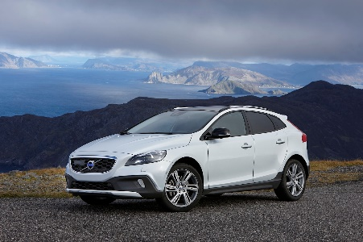
Figure 3-1 3 Vehicles (Left): TOYOTA AYGO (TOYOTA, 2020);(Middle): Triumph Tiger 800XC (Triumph); (Right): V40 Cross Country (Volvo, 2020)

3.1 Engine and Vehicle Performance
Firstly, V40 has the largest engine displacement, meaning a largest power. Of course, it has the largest setting power. However, it’s unreasonable to compare their ability just by these data. Therefore, author decides to use parameter power-per-litre to evaluate the power performance. Power-per-litre is the maximum effective power obtained from 1 litre of the cylinders of an internal-combustion engine, which is a key characteristic of the engine (entsiklopediya, 1979). 3 engines power-per-litre are shown in Table 3-1.
Table 3-1 Power-per-litre
 | TOYOTA AYGO | Triumph Tiger 800XC | V40 Cross Country
Power | 51kw@6000rpm | 69.1@9300rpm | 88@3750rpm
Displacement (cc) | 998 | 799 | 1969
Power-per-litre(kw/L) | 51.1 | 86.5 | 44.6
The results show that the Triumph has the most powerful engine (86.5kw/L). What’s more, it’s hard to determine whether engine provide the all power in the ‘Drive Circle’. Hence this characteristic can only be compared in terms of the setting data. In addition, here comes a similar parameter, power-to-weight ratio, which shows the capacity of whole vehicle not just engine. The results are shown in Table 3-2.
Table 3-2 Power-to-weight Ratio
 | TOYOTA AYGO | Triumph Tiger 800XC | V40 Cross Country
Power | 51kw@6000rpm | 69.1@9300rpm | 88@3750rpm
Weight (kg) | 1240 | 214.5 | 1970-2055
Power-to weight Ratio (kw/t) | 41.1kw/t | 322kw/t | 42.8-44.6kw/t
From these two evaluation criteria, 800XC has the most powerful engine, AYGO and V40 are in the same high level. As for testing and setting power shown in Figure 3-2 and Table 3-4, expect V40, other two engines doesn’t take full use of their power. In other words, this driving circle doesn’t have high requirement about power. General engine can perform well in this environment. What’s more, there is also some problem in Volvo specifications because only this one output max power though it’s a powerful engine.
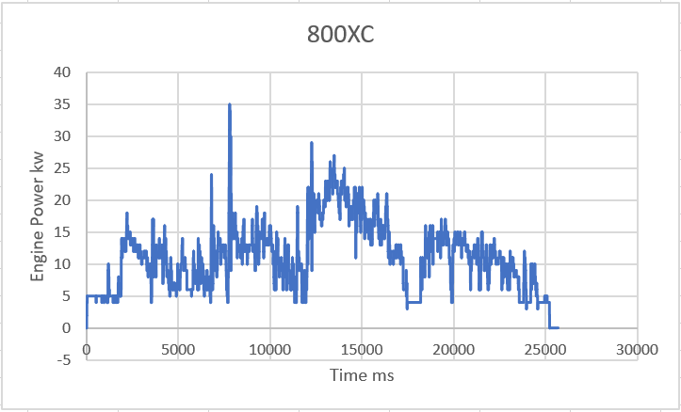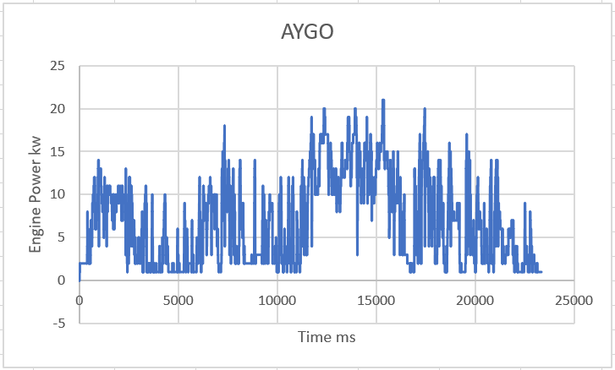
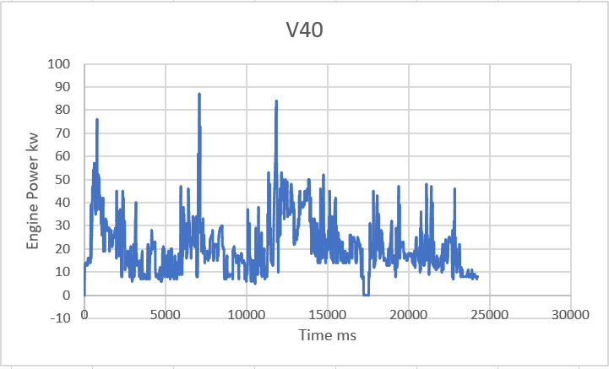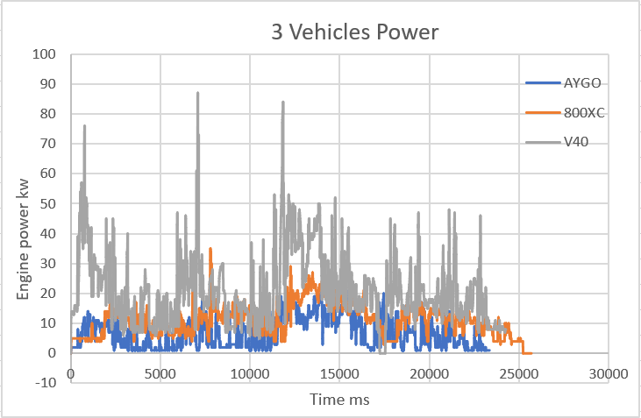
Figure 3-2 3 Vehicles’ Power
Table 3-3 3 Vehicles’ Power
 | TOYOTA AYGO | Triumph Tiger 800XC | V40 Cross Country
Testing Value/kw | 21 | 35 | 87
Setting Value/kw | 51 | 69.1 | 88
In addition, output torque is proportional to the engines’ displacement. Larger torque it’s a kind of guarantee of the engine to afford the load. There is only engine load value in AYGO test data, hence, it’s impossible to compare the engine load. Engine load, also called load rate, is defined as the rate of torque at part of the throttle with the maximum torque at full throttle at the same rpm. AYGO’s engine load are shown in Figure 3-3, AYGO: Max engine load:95.3%, Max Torque:78.9Nm. The load is distributed between 11.4% to 95.3%. Engine working in high load can improve the fuel economy, but too high rate reducing the service life. What’s more, the testing max and setting values are shown in Table 3-4.
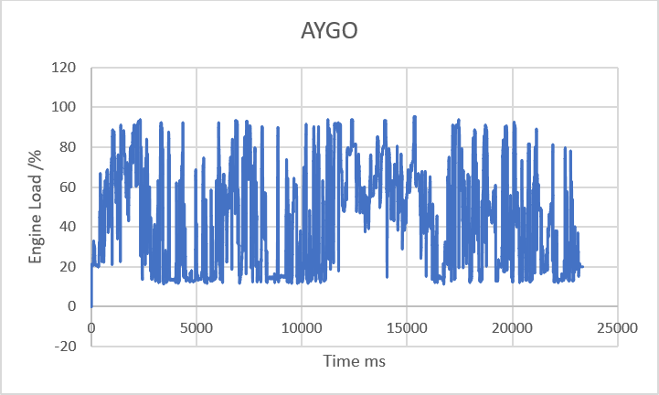
Figure 3-3 AYGO’s Engine load
Table 3-4 3 Vehicles’ Torque
 | TOYOTA AYGO | Triumph Tiger 800XC | V40 Cross Country
Testing Value/Nm | 78.9 | 51.4 | 335.5
Setting Value/Nm | 95 | 79 | 280
V40’s test value exceeds the testing value, meaning its power is not enough or the setting value is not correct. However, 800XC’s max torque is much lower than the settings. AYGO’s testing value and setting value are close. In other words, AYGO is the most suitable one for this driving circle because it can take full use of engine’s characteristics in the circle.
V40 needs a high compression ratio because of its ignition method: pressure burns style (no sparks). For other two petrol engines, 800XC has a larger ratio, which results in a better power, but also the risk of knock. Hence, this engine maybe a more expensive device.
Generally, 3 evaluation parameters are used to evaluate vehicles dynamics. (Yu, 2019):
Vehicles maximum speed
Vehicles acceleration time
Vehicles maximum gradeability
Though there are 3 parameters, max speed can reflect vehicles’ ability of acceleration and climbing. Hence, it’s fair to compare the dynamics by max speed only. 800XC has the highest speed (193.2km/h), then comes V40 (190km/h) and AYGO (159.3km/h). Absolutely, 800XC has a powerful engine. Its triple design combines good-performance and real-world usability, which means it has both some lovable Twin torque and almost the best thrill of an Inline-Four (Triumph). In the real drive test, three vehicle max speeds are 113km/h, 117km/h and 121km/h (using GPS vehicle speed and ‘MAX’ function in EXCEL), showing on one release its whole performance. Therefore, every engine meets the requirement about speed in this drive circle, which gives an advice to further work. What’s more, there is an interesting phenomenon: starting time(speed>0) are 4262ms, 361ms and 3870ms respectively. From the data, motorcycle has the best flexibility, which is a crucial parameter in some environment, especially the urban area.
There is another small difference in the transmission that is not recorded in Table 2-2. Both AYGO and V40 has two types transmission, which results in the difference in their performance (shown in Table 3-5). However, there is also little difference of performance. Therefore, author thinks it’s not reasonable to make a conclusion which one is better.
Table 3-5 Different Transmissions
Vehicle | TOYOTA AYGO |  | Triumph Tiger 800XC
Transmission | 5-speed manual | x-shift | M66F | AW TF-71SC
Max Speed | 99mph | 99mph | 190km/h | 190km/h
Fuel Consumption | 68.9mpg | 67.3mpg | 3.7L/100km | 3.9L/100km
CO₂ | 95g/km | 97g/km | 96g/km | 101g/km
0-100km/h acceleration | 14.2s | 15.5s | 10.6s | 10.6s
In addition, safety is also a key parameter of the vehicle. Judging by their braking devices, V40 has better performance on braking absolutely.

3.2 CO₂ and Fuel Consumption
UK has announced a ban to achieve zero emissions by 2035 (Williams, UK government pulls the plug on hybrids as it sets 2035, 2019) (expect motorcycles (Williams, Motorcycles in 2035, 2019)), giving a signal that the CO₂ content is a significant parameter. 2 vehicles CO₂ content is 97g/km and 101g/km respectively. The greenhouse effect has caused great damage to the global environment. Hence, it can’t wait to reduce the CO₂ production by several alternating sources like electric ad hydrogen. For passenger vehicles, EU regulation 443/20009 set the 95 grams CO₂ emissions target, which will apply from 2021 (Peter Mock, 2014). Hence, AYGO and V40 are not good enough. And it seems that there are not available data in the drive circle, so author doesn’t compare them.
The fuel consumption it’s another parameter under the environment of energy conservation and emission reduction. It also reflects vehicles fuel economic because the fuel prices are same 3.5. Setting specifications are 4.1L/100km, 5.3L/100km and 3.9L/100km respectively. However, these data may can’t reflect the fuel consumption in this drive circle. Hence author needs to calculate it (use ‘Volume of fuel consumed since last fuel consumption reset’ and ‘Distance travelled since last fuel consumption reset’), and the results are shown in Table 3-6.
Table 3-6 Fuel Consumption
 | TOYOTA AYGO | Triumph Tiger 800XC | V40 Cross Country
Fuel Volume | 1.4L | 2.6L | 4.4L
Travel Distance | 30.9km | 31.2km | 30.7km
Real Fuel Consumption | 4.5L/100km | 8.3L/100km | 14.3L/100km
Set Fuel Consumption | 4.1L/100km | 5.3L/100km | 3.9L/100km
From the results, only AYGO’s settings provide the correct fuel consumption. What’s more, AYGO’s fuel consumption are shown in a different way, shown in Figure 3-4.
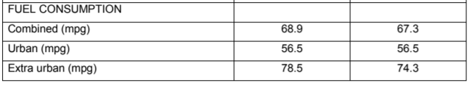
Figure 3-4 TOYOTA AYGO’s Fuel Consumption Specification
AYGO’s total fuel consumption are combined with urban and extra urban data, which looks like more reasonable. In the Europe, New European Driving Cycle (NEDC) are used to measure and evaluate vehicles’ fuel economy. NEDC is consist of four repeated ECE-15 urban driving cycles in first 780s (UDC) and one Extra-Urban driving circle from 780 to 1180s (EUDC) (UNECE, 1997). The driving circle diagram is shown in Figure 3-5 (WIKIPEDIA, 2020). It seems that AYGO’s fuel consumption is measured under this cycle. And the fuel consumption targets are shown in Table 3-7 (Yu, 2019).
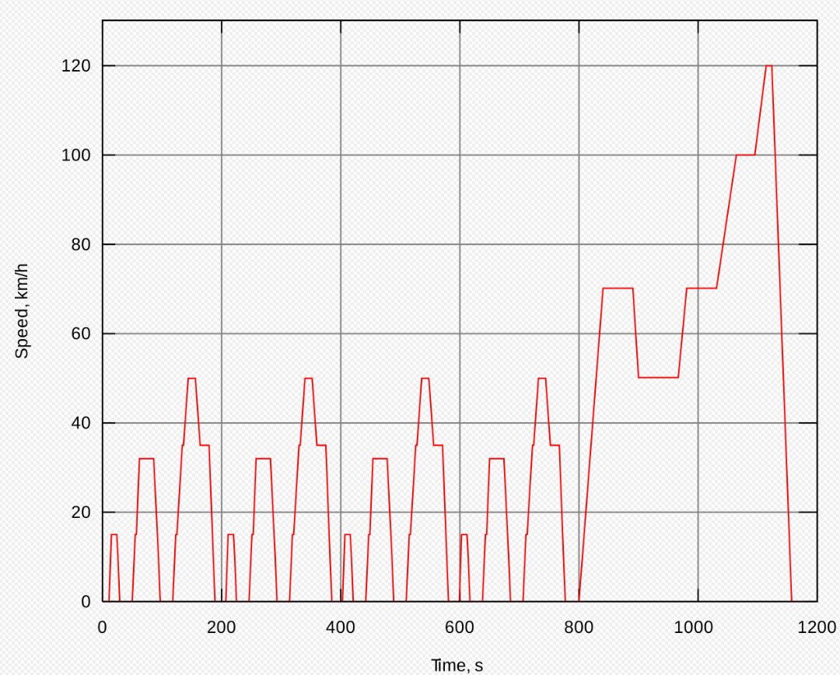
Figure 3-5 NEDC Diagram
Table 3-7 Fuel Consumption Targets
 | 2015 | 2020 | 2025
Target (L/100km) | 5.2L/100km | 3.8L/100km | 3L/100km
For 3 vehicles, the setting data shows that they have met 2015’s target. However, the test data in this study tell the other truth. Hence, author decides to plot their driving circle diagrams (vehicle speed-time) to judge the accuracy and validity of the specification data, which are shown in Figure 3-6.

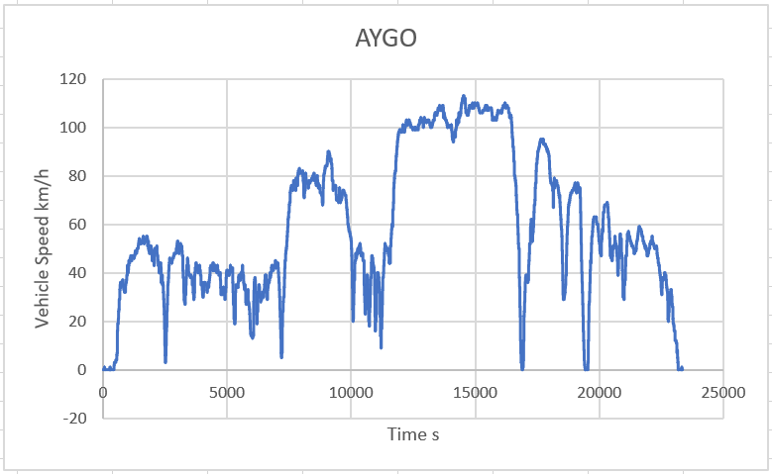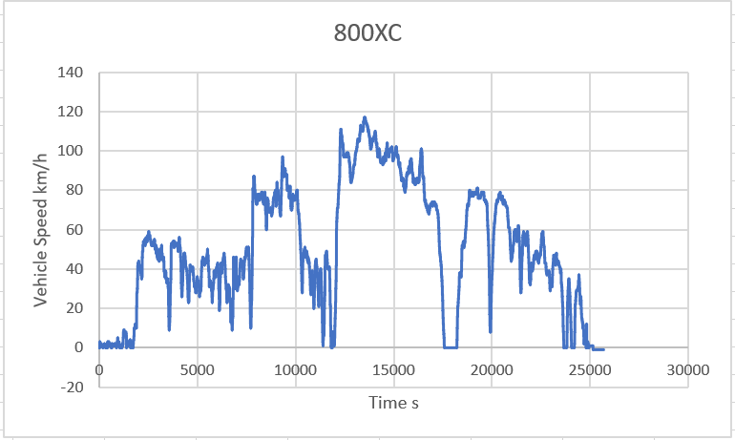
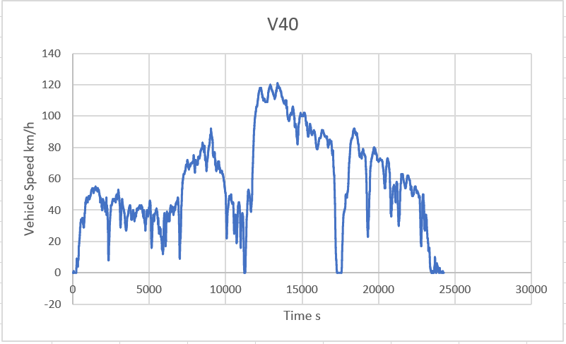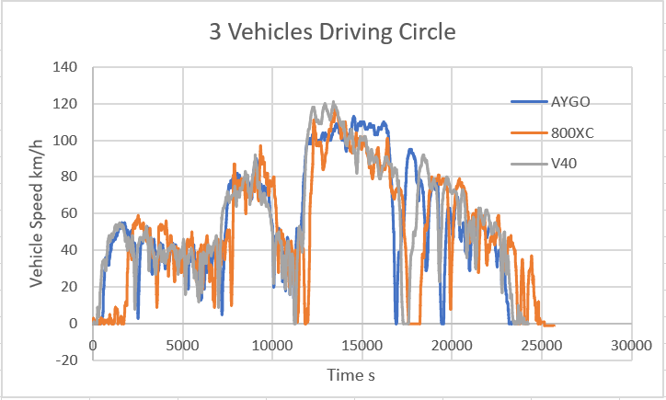
Figure 3-6 3 Vehicles Driving Circle Diagrams (EXCEL2016, 2016)
3 vehicles curves are in the same trend, which is similar to the NEDC. Hence, it’s reasonable to make a conclusion: only AYGO put the correct fuel consumption in the specifications. At same time, the data processing work has finished. The necessary are:
Frame Time (ms)
GPS Vehicle Speed
CO2 content derived from the 'Fuel type' vehicle setting
Distance travelled since last fuel consumption reset
Volume of fuel consumed since last fuel consumption
Fuel price entered at last fill up
Absolute Load Value
Trip torque stats; Max
Calculated engine power

Ideal Vehicle
Generally, these 3 vehicles can work normally under current vehicle standards and circumstances. However, with the development of technology and more and more strict standards, vehicle engineers should upgrade vehicles devices. In this part, author will add some new technologies based on the TOYOTA AYGO, which has a relatively good performance and precise setting value in this driving circle.

4.1 Hybrid/Electric/Hydrogen Vehicles
As mentioned previously, UK government is going to realize the zero-emission target by 2035. Therefore, AYGO should find an alternative energy sources like electric or hydrogen. What’s more, it’s impossible to replace the internal combustion engine directly from the point of vehicle industries. For example, only in 2019, there are 2.3 million vehicles registered in UK (65% are petrol and 25% are diesel) (Williams, UK government pulls the plug on hybrids as it sets 2035, 2019). At this time, hybrid vehicle is applied in the transition period.
Unlike normal vehicles, hybrid vehicle has two power sources: an internal combustion engine and an electric motor. This structure not only increase the economy, but also decrease the production of CO₂ by switching between pure electric power at low speed and engine power at high speeds. Figure below shows the components of a TOYOTA’s petrol hybrid vehicle. The engine and electric motor only work together during heavy acceleration, and during the normal cruising braking, engine can also power the generator to store electricity in battery for later use. What’s more, TOYOTA hybrid vehicles using a clever system named ’regenerative braking’ to recycle the energy when the drive brakes or step on the gas, which seems to be a clever technology. And there are 11 types self-charging and plug-in hybrid TOYOTA productions, which is a little figure compared with the normal cars (TOYATO, 2020). What’s more, hybrid won’t exist long because of the strict ban, though it never has a good market.
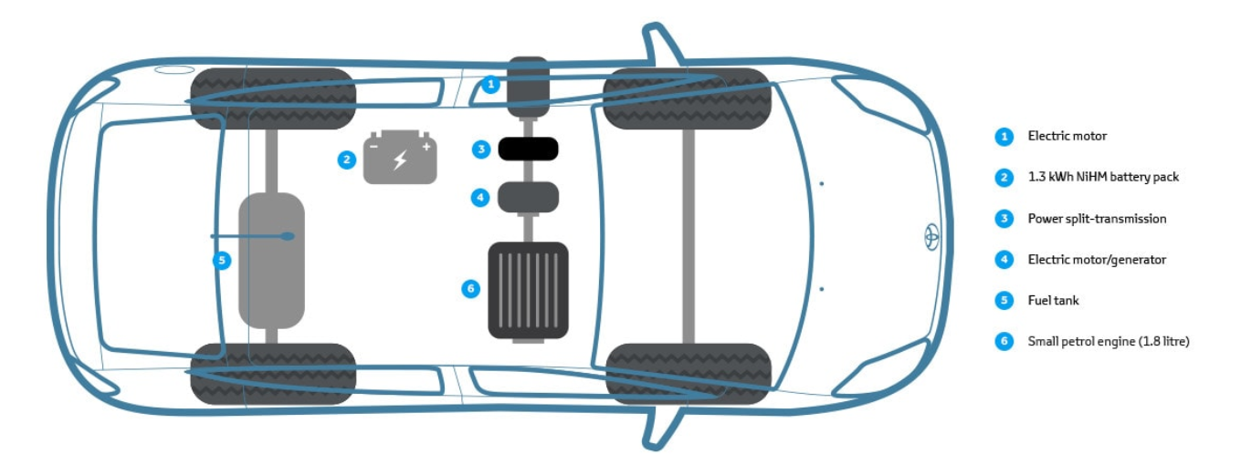
Figure 4-1 TOYOTA Hybrid Vehicle Components
Judging by nowadays sources research, electric and hydrogen have the biggest likelihood to be widely used just like fossil energy in 2035. What’s more, maybe in the future, nuclear power will become a normal energy, human can control and use it perfectly. However, that must be a long time because many factors can impact its growth like politics, safety and expense.
Electric vehicle (EV) powers are from one or more electric motors or traction motors. An electric vehicle can be powered by a battery, solar panels or fuel cells, also through a collector system by electricity from off-vehicle sources (Faiz, Weaver, & Walsh, 1996). Figure below shows the components of the electric vehicle (Johnson, 2014).
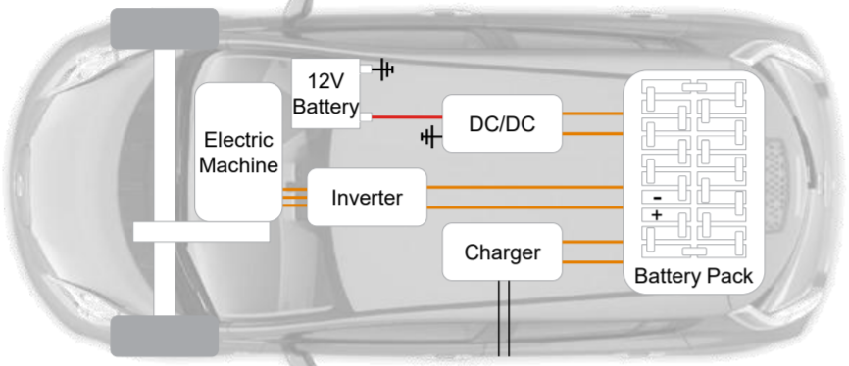
Figure 4-2 EV’s Components
Compared with the normal fossil fuel engines, EV release no tail pipe air pollutants and lower noise pollution when working. Absolutely, using of EV will create a huge net environmental benefit. In other words, EV has a gift to match UK’s ban. Motors are simple mechanically and provide a high energy conversion efficiency (90%), also support the vehicle to work quietly and smoothly (WIKIPEDIA, 2020). What’s more, electric vehicles are thought has lower performance and shorter range, hence author find some Tesla EV specifications shown in Table 4-1. Surprisingly, EV has an excellent performance and long range. However, the price is also ‘excellent’, and not every family can afford such an expensive transportation tool. It’s a key factor that should be taken into consideration when government pushes the revolution.
Table 4-1 Tesla EV’s Specification
Model  Name | Type | Range (WLPT)/mi | Top Speed/mph | Acceleration 0-60mph/s | Price/Pound
Model S | Long Range | 379 | 155 | 3.7 | 81200
Model S | Performance | 367 | 162 | 2.4 | 95800
Model 3 | Standard | 254 | 140 | 5.3 | 39500
Model 3 | Long Range | 348 | 145 | 4.4 | 46990
Model 3 | Performance | 329 | 162 | 3.2 | 55500
Model X | Long Range | 314 | 155 | 4.4 | 86200
Model X | Performance | 301 | 155 | 2.7 | 100400
Model Y | - | 298 | 150 | 3.5 | -
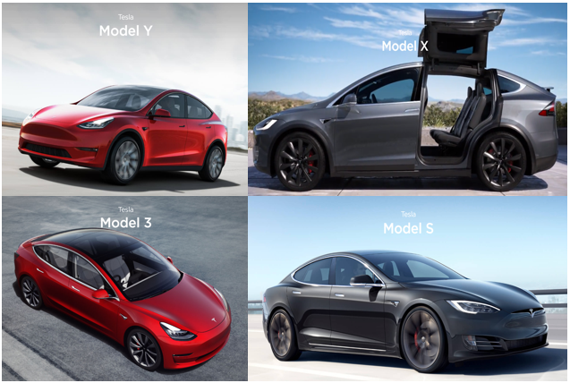
Figure 4-3 Tesla EV’s
Hydrogen vehicles are vehicles that use hydrogen as the fuel. And there are two types vehicles: one burns hydrogen in an internal combustion engine and another one converts chemical energy in hydrogen into mechanical by electrochemical reaction (WIKIPIEDIA, 2020). First type vehicle can simply convert petrol engine to use hydrogen, second type’s structure are shown in Figure 4-4 (BMW, 2020). In the hydrogen fuel cell, energy directed into battery and electric motor are generated by the reaction. What’s more, the efficient of engine running on hydrogen is 25%, which is even lower than running on petrol. However, it can give 60% efficiency when put into electric motor. Hence, using hydrogen fuel cell is a wiser decision (Williams, Hydrogen fuel cells: is it the future for motorbikes?, 2020). Hydrogen cell electric vehicle (HCEV) doesn’t have the problem of emissions because the only emission is H₂O. And the hydrogen is easy to get. Though the energy from 1kg hydrogen (142 megajoules) is bigger than from 1 kg petrol (46 megajoules), the power-per-litre is too low. In addition, storage and transportation of the hydrogen, and the energy cost in the process of production are the shortages of this technology. In the reality, though HCEV is not in mass production yet, some companies like HYUNDAI has designed some tester, and the performance is shown in Table 4-2 (HYUNDRI, 2020). Also, HCEV has good performance and the price is not too high, which is a respect that is better than EVs.
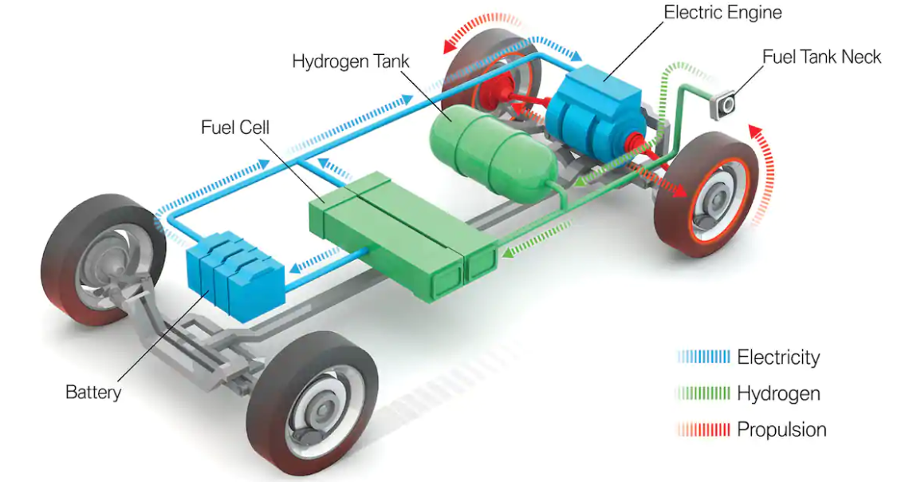
Figure 4-4 Hydrogen Vehicle Structure
Table 4-2 HYUNDAI HCEV NEXO’s Performance
Parameter | NEXO
Top Speed (km/h) | 177
Max Torque (Nm) | 395
Single Charge Time (min) | 5
Acceleration 0-100km/h (s) | 9.2
Purchase Price (dollar) | 27014
Max Range (based on Korean combined fuel economy)/km | 609
Compared above 3 vehicles technology characteristics, EV seems to be an ideal tool.

4.2 Stop-stars
In the NEDC, 25% of the circle is spent addling, which results in an extra fuel consumption. And in nowadays urban area, lots of fuel is cost under addling because of the crowed and complex traffic. There is no doubt that this condition should be improved, and new technology stop-stars can provide help. When vehicle is running, stop-start systems will shut down and restart the engine automatically to reduce engine idling time, reducing the fuel consumption (WIKIPEDIA, 2020). This technology is first used on a Bentley, and help it achieve the 13.1L/100km fuel consumption and 296g/km emissions based on NEDC.

4.3 KERS
In the reality, most energy released from fuel combustion has been wasted in several forms. Kinetic energy recovery system (KERS) is a system used to recover the energy when the vehicle is braking. The energy is stored in a reservoir like battery or flywheel, and the working diagram is shown in Figure 4-5. There are some advanced systems designed for Formula One racing like Zytek, Flybrid, Torotrak and some simple system designed for passenger and commercial vehicles like CPC-KERS. This technology was firstly applied in F1 race car. In the public transportation, it’s firstly applied on London’s bus and anticipated to make the fuel efficiency 20% up (WIKIPEIDA, 2020).
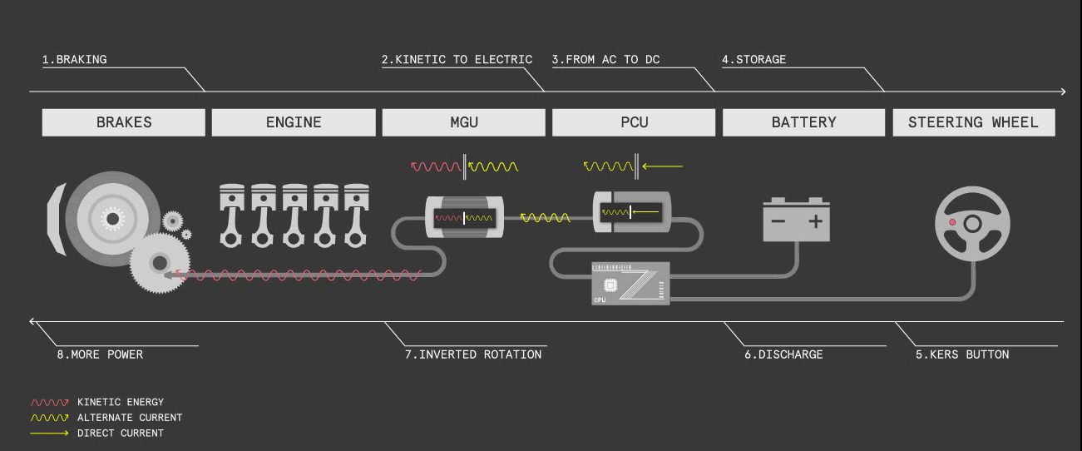
Figure 4-5 KERS Working Diagram

4.4 Self-Driving
Self-driving car, also known as autonomous vehicle (AV), is a car that is able to move and sense surrounds with no or little human input. Several sensors like radar, GPS, odometry are used to sense its environments. In addition, advanced control systems are used to identify sensors information to distinguish relevant signals and road carriers, then choosing an appropriate guide way (O'Toole, 2010) (Macdonald, 2011). Driverless can reduce the incidents caused by human error efficiently, also reducing labour costs. What’s more, being controlled by ECU makes the traffic much easier to control and more harmonious, also increasing the fuel economy. And the degrees of driving automation are defined from level 0 (The automated system issues warnings and may momentarily intervene but has no sustained vehicle control) to level 5 (No human intervention is required at all. An example would be a robotic taxi that works an all roads all over the world, all year around, in all weather conditions) (SAE, 2018). From 19 October 2016, Tesla implement hardware building to match SAE level 5 (most safe). The hardware includes forward-facing radar, eight surround cameras and 12 updated ultrasonic sensors, which is shown in Figure 4-6 (Tesla, 2020). Eight cameras provide visibility in 360 degrees at the range of 250 meters around the vehicle. Twelve updated ultrasonic sensors are able to detect hard and soft objects in this range. One forwarded facing radar with the ability of improve processing provides more information about around environment on a redundant wavelength, which is available in any severe weather and crowded traffic (Tesla, 2020).
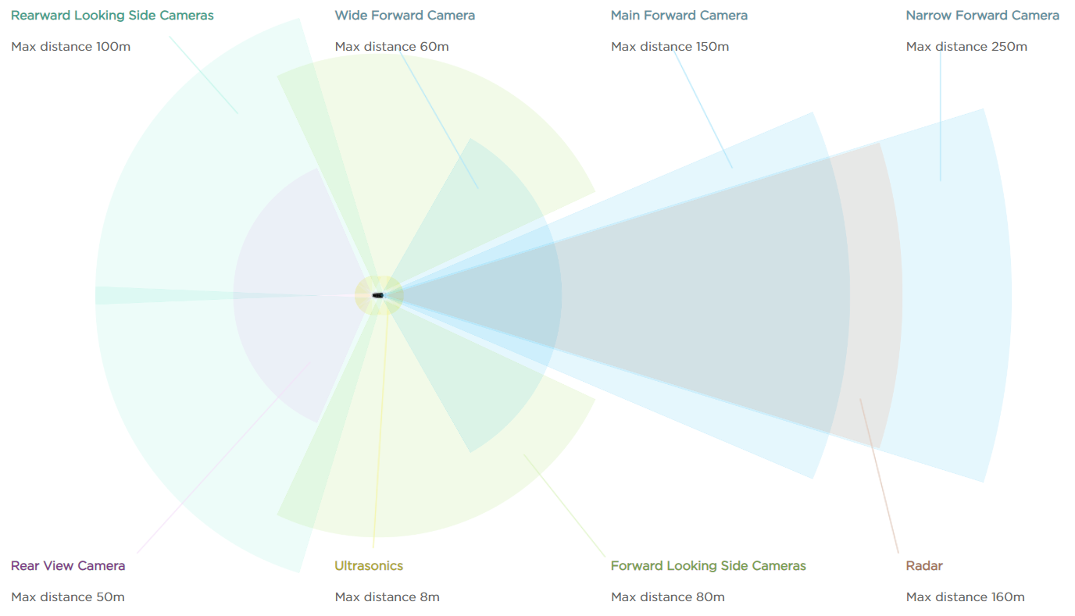
Figure 4-6 Tesla Self Driving Vehicle Hardware

4.5 ABS/EBD
Strictly, ABS and EBD are not very new technology. However, they are most useful braking assist systems currently. Because safety is the most important thing of a production, author still gives a brief introduction of these two technologies. ABS (Anti-lock braking system) can avoid wheel lock-up and vehicle out of control by distributing the braking force of four wheels. As ABS’ subsystem, using with ABS while braking, the function of EBD is putting appropriate barking force to maintain ESC (electric stability control) work normally (WIKIPEDIA, 2020).

Specifications
In this part, author will set specifications for a vehicle running in this driving circle. What’s more, this vehicle should be economically and politically viable for the 2028 production. All specifications will be set based on previous analysis and research results.
Firstly, power type needs to be determined. In 2028, though governments’ ban become stricter, it’s still in a transition period. Hence, the best choice is hybrid vehicle, which not only reduce the emission but also take care of vehicle companies’ interests. For 3 testing vehicles, TOYOTA AYGO is most suitable for this drive circle, which will become the basis of the 2028 production.
From the 1st of September 2019, all passenger cars and light commercial vehicles in the EU must abide by the WLTP (world harmonized light-duty vehicles test procedure) standards, which is considered more reasonable than NEDC (UNECE, 2020). For passenger vehicles, the CO₂ target set for 2021 is 95g/km, which is updated to 67g/km in 2025 and 50.5g/km in 2030 found from ICCT’s chart (ICCT, 2019). What’s more, the fuel consumption in 2028 is updated to 3.42L/km found from ICCT’s chart (ICCT, 2019).
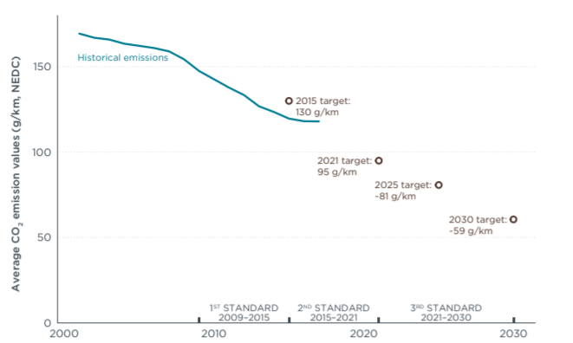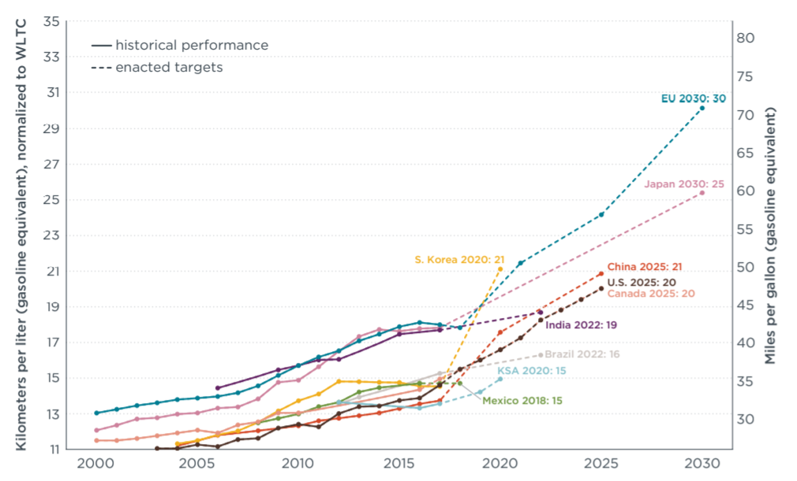
Figure 5-1 (Left) EU CO₂ Emission Standards; (Right) Fuel Consumption Standards
What’s more, the specifications of TOYOTA’s hybrid vehicle YARIS are shown in Table 5-1 (TOYATO, 2020).
Table 5-1 TOYATO YARIS Specifications
Vehicle | YARIS Hybrid
Fuel consumption (WLTP)
Combined (L/100km) | 5.8
ENGINE
Type | 1.0-litre VVT-i
Configuration | 3-cylinder, in-line
Displacement (cc) | 998
Bore x stroke (mm) | 71 x 84
Compression ratio | 11.5:1
Maximum torque (Nm @rpm) | 95@4300-6000
Maximum output (kw @rpm) | 51@6000
CO₂ (NEDC equivalent)
Combined driving (g/km) | 107
Battery
Hybrid vehicle battery: type | Nickel-metal hydride
Hybrid vehicle battery: capacity Ah (hr) | 6.5
Electric Motor
Type | Permanent magnet synchronous
Maximum output (kw) | 45
Maximum torque (Nm) | 169
Performance
Maximum speed (km/h) | 162.5
Acceleration 0-100 km/h (sec) | 15.3
Total hybrid system combined output (kw) | 100
YARIS some specifications can’t meet 2028 standards, but specifications still can be determined using YARIS as a basis. Driving cycles like NEDC and WLTP are set to control the CO₂ emission and fuel consumption. Hence, in this 30km driving circle, CO₂ emission and fuel consumption are key parameters. As for engine performance, nowadays engine can work appropriately in this circle. According to the testing data, max speed and engine output power don’t need to set too high, reducing the fuel consumption and cost. Therefore, the battery can also be decreased at the same time. And the 0-100km/h acceleration time don’t need to change.
With the development of technology and hardware, the self-driving circle vehicles maybe available at 2028 at an affordable price. At same time, the traffic accidents, traffic jams can also be reduced significantly. Especially in complex environment like this driving circle, vehicles will have better performance if controlled by the control systems capable of analysing sensory data in order to provide accurate detection of other vehicles and the road ahead (Zhu, Miao, Hu, & Qing, 2014). Of course, 5-speed shift and ABS, EBD are also important specifications.
Hence, the specifications for 2028 based on previous analysis are shown in Table 5-2:

Table 5-2 2028 Vehicle Specifications
Specifications 2028 | Value
CO₂ emissions | 50.5g/km (ICCT’s targets)
Fuel consumption | 3.42L/km (ICCT’s targets)
Operation | Self-driving (Based on Tesla systems)
Vehicle type | Hybrid Vehicle (Based on UK’s ban)
Max output speed | 150km/h (Based on testing and YARIS data)
Max output power | 70kw (Based on testing and YARIS data)
Max output torque | 95Nm (Based on testing and YARIS data)
Acceleration 0-100km/h | 15.5s (Based on YARIS and AYGO data)
Brakes | Front discs, rear drums with ABS and EBD (Base on AYGO)
Transmission | 5-speed/automated manual (Based on AYGO data)
Battery capacity Ah (hr) | 6.5 (Based on YARIS data)
Motor output power | 38kw (Decreased)
Motor output torque | 140Nm (Decreased)

Conclusion
In this report, study is carried out about 3 vehicles in these respects: test and setting data processing, vehicle performance comparation based on data processing results, ideal vehicle building by applying new technologies, specifications setting for 2028 vehicle production. And 3 vehicles are TOYOTA AYGO, Triumph Tiger 8000XC (motorcycle) and V40 Cross Country.
3 test vehicles are applied to a driving circle over 30km distance, including several road circumstances (extra urban, unclassified road, city driving, motorway). The testing data is output from software in two types: CSV and .lfg, and vehicles specifications are also provided. First, only basic processing work is done on the CSV file.
Next, vehicles comparation work. Initial analysing work is based on the parameters provided by the company, which is the basis of the test data processing. Through analysing power-per-litre, max speed and torque according to setting value, 800XC seems to have the most powerful engine. However, the test data shows that the V40’s specification is not precise. In addition, CO₂ and fuel consumption testing value approves that AYGO’s parameters are more precise. Through this process, the data processing work is finished.
Using TOYOTA AYGO as a start, an ideal vehicle is built. New technologies are applied to improve the performance and abide by government ban, including Hybrid, electric, hydrogen, stop-starts, KERS and self-driving. What’s more, company’ advanced vehicles are used to support the analysis like TOYOTA hybrid vehicle, Tesla’s EV, Hyundai’ NEXO.
Finally, specification suitable for the driving circle are determined for 2028 production from a point of the company engineer. Hence, in this drive circle, CO₂ emission and fuel consumption are determined based on the EU’s regulations. And the vehicle type is set as hybrid vehicle. Then, other specifications are set based on TOYOTA YARIS hybrid vehicle’ characteristics.

Reference
BMW. (2020, 3 17). Hydrogen fuel cell cars: everything you need to know.
entsiklopediya, B. s. (1979). The Great Sovient Encyclopedia.
EXCEL2016. (2016).
Faiz, A., Weaver, C. S., & Walsh, M. P. (1996). Air Pollution from Motor Vehicles: Standards and Technologes for Controlling Emissions. World Bank Publication.
HYUNDRI. (2020, 3 22). All-New NEXO. Retrieved from www.hyundri.co.uk.
ICCT. (2019). CO2 Emission Standards For Passenger Cars an Light-commercial Vehicles in European Union.
ICCT. (2019). JAPAN 2030 FUEL ECONOMY STANDARDS.
Johnson, N. (2014, 1 29). Introduction to EV Powertrain Function and.
Macdonald, I. D. (2011). A Simulated Autonomous Car.
O'Toole, R. (2010). Gridlock: Why We're Stuck in Traffic and What To Do About It.
Peter Mock. (2014, 1 17). EU CO2 standards for passenger cars and light-commercial vehicles.
SAE. (2018, 7 1). Automated Driving-Levels of Driving Automation are defined in New SAE international Standard J3016. SAE international.
Tesla. (2020, 3 20). Future of Driving. Retrieved from www.tesla.com.
TOYATO. (2020, 3 20). TOYOTA Hybrid Cars. Retrieved from www.toyota.co.uk.
TOYATO. (2020). YARIS Hybrid Brochure.
TOYOTA. (2020, 3 16). Retrieved from www.toyota.co.uk.
TOYOTA. (n.d.). TOYOTA AYGO TECHNICAL SPECIFICATIONS.
Triumph. (n.d.). Triumph Tiger 800XC Specifications.
UNECE. (1997). UN Vehicle Regulations - 1997 Agreement.
UNECE. (2020, 3 21). Worldwide harmonized Light vehicles Test Procedure (WLTP). Retrieved from unece.org.
Volvo. (2019, 1 28). 2016 V40 Cross Country - Technical Data - Volvo Car Group Global Media Newsroom.
Volvo. (2020, 3 16). Retrieved from www.volvocars.com.
WIKIPEDIA. (2020, 3 20). Electric Vehicle. Retrieved from en.wikipedia.org.
WIKIPEDIA. (2020, 3 20). Electronic brakeforce distribution. Retrieved from en.wikipedia.org.
WIKIPEDIA. (2020). New European Driving Cycle.
WIKIPEDIA. (2020, 3 20). Start-stop system. Retrieved from en.wikipedia.org.
WIKIPEIDA. (2020, 3 20). Kinetic energy recovery system. Retrieved from en.wikipedia.org.
WIKIPIEDIA. (2020, 3 20). Hydrogen Vehicle. Retrieved from en.wikipedia.org.
Williams, O. (2019). Motorcycles in 2035.
Williams, O. (2019). UK government pulls the plug on hybrids as it sets 2035. UK.
Williams, O. (2020). Hydrogen fuel cells: is it the future for motorbikes?
Yu, Z. (2019). Automobile Theory.
Zhu, W., Miao, J., Hu, J., & Qing, L. (2014, 3 27). Vehicle detection in driving simulation using extreme learning machine. Neurocomputing.

