
Assessment component 1: Marketing Environment Analysis

Programme Name: Master of Business Administration
Student Name: Delwar Hussen Raju
Student ID: 2506700
Module Name: Marketing Management Module
Code: LCMB7024
Lecturer’s Name: Dr Laila Maazouz (London)
Work Count: 2689
Submission Date: 20 November 2025

Contents
1. Introduction 3
2.1 Macro Marketing Environment Overview. 4
2.2 Two External Macro Marketing Actors Chosen. 6
Technological Factors 6
Environmental Factors 7
2.3 Actor Critical Analysis. 8
A.Technological Actor 8
Figure: Technological Advantage Curve Pioneers vs. Followers in the EV Industry 9
B. Environmental Actor 9
Table 2: Environmental Opportunities and Threats for Tesla (Pioneer) and BYD (Follower) 10
3.1 Pioneering Organisations’ Strategic Responses 10
Ansoff’s Growth Matrix and Tesla’s Strategy 11
Porter’s Generic Strategies and Tesla’s Competitive Position 11
Strategic Implications 12
3.2 Strategic Responses of Follower Organisations. 12
Follower Strategies through Growth Matrix Ansoff. 13
Follower Strategies 13
Critical Assessment 13
4. Conclusion 13
5.References 15

1. Introduction
The market conditions today are very dynamic and organisations have to constantly evaluate their external environments to ensure that they have a competitive advantage. Macro-environmental analysis is the basis of evidence-based decision-making and long-term positioning in strategic marketing management. This report discusses the impact of macro-environmental changes on pioneer and follower companies in the global electric-vehicle (EV) industry, where the high-speed technological change, sustainability, and changing consumer demands are overriding.
Environmental scanning enables managers to predict market turbulence and coordinate strategies with new opportunities and threats (Kotler and Keller, 2022). The PESTEL framework offers an organized approach to evaluating political, economical, social, technological, environmental, and legal forces that influence the strategic results (Makvandi, 2024). In the case of EV leaders like Tesla and BYD, technology advancement and environmental regulation are the strongest forces and they affect the competitive processes, developmental paths, and strategies.
In this regard therefore, this report critically examines the macro marketing environment with a particular focus on the technological and environmental determinants and assesses the reactions of pioneer and follower firms through models like the Ansoff Growth Matrix and Porters Generic Strategies. It will be based on the academic theory and the industry evidence to illustrate the strategic importance of continuous
environmental scanning to maintain a market leadership.
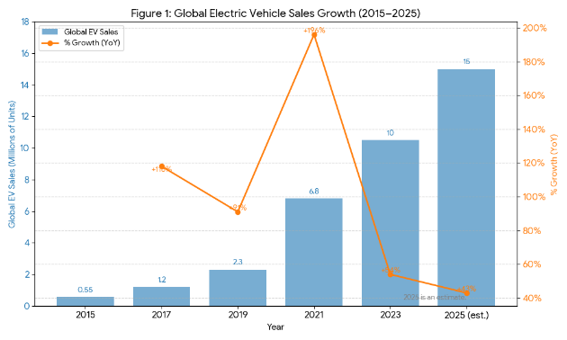
(Source: International Energy Agency [IEA], 2024; Statista, 2024)
As Figure 1 shows, the sale of electric vehicles (EV) has grown by almost twenty times between 2015 and 2023, which is explained by the technological progress and the decreased price of batteries, as well as the introduction of environmental policies.The future prognosis of 2025 supports the fact that technology and sustainability are now the driving factors in automotive strategy, which is able to afford early-mover benefits to companies like Tesla and also provide the scalability opportunities to companies like BYD.

2.1 Macro Marketing Environment Overview.
The macro marketing environment is a set of wide external forces influencing all organisations in an industry and is not much in the control of managers. These forces influence the market opportunities, consumer behaviour and strategic direction (Kotler & Keller 2022). Once managers understand these dynamics in a holistic manner, they are able to predict risks and develop flexible strategies which are sensitive to change.
One of the most popular analytical tools to analyse these influences on six dimensions is the PESTEL model that includes Political, Economic, Social, Technological, Environmental and Legal (Yuksel 2012). It helps the marketer to be aware of external trends that influence the industry performance and competitiveness.
The macro environment has a significant impact on the demand and strategy in the electric-vehicle (EV) industry. The car industry is changing due to the high rate of technological development, growing environmental consciousness, and decarbonisation policies of governments (Zaino et al. 2024). The change in social interests towards sustainability, as well as the unstable state of world economies, also influence the development of EV markets.The following figure shows the macro factors that affect the EV sector in the form of a PESTEL analysis.

Factor | Key Drivers | Impact on EV Industry
Political | The aims and subsidies of carbon neutrality by government. | Promote the use of electric cars by taxes and infrastructure.
Economic | Inflation, battery prices, interest charges. | Influences the cost of production, price, and the affordability of consumers.
Social | Green awareness and behaviour modification. | Raise the level of sustainable transport.
Technological | Innovation in batteries, AI and charging networks. | Motivate product differentiation and operational effectiveness.
Environmental | Resource sustainability and emission. | Establish innovation regulatory pressure and incentives.
Legal | Trade laws and regulations on safety. | They influence international growth and conformity expenses.
Systematic review of these determinants will allow organisations to determine the emerging opportunities e.g. improvements in battery efficiency and threats e.g. disruption in the supply chain or stricter emission regulations. The lessons learned in such an analytical process can be used as a strategic guiding template not only by the front runners in innovation, as in the case of Tesla, but also by later entrants to the market, as in the case of BYD, in determining how to maintain a competitive edge in a dynamically changing market environment.
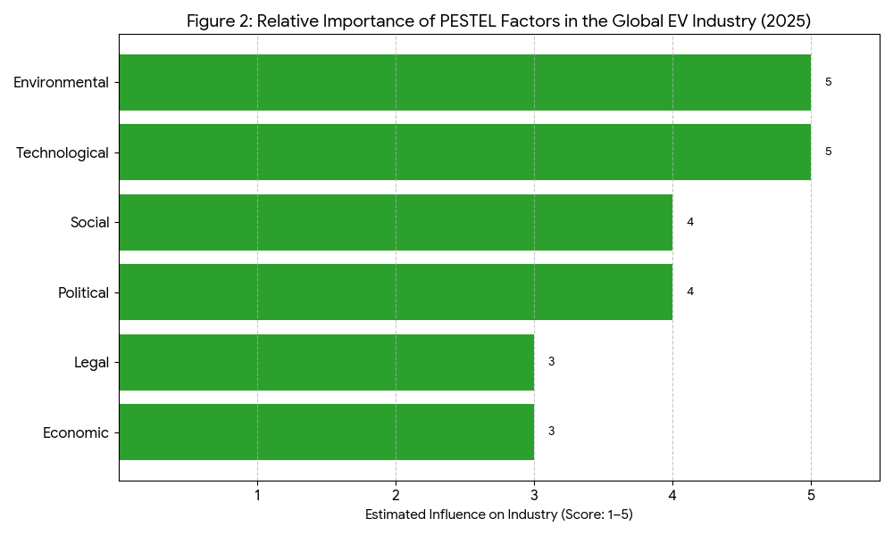
(Source: Adapted from (BIELEWSKI et al., 2024); IEA 2024; European Commission 2023)

Figure 2 demonstrates the two forces rated as 5/5 that include technology and environment and which are the most significant external forces of the EV industry. Technological forces drive innovation in battery chemistry and autonomous capabilities and environmental pressures drive long-term strategic direction, especially decarbonisation targets (European Commission 2023). Both the economic and legal variables have moderate but strong implications on the cost structures and the growth of global markets.

2.2 Two External Macro Marketing Actors Chosen.
The technological and environmental aspects of the EV industry have the greatest and most transformative effect on the industry as compared to the other five dimensions of PESTEL. The forces have been chosen to be analyzed due to their powerful, connected influence on the innovation, cost efficiency, and sustainability as three essential forces of competitive advantage in the industry.

Technological Factors
Technological advances are the key factors that define the pace and trend of development in the EV industry. The developments in battery chemistry, energy density, the growth of charging networks, and the digital connectivity have changed the way that companies develop and generate value. The report by BloombergNEF (2024) states that the average price of battery packs dropped to USD 115 per 1000Wh in 2024, which is a decrease of 9 percent relative to the year before. This price cut has helped innovators like Tesla to gain margins, and imitators like BYD to gain cost competitiveness due to economies of scale. Self-driving cars and artificial intelligence (AI) have also become one of the main differentiators. The examples of Tesla and BYD with Autopilot and DiPilot can show how leaders and followers can use AI to promote brand perception and user experience. The rate of technological adoption also has an impact on strategic responses: first movers have to constantly innovate to remain differentiated, and followers can more easily adopt established technologies with less risk (Grant, 2023).

Environmental Factors
The issue of environmental sustainability has become a regulatory demand and a demand by the consumer. Increasing environmental awareness, tighter emission rules and global net-zero towards the world are accelerating the change to cleaner mobility. The uptake of electric vehicles is one of the key aspects of the Fit for 55 package of the EU, which aims at lowering the greenhouse-gas emissions by 55 percent by 2030 (European Commission, 2023).These policies present both opportunities and challenges to the industry players in terms of green incentives and reputational benefits and also compliance costs, material shortages, and recycling requirements (Statista 2024). The sustainability plan of Tesla focuses on the full life-cycle control with the help of renewable energy, whereas BYD uses the governmental-backed recycling and a very localised Chinese supply chain to decrease the carbon intensity.

Factor | Current Trend (2024–2025) | Opportunity | Threat
Technological | Falling battery costs; AI-based driving systems; smart-grid charging | Innovation leadership; new business models | Short product cycles; high R&D costs
Environmental | Net-zero regulations; consumer eco-awareness; recycling policies | Green incentives; enhanced brand image | Resource shortages; compliance pressure
(Source: BloombergNEF 2024; European Commission 2023; Statista 2024)
The combination of these two macro actors explains a significant share of the structural change that has been experienced in the electric vehicle industry. The technological advancement offers the basis of the greater affordability and performance, but the environmental requirements act to justify and hasten the process of the internal-combustion engine replacement. Taken together, these forces define the strategic environment within which pioneering and following firms are operating.

2.3 Actor Critical Analysis.

A.Technological Actor
The most important competitive force in the EV industry is technological development that affects the production costs, performance, and market penetration. Proprietary innovations, ecosystem development, and cumulative learning effects are all advantages enjoyed by first movers like Tesla. Initial investments in large-scale battery manufacturing and internal software have helped Tesla to gain economies of scale and high brand differentiation (Rakesh Chinta, 2025).
Technological leadership is however risky. The cost of R&D is high and the pace of technological obsolescence is fast and thus the early innovation may be rendered useless and hence has to be reinvested again and again. This poses strategic weakness. Conversely, late entrants like BYD enjoy the advantage of late entrants by adopting mature, less risky technologies with less cost curves (Islam & Islam, 2025). The fully battery assembly at BYD enables scaling much quicker and more efficiently than the time-consuming trial and error Tesla undertook (Islam, 2025).

Figure: Technological Advantage Curve Pioneers vs. Followers in the EV Industry
Stage | Pioneer Advantage (Tesla) | Follower Response (BYD) | Strategic Outcome
Early Innovation | R&D leadership, patents, brand prestige | Observation and benchmarking | Knowledge spillover
Market Growth | Rapid scaling, high margins | Fast adoption, cost imitation | Market share diffusion
Maturity | Tech saturation, high upgrade costs | Efficiency focus, localisation | Cost-based advantage
(Source: Adapted from Islam and Islam, 2025; Rakesh Chinta Rakesh Chinta, 2025)
Technological change helps in consolidating leadership by pioneers with continuous innovation and the followers narrow the performance gap by emulating best practices and making operations more efficient. The decreasing cost of batteries and the growing modularity of software make the barriers to entry lower, giving innovators the motivation to seek service-based differentiation as an example, Tesla offers over-the-air software updates, and it has its own charging network.

B. Environmental Actor
Regulatory frameworks, consumer expectations and global sustainability agendas are determined by environmental forces. Early conformity to the environmental laws gives strategic legitimacy to innovators. The Tesla business model also conforms to the global trends of decarbonisation, which in turn allows the company to affect the market share as well as the policies (Rakesh Chinta, 2025). Environmental pressures have therefore become strategic necessities making carbon neutrality a part of corporate identity.
To followers like BYD, environmental changes offer the chance to exploit the localized policy incentives, as well as to increase the output in a sustainability context. The growth of BYD goes hand in hand with the goals of carbon duality and green-technology subsidies in China, thus being able to afford cost-effective growth. Nevertheless, the change in the environment presents the risks that are concomitant, which include the lack of raw-materials, increased recycling, and supply chains that are energy-intensive (Masieri et al., 2016).These dynamics are compared below.

Table 2: Environmental Opportunities and Threats for Tesla (Pioneer) and BYD (Follower)
Dimension | Tesla (Pioneer) | BYD (Follower)
Opportunities | Global sustainability leadership; policy influence; carbon credit sales | Domestic green subsidies; cost-efficient compliance; sustainability branding
Threats | Supply-chain vulnerability (lithium, cobalt); recycling mandates | Environmental compliance costs; international trade barriers
Strategic Focus | Life-cycle sustainability, global EV infrastructure | Localised production, green branding for mass market
(Source:Masiero et al., 2016)
To conclude, the changes in technology and the environment simultaneously create differentiation opportunities and provoke the threats of disruption. Innovation, especially in Tesla, should be an unstoppable process that gives the company a competitive advantage, but the followers, such as BYD, can benefit by adapting swiftly, leading in cost, and complying with national sustainability policies. It is the interaction between these players that, therefore, coordinates the strategic development of the electric-vehicle sector.

3.1 Pioneering Organisations’ Strategic Responses
Pioneering companies have to constantly change with technology and environment changes that can be attributed to their first-mover advantage to remain competitive. As a result of the unremitting innovation, vertical integration, and strategic development, Tesla, the prototypical leader of the EV market, is an example of strategic adaptability. Its responses can be analysed using the Porters Generic Strategies and the Growth Matrix by Ansoff.

Ansoff’s Growth Matrix and Tesla’s Strategy
Tesla has applied multiple growth dimensions simultaneously to maintain its pioneering edge.
Ansoff Strategy | Tesla’s Action | Outcome
Market Penetration | The approaches to market penetration include intensive price cuts and financing schemes to stimulate the adoption of EV in the developed markets, including the United States and Europe, and, therefore, gain a broader market share and a larger consumer base. | Broader consumer base and higher market share.
Product Development | Launch of new models (Cybertruck, Semi) and enhancement of Autopilot features through OTA software updates. | Product innovation reinforces brand leadership.
Market Development | Expansion into emerging markets such as India and Southeast Asia. | Geographic diversification mitigates regional risk.
Diversification | Investment in solar panels, energy storage, and AI-driven vehicle software. | Strengthens ecosystem and future-proofs business model.
(Source: Ansoff 1988; Tesla Annual Report 2024)
This end-to-end approach helps Tesla to achieve long-term growth using its technological ecosystem and brand equity. However, the capacity of the company to maintain its innovative advantage is more of a matter of its innovation rate rather than its originality, since technology is diffusing very fast (Grant 2023).

Porter’s Generic Strategies and Tesla’s Competitive Position
In the model provided by Porter, Tesla can be combined to both focus and differentiation strategies (Porter 1980). Through software integration, sustainable branding and innovation leadership, it attains premium pricing and customer loyalty. Strategic Element Implementation Effect on Strategy.
Strategic Element | Implementation Example | Strategic Impact
Differentiation | Proprietary battery management and over-the-air updates enhance performance and customer experience. | Strengthens unique value proposition and brand prestige.
Focus | Concentration on environmentally conscious and tech-oriented consumers. | Builds niche loyalty and community advocacy.
Cost Leadership (partial) | Gigafactory scale lowers per-unit costs over time. | Supports profitability and cost efficiency against new entrants.
(Source: Porter 1980; Lu, 2025)
The closed-loop competitive advantage is the integration of a hardware and software ecosystem, to which Tesla is less reliant on external suppliers, and user lock-in is reinforced. However, the weaknesses of this strategy are high capital intensity, increased responsiveness to material availability and extreme vulnerability to regulatory and policy changes.

Strategic Implications
Tesla has a pioneering strategy in overcoming the interwoven technological and environmental macro-actors, which is an active approach to innovation. The company redefines the environmental requirements, including the strict emission laws, as sources of strategic differentiation, becoming one of the leaders of sustainability. Maintaining this high end status, however, requires a delicate balancing act between the speed of innovation and cost effectiveness as rivals such as BYD continue to close the technological divide due to economies of scale and localized implementation.

3.2 Strategic Responses of Follower Organisations.
Late entrants to the strategic environment face a different strategic environment (follower organisations). Instead of spending a lot of resources on uncertain breakthrough innovation, followers focus on learning, cost-effectiveness, and incremental improvement and convert pioneer-borne risk into operational advantage (Lieberman & Montgomery 1998). The theoretical models of Growth Matrix and Generics Strategies by Ansoff and Porter can explain how the followers can maintain competitiveness in the dynamic industries.

Follower Strategies through Growth Matrix Ansoff.
The followers enhance market penetration, use competitive prices and effective production systems to achieve volumes when the technologies stabilise. Followers can grow fast by avoiding the uncertainty of high R&D by using well-established designs and enjoying the benefits of learning curves (Klepper 1996).

Follower Strategies
Product Development  Followers focus on incremental innovation to reduce risk and improve reliability (Teece, 1986). | Market Development  Followers target underserved, price-sensitive markets waiting for mature alternatives (Rogers, 2003). | Related Diversification  Followers integrate upstream into battery and component manufacturing (Zhou & Li, 2023).

Critical Assessment
In general, the competitiveness of the follower is dependent on the synthesis of absorptive capacity, effective scaling, and incremental innovation. According to Cohen and Levinthal (1990), followers with strong learning abilities are able to internalize any external knowledge better and therefore overcome pioneers in terms of cost, volume and market penetrations. Despite the increased risk faced by followers in case of sudden shifts in technological paradigms, the literature suggests that well-trained capability building and strategic flexibility can enable most of the followers to achieve high and sustainable competitive advantage.

4. Conclusion
This paper illustrates that technological and environmental forces are the strongest macro-environmental forces that determine strategic marketing choices in the electric-vehicle industry. Empirical evidence suggests that the early innovators, the pioneering firms, depend on radical technological development, product differentiation and long term capability building to maintain competitive advantage. Conversely, follower organisations maintain market standing by being cost efficient, incremental, geographically expansive, and strong absorptive capacity. Application of analytic models like PESTEL, Growth Matrix of Ansoff, and the Generic Strategies of Porter explain how every type of firm perceives and responds to the external forces differently. Finally, the results highlight the need to conduct ongoing environmental scanning and strategic adaptation. Companies that manage to match the technological opportunities with the environmental sustainability needs are better placed to achieve sustainable competitive advantage regardless of whether they are pioneers or followers.

5.References
- Ansoff, H. I. (1988) Corporate Strategy. Rev. ed. New York: McGraw-Hill.
- BIELEWSKI, M., PFRANG, A., QUINTERO, P.D., BOBBA, S., SCHADE, B., GEORGAKAKI, A., LETOUT, S., MOUNTRAKI, A. and INCE, E. (2024). Clean Energy Technology Observatory: Battery Technology in the European Union - 2024 Status Report on Technology Development, Trends, Value Chains and Markets. JRC Publications Repository. [online] doi:https://doi.org/10.2760/4852968.
- BloombergNEF (2024) Battery Price Survey 2024: Market Outlook and Cost Trends. London: Bloomberg New Energy Finance.
- Cohen, W.M. & Levinthal, D.A. (1990) ‘Absorptive capacity’, Administrative Science Quarterly, 35(1), pp. 128–152.
- European Commission (2023) Fit for 55: Delivering the EU’s 2030 Climate Target. Brussels: Publications Office of the European Union.
- Grant, R. M. (2023) Contemporary Strategy Analysis. 12th ed. Oxford: Wiley-Blackwell.
- International Energy Agency (IEA) (2024) Global EV Outlook 2024: Driving the Transition to Electric Mobility. Paris: IEA Publications.
- Islam, Q.T. and Islam, Q.T. (2025). Strategic Leap: BYD’s Forward Vertical Integration Into the EV Market. [online] SAGE Publications: SAGE Business Cases Originals eBooks. SAGE Publishing. doi:https://doi.org/10.4135/9781071968819.
- Klepper, S. (1996) ‘Entry, exit, and shakeouts’, International Journal of Industrial Organization, 14(4), pp. 667–698.
- Kotler, P. & Keller, K. L. (2022) Marketing Management. 16th ed. Harlow: Pearson Education.
- Lieberman, M.B. & Montgomery, D.B. (1998) ‘First-mover (dis)advantages’, Strategic Management Journal, 19(12), pp. 1111–1125.
- Lu, Z. (2025). An Analysis of Tesla’s Market Position and Future Prospects. Advances in economics, business and management research/Advances in Economics, Business and Management Research, [online] pp.919–928. doi:https://doi.org/10.2991/978-94-6463-748-9_100.
- Makvandi, R. (2024). Analysis of the Impact of Macroeconomic Factors on the Development of Financial Products: Application of the PESTEL Model in Identifying Opportunities and Threats. Transactions on Quantitative Finance and Beyond, [online] 1(2), pp.233–246. doi:https://doi.org/10.22105/tqfb.v1i2.40.
- Masiero, G., Ogasavara, M.H., Jussani, A.C. and Risso, M.L. (2016). Electric Vehicles in China: BYD Strategies and Government Subsidies. RAI Revista De Administração E Inovação, [online] 13(1), pp.3–11. doi:https://doi.org/10.1016/j.rai.2016.01.001.
- Porter, M. E. (1980) Competitive Strategy: Techniques for Analyzing Industries and Competitors. New York: Free Press.
- Rakesh Chinta Rakesh Chinta (2025). Tesla PESTEL Analysis -Harvard. SSRN Electronic Journal. doi:https://doi.org/10.2139/ssrn.5539158.
- Rogers, E.M. (2003) Diffusion of Innovations. 5th edn. New York: Free Press.
- Statista (2024) Global Electric Vehicle Market – Sustainability and Recycling Trends 2024. Hamburg: Statista GmbH.
- Teece, D.J. (1986) ‘Profiting from technological innovation’, Research Policy, 15(6), pp. 285–305.
- Tesla Inc. (2024) Annual Impact and Financial Report 2024. Palo Alto: Tesla Inc.
- Yuksel, I. (2012). Developing a Multi-Criteria Decision Making Model for PESTEL Analysis. International Journal of Business and Management, [online] 7(24), pp.52–66. doi:https://doi.org/10.5539/ijbm.v7n24p52.
- Zaino, R., Ahmed, V., Alhammadi, A.M. and Alghoush, M. (2024). Electric Vehicle Adoption: A Comprehensive Systematic Review of Technological, Environmental, Organizational and Policy Impacts. World Electric Vehicle Journal, [online] 15(8), p.375. doi:https://doi.org/10.3390/wevj15080375.
- Zhou, Q. & Li, W. (2023) ‘China’s dual carbon policy’, Journal of Sustainable Business Studies, 9(2), pp. 44–59.

