Iyesha Thomas
1714914@student.uwtsd.ac.uk
Module/Task Description
Change management portfolio (5500 words +/- 10%)
Leading and implementing workplace change
BMSW6103 Prof Dennis Pebble
Sub.06.04.2023
BA (Hons) Leadership and Management Skills for the Workplace.
Leading and implementing workplace change

Introduction
Power, a word that can be defined as the capability to capacitate, facilitate, or motion an objective, with the intent of achieving the favoured notions successful outcome, (Parson, 1986). This can be interpreted as seeing power as a tool that can be used to assert and push beyond the expectancy for desired agendas. This key term Power can be defined in many ways, this is why it is important to define it in context, a. This assignment focuses on the importance of the power dynamic within and organisation, considering the cultural aspects and hierarchical differentiation associated. Change Management theories will be critically discussed, for both management and employees, and their limitations identified. Ting-Toomey’s, conflict resolution model will be used in ode to a reflection on work-place conflict, specifically selected to demonstrate the concept, the model will be reviewed, applied to the conflict identified in the reflective review and evaluated. Finally, the findings that are discovered within this report will we concluded, and some recommendations will be made.

Power

What is Power?
To be able to understand what power is, how it manifests itself within the organisational context, the role it plays, and the impact culture can have on its dynamic, it is firstly important to understand how power is perceived professionally and domestically, nationally, and internationally.
Being an asset that can be utilised in various ways, the use of power can result in a variable of outcomes, both with oppressive and liberating results. It was defined by Bertrand Russell (1986), as an essential concept within the realm of social-science, one so fundamental that it is compared to the importance energy contributes to the nature of physics.
Power is distinguishable, a characteristic that is recognizable within individuals and social constructs, such as in work, the community, and politics for example. It can be used to influence and coerce a magnitude of situations, in favour of or against a cause of action.

Power Types
There are many types of power, they are noticeable or apparent in numerous ways, such as through speech, language, authority, and name to mention a few, for the argument of this paper, organisational and cultural powers will be discussed. With there being so many denominators in the subject of power and its possession, French & Raven (1959), saw it as transference from A to B. The purpose for A to action use of power over B and what determines B to comply. Based on this concept they created the bases of power; this would help break down the complexity of power and help create a knowledgeable thesis.

Formal Power
Formal power is formulated (Erchul, et al., 2001) within an individual through development, it comes from position and accolades, earned to say, Buchanan & Badham,( 2008) state that it is dependant on both oneself who manifest this power, and those who are around validate it, for example, the group must belive that the individual possses the means of power for the power to be valid, if the do not believe they posses the attributes to delegate actions, they fail to belive they have the power to be powerful.
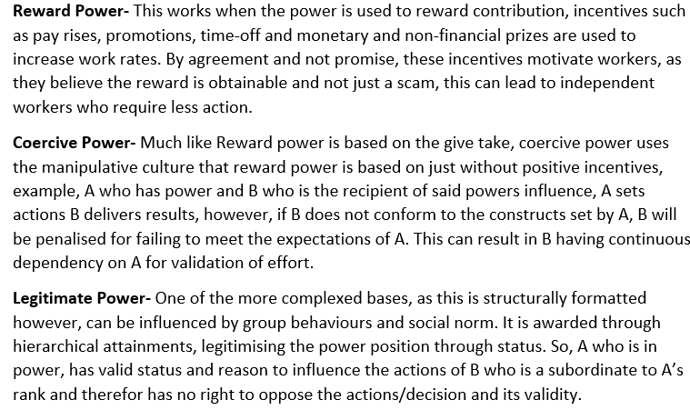
(adapted from (French & Raven, 1959)).

Informal Power
Informal power is self-employed, it is not tied to a position, a hierarchical rank or formality. A person’s characteristics and their social skills and confidence play a large part in the maintenance. It allows for the individuals, or the group involved to influence the decisions and actions of those in their vicinity. They can sway opinions and create a bias in their favour. It relies on the belief that the recipients will get what the holder promises, (Dahl, 1974).
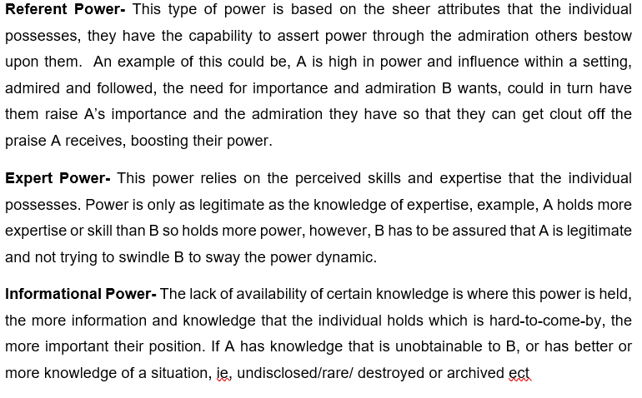
(Adapted from the text of (Erchul, et al., 2001)).

Culture

What is culture?
Culture has been defined as the collective thoughts, manifestations, and customs of a communal. This can be displayed in behaviours, mannerism, social hierarchies, and belief systems, those who are included in this group all understand the dynamics and can distinguish those associated even outside of the group setting, it is part of their identity, (Schein, 2011).

How can Culture impact Power and why?
Culture is part of a persons character that adheres to the social-norms set by their specific grouping, an example of cultural differences can be seen in everyday actions, such as a greeting; here in the UK, a hand firm shake is an appropriate way to greet a person, we are taught it is polite and respectful, it shows etiquette, and speaks to the strength of our character, we go on to teach this to our children and others who invest in our culture, it is part of who we are and how we communicate, however, in Japan it is customary to bow, the deeper the bow the more respect is shown, China to have a soft handshake and Thailand also bow, however, they position their hands in what would be considered a praying position by some culture and religions, the higher the peak of the bow, the more respect is shown to the recipient.
In countries such as Africa and Inia, it is imperative to greet the elders before the younger attendees, this shows respect, as these two cultures are taught to honour and respect the status of an elder, as age is a believed to hold knowledge, experience and wisdom positions that come with power.
Greetings, something so mundane to everyday life, can hold a lot of power in culture, it can lift the level of admiration for a person or banish them and their actions. Custom and tradition influence power both at home and at work, (Shidujaman & Mi, 1991).

How does culture impact power?
Culture can have a substantial bearing on power dynamics, as stated it shapes the values, beliefs, and behaviours of a society or group. A few ways in which culture can affect power are as followed:
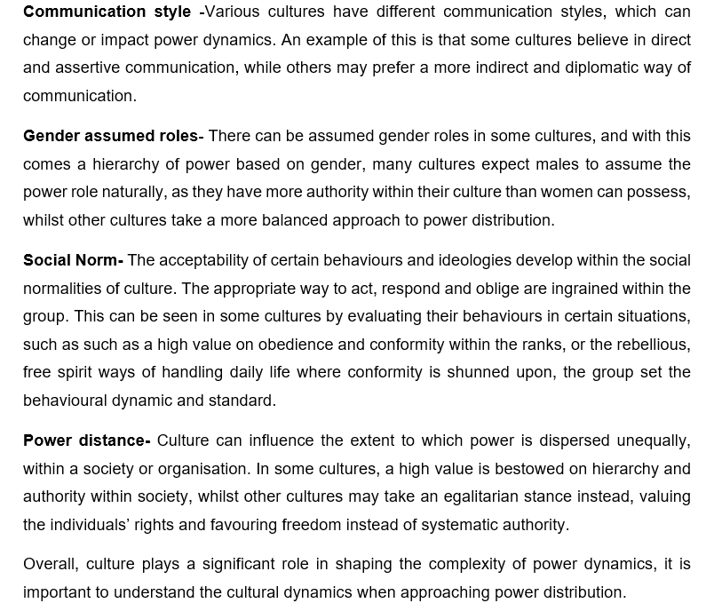
  - (Adapted from the text of (Hofstede, 2010))
These dynamics can be further broken down into two categories, Achievement-orientation and ascription-orientation. Culture plays a crucial role in the make-up of these dimensions and due to this organisation instil these principles within society, (French & Raven, 1959).
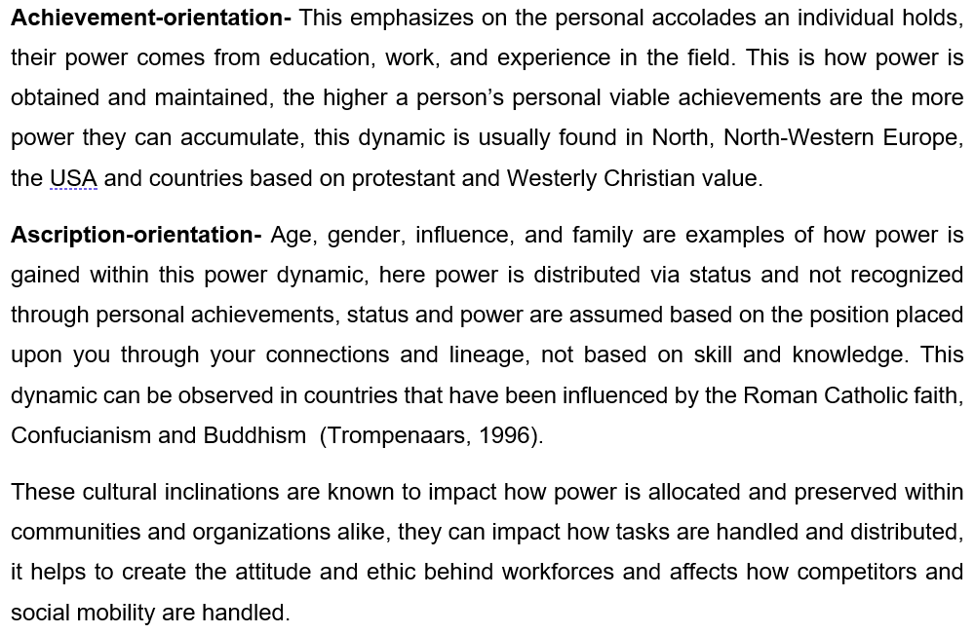

Culture in Organisations
The shared values, belief and practices help to shape organisational culture, they form the shared principles and standards acceptable within the organisation, the conduct of employees and the power dynamic. It is crucial that the company’s missions, vision, customs, social-norms, and rituals are included in the foundation. It implies stability and inclusion, sharing with like-minded people and group-life, (Gittell & Godwyn, 2011).

Power distance in organisations
The power distance in cultures rolls over into the organisational structure. This section will discuss two dimensions, the Tall-Organisational structure and Flat-Organisational structure.
In the Tall-Organisational structure, there are multiple levels of management, this means that the organisational culture is one typically top-down and on the more authoritative level. Power tends to be focused at the top of management and decision making is made by those in higher-ranking positions, then translated down to the lower levels. A much less flexible and more bureaucratic culture, with less importance on innovation and employees do not feel empowered in the decision-making process, (Rocco Carzo & Yanouzas, 1969).

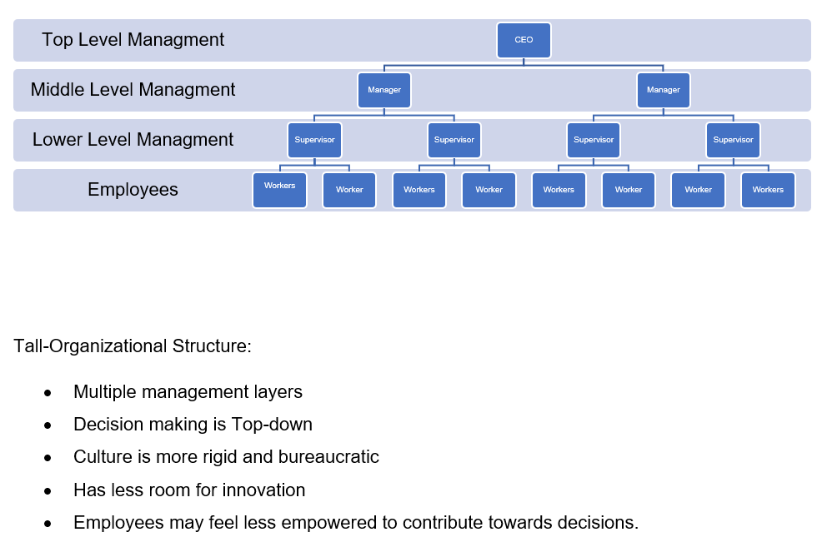
Fig.1. Example of a Tall-Organisational structure (Adapted from the text and graphs of (Rocco Carzo & Yanouzas, 1969) and (Hans Marius Norbom & Lopez, 2016).

Flat- Organisational structure consist of less managerial positions, so a decentralisation of power is seen. This encourages a collaborative and egalitarian culture within the organisation, employee autonomy and responsibility are valued, structuring an organisation this way can lead to an innovative and more responsive workforce. However, this structure does require that employees self-direct and are held responsible for their actions, (Rocco Carzo & Yanouzas, 1969).
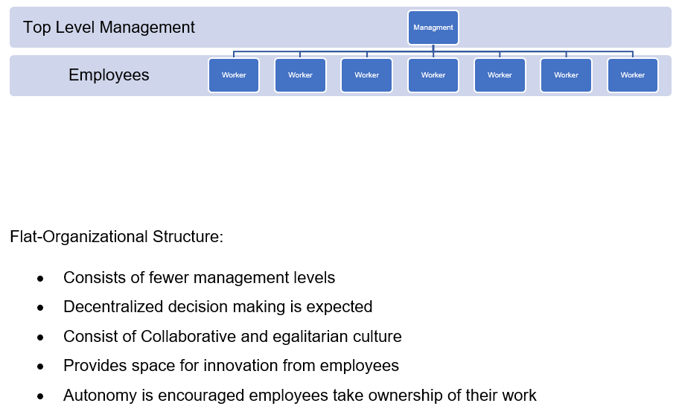

Fig.2. Example of a Flat-organisational structure and a breakdown of consequences, (Adapted from the text and graphs of (Rocco Carzo & Yanouzas, 1969) and (Hans Marius Norbom & Lopez, 2016).

Power distance and National Power influence.
With power distance we refer to the degree to which people in a certain culture acknowledge and expect power and authority to be unequally distributed amongst them. This concept was established by Dutch social psychologist Geert Hofstede, who conducted extensive research on culture dimensions.
Hofstede (2010), stated that high-power distance cultures are made up of those who accept and expect there to be an unequal distribution of power, it is seen as a normality, however, low-power distance cultures are opposed this ideology and are made up of people who challenge this notion and believe in more evenly distributed power, willing to challenge authority.
The impact can also be seen in governance and politics of the country, example, high-power distance countries tend to have centralised government, with little to no input from the population and rarely are they challenge, held accountable for or questioned on actions. Low-power distance cultures will try to hold leaders accountable, challenge their decisions and have input in the governing of the people, this creates a more democratic environment,(French & Raven, 1959).
Countries with high-power distance cultures are less likely to challenge authorities outside of their cultural countries of influence. This can impact their negotiating negatively as well as limit diplomatic relationships, alliances and trades globally. The open dialogue granted in low-power distance cultures creates a larger platform for negotiations, high influence globally, more productive diplomatic relationships and better trade deals, (French & Raven, 1959).
To summarise, power distance high or low, can impact the formation of government held within a society, due to their cultural practises and beliefs. This in-turn establishes their capacity of influence globally and accessible to outside establishments, we must however note that power-distance is only one of many cultural dimensions that has been shown to impact national power, as cultures are known to prioritise and value these dimensions differently.

Reflecting on any workplace conflict over the last 12 months, identify the cause of conflict and critically discuss a change management theory (2000 words)
    - Pick a conflict (Strike, Paramedics, schools, trains, royal mail, teacher, Royal Family etc. This needs to be a workplace that can be fact checked.)
    - Explain the conflict, describe what happened, background story. Name of company, key players, cause, what is happening in organisation.
500 words
    - Discuss change management theories and how these are affected in their approach. Needs two theories, one for managers and one for employees. (Scientific management theory – Tell what it is and how it affects managers) (Can also talk about change management (Lewin or Kotler)) Remember to include the limitations on each theory)
1500 words

Workplace conflict and Change Management theories.

