
Assignment
International Financial Management
Assessment 1

Lecturer: Taye Osadiya
Submitted by: Alina Foltea
Student number: 1917686

February 2022

Table of Contents
Introduction 3
1. Dividend distribution policies of the company 3
Internal factors 4
External factors 4
2. Analysis of efficient market hypothesis theory 5
3. Methods of appraising projects of the company 6
Economic analysis 6
Market analysis 7
Financial analysis 7
Conclusion 7
References 9

Introduction
International financial management plays a crucial role in managing the finances of a company by which they can maintain its financial operations with much ease. International financial management is also helpful in understanding the exchange rate of different countries since it associates the monetary transactions of foreign companies. Moreover, the selected multinational corporation for this study is Unilever Plc which has extended market operations in more than 190 countries of the world. Hence, the study aims to measure the dividend distribution policies and market hypothesis theory for the company for estimating its performance at the international level. Lastly, the study is focusing on the project appraisal method of Unilever by which they make finances for their acquisitions significantly.

1. Dividend distribution policies of the company
The dividend distribution policy is one of the financial policies of Unilever by which they estimated the cash value of dividends for their payment to their equity holders. Unilever Plc has its own created dividend policy by which they maintain the balance between dividend pay-out and retained earnings of the firm (Agrawal, 2021). It is quite evident that the company paid a dividend every year to its shareholders based on their retained earnings of the business. The retained earnings balance of the company depends upon the generation of net income which will be further utilized in uncertain events. The main reason behind the payment of the dividend is to depict clarification in the distribution network adopted by the company. Moreover, the dividend distribution policy of Unilever Plc ensures that the investments made by their shareholders in the company will be returned in form of cash after the compilation of the accounting year (Barros and Joaquim, 2020, p. 88). Hence, after the closure of accounting years, the company distributes some part of its profit to shareholders in cash so that they invest more in their business.
In addition, Unilever Plc believes in continuous shareholder value enhancement and for this, they pay attractive and growing dividends to their shareholders. Hence, the company follows the Relevance Theory of Dividend, which depicts that the payment of dividends ensures the firm's position in the international market, and for this; the company became successful in payment of growing dividends (Kilincarslan and Demiralay, 2021). Besides, Unilever Plc follows the Gordon Growth Model in their payment of dividends that estimates all the future payments of dividends to their shareholders. Hence, a higher estimation of dividends attracts more shareholders in business who invests their money in Unilever's business for making the business grow in the future periods. The board of directors of Unilever is responsible for determining the time for declaration of dividend and the rate at which dividend will be paid as well.
Based on the performance of the company, the BOD of Unilever can pay the interim and final dividend simultaneously. However, the proposed dividend by BOD of Unilever needs the approval of shareholders at the annual general meeting of the company (Zou and Bai, 2022). The meeting portrays that the shareholders will be eligible for the value of the dividend recommended by the BOD. Lastly, the dividend distribution policy of Unilever depends on several internal and external factors which are provided below:

Internal factors
- Expected and existing performance
- Investment plans and capital expenditures
- Liquidity position and cash flow
- Disposals and acquisitions

External factors
- The environment of macroeconomic
- Consumer trends and market conditions
- Expectations of shareholders
- Changes in regulatory requirements

2. Analysis of efficient market hypothesis theory
The efficiency market hypothesis theory (EMHT) can be defined as the theory which reflects that the share price of a company depicts the financial and non-financial information about their business. Therefore, by using this theory one can understand the financial and non-financial business information of Unilever and its expected performance as well (Dreżewski et al. 2018). This is because the trend in their share price or changes in share price reflects whether the company will be profitable in the industry or not. Moreover, according to this theory, if Unilever will make any changes in their business, it will be measured or understood by their share price performance. However, the theory has criticism that the changes in one company can be identified by either company by which they can take market advantage by deceiving the business of the firm. Moreover, the past share price of 5 years of Unilever Plc is used below for illustrating the efficiency market hypothesis theory:
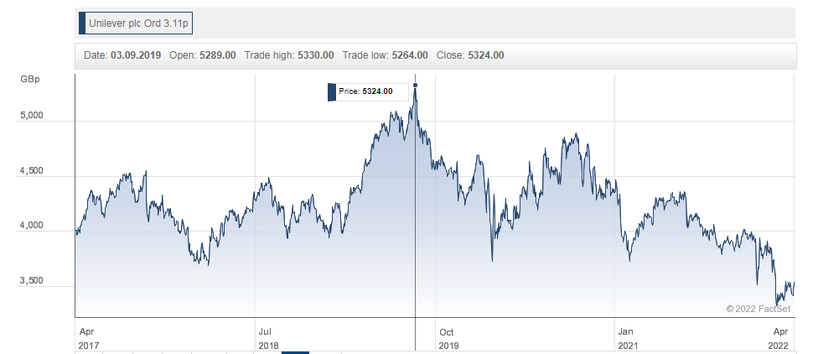
Figure 1: Share price (Unilever)
(Source: Hl.co.uk, 2022)
The above graph of Unilever Plc depicts the share price information of the company in the last five years (Liu et al. 2022). The graph of the share price is depicted above since the efficiency market hypothesis theory depends on the share price information of a company. Due to this reason, one needs to understand the trends in the share price of Unilever before understanding the hypothesis theory of the market. Moreover, based on the above graph it is illustrating that during 2018 and 2019 the share price of Unilever Plc was at its peak when the Covid-19 pandemic has not affected the globe. However, the share price of the company has fluctuated after 2019 and it increases and decreases but never goes away from the 2018-19 prices (Serrano-Monge, 2022). Moreover, the highest share price of the company in the last five years was 5324 and at the end of the year, it declined significantly due to the negative impact of the Covid outbreak across the globe.
Lastly, it is illustrating that the use of the efficient market hypothesis theory enables the shareholders or competitors of Unilever to understand the trends and changes in their business. According to this theory, the investors of Unilever can earn significantly by investing at a low-cost investment in their business (Ying et al. 2019). This is because the use of theory stated that changes made by the company either increase their share price or decrease their share price. Hence, once the share price decreases the investor can invest their money in the company so that when the price rises, they will earn a high rate of profit for their investment.

3. Methods of appraising projects of the company
A project appraisal is done by Unilever Plc after making critical research on the acquisition and if the company thinks that the acquisition will be profitable for them then they will undertake the project. Moreover, Unilever Plc appraises a project by undertaking several methods, which provide the suitability and reliability of the projects (Abbati et al. 2021). Hence, the methods appraised by Unilever Plc are “Economic analysis, Market analysis, and financial analysis”. The illustration of the analysis methods along with the acquisitions made by Unilever is provided below:

Economic analysis
Economic analysis can be done by Unilever Plc by considering the economic variables such as sales, purchases, and expenses. Moreover, under this analysis, Unilever Plc highlights the requirements of raw materials for the project and anticipates the profit of the project in future periods (Bosch-Badia et al. 2020). For instance, Paula's Choice, a leading digital-led skincare brand, was acquired by Unilever in 2021 for which the company first estimated the profitability of the brand and goodwill as well in the market (Unilever.com, 2022). Therefore, Unilever has done the economic analysis before the final announcement of the acquisition of Paula's Choice in which they successfully estimated the required materials and revenue of the brand in past years.

Market analysis
Market analysis is the technique for measuring the marketing of a project before appraising the project. Hence, in this analysis, Unilever Plc first measures the possible future market benefits of the project by which they can earn high growth in business and significant profitability as well (Lima et al. 2017). For instance, SmartyPants Vitamins was acquired by Unilever plc in December 2020 after doing market research and analysis (Unilever.com, 2022). Smarty-pants Vitamins was a US-based vitamin and supplements-based company that had a market reputation in the US for providing excellent services to their customers. Hence, Unilever appraised this project.

Financial analysis
Financial analysis can be defined as the analysis of finance estimated by a company before making acquisitions and investments in a project. In the same way, Unilever Plc always estimated the cost and benefits of a project before undertaking the project (Sarwary, 2019). For instance, Astrix was the manufacturer of home and personal care brands and was acquired by Unilever in 2019 (Unilever.com, 2022). Before the acquisition of the company, Unilever made the estimations of the finances required for the company. Hence, after successfully estimating finances for the company Unilever acquired the company in 2019 and it becomes a subsidiary part of the company.

Conclusion
The above discussions depict the international financial management of Unilever Plc in which several critical aspects of their business have been depicted. It is concluded from the above statements that Unilever Plc follows the relevance theory in their dividend distribution so that every shareholder can receive an equal dividend based on their investments. Moreover, it is also found from the statements that Unilever has acquired a range of businesses, and for this; they used the project appraisal methods, which successfully helped the company in estimating the reliable and viable estimations of the project. Vitamins were a US-based vitamin and supplements-based company that had a market reputation in the US for providing excellent services to their customers. Hence, Unilever appraised this project.

References
Journals
Abbati De Assis, C., Suarez, A., Prestemon, J.P., Stonebraker, J., Carrillo, C., Dasmohapatra, S., Jameel, H. and Gonzalez, R., 2021. Risk analysis, practice, and considerations in capital budgeting: Evidence from the field for the bio-based industry. BioResources, 16(1), pp. 19-45.
Agrawal, A., 2021. Impact of Elimination of Dividend Distribution Tax on Indian Corporate Firms Amid COVID Disruptions. Journal of Risk and Financial Management, 14(9), pp. 413.
Barros, V. and Joaquim, M.S., 2020. Does ESG Affect the Stability of Dividend Policies in Europe? Sustainability, 12(21), pp. 8804.
Bosch-Badia, M., Montllor-Serrats, J. and Maria-Antonia Tarrazon-Rodon, 2020. The Capital Budgeting of Corporate Social Responsibility. Sustainability, 12(9), pp. 3542.
Dreżewski, R., Dziuban, G. and Pająk, K., 2018. The Bio-Inspired Optimization of Trading Strategies and Its Impact on the Efficient Market Hypothesis and Sustainable Development Strategies. Sustainability, 10(5), pp. 1460.
Kilincarslan, E. and Demiralay, S., 2021. Dividend policies of travel and leisure firms in the UK. International Journal of Accounting and Information Management, 29(2), pp. 324-344.
Lima, A.C., Da Silveira, J.,Augusto Giesbrecht, MatoS, F. and Xavier, A.M., 2017. A qualitative analysis of capital budgeting in cotton ginning plants. Qualitative Research in Accounting and Management, 14(3), pp. 210-229.
Liu, G., Yu, C., Shan-Neng, S. and I-Tung, S., 2022. The Efficient Market Hypothesis and the Fractal Market Hypothesis: Interfluves, Fusions, and Evolutions. Sage Open, 12(1),.
Sarwary, Z., 2019. Capital budgeting techniques in SMEs: A literature review. Journal of Accounting and Finance, 19(3), pp. 97-114.
Serrano-Monge, E., 2022. Inferences from Portfolio Theory and Efficient Market Hypothesis to the Impact of Social Media on Sovereign Debt: Colombia, Ecuador, and Peru. Journal of Risk and Financial Management, 15(4), pp. 160.
Ying, Q., Yousaf, T., Qurat, U.A., Akhtar, Y., and Muhammad, S.R., 2019. Stock Investment and Excess Return A Critical Review in the Light of the Efficient Market Hypothesis. Journal of Risk and Financial Management, 12(2), pp. 97.
Zou, Y. and Bai, Q., 2022. The Impact of Dividend Policies and Financing Strategies on the Speed of Firms’ Capital Structure Adjustment. Discrete Dynamics in Nature and Society, 2022.
Website
Hl.co.uk, 2022, Overview, Viewed on 22nd April 2022<https://www.hl.co.uk/shares/shares-search-results/u/unilever-plc-ordinary-3.11p/share-charts>
Unilever.com, 2022, Overview, Viewed on 22nd April 2022<https://www.unilever.com/investors/news-and-announcements/acquisitions-disposals/>

