ECIE4003

Additional Needs in Context

Portfolio

Student Number: 2116580
Chloe Pickin

Element 1

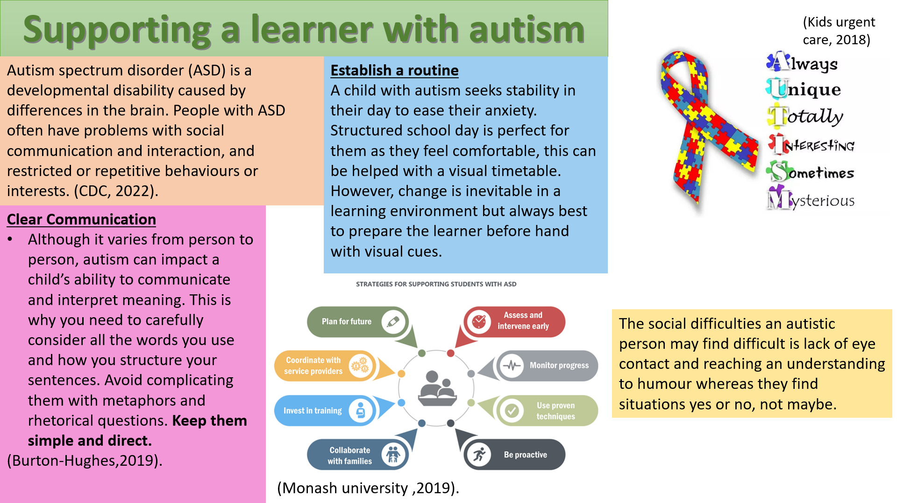

References
Centres for Disease and Control Prevention (2022)- Signs and Symptoms of Autism Spectrum Disorder
Kids Urgent Care (2018)- Autism Awareness Month
Liz Burton Hughes (2019)- How to support a child with autism in the classroom
Professor Umesh Sharma and Dr Erin Leif (2019)- How teachers in mainstream schools can support students with autism spectrum disorder

Element 2
Explore the wide and complex spectrum of additional needs
This essay discusses the wide and complex spectrum of additional needs. Additional needs can be defined as an individual with a physical or mental condition that affects their everyday life. A child with additional needs can find normal everyday natural tasks challenging such as walking, talking and interacting with others. Moreover, this essay will discuss the social model which is a preferred term when discussing an individual who has a disability because of the medical model originally using the terms “disabled” meaning less able. When discussing additional needs, it is important to mention Maslow Hierarchy of needs “Maslow’s hierarchy of needs is a model for understanding the motivations for human behaviour. It maps different motivations onto a pyramid, with each level representing a different human need. These include physiological needs, safety, love and belonging, esteem, and self-actualization.” (Gepp, 2022).
Some children suffer throughout their early years of life through social model of disability due to the physical barriers faced. An example of this is a child who uses a wheelchair that is unable to attend a mainstream school because the school is not equipped with ramps or lifts for the child with wheelchair user needs. Further excluding the individual’s chances of feeling equal like every other child attending mainstream school. The importance of the social model it identifies it’s not the child’s responsibility “social model recognises that this is a problem with the building, not the person, and would suggest adding a ramp to the entrance. (Scope, 2022). It is the negative attitude and neglect on society that prevents individuals achieving their full potential however it is the social model that focuses on accessibility so there are no physical barriers stopping them, independence to make them feel they are stronger and better than their “disability” and opportunity, so they are treated equal to every other individual because they are also capable.
Moreover, a crucial change for Wales is going from Special Educational Needs to Additional Learning Needs to “separate systems for special educational needs (SEN) in schools and learning difficulties and/or disabilities (LDD) in further education, to create a unified system for supporting learners from 0 to 25 with ALN.” (Wales gov, 2018). This has a positive outcome for learners with ALN because they’re further helping them through education to achieve the best of their ability to go through college and university. In addition, there has been an act passed in Wales in 2021 “the additional learning needs code” this ensuring all learners with ALN are having they’re needs met in mainstream education by being thoroughly supported at school, home and building a relationship, understanding with parents. Every child’s additional need is different and varies from communication, learning or sensory needs. A child with autism struggles with social interaction. This is because they can’t control their emotions and feel comfortable in an everyday routine as it reduces their anxiety therefore may struggle if people change plans causing the child to feel frustrated. A way of improving the child’s frustrations in these scenarios as change is inevitable in everything that happens “Building up social skills with practice can help enhance participation in the community and support outcomes like happiness and friendships.” (Autism speaks, 2022). Another ALN a child could have, hearing impairment and require extra support from a specialist, equipment to suit their learning needs in school. “A radio aid is a microphone worn by the teacher that connects to a hearing aid and can also be passed to other pupils during activities such as group reading. This will help the child to feel part of the class and ensure that they don’t miss any important information.” (Finch, 2020).
To elaborate on ALN, good practice is important for a child with an additional learning need such as support from expert organisations and school building a strong relationship with parents. The best support to provide a child in a classroom with additional needs is to stay positive and be understanding. The ALN code specifies “The new system puts the learner at the heart of everything that happens, and we expect schools, PRUs, FEIs and local authorities to take a person-centred approach to planning for, and supporting, children and young people.” (Welsh gov, 2022). It’s beneficial for parents to have support from organisations as they can support, answer questions for the parents that their unsure of such as their child going through a diagnosis. In school’s that have an ALN department, parents also receive support from the school SENCO who`s duty is, “It is a SENCos responsibility to ensure that the needs of pupils with SEND are met, that adjustments are made within the school when needed, and that parents and any other outside agencies or specialists are involved in the child's provision and progress.” (Twinkl, 2022).
To conclude there are many different types of additional learning needs. All children with any disability should have a right to equal opportunities with support of their parents and school to help them achieve the best of their ability, that is why it is necessary for outside agencies to get involved to provide their expert advice on any matters, concerns faced. Early diagnosis of the child is essential as it benefits the strategies that are put in place for the child in mainstream education. Most importantly children with additional needs physically or mentally should not be stereotyped because of their disability, they are more than their disability.

References

Autism Speaks (2022)- “Social Skills and Autism”
Karin Gepp (2022)- “Maslow’s hierarchy of needs: Uses and criticisms”
Matt Finch (2020)- “How to support a child with a hearing impairment in school”
Scope (2022)- “Social Model of Disability”
Twinkl (2022) – “Special Educational Needs Coordinator (SENCo)”
Wales Government (2018)- “Additional learning needs (ALN) transformation programme”
Welsh Government (2022)- “The additional learning needs transformation programme: frequently asked questions”
Element 3
Explore and summarise the additional learning needs of a pupil using a person centred planning approach.
(Based upon Section 1C IDP : Profile (About me)
and
2A IDP : Description of the child or young person’s additional learning needs (ALN))

Section 1C: Profile (About me)
Child A is a seven-year-old female who has been diagnosed with Autism. She attends an English-speaking school in Port Talbot and her first language is English.

• What is important to the learner
Mam, Dad and sister are really important to her along with her two cats Rosie and Shady. Her favourite colour is red so every opportunity to write and colour tends to be in red. Whenever given a choice with colours red is always her first choice, when given any other colour this can cause her to feel distressed. To always be able to access her noise cancelling headphones when there’s loud music or singing. At the start and end of everyday it’s important for her to be greeted and show affection to others with a hug.

• What is important for the learner
For the learner to be supported with her writing as she’s able to write and spell words but needs constant reassurance. Also, important to keep her focussed on the task by reiterating the task one step at a time. Additionally, for her to repeat what her task is to show her understanding.

• What is working and should be built on
She’s developing her social skills and ability to be patient and wait her turn to speak instead of interrupting, shouting out answers and ideas. She learning to patiently wait her turn and accepts when she’s not picked to speak, understanding that her peers also need an opportunity to speak. She’s enjoyed using technology to work on her maths skills and knowledge and has used children’s laptops to access educational games. This is also helping to develop her independence as when playing the games, she answers questions without fear of getting them wrong and therefore not asking for support.

• What is not working and needs to change.
Specifically in PE lessons when she’s not getting selected in a certain role in a game, she has an emotional breakdown and doesn’t cope. In free play scenarios she doesn’t know how to correctly engage with her peers to be involved in what they' doing, example of this is asking to join in to play then relying on the adult in the room to come and help her.
Section 2A: Description of the child or young person’s additional learning needs (ALN)
Cognition and Learning
Child A has good understanding and general subject knowledge and actively participates in whole class discussions. When supported child A is able to access the curriculum. Child A learns best through repetition and tasks being broken down into steps into simpler terms to her understanding. When completing work child A likes the fulfilment of positive feedback, stickers and high fives (positive touch) when trying her best and successfully completing any task or work in class.

Communication and Interaction
Child A is very inquisitive and loves to ask questions to gain a better understanding and/ or clarify what she already understands. Child A generally happy in her own company and doesn’t seek interaction but happily accepts interaction with her peers when she’s approached.

Sensory and/or Physical
Child A doesn’t cope with loud noises and needs her sound cancelling headphones whenever there’s a loud activity in the classroom e.g. singing practice. Her noise cancelling headphones make her feel safe on a daily basis when she is feeling shocked or frustrated by a loud noise.

Behaviour, Emotional and social development
One of her daily needs is regular positive touch to start and end her day. Child A seeks out a hug from trusted adults for comfort and reassurance before begins an activity. At playtime she prefers to play with the one to one and she gets emotionally distressed if the one-to-one shows more attention to other children other than her. She doesn’t cope well with playing in group scenarios.

Element 4
Discuss the potential support provided to your chosen pupil (utilising the key principles, approaches and policies that guide inclusive practice).
Based upon Section 2B IDP : Description and delivery of the child or young person’s additional learning provision (ALP)

I have provided 4 section boxes in this template 2B1, 2B2, 2B3, 2B4.
This will provide space for 4 ALPs

If you require more, copy and paste the section box as needed – each ALP should be contained in its’ own individual section box.

n.b. Each section box contains 858 title words – these do not count towards your word count for this element

Section 2B1: Description and delivery of the child or young person’s additional learning provision (ALP)
2B1.1) Intended outcome:  These outcomes should be SMART (Specific, Measurable, Achievable, Realistic,  Timebound). | To follow the ‘Language Structure’ section of Language Link and improve her understanding and use of targeted grammatical structures. This target is specific to language structure for child A to communicate in the correct mannerism while speaking about past tense. This target is measurable and achievable for child A as it’s being monitored twice a week with an aimed accuracy to achieve in each session. This target is realistic because activities focus on grammatical structures that needs improving. This target has a timebound to achieve by October giving the child four months to achieve this target.
2B1.2) ALP to be provided:  This should include how often (daily, weekly); the type of support; who provides the support. The description of the Additional Learning Provision (ALP) should be very clear and precise, the above could then be split into smaller goals and targets. |  | 2B1.3) Should the ALP be provided in Welsh? | 2B1.4) Organisation/  Service to provide the ALP, (e.g. NHS, Inclusion Service, Specialist Teacher, etc.): | 2B1.5) Start date: | 2B1.6) End / Review date:
To successfully complete ‘Language Structure’ activities twice a week. Achieving ‘P= Partial’ 79%- 50% accurate in each activity. To understand sentences using target vocabulary. To improve her understanding and use of targeted grammatical structures during the sessions. Achieving ‘P=Partial’ 79%-50% accurate in each activity. To recognise past verbs in her surroundings ‘brushed, played, painted, cleaned, washed’ and use them correctly in her vocabulary. |  | No | Specialist Teacher  Class Teacher and TA | June 2022 | October 2022
2B1.7) Rationale for the ALP listed above:
If there is a difference of opinion it should be recorded here e.g. a difference of opinion between the child, child’s parent or young
person and professionals. The section could explain how different opinions have been taken into consideration before a particular decision was reached.
Section 2B2: Description and delivery of the child or young person’s additional learning provision (ALP)
2B2.1) Intended outcome:  These outcomes should be SMART (Specific, Measurable, Achievable, Realistic,  Timebound). | To work through the Colourful Semantics sessions focussing on Who? What doing? What? This target is specific for child A to structure her sentences correctly with the use of pictures to help be able to recall and write sentences herself. This target is measurable as you can track her progress whether she is structuring the sentences correctly or not. This target is achievable because it’s not too easy or not too hard for child A to achieve with practice. This target is realistic for child A as she needs to develop her sentence structures. This target has a timebound to achieve by October giving the child four months to achieve this target.
2B2.2) ALP to be provided:  This should include how often (daily, weekly); the type of support; who provides the support. The description of the Additional Learning Provision (ALP) should be very clear and precise, the above could then be split into smaller goals and targets. |  | 2B2.3) Should the ALP be provided in Welsh? | 2B2.4) Organisation/  Service to provide the ALP, (e.g. NHS, Inclusion Service, Specialist Teacher, etc.): | 2B2.5) Start date: | 2B2.6) End / Review date:
To use the semantic boards and cards to build sentences of Child A choice. To recall the sentence out of context to check understanding. Both TA and child A practice using the actions as a prompt for each part. Who? Doing what? What? To successfully complete the semantics in and out of context using the pictures and actions. Specialist teacher to visit and assess child A to see if she is ready to move onto the ‘where’ target. |  | No | Specialist Teacher  Class teacher and TA | June 2022 | October 2022
2B2.7) Rationale for the ALP listed above:
If there is a difference of opinion it should be recorded here e.g. a difference of opinion between the child, child’s parent or young
person and professionals. The section could explain how different opinions have been taken into consideration before a particular decision was reached.
Section 2B3: Description and delivery of the child or young person’s additional learning provision (ALP)
2B3.1) Intended outcome:  These outcomes should be SMART (Specific, Measurable, Achievable, Realistic,  Timebound). | To develop child A independence skills throughout the school day. This target is specific for child A not to always be reliant on an adult. This target is measurable as you can monitor progress visually every day. This target is achievable with encouragement from staff for child A to play with friends. This target is realistic for child A to develop social skills by interacting with others. This target has a timebound to achieve by October giving the child four months to achieve this target.
2B3.2) ALP to be provided:  This should include how often (daily, weekly); the type of support; who provides the support. The description of the Additional Learning Provision (ALP) should be very clear and precise, the above could then be split into smaller goals and targets. |  | 2B3.3) Should the ALP be provided in Welsh? | 2B3.4) Organisation/  Service to provide the ALP, (e.g. NHS, Inclusion Service, Specialist Teacher, etc.): | 2B3.5) Start date: | 2B3.6) End / Review date:
With support read through her work when completed and check the marking for any errors that have been made to correct. Prompted by teacher/ TA. To play a game with a friend using the outdoor play equipment (game modelled and encouraged by staff.) |  | No | Specialist Teacher  Class Teacher and TA | June 2022 | October 2022
2B3.7) Rationale for the ALP listed above:
If there is a difference of opinion it should be recorded here e.g. a difference of opinion between the child, child’s parent or young
person and professionals. The section could explain how different opinions have been taken into consideration before a particular decision was reached.
Section 2B4: Description and delivery of the child or young person’s additional learning provision (ALP)
2B4.1) Intended outcome:  These outcomes should be SMART (Specific, Measurable, Achievable, Realistic,  Timebound). | To develop Child A ability to communicate clearly and be understood. This target is specific to the child’s social skills for her to be able to have conversations with pupils and staff. This target is measurable as ‘check as you go’ strategy can monitor progress to see if child A is processing information, encouraging questions. This target is achievable as strategies are used everyday throughout the day in class. This target is realistic for child A to improve her speech for speaking with pupils and teachers, giving her confidence to be involved in class discussions and ask questions. This target has a timebound to achieve by October giving the child four months to achieve this target.
2B4.2) ALP to be provided:  This should include how often (daily, weekly); the type of support; who provides the support. The description of the Additional Learning Provision (ALP) should be very clear and precise, the above could then be split into smaller goals and targets. |  | 2B4.3) Should the ALP be provided in Welsh? | 2B4.4) Organisation/  Service to provide the ALP, (e.g. NHS, Inclusion Service, Specialist Teacher, etc.): | 2B4.5) Start date: | 2B4.6) End / Review date:
In class use teaching strategy ‘explain clearly’ by providing context. Link new ideas to previous learning and personal experience. In class use teaching strategy ‘explain clearly’ by teaching/ discussing the meaning of key vocabulary for the lesson. In class use teaching strategy ‘check as you go’ by pausing, repeating and rehearsing when possible. In class use teaching strategy ‘check as you go’ by allowing time for processing. Asking questions and encourage questioning. |  | No | Specialist Teacher  Class Teacher and TA | June 2021 | October 2021
2B4.7) Rationale for the ALP listed above:
If there is a difference of opinion it should be recorded here e.g. a difference of opinion between the child, child’s parent or young
person and professionals. The section could explain how different opinions have been taken into consideration before a particular decision was reached.

