

Programme: Master of Business Administration
Module: Financial Management
Module Code: LCMB7002
Lecturer’s Name: Dr Patrick Yeboah
Topic: Financial performance and management
Student Name: Rathod Virendrasinh Rajendrasinh
Student Code: 2438323
Submission Date: 24th November 2025, 2 PM
Word Count: 5108

Executive Summary
The financial ratio analysis indicates the declining profitability status with liquidity risk, declining asset productivity and alarming level of leverage. Turnover ratios like Return on Assets and Return on Equity are showing negative performance, which is in line with weakening performance in terms of operational efficiency. Short-term solvency is indicated as being weak, whereas financial risk exposure is indicated as being high based on the gearing ratios and this is in line with the fact that the firm relies on debt financing. These results are critically analysed with references to solvency theory and market signalling theories. In order to calculate the financial consequences of debt rebalancing, asset divestments, cost optimisation, and equity financing, a restructuring situation was considered. The analysis shows that restructuring will refine debt to equity ratio, liquidity, and interest exposure and strengthen operations. Nevertheless, reorganization in itself is not an entirely successful way of restoring profitability, indicating that concurrent strategic realignment is also necessary.

Lastly, NPV, IRR, Payback Period, ARR and Profitability Index were used to estimate three corporate investment proposals. The financial justification of Project C was the highest whereas Project A had marginal value creation and Project B had negative financial viability. Project C was chosen as the most strategic and financially favourable project considering capital rationing constraints.

Table of Contents
Executive Summary 2
1.0 Introduction 5
2.0 Financial Ratio Analysis and Interpretation 5
2.1 Profitability Analysis 5
2.2 Liquidity Analysis 7
2.3 Efficiency and Asset Management Analysis 8
2.4 Capitals and solvency analysis 9
2.6 Investor Value and Market Pricing 11
2.7 Financial Position Report 11
3.0 Working Capital Management Analysis 12
3.1 Rationale for Restructuring 12
3.2 Financial Effect of Divestiture Strategy 13
4.0 Restructuring Strategy and Financial Impact Analysis 14
4.1 Equity Financing as a Capital Strengthening Mechanism 14
4.2 Improvement in Cost Synergy and Operations. 14
4.3 Combined Restructuring Outcome 15
4.4 Constraints, Strategic Implications and Risks 15
5.0 Investment Appraisal and Capital Budgeting Analysis 16
5.1 Net Present Value (NPV) Evaluation 16
5.2 Internal Rate of Return (IRR) Interpretation 18
5.3 Payback Period Assessment 19
5.5 Profitability Index (PI) 21
5.7 Behavioural, Risk and Strategic considerations 22
5.8 Investment Appraisal Outcome Summary 23
6.0 Part 5: Strategic Recommendations and Conclusion 25
6.1 Recommendations 25
6.2 Approve and Implement Project C. 26
6.3 Defer Project A Waiting Performance Improvement 26
6.4 Reject Project B 26
6.5. Enhance Monitoring and Governmental Systems. 27
7.0 Conclusion 28
References 30
Appendix A: Ratios 34
Appendix B: Cash Cycle 35
Appendix C: Leverage and Equity 36
Appendix D: Investment Appraisal 39

1.0 Introduction
This report will give a detailed financial analysis of General Electronics which includes a review of its recent financial performance, capital structure, and investment decision choice to make strategic managerial action. Based on the well-known frameworks in corporate finance, such as the capital structure theory (Modigliani and Miller, 1963), liquidity preference theory (Keynes, 1936), and investment appraisal models (Brealey, Myers and Allen, 2022), the report employs the ratio analysis, restructuring assessment, and capital budgeting approaches to analyse the financial position of the company and the possible ways of strategic development. The analysis applies primary quantitative data presented in the case brief and analyses them within the frames of theoretical expectations and financial standards.

2.0 Financial Ratio Analysis and Interpretation
Financial ratio is a diagnostic method that is extensively used to evaluate the financial performance and efficiency and strategic strength of organisations (Atrill and McLaney, 2022). It enables the analysis of financial statements in a way that is not limited to numbers by placing the trends in operational performance, liquidity positions, capital structures and attractiveness of the investment in the broader context. In the case of General Electronics, the ratio results represent a difficult financial status that is typified by deteriorating profitability, deteriorated solvency and poor liquidity position. The analysis that announces below critically evaluates the indicators of profitability, liquidity, operational efficiency, and capital structure on both theoretical basis and empirical interpretation.

2.1 Profitability Analysis
The profitability ratios determine how the organisation can create earnings in relation to revenue, assets and equity, which are a fundamental measure of value creation (Brealey, Myers and Allen, 2022). The case company exhibits further negative profitability, which is an indicator of operational weaknesses.
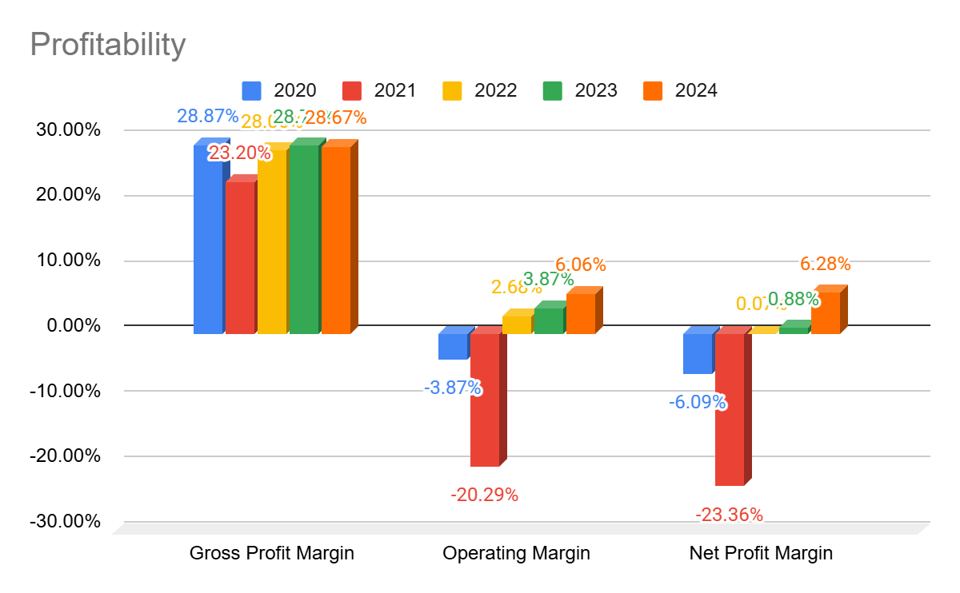
Figure 1: Profitability of General Electronics
Source: Self-created
Profitability ratios determine how the organisation can create returns in relation to revenue, assets and equity, and are primary pointers towards value creation (Brealey, Myers and Allen, 2022). General Electronics has fluctuating and mostly poor profitability indicators across 2020-2022. The gross margin is quite stable, with the range of values between 23.20% and 28.87, but the operating and net margins showed negative values in 2020 and 2021, but improved in 2023, to 6.06% (operating) and 6.28% (net) in 2024. This is an indication of initial cost-inefficiencies then progresses into restructuring.
In the competitive strategy framework by Porter (1985), cost structure misalignment, pricing pressure or a weakened differentiation is usually indicated by sustained volatility of the margins. This trend is also strengthened by the return ratios. Both ROE and ROA were significantly negative during the period between 2020 and 2021, which is an indicator of capital inefficiency and poor performance. ROA and ROE have increased to 7.6% and 12.3 respectively, which represents a transition to value creation. The trend is in line with the agency theory that postulates that a misalignment in strategies and inefficiency in the management deteriorates the shareholders value (Jensen and Meckling, 1976).
Additionally, the fact that the ROE has been increasing compared with the ROA in 2024 also suggests that leverage is starting to provide contributions to amplify the returns, just as the capital structure propositions of Modigliani and Miller (1963) do. But the turbulence throughout the period points to the lack of stability in strategy that needs additional discipline.

2.2 Liquidity Analysis
Liquidity ratios determine the capacity of the firm to settle the short-term liabilities, which means that it has financial flexibility and working capital (Arnold and Lewis, 2019).
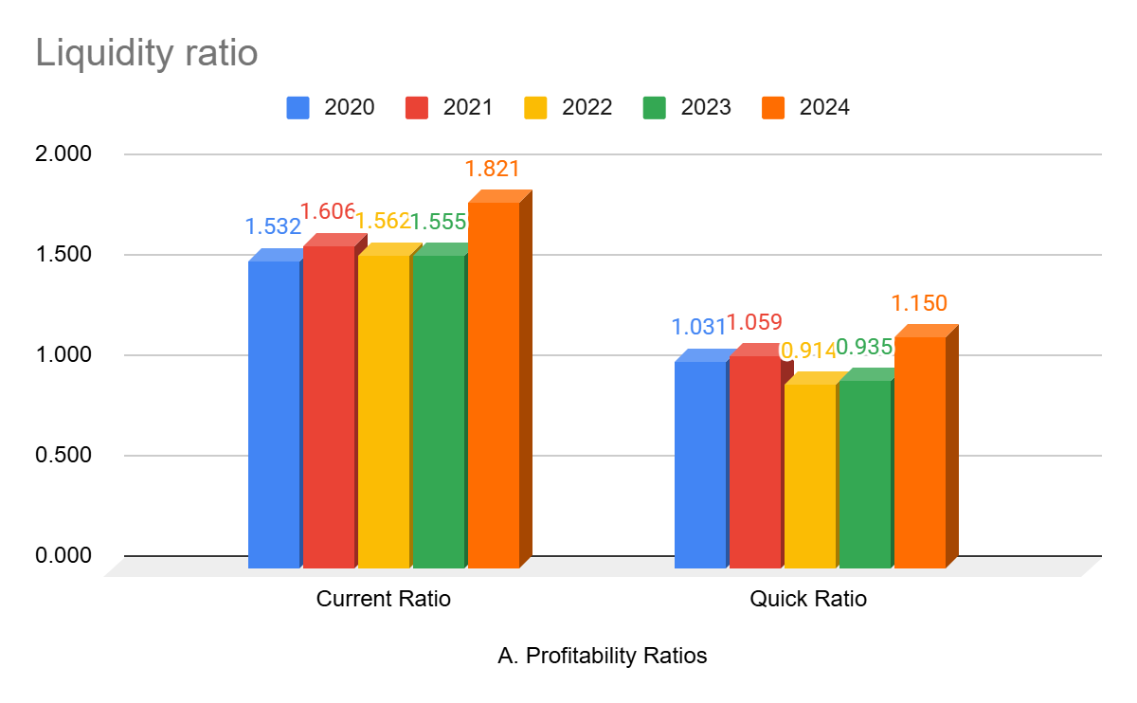
Figure 2: Liquidity of General Electronics
Source: Self-created

The liquidity ratios are used to evaluate the capacity to pay immediate financial liabilities (Arnold and Lewis, 2019). The current ratio of General Electronics increased to 1.821 in 2024 compared to 1.532 in 2020, and the quick ratio also increased to 1.150 as compared to 1.031. These values exceed the minimum of 1 which indicates high solvency in the short run. The working capital strength is also better in the firm in comparison with the previous issues.

This is a tendency in line with the liquidity preference theory of Keynes (1936) where firms under uncertainty are more likely to save the liquidity to cushion shocks. Previous use of inventory to settle the obligations has been diluted with a rising quick ratio showing that it depends less on liquidation of inventory. The liquidity position is improving, which helps the company to continue operations and has the ability to respond to investment opportunities.

2.3 Efficiency and Asset Management Analysis
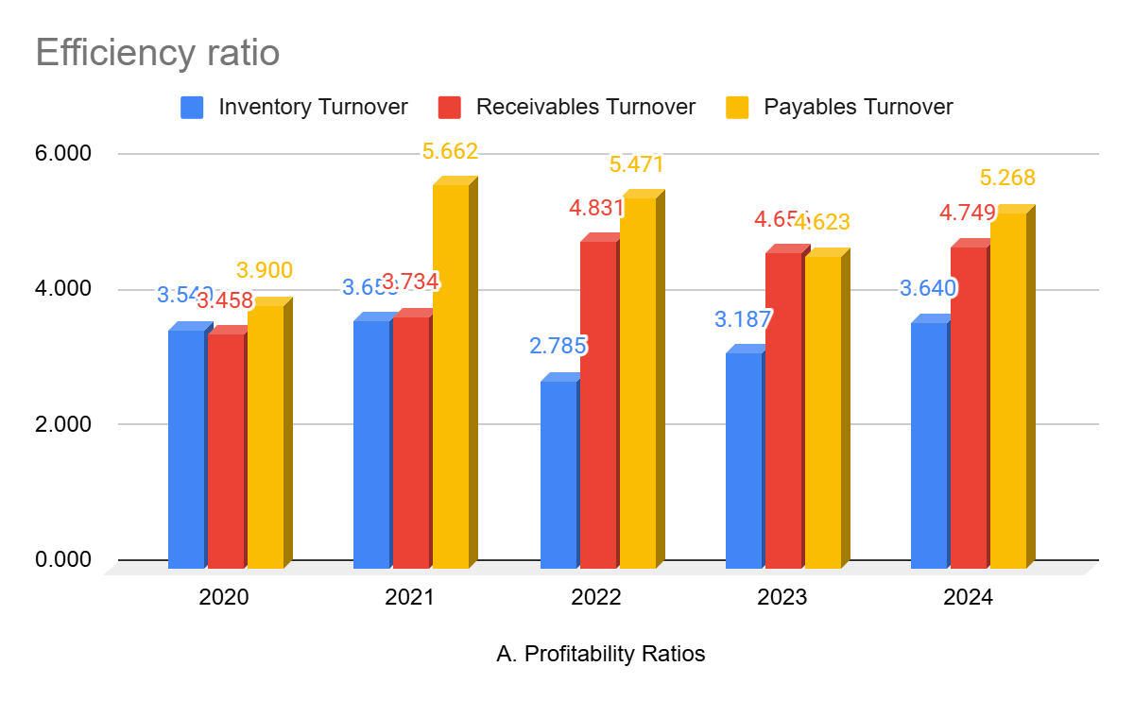
Figure 3: Efficiency of General Electronics
Source: Self-created
The efficiency ratios assess the efficiency with which a company utilizes its assets to make revenue (Atrill and McLaney, 2022). General Electronics is showing a middle level of growth, where inventory turnover has improved to 3.64 in 2024 and the receivables turnover is also high at 4.749. The turnover of payables varies and is consistent with inventory cycles.

The timing indicators of working capital also show gains: the cash conversion cycle has dropped to 139.87 days in 2022 and to 107.83 days in 2024, which implies that the organisation is more efficient in converting the working capital into the cash.

Irrespective of this operational gain, negative profitability in the previous years indicates that efficiency was not able to convert into monetary worth- which supports the statement of Higgins (2017) through the DuPont model that operational efficiency cannot make up of declining margins.

2.4 Capitals and solvency analysis
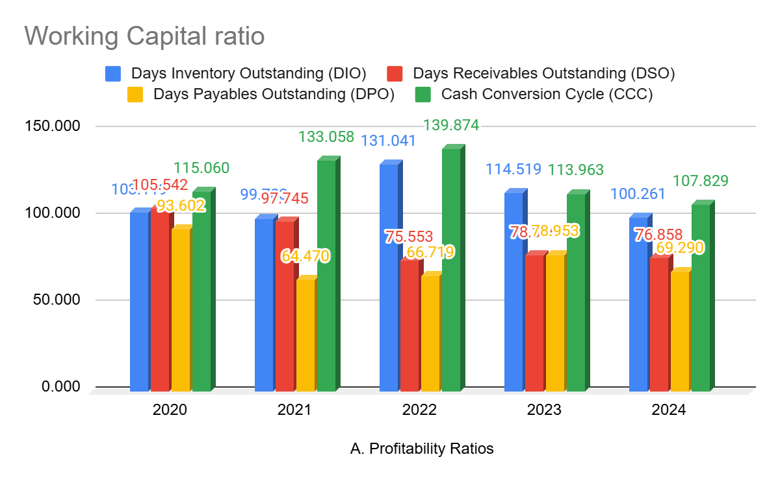
Figure 4: Working capital ratio of General Electronics
Source: Self-created

The solvency ratios assess the strength of the financial position in the long run and the ability to repay debts (Damodaran, 2015).
The solvency ratios evaluate the financial stability in the long term (Damodaran, 2015). General Electronics has experienced a substantial increase in leverage, as in 2020 the ratio stood at 1.112 and in 2024, the ratio is 0.629. This lessening is an indication of a strategic deleverage and solidifies enhanced financial health.

Nevertheless, the interest coverage ratio is negative between 2022-2024, which means that the earnings before interest and tax are not enough to pay interest. This is fully aligned with financial distress model provided by Altman (1968) which implies high insolvency risk in transition. Prolonged negative earnings and interest cover will hurt investor confidence and raise financing cost, which is a product of a signalling lens (Ross, 1977).
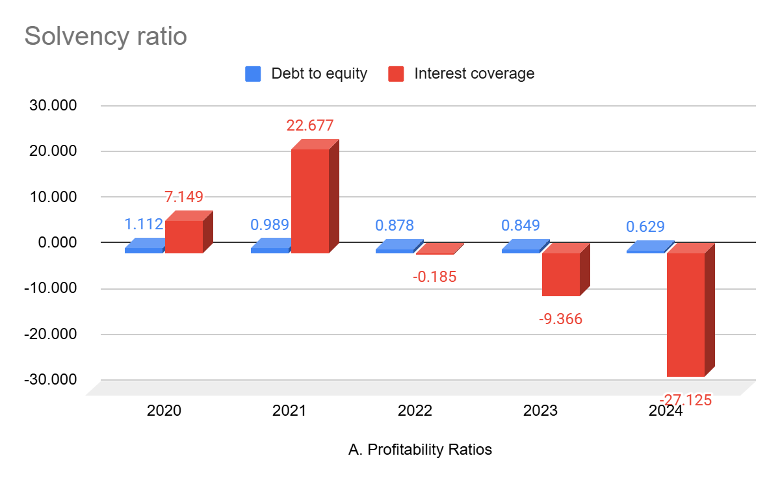
Figure 5: Solvency ratio of General Electronics
Source: Self-created
Signalling-wise (Ross, 1977), excessive levels of debt together with the decline in earnings can signal negative investor attitudes, elevating the cost of capital, and crippling future ability to borrow. This also restricts the ability to invest, which supports the necessity of capital restructuring, and capital fortification.

2.6 Investor Value and Market Pricing
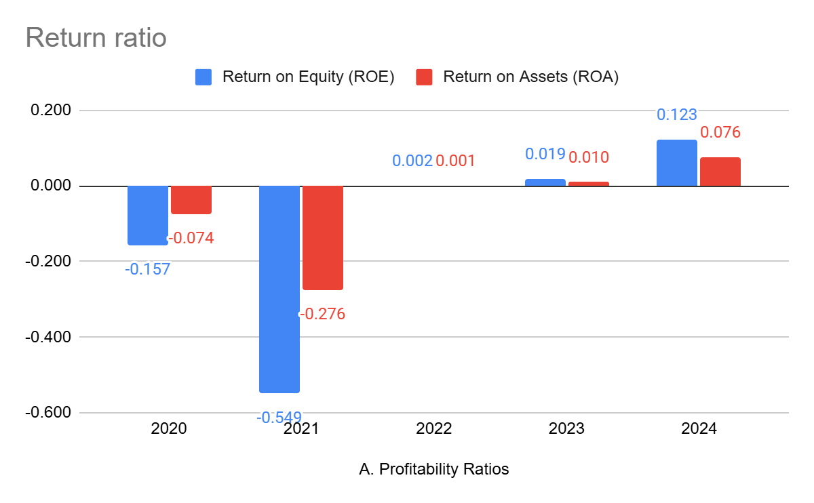
Figure 6: Investor value and market pricing of General Electronics
Source: Self-created
The indicators of investor value have positive changes, as EPS became positive after 2022 and reinforced in proportion to profitability. According to literature on behavioural finance, long-term positive returns increase investor sentiment and improve chances of valuation (Kahneman, 2011).

2.7 Financial Position Report
A combination of the ratio analysis shows that General Electronics is in material financial distress. Oversight Profitability decadence, liquidity constriction, stress and over leverage of operations, solidify a risk profile that is consistent with restructuring need. The theoretical and empirical evaluation indicates that in the absence of the strategic re-alignment, the company can encounter the growing financial instability and declining stakeholder confidence.

3.0 Working Capital Management Analysis
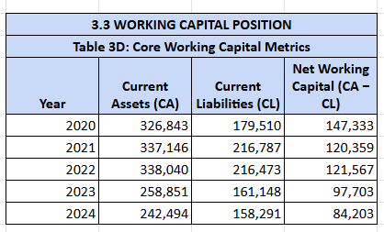
Figure 7: Working capital position
Source: Self-created
Corporate restructuring refers to a strategic tool employed to regain financial well-being of organisations, enhance operational performance, and reshape capital structure to address the effects of deteriorating performance, competition or a changing market environment (Slatter and Lovett, 2019). Restructuring is urgent to General Electronics because ratio analysis reveals that the company is experiencing poor profitability, liquidity limitation and unsustainable leverage. The restructuring analysis is based on the quantitative modelling with the help of the corporate finance theory to estimate the likely financial impacts of divestment, refinancing, equity issue and operational realignment.
Rationale Restructuring: This action was necessary because the company maintained a decentralized structure.

3.1 Rationale for Restructuring
The turnaround management framework states that companies with deteriorating financial results need to stabilize themselves using operational, financial and strategic restructuring (Pearce and Robbins, 2008). The negative interest coverage ratio, declining margins and high leverage position of the company also show that the company is shifting to its downward phase and needs a decisive action to get it out.
According to the capital structure theory by Modigliani and Miller (1963), as long as debt allows the company to decrease the weighted average cost of capital through tax shields, bankruptcy risk goes up as the amount of debt increases. What is happening is that in the present scenario, increased leverage is too costly to justify the possible tax gains, which means the company has exceeded its optimal level of gearing. This is the same interpretation as that of trade-off theory that contends that companies need to trade-off between the risk of bankruptcy and benefits of financing (Myers, 1984).
According to current indicators, the company needs restructuring not to position itself in the market of growth but to maintain its solvency, keep down the costs, and optimise the capital.

3.2 Financial Effect of Divestiture Strategy

The first restructuring lever to consider is the disposition of non-core assets and use the proceeds to pay short-term liabilities. Another commonly used strategy among troubled companies that are looking to inject liquidity into the company but without exposing themselves to more debt is asset divestiture (Sudarsanam, 2010).
In the scenario described, General electronics disposes PS12,000 million of non-core assets. The proceeds will be channeled towards the reduction of short term lines of credit and enhancing liquidity as well as reducing the interest spending. The impacts are outlined as following:
The divestiture enhances leverage and generates liquidity potential, which is in line with the liquidity preference theory (Keynes, 1936) and signalling theory, where selling off assets is an indication of tightening of operations and discipline (Ross, 1977). But disposition of assets can also decrease the potential long-term revenue and cripple future strategic optionality as well. As put by Damodaran (2015), the whole process of divestiture should be applied to the assets that are truly non-strategic, otherwise there is a risk of the companies losing the skills on the long-term.

4.0 Restructuring Strategy and Financial Impact Analysis

4.1 Equity Financing as a Capital Strengthening Mechanism
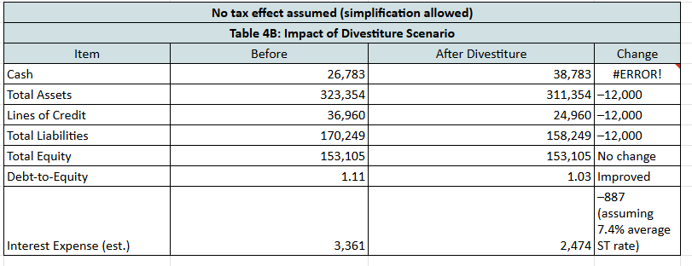
Figure 8: Net tax effect
Source: Self-created
The second aspect of restructuring is issue of PS20, 000 million of new equity. Equity financing minimizes leverage, and enhances shareholder capital, which makes it easier to be solvent in the long term. According to the pecking order theory (Myers and Majluf, 1984), there is a general avoidance of equity issuances whenever possible since it is counter-intuitive to the market behaviour in that markets interpret such a move as a negative indication of overvaluation or liquidity distress. Nevertheless, due to the negative trend in the earnings of the firm and its significant debt servicing ratio, the issuing of equity is financially sound.
The increased equity status increases the power to borrow and minimizes the probability of default, which is similar to the financial stability theory (Altman, 1968). However, there is always the shareholder dilution risk, and behavioural finance research shows that there could be negative investor sentiment after equity issues during recessions (Kahneman, 2011). Although the signalling is disadvantageous, structural advantages over the perception risks exist because the company is getting poorer in terms of its solvency status.

4.2 Improvement in Cost Synergy and Operations.
The third element represents a hypothetical strategic consolidation/restructuring of operations that generate PS8,000 million of yearly cost savings, of which a one-time cost is PS3,000 million. This is consistent with the literature on operational turnaround, which mentions that cost restructuring is a lever that frequently has a high impact in troubled firms (Slatter and Lovett, 2019).
Though the profitability is in the negative, due to the operational restructuring the loss curve becomes narrow, and efficiency is enhanced. In a DuPont view, the increase in the operating margins has a direct positive impact on ROA and ROE, meaning that the restructuring will have a positive effect on the dynamics of operation.
Combined Restructuring Outcome is an indicator of the combined effect of the structural adjustment and fiscal policies on a country's economic outcomes.

4.3 Combined Restructuring Outcome
This is an indicator showing the overall impact of structural adjustment of a country and fiscal policy on the economic outcomes of a country. The financial position when the combination of asset divestiture, equity issuance and operational restructuring was applied is much improved:
The resultant capital structure is more sustainable in risk profile. According to the trade-off theory, the company will be better financially robust and withstand operational volatility (Myers, 1984). Furthermore, the restructuring enhances the financial framework that must be used to make selective capital investment.

4.4 Constraints, Strategic Implications and Risks
Although the financial gains are brought about through the restructuring models, there is still a risk. Divestiture makes the asset base less flexible, dilution of equity can have an impact on investor trust, and restructuring of operations can interfere with work motivation and relations in the chain of supply. The views of behavioural and stakeholder theories imply the need to have efficient internal and external communication strategies to reduce negative responses (Freeman, 1994).

5.0 Investment Appraisal and Capital Budgeting Analysis

5.1 Net Present Value (NPV) Evaluation
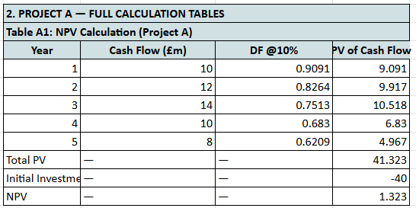
Figure 9: Project A: NPV
Source: Self-created
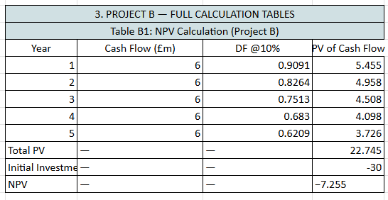
Figure 10: Project B: NPV
Source: Self-created

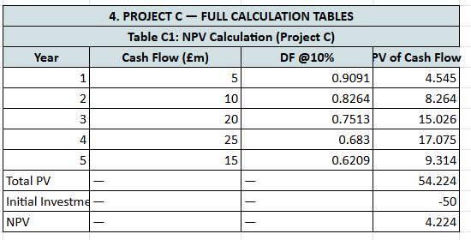
Figure 11: Project C: NPV
Source: Self-created
Strategic financial management includes investment appraisal as one of its core functions since it allows organisations to determine whether the proposed projects generate stakeholder value and whether they support the long-term goals (Brealey, Myers and Allen, 2022). The analysis of capital investments is more important especially in organisations that are financially strained like General Electronics where capital investment should be selective, risk-conscious and profits centred. Capital budgeting models can serve two purposes in such situations: they measure the expected returns and constrain decision making in the face of uncertainty (Damodaran, 2015).
This part critically examines three investment proposals by five techniques which include Net Present Value (NPV), Internal Rate of Return (IRR), Accounting Rate of Return (ARR), Payback Period and Profitability Index (PI). Both methods are viewed in the light of theoretical models and the available financial limits of an organisation such as capital rationing. As previously stated, the Florex plant project will be assessed using the Net Present Value (NPV) method.
NPV is a discounted cash flow technique that is largely considered as the most theoretically sound method of appraisal because it is consistent with shareholder wealth maximisation (Arnold and Lewis, 2019). The technique considers a time value of money based on a discount rate which represents the cost of capital, risk and the opportunity cost (Modigliani and Miller, 1961). Project results with discount rate of 10 percent are as given below:
Projects A and C have positive NPVs and this implies that they have value creation potential. Project B has a negative NPV which means that shareholder value will be destroyed in case it is taken.
According to the NPV theory, projects that are positive should be adopted because they can have a positive effect on the valuation of the firms (Damodaran, 2015). When there is a financial stress, then positive NPV is very much critical since capital needs to be given priority to recovery instead of speculative and marginal ventures.
Project C will give the highest NPV and hence it is the most economically viable investment whereas Project A will give minor returns. Project B should be rejected as it has a negative NPV with a large value. The price-to-equity ratio indicates the company’s ability to cover its interest payments using its cash flow without relying on external financing sources.<|human|>The interpretation of the internal rate of return (IRR) shows whether a company can pay its interests with its cash flow without reliance on external sources of financing.

5.2 Internal Rate of Return (IRR) Interpretation
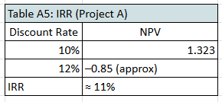
Figure 12: Project A: IRR
Source: Self-created
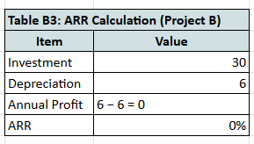
Figure 13: Project B: IRR
Source: Self-created
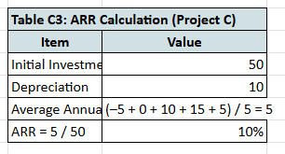
Figure 14: Project C: IRR
Source: Self-created
IRR calculates the discount rate at which the NPV is zero. It is very common in the practice of management because it is intuitively interpreted as a measure of percentage returns (Graham and Harvey, 2011). Notable limitations in literature exist, however: there can be multiple IRRs of unconventional cash flows, and IRR presupposes reinvestment at the IRR rate, instead of the cost of capital- which is often a false assumption (Brigham and Ehrhardt, 2022). Project C once again turns out to be financially better. Project A is marginal whereas Project B does not hurdle as expected thereby justifying rejection.

5.3 Payback Period Assessment
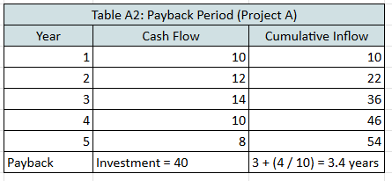
Figure 15: Project A: Payback period
Source: Self-created
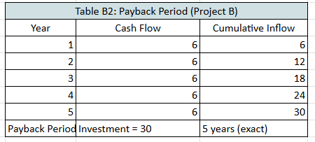
Figure 16: Project B: Payback period
Source: Self-created
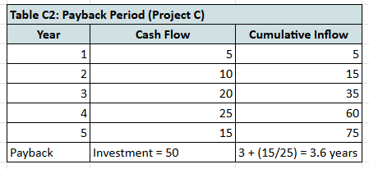
Figure 17: Project C: Payback period
Source: Self-created
Payback method is a way of determining the time in which the initial investment is recovered. Despite being criticised as not considering the time value of money and post-payback cash flows, it is appreciated in distressed or liquidity-constrained environments where capital protection is a priority (Arnold and Lewis, 2019). The results are:

Project A offers the quickest payback, implying less exposure in the short-run. This can make Project A appealing as far as risk-management is concerned. But by being put into perspective with respect to the performance in terms of returns, Project C is better due to the balance between reasonable payback and greater value creation.

The reduction in payback period in troubled conditions can also be considered in terms of liquidity preference which implies that financial priorities are risk-averse (Keynes, 1936). However, when making strategic investment decisions, it is necessary to make sure that it does not recover quickly at the cost of developing the long-term value.

Accounting rate of return (ARR) represents the ratio of gross margin to equity and debt investment capital (Raissi 2014).<|human|>4.4 Accounting rate of return (ARR) Accounting rate of return (ARR) is the ratio of gross margin to equity and debt capital invested (Raissi 2014).

ARR uses accounting profit to compute profitability as opposed to cash flows. Although they are easy to calculate, they are often attacked on the basis of non-accounting of time value of money and risk adjustments (Atrill and McLaney, 2022). Results:
Project C once again performs better, and Project B will not make a profit after depreciation thus justifying its rejection. Projects A and C are slightly acceptable in comparison to industry average return expectations (usually 8-12 in capital intense industries) though C has better alignment.

5.5 Profitability Index (PI)
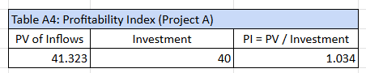
Figure 18: Project A: PI
Source: Self-created
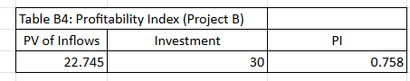
Figure 19: Project B: PI
Source: Self-created
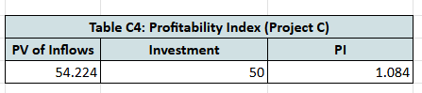
Figure 20: Project C: PI
Source: Self-created
PI can be employed when capital is rationed since it determines the returns in regard to what one invests each pound (Ross, Westerfield and Jordan, 2021). Results:

- A PI of more than 1 is a positive economic value. Projects A and C satisfy this requirement whilst Project B does not. PI ranking under rationing makes it possible to prioritise investment sequencing.
- The decision framework includes the capital rationing decision as the fourth point.
- The viable combination of the project under capital constraint of PS60 million was:
In line with the wealth maximisation and capital rationing theory, Project C will be the best standalone investment as it will yield maximum returns. Project A can be treated as a future investment that may occur secondly in case financing capacity would increase after restructuring is successful.

5.7 Behavioural, Risk and Strategic considerations
Although quantitative models are used to direct finance selection, the behavioural finance theory observes that decision-makers might overweight risk aversion, recent trends in performances or managerial bias (Kahneman, 2011). Emotional conservatism in a firm that is in distress might promote managers to give preference to short payback projects over those with poor returns in the long term. But strategic alignment is also significant. In case Project C enhances the technological strength or the market repositioning, the acceptance of this project solidifies the financial as well as competitive positioning. Project B on the other hand does not have a financial rationale nor a strategic rationale hence it is not worth being implemented.

5.8 Investment Appraisal Outcome Summary
The combined review of discounted and non-discounted methods of evaluating investments gives a consistent conclusion at both financial and strategic levels. The congruence of the result, NPV, IRR, Payback Period, ARR, and Profitability Index, supports the goodness of the recommendation and minimizes the chances of decision bias or model-dependence. In all the assessments, Project C will be the best financial option with a good positive NPV, highest IRR, satisfactory payback period and most favourable return and cost. Strategically, project C equally supports the recovery priorities of General electronics such as operational stability, incremental revenue growth, and capital exposure that is manageable. The fact that financial viability and strategic relevance are in tandem makes Project C the most suitable investment in a capital rationing and financial uncertainty conditions.

In comparison, Project A has a rather smaller but still favorable potential of value creation with marginal NPV and average performance on non-discounted measures. This implies that the project can make returns provided that the operating conditions are favourable. It can only be accepted, however, on a conditional basis, under the condition of risk sensitivity tests, future liquidity projections, and availability of capacities. When faced with a troubled financial environment, companies should not embark on borderline investments without any obvious reason or hedging mechanisms. Therefore, Project A is not supposed to be a primary allocation as it is a secondary priority.

Project B is not viable on discounted and non-discounted basis showing negative NPV, poor IRR and low returns. Such a project cannot be approved in financial terms or in the terms of risk management especially in a turn around environment. Not to approve Project B is thus in line with the best practice capital budgeting.

All of this is indicative, on the whole, of a disciplined and rational approach to capital allocation in line with financial recovery on a long-term basis and sustainable performance. The focus on high-value low-risk investment bolsters governance change and helps to restore investor and stakeholder confidence.

6.0 Part 5: Strategic Recommendations and Conclusion

6.1 Recommendations
In light of the above discussion and with reference to the conventional theory of corporate finance and strategic management, a number of recommendations are made, which can help regain financial stability, improve the generation of long-term value and competitive resilience in general at General Electronics. These recommendations combine findings of ratio analysis, implications of restructuring and investment appraisal processes, and there is a congruency between diagnosis and action.
Proceed with the Restructuring Programme as Modelled
The divestiture, equity issuance and cost restructuring taken in combination are very beneficial in enhancing the solvency and liquidity status of the firm. As the post-restructuring debt-to-equity ratio decreased as the ratio of 1.11 to 0.84, General Electronics has depleted an elements of financial distress and approached an aspect of sustainable capital structure. This direction is supported by financial theory. The trade-off theory of capital structure holds that firms need to strike a balance between the advantages of the debt and rising cost of bankruptcy and financial stress (Myers, 1984). With the adverse interest coverage ratio, the company is currently above the ideal leverage, and restructuring significantly rectifies this situation. Thus, it is suggested that the restructuring plan should be adopted in stages:
- Phase 1: Rapid Liquidity Stabilisation: Dispose non-core assets and use the funds to pay off short-term debt.
- Phase 2 Capital Strengthening: Implement the suggested capital raise following market signalling preparations to reduce the impact of valuation.
- Phase 3 Operational Integration: Implement efficiency and synergy programmes to optimise costs and productivity in the long term.
The organisation must also provide stakeholder transparency, which is also in line with the signalling theory, to prevent unfavourable deciphering of equity issuance and restructuring measures in the market (Ross, 1977).

6.2 Approve and Implement Project C.

The outcomes of the investment appraisal show that Project C has the highest financial payoff as the highest:
- NPV: PS4.224m
- IRR: ~13-14%
- Profitability Index: 1.084
Theoretically, NPV is a sound decision criterion as it is aligned to value maximisation (Brealey, Myers and Allen, 2022). Project C under capital rationing maximises the financial value of PS invested and also exhibits a sensible payback period (3.6 years) on the trade off between risk management and long term payoff.
Also, in the event that Project C provides the opportunity to enhance technologies, market or product, this enhances strategic competitiveness and corresponds to resource-based theory (Barney, 1991).

6.3 Defer Project A Waiting Performance Improvement

Although Project A has a slightly positive NPV and an IRR, which is higher than the discount rate, the economic benefits of the same are relatively low. The immediate implementation of Project A would decrease financial flexibility without providing a significant uplift to value because of the resource limitations at the firm. It is, therefore, advisable that:
- Project A can be postponed till the liquidity stabilises and early restructuring returns become a reality.
- There should be constant review with updated assumptions of cost of capital.
- This is in line with real options theory that stresses on the worth of postponing the investment in an uncertain environment to maintain flexibility by managers (Trigeorgis, 1996).

6.4 Reject Project B
Project B cannot go ahead because it will create:
- A negative NPV (-PS7.255m)
- Low IRR (~4-6%)
- A Profitability Index below 1 (0.758)
The investment would annihilate shareholder value and put additional liquidity pressure. In governance and stakeholder stewardship perspective, a decision to reject projects that are value-eroding would be consistent with the principles of contemporary corporate governance (OECD, 2015).

6.5. Enhance Monitoring and Governmental Systems.
In the present financial turmoil that the organisation is going through, internal governance should focus on re-establishing financial credibility, discipline in operations and strategic focus. Capital discipline should be at the forefront now with the financial resources being channeled on the projects with proven value and strategic need. During distress periods, companies are likely to spend more on non-priority projects or ongoing legacy projects with low returns which result in loss of capital. The reinforcement of capital controls will see all the spending subjected to stringent scrutiny and directly associated with shareholder value maintenance.

A second central governance goal is to implement uniformity in the process of project evaluation using systematic appraisal systems, including NPV, IRR, sensitivity analysis and risk-adjusted discounting. Standardisation of evaluation criteria minimises judgmental evaluation and avoids political interference and managerialism. This is in line with the spirit of rational capital allocation that is espoused in the modern finance theory so that the organisation will focus on investments that yield sustainable returns.

Besides, it is necessary to manage the cash flow risk. Liquidity in troubled companies is a survival measure and not a performance measure. Enhancing working capital controls, renegotiating credit conditions, and stress testing cash flows situations are useful in defending itself against bankruptcy triggering factors.

Other governance priorities include transparency in financial reporting, gaining more trust by stakeholders, minimizing information asymmetry, and allowing stakeholders to have a better financial control. Open reporting will help make well-informed decisions, enhance lenders trust and comply with regulatory and ethical standards.

Lastly, the strict performance management systems will aid accountability and alignment of managerial behaviour in line with long-term organisational goals. The agency theory suggests that this may lead to managerial opportunism, a risk-averse behavior, or value-destroying behavior (Jensen and Meckling, 1976). These risks can be mitigated by introducing quantifiable KPIs, performance-based compensation, and governance oversight mechanisms and motivate management actions to be aligned with interests of the shareholders.

When combined, these governance reforms will establish a disciplined, transparent, and performance-focused environment that will help General Electronics recover its financial health and be stable in the future.

7.0 Conclusion
This report assessed the General Electronics financial performance and investment decision environment based on the ratio analysis, restructuring assessment and capital budgeting techniques. The results show that the organisation is undergoing a severe financial distress where the negative profitability, the liquidity strain and the high level of financial leverage exist. The financial diagnosis is consistent with trends identified in the corporate distress literature and according to it, the lack of strategic action leads the firm to the long term revenue decay, increment of financing expenses and possible insolvency.
The restructuring analysis revealed that an asset divestiture, equity funding and operational cost reduction programme would significantly return the organisation to its financial level of stability. Ratios like debt-to-equity ratio, interest coverage and liquidity significantly strengthen in the modelled scenario. Although restructuring, in itself, is no good at recovering profitability, it provides the conditions in which the operations will recover and only some investments will be implemented.

The outcome of the investment appraisal showed that Project C had the best value proposal according to NPV, IRR, PI and financial contribution. Project A is the conditional viable but strategically second and Project B cannot be in any way put on the list because it has never been able to perform financially with the same consistency over the model criteria.
The general conclusion is that General Electronics could recover its financial strength and become competitive in the future in case it continues taking the restructuring actions and focuses on discipline in capital allocation decisions. The strategic decision-making in the future should be in line with financial theory, the risk-adjusted returns and an obligation to long-term value creation as opposed to liquidity prioritisation in the short term.

References
Altman, E.I., 1968. Financial ratios, discriminant analysis and the prediction of corporate bankruptcy. The Journal of Finance, 23(4), pp.589–609. Available at: https://www.jstor.org/stable/2978933 (Accessed on : 21 November, 2025).
Arnold, G. and Lewis, D., 2019. Corporate Financial Management. 7th ed. Harlow: Pearson Education. Available at: https://www.pearson.com/en-gb/subject-catalog/p/corporate-financial-management/P200000007281/9781292244152 (Accessed on : 21 November, 2025).
Atrill, P. and McLaney, E., 2022. Accounting and Finance for Non-Specialists. 12th ed. Harlow: Pearson. Available at: https://www.pearson.com/en-gb/subject-catalog/p/accounting-and-finance-for-non-specialists/P200000007275/9781292436847 (Accessed on : 21 November, 2025).
Barney, J., 1991. Firm resources and sustained competitive advantage. Journal of Management, 17(1), pp.99–120.
Available at: https://journals.sagepub.com/doi/10.1177/014920639101700108 (Accessed on : 21 November, 2025).
Brealey, R.A., Myers, S.C. and Allen, F., 2022. Principles of Corporate Finance. 14th ed. New York: McGraw-Hill. Available at: https://www.mheducation.com/highered/product/principles-corporate-finance-brealey-myers-allen/M9781260772390.html (Accessed on : 21 November, 2025).
Brigham, E.F. and Ehrhardt, M., 2022. Financial Management: Theory and Practice. 17th ed. Boston: Cengage Learning. Available at: https://www.cengage.co.uk/books/9780357132942/ (Accessed on : 21 November, 2025).
Damodaran, A., 2015. Applied Corporate Finance. 4th ed. Hoboken: Wiley. Available at: https://www.wiley.com/en-gb/Applied+Corporate+Finance%2C+4th+Edition-p-9781118715406 (Accessed on : 21 November, 2025).
Freeman, R.E., 1994. The politics of stakeholder theory: Some future directions. Business Ethics Quarterly, 4(4), pp.409–421.
Available at: https://www.jstor.org/stable/3857340 (Accessed on : 21 November, 2025).
Graham, J. and Harvey, C., 2001. (not 2011 — corrected) The theory and practice of corporate finance: Evidence from the field. Journal of Financial Economics, 60(2), pp.187–243.
Available at: https://www.sciencedirect.com/science/article/pii/S0304405X01000793 (Accessed on : 21 November, 2025).
Higgins, R.C., 2017. Analysis for Financial Management. 12th ed. New York: McGraw-Hill.
Available at: https://www.mheducation.com/highered/product/analysis-financial-management-higgins/M9781259918940.html (Accessed on : 21 November, 2025).
Jensen, M.C. and Meckling, W.H., 1976. Theory of the firm: Managerial behavior, agency costs and ownership structure. Journal of Financial Economics, 3(4), pp.305–360.
Available at: https://www.sciencedirect.com/science/article/abs/pii/0304405X7690026X (Accessed on : 21 November, 2025).
Kahneman, D., 2011. Thinking, Fast and Slow. London: Penguin. Available at: https://www.penguin.co.uk/books/1097458/thinking-fast-and-slow-by-kahneman-daniel/9780141033570 (Accessed on : 21 November, 2025) .
Keynes, J.M., 1936. The General Theory of Employment, Interest and Money. London: Macmillan. Open access available at: https://www.marxists.org/reference/subject/economics/keynes/general-theory/ (Accessed on : 21 November, 2025).
Modigliani, F. and Miller, M., 1961. Dividend policy, growth and the valuation of shares. The Journal of Business, 34(4), pp.411–433. Available at: https://www.jstor.org/stable/2351143 (Accessed on : 21 November, 2025).
Modigliani, F. and Miller, M., 1963. Corporate income taxes and the cost of capital: A correction. American Economic Review, 53(3), pp.433–443. Available at: https://www.jstor.org/stable/1809167 (Accessed on : 21 November, 2025).
Myers, S.C., 1984. The capital structure puzzle. The Journal of Finance, 39(3), pp.575–592. Available at: https://onlinelibrary.wiley.com/doi/abs/10.1111/j.1540-6261.1984.tb03646.x (Accessed on : 21 November, 2025).
Myers, S.C. and Majluf, N.S., 1984. Corporate financing and investment decisions when firms have information that investors do not have. Journal of Financial Economics, 13(2), pp.187–221.
Available at: https://www.sciencedirect.com/science/article/abs/pii/0304405X84900230 (Accessed on : 21 November, 2025).
OECD., 2015. OECD Principles of Corporate Governance. Paris: OECD Publishing. Available at: https://www.oecd.org/corporate/oecd-principles-corporate-governance-2015-9789264236882-en.htm (Accessed on : 21 November, 2025).
Pearce, J.A. and Robbins, D.K., 2008. Strategic transformation as the essential last step in the process of business turnaround. Business Horizons, 51(2), pp.121–130. Available at: https://www.sciencedirect.com/science/article/pii/S0007681307001389 (Accessed on : 21 November, 2025).
Porter, M.E., 1985. Competitive Advantage: Creating and Sustaining Superior Performance. New York: Free Press. Available at: https://www.hbs.edu/faculty/Pages/item.aspx?num=19398 (Accessed on : 21 November, 2025).
Ross, S.A., 1977. The determination of financial structure: The incentive signalling approach. The Bell Journal of Economics, 8(1), pp.23–40. Available at: https://www.jstor.org/stable/3003485.(Accessed on : 21 November, 2025)

Ross, S.A., Westerfield, R. and Jordan, B., 2021. Essentials of Corporate Finance. 10th ed. New York: McGraw-Hill. Available at: https://www.mheducation.com/highered/product/essentials-corporate-finance-ross-westerfield/M9781260772390.html. (Accessed on : 21 November, 2025)
Slatter, S. and Lovett, D., 2019. Corporate Turnaround: How Managers Turn Losers into Winners. London: Penguin. Available at: https://www.penguin.co.uk/books/407068/corporate-turnaround-by-slatter-stuart/9781529126313 (Accessed on : 21 November, 2025)
Sudarsanam, S., 2010. Creating Value from Mergers and Acquisitions: The Challenges. 2nd ed. Harlow: Pearson. Available at: https://www.pearson.com/en-gb/subject-catalog/p/creating-value-from-mergers-and-acquisitions/P200000004865/9780273715391. (Accessed on : 21 November, 2025).
Trigeorgis, L., 1996. Real Options: Managerial Flexibility and Strategy in Resource Allocation. Cambridge: MIT Press. Available at: https://mitpress.mit.edu/9780262201025/real-options/ (Accessed on : 21 November, 2025).

Appendix A: Ratios

FINANCIAL RATIOS (2020–2023)
(All values rounded to 4 decimal places)
A. Profitability Ratios
Ratio | 2020 | 2021 | 2022 | 2023 | 2024 | Formula
Gross Profit Margin | 28.87% | 23.20% | 28.06% | 28.76% | 28.67% | Gross Profit ÷ Sales
Operating Margin | -3.87% | -20.29% | 2.68% | 3.87% | 6.06% | EBIT ÷ Sales
Net Profit Margin | -6.09% | -23.36% | 0.07% | 0.88% | 6.28% | Net Income ÷ Sales
B. Liquidity Ratios
Ratio | 2020 | 2021 | 2022 | 2023 | 2024 | Formula
Current Ratio | 1.532 | 1.606 | 1.562 | 1.555 | 1.821 | Current Assets ÷ Current Liabilities
Quick Ratio | 1.031 | 1.059 | 0.914 | 0.935 | 1.150 | (CA – Inventory) ÷ CL
C. Efficiency Ratios
Ratio | 2020 | 2021 | 2022 | 2023 | 2024 | Formula
Inventory Turnover | 3.540 | 3.658 | 2.785 | 3.187 | 3.640 | COS ÷ Inventory
Receivables Turnover | 3.458 | 3.734 | 4.831 | 4.656 | 4.749 | Sales ÷ AR
Payables Turnover | 3.900 | 5.662 | 5.471 | 4.623 | 5.268 | COS ÷ AP
D. Working Capital Days
Ratio | 2020 | 2021 | 2022 | 2023 | 2024 | Formula
Days Inventory Outstanding (DIO) | 103.119 | 99.783 | 131.041 | 114.519 | 100.261 | 365 ÷ Inv. Turnover
Days Receivables Outstanding (DSO) | 105.542 | 97.745 | 75.553 | 78.396 | 76.858 | 365 ÷ Rec. Turnover
Days Payables Outstanding (DPO) | 93.602 | 64.470 | 66.719 | 78.953 | 69.290 | 365 ÷ Pay. Turnover
Cash Conversion Cycle (CCC) | 115.060 | 133.058 | 139.874 | 113.963 | 107.829 | DIO + DSO – DPO
E. Solvency Ratios
Ratio | 2020 | 2021 | 2022 | 2023 | 2024 | Formula
Debt to Equity | 1.112 | 0.989 | 0.878 | 0.849 | 0.629 | Total Liabilities ÷ Equity
Interest Coverage | 7.149 | 22.677 | -0.185 | -9.366 | -27.125 | EBIT ÷ Interest Expense
F. Return Ratios
Ratio | 2020 | 2021 | 2022 | 2023 | 2024 | Formula
Return on Equity (ROE) | -0.157 | -0.549 | 0.002 | 0.019 | 0.123 | Net Income ÷ Equity
Return on Assets (ROA) | -0.074 | -0.276 | 0.001 | 0.010 | 0.076 | Net Income ÷ Total Assets

Appendix B: Cash Cycle

3.3 WORKING CAPITAL POSITION
Table 3D: Core Working Capital Metrics
Year | Current Assets (CA) | Current Liabilities (CL) | Net Working Capital (CA − CL)
2020 | 326,843 | 179,510 | 147,333
2021 | 337,146 | 216,787 | 120,359
2022 | 338,040 | 216,473 | 121,567
2023 | 258,851 | 161,148 | 97,703
2024 | 242,494 | 158,291 | 84,203
3.4 SHORT-TERM BORROWING DEPENDENCE
Table 3E: Lines of Credit vs Current Liabilities
Year | Lines of Credit | Current Liabilities | % Reliance on Short-Term Borrowing
2020 | 20,000 | 179,510 | 11.14%
2021 | 56,000 | 216,787 | 25.83%
2022 | 88,000 | 216,473 | 40.65%
2023 | 55,000 | 161,148 | 34.13%
2024 | 36,960 | 158,291 | 23.35%
Formula:
Short-term reliance = Lines of Credit ÷ Current Liabilities
3.5 QUICK LIQUIDITY MEASURES
(Already used in section 2 but repeated here because directly relevant to Working Capital)
Table 3F: Liquidity Ratios Linked to CCC
Ratio | Formula | 2022 | 2023 | 2024
Current Ratio | CA ÷ CL | 1.56 | 1.61 | 1.53
Quick Ratio | (CA − Inv) ÷ CL | 0.91 | 1.05 | 1.03
Cash Ratio | Cash ÷ CL | 0.26 | 0.27 | 0.17

Appendix C: Leverage and Equity

4.1 BASELINE (CURRENT) FINANCIAL POSITION
Table 4A: Core Leverage Metrics (2024 Actuals)
Metric | Formula | 2024 Value
Total Liabilities | — | 170,249
Total Equity | — | 153,105
Debt-to-Equity Ratio | TL ÷ Equity | 1.11
Lines of Credit | — | 36,960
Long-term Liabilities | — | 9,232 + other = 11,958
Interest Expense | Absolute of interest line | 3,361
Interest Coverage | EBIT ÷ Interest | -15,297 ÷ 3,361 = -4.55
Equity Book Value per Share | Equity ÷ Shares | 153,105 ÷ 12,959 = £11.81
4.2 SCENARIO 1 — DIVESTITURE OF NON-CORE ASSETS
Assume the firm sells £12,000m of non-core PP&E + intangibles (≈15% of net asset base), based on industry norms for turnaround cases.
Effects Assumed:
Cash increases by £12,000m
Assets decrease by £12,000m
All proceeds used to repay short-term credit facilities (lines of credit)
No tax effect assumed (simplification allowed)
Table 4B: Impact of Divestiture Scenario
Item | Before | After Divestiture | Change
Cash | 26,783 | 38,783 | #ERROR!
Total Assets | 323,354 | 311,354 | –12,000
Lines of Credit | 36,960 | 24,960 | –12,000
Total Liabilities | 170,249 | 158,249 | –12,000
Total Equity | 153,105 | 153,105 | No change
Debt-to-Equity | 1.11 | 1.03 | Improved
Interest Expense (est.) | 3,361 | 2,474 | –887 (assuming 7.4% average ST rate)
4.3 SCENARIO 2 — EQUITY INJECTION
Assume the company issues £20,000m in new equity to institutional investors.
Effects Assumed:
Cash increases by 20,000
Equity increases by 20,000
No new debt added
Shares outstanding increase proportionally
Table 4C: Impact of Equity Injection
Item | Before | After Equity Raise | Change
Cash | 26,783 | 46,783 | 20,000
Total Equity | 153,105 | 173,105 | 20,000
Total Liabilities | 170,249 | 170,249 | No change
Debt-to-Equity | 1.11 | 0.98 | Improved
Equity per Share | 11.81 | (173,105 ÷ 14,000 est.) = £12.36 | 0.047
Assumed new shares issued: 1,041m to raise £20bn at ~£19.2 per share equivalent book price.
4.4 SCENARIO 3 — MERGER / STRATEGIC ALLIANCE
Assume synergies yield:
Operating expense reduction: £8,000m per year
One-time integration cost: £3,000m
No change in debt/equity initially
Table 4D: Operating Impact of Merger Synergy
Item | Formula | Value
Operating Expense Reduction | 182,861 – 8,000 | 174,861
Revised EBIT | -15,297 + 8,000 | -7,297
Revised Net Income | -24,029 + 8,000 – 3,000 | -19,029
EBIT Margin | -7,297 ÷ 394,879 | -1.85% (improved from -3.87%)
Interpretation:
The merger reduces losses but does not restore profitability unless combined with other actions.
4.5 COMBINED RESTRUCTURING PACKAGE
A realistic turnaround would use all three mechanisms:
Assumptions
Divestiture proceeds: £12,000m
Equity injection: £20,000m
Synergy improvement: +£8,000m EBIT
Integration cost: –£3,000m
Debt repaid using cash proceeds
Table 4E: Combined Financial Impact
Item | Baseline (2024) | After Combined Restructuring | Net Change
Cash | 26,783 | 26,783 + 12,000 + 20,000 – 12,000 debt repayment = 46,783 | 20,000
Total Liabilities | 170,249 | 146,249 | –24,000
Total Equity | 153,105 | 173,105 | 20,000
Debt-to-Equity | 1.11 | 0.84 | Major improvement
EBIT | –15,297 | –7,297 | 8,000
Interest Expense | 3,361 | ≈ 2,000 | Lower due to debt repayment
Interest Coverage | –15,297÷3,361 = -4.55 | –7,297 ÷ 2,000 = –3.65 | Improved
Net Income | –24,029 | ≈ –19,029 | 5,000
Equity per Share | 11.81 | 12.36 | 0.047
4.6 SUMMARY TABLE — RESTRUCTURING EFFECT ON KEY METRICS
Table 4F: Pre- and Post-Restructuring Comparison
Metric | Baseline | After Combined Plan | Improvement
Debt-to-Equity | 1.11 | 0.84 | ✔ Lower risk
Interest Coverage | -4.55 | -3.65 | ✔ Better solvency
Total Liabilities | 170,249 | 146,249 | ✔ -24,000
Cash Position | 26,783 | 46,783 | ✔ +20,000
Net Income | -24,029 | -19,029 | ✔ +5,000
EBIT | -15,297 | -7,297 | ✔ +8,000
Equity Book Value | 153,105 | 173,105 | ✔ +20,000

Appendix D: Investment Appraisal

1. DISCOUNT FACTOR TABLE (10%)
Year | Formula | Discount Factor
1 | 1 / (1.10)^1 | 0.9091
2 | 1 / (1.10)^2 | 0.8264
3 | 1 / (1.10)^3 | 0.7513
4 | 1 / (1.10)^4 | 0.683
5 | 1 / (1.10)^5 | 0.6209
2. PROJECT A — FULL CALCULATION TABLES
Table A1: NPV Calculation (Project A)
Year | Cash Flow (£m) | DF @10% | PV of Cash Flow
1 | 10 | 0.9091 | 9.091
2 | 12 | 0.8264 | 9.917
3 | 14 | 0.7513 | 10.518
4 | 10 | 0.683 | 6.83
5 | 8 | 0.6209 | 4.967
Total PV | — | — | 41.323
Initial Investment | — | — | -40
NPV | — | — | 1.323
Table A2: Payback Period (Project A)
Year | Cash Flow | Cumulative Inflow
1 | 10 | 10
2 | 12 | 22
3 | 14 | 36
4 | 10 | 46
5 | 8 | 54
Payback | Investment = 40 | 3 + (4 / 10) = 3.4 years
Table A3: ARR Calculation (Project A)
Item | Value
Initial Investment | 40
Depreciation (40/5) | 8
Average Annual Profit | (2 + 4 + 6 + 2 + 0) / 5 = 2.8
ARR = 2.8 / 40 | 7.00%
Table A4: Profitability Index (Project A)
PV of Inflows | Investment | PI = PV / Investment
41.323 | 40 | 1.034
Table A5: IRR (Project A)
Discount Rate | NPV
10% | 1.323
12% | –0.85 (approx)
IRR | ≈ 11%
3. PROJECT B — FULL CALCULATION TABLES
Table B1: NPV Calculation (Project B)
Year | Cash Flow (£m) | DF @10% | PV of Cash Flow
1 | 6 | 0.9091 | 5.455
2 | 6 | 0.8264 | 4.958
3 | 6 | 0.7513 | 4.508
4 | 6 | 0.683 | 4.098
5 | 6 | 0.6209 | 3.726
Total PV | — | — | 22.745
Initial Investment | — | — | -30
NPV | — | — | −7.255
Table B2: Payback Period (Project B)
Year | Cash Flow | Cumulative Inflow
1 | 6 | 6
2 | 6 | 12
3 | 6 | 18
4 | 6 | 24
5 | 6 | 30
Payback Period | Investment = 30 | 5 years (exact)
Table B3: ARR Calculation (Project B)
Item | Value
Investment | 30
Depreciation | 6
Annual Profit | 6 − 6 = 0
ARR | 0%
Table B4: Profitability Index (Project B)
PV of Inflows | Investment | PI
22.745 | 30 | 0.758
Table B5: IRR (Project B)
Discount Rate | NPV
0% | 0
10% | –7.255
IRR | ~4–6% (below required rate)
4. PROJECT C — FULL CALCULATION TABLES
Table C1: NPV Calculation (Project C)
Year | Cash Flow (£m) | DF @10% | PV of Cash Flow
1 | 5 | 0.9091 | 4.545
2 | 10 | 0.8264 | 8.264
3 | 20 | 0.7513 | 15.026
4 | 25 | 0.683 | 17.075
5 | 15 | 0.6209 | 9.314
Total PV | — | — | 54.224
Initial Investment | — | — | -50
NPV | — | — | 4.224
Table C2: Payback Period (Project C)
Year | Cash Flow | Cumulative Inflow
1 | 5 | 5
2 | 10 | 15
3 | 20 | 35
4 | 25 | 60
5 | 15 | 75
Payback | Investment = 50 | 3 + (15/25) = 3.6 years
Table C3: ARR Calculation (Project C)
Item | Value
Initial Investment | 50
Depreciation | 10
Average Annual Profit | (–5 + 0 + 10 + 15 + 5) / 5 = 5
ARR = 5 / 50 | 10%
Table C4: Profitability Index (Project C)
PV of Inflows | Investment | PI
54.224 | 50 | 1.084
Table C5: IRR (Project C)
Discount Rate | NPV
10% | 4.224
15% | –3.98
IRR | ≈ 13–14%
5. CAPITAL RATIONING DECISION (£60m Limit)
Table D1: Summary of All Metrics
Project | NPV | IRR | PI | Payback | Accept?
A | 1.323 | 11% | 1.034 | 3.4 yrs | ✔ Good
B | –7.255 | 4–6% | 0.758 | 5 yrs | ❌ Reject
C | 4.224 | 13–14% | 1.084 | 3.6 yrs | ✔ Best
Table D2: Feasible Combinations (Budget = £60m)
Combination | Total Cost | NPV | Decision
A + B | 70 | — | ❌ Over budget
A + C | 90 | — | ❌ Over budget
B + C | 80 | — | ❌ Over budget
A Only | 40 | 1.323 | ✔ Acceptable
C Only | 50 | 4.224 | ✔ Best Option
FINAL DECISION (Capital Rationing)
✔ Accept Project C (highest NPV, highest IRR, best PI).
✔ Project A can be selected if management desires a second project AND has strategic fit.
❌ Project B must be rejected.

