

Investigation into the
administrative tools required to establish a
Community Amateur Sports Association
(CASA)

Research Proposal
by
Martin Darzins

Supervisor: Mr. James Williams

Proposal submitted as part of the requirements
for the award of BSc (Hons) Applied Computing

21st October 2022

Table of Contents
2 introduction 4
2.1 Proposal Structure 5
3 background research 6
4 aims & objectives 8
4.1 Aims 8
4.2 Objectives 8
4.3 Expected Outcomes & Deliverables 8
5 project design 9
5.1 Process Outline 10
5.1.1 Mixed Approach 10
5.1.2 Selected Databases & Searches 10
5.2 Data Collection 11
5.3 Data Evaluation 12
5.3.1 Quantitative Analysis 13
5.3.2 Qualitative Analysis 13
5.4 Risks & Limitations 16
5.5 Ethical Issues 17
5.6 Reliability, Generalisability, Validity 18
5.6.1 Reliability 18
5.6.2 Generalisability 18
5.6.3 Validity 18
6 resources & planning 19
6.1 Hardware 19
6.2 Software 19
6.3 Other – (Information, Human) 19
6.4 Planning (Gantt Chart) 20
7 reference list 21
8 bibliography 24
9 appendices 27
10 Abbreviations 28

Figure 1 - Waterfall & Agile Techniques (image courtesy of trustradius.com [3]) 9
Figure 2 - Research Onion (image courtesy of Prentice Hall [4]) 9
Figure 3 - Data Evaluation (image courtesy cdsmr.com [15]) 12
Figure 4 - Case Study (image courtesy favpng.com [24]) 14
Figure 5 - Grounded (image courtesy youtube.com [25]) 14
Figure 6 - Phenomenology (image courtesy owlcation.com[26]) 15
Figure 7 - Thematic (image courtesy scientific editing [27]) 15
Figure 8 - Risks (image courtesy workfront.com [28]) 16
Figure 9 - Ethics Form 17

Table 1 - Lifespan Strength & Balance (image courtesy gov.uk [2]) 6
Table 2 - Hypothesis 12
Table 3 - Mitigations 16
Table 4 - Planning (Gantt Chart) 20

introduction
As a student studying BSc (Hons) Applied Computing at UWTSD Swansea, it is recognised that the University’s Applied Computing module not only incorporates a far-reaching range of technical skills appropriate for the IT industry, but also features extensive project management, leadership skills and communication prerequisites.
It is the combination of both these technical skills and management processes, that ideally suit the Research Proposal herein endorsed, an ‘Investigation into the administrative tools required to establish a Community Amateur Sports Association (CASA)’.
This research will enable others to more readily establish their own ‘not-for-profit’ CASA and thus help support wider governmental ambitions to promote greater physical and mental health, improve personal well-being and welfare, through the promotion of greater physical activity.
Initial current literature reviews have identified gaps in offering a comprehensive approach to establishing a CASA. This resultant procedural and Web application details will help resolve the problem. It will provide communities with full information and IT tool package details, that further deliver positive social impacts, making sport more readily available.
CASA’s cater for an extensive range of varied sporting activities; therefore, this proposal will limit itself to that of forming a Walking Football Club serving the local community of Llanelli, Carmarthenshire, but the major principles described therein will be applicable to the vast majority of CASA’s.
The sport of Walking Football is similar to that of the ‘beautiful game’, but where players walk instead of running; designed to help people improve their fitness and maintain an active lifestyle. It helps support people getting back into physical activities despite their gender, age, fitness or ability, however this project is focused more on older adults.
This proposal will establish appropriate procedural guidelines and a technical website facility to assist in and promote the establishment of a CASA for local communities but will be specifically partnered with Evans & Williams Sports & Football Club.
The results being an increase in mature aged adult participation in Walking Football, the establishment of a CASA, the creation of guideline documentation and an appropriate functional Walking Football website.

Proposal Structure
This Research proposal will adhere to the following structure:
- Introduction
- Research Background
- Aims & Objectives
- Project Design
- Resources & Planning
- References
- Bibliography
- Appendices
- Abbreviations

background research
Regular physical activity provides a range of physical and mental health, and social benefits, many of which are increasing issues for individuals, communities and society
The government’s 2019 consultative green paper [1] states;
“ …that becoming more active is good for our mental and physical health and reduces our risk of developing a number of health conditions.”
As strength and balance deteriorates over lifespans, greater physical activity is encouraged, to stave off disability [2].
Table 1 - Lifespan Strength & Balance (image courtesy gov.uk [2])
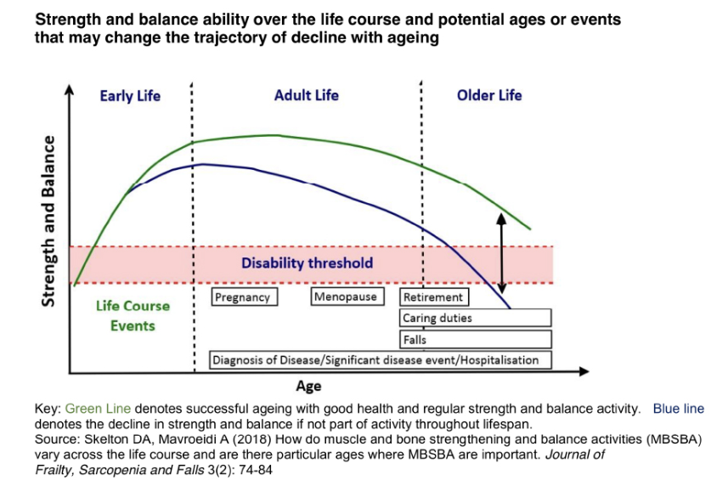
Walking Football is being played by more-and-more mature aged adults as a way to have fun, keep physically fit and spend time with friends. Expanding the number of CASA facilities will increase participation and assist in meeting government aims.
This project partners with Evans & Williams Sports Club to focus on making CASA Walking Football more widely available for all within the community, without discrimination, but with an immediate focus on the older adult aged groups 50+.
By enabling and encouraging greater participation in the sport and for individuals to become more physical active, will promote welfare, well-being and mental health in the community. Reducing isolation and loneliness, through team camaraderie, greater social contact and inter-action within the club, thus supporting government guidance.
An initial literature review reveals disparate scholarly academic, official government and football federation information on the subject matter. The bibliography details further on-going reviews intended to be undertaken.

aims & objectives

Aims
Due to time constrictions and efforts to limit the scope, the overarching Aim of this study will be restricted in structure to answering the Research question of;
‘How can mature aged adult participation in local community sport be increased?’

Objectives
This Aim will be achieved by ‘establishing a suitably effective local CASA’ and through utilisation of SMART techniques and criteria, the following objectives are to;
- Analyse local needs through surveys, interviews & questionnaires
- Develop a Project Plan c/w Mind Map & Gantt chart, incorporating Agile Development
- Design a suitable Website utilising Wireframe, Scope & Requirement Statements (MoSCoW)
- Evaluate processes, procedures, guidelines & flowcharts

Expected Outcomes & Deliverables
The expected outcomes will be a determination as to whether a CASA is required within the community studied and if so, realise an increase in mature aged adult participation in Walking Football.
The deliverables will be the establishment of a CASA, including various procedural guideline documentation and an appropriate functional Walking Football website.

project design
Project creation will be via a sequential and structured SDLC Waterfall approach, using Agile Development techniques, where Agile is the methodology following an iterative approach used for project management purposes and SDLC is a process of design and development of a product or service [3].
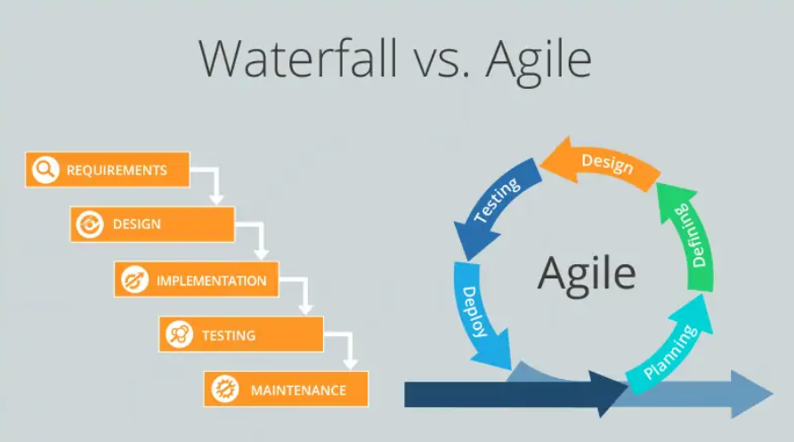
Figure 1 - Waterfall & Agile Techniques (image courtesy of trustradius.com [3])
The appropriate research strategy and data collection methods will enable sufficient progress to be made, allowing analysis and conclusions to be constructed.
Typical research philosophies, approaches, strategies, and data collection methods are shown in the ‘Research Onion’ [4].
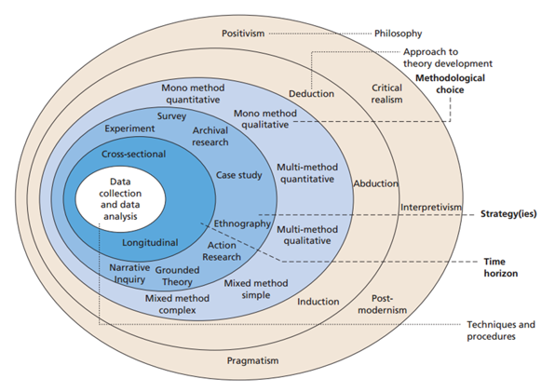
Figure 2 - Research Onion (image courtesy of Prentice Hall [4])

Process Outline

Mixed Approach
For this project, the Mixed Approach philosophy of Positivism and Phenomenology, along with both Inductive and Deductive research approaches will be initially selected.
Research Philosophy is a crucial element of Research Methodology and is a view on the manner in which data is collected, analysed and used [5].
Philosophy selection will impact research and can be classified as;
- ontology (study of being based on the reality of existence),
- epistemology (nature of knowledge – what is known to be true) and
- axiology (in the philosophy of research what is and why something is valuable).
Typically, a project Research Methodology will consist of 3 elements, with selections being made between;
- Philosophy - Positivism (factual knowledge, quantitative data, led by science) [6] &/or Phenomenology (focusing on conscious experiences, thoughts, perceptions and emotions) [7].
- Research Reasoning Approach either Inductive (Phenomenological) where observation is first [8] or Deductive (typically Positivistic) where the idea is first [9].
- Data collection strategies where the collection methods and results are triangulated and compared to ensure validity.

Selected Databases & Searches
To uncover appropriate databases and source materials, related to the selected project, keywords will be identified from within the project Aim and proposed Research question.
Developing a Concept Map systematic approach (as opposed to a centre-out Mind Map), results in the identification of these key themes and words. Concept maps detail top-down concepts, in a hierarchical order focusing on (and answering) the specific question/problem, in the form of an explaining sentence.
The following databases are determined as a digital resource of information and will be used in the search for high quality, reliable information;
- UWTSD library
- Google Scholar
- Wiley Online Library
To maximise search results, further filter research methods, including Boolean tools, to be used are;
- Hashtags
- Joining words via “ “
- Using asterisk * for any variations/wildcard options
- Boolean logic operators of AND, NOT, OR.
Deploying the above techniques will uncover more appropriate question related databases, websites and scholarly articles.

Data Collection
Data collection methods directly measure variables and gather information to gain knowledge and insights into the research problem [10].
High quality data collection is obtained by taking the time to explain the research paper and recording in a systematic manner [11].
This Project will embrace Multiple Methods of data collection in achieving its Aim & Objectives, ensuring the validity of the research by incorporating Triangulated Research [12] using;
- Research and investigation into a local community (Llanelli) and in particular a single Organisation (Evans & Williams) membership, identifying the need.
- Verbal data collection method (interview).
- Survey/Questionnaire techniques will be designed, justifications stated, piloted (potentially via SurveyMonkey) to gather data, either handed out in-person, undertaken online.
- and the vitally important Literature review, which will strengthen the evaluation processes, highlight any missing knowledge or contradictions and will identify already undertaken project relevant, current, secondary information research/sources, for example: ”Practical Approach to an Amateur Sports Club Activities Development” – see Bibliography.
Eisenhardt, 1989 [13] argues that it is best to;
‘combine data collection methods such as archive searching, interviews, questionnaires and observations. The evidence may be qualitative (e.g., words), quantitative (e.g., numbers) or both’.
Therefore, the Data collection activities will include both Quantitative (expressed in numbers & graphs and analysed via statistical methods - Surveys) along with Qualitative data (expressed in words and analysed through interpretation and categorisation – Literature review) type questions. This will help overcome the potential basis of a single method approach, as will;
- Mixed use of both Open and Closed type questions.
- Collection of secondary data incorporating the CRAP methodology of how (Current, Relevant, Authoritative, Accurate and fit for Purpose), the information is.
Furthermore, a Research question Hypothesis can be determined and assessed, in terms of;
Table 2 - Hypothesis
Research Question | Hypothesis | Null Hypothesis
How can mature aged adult participation in local community sport be increased? | Increasing the number of CASA’s will result in a greater number of mature aged adults in sport participation. | Increasing the number of CASA’s will have no effect on mature aged adults in sport participation.

Throughout, on-going small surveys will be conducted to acquire greater in-depth Feedback, which may alter the design of the project’s practical implementation, recommendations and conclusions.
As all feedback including unexpected/critical feedback, if responded with “Thank you tell me more” (2014, Dr. J.Izzo) [14], will help review the project from different perspectives, and give greater understandings of the topic and to the people it relates to.

Data Evaluation
Data evaluation will be conducted via both Quantitative and Qualitative analysis, which are different, but not opposite each other; they are different philosophies when used together providing valuable intelligence to enable informed decision making [15].
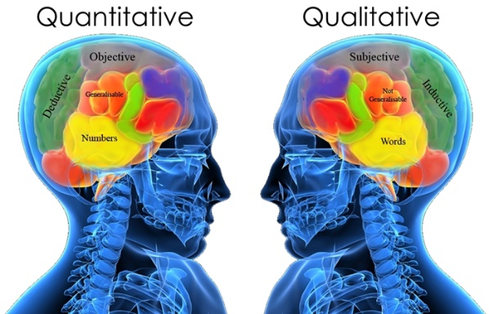
Figure 3 - Data Evaluation (image courtesy cdsmr.com [15])

Quantitative Analysis
This number-based technique uses mathematical and statistical modelling, measurement and research, to understand behaviour in terms of a numerical value to quantify attitudes, opinions, behaviours, or variables with types including graphs, linear regressions and hypothesis testing [16].
It provides statistical methods of organising and examining the data to forecast the probability of a particular event happening and discover patterns in the data collected. Graphs in various formats are the most frequently used analytical tools to visualise and organise the data, with the histogram graph being the most common [17,18].
Typically, quantitative analysis can show number of occurrences from data collection methods such as: online & paper surveys and questionnaires, telephone interviews and polls, and whilst this forms a key element of the research process, the data needs to be examined and can be analysed in a number of diverse ways [19], such as;.
- Descriptive: analysis converts the collected raw statistical data into a perspective view and reasoning (arguments), using text descriptions, numbers, charts, tables and graphs. It is a data-set snap-shot that produces a more easily understood summary, commonly utilised within the project’s primary research analysis stage. The conclusions drawn from these arguments are known as Inferential Analysis.
- Hypothesis testing: is commonly employed to assess a new product/service or gain insight into public opinion. Used to determine the probability of an event having the same response or characteristic under specific conditions, its accuracy depends largely on the size of the sample population, randomly selecting from the population, accuracy of the questions, and errors in collecting the information.

Qualitative Analysis
Useful in understanding complex situations, Qualitative analysis is a scientific research method used to obtain non-numerical subjective data, based on non-quantifiable information, acquiring data by studying subjects in their natural habitat. It seeks to gain a deeper insight, through understanding the users experience into a research issue [20].
Primarily words, perceptions and feelings based, it focuses on understanding the why and how of human behaviour in situations, helping discover patterns/trends and gain an understanding of people’s experience, reasons, opinions and motivations, offering theories/explanations as to the analysis [21].
Collecting and analysing methods include no-numerical data from unstructured interviews, user testing focus groups, surveys, observations and secondary research, the many types of Qualitative analysis include the following [22,23];
- Case study - Triangulates different data sources to assess the degree of convergence and compile a bigger conclusion.
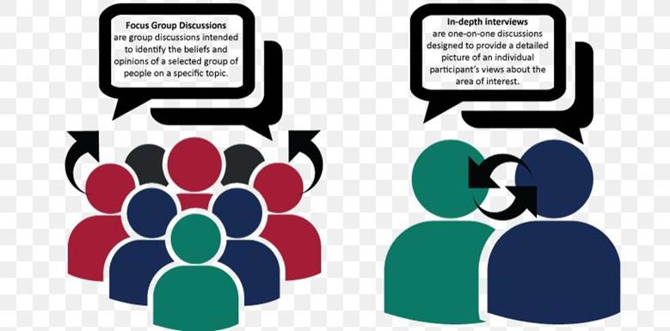
Figure 4 - Case Study (image courtesy favpng.com [24])
- Grounded - Explains why actions evolved, developing theoretical models and creating new theories through inductive reasoning.

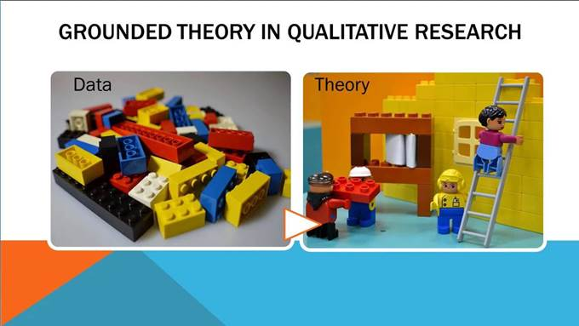
Figure 5 - Grounded (image courtesy youtube.com [25])
- Phenomenology - subject-centred study of an event as it happens, it is primarily a perception-based research method.


Figure 6 - Phenomenology (image courtesy owlcation.com[26])
- Thematic - text based qualitative method that identifies patterns and themes in transcripts.
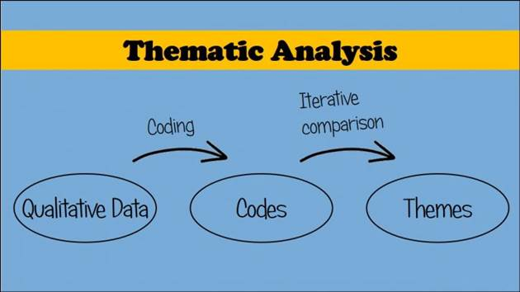
Figure 7 - Thematic (image courtesy scientific editing [27])

Risks & Limitations
Whilst there are a number of potential risks to this project, the main are those related to Quality, Scope, Time, Cost, Benefits and Risk itself [28].
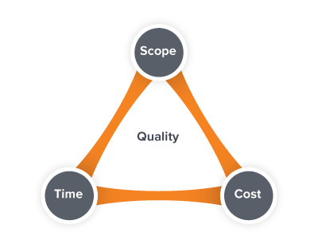
Figure 8 - Risks (image courtesy workfront.com [28])
Specific project Risks & Mitigations are detailed in Table 2 items 1 – 12, typical project issues are shown in additional items 13 – 18.
Table 3 - Mitigations
Item | Risks & Limitations | Contingencies & Mitigations
1 | Lack of Planning. | Create Project Plan, Roles, Responsibilities & RACI matrix.
2 | Insufficient Time to complete project. | Gantt chart.
3 | Project milestone/completion dates missed. | Weekly UWTSD Supervisor meetings.
4 | Deficient scope details. | Scope Statement.
5 | Unsatisfactory requirement specifications. | Requirements Statement.
6 | Scarce local community interest. | Market Research.
7 | Defective data and equipment security. | GDPR and Security dept reviews.
8 | No back-up – hardware & system. | Employ triple back-up : UPS, Server, Storage (RAID)
9 | Flawed software. | Employ skilled practitioners.
10 | Network and internet connectivity unavailable | Review back-up and Disaster Recovery Plans
11 | Project/scope creep. | Maintain & limit work to objectives/deliverables set.
12 | Too many ‘Must have’ MoSCoW features. | Limit requirements to achievable expectations.
13 | Unrealistic expectations. | Team and Stakeholder feedback and review.
14 | Cost overruns exceed budgetary amount. | Monitor spend.
15 | Budget inadequate to fulfil project scope. | Early Stakeholder buy-in.
16 | Staff expertise, capabilities and skills wanting. | Early engagement with HR & internal Training depts.
17 | Project not financially viable. | Review with Finance and Stakeholders
18 | Quality of work below expectations. | Ensure strong leadership.

Ethical Issues
Ethical research matters for scientific integrity, human rights and dignity, and collaboration between science and society. These principles make sure that participation in studies is voluntary, informed, and safe [29].
In order for Research to be conducted in and by University students, it needs to be undertaken in accordance with commonly agreed standards of good practice, the Concordat to Support Research Integrity, and must abide by the UWTSD Ethical Code of Practice, recognising that the core aspects of research integrity include:
- Honesty
- Transparency and open communication
- Care and respect
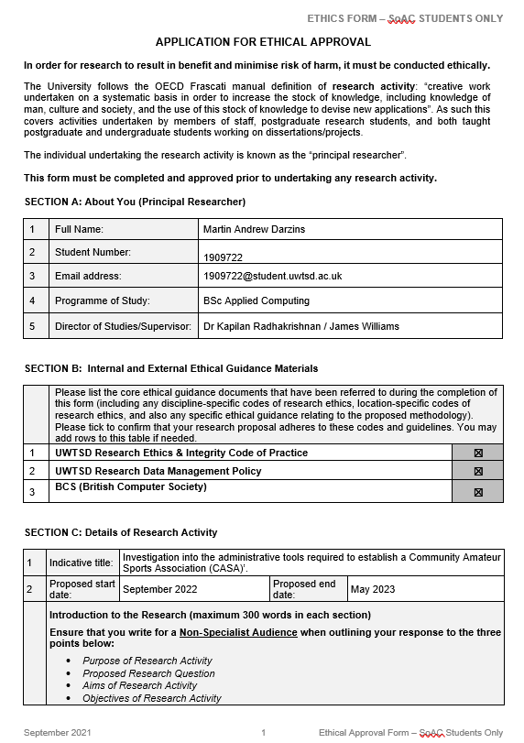
Figure 9 - Ethics Form
UWTSD Ethical approval has been requested for this project to ensure the Researcher gives appropriate Ethical consideration to the research proposal, safeguarding the Researcher and others.
This Application currently awaits sign-off from an ethics perspective, before that part of work which requires approval is being sought, begins.

Reliability, Generalisability, Validity
In order to ensure Research Validity, Reliability and Generalisability, this project will deliberate both the practical elements and ability to collect and consider the data collected, as quality Research projects need to be reliable and valid, requiring endorsed measurements with reproducible test results [30].
Appropriate sampling strategies will cater for how the acquisition of data will impact the research.
Limit the number of respondents for Qualitative data (interviews/focus groups) due to time and resources, limited people available with relevant experience and knowledge, by using Typical and Unusual case, Snowball and Random sampling methods.
Similarly limit the numerical data (Quantitative) responses, but should many results become available, incorporate mathematical probabilities to sample a ‘fair representation’ of the population studying, via Random, Systematic, Stratified and Cluster sampling methods.

Reliability
All Research projects gain credibility from reliable consistent results gained from experiments & user feedback. Validity from accurate measurements accordant with other established theories, typically from Literature reviews.
Multiple Data collection and Triangulation methodologies will assist, as will the comparing of Secondary literature review against primary research test findings.
Questionnaires require careful planning and designing to make easily repeatable in the same manner. Clearly documented, with consistent collection methods, ensuring all participants are given the same details under the same non-biased conditions.

Generalisability
Generalisability is the degree to which the research findings, based on a sample, can be applied to the whole or target population. It is not possible to achieve absolute generalisability but is increased by considering factors such as the characteristics of the participants and response rate. A High response rate or multiple tests and steps to increase reliability & validity will boost the project’s generalisability.

Validity
For valid generalisable results, the appropriate sample population required is defined specific to the research project, in this case all mature aged adults in the local Llanelli community area, to ensure sufficient participants, which are generally representative of the target population. Research errors, faulty research procedures, poor samples and inaccurate or misleading measurement, can undermine validity.
The above strategy will ensure enhanced project research validity, reliability and generalisability [31].

resources & planning
The following resources have currently been identified as being required;

Hardware
- Laptop Computer
- Internet connection

Software
- Web applications, HTML, CSS
- Javascript, JQuery, ThemeRoller, Python
- GIS software, MapInfo
- Tableau
- Microsoft Visio and related Word/Excel products
- Access to Web tools, W3Schools, books, articles and websites
- Web design guidelines for usability and accessible issues
- UWTSD & Wiley Online Library access to journals
- Google Scholar

Other – (Information, Human)
- Participants to survey, question for information and feedback
- Project supervisor for, help, guidance, feedback and direction
- Banking facilities
- Sponsorship contacts
- Local Council & Community Centres
- Existing local Walking Football clubs & CASA’s
- Membership to relevant Football Associations (FAW, WWFF)
- Training facilities (via Evans & Williams- Coleg Sir Gar (Graig Campus)

Planning (Gantt Chart)
The Gantt chart extracts below, detail the proposed method of project planning and managing the various activities required to complete the project. Expanded details can be viewed via Appendix 1.
The main headings of Literature Review, Design, Evaluation and Build & Test, have been broken down into various tasks, with individual timeframes initially allocated. These are subject to change as the project progresses and supervisor guidance dictates.
Table 4 - Planning (Gantt Chart)
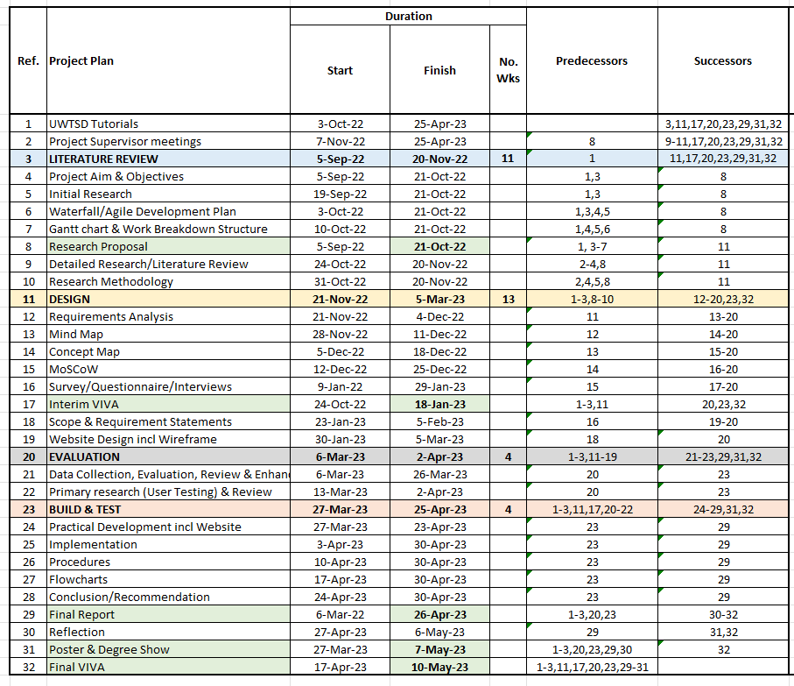

reference list

[1] gov.uk, “Advancing Our Health: Prevention in the 2020s – consultation document”,
2019. [Online]. ISBN: 978-1-5286-1545-7, Published 22 July 2019.
Available:https://www.gov.uk/government/consultations/advancing-our-health-prevention-in-the-2020s/advancing-our-health-prevention-in-the-2020s-consultation-document
[Accessed: Oct, 16, 2022].

[2] gov.uk, “Health matters: physical activity - prevention and management of long-term conditions”,
2020. [Online]. Published 23 January 2020.
Available:https://www.gov.uk/government/publications/health-matters-physical-activity/health-matters-physical-activity-prevention-and-management-of-long-term-conditions
[Accessed: Oct, 16, 2022].

[3] trustradius.com, “Agile vs Waterfall: What is the Difference? Which is Best for You?”, 2021. [Online].
Available: https://www.trustradius.com/buyer-blog/difference-between-agile-vs-waterfall
[Accessed: Oct, 16, 2022].

[4] P. Lewis M. Saunders, and A. Thornhill, “Research Methods for Business Students”, 4th ed., 2006.
Harlow, FT. Prentice Hall.
ISBN13: 9780273701484.

[5] S.G. Thakurta, P. Chetty, “Understanding research philosophy”, Jun, 25, 2015. [Online].
Available: https://www.projectguru.in/research-philosophy/
[Accessed: Oct, 16, 2022].

[6] J. Dudovskiy, “Positivism Research Philosophy”, 2022. [Online].
Available: https://research-methodology.net/research-philosophy/positivism/
[Accessed: Oct, 16, 2022].

[7] J. Dudovskiy, “Phenomenology”, 2022. [Online].
Available: https://research-methodology.net/research-philosophy/phenomenology/
[Accessed: Oct, 16, 2022].

[8] J. Dudovskiy, “Inductive Approach (Inductive Reasoning)”, 2022. [Online].
Available:https://research-methodology.net/research-methodology/research-approach/inductive-approach-2/
[Accessed: Oct, 16, 2022].

[9] J. Dudovskiy, “Deductive Approach (Deductive Reasoning)”, 2022. [Online].
Available:https://research-methodology.net/research-methodology/research-approach/deductive-approach-2/
[Accessed: Oct, 16, 2022].

[10] scribbr.com, "Research Design: Choosing your Data Collection Methods", May, 12, 2021. [Online].
Available: https://www.youtube.com/watch?v=q17s84ADGfA>
[Accessed: Oct, 16, 2022].

[11] emeraldgrouppublishing.com, “How to…Design a research study”, 2022. [Online].
Available: https://www.emeraldgrouppublishing.com/how-to/research-methods/design-a-research-study
[Accessed: Oct, 16, 2022].

[12] H. Noble, R. Heale, “Triangulation in research, with examples”, 2019. [Online].
Available: https://ebn.bmj.com/content/22/3/67
[Accessed: Oct, 16, 2022].

[13] Eisenhardt, K. M., “Building Theories from Case Study Research,”
Academy of Management Review, Vol 14, No 4”, pp. 532-550. 1989. [Online].
Published Online: 1 Oct 1989 https://doi.org/10.5465/amr.1989.4308385
Available: https://journals.aom.org/doi/full/10.5465/amr.1989.4308385
(Accessed: Oct, 16,2022).

[14] youtube.com, “5 Words That Will Improve Your Ability to Receive Feedback”, Apr. 01, 2014. [Online].
Available: https://www.youtube.com/watch?v=4BpPtjKpJZM
[Accessed: Oct, 16, 2022].

[15] B. Crenshaw, "Qualitative & Quantitative Research - The CDS Way", 2016. [Online].
Available: https://www.cdsmr.com/newsworthy/qualitative-quantitative-research-the-cds-way
[Accessed: Oct, 16, 2022].

[16] C. Larmore, “What Are the Different Types of Quantitative Analysis Tools?”. 2022. [Online].
Available:https://www.smartcapitalmind.com/what-are-the-different-types-of-quantitative-analysis- tools.htm
[Accessed: Oct, 16, 2022].

[17] S. Few, “Now you see it: simple visualization techniques for quantitative analysis”, 2009.
Oakland, CA. Analytics Press. Pg 319-321.
ISBN 9780970601988.

[18] guides.auraria.edu, “Data Visualization: Quantitative vs. Qualitative”, 2022. [Online].
Available: https://guides.auraria.edu/c.php?g=528873&p=3964258
[Accessed: Oct, 16, 2022].

[19] planningtank.com, “Quantitative Data – Types, Analysis, Methods, Pros-Cons & Examples”, 2020. [Online].
Available: https://planningtank.com/market-research/quantitative-data
[Accessed: Oct, 16, 2022].

[20] humansofdata.atlan.com, “Your Guide to Qualitative and Quantitative Data Analysis Methods”,2018. [Online].
Available: https://humansofdata.atlan.com/2018/09/qualitative-quantitative-data-analysis-methods/
[Accessed: Oct, 16, 2022].

[21] V. Cross, ”What Is Qualitative Business Metrics?”, 2017. [Online].
Available: https://bizfluent.com/info-8352853-research-analytical-skills-job-applications.html
[Accessed: Oct, 16, 2022].

[22] H. Vashishtha, “5 Types of Qualitative Research Methods”, 2019. [Online].
Available: https://sixthfactor.com/5-types-qualitative-research-methods/
[Accessed: Oct, 16, 2022].

[23] K. Warren, E. Rautenbach, “Qualitative Data Analysis Methods 101: The “Big 6” Methods + Examples”, 2020. [Online].
Available: https://gradcoach.com/qualitative-data-analysis-methods/
[Accessed: Oct, 16, 2022].

[24] image courtesy of favpng.com
https://favpng.com/png_view/marketing-focus-group-interview-case-study-qualitative-research-marketing- png/8YYg1SRC

[25] image courtesy of youtube.com
https://www.youtube.com/watch?v=RUqAgp5ZJXI

[26] image courtesy of owlcation.com
https://owlcation.com/humanities/What-is-Phenomenology-and-Its-Role-In-Consciousness

[27] image courtesy of scientific editing
https://www.scientific-editing.info/blog/how-to-do-a-thematic-analysis/

[28] workfront.com, “Project Constraints”, 2022. [Online].
Available: https://www.workfront.com/project-management/knowledge-areas/project-constraints
[Accessed: Oct, 16,2022].

[29] uwtsd.ac.uk, “Research Ethics & Integrity Code of Practice”, 2020. [Online].
Available: https://www.uwtsd.ac.uk/media/uwtsd-website/content- assets/documents/research/research- ethics-integrity-code-practice.pdf
[Accessed: Oct, 16,2022].

[30] F. Middleton, “Reliability vs Validity in Research, Differences, Types and Examples”, Feb, 17, 2022. [Online].
Available: https://www.scribbr.com/methodology/reliability-vs-validity/
[Accessed: Oct, 16, 2022].

[31] Denzin, N. K., “The Research Act: A Theoretical Introduction to Sociological Methods”, 2017.
Englewood Cliffs, NJ: Prentice Hall.
ISBN: 9780137743810.

bibliography
Literature reviews yet to be undertaken include;

- PRACTICAL APPROACH TO AN AMATEUR SPORTS CLUB ACTIVITIES DEVELOPMENT
Available:https://www.theseus.fi/bitstream/handle/10024/120550/Milan_Tiina.pdf?sequence=1

- The disparate roles of accounting in an amateur sports organisation: The case of logic assimilation in the Gaelic Athletic Association
https://www.emerald.com/insight/content/doi/10.1108/AAAJ-06-2018-3523/full/html

- The amateur sports leadership challenge: A study of who leads amateur sports in America today and how well they practice exemplary leadership
https://www.proquest.com/openview/0992a51029d2cc81d94fba7071f610ee/1?pq-origsite=gscholar&cbl=18750

- MARKETING IN AMATEUR SPORTS: HOW TO MARKET A FLOORBALL CLUB WITH LIMITED RESOURCES
https://www.theseus.fi/handle/10024/97598

- CONTEMPORARY ISSUES AND CHALLENGES OF PROFESSIONAL AND AMATEUR SPORTS IN INDIA
https://oapub.org/edu/index.php/ejep/article/view/2235

- National sports organisations and sponsorship: an identification of best practices
https://www.researchgate.net/profile/Benoit-Seguin-3/publication/237050835_National_sports_organisations_and_sponsorship_An_identification_of_best_practices/links/0deec51b0b6a6e469b000000/National-sports-organisations-and-sponsorship-An-identification-of-best-practices.pdf

- Amateur Sports Clubs. Their Salient Features and Major Advantages “So popular are clubs that in an era of expensive public sports facilities, they continue to provide much needed facilities, organisation, and social support.”
https://journals.sagepub.com/doi/abs/10.1177/101269027801300402

- Volunteering in Community Sports Associations: A Literature Review
https://brill.com/view/journals/vrbr/2/1/article-p1_1.xml

- Spreading of a safety culture in a community of amateur sports practitioners. The case of the French Free Flight Federation (FFVL)
https://hal.archives-ouvertes.fr/hal-03048188/

- Amateur Sports of the Elderly: A Chance for Health and a Higher Quality of Life” the interests of older people so that their involvement in physical activity determines a safe and healthy lifestyle.”
https://www.scirp.org/html/4-2420107_48050.htm

- Three models, one goal: Assessing financial vulnerability in New Zealand amateur sports clubs
https://www.sciencedirect.com/science/article/abs/pii/S1441352312000964

- Prepared for sudden cardiac arrest? A cross-sectional study of automated external defibrillators in amateur sport
https://bjsm.bmj.com/content/47/18/1171.short

- Measuring the formalization of community sports clubs: findings from the UK, Germany and Australia
https://www.tandfonline.com/doi/abs/10.1080/19406940.2015.1006661

- Amis, J. and Slack, T., 1996. The size-structure relationship in voluntary sport organizations. Journal of Sport Management, 10 (1), 76–86. [Google Scholar]

- Cabinet Office, 2013. Giving of time and money: findings from the 2012–13 Community Life Survey [online].
Available: http://communitylife.cabinetoffice.gov.uk/assets/topic-reports/2012-2013-giving-time-and-money-report.pdf. [Google Scholar]
- Harris, S., Mori, K., and Collins, M., 2009. Great expectations: voluntary sports clubs and their role in delivering national policy for English sport. Voluntas, 20, 405–423. doi:10.1007/s11266-009-9095-y [Google Scholar]

- May, T., Harris, S., and Collins, M., 2013. Implementing community sport policy: understanding the variety of voluntary club types and their attitudes to policy. International Journal of Sport Policy and Politics, 5 (3), 397–419. doi:10.1080/19406940.2012.735688 [Taylor & Francis Online], [Google Scholar]

- Nichols, G. and James, M., 2008. One size does not fit all: implications of sports club diversity for their effectiveness as a policy tool and for government support. Managing Leisure, 13, 104–114. doi:10.1080/13606710801933461 [Taylor & Francis Online], [Google Scholar]

- Nichols, G., et al., 2012. The relationship between types of sports club and English government policy to grow participation. International Journal of Sport Policy and Politics, 4 (2), 187–200. doi:10.1080/19406940.2012.662693 [Taylor & Francis Online], [Google Scholar]

- Schulz, J., Nichols, G., and Auld, C., 2011. Issues in the management of voluntary sports organisations and volunteers. In: B. Houlihan and M. Green, eds. Handbook of sports development. London: Routledge, 432–445. [Google Scholar]

- Wicker, P. and Breuer, C., 2013. Understanding the importance of organizational resources to explain organizational problems: evidence from non-profit sport clubs in Germany. Voluntas, 24 (2), 461–484. doi:10.1007/s11266-012-9272-2 , [Google Scholar]

- Register as a community amateur sports club (CASC)
https://www.gov.uk/register-a-community-amateur-sports-club

- The Community Amateur Sports Club (CASC) scheme provides a number of charity-type tax reliefs to support local sports clubs.
https://www.sportenglandclubmatters.com/governance/getting-the-right-structure/casc-article/

- https://www.lbhf.gov.uk/sites/default/files/A_Guide_to_Starting_a_Sports_Club_tcm21-149209.pdf

- https://www.anthonycollins.com/insights/ebriefings/community-amateur-sports-clubs/

- https://www.communitycompanies.co.uk/community-amateur-sports-clubs

- https://www.sport.wales/grants-and-funding/club-support/managing-your-sports-club/club-structures/legal-status/

- http://www.acasc.org.uk/membership/casc.htm

- https://wcva.cymru/

- https://en.wikipedia.org/wiki/Community_amateur_sports_club

- "Community Amateur Sports Clubs". agco.org.uk.

- "Tax guidance for Community Amateur Sports Clubs". H. M. Revenue and Customs. Retrieved 3 August 2014.

- "Qualifying conditions for CASC status". HMRC. Retrieved 3 August 2014.

- ACASC "The Association of Community Amateur Sports Clubs providing compliance information and guidance for individual CASC registered clubs and clubs aspiring to become CASC registered."

- Cascinfo.co.uk "The definitive guide for Community Amateur Sports Clubs"
gov.uk "Gov.uk CASC portal"

- thefa.com "The Football Association CASC guidance for clubs"

- https://www.gov.uk/government/consultations/community-amateur-sports-clubs-casc-scheme

- B. Roseke, “Project Management Fundamentals”, 2021. [Online].
Available: https://www.projectengineer.net/project-management-fundamentals/

- M. Matthew, “What is a Functional Requirement in Software Engineering? Specification, Types, Examples”, 2022. [Online]. Available: https://www.guru99.com/functional-requirement-specification-example.html

- B. Roseke, “How to Write a Project Scope Statement”, 2020. [Online].
Available: https://www.projectengineer.net/how-to-write-a-project-scope-statement/

- E. Quilliam, “What are the Different Software Prototyping Methods?”, 2022. [Online].
Available:https://itenterprise.co.uk/software-prototyping- methods/#:~:text=Extreme%20prototyping%20is%20used%20mostly%20for%20web- based%20applications,created%2C% 20which%20is%20just%20a%20series%20of%20pages.

- scrum.org, “What is SCRUM?”, 2022. [Online].
Available: https://www.scrum.org/resources/what-is-scrum/

- primalspace.co.uk , “Client Requirements for Website Design”, 2016. [Online].
Available:https://www.primalspace.co.uk/client-requirements-website- design/#:~:text=Website%20Design%20Requirements%201%20Your%20Idea%20and%20Vision.,need%20to% 20get%20going%20with%20your%20websites%20build

- balsamiq.com, “Balsamiq wireframes”, 2022. [Online].
Available: https://balsamiq.com/wireframes/

- F. Mojica, “Perfect Properties: Responsive Web App”, 2022. [Online].
Available: https://frankmojica.design/perfect-properties

- wrike.com, “What are Project Management Skills”, 2022. [Online].
Available: https://www.wrike.com/project-management-guide/faq/what-are-project-management-skills/

appendices
Appendix 1 – Gantt Chart
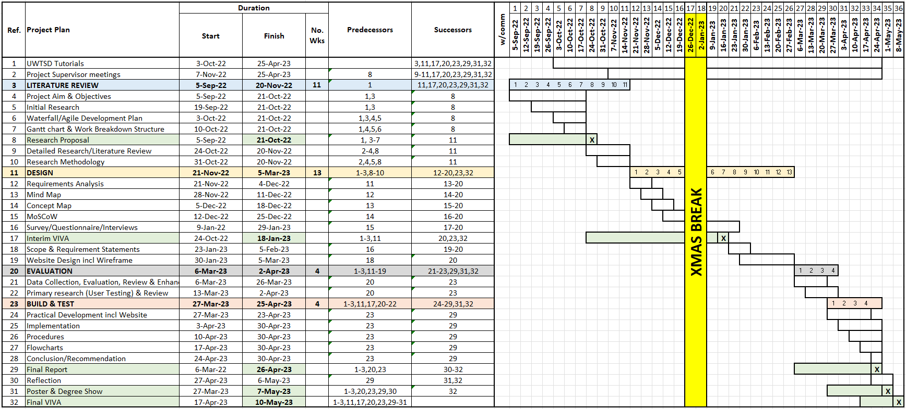

Abbreviations
BSc - Bachelor of Science
CASA - Community Amateur Sports Association
CRAP - Current, Reliable, Authoritative, Purpose (point of view)
CSS - Cascading Style Sheets
DFD - Data Flow Diagram
ERD - Entity Relationship Diagram
FAW - Football Association Wales
GDPR - General Data Protection Regulations
GIS- - Geographic Information System
HR - Human Resources
HTML - HyperText Markup Language
IT - Information Technology
MBSBA - Muscles and Bone Strengthening and Balance Activities
MoSCoW - Must, Should, Could, Won’t
RACI - Responsible, Accountable, Consulted, Informed
RAID - Redundant Array of Inexpensive Disks
SDLC - Software Development Life Cycle
SMART - Specific, Measurable, Achievable, Relevant, Time-bound
SPSS - Statistical Package for the Social Sciences
UPS - Uninterrupted Power Supply
UWTSD - University of Wales Trinity Saint David
WWFF - Wales Walking Football Federation

