Developing Workplace Critical Thinking
Critical Analysis on the Implementation of Old Classical and Modern Management Theories within Richard Branson Virgin Group

Mr Leighton Fernandes (1915091)
University of Wales Trinity Saint David (UWTSD)
10th December 2021
Lecturer: Dr Shehla Khan
BMSW5101

Exclusive summery
This paper concludes that implementing Fredrick Taylors scientific management theory influences performance of employees at Virgin Group to determine scientifically the best methods for performing any task, and for selecting, training, and motivating employees. Herzberg motivation theory which is a new management theory has also been implemented to fill the gap that has been left behind by the old classical management theory, which has influenced Virgin employees with motivator factors. CEO Richard Branson, highly values all his employees and takes personal responsibility to ensure that his beliefs are instilled among all of them, and these values are the reason for Virgin Groups success today. Virgin group has shown they are committed to environmental concerns and Richard Branson is directly involved in several projects that bring issues regarding climate change.

Table of Contents
1.0 Introduction 2
2.0 Main Findings 2
2.1 Values, Beliefs and Attitudes 2
2.2 Fredrick W Taylor Scientific management theory 2
3.0 Recognise assumption 3
3.1 Elevate 3
3.2 Draw Conclusion 4
4.0 Personal Value Assessment using Barret Assessment Model 5
5.0 Conclusion 5
6.0 Reference List 5

1.0 Introduction
Richard Branson is best known for founding the Virgin Group which comprises more than 60 Virgin companies worldwide, employing approximately 71,000 people in over 35 countries (Virgin, 2021). This report will consider the critical analysis of old classical management theories and evaluating supporting evidence on how these management theories are implemented within this organisation in relation to its values, belief, and attitudes and its impact on employees and sustainability. Considering the advantages/disadvantages this theory has on this organisation. Also exploring a new modern management theory and how this theory can bridge any gap that has been left by the old management theory. Using Barratts assessment model the researcher will be matching their own values, beliefs, and attitudes to that of the organisation. This report will show the implementation of Fredrick Taylors scientific management theory, using Toulsman RED model.

2.0 Values, Beliefs and Attitudes
Virgin Group is influenced by the personal beliefs and corporate philosophies that “People are our greatest asset” of its founder, Richard Branson and is one of the reasons for the success of the organisation (Abdul, 2015). Branson highly values all his employees and takes personal responsibility to ensure that his beliefs are instilled among all of them. Virgin group states is ambition is to secure a healthy future and seeks continuous improvements to minimise carbon, energy, waste, and water footprints onboard (Mistry, 2017). Chief Commercial Officer at Virgin Group states’ reducing our carbon footprint is our number one climate action priority and the removal of CO2 directly from the atmosphere has the potential to become a powerful tool in reaching our target of net zero carbon emissions by 2050 (Virgin, 2021).

2.2 Fredrick W Taylor Scientific management theory
Scientific management theory is a management approach formulated by Fredrick W Taylor and other between 1890-1930, that sought to determine scientifically the best methods for performing any task, and for selecting, training, and motivating employees (Oberoi, 2011). The theory suggests that the only way to expand productivity is to raise the efficiency of the workforce. Taylor (1960) scientific theory can be found in the Virgin group business structure showing some signs of organisational bureaucracy in the aspect of selection, training and compensation based on output (Study, 2021). Bureaucracy is a structure in which people are held accountable for their actions because they are required to act in accordance with rules and standard operating procedures (Mbakno, 2021). Although Richard Branson has a reputation for maintaining a relaxing working environment, certain employees have been offered incentives for displaying aspiration to establish their own businesses and exhibiting signs of inventive thinking. Branson believes that the employees are the backbone of the company, and it is important that they have enough involvement and authority in decision making (Preston, 2017). Virgin Group has its own management structure with no attachment to an exact model of management but instead an employment of diverse management concepts all together to shape its own unique style (Virgin, 2021)

3.0 Recognise assumption
Recognising the assumption that Richard Branson highly values his employees. Also exploring Virgin Groups commitment to seeking continuous improvements to minimise carbon, energy, waste, and water footprints.

3.1 Elevate
In order to explain this claim and assumption we need to first investigate the following evidence from a range of sources:

There is data suggesting that Richard Branson has built a successful global business on the principle of putting employees first. The Virgin Group employer brand is down to a leadership style that recognises that happy employees’ equal happy customers. In turn, an unhappy employee can ruin the brand experience for customers (Tucker, 2021). Richard Branson knows that a happy team of staff is important for the business. He operates with the philosophy that if you can put your employees first, your customer second, and shareholders third, in the end the shareholders do well, the customers do better and you yourself are happy (Half, 2018).

A recent study suggests’ the ability that Virgin has is to operate effectively with almost a non-formal structure is because of its unique organisational culture. The culture of the Virgin Group reflects Branson’s casual nature, his hate for hierarchy and formal authority, commitment to employees and consumers and his belief in hard work and responsibility (Roberts, 2016).

Richard Branson states that employees are an important asset for every organisation, and they should be recognised for the efforts they contribute and to celebrate their achievements. In turn, individuals become motivated to work and perform in their jobs. (Ezzely, 2018). The key is to treat your staff how you would like to be treated. People want to work on projects that mean something to them and be surrounded by colleagues who treat them with the respect they deserve.

This warrants that the main concept of the corporate philosophy is that Branson likes to preserve the entrepreneurial integrity within Virgin. Branson states that’ if you fail to motivate people, you cannot help them get through tough times. If your employees are happy and enjoying their work, they will stay productive. Consequently, the customers will enjoy their experience (Mistry, 2017). Although Leaders cannot invest all their time in monitoring or motivating the employees, they must instil their values and beliefs to the Managers, who are responsible for formulating, communicating, and regulating the people related policies and ensures that employees expectations are fulfilled, and they are working based on management expectations of them (work911, 2021).

This Warrants that there are signs of organisational bureaucracy. However, the department of labour and the hierarchy is also an essential requirement of any organisations structure (Brighthr, 2021). Although this structure is necessary, the unique organisational culture at Virgin Group allows Taylor’s scientific theory to work. Virgin describes itself as a family with informal but strong belief system and values. Having such a culture enables the Virgin Group to have effective coordination among its various departments. Working as a community rather than a corporation and instils the ability to communicate effectively among the many companies in the Group (Virgin, 2020).

A recent case study suggests’ the culture at Virgin Group shares the same beliefs and care for the welfare of the employees and allows them to work in a free environment. Because of these primary beliefs and values, Virgin has been able to compete, thrive, and challenge new business opportunities. Also, Richard Branson has influenced the culture of the organisation the most as he has managed to instil his belief system into all his employees, and this has motivated them to strive to perform better (Mbakno. 2021)

According to Virgin Group they offer every employee private healthcare through Bupa, and they benefit from getting to see a specialist faster, no matter if it is for a quick check up with an expert, physio treatment or more serious, your medical plan cover with Bupa can help. Bupa, also provide access to a 24/7 helpline called Healthy Minds. If an employee needs to talk to someone in confidence about relationships to financial worries, legal issues, the employee will have access to a trained therapist to help straight away (Virgin, 2021)

A recent article by Forbes suggests Virgins Richard Branson was accused during the pandemic of double standards. Virgin Atlantic, requested its staff take eight weeks unpaid leave during the coronavirus pandemic. Although Atlantic, in which Branson owns a majority stake, also called for a 7.5-billion-pound ($8.6-billion, $9.4 billion) bail out for the airline industry. Airlines, retail, and the hospitality are among the worst hit sectors as the global economy comes to a halt (Dawkins, 2020).

Although Richard Branson offered to put $250 million of his personal cash into the Virgin group to show the government his good will, though it isn't clear how much of that would be for the airline as Virgin as a group is not doing so great, including its hotels and health clubs. Branson's business empire has been hit hard by the coronavirus pandemic. (Dw, 2021).

Richard Branson has used his leadership position to take on several environmental issues that are facing our planet, including environmental sustainability, climate change and our dependence on fossil fuels. (Gabriel, 2016).

There is data suggesting in 2004 Virgin established the non-profit foundation “Virgin Unite to tackle challenging social and environmental issues”. The goal is to “unite people and entrepreneurial ideas to create opportunities for a better world. As a result, they have reached over 4,000 entrepreneurs and gave them the skills and support they have needed to launch their own businesses. The goal was to reach one million entrepreneurs by 2020 and help them create jobs to help their own communities (Vizard, 2019).

There is data suggesting that Virgin Group are involved in several environmental concerns, including environmental sustainability and climate change and has been involved in several initiatives that bring issues regarding environmental sustainability and in 2006, made the pledge to invest $3 billion over a period of ten years into the development of clean fuels, environmental technologies, and renewable energies. Also in 2007, set up the Virgin Earth Challenge which is a $25 million prize for scalable and sustainable ways of removing greenhouse gases from the air. After several long stages of rigorous technical analysis, they have identified 11 finalists in the competition (Wang, 2012).

Richard Branson Awards his own Businesses for their Environmental Work. Every year, Richard Branson holds the Virgin stars of the year awards to celebrate the work of some of the top employees within the company. Richard Branson announces all the winners, and in 2011, he made a new category, special award for environment (Gabriel, 2016).

3.2 Draw Conclusion
Leaving us to draw conclusion that Richard Branson CEO of Virgin Empire highly values his employees since his person values and beliefs are based around putting people first. His philosophy is that organisations should put employees first and as a result the customers are happy and are put second. Branson states that in that exact order, stakeholders are happy to be put third because the employees are engaged and more productive, customers are happy and in the end stockholders do well. Branson do not only put his employees first he really cares about the health and well-being of everyone in his organisation, offering private health care to all his workforce and even support in their private lives with person issues. Moreover, Virgin group has shown that they are committed to environmental concerns and Richard Branson is directly involved in a lot of projects that bring issues regarding climate change and has invested billions of pounds over the years to removing greenhouse gases from our environment.

4.0 Personal Value Assessment using Barret Assessment Model
Barrett’s assessment model is a tool used to address an actual gap relating to how organisations are to transform and achieve a higher degree of employee development and environmental sustainability, with a particular emphasis on the alignment of individual and organisational transformation. One of the advantages of Barrett’s model is that he connects the personal–individual level to that of the organisation (Wiedemann, 2015).

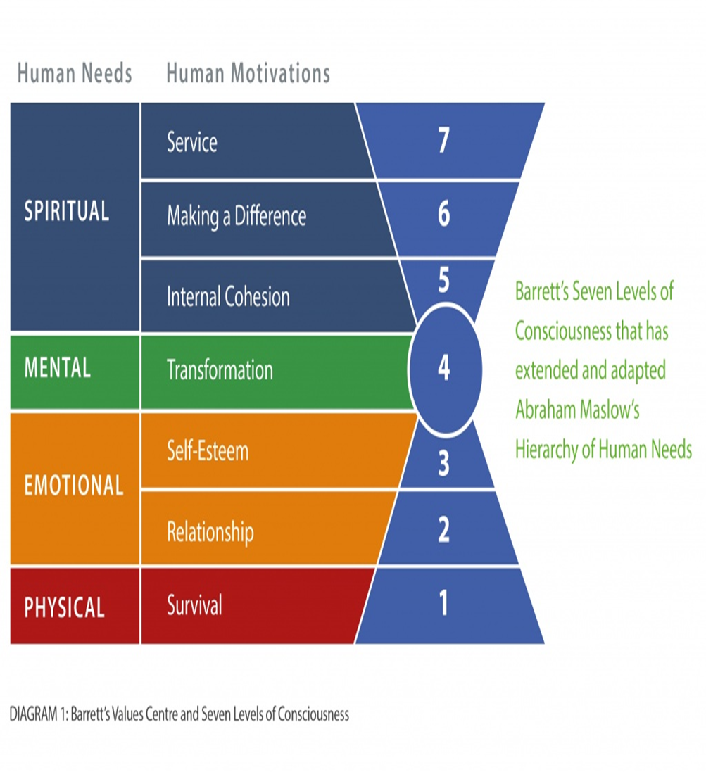
Below the researcher have applied Barrets Organisational Consciousness theory as a framework to show his personal values to that of the Virgin Group:

DIAGRAM 2: Personal Value Assessment using Barret Assessment Model
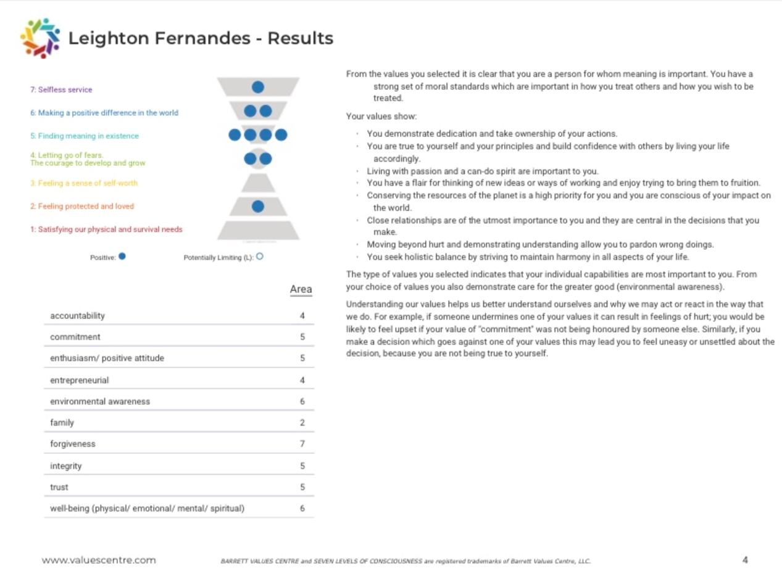

Barretts personal assessment model shows that close relationships are the upmost importance to the researcher and are central in the decisions he makes. Virgin Group have the same values in terms of employee relationships, since Richard Bransons Values and beliefs are putting his employees first. Also, Barrets model shows that conserving the resources on the planet is a high priority to the researcher and he is conscious of his impact on the world. It is apparent that Virgin Group share the same value and beliefs towards environmental sustainability. For example, Richard Branson states’ the goal is to “unite people and entrepreneurial ideas to create opportunities to tackle climate change and to create an environment for its employees where they have training initiatives where they give them a positive experience, so they feel valued and at that point their beliefs become the same of the organisation.

5.0 Conclusion
As a result of Fredrick Taylors scientific management theory, it has become apparent that this theory influences performance of employees at Virgin Group to determine scientifically the best methods for performing any task, and for selecting, training, and motivating employees. Although the department of labour and the hierarchy is also an essential requirement of any organisations structure, Branson has ensured since the beginning to minimise bureaucracy as much as possible since he strives to have no hierarchy, and strongly believes that his entire company are part of a family group and will not be seen as a hierarchy. Since, Bransons philosophy is to put employees first. Whereas Fredrick W Taylors philosophy on employees states that “we do not ask the initiative of our men. We do not want any initiative. All we want of them is to obey the orders we give them, do what we say, and do it quick”. Richard Branson do not share these same values and beliefs as he cares dearly for the welfare of the employees and allows them to work in a free environment. Because of these primary beliefs and values.

The disadvantage of this theory is that human emotions are not considered or given respect and is a more authorial style and, in this day, and age this management style cannot be used on its own and do not match up with the values, beliefs and culture at Virgin. It is evident that Richard Branson has implemented Herzberg motivation theory which is a new management theory to fill the gap that has been left behind by the old classical management theory which has influenced Virgin employees with motivator factors. For example, employees can reap rewards for innovative ideas and are recognised for the efforts they contribute are celebrated for their achievements. Branson aims to flatten the bureaucratic company policies, ensures everyday the working culture at Virgin is supportive, no bullying, no cliques and that everyone is treated with equal respect.

6.0 Reference List

Brighthr. (2021). Is having a corporate hierarchy important?. Available: https://www.brighthr.com/articles/culture-and-performance/corporate-hierarchy/how-important-is-workplace-hierarchy/. Last accessed 4th December 2021.

Crystal Wiedemann. (2015). Theoretical Support for the Barrett Model. Available: https://www.valuescentre.com/resource-library/theoretical-support-barrett-model/. Last accessed 5th December 2021.

David Dawkins. (2020). Virgin Billionaire Branson Attacked In Parliament Over Staff Pay During Coronavirus Crisis–But Employees Remain Supportive. Available: https://www.forbes.com/sites/daviddawkins/2020/03/19/virgin-billionaire-branson-attacked-in-parliament-over-staff-pay-during-coronavirus-crisisbut-employees-remain-supportive/?sh=12a884c13b8f. Last accessed 5th December 2021.

Dr Roopinder Oberoi. (2011). Frederick Wilson Taylor’s Scientific Management Theory. Available: https://epgp.inflibnet.ac.in/epgpdata/uploads/epgp_content/S000030PU/P001502/M016156/ET/146536875003.ET.Taylor-Roopinder_Oberoi.pdf. Last accessed 2nd December 2021.

Dw. (2021). Virgin's Richard Branson accused of double standards during coronavirus crisis. Available: https://www.dw.com/en/virgins-richard-branson-accused-of-double-standards-during-coronavirus-crisis/a-53115031. Last accessed 5th December 2021.

Ezzely. (2018). This is How Richard Branson Motivates His Team. Available: https://blog.ezzely.com/this-is-how-richard-branson-motivates-his-team/. Last accessed 3rd December 2021.

higherstudy. (2021). Scientific Management Theory by Taylor (5 Principles & More). Available: https://higherstudy.org/scientific-management-theory-by-taylor/. Last accessed 2nd December 2021.
Jack Preston. (2017). Understanding the Richard Branson approach to leadership. Available: https://www.virgin.com/about-virgin/latest/understanding-richard-branson-approach-leadership. Last accessed 2nd December 2021.

Julie Tucker. (2021). CREATIVE ENTREPRENEURS: EMPLOYEES COME FIRST FOR SIR RICHARD BRANSON. Available: https://www.headspacegroup.co.uk/sir-richard-branson-employees-come-first/. Last accessed 3rd December 2021.

mbakno. (2021). Case Study: Organizational Structure and Culture of Virgin Group. Available: https://www.mbaknol.com/management-case-studies/case-study-organizational-structure-and-culture-of-virgin-group/#:~:text=Bureaucracy%20is%20a%20structure%20in%20which%20people%20are,a%20wide%20span%20. Last accessed 2nd December 2021.

PRIYANSHA MISTRY. (2017). RICHARD BRANSON: “CLIENTS DO NOT COME FIRST. EMPLOYEES COME FIRST.”. Available: https://www.thehrdigest.com/richard-branson-clients-do-not-come-first-employees-come-first/. Last accessed 1st December 2021.

Richard Roberts. (2016). Employee Engagement the Virgin way. Available: https://www.hrzone.com/community/blogs/richard-roberts/employee-engagement-the-virgin-way. Last accessed 3rd December 2021.

Rob Abdul. (2015). Virgin corporate strategy, Case Study. Available: https://www.robabdul.com/business/virgin-corporate-strategy-case-study-article-this-report-closely-examines-the-virgin-groups-corporate-rationale/. Last accessed 27th November 2021

Robert Half. (2018). 9 leadership skills from Sir Richard Branson. Available: https://www.roberthalf.ae/advice/people-management/9-leadership-skills-sir-richard-branson. Last accessed 3rd December 2021.

Sarah Vizard . (2019). How Virgin Media is using the power of its brand to tackle the disability employment crisis. Available: https://www.marketingweek.com/virgin-media-tackle-disability-employment-crisis/. Last accessed 4th December 2021.

Virgin Group. (2021). The Virgin Group is a global, growth investor founded by Richard Branson.. Available: https://www.virgin.com/about-virgin/virgin-group/overview. Last accessed 3rd December 2021.
Virgin Group. (2021). Virgin Atlantic works towards a greener future. Available: https://www.virgin.com/about-virgin/latest/virgin-atlantic-works-towards-a-greener-future. Last accessed 1st December 2021.

Virgin. (2020). about-virgin/our-story. Available: https://www.virgin.com/about-virgin/our-story. Last accessed 4th December 2021.

Virgin. (2021). benefits-flexibility-wellbeing. Available: https://careers.virginmedia.com/about-us/benefits-flexibility-wellbeing/. Last accessed 4th December 2021.

Virgin. (2021). Richard Branson’s story. Available: https://www.virgin.com/branson-family/richard-branson. Last accessed 27th November 2021.

Walter Wang . (2012). TOP TEN SUSTAINABILITY INITIATIVES OF RICHARD BRANSON. Available: https://cleantechies.com/top-ten-sustainability-initiatives-of-richard-branson/. Last accessed 4th December 2021.

Wendy Gabriel . (2016). Richard Branson and Sustainability. Available: https://recyclenation.com/2016/06/richard-branson-and-sustainability/. Last accessed 5th December 2021.
work911. (2021). Who Should Be Responsible For Implementing A Strategic Plan?. Available: http://work911.com/planningmaster/faq/implementwho.htm. Last accessed 4th December 2021.

