Name | Student Number | Date | Lecturer’s Name | Your score
Mihai Horia Zbircea | 2435086 | 25.06.2025 | Ellie Ristic | To be filled by the marker  ___/40
You will have 75 minutes to complete this assessment. It is divided into three sections: note-taking, paraphrasing and writing a paragraph.
---------------------------------------------------------------------------------------------------------------------
1. Take diagrammatic notes from the passage below using the space provided:

It's difficult to know whether undergraduate study is right for you until you've experienced it first-hand. Many first-year students have second thoughts on their decision to go to university for a number of reasons. For example, you may have changed your mind about the career you'd like to pursue, and the course you're enrolled on is no longer suitable. Another common reason is that you're struggling to cope with the workload or aren't being challenged enough on the course; perhaps you don't respond well to the teaching and assessment methods or it's simply not what you expected. Thirdly, it might well be that the university you have chosen is too big or too small; you've stayed close to home and would like to move away or you moved further away and are feeling homesick. There might also be financial reasons. Maybe you cannot afford the tuition or accommodation fees, living costs are out of your budget or you're not comfortable with the idea of accumulating and dealing with student debt. Finally, let us not underestimate personal circumstances. You may have a disability or health issues that make university life difficult to cope with, you have a delicate family situation or you're finding it challenging to balance your studies with other commitments.
Adapted from: https://www.prospects.ac.uk/applying-for-university/changing-or-leaving-your-course

Space for your notes (max 12 marks):
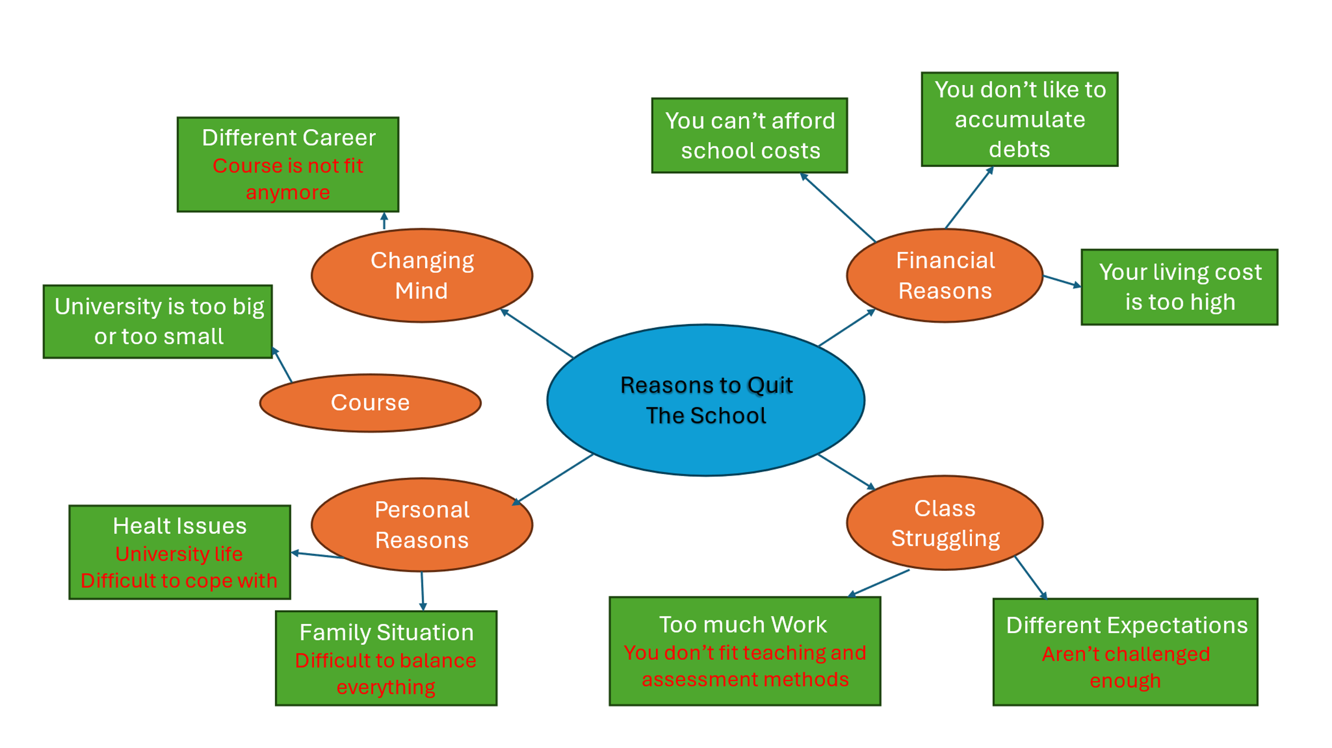

2. Paraphrase the following sentences (max 3 marks for each, max 12 marks in total):

a) It's difficult to know whether university study is right for you until you've experienced it first-hand.

You have to experience the student life first in order to decide that the university study is right for you.

b) Developing good study habits is essential for academic success.
If you want an academic success you have to develope some good study habits.

c) When you feel overwhelmed with your studies, consider adopting strategies to manage stress more effectively.
It’s helping to adopt effective strategies of stress managing when you are struggled with studies.

d) Consistent reading practice can improve your writing skills.

Your writing skills can be improved with consisting reading practice.

3. Write a well-structured paragraph (8 sentences) on the following topic:

The challenges of studying at a UK university.

Your paragraph must be written in full sentences (no bullet points) and in an academic style.

(max 16 marks in total)

Students have different kind of issues in their academical journey. They must decide how will follow the struggles and there are different solutions. Students can drop out courses, change the courses or make them part-time or swap the university. According to Higginbotham D.(2025) there are 5 main reasons students leave the academical life and these are changing career making courses useless, struggling with workload or courses like teaching or assessment methods or are not challenging enough, school institution is at different level too big or too small or they are too close or too far away by school, financial issues from costs of courses or life cost or just stressed about student debt accumulation and last but not least personal problems like health issues as disability which making university life hard to keep in line or some family problems who make the balance of study life and personal life impossible. Leaving school life for those reasons is much easier in the first year of study and in second of third is better if you find a way to stay to finish even if you make changes of courses or institutions or put on hold for 1 year for different reasons. However, there are costs of leaving courses related at the time distance you were in school which can make you think twice. Student also can be advised by other people like friends, family or other students or even careers service. Whatever decision they take it’s not easy whatsoever because a wrong decision can be followed later by regrets.
Higginbotham D. (June 2025) Available at: https://www.prospects.ac.uk/applying-for-university/changing-or-leaving-your-course (Accessed: 25.06.2025)

