 DIG: Assessment 3

ROLE OF LINKEDIN IN STAFF RECRUITMENT

Module Name: Digital Skills
Module Code: LCM 4002
Student’s Name: Alexandru Florin Paun
Student’s ID: 2411677
Group: 3
Lecturer’s Name: Suneth Warnakulasooriya

Table of Contents
What is LinkedIn 1
What is the difference between LinkedIn and other forms of social media 2
How LinkedIn Helps for Job Seekers? 3
How LinkedIn helps employers? 4
How LinkedIn Helps for Job Seekers? 5
How LinkedIn helps employers? 6
Conclusion ……………………………………………………………………………………………………………7
References ………………………………………………………………………………………………………………….8

What is LinkedIn?

LinkedIn is a dynamic social networking platform tailored specifically for the business community. Established in 2002, it serves as a pivotal space for professionals to connect with both former and current colleagues, enabling users to cultivate and expand their business relationships. The platform is a venue for networking within specific industries and facilitates discussions around innovative business ideas, job searching, and recruiting new talent. Once users create an account, they can build comprehensive profiles that function similarly to resumes, detailing their professional experiences, accomplishments, skills, and areas of expertise. These profiles also allow members to showcase their educational background and memberships in professional development organizations, giving others a clear picture of their qualifications and interests. Upon completing their profiles, users can send connection requests to other members, allowing them to seamlessly grow their professional network. This interconnected web of professionals enhances opportunities for collaboration, mentorship, and career advancements, making LinkedIn an indispensable resource for anyone looking to thrive in their field.
(Peek, 2023)

What is the Difference between LinkedIn and other forms of social media?

LinkedIn stands out from other social networks due to its exclusive focus on professional networking and career development. Its features, such as job search tools, industry-specific groups, and professional events, are specifically designed to foster meaningful connections and facilitate career advancement. With over 310 million active users, LinkedIn boasts a higher engagement rate for content related to professional development. In contrast, platforms like Facebook, Instagram, and Twitter cater to a broader range of social interactions and diverse content types. Exploring LinkedIn further will demonstrate how its specialized tools and tailored features can uniquely enhance your professional trajectory.
(Macdonald, 2024)

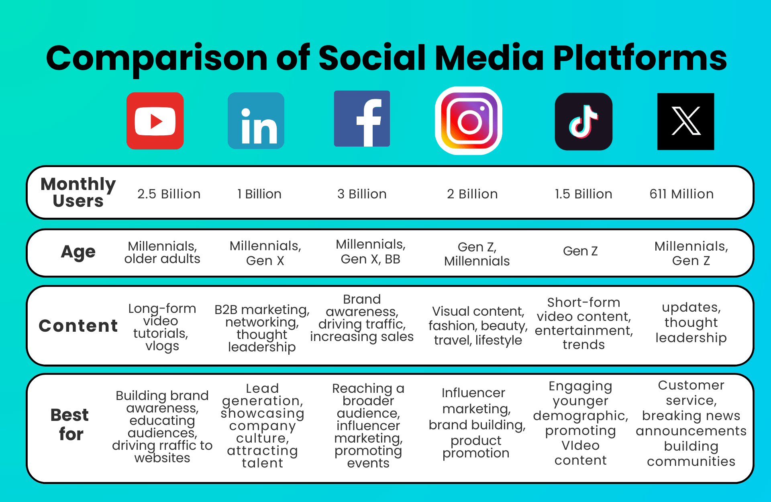
(Parra, 2023)

How LinkedIn Helps for Job Seekers?

The optimum success and competence of an organization do not merely depend on its financial resources or using the best strategy, rather it is determined by the extent to which and how it is using its competent human resources (Hosain, 2017). In the highly competitive job markets of India and Bangladesh, where there is an abundant supply of labour, job seekers often find it challenging to search for and secure good job opportunities through traditional means such as paper advertisements, job circulars, and company websites. Fortunately, advancements in internet technology have introduced valuable tools, including social networking sites (SNSs). LinkedIn is a prominent professional online SNS that connects employers and potential employees on the same platform. For example, companies can enhance their branding, promote their services, and conduct talent searches by creating professional accounts on LinkedIn. Meanwhile, existing employees and unemployed graduates can also create accounts to explore job opportunities, network with others, and exchange valuable information. Since its launch in 2003, LinkedIn has evolved into a significant platform for job-related sharing and is recognized by users across approximately 200 countries (Zide, Elman, & Shahani-Denning, 2014). According to the LinkedIn Press Center (n.d.), all Fortune 500 companies have been represented on the platform since its inception. Moreover, a survey conducted by the Society of Human Resource Management (SHRM) revealed that 95% of HR professionals reported using LinkedIn to recruit passive candidates who might not otherwise apply for jobs. (MD SAJJAD HOSAIN and LIU, 2020)

How LinkedIn helps employers?
LinkedIn serves as a vital platform for both job seekers and employers, offering a comprehensive resource for businesses aiming to attract high-calibre talent. By posting job listings on LinkedIn, organisations can engage with a global pool of professionals possessing the necessary skills and qualifications. The platform's ability to target specific demographics enables companies to connect with candidates who meet their precise hiring criteria. Research indicates that LinkedIn is the leading social network utilized by recruiters, with 95% of professionals in the field leveraging the site for recruitment efforts. Additionally, LinkedIn facilitates the process of headhunting by allowing companies to tap into its extensive user database. Businesses can utilize the platform's robust search capabilities to identify candidates based on various factors, such as location, experience, education, and skill set. **Brand Building** LinkedIn is also a significant tool for businesses aiming to build and enhance their brand presence. It provides an ideal environment for organisations to showcase their offerings and engage with their audience. Creating a company page allows businesses to cultivate a following, connect with potential clients, and highlight their products or services. Through a company page, organisations can share updates, industry news, and insights, which helps establish their brand as a thought leader and enhances their reputation among key stakeholders. Furthermore, LinkedIn's algorithm favours content that garners engagement, meaning that the more interaction a post receives, the broader its reach will be. LinkedIn also provides paid advertising options, such as Sponsored Content, Sponsored email, and Display Ads, enabling businesses to effectively target their desired audience. However, it’s worth noting that LinkedIn advertising can be pricier than ads on other social media platforms, necessitating careful audience targeting.
(Ritchelle, 2024)

Conclusion

In conclusion, LinkedIn is an essential tool for businesses of all sizes and sectors. Its primary function is to facilitate professional networking and connections among like-minded individuals. By participating in professional groups on LinkedIn, businesses can engage with others in their industry, fostering opportunities for learning and growth. Ultimately, LinkedIn stands out as a premier platform for job seekers and employers, providing valuable resources for recruitment while allowing businesses to establish and grow their brand presence in the marketplace.
(Ritchelle, 2024)

References
Macdonald, M. (2024). Comparative Analysis: Linkedin Vs. Other Social Networks for Professional Growth - Product London Design. [online] Product London Design. Available at: https://productlondondesign.com/linkedin-vs-other-social-networks/ [Accessed 8 Dec. 2023].
MD SAJJAD HOSAIN and LIU, P. (2020). LinkedIn for Searching Better Job Opportunity: Passive Jobseekers’ Perceived Experience. [online] NSUWorks. Available at: https://nsuworks.nova.edu/tqr/vol25/iss10/13/ [Accessed 8 Dec. 2024].
Parra, S. (2023). Detailed Comparison of Social Media Platforms. [online] mini designs. Available at: https://mindesigns.com.au/blog/comparison-of-social-media-platforms/.
Peek, S. (2023). What Is LinkedIn? [online] Business News Daily. Available at: https://www.businessnewsdaily.com/2489-linkedin.html [Accessed 8 Dec. 2024].
Ritchelle, N. (2024). How Does LinkedIn Benefit Businesses. [online] www.linkedin.com. Available at: https://www.linkedin.com/pulse/how-does-linkedin-benefit-businesses-ritchelle-n--24yvc [Accessed 8 Dec. 2024].

