

Student name: Karen Alcantara Vicioso

Student ID: 2213116

Module name: Introduction to Public Health

Module code: LCHS4004_LON

Lecturer name: Dr Laila Surani

Table of Content

- Introduction………………………………………………………… Page 3

- Strategies used in the UK to measure, monitor and control mumps ………………………………………………………………………… Page 4

  - Strategies used in UK to measure mumps………… Page 4

  - Strategies used in UK to monitor mumps…………. Page 5

  - Strategies used in UK to control mumps…………. Page 6

- Conclusion …………………………………………………………. Page 6

- References …………………………………………………………. Page 7

- Introduction

The mumps virus is the subject of this report. Methods of disease assessment, monitoring, and control implemented in the UK. We will go through what mumps is, how it spreads, and what ca be done to avoid getting it. Certain cases are illustrated in this paper.

What it is mumps?

“Mumps is a contagious viral infection caused by a type of virus called paramyxovirus” (Vicent, P, 2023). Such as the common cold and other upper respiratory tract infections, it is spread through saliva. The virus can be spread through direct contact with infected surfaces, such as doorknobs, or through inhaled droplets (Vicent, P, 2023).

The UK's MMR vaccine has reduced mumps cases. Unvaccinated kids get mumps most often. The MMR vaccine is given twice, once at a year and again in the "pre-school booster" at 3 years 4 months. Risk reduction requires both dosages. MMR reduces measles risk by 96% and mumps risk by 86% (Vicent, P, 2023).

Mumps symptoms appear 2–3 weeks after exposure. Some have no or minor symptoms. Flu-like symptoms may appear first: (MAYO CLINIC, 2023).

- Fever.
- Headache.
- Muscle aches or pain.
- Not wanting to eat.
- Tiredness.

Within days, salivary glands swell. Possible symptoms: (MAYO CLINIC, 2023).

- Swelling of one or both glands on the sides of the face.
- Pain or tenderness around the swelling.
- Less often, swelling of glands below the floor of the mouth.

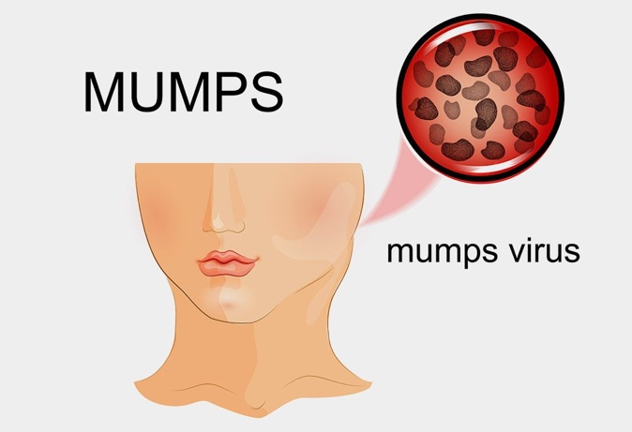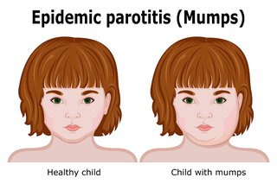

(FistoryParenting, nd). (HSE, 2023).

Strategies used in the UK to measure, monitor and control mumps

- Strategies used in UK to measure mumps disease:

Mumps infection is confirmed using RT-PCR and viral culture. For RT-PCR testing, buccal swabs are most typically utilised, but urine and CSF may also be used in certain circumstances. Mumps disease can also be diagnosed using IgM serology. The vaccination status of a patient and the timing of specimen collection are critical for interpreting laboratory results. A negative test result does not rule out the possibility of mumps infection (CDC, Nd).

Every few years, UK mumps epidemics occurred in winter and spring. In 1988, a preschool catch-up programme and 5-MMR immunisation of 1-year-olds began. Mumps became notifiable, and its prevalence dropped dramatically in the 1990s (fig 1). Unvaccinated youngsters were vulnerable since measles was scarce. The 1994 national catch-up effort for 5-16-year-olds was prompted by secondary school measles outbreaks that threatened an epidemic. They received a measles-rubella vaccine instead of MMR. During a mumps vaccine shortage, MMR vaccine was scarce. The reported cases (fig 2) have impacted people born between 1982 and 1986 who have not been exposed to spontaneous infection (due to the decline in circulating mumps) or vaccinated. Due to early natural infection in the pre-MMR era, up to 98% of people born before 1982 are immune (National Library of Medicine, Nd).

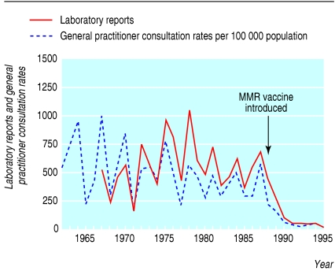

Fig 1: “Incidence of mumps and numbers of confirmed cases reported to the Communicable Disease Surveillance Centre, 1962-95” (National Library of Medicine, Nd).

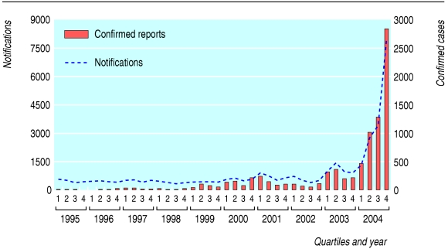

Fig 2: “Mumps notifications and confirmed cases, 1995-2004 by quarter” (National Library of Medicine, Nd).

- Strategies used in the UK to monitor mumps disease:

The MMR vaccine made mumps a notifiable disease in the UK in October 1988. Mumps transmission in the UK decreased due to high MMR vaccine coverage, including in unvaccinated older people.
Clinically diagnosed and laboratory-confirmed mumps cases plummeted after 1989. Measles-rubella (MR) vaccine was given to five- to 16-year-olds in November 1994 to prevent an epidemic. Insufficient MMR was available to vaccinate all these youngsters against mumps. Younger people of this age group were unlikely to have been exposed to mumps, and many remained susceptible until early adulthood (Mumps, P 256, 2013).

MMR was two-dosed in October 1996. UK mumps vaccines protect 61% to 91% of recipients (Plotkin and Orenstein, 2004). Individual and population protection requires two doses. Since 1982, Finland has used a two-dose MMR regimen with high coverage. Since 1994, indigenous measles, mumps, and rubella are gone. In 1989, the US implemented its two-dose schedule and declared endemic transmission over in 2000. (Plotkin and Orenstein, 2004). Around 100 countries, including EU, North American, and Australasia, routinely administer MMR (Mumps, P 256, 2013).

Mumps incidences have risen since 1999.
Most of these incidences occurred in teens or young adults who were too old to receive MMR in 1988 or a second dose in 1996. They were susceptible because they had never experienced mumps as youngsters. Mumps cases rose again in late 2004. Most occurrences were in people born between 1980 and 1987, and outbreaks mostly occurred in higher education institutions. Mumps-affected cohorts believe they were immunised with mumps-containing vaccine. The 1994 campaign employed MR vaccination since MMR vaccine was unavailable. Until 1988, the UK did not routinely immunise against mumps. Hence, children may have received two measles-containing vaccines and one rubella vaccine but no mumps vaccine (Mumps, P 256, 2013).

- Strategies used in UK to control mumps disease:

The treatment for mumps focuses on alleviating symptoms until the immune system of the patient is able to successfully fight off the illness. At this time, there is no medication that can be used to treat the mumps virus (CDC, 2021).

Some strategies they used to control mumps are:

- Confirm suspected mumps: Mumps symptoms appear 2–3 weeks after exposure. Some have no or minor symptoms (CDC, 2021).

- Isolate the patient: Even if lab results are negative, mumps suspects should self-isolate for 5 days after parotitis or other salivary gland enlargement (in the absence of a more likely diagnosis or positive lab result for other etiology). Lab-confirmed mumps patients without parotitis should self-isolate for 5 days following their first symptom (CDC, 2021).

- Identify the source of the infection and conduct case finding: Ask the patient if they have had interaction with anyone with mumps or mumps-like symptoms, which including jaw clenching or puffy cheeks, in the prior 12 to 25 days (the mumps incubation period). Public health personnel can better understand circulation in their area by detecting infectious sources (CDC, 2021).

- Known close contacts: Family members, partners, and roommates should be tested for immunity and vaccinated against MMR. Fully vaccinated people can have mumps, but their risk is substantially lower (CDC, 2021).

- Groups of people who are likely to have close contact with a mumps patient: mumps patients' study group, social group, theatre or choral group, or fraternity or sorority.
co-workers or friends of mumps patients. Athletes who practise with a mumps patient (CDC, 2021).

Conclusion

In conclusion, the infection that causes mumps is caused by a virus. Everyone ought to look out for themselves and make an effort to maintain a safe environment in their own homes. As was noted before, this condition can be passed on through saliva, and the incidence of it in youngsters is much higher than in adults. Schools, nurseries, colleges, and places of employment are the most likely settings in which an individual might be exposed to this disease. The disease known as mumps does not have a known cure; the only proven method of protection against mumps is immunisation. When they turn five years old, children must to have had two doses of the MMR immunisation administered to them.

- References

- CDC (2021) Available at: https://www.cdc.gov/mumps/health-departments/strategies.html (Accessed: 20 April 2023).

- HSE (2023) Available at: https://www2.hse.ie/conditions/mumps/symptoms/ (Accessed: 20 April 2023).

- Vicent, P. (2023) Mumps. Available at: https://patient.info/travel-and-vaccinations/mumps-leaflet (Accessed: 20 April 2023).

- MAYO CLINIC (2023) Available at: https://www.mayoclinic.org/diseases-conditions/mumps/symptoms-causes/syc-20375361 (Accessed: 20 April 2023).

- NHS (Nd) Available at: https://www.ncbi.nlm.nih.gov/pmc/articles/PMC557899/ (Accessed: 20 April 2023).

- NHS (2021) Available at: https://www.nhs.uk/conditions/mumps/treatment/ (Accessed: 20 April 2023).

- Mumps (Nd), P 256. Available at: https://assets.publishing.service.gov.uk/government/uploads/system/uploads/attachment_data/file/147975/Green-Book-Chapter-23-v2_0.pdf (Accessed: 20 April 2023).

