COMBINED ADVANCED VEHICLE DYNAMICS
(ACHA6003)

AWD Torque Vectoring

BEng Motorsport Engineering

BILAL MOHAMED AHMED
(1904401)
21/03/2022


Contents
1. INTRODUCTION 3
2. FERRARI FF 2011 3
3 Differentials 6
3.1 Open Differential / Looked differential 6
3.2 Limited Slip Differential (LSD) 7
3.2.1 Mechanical LSD 7
3.2.2 Viscous/Ferguson LSD 7
3.2.3 Torsen LSD 7
3.3 Torque Vectoring “Differential” 8
3.3.1 Differential and clutch based 8
3.3.2 Brake-based Torque Vectoring 9
3.3.3 Electric Torque Vectoring 9
4. Vehicle Dynamics (Calculations) 10
4.1 Center of Gravity (CoG) 10
4.2 Vehicle moment of Inertia 10
4.3 Dynamic Index / Inertia Conjugate 10
5. Torque Vectoring (Calculations) 11
5.1 Clutch Pack 11
5.2 Potential Yaw Rate 12
6. Summary / Conclusion 14
References 15

1. INTRODUCTION
It is the study of the movement of the car and the forces that determine it. The vehicle is a body subject to the laws of mechanics, but its configuration is such that it determines a characteristic and peculiar behavior. The motion of a car is determined by the reactions (forces) applied to it from the outside. These are of 2 types: with the air (aerodynamics forces) and with the ground (wheel-ground Forces). Each of these forces consists of several components.
To improve the vehicle dynamics, different technologies / systems were developed.
This report analyses the All-Wheel Drive system (4RM) of a Ferrari FF 2011, the effects in the vehicle dynamics and the potential control strategies from the torque vectoring front wheel drive system.

2. FERRARI FF 2011
The Ferrari 4RM (4 ruote motrici) all-wheel-drive system, first introduced on the Ferrari FF and now on the Ferrari GTC4 Lusso with the addition of the four-wheel steering (4RM-S Evo), is innovative and extremely complex. The complex system, instead of using the classic 3 differentials (front, rear and center) that are usually adopted by common four-wheel drive systems, adopts a single rear differential integrated with the dual-clutch gearbox and seven-speed transaxle configuration and one Front PTU (power transfer unit) that is a sort of small front automatic gearbox with two forward gears and one reverse gear.
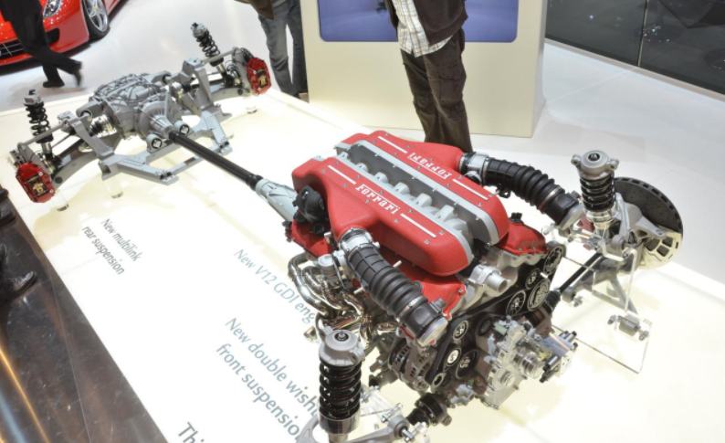
Figure 1. Ferrari FF 2011 4RM System (Ferrari, 2011)
Both transmissions are therefore directly connected to the engine arranged longitudinally in the front central position behind the front suspension axle. The rear double-clutch transmission (transaxle) is connected to the engine via the classic propeller shaft and sets the rear sports differential in motion. and both the two rear wheels. The front two-speed automatic gearbox with helical gears is, on the other hand, is connected to the crankshaft but in the front by means of a bevel gear and transmits the motion to two multi-disc clutches in oil, one per wheel, which manage each front wheel via an electro-hydraulic drive.
The functioning of the two gearboxes and the two axles, both driving, are kept distinct, allow four-wheel drive and rear-wheel-drive but never just front-wheel-drive. The front-wheel-drive intervening only when needed, can be defined as "On-demand" and not integral permanent.
To make this work, firstly the front PTU, comes into play only when the electronics feel the need and up to a maximum speed of 200 km / h, beyond which, even if with all-wheel drive, the Ferrari goes back to being purely rear-wheel-drive. This insertion of the front-wheel-drive takes place via an electronically managed clutch that connects or disconnects the PTU unit from the engine. Secondly, the first gear of the front gearbox works in conjunction with the first and second gear of the rear gearbox while the second gear of the front gearbox works in conjunction with the third and fourth gear of the rear gearbox. This was made possible by designing a 6% longer front first gear than the rear second gear and by designing a 6% longer front second gear than the rear fourth gear. The reverse gear of the front gearbox and rear gearbox have been designed with the same ratio so that they can work in unison, offering all-wheel drive even in reverse. Finally, when the Ferrari engages the fifth, sixth or seventh gear of the dual clutch rear gearbox or exceeds the fateful 200 km / h previously mentioned, the front PTU unit puts the gearbox in neutral and the clutch disconnects the same unit from the engine letting the car go back to being a real rear-wheel-drive.
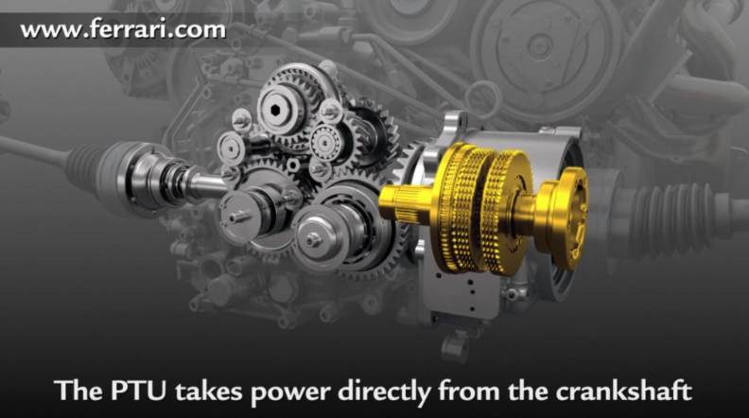
Figure 2. Ferrari PTU System (Ferrari, 2011)
As well, on the front there is two electro-hydraulically operated multi-disc clutches in oil bath, one per wheel, which transmit motion from the PTU to the two front wheels. These clutches have been designed to work constantly in slip in order to allow the two gears of the front gearbox to interact in the best and smoothest way possible with the four gears of the rear gearbox. To maintain a rear-wheel-drive dynamic behavior as much as possible, only 20% of the total torque goes to the front leaving the remaining 80 on the rear even in the most difficult situations.
Of this 20% of torque at the front, the two multi-plate clutches in oil bath will decide each time based on the specific situation which percentage to distribute to each individual front wheel, being able to send the entire 20% to just one of the two wheels and acting as a sort of torque vectoring. The same goes for the rear where the E-diff sports differential, an electronically controlled LSD limited slip differential, is able to distribute 80% of the torque arriving at the rear gearbox as needed between the two rear wheels, sending all the quantity even on a single wheel so as to create a sort of torque vectoring in this case as well.
This innovative system, without the classic central differential (viscous or lamellae or Torsen joint) and the classic front differential (normal or self-locking), is lighter than all the other four-wheel drive systems currently on the market. The PTU system and the two multi-plate clutches in oil bath, in fact, weigh only 45 kg and are positioned exactly in the front and below the engine, so as to further improve weight distribution (47% at the front and 53% at the rear, also thanks to the transaxle solution) and the height from the ground of the center of gravity.
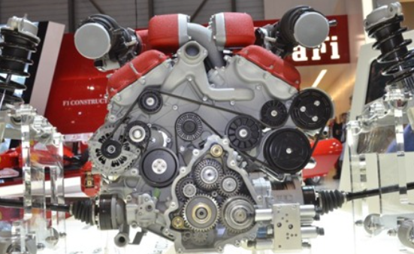
Figure 3. Ferrari FF Front Engine Layout (Ferrari, 2011)
The following table shows the most relevant technical data:
Length | 4907 | mm | Max. Power | 465kw - 660 cv at 8000rpm
Width | 1953 | mm | Max. Torque | 683Nm at 6000rpm
Height | 1379 | mm
Wheelbase | 2990 | mm
Front Track | 1676 | mm
Rear Track | 1660 | mm
Kerb Weight | 1880 | Kg
Dry Weight | 1790 | Kg
Weight Distribution | 47% F - 53% R
Weight Front | 883.6 | Kg
Weight Rear | 996.4 | Kg
Table 1. Technical Data Ferrari FF 2011
The following figure shoes the dimensions:
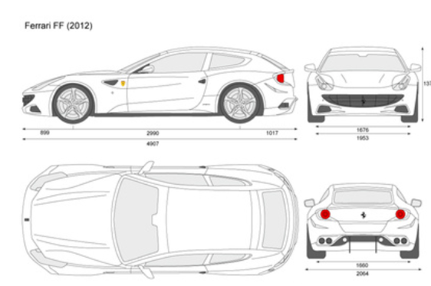
Figure 4. Dimensions Ferrari FF 202

3 Differentials
A differential is an essential mechanical component for any car, except many electric ones. Thanks to it, the outer wheel that moves a vehicle can turn faster than the inner one during a curve. An essential difference, since the first has to travel more distance than the second during a maneuver.
Another way to describe its function is: The engine or motor only rotates at a certain speed at any one time, but it must be able to move two wheels at different speeds. The differential adds a few more gears to a car's transmission to make this possible.
The amount of torque that is transmitted to each wheel depends in part on the differential, but it also depends in part on the grip each wheel finds on the ground. That is why it is not correct to speak of "torque distribution" when we refer to the differential mechanism, because it is not the differential that "distributes the torque", but also the grip itself that exists on the ground. It is the sum of the two factors that determines the final torque at each wheel.
Is important to remark that the different systems impact in the vehicle dynamics.

3.1 Open Differential / Looked differential
The open Differential is the most basic differential, most street cars, without being sports cars. Under normal conditions they are not a problem, but in unfavourable conditions such as on a circuit or offroad, the inside wheel, if we do not have traction and stability control, can end up spinning uncontrollably causing slippage or loss of grip.
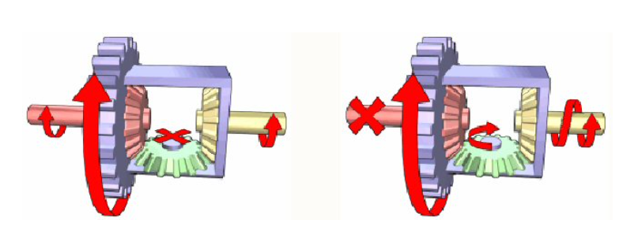
Figure 5. Open Differential (MatFoundry, 2021)

The looked Differential is for road vehicles, it is essentially an open differential with the ability to be locked in place to create a fixed axle instead of an independent one. This helps to eliminate the problem of uncontrolled spinning but create another one called binding, produced by the excess of rotational energy.

3.2 Limited Slip Differential (LSD)
It combines the benefits of Open and Locked differentials and fixed their problems through a more complicated system. There is different LSD.

3.2.1 Mechanical LSD
This type of LSD surrounds the same core gearing seen in the open diff with a pair of pressure rings, which exert force on two sets of clutch plates positioned alongside the gears. This provides resistance to the independent rotation of the wheels changing the effect of the differential from open to locked – and providing it with the increased traction. (MatFoundry, 2021)
The downside to mechanical LSDs is they require regular maintenance to keep operational and are prone to wearing out completely, making for an expensive part replacement. (MatFoundry, 2021)
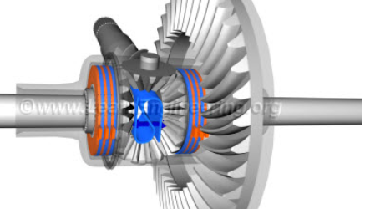
Figure 6. Mechanical LSD (Mathew, 2014)

3.2.2 Viscous/Ferguson LSD
It works thanks to an oil with silicones that becomes denser as it heats up due to friction. In this way, it transmits the movement to the stopped wheel. They are able to direct torque more effectively to the wheel that has more traction but after prolonged use they lose effectiveness.
As well with Mechanical LSD in high-speed cornering they can generate over/understeer.
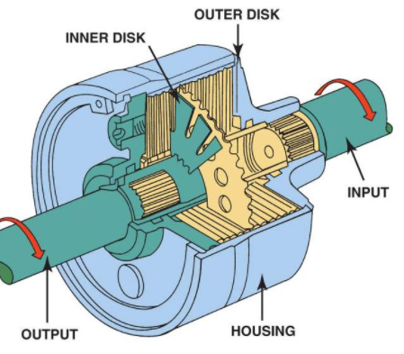
Figure 7. Viscous LSD

3.2.3 Torsen LSD
A helical spur gear drives a gear. It has a ring gear, diagonally toothed sprockets that fit into helical spur gears, other sprockets horizontally, and again more helical spur gears. It is the most efficient when considering the driving conditions, since it reacts according to the resistance that each wheel opposes to the turn, whether in acceleration or braking.
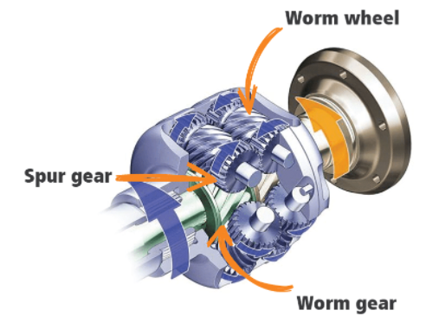
Figure 8. Torsen Differential (Timmer, 2022)

3.3 Torque Vectoring “Differential”
This system is by far the most complex, is a electronically enhanced system that manipulate the angle, or vector, of the vehicle in and out of the turns by encouraging specific wheels to receive more torque at key moments, improving cornering performance.

3.3.1 Differential and clutch based
Typical differential-based torque vectoring systems combine an open differential with a pack of multi-plate clutches on either side, together with sensors measuring the wheel speed, pitch, and the yaw of the car. The clutches are not always engaged and are instead electronically- or hydraulically actuated. (Shah, 2020)
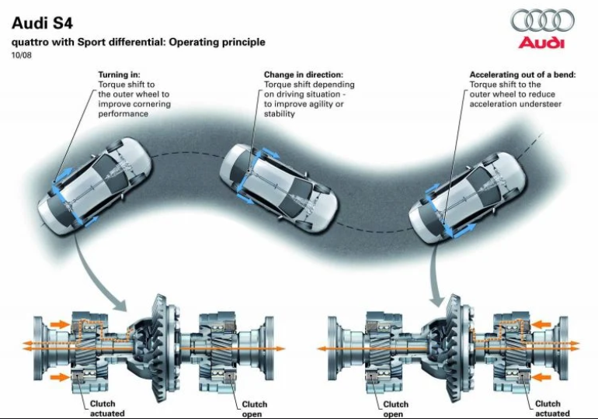
Figure 9. Audi S4 Quattro with Sport Differential (Audi, 2008)

3.3.2 Brake-based Torque Vectoring
Brake-based torque vectoring is a less sophisticated system that attempts to replicate the capabilities of the mechanical system above through simpler, cheaper means. Rather than torque being shuffled through a differential, this system momentarily applies the brake to one of the wheels (e.g., the inside wheel in a turn). (Shah, 2020)
Even if this system increases the yaw and helps to rotate the car, is slower for lap times because of the use of the brakes, additionally, this can overheat the brakes on track days and cause greater wear and tear.
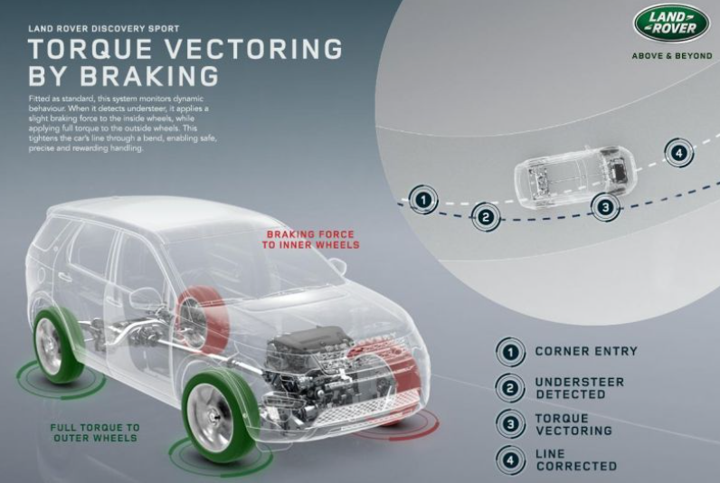
Figure 10 . Land Rover Torque Vectoring by Braking (Rover, 2017)

3.3.3 Electric Torque Vectoring
Electric motors are able to respond instantly to inputs from an onboard computer or the driver and are able to rapidly vary the amount of power and torque they produce. They offer the ideal foundation for the holy grail of torque vectoring – all-wheel torque vectoring. (Shah, 2020)
The torque and power levels can be adjusted in a very precise way and constantly, this flexibility means much greater control in vehicle dynamics.
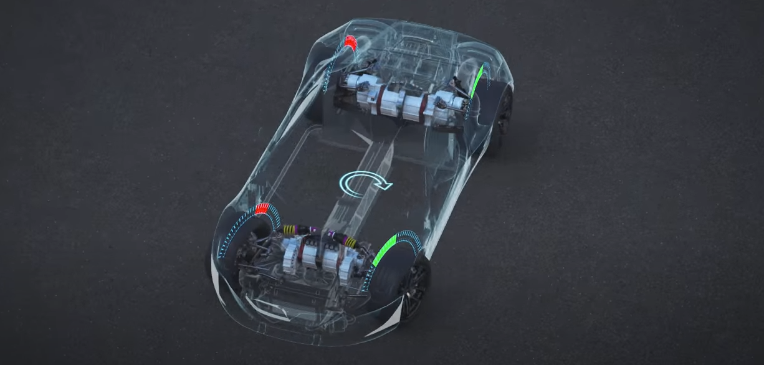
Figure 11. Rimac All Wheel Torque Vectoring (Rimac, 2016)

4. Vehicle Dynamics (Calculations)
The ideal chassis would have a low centre of gravity, an equal weight distribution on to all 4 of its wheels and it would have a wheelbase that gives the axles the correct amount of leverage upon the centre of gravity (dynamic indexing).

4.1 Center of Gravity (CoG)
The center of gravity is an imaginary point where we can assume that all the weight of a vehicle is concentrated and in equilibrium. This point is one of the most important aspects in a vehicle, since it determines its behavior and its stability.
$CoG=\frac{W_{1}D_{1} + W_{2}D_{2} + …}{W}$ Eq. 1
Substituting with the previous data:
$CoG=\frac{0.47*1880*0 + 0.53*1880*2990}{1880} =1584.7 mm= 1.5847 m$

4.2 Vehicle moment of Inertia
Inertia is the tendency that a body can have, in our case a vehicle or parts of it, to maintain its state, which can be in motion or at rest.
The calculation of inertia is carried out based on a force that is what produces the change from rest to movement (translation or rotation). Conversely, it also measures the force necessary for a moving body to come to rest.
$I=Mx R^{2 }$ Eq. 2
In this case is the Yaw Inertia, substituting with the previous data:
$$I=\left(883.6*{1.4053}^{2}\right)+\left(996.4*{\left(2.990-1.5847\right)}^{2}\right)= 3712.752 kg.m2$$

4.3 Dynamic Index / Inertia Conjugate
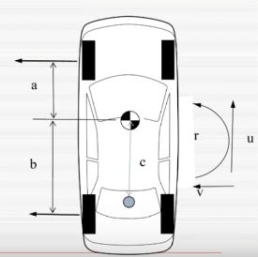
The distance of the centre of rotation with respect to the rear axle is referred to as the “Dynamic Index”
$D.I=\frac{I_{zz}}{m*a*b}$ Eq. 3
Substituting:
$$D.I=\frac{3712.752 }{1880*1.4053*1.5847}=0.8868$$
Figure 12. Inertia Diagram
This implies that the inertia conjugate point is in a distance c < b.

5. Torque Vectoring (Calculations)
As mentioned before, the PTU takes power directly from the crankshaft, with an integrated hydraulic control system, two separate multi-plate wet clutches drive the front wheels independent. The maximum available torque for the front wheels is the 20% of the total torque.
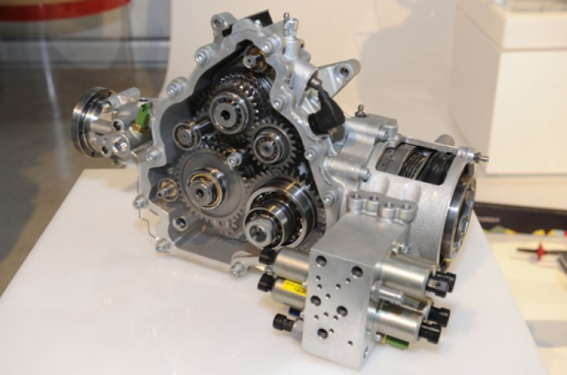
Figure 13. PTU System (Ferrari, 2011)

5.1 Clutch Pack
Each pair of contact surfaces carries the full load with each side of each plate generally effective.
The following data is for the multi-plate clutch.
- Number of plates. 4
- Speed rev/min 6000
- Outside radius mm 85
- Inside radius mm 50
- Coefficient of friction 0.20 Wet Cast Iron-Steel
- Torque 136.6Nm
Maximum Axial Power that the clutch can transit without slipping based on constant wear theory:
Eq. 4
Substituting:
$$W=\frac{2*136.6}{2*4*0.20*(0.085+0.050)}=1264.815 N$$
Maximum Axial Power that the clutch can transit without slipping based on constant pressure theory:
Eq. 5
Substituting:
$$W=\frac{3*136.6}{2*4*0.20* 0.1035*2}=1237.32 N$$

5.2 Potential Yaw Rate
The following table shows some characteristics:
Length | 4907 | mm | Max. Power | 465kw - 660 cv at 8000rpm
Width | 1953 | mm | Max. Torque | 683Nm at 6000rpm
Height | 1379 | mm | Torque front | 136.6
Wheelbase | 2990 | mm | Torque Rear | 546.4
Front Track | 1676 | mm | Coefficient of friction | 0.3
Rear Track | 1660 | mm | Coefficiont of drag | 0.329
Kerb Weight | 1880 | Kg | Coefficient RR | 0.011
Dry Weight | 1790 | Kg | Tyre rolling radius R/F | 354.5 / 340.5
Weight Distribution | 47% F - 53% R |  | Frontal Area | 2.03
Weight Front | 883.6 | Kg | Centre of gravity Height | 0.45
Weight Rear | 996.4 | Kg | Inertia | 3712.752
Table 2. Ferrari FF 4WD Specs Necessary for Calculation
The car is driving on packed snow around a 15m radius curve at a constant 5m/s. For be able to calculate the potential yaw rate the following calculations are needed.
Rolling Resistance Force. Defined by the following equation:
$$Rs=Vf x Crr=1880*9.81*0.1 = 1844.28 N$$
Where
- Rs = Rolling Resistance Force
- $Vf$ = Vertical Force
- $Crr$= Rolling Resistance Coefficient

Aerodynamic Resistance. Defined by the following equation:
$$=\frac{1}{2} ρ v^{2}C_{D} A=\frac{1}{2}*1.2*2.03*0.329*5^{2} =10.09 N$$
Where
- $Ar$ = Aero Resistance
- $ρ$ = Density of fluid
- $v$ = Speed
- $C_{D}$ = Drag Coefficient
- $A$ = Frontal Aera
Total Tractive effort to maintain the speed = $Rs+Ar =1854.37N$
Centripetal Acceleration = $\frac{V^{2}}{R}= \frac{25}{15}=1.67\frac{m}{s^{2}}$ ; $π*d=94.2m ;$
$$t= \frac{94.2}{5}=18.84\frac{secs}{lap}=\frac{360degress}{18.84s}= 19.1\frac{degs}{s}$$

$$Weight Transfer front=Force x\frac{Height}{track}= 883.6*\frac{0.45}{1.676}*1.67 =396.196 N$$
$$Weight Transfer Rear=Force x\frac{Height}{track}= 996.4*\frac{0.45}{1.660}*1.67=451.081 N$$

$$Static Loading=\frac{1880}{4}*9.81= 4610.7 N$$

$$Inner Wheel Front=4610.7-396.196= 4214.504 N$$
$$Outer Wheel Front=4610.7+396.196= 5006.896 N$$
$$Inner Wheel Rear=4610.7-451.081 =4159.619 N$$
$$Outer Wheel Rear=4610.7+451.081=5061.781 N$$
$$F=m x a=1880*1.67= 3139.6 N ; \frac{3139.6}{2}=1569.8 N$$
$$Total Axle Loading front=883.6*9.81= 8668.116 N$$
$$Total Axle Loading Rear=996.4*9.81=9774.684 N$$

$$Percentage inner front=\frac{4214.504}{8668.116} =48.6\% ;48.6*1569.8=762.93 N$$
$$Percentage outer front=\frac{5006.896}{8668.116} =57.78\% ;57.78*1569.8=907.03 N$$
$$Percentage inner Rear=\frac{4159.619}{9774.684} =42.25\%;52.25*1569.8=663.24N$$
$$Percentage outer Rear=\frac{5061.781}{9774.684} =51.8\% ;51.8*1569.8=813.1564 N$$

$$Inner Wheel Front Radius= 4214.504 *0.3 =1264.351 N$$
$$Outer Wheel Front Radius= 5006.896*0.3= 1502.069 N$$
$$Inner Wheel Rear Radius= 4159.619 *0.3 =1247.886 N$$
$$Outer Wheel Rear Radius= 5061.781*0.3 =1518.53 N$$
$$Available Longitudinal Grip Inner Wheel Front =\sqrt{ {1264.351}^{2}-{762.93}^{2}} =1008.227 N$$
$$Available Longitudinal Grip Outer Wheel Front = \sqrt{ {1502.069}^{2}-{907.03}^{2}}= 1197.29 N$$
$$Available Longitudinal Grip Inner Wheel Rear= \sqrt{ {1257.886}^{2}-{663.24}^{2}} =1068.83 N$$
$$Available Longitudinal Grip Outer Wheel Rear= \sqrt{ {1518.53}^{2}-{813.1564}^{2}} =1282.46 N$$

$$Tractive effort per wheel \left(4WD\right)= \frac{1854.37}{2}=927.185N per wheel$$

$$Excess Grip Inner Wheel Front = 1008.227-927.185= 81.042 N$$
$$Excess Grip Inner Wheel Rear= 1068.83-927.185 =141.645 N$$

Standard open differential:
$$Initial Acceleration Front= 81.042 N*2=\frac{162.084}{1880 }=0.086m/s^{2}$$
$$Initial Acceleration Rear= 141.645 N *2=\frac{283.29}{1880}=0.15 m/s^{2}$$
Ediff:
$$MaxAcceleration Front= 1197.29-927.185=270.105+81.042 =\frac{351.147}{1880}=0.187 m/s^{2}$$
$$MaxAcceleration Rear= 1282.46-927.185=355.275+141.645=\frac{496.92}{1880}= 0.264 m/s^{2}$$

$$Different force front = 270.105-81.042=189.063 N;189.063*\frac{1.676}{2}=158.435 Nm$$
$$Different force rear= 355.275-141.645 =213.63 N;213.63*\frac{1.660}{2}= 177.313 Nm$$

$$Yaw rate front=\frac{158.435}{3712.752}=0.0426\frac{rads}{s^{2}}=2.441 degs/\sec^{2}$$
$$Yaw rate rear=\frac{177.313}{3712.752}=0.048 \frac{rads}{s^{2}}=2.75 degs/\sec^{2}$$
$$Total Yaw Rate=19.1+2.441+2.75=24.291 degs/sec$$

6. Summary / Conclusion
The Ferrari FF 2011 with the 4RM system, was a revolutionary technology that shows the importance of different factors in vehicle dynamics, such as weight, weight distribution, center of gravity and power control to each wheel. The optimization of this factors can improve the feeling of the car and the performance significantly. Even so, there are a series of disadvantages, such as the price or the complexity of the different components / systems that can generate different problems.
This makes it clear, when buying a vehicle, it is essential to analyse the type of use that we are going to give it and adjust to the available options.

References
Audi, 2008. Quattro with sport differential: Operating Principle, s.l.: s.n.
Ferrari, 2011. 4RM System, s.l.: s.n.
MatFoundry, 2021. TYPES OF DIFFERENTIAL AND HOW THEY WORK. [Online]
Available at: https://www.matfoundrygroup.com/News%20and%20Blog/Types_of_Differential_and_How_They_Work
Mathew, S., 2014. Working of a Limited Slip Differential (LSD), s.l.: Lesics.
Rimac, 2016. Electric Torque Vectoring, s.l.: s.n.
Rover, L., 2017. Torque Vectoring by Braking, s.l.: s.n.
Shah, V., 2020. Torque vectoring explained, s.l.: CarExpert.
Timmer, G., 2022. Torsen vs. plated limited slip differential.. [Online]
Available at: https://www.kmpdrivetrain.com/differentials/torsen-vs-plated-limited-slip-differential/

