INTERCULTURAL COMPETENCE REPORT

BMIH5003
Cultural Awareness
Student ID: 2206963
Student Name: Andreea Raluca Suciu
Total Wordcount: 1100
Executive Summary
Diversity Hotel & Spa in London has expanded its business overseas and the chosen area is Dubai. This report has included a vivid description and comparison of the culture of the UK and Dubai. For the same, Hofstede’s cultural dimensions have been analysed in both areas. Furthermore, the Globe project overviews and analysis have denoted a clear insight into both the area’s cultural perspectives and leadership customs. Lastly, some of the strategies have also been recommended for the hotel for a better understanding of the Dubai market and to ensure further endurance.
Table of Contents
Introduction 4
Main body 4
Cultural Overview 4
GLOBE Project/country analysis 6
Discussion 8
Conclusion 8
Recommendations 8
References 9

Introduction
In the context of cultural awareness through the concept of overseas business expansion, any organisation can choose to analyse the chosen country’s culture and customers along with the differences. Here in this report, the hotel named Diversity Hotel & Spa is trying to enter the market of Dubai in the United Arab Emirates (UAE) from its core origin, the UK. For the same, the intercultural differences will be evaluated based on Hofstede’s dimension and Globe Project analysis outcomes.

Main body
Considering the organisational endeavour to go overseas, the most important things to be considered are the intercultural competence of the company and leadership customs. Based on the outcomes of the analysis, the differences and behavioural alterations of people can be evaluated to govern the organisation's proposition for cultural intelligence and sensitivity further.

Cultural Overview
Considering the culture of the United Kingdom and comparing it with the business orientation of Dubai, the core of UAE, there are a lot of intercultural differences that can be seen. In order to capture cultural perspectives across different societies, Hofstede’s cultural dimension theory can cater to recognise international administrative differences (Gerlach and Eriksson, 2021). Comparing the UK with the culture of Dubai, different dimensions can project distinguishable contrasts which need to be contemplated by the general manager of Diversity Hotel & Spa.
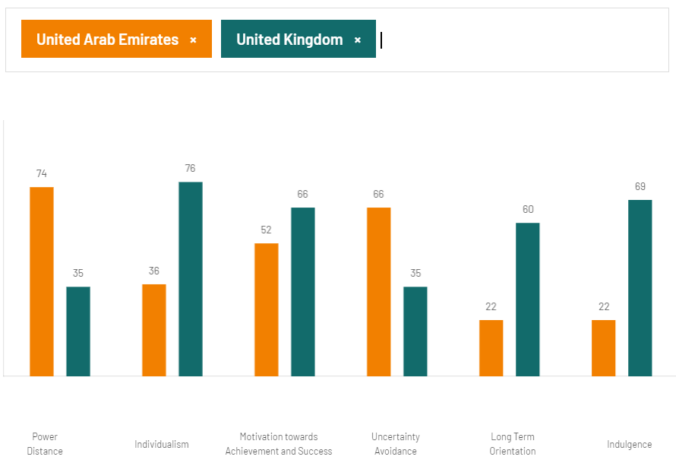
Figure 01: Cultural differences in different dimensions considering the UK and Dubai
(Source: hofstede-insights, 2023)
For instance, the UAE culture is more power-driven as it reflects a score of 74 while in the UK it is just 35. As a result, individualism is greater in the UK than in Dubai and the scores are also showing the same addressing 76 and 36 respectively (hofstede-insights, 2023). Furthermore, based on individualism, masculinity which is the notion of achievement and success is more valued in the UK as it scores 66, dominating Dubai's culture of hierarchy and 52 score. On the other hand, in risk mitigation and uncertainty avoidance, Dubai is in a better position having a score of 66 overshadowing the UK’s 35. The long-term orientation again uplifted the culture of the UK, scoring 60 against 22 of Dubai. On the contrary, Arab’s culture of entrepreneurship and innovation has a long history and more investment is made for strategic global partnerships and further economic diversification (Alardhi, 2023). Contemplating the indulgence of the people of the UK is more conducive to innovation than the restraining behaviours of Arabs. For instance, Dubai has succeeded in trying to have a regulatory culture and cohesive business environment for achieving further endured growth (Forbes, 2022).

GLOBE Project/country analysis
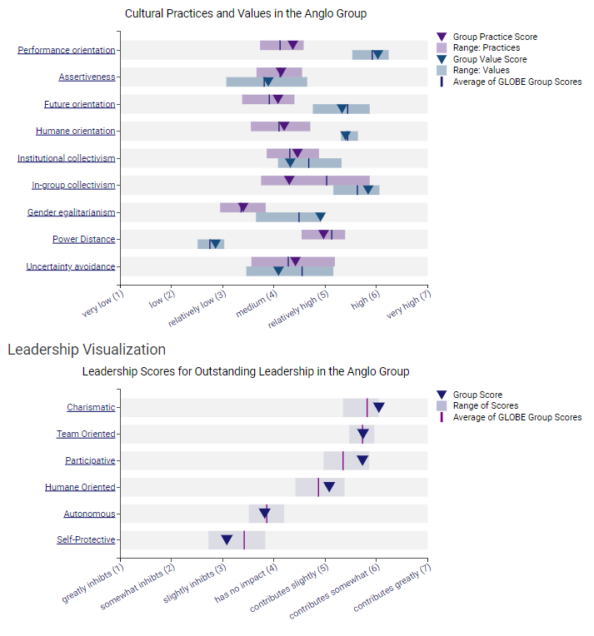
Figure 02: Cultural group analysis of the country, UK
(Source: Globeproject, 2023)
Based on the fact of intercultural differences and custom-based orientation, the above analysis can depict some introspection for the hotel venture. In the UK especially, performance orientation and the related practices are beyond the average values of the world and the same notion can be addressed in terms of uncertainty avoidance, organisational collectivism and future orientation (Globeproject, 2023). On the contrary, in-group team collaboration practice is in a lower magnitude than the global value and the future orientation values secured its position behind the globe group scores. For instance, the fourth revolution uplifted the future orientation practice of the UK culture revamping technological advancement such as AI, robotics, additive manufacturing and environmental sustainability (McKinsey, 2021). Considering the leadership customs, charismatic leadership, organisational team orientation and participative culture can foster an optimistic insight. While, in the same context, hindrances in autonomy and self-protection can be the reasons for certain prohibitions of business practices.
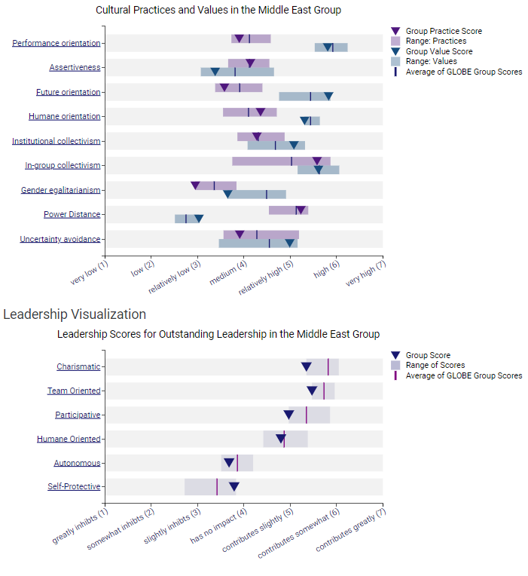
Figure 02: Cultural analysis of the Nation, UAE and Dubai
(Source: Globeproject, 2023)
Contemplating this analysis about the Middle East group within which Dubai resides, A decent difference can be ostensible in performance orientation in comparison with the UK. Apart from that, with further investigation, a contradictory insight is in the future orientation where the values are ahead of the globe score but the practices are far behind the average. The global cost-of-living crisis can be festered as the rationale due to high inflation and commodity prices the business can be threatened and people might behave in a more restrained manner (arabnews, 2023). The uncertainty avoidance is thus showing a lower score than average even lower than that of the UK. Furthermore, looking towards leadership and business customs charismatic leadership, team orientation, participative nature of people can impact more to businesses. Particularly in these attributes, Dubai and the whole Middle East group are going downstairs than the average globe score.

Discussion
Based on the critical evaluation of these two areas of the world, the UK is in a better position than Dubai and a greater perspective, the UAE. For instance, the difference in the market proposition of the hotel sector in both countries can be addressed. In the UK, the expected market growth rate is 1.59% while in 2023, the market share remains at 17.25 billion GBP (Statista, 2023 a). The COVID pandemic has severely affected this area of the UK landscape but recovery is steep in a true sense. Dubai is far behind having a market of 0.34 billion GBP with a growth rate of 2.30% (Statista, 2023 b). It can be commented that the UK is growing more empirically based on the uncertain avoidance notion, charismatic leadership and participative nature of the people to innovate more for future orientation. The company can face a lot of hindrances in Dubai because of the sensitivity, however, it is now a global epicentre of entrepreneurship. The poor long-term orientation and power-driven culture can prohibit the individual upliftment of employees and achieving their endeavours.

Conclusion
From the above analysis, it can be concluded that the hotel “Diversity Hotel & Spa in London” is better suited to the UK culture to grow further as in Dubai it may face some prohibitions to grow rapidly. The interculture viability is certainly restraining and the leadership custom is sensitive to adopt radical changes.

Recommendations
- Social network is a huge part of the culture of Dubai and thus, the hotel group need to take off social connection in this city and through online penetration for promoting the business, customer acquisition may foster a better outcome.
- Technological advancement is a certain need as Dubai is investing hugely to grow as a global technology leader, socially valuing big data, and artificial intelligence along with some sustainable measurement (creationbc, 2023). In this regard, the hotel group and the general manager must think about digital change to penetrate the market of Dubai.
- Lastly, to acquire more knowledge about the culture and people’s intentions, affiliated programs can be recommended where some local corporations of Dubai can help with shared information and shared resources.

References
Alardhi, M. (2023). Innovation will drive change through the GCC. Available at: https://www.thenationalnews.com/opinion/comment/innovation-will-drive-change-through-the-gcc-1.1209886 (Accessed: 10 November 2023)
arabnews (2023). Cost-of-living crisis stands as the biggest threat to UAE businesses: WEF report. Available at: https://www.arabnews.com/node/2238036/business-economy (Accessed: 10 November 2023)
creationbc (2023). DRIVING EFFICIENCY & GROWTH: THE IMPACT OF TECHNOLOGY IN UAE BUSINESS. Available at: https://www.creationbc.com/news/driving-efficiency-growth-the-impact-of-technology-in-uae-business/ (Accessed: 10 November 2023)
Forbes (2022). How To Conduct Business With Middle Eastern Investors. Available at: https://www.forbes.com/sites/forbesbusinesscouncil/2022/05/31/how-to-conduct-baaron-dabbaghzadehusiness-with-middle-eastern-investors/?sh=6e23d9bc2685 (Accessed: 10 November 2023)
Gerlach, P. and Eriksson, K. (2021). Measuring cultural dimensions: external validity and internal consistency of Hofstede's VSM 2013 Scales. Frontiers in Psychology, 12, p.662604.
Globeproject (2023). GLOBE 2020 – Culture Groups. Available at: https://globeproject.com/results/clusters/anglo?menu=cluster#cluster (Accessed: 10 November 2023)
hofstede-insights (2023). COUNTRY COMPARISON TOOL. Available at: https://www.hofstede-insights.com/country-comparison-tool?countries=united+arab+emirates%2Cunited+kingdom (Accessed: 10 November 2023)
McKinsey (2021). Facing the future: Britain’s new industrial revolution. Available at: https://www.mckinsey.com/capabilities/operations/our-insights/facing-the-future-britains-new-industrial-revolution (Accessed: 10 November 2023)
Statista (2023 a). Hotels - United Kingdom. Available at: https://www.statista.com/outlook/mmo/travel-tourism/hotels/united-kingdom (Accessed: 10 November 2023)
Statista (2023 b). Hotels - United Arab Emirates. Available at: https://statista.com/outlook/mmo/travel-tourism/hotels/united-arab-emirates#:~:text=Revenue%20in%20the%20Hotels%20market,US%240.46bn%20by%202027. (Accessed: 10 November 2023)

