 | Targed/Targets | Yr hyn rwyf wedi'i wneud yn yr aseiniad hwn... / What I have done in this assignment...
Targed/Target 1 | Proofread your work to ensure accuracy of spelling and possessive apostrophe. | I made sure I researched the possessive apostrophe before starting my assignment.
Targed/Target 2 | Further develop your critical thinking and synthesise your ideas. | I used different theorists to contradict other theorists.

Assignment title- Critically reflect on your pedagogical progress demonstrated through required elements of the Professional Learning Passport, identifying a specific area for Professional development and justifying next steps for improvement.

Contents Page

Part 1 Page Numbers

-Subject Knowledge Development. 3-5

-Reflection on Planning for Progression in 6-9
Sequences of lessons.

-Reflection on Planning for the 4 purposes 10-13

Part 2
-Written reflection on one aspect of PTE3 I 15-19
wish to Develop further.

Reference list 20-23

Appendices 24-43

Subject Knowledge Development
Asset 1: Literacy
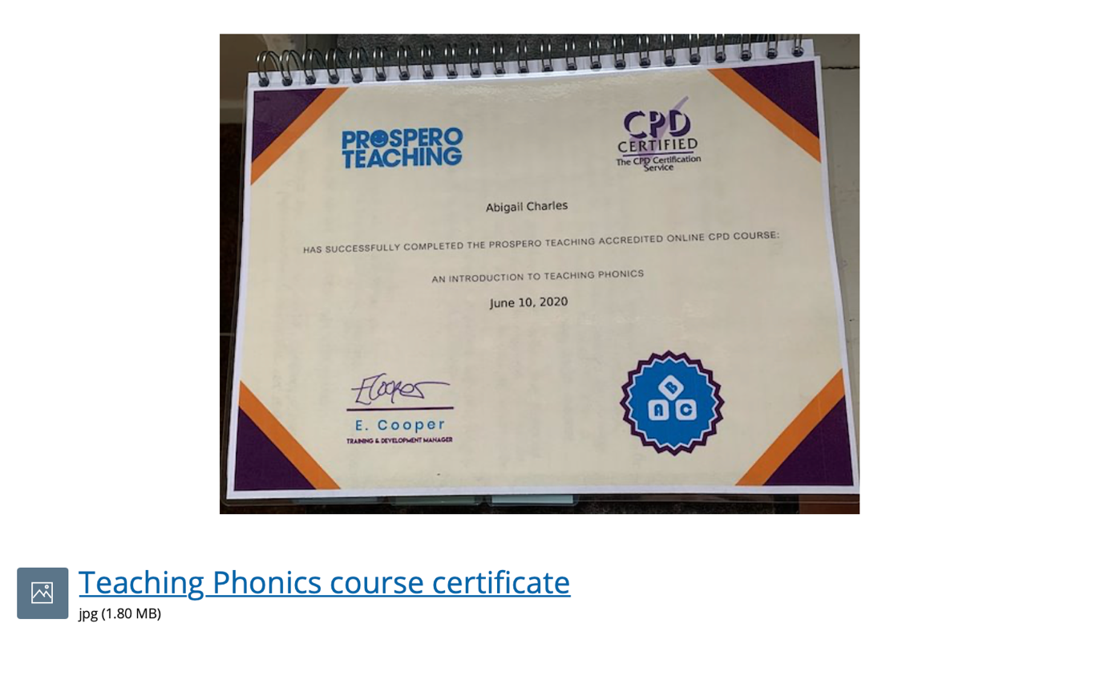
During the Summer term, I completed many courses to develop my own knowledge and skills. One course that I completed was called an ‘Introduction to Teaching Phonics.’ This course showed me the different ways to use phonics in the classroom and different strategies that teachers agree on. It is really important to understand phonics as that is the concept behind how young children learn how to speak, read and write. Throughout my experience in PTE3, I was given the opportunity to teach phonics at a Foundation phase level. The pupils used phonics daily at school so this way, the children were able to learn new sounds and understand new vocabulary using a range of techniques.

Phonics in general play an important role to a child’s early years as it enables them to become successful readers and writers in the future (Cunningham and Cunningham, 2002). This course provided me with a variety of resources and tips when teaching phonics which helped me fully understand the concept behind it and how young children think. This course also noted the specific people I could contact if I had any questions or needed more information on how to teach phonics. I have learnt the impact phonics have on children and how it develops their knowledge of sounds and letters.

This course will impact my future practice as I now understand the tricky words pupils find difficult as well as how the blending sequence works. The notes from this course will be used in the classroom as I will explain to the pupils the correct way of using phonics to develop their own skills of letters and sounds.
Subject Knowledge Development
Asset 2: Digital Competence
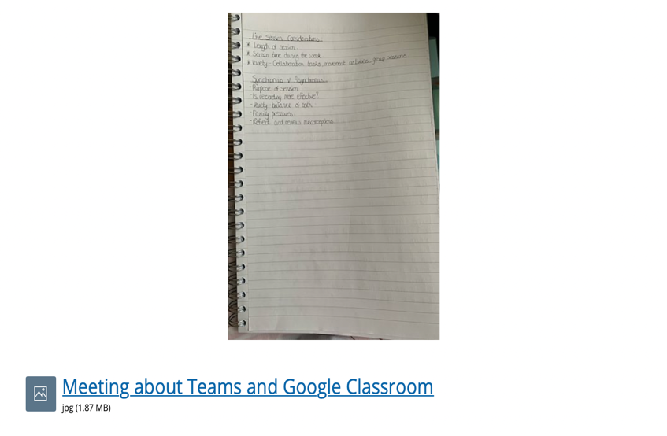
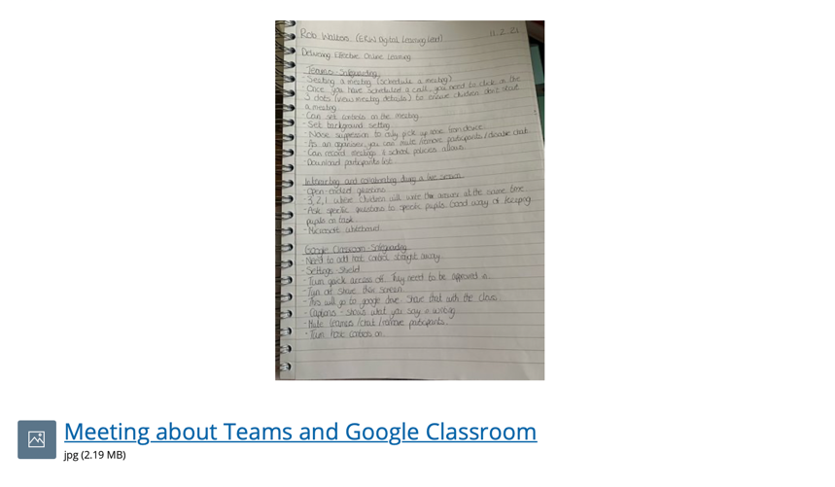
Due to the Coronavirus pandemic, I had to adapt my skills to teach online. These two assets show the small course I attended with an ERW leader called Rob Walters (2021). During this small course, we talked about the different ways teachers can use Teams and Google Classroom. Rob Walters (2021) also explained the safeguarding procedures that need to be in place with both of these platforms. This was developing my own knowledge and understanding of both platforms and how I can use them during blended online teaching. Before this course, I did not understand the basic procedures that needed to be in place to safeguard myself and the children. For example, this small course taught me that all teachers should blur out their background when teaching as this could lead to major issues.
This course was very informative and developed my knowledge of Teams and Google Classroom. Schools “faced unprecedented challenges resulting from the COVID-19 virus pandemic” so they needed to use the correct software that was suitable to use at home (Bubb and Jones, 2020, p.209). It was crucial that teachers fully understood the safeguarding procedures swiftly for the software’s prior to using them as teachers had very “little preparation or training time” on this (Bubb and Jones, 2020, p.209).
As a result of undertaking this course, it allowed me to become fully aware of Teams and Google Classroom. Rob Walters (2021) explained which software was best to use at certain times, for example, teams should only be used with the higher year groups as it is more complex than google classroom. I will use the information I learnt on this course to use in future practices if teaching and learning needed to become remote.
Subject Knowledge Development
Asset 3: Welsh Language Development
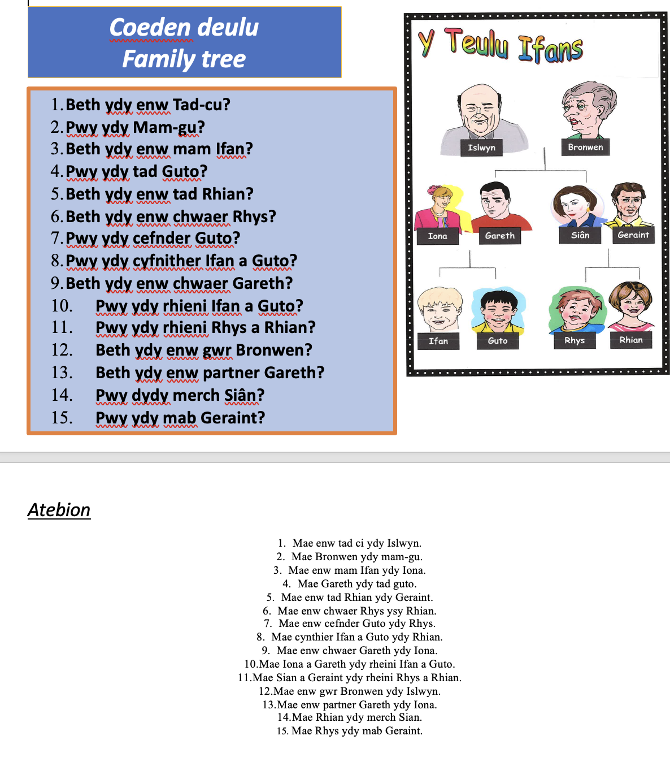
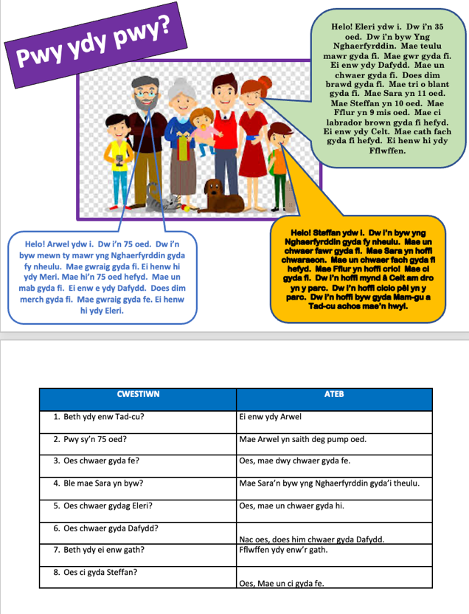

As part as my Rhagoriaith sessions at University, I have completed additional tasks to improve my own understanding of the Welsh language and the different ways I can use these phrases in the classroom when teaching. These Welsh tasks show that I needed to answer and ask questions in Welsh. After I completed these activity sheets, I used my university sessions and tutor to check that my answers were correct.

These extra Welsh activities helped me understand the different topics that schools may use when teaching Welsh. It also provided me with a better understanding of the different welsh activities and games I could use in the classroom with the pupils to help improve engagement and enjoyment.

If teachers enhance their own knowledge of the Welsh language, then this will result in pupils building their own confidence to use the Welsh language in a variety of contexts (Welsh Government, 2017). Teachers develop a passion for the Welsh language if they have had enough support to extend their skills (Welsh Government, 2017).
I will use these additional tasks in the future as they will extend my knowledge of the Welsh language and shows how I used my skills I learnt in my Rhagoriaith sessions into practice as if I was a pupil. This helps me understand any misconceptions the pupils may have on these tasks and allows me to think of different ways of helping them and resolving the misconceptions.
Pedagogy Standard: Advancing: Progression in Learning​
Progression in Learning
What did you do and why?
During my experience on PTE3, I was given the opportunity to plan a range of different maths lessons that showed progression. As I was placed in a Reception class and because the pupils were not in school due to lockdown, I had to start with basic maths such as counting using resources. One theme was Space, so I created a worksheet where pupils needed to count the different space objects and write the correct number in the boxes (See Appendix A). When all pupils understood this, I asked them to complete an iSpy worksheet where they needed to find all the space objects on the sheet and count them altogether. After this, I moved onto addition where I filmed a video of myself explaining to the pupils that they will need to find resources from their house to help them with adding. Most pupils understood and I had excellent results that came back. When the pupils arrived back at school, I wanted to check if they fully understood the counting sequence, so I asked pupils to order the dinosaurs according to their numbers. For the low ability group, I asked them to order numbers between 1-5, the middle ability group needed to order numbers between 1-10 and the high ability groups had to order numbers between 10-20. Most pupils understood this very well. Following this was Easter week, so I printed off a variety of Easter eggs and created an addition worksheet. I used the Easter eggs as a physical resource to allow pupils to see exactly what they were adding. I made sure I asked pupils what addition means before we started the task, and most pupils were able to explain back to me. Overall, these series of maths lessons show the progression pupils made in their learning by starting with counting including resources, counting without resources which lead onto adding up to 10 and 20. These lessons helped me understand the different abilities of the children and where I should tailor my teaching (See Appendix B).

What have you learned?
As I was in a Reception class, I needed to start with basic maths in order for them to understand the counting sequence. I had to ensure that the children understood the counting sequence first before moving onto more tricky maths questions such as addition. This experience has taught me the different abilities that could be in one class and the impact of using resources for some children. During my experience in PTE3, I have learnt that progression in learning is a fundamental step when teaching and builds on a range of previous experiences.
What Next?
As a result of my PTE3 experience, I have realised that I need plan and deliver with the 'progression in learning' in mind so that pupils are able to extend their learning and understand different concepts. I believe progression in learning is at the centre of teaching as it enables pupils to build from pervious knowledge and develop new skills in the same topic.

Pedagogy Standard: Advancing: Progression in Learning​
Progression in Learning
What did you do and why?
During my PTE3 experience I was asked to plan and deliver a variety of Welsh lessons that progressed pupils in their learning. Firstly, I Started with basic knowledge by encouraging them to sing the 'Sut Mae'r Tywydd song' in the mornings. I needed to see exactly where the pupils were at with their Welsh language skills. After practicing this song many times in the morning, I then moved onto explaining the importance of the Welsh language during St David's Day and encouraged the pupils to speak more Welsh in the classroom. During this St David's day, I asked the pupils to have a go at saying the Welsh foods and items when looking for them in the Welsh scavenger hunt (See Appendix C). I used a range of different phrases in the classroom such as 'pwy sy'n barod?', 'edrychwych arna I!' and 'mae h'n amser tacluso" when it was tidy up time. I avoided directly explaining what the phrases meant and used many hand gestures to see if the pupils could understand what I was saying. When I was going through a colours PowerPoint, I asked the pupils what the colours were in English before asking them for the Welsh colours. This PowerPoint lasted around 2 days as I wanted to check the pupils understanding with very little support on the second day. One day I went through the PowerPoint explaining what the colours were in Welsh and on the next day, I asked pupils if they could remember what the Welsh colour was without any support. I saw a progression in their learning when most pupils could explain what the colour was in Welsh. When the pupils had fully understood the Welsh colours, I read a story whilst asking questions such as 'pa liw' where the pupils needed to tell me the colour of the item that Tedi Twt was wearing in Welsh (See Appendix D). Overall, I saw a huge progression in most pupils Welsh learning especially as they had not had many Welsh sessions due to the Coronavirus pandemic.
What have you learned?
I have learnt the importance of encouraging pupils to do their best when learning the Welsh language. Pupils find it hard to learn a different language and there needs to be a variety of support in the classroom in order for them to progress with their Welsh learning. It is also really important that I, as the class teacher, incorporate a range of different Welsh phrases and words into my everyday teaching.

What Next?
It is important that I provide a range of different resources for the classroom environment that engages pupils in their learning. The Welsh language is a crucial aspect of progressing pupils as Welsh is a fundamental core subject that pupils need to feel passionate about. I am also going to be encouraging the pupils to progress in their learning by providing verbal feedback that starts with a positive and then leads to their targets.

Pedagogy Standard: Advancing: Planning for the Four Purposes

Four Purposes

What did you do and why?
There was a range of different experiences that enabled me to meet the four purposes during my training on PTE3. One experience I enjoyed teaching about was St David's Day on March 1st. The pupils became ethically, informed citizens of the world as they were learning about their own culture and the importance of St David's day. I created a St David's PowerPoint where I asked pupils if they had ever experienced wearing Welsh clothing or tried foods specific to Wales etc (See Appendix E). This way, the pupils could see the importance of these items in Wales as well as understanding the importance of St David's day as a whole. I showed the pupils what children used to wear at school and the old traditions that we have in Wales that are still going today. I also included a video clip where pupils could see and hear old Welsh dancing and music which the pupils really enjoyed as well as the Welsh national anthem (See Appendix F). I explained the importance of both of these and encouraged them to take part in some activities. It was important to show the pupils the significance of Wales and the traditions that are special to us. “It is part of what defines us as people and as a nation” (Welsh Government, 2017, p.2). I planned a Welsh scavenger hunt for this day and the pupils had to look for Welsh items and have a go at saying them in Welsh. the pupils could easily explain what they item was, so they had clearly seen and tried the items before which showed their passion for being a citizen in Wales.

What have you learned?
I have learnt that teachers need to have a passion when teaching in Wales in order for pupils to understand how special Wales really is. I have learnt that parents are becoming more involved with Welsh traditions which then helps the pupils to understand why Wales and the Welsh language is important to them. It is important for teachers to incorporate the four purposes in most of their lessons to ensure they teach them as one and not separate to the core lessons.

What Next?
It is important to take forward the different ways I have incorporated the four purposes in my lessons from PTE3 for future practice when I have my own class. I need to now find different ways I can incorporate the four purposes in most of my lessons in order to ensure pupils are becoming young and healthy citizens of Wales and the wider world.

Pedagogy Standard: Advancing: Planning for the Four Purposes

Four Purposes

What did you do and why?
Fitness Friday was a day where we had a range of different apparatus and pe activities for the pupils to keep healthy and fit. I planned an activity that the pupils completed with me, but other teachers also planned and delivered their own activities. This meant that the pupils completed many activities throughout the day to ensure they were keeping fit (See Appendix G) The pupils were given the opportunity to engage in physical activity (Donaldson, 2015) that allowed them to be confident with different movements and build positive relationships with their peers when they needed to work together. The pupils were also able to build "confidence to participate with performance" (Donaldson, 2015, p.30). Once I had modelled what the pupils needed to do, the pupils then had to try the routine for themselves and they built confidence to do this in front of myself and the pupils. Pupils were also able to interact with a range of different challenges and needed to identify ways to overcome them. To begin with I asked pupils the importance of a warmup and how it affects the body. I then went onto a Welsh bean bag game where I shouted out a Welsh colour and the pupils had to run to the corner of the coloured bean bag. The pupils were able to tell me what changed with their bodies after they had been running. I then explained the main task where I modelled the routine that the pupils needed to complete. This consisted of crawling over apparatus, balancing on a bean pole, jumping and a roll pole at the end (See Appendix H). Some pupils did not know how to do a role pole at first but came up with different ways that helped them to complete it. Overall, this was a very healthy lesson for the pupils as it was making sure they were fit and active as well as showing them what happens to our bodies when we complete exercise.

What have you Learned?
During this fitness Friday, I learnt that pupils need to be given a range of activities to complete in PE to make it exciting and engaging for them. It is really important to incorporate PE lessons at least once a week to ensure that the pupils are still active and keeping fit. I have also learnt that pupils need the break from core subjects at least once a week because I can see that all pupils enjoyed this fitness Friday as it was something different and exciting for them.

What Next?
I will be using a range of different PE lessons at least once or twice a week to ensure the pupils are keeping fit at home and engaging with physical activity. I need to ensure that when I teach these PE lessons with my own class, I also need to ask the pupils what impact it has on their body. I will defiantly be doing this fitness Friday again as it worked very well with the pupils and built their confidence in a variety of different ways. Physical activity is crucially important with young children as it helps them to see the benefits when they do complete it and helps overcome obesity in children.

References for Part 1
Bubb, S. Jones, M.A. (2020) Learning from the COVID-19 home-schooling experience: Listening to pupils, parents/carers and teachers. Improving Schools: SAGE. Vol. 23(3) 209–222. Available at: https://journals.sagepub.com/doi/pdf/10.1177/1365480220958797 (Accessed on 20.04.21).
Cunningham, P.M. & Cunningham, J.W. (2002). What Research Has to Say About Reading Instruction (3rd ed., pp. 87–109). International Reading Association. Available at: http://citeseerx.ist.psu.edu/viewdoc/download?doi=10.1.1.552.1728&rep=rep1&type=pdf (Accessed on 17.04.21).
Welsh Government (2017) Welsh in education: Action plan 2017–21. Welsh Government: Cardiff. Available at: https://gov.wales/sites/default/files/publications/2018-02/welsh-in-education-action-plan-2017–21.pdf (Accessed on 15.04.21).
Welsh Government. (2017) Cymraeg 2050: A Million Welsh Speakers. Welsh Government: Cardiff. Available at: https://gov.wales/sites/default/files/publications/2018-12/cymraeg-2050-welsh-language-strategy.pdf (Accessed on 22.04.21).

Part 2- Written Reflection

Title- A critical reflection (2000 words, +/-10%). Based on the evidence collected for part 1, identify a specific aspect of your practice to develop in order to support learner progression. Justify, with reference to reading, how you will develop this in future teaching.

Link to my Professional Learning Passport: https://v3.pebblepad.co.uk/spa/#/public/kwhG4Zjm59nMrrxfHdjzGR6MnM

For the purpose of this assignment, physical activity will be explored in order to support learner progression. The World Health Organisation (WHO) defines physical activity as any body movement that exerts the body through a range of ways to develop health and well-being (WHO, 2020). Physical activity as referred to by the Healthy Schools Organisation (2010, p.4A) noted that it is “an integral part of daily life in a health-promoting school.” During experiences in schools, there has been ongoing issues with pupils’ health and wellbeing within and outside of the classroom (Dyson B. and Casey A, 2016). Throughout the variation of University modules, we have explored the importance of healthy children and how it can enable them to achieve their goals. I have therefore decided to complete further research on this topic to improve my own knowledge and understanding on the beneficial impact of pupils’ becoming healthier in the classroom. This topic also links to the Four Purposes section in part one as I experienced on a first-hand basis the excitement and enjoyment as well as the learning the pupils’ experienced during the fitness Friday sessions (Donaldson, 2015). Researching this topic will provide me with a range of techniques and activities I can use in the classroom to encourage children to become active citizens. It will also enhance my own professional development that can link to my targets as discussed in the Professional Learning Passport (PLP). Donaldson (2015) outlines how one of the core purposes of the new curriculum in 2022 helps improve pupils to become healthy, confident citizens. During the course of this written reflection, I will be exploring the importance of pupils’ becoming healthier in the classroom as well as discussing the benefits and limitations of this aspect.

Coe et al. (2014) evaluate the impact of good teaching and believe that in order for pupils to become confident in what they are learning about, the class teacher needs to exhibit the purpose of the activity and explain how it has an effect on these pupils. Teachers must have a passion when educating the pupils’ as well as being a positive role model (Coe et al. 2014). This links to Albert Bandura’s Social Learning Theory as he explains that children observe actions and behaviours from positive role models which would lead to pupils imitating them (McLeod, 2016). Therefore, if pupils recreate these positive behaviours and actions during the physical activity sessions, then the educators will reward the pupils with positive reinforcement to encourage the pupil to reconstruct the behaviour (McLeod, 2016). Similarly, Dyson and Casey (2016) demonstrate that teachers must create positive learning environments to enhance pupils’ expertise. During physical activities, teachers must promote the what as well as the how these experiences would impact each and every pupil as stated by Beni et al. (2019).

The planning and teaching of physical activities must be considered for a number of reasons (Jenkinson and Benson 2010). The Healthy Schools Organisation (2007) suggests in order for pupils to become motivated to participate, teachers need to make the environment positive and inviting. Teachers need to consult with all pupils involved in order to identify the barriers to participation (Healthy Schools Organisation, 2010). Additionally, Jenkinson and Benson (2010) agree suggesting other barriers that schools may face when planning and teaching physical activities. These include budget issues, reduction with time as a result of the curriculum and the lack of equipment indicating that some schools are in a crisis when undertaking physical activity lessons (Jenkinson and Benson, 2010). Teachers need to fully understand the schools’ physical activity and education policies to develop their own knowledge and magpie excellent ideas according to previous teachers who have successfully engaged all pupils with the activity (Horn et al. 2012).

Following the Wellbeing Act, which was introduced in 2015, Welsh Government (2015) have clarified that Wales must become a healthier country where people’s physical and mental well-being escalates. Similarly, Horn et al. (2012, p.69) defined physical activity as the most powerful tool when improving “healthy psychosocial and physical development” in children and adolescents. Additionally, Hills et al. (2007) state that there has been a substantial increase with childhood obesity and suggests that physical activity needs to be raised at schools. Comparably, the Curriculum for Wales Guidance document (2022) explains when pupils understand the importance of physical activity and the impact it has, they will experience healthy and active lifestyles which would ultimately reduce obesity (Welsh Government, 2020). Weight gain and the decrease of health occurs when low physical activity is obtained (Hills et al. 2007). Throughout the recent years, obesity in children and adolescents has increased due to new technology including computers, phones, games and cars which lead to “sedentary pursuits” (Hills et al, 2007, p.5). The meaningful experiences that occur during physical activity is crucial within schools especially throughout the early stages of their life (Beni el al. 2019, p.1). It implies that this type of activity increases the pupils’ social interaction and “motor competence” Beni el al. 2019, p.1). Providing pupils with a meaningful physical activity allows them to see the benefits it has and enables them to have fun but also overcome their challenges in many ways (Hills et al, 2007, p.5).
Hewitt et al. (2019) demonstrate that the Chief medical officer for Wales announced that every child and young adolescent must engage with medium to vigorous exercise for at least sixty minutes daily. The ‘must’ suggests that it has now become a necessity in schools to engage with physical activity as it will reduce pupils becoming overweight (Hewitt et al, 2019). Hewitt et al. (2019) describe a case study which shows that more males were active than females when completing exercise and that adolescents from more affluent families were more likely to complete the daily exercise of sixty minutes. As a result of this, Estyn (2019, p.2) state that females under the age of sixteen reported “lower well-being and worse health” which suggests that physical activity needs to be increased for females specially to raise their physical and mental wellbeing levels. According to Eco-Schools (2014, p.03), this generation that are evolving will experience “lower life expectancy than their parents.” Eco-Schools (2014) implies that the issues in the world such as social media and the influence of celebrities will delay pupils wanting to take part in physical activity during or after school.
Eco-Schools (2014) teaches pupils the importance of exercising and eating healthy nutrients in order to fully develop. Eco-Schools (2014) develop as a whole school approach with many pupils being eco-school councillors. It encourages pupils to participate in physical activity at school as they can see the benefits it has (Eco-Schools, 2014). Similarly, Personal, Social, Health and Economic (PSHE) is another organisation that schools use to help pupils feel safe and loved at school, physically and emotionally (PSHE Association, 2019). It is a way of introducing PSHE into core subjects in order for pupils to thrive in every way possible (PSHE Association, 2019). The key skills that are developed in PSHE sessions are teamwork skills, resilience and critical thinking skills (PSHE Association, 2019).
Nevertheless, Estyn (2019) explain some limitations when completing physical activity in schools. There have been numerous occasions where schools are not able to complete their physical activity lessons because of a variety of reasons such as the availability of the school hall, apparatus and the change of weather (Estyn, 2019). This suggests that schools need more funding and space in order for teachers to teach the physical activity lessons to the best of their ability. In addition, Estyn (2019) explain that although physical activities are being prepared and taught, teachers are not exerting the pupils to their potential which is a limitation with physical activity at schools. Another limitation that UNICEF (2010, p. vi) reported was that most physical conditions at schools were “far from child friendly” which needed to be changed.
In order to obtain successful physical activity sessions, Parker and Hellison (2013) believe that pupils need to take an active role when deciding on the type of activity they would like to receive. This suggests that pupils will be able to reflect on their choices and explain what went well and what they would improve on in future lessons. This is a strategy that teachers need to consider when planning (Parker and Hellison, 2013). In addition to Parker and Hellison (2013), Chróinín et al. (2017, p.128) also explains that teachers must become “responsive to children’s ideas” which leads to meaningful cooperation. This suggests that pupils will be more engaged if teachers are using the pupils’ own ideas (Chróinín et al. 2017). Similarly, teachers need to uphold an exceptional repertoire of teaching strategies that are appropriate for pupils of all ages (Gumbo et al. 2017). Various teaching strategies will enable pupils to work at their own pace and will “increase student responsibility for learning and feedback” (Gumbo et al. 2017, p.61). This advocates that teachers will be able to improve their lessons in order to suit every child’s needs after they have received the feedback (Gumbo et al. 2017).
The Centre for Disease Control and Prevention (2018) declares that physical activity enables pupils to become motivated in their learning and increases concentration levels. However, teachers must consider whether all activities are appropriate for certain cultures at school (Centre for Disease Control and Prevention 2018).
Creating greater amounts of physical activity sessions during school times will help the child progress in many ways (Barbosa et al. 2020). Vigorous physical activity provides “positive effects on academic achievement” (Barbosa et al. 2020, p.28) with young children as well as improving their bone health and cardiovascular function (Howie and Pate, 2012). Welsh Government (2013) also agree and illustrate that physical activity is important to develop academic achievement in young children to carry forward into their later years. Physical activity is crucial for young children as it enhances positive mental health (Howie and Pate, 2012). Engaging with physical activity will encourage positive well-being and a healthy lifestyle in general (Welsh Government, 2013). Additionally, Lev Vygotsky noted that children learn best through physical interactions which implies that the physical environment and being active plays a contributing role in their learning (McLeod, 2018). As a result of physical activity, Scheuer and Dr. Mitchell (2004) demonstrate that young children will experience higher energy levels, improved brain functions and an increase in their self-esteem and confidence. “Physical inactivity is considered a major public health issue” and suggests that obesity is a nationwide concern which must be reduced (Smith and Lounsbery, 2009, p.42).
Following this assignment, physical activity is a crucial aspect to implement daily in schools in order to progress pupils in their learning (Barbosa et al. 2020). As a result of conducting this research, I have identified many ways I can promote pupil participation at schools in order to understand the barriers they may have. During future teaching practices, I will include at least one physical activity session per day to reduce obesity in young pupils as well as improving their mental health (Estyn, 2019). Firstly, I will ensure that all children fully stretch before taking part in any physical activity. Daily simple stretches can help pupils become more flexible, develop their stamina and they will have an overall healthier body (Havard Health, 2019). Another strategy I will bring into the classroom for pupil participation is pupil voice where I would ask pupils to tell me what they would like to do. (Chróinín et al. 2017). I could then include these suggestions into my lessons where possible which would lead pupils to become more involved with their learning and therefore more likely to take part.
There will always be limitations on physical activities in primary schools, however, where possible I will always try to make time and use of the resources that are available (Estyn, 2019). It is key for teachers to acknowledge that some resources are not age appropriate and therefore, this will need to be considered when teaching physical activity lessons (UNICEF, 2010). As stated previously, I will plan my lessons which include a fitness Friday session each week where I will encourage the pupils to wear appropriate clothing and trainers for a fun and active class that develops their practical skills. As part of Donaldson’s Four Purposes, incorporating physical activity sessions will allow pupils to become “healthy, confident individuals, ready to lead fulfilling lives as valued members of society” (Donaldson, 2015, p.29).

References

Beni, S. Chróinín, D-N. Fletcher, T. (2019) A focus on the how of meaningful physical education in primary schools. Department of Kinesiology, Brock University, St. Catharines, Canada. Oxford. Routledge. Available at: https://www-tandfonline-com.ezproxy.uwtsd.ac.uk/doi/epub/10.1080/13573322.2019.1612349?needAccess=true (Accessed on 13.04.21).
Centres for Disease Control and Prevention. Strategies for Classroom Physical Activity in Schools. Atlanta, GA: Centres for Disease Control and Prevention, US Dept of Health and Human Services: United States. Available at: https://www.cdc.gov/healthyschools/physicalactivity/pdf/classroompastrategies_508.pdf (Accessed on 22.04.21).
Chróinín, N.D. Fletcher, T. O’Sullivan, M. (2018) Pedagogical principles of learning to teach meaningful physical education. Physical Education and Sport Pedagogy. Routledge: Oxford. Available at: https://www.tandfonline.com/doi/pdf/10.1080/17408989.2017.1342789?needAccess=true (Accessed on 18.04.21).

Coe, R. and Aloisi, C. and Higgins, S. and Major, L.E. (2014) 'What makes great teaching? Review of the underpinning research.', Project Report. Sutton Trust, London. Available at: https://dro.dur.ac.uk/13747/1/13747.pdf?DDD45+DDD29+DDO128+ded4ss+d700tmt (Accessed on 14.04.21).

Donaldson, G (2015) Successful Futures: Independent Review of Curriculum and Assessment Arrangements in Wales: Welsh Government. (Accessed on 14.04.21).

Dyson B. and Casey A. (2016) Co-operative Learning in Physical Education and Physical Activity: A Practical Introduction. Oxford. Routledge. Available at: https://books.google.co.uk/books?hl=en&lr=&id=qRy4CwAAQBAJ&oi=fnd&pg=PP1&dq=Dyson+B.+and+Casey+A.+(2016)+Co-operative+Learning+in+Physical+Education+and+Physical+Activity:+A+Practical+Introduction.+Oxford.+Routledge+&ots=55_wJJB2P7&sig=XPSzD3WBcZidtDGUYESuZHvW674&redir_esc=y#v=onepage&q&f=false (Accessed on 13.04.21).
Eco-Schools. (2014) Eco-Schools Inspiration: Healthy Living. Environmental link: Northern Ireland. Available at: https://www.eco-schoolsni.org/eco-schoolsni/documents/006530.pdf (Accessed on 22.04.21).
Estyn (2019) Healthy and happy School impact on pupils’ health and wellbeing. Estyn: Cardiff. (Accessed on 16.04.21).
Gumbo, S. Magonde, G. Nhamo, E. (2017) Teaching Strategies Employed by Physical Education Teachers in Gokwe North Primary Schools. International Journal of Sport, Exercise and Health Research 2017; 1(2): 61-65. Department of Physical Education and Sport, Faculty of Science and Technology, Zimbabwe Open University. Available at: http://www.sportscienceresearch.com/IJSEHR_201712_03.pdf (Accessed on 22.04.21).
Harvard Health. (2019) The importance of stretching. Harvard Health Publishing. Harvard Medical School. Available at: https://www.health.harvard.edu/staying-healthy/the-importance-of-stretching (Accessed on 23.04.21).
Healthy Schools Organisation (2007) Physical Activity Booklet A. British Heart Foundation: London. Available at: https://www.london.gov.uk/what-we-do/health/healthy-schools-london/awards/sites/default/files/Physical%20Activity%20-%20Booklet%20A.pdf (Accessed on 22.04.21).
Hewitt G., Anthony R., Moore G., Melendez-Torres G.J., Murphy S. (2019) Student Health and Wellbeing In Wales: Report of the 2017/18 Health Behaviour in School-aged Children Survey and School Health Research Network Student Health and Wellbeing Survey. Cardiff University, Cardiff, UK. (Accessed on 21.04.21).
Hills, A.P. King, N.A. Byrne, N.M. (2007) Children, Obesity and Exercise: Prevention, Treatment and Management of Childhood and Adolescent Obesity. Routledge: Roehampton University, London, UK. Available at: https://web-b-ebscohost-com.ezproxy.uwtsd.ac.uk/ehost/ebookviewer/ebook/bmxlYmtfXzIwMTgwMl9fQU41?sid=b10548d4-1bbe-461c-9fc4-ea4eb16acea5@sessionmgr101&vid=0&format=EB&rid=1 (Accessed on 16.04.21).

Horn, V. PHD, Linda. RD, Banks, L, M.SC. Vincent, Eileen, M.S. Brian, M. (2012) The Importance of Nutrition and Physical Activity for Children. Pediatric annals, vol. 41, no. 2, pp. 67-72. Available at: https://search-proquest-com.ezproxy.uwtsd.ac.uk/docview/919438219/fulltext/4E177A6B11FC464EPQ/1?accountid=130472 (Accessed on 20.04.21).
Jenkinson, K.A. Benson, A.C. (2010) Barriers to Providing Physical Education and Physical Activity in Victorian State Secondary Schools. Australian Journal of Teacher Education. Vol. 35, I8. Available at: https://ro.ecu.edu.au/cgi/viewcontent.cgi?referer=https://www.google.com/&httpsredir=1&article=1481&context=ajte (Accessed on 24.04.21).
McLeod, S. (2016) Albert Bandura's Social Learning Theory. Simply Psychology. Available at: https://www.simplypsychology.org/bandura.html (Accessed on 23.04.21).
McLeod, S. (2018) Lev Vygotsky. Simply Psychology. Available at: https://www.simplypsychology.org/simplypsychology.org-vygotsky.pdf (Accessed on 21.04.21).
Parker, M. Hellison, D. (2013) Teaching Responsibility in Physical Educations: Standards, Outcomes and Beyond. Vol. 72 No.9. Routledge. Available at: https://shapeamerica.tandfonline.com/doi/pdf/10.1080/07303084.2001.10605863?casa_token=452mlSQqitMAAAAA%3Ae0JbZ6ljir6RCOoEzbDh98fgztzOhRYufPOlBscqBGtdJavcBidujITBPeEoRCqKh4hHRCruVAA& (Accessed on 17.04.21)
Scheuer, L. Dr. Mitchell, D. Does Physical Activity Influence Academic Performance? University of Central Florida- Orlando, FL USA. Available at: http://citeseerx.ist.psu.edu/viewdoc/download?doi=10.1.1.513.9420&rep=rep1&type=pdf (Accessed on 21.04.21).

Smith, N. Lounsbery, M. (2009) Promoting Physical Education: The Link to Academic Achievement. Journal of Physical Education, Recreation & Dance; Jan 2009; 80, 1; Research Library Core: California. (Accessed on 22.04.21).
UNICEF (2010) UNICEF’S Child-Friendly Schools: Ethiopia Case Study. UNICEF: Addis Ababa, Ethiopia. Available at: https://www.unicef.org/french/education/files/CFS_Case_Study_Ethiopia_2010.pdf (Accessed on 22.04.21).
Welsh Government (2013) Physical Literacy an all-Wales approach to increasing levels of physical activity for children and young people. Welsh Government: Cardiff.
Welsh Government. (2015) Well-being of Future Generations (Wales) Act 2015: The Essentials. Welsh Government: Cardiff Available at: https://www.futuregenerations.wales/wp-content/uploads/2017/02/150623-guide-to-the-fg-act-en.pdf (Accessed on 15.04.21).

Welsh Government. (2020) Curriculum for Wales Guidance. Welsh Government: Cardiff. Available at: https://hwb.gov.wales/storage/b44ad45b-ff78-430a-9423-36feb86aaf7e/curriculum-for-wales-guidance.pdf (Accessed on 16.04.21).
World Health Organisation (WHO) (2020). Physical Activity. WHO: Geneva, Switzerland. Available at https://www.who.int/news-room/fact-sheets/detail/physical-activity (Accessed on 17.04.21).

Appendices

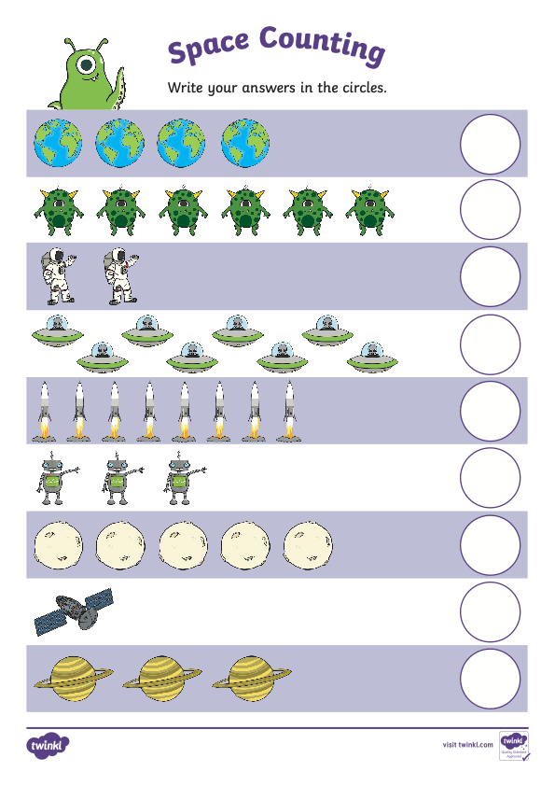
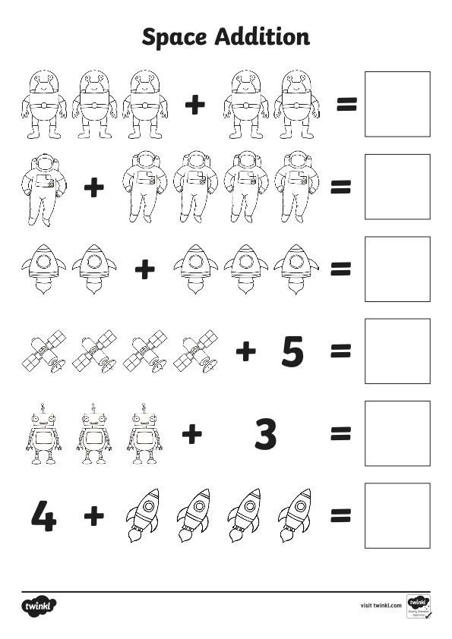
Appendix A- Space Counting Sheets

Appendix B- Maths’s Lesson Plan

Student-teacher | Abigail Charles | Class: | Reception
AoLE/Subject | Mathematics and Numeracy | Date: | 26.01.21
Lesson Focus: | To understand how we add numbers together.
Relevant/meaningful links to:  Curriculum  &  Cross-curricular responsibilities | Mathematics and Numeracy:  I can notice, recognise and write numbers in a range of media, through a multisensory approach, from 0 to 10 and beyond.  I can use my experience of the counting sequence of numbers and of one-to-one correspondence to count sets reliably. I can count objects that I can touch, and ones that I cannot.  I have explored forming a quantity in different ways, using combinations of objects or quantities.  I can communicate how sets change when objects are added to and taken away from them.
Personal Targets  (Linked to QTS and identfied in weekly review) | Learning outcomes and well-being

Learning Objectives (Focus on Learning) | I can count objects that I can touch, and ones that I cannot.
Success Criteria  (process/product) | - All pupils should be able to add most numbers together using practical resources.  - Some pupils will be able to identify all objects on the ispy worksheet.  - Some pupils might be able to act out the video.

Key Resources Health & Safety | - Video of myself explaining the ispy worksheet.  - ispy worksheet  - Counting aliens up to 10 and 20 worksheet  - 5 little men video

Time | Content, Pedagogy & Assessment Opportunities (key teaching points and questions)
Links to Previous Learning | The children would have already had addition questions before and understand the process of adding numbers together. The children would have also been read the story ‘Whatever Next’ by myself so they are familiar with the story.
Opening Phase | Start the activity by asking the children to listen to the pre-recorded video of myself to understand a worksheet.
Teaching & Core Learning | The pupils will need to count aliens together.  The pupils will also have to identify objects in an ispy sheet where they will need to add the objects together and write the numbers in the box.  I have also asked the children to count the stars in the sky or story book to have practical activities.  Watch the video 5 little men and see if the children can make up any actions and singing.
Plenary | Children upload their work onto Class Dojo and I will give them a comment.

Evaluation of Pupil Learning

Evidence of Learning (including attitude to learning over time) | The pupils enjoyed these activities and thought they were engaging. Most pupils were able to count objects together but needed some support with number writing. Some pupils were able to record how they added the objects together and some showed what resources they used to help them add. Most pupils completed these maths activities which was great.
Next Steps for Progress | The pupils will now need to add up to bigger numbers such as 20 to 30.

Reflective Analysis of Teaching and Strategies for Development – including justification/rationale for pedagogical choices

Evidence of my Effective Practice | I thought the explanation of the tasks were clear and simple for the pupils and parents to understand. I made a video for the previous week and some children used that t help them add the objects together. I showed them what resources they could use to help them. I made sure I stayed on the Class Dojo website to see if any parents had any questions of the task.
Areas for my Development  Personal Targets for Progress | I need to now make sure I explain the task by voice so the children can hear a familiar person explaining the task.

Appendix C- Welsh Scavenger Hunt

Appendix D- Pa liw? Tedi Twt Lesson Plan

Student-teacher | Abigail Charles | Class: | Reception
AoLE/Subject | Languages, Literacy and Communication | Date: | 25.02.21
Lesson Focus: | To understand Welsh vocabulary.
Relevant/meaningful links to:  Curriculum  &  Cross-curricular responsibilities | LLC (Welsh):  I can recognise and follow pictorial and/or spoken information and multi-step instructions about familiar topics and routines.  I can listen to others with growing attention.  I can understand there is a one-to-one relationship between the printed and spoken word.  I am beginning to recognise and read high-frequency words that I encounter.  I can use context and pictures to help me understand words.  I can experiment with newly-learned vocabulary.  I am beginning to ask and answer questions.  I can join in with familiar songs, rhymes and stories.  I can use familiar words and phrases and experiment with newly-learned vocabulary.
Personal Targets  (Linked to QTS and identfied in weekly review) | Welsh Language Skills

Learning Objectives (Focus on Learning) | I can use context and pictures to help me understand words.
Success Criteria  (process/product) | - Most pupils will be able to explain what the main colours are: pinc, melyn.  - Some pupils will be able to answer pa liw to different items.  - Some pupils will be able to explain pa liw to items in the classroom.

Key Resources Health & Safety | - Tedi Twt Siopa book  - Pa liw song  - Tedi Twt cards

Time | Content, Pedagogy & Assessment Opportunities (key teaching points and questions)
Links to Previous Learning | Pupils will know some Welsh colours but will need to re-cap again.
Opening Phase | Start by settling pupils after the cofestra. Explain to pupils that we will be looking at tedi twt and the lliwiau yn gymreag.
Teaching & Core Learning | Read the Tedi Twt story and ask questions such as:  - Pa liw ydy’r Tedi Twt?  - Pa liw ydy’r afal?  - Pa liw ydy’r sudd oren?  - Pa liw ydy’r siolced?  - Pa liw yw cot Mr Jones?  - Pa liw yw crys ti tedi twt?  - What do the pictures mean in English?  Sing colour song (Rainbow song). Coch, melyn, pinc a glas, porrfor a oren a gwyn, dyma lliwiau enfius, lliwiau enfis, lliw enfis nawr.  Hold up cards of tedi twt and ask pa liw ydy’r tedi twt?  Key Vocabulary: Pa liw? Tedi twt, pinc, melyn, gwyrdd, glas, porffor, oren, gwyn, dyma lliwiau enfius.
Plenary | Ask pupils what colour items are in the classroom.

Evaluation of Pupil Learning

Evidence of Learning (including attitude to learning over time) | The pupils were very confident when singing the lliwiau enfius song as they sing this in the classroom daily. After I explained what ‘pa liw’ meant in English, the pupils were able to tell me what the colour of different items were using a variety of English and Welsh language. When reading the story, the pupils could tell me what the object meant in English and could tell me the colour of the item. Most pupils were able to explain pa liw to items in the classroom.
Next Steps for Progress | The pupils will now need to have a go at writing these Welsh colours down to see how they are spelled and pronounced.

Reflective Analysis of Teaching and Strategies for Development – including justification/rationale for pedagogical choices

Evidence of my Effective Practice | I ensured that I did not directly translate the Welsh phrases to English straight away. I used a variety of hand gestures to show the pupils what I was talking about. I repeated the phrases ‘pa liw’ and ‘lliwiau enfius’ to help pupils understand the words. I also gave out Welsh stickers to the pupils to encourage them to use more Welsh during lessons and around the classroom.
Areas for my Development  Personal Targets for Progress | I now need to ensure that I use the Welsh colours as part of the morning routine to make sure the pupils fully understand this.

Appendix E- St David’s Day PowerPoint Lesson Plan

Student-teacher | Abigail Charles | Class: | Reception
AoLE/Subject | Languages, Literacy and Communication | Date: | 25.02.21
Lesson Focus: | To understand the importance of St David’s Day.
Relevant/meaningful links to:  Curriculum  &  Cross-curricular responsibilities | LLC (Welsh):  I can recognise and follow pictorial and/or spoken information and multi-step instructions about familiar topics.  I can listen to others with growing attention.  I am beginning to ask and answer questions to clarify my understanding.  I can respond to what I hear, read and see.  I can talk about what I hear, read or see and express simple opinions.  I can use context and pictures to help me understand words.  I am beginning to use appropriate language to talk about events in the past and future.  I am beginning to take turns in conversations, following the topic.  I can use familiar words and phrases and experiment with newly-learned vocabulary.
Personal Targets  (Linked to QTS and identfied in weekly review) | Welsh Language Skills

Learning Objectives (Focus on Learning) | I am beginning to use appropriate language to talk about events in the past.
Success Criteria  (process/product) | - Most pupils will be able to explain what the items are in the PowerPoint.  - Some pupils will be able to ask and answer any questions.  - Some pupils could be able to explain their own personal experiences with the different items in the PowerPoint.

Key Resources Health & Safety | - St David’s Day PowerPoint

Time | Content, Pedagogy & Assessment Opportunities (key teaching points and questions)
Links to Previous Learning | The pupils will know some items that are special to Wales e.g. welsh cakes.
Opening Phase | Settle the pupils on the carpet facing the whiteboard. Explain that it is St David’s Day, and this PowerPoint will explain a bit more about today.
Teaching & Core Learning | I will go through PowerPoint asking some questions such as:  -Does anybody know what this item is?  -Has anybody been here? For a rugby game etc.  Explain that we are special as we have our own items in Wales.  Key Vocabulary: Wales, culture, experience, St David, food, rugby
Plenary | Pupils explain one item that is special to Wales.

Evaluation of Pupil Learning

Evidence of Learning (including attitude to learning over time) | The pupils were able to explain to me the different Welsh items and some could explain the Welsh word for the items. The pupils were also able to answer my questions about Wales and the pupils were given the opportunity to ask any questions. The pupils were able to answer the question ‘what makes us special and different to anybody else?’ which showed me that they understood the meaning behind the PowerPoint.
Next Steps for Progress | The pupils will now need to look at more advanced Welsh items and know the importance of them. The pupils will also need to try some Welsh items as they will be able to physically experience them.

Reflective Analysis of Teaching and Strategies for Development – including justification/rationale for pedagogical choices

Evidence of my Effective Practice | I ensured I asked pupils questions before moving the next slide on, so they were not just reading from the board. I also took some welsh cakes in to show the pupils what they look like. I kept using the word ‘special’ to show the importance these items have in Wales. When explaining about old Welsh clothing, I asked pupils with the same outfits to stand up so other children could physically see what the clothing looked like which the pupils' thought was nice. I allowed time for the pupils to give me some stories that they may have going to a rugby game or eating welsh cakes etc.
Areas for my Development  Personal Targets for Progress | I know need to ensure I bring more physical items to the classroom when I am explaining about St David’s day again to allow pupil to actually see the items.

Appendix F- St David’s Day PowerPoint

Link to asset- https://v3.pebblepad.co.uk/spa/#/public/kwhG4Zjm59nMfGxzm4xb4Z6bGc

Appendix G- Fitness Friday Lesson Plan

Student-teacher | Abigail Charles | Class: | Reception
AoLE/Subject | Health and Wellbeing | Date: | 02.03.21
Lesson Focus: | To develop gross motor skills.
Relevant/meaningful links to:  Curriculum  &  Cross-curricular responsibilities | Health and Wellbeing:  I have the confidence and motivation to move in different ways and I am beginning to develop control of gross motor and fine motor movements in different environments, moving safely in response to instructions.  I am beginning to recognise the connection between the physical and emotional changes that can occur in different contexts.  I can recognise and follow rules and norms in the groups and situations in which I take part.  I can show care and respect for others.
Personal Targets  (Linked to QTS and identfied in weekly review) | Welsh Language Skills

Learning Objectives (Focus on Learning) | I have the confidence and motivation to move in different ways and I am beginning to develop control of gross motor and fine motor movements in different environments, moving safely in response to instructions.
Success Criteria  (process/product) | - All children should be able to understand the Welsh game.  - Some children should be able to explain what the colours in Welsh mean in English.  - Some children will be able to explain the different moves they have performed.

Key Resources Health & Safety | - Mats  - Bean bags  - Apparatus

Time | Content, Pedagogy & Assessment Opportunities (key teaching points and questions)
Links to Previous Learning | The pupils already know about PE and understand the impact of PE activities.
Opening Phase | Start the lesson by explaining that this is a PE session. Explain to the pupils the clear boundaries and expectations of the tasks:  -Stop when a teacher says to as you could hurt yourself.  -Only one child on an apparatus at a time.  -You will be told when the time is appropriate to use the apparatus etc.
Ask pupils what a warmup is. Play a Welsh colour game. Clearly explain that I will call out Welsh colours and the pupils will need to run to the correct coloured bean bags. Use different coloured bean bags in all the corners of the room.

Line the children up next to the apparatus. Ask pupils “click your fingers if you can hear me” etc to gain pupil’s attention. Model the task to the pupils.

Pupils will need to crawl around the horse bench, walk along the plank board and then complete a Roly Poley move.

Plenary | Ask pupils what move they have learnt.  Ask pupils what they had enjoyed/ did not enjoy.

Evaluation of Pupil Learning

Evidence of Learning (including attitude to learning over time) | Most pupils dressed appropriately and listened well to instructions. Most pupils dressed appropriately and listened well to instructions. Most children were able to explain to me what a warmup is which was great. The pupils were able to complete the warmup activities as well as the assault course. Most children waited patiently for their turn.
Next Steps for Progress | The pupils will now need to complete more extensive PE techniques and moves to develop their knowledge and skills.

Reflective Analysis of Teaching and Strategies for Development – including justification/rationale for pedagogical choices

Evidence of my Effective Practice | I made sure I was a good role model by wearing sports clothing and made sure I wore no jewellery to school. Today, I felt more organised during registration time as I made a note of the routine on paper to remind me of all the morning procedures. I believe I explained the lesson expectations and ground rules to the children well and made it clear that when I shouted stop, they needed to stop what they were doing straight away as they could get hurt because of all the equipment. I made sure I asked the pupils what a warmup is to gain understanding of their knowledge on PE. I also ensured that I shouted the colours of the bean bags in Welsh and gave some support when they did not understand. I modelled the focussed task well and completed a demonstration, so they good see a WAGOLL of the activity.
Areas for my Development  Personal Targets for Progress | I need to ensure I keep explaining the ground rules clearly, so pupils understand the expectations of the task.

Appendix H- Cards for PE Lesson

Army
Crawl!





Jump!

Walk
across the plank!

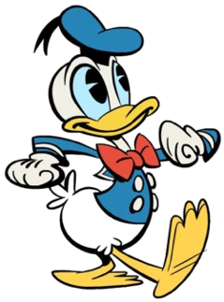



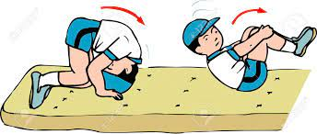Forward Roll

