

NAME: MANJUSHA MAHENDRAN SMITHA MANTHATTIL
STUDENT NUMBER:2243257
UNIVERSITY: UNIVERSITY OF WALES TRINITY SAINT DAVID
COURSE: MSc Public Health and Social Care in Practice
MODULE: Population Health and Digital Health Promotion
MODULE CODE: LCHS7007
ASSIGNMENT TITLE: Blog And Poster
Lecturer name: Dr Diola Bijlhout

BLOG 1
Critically discuss the impact of an existing digital technology currently used for a digital health promotion intervention

Introduction:
The emergence of digital technology has fundamentally transformed our approach to addressing public health challenges. With the proliferation of health-focused applications and platforms, the landscape of health promotion is unmistakably shifting towards digital solutions. This article centers on the profound influence of digital interventions on a significant public health issue in the United Kingdom: obesity. We will examine the role of a specific digital innovation in addressing this prevalent concern.



The Seriousness of the Obesity Crisis in the UK:
According to the 2020 NHS Digital report, a troubling 63% of adults in England are either overweight or obese. Obesity goes beyond mere statistics; it acts as a precursor to numerous severe health conditions, including type 2 diabetes, cardiovascular diseases, and specific types of cancer. The financial implications of managing these related health challenges further strain the UK's healthcare system (NHS Digital, 2020).


The Impact of MyFitnessPal in Combating Obesity:
MyFitnessPal standshttp://dx.doi.org/10.1136/bjsports-2015-095538 out as a quintessential digital tool in the fight against the obesity epidemic. This mobile and web-based platform enables users to:
• Record their Nutritional Intake: Users can meticulously log their food consumption, utilize barcodes to access precise nutritional information, and even keep a record of homemade meals.
• Monitor Physical Activity: It seamlessly integrates with various fitness-oriented devices and applications.
• Set and Manage Weight Loss Goals: Based on an individual's profile, the platform provides personalized daily calorie guidelines.
• Foster a Community Connection: Users can share their achievements, exchange healthy recipes, and provide mutual support (MyFitnessPal, 2023).
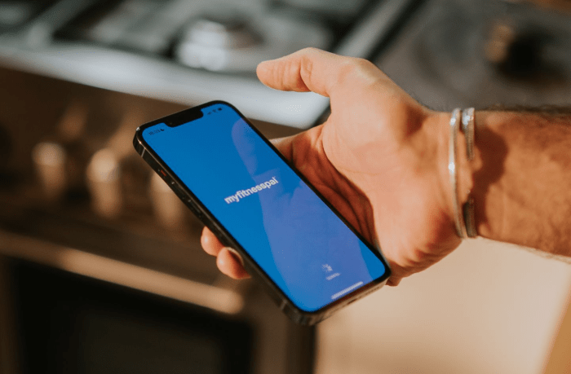

Supporting MyFitnessPal's Role in Enhancing Health:
Several scholarly studies highlight the effectiveness of MyFitnessPal. Notably, a 2016 study published in the Journal of Medical Internet Research found that regular users of the app experienced more significant weight loss compared to those who were less engaged (Laranjo et al., 2015). Additionally, the community-driven aspect of the app demonstrably enhances sustained motivation (Laranjo et al., 2015).

Analytical Overview: Pros and Cons of MyFitnessPal:
Advantages:
• User-Friendly Design: The platform features a user-centric design, ensuring accessibility for individuals unfamiliar with digital interfaces.
• Reliable Nutritional Information: The extensive food database ensures users receive accurate dietary details.
• Community-Based Motivation: Interacting within a supportive community significantly bolsters user commitment.

Drawbacks:
• Reliance on User Entries: There is a potential for incomplete or omitted entries in user logs, leading to data discrepancies.
• Generalized Dietary Guidance: While the app is comprehensive, it may not cater to specific dietary requirements, such as those of diabetics or individuals with hypertension.
• Risk of Excessive Monitoring: Continuous monitoring may lead to an unhealthy fixation on metrics.

Strategies to Address the Limitations:
• Implement Reminder Systems: Gentle reminders can encourage users to consistently log their entries, enhancing data accuracy.
• Collaborate with Healthcare Professionals: Incorporating input from dietitians or medical practitioners can make the platform more inclusive for a wide range of health needs.
• Promote a Holistic Approach to Health: Emphasizing a comprehensive approach to health beyond mere statistical insights is crucial.

Conclusion:
Innovative digital solutions like MyFitnessPal are at the forefront of healthcare advancement. While they present certain challenges, their ongoing development, guided by user feedback, positions them as valuable assets in addressing public health issues such as obesity. The evolution of digital health tools is poised to redefine the paradigms of health promotion, making them more user-friendly, resourceful, and impactful.

BLOG 2
Overview:
The shifting dynamics of our world have not only affected physical health but have also emphasized the importance of mental well-being. In this context, the United Kingdom is witnessing a troubling increase in mental health disorders. This blog introduces "MindScape," a digital innovation created to address this pressing issue.

The Growing Concern: Mental Health in the UK:
Data from Mind, a leading mental health charity in the UK, reveals that approximately 25% of UK residents face mental health issues each year. Primarily, anxiety and depression are prevalent, especially among the younger population. The consequences of declining mental health, ranging from reduced productivity and strained relationships to, in extreme cases, suicide, impose significant societal and individual pressures (Mind, n.d).



Introducing "MindScape": A Digital Solution:
“MindScape" is a versatile digital platform that utilizes AI-driven chatbots, an extensive resource library, and a community forum to achieve its goals of delivering prompt support, dispelling misconceptions through educational initiatives, and nurturing a robust sense of community among its users.

• AI-Powered Chatbots: These offer users an immediate, confidential platform to share their concerns and find relief during distress.
• Resource Repository: A collection of articles, videos, and audio content to educate and empower users about mental health.
• Community Forum: A space where users can share their experiences, seek advice, and find support.
Objectives of "MindScape":
• Immediate Support: The AI chatbot serves as a quick point of contact, especially during non-business hours.
• Education: It dispels myths and reduces stigma by providing essential resources, enhancing understanding of mental health.
• Community Building: The forum provides a pillar of support through shared experiences.



Evaluation of "MindScape" in Mental Health Advocacy:
Pros:
• Continuous Availability: Ensures support is available at all times.
• Anonymity: Creates a judgment-free environment, encouraging more individuals to seek help.
• Comprehensive Resource Hub: Offers invaluable insights.

Challenges:
• Lack of Human Touch: AI chatbots, despite their promptness, cannot replace human empathy, especially in critical situations.
• Reliability Concerns: The accuracy of information derived from AI may be questioned.
• Potential for Misuse: Without stringent moderation, community forums may unintentionally become platforms for negativity.

Mitigating Challenges:
• Hybrid Approach: Integrate human experts into the process, allowing them to intervene when AI detects acute distress.
• Ongoing Improvements: Continuously refine the AI system based on expert feedback.
• Robust Moderation: Implement a strong moderation framework, potentially utilizing AI to flag harmful content.

Final Thoughts:
Given the escalating mental health challenges, platforms like "MindScape" are at the forefront of offering solutions. Despite certain inherent challenges, through iterative refinement and the fusion of technology with human empathy, "MindScape" has the potential to revolutionize mental health interventions.

REFERENCES

- NHS Digital. (2020). Statistics on Obesity, Physical Activity, and Diet - England, 2020.
- MyFitnessPal. (2023). About MyFitnessPal.
- Laranjo, L., Arguel, A., Neves, A. L., & Gallagher, A. M. (2015). The influence of social networking sites on health behavior change: a systematic review and meta-analysis. Journal of the American Medical Informatics Association, 22(1), 243-256.Mind. (2015). Mental Health in the UK: Key Statistics.
- "MindScape" Official Website. (n.d.). About MindScape.
- Naslund, J. A., Aschbrenner, K. A., Bartels, S. J. (2016). How people with serious mental illness use smartphones, mobile apps, and social media. Psychiatric Rehabilitation Journal, 39(4), 364-367.
- Torous, J., Staples, P., Shanahan, M., Lin, C., Peck, P., Keshavan, M., & Onnela, J. P. (2015). Utilizing a Personal Smartphone Custom App to Assess the Patient Health Questionnaire-9 (PHQ-9) Depressive Symptoms in Patients With Major Depressive Disorder. JMIR Mental Health, 2(1), e8.
- MyfitnessPal(2023),British Journal of Sports Medicine, http://dx.doi.org/10.1136/bjsports-2015-095538July 01,2017
- Whiteford HA, Degenhardt L, Rehm J, Baxter AJ, Ferrari AJ, Erskine HE, et al. Global burden of disease attributable to mental and substance use disorders: findings from the Global Burden of Disease Study 2010. Lancet 2013 Nov 9;382(9904):1575-1586.



