Assignment 1 - Self-Development, Professional Practice and the Management of Construction Personnel.
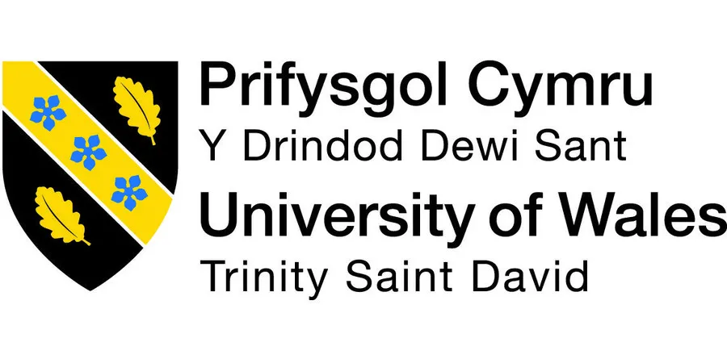
Table of Contents
Introduction 3
Professionalism and Ethics 3
How can we measure professionalism within the construction industry? 4
Career/Work experience to date and organisational context. 5
Personal Development Plan. 7
Understanding the importance of organisational behaviour and the benefit this would add to your personal development. 7
CV 10
Leadership 11
Critical Analysis 12
Conflict Management 13
Teamwork 15
Why is teamwork so important? 16
Appendix 17
Reference List 18

Introduction
This report emphasises the need for standards to be able to measure professionalism as it discusses the significance of ethics and professionalism in decision-making during a construction project. The report will also include a personal development plan and a continued personal development plan, as well as a reflective account of my career path to date within the industry. I'll talk about my responsibilities and perceived leadership style, as well as how my knowledge and experiences affect the organisational behaviour of the team around me. I'll also discuss how I can develop professionally and help my business strive for better outcomes.

Professionalism and Ethics
  - What is professionalism?
Herrity, J (2017), creates the impression that professionalism is the collection of actions, attitudes, and traits that people in a given profession are expected to exhibit. It entails upholding moral and ethical standards as well as showcasing one's skill, dependability, and accountability in one's work. Professionalism can be seen in a variety of contexts, including teamwork, communication, attire, punctuality, and work ethic. To develop trust with clients, colleagues, and the larger community as well as to uphold a positive reputation for themselves and their profession, it is crucial for people to act professionally at work.
  - What is ethics?
The study of moral principles and values that help people and societies decide what is right and wrong is known as ethics. It entails studying ideas like justice, accountability, responsibility, and fairness and applying them to actual circumstances. The application of ethics can be seen in several disciplines, such as business, law, medicine, and science, and it can have a significant impact on how people and organisations interact with one another. The purpose of ethical reasoning is to establish a framework for making wise decisions that consider how our actions will affect other people in the present and the future. (BBC, 2009).
  - Example of ethics and professionalism in construction.
To ensure the security, calibre, and sustainability of construction projects, professionalism and ethics are crucial in the construction sector. This entails maintaining a high level of knowledge, aptitude, and commitment, as well as behaving morally upright and honestly, and considering the long-term effects of one's decisions.
According to the BBC, (2021), the collapse of the Champlain Towers South condo in Surfside, Florida in June 2021 is one incident that emphasises the value of ethics and professionalism in the construction industry. Investigators are currently looking into several potential contributing factors, such as design flaws, construction flaws, and deferred maintenance. The collapse claimed the lives of 98 people. It seems likely that the tragic result, in this case, may have been influenced by a lack of professionalism and ethics. According to reports, the building had a history of structural problems and water damage, which its management and maintenance staff either ignored or failed to properly address. Additionally, a 2018 report from the building's engineering consultant stated that the structure had "major structural damage" and required extensive repairs. However, it seems that these cautions were not taken seriously enough, and the repairs were not carried out.
The significance of ethics and professionalism in the construction industry is highlighted by this incident. Engineers, contractors, and maintenance personnel are just a few of the professionals in the construction industry who need to take their duties seriously and make sure that buildings are made to the highest possible standards of quality and safety. This entails performing routine inspections, responding to problems quickly, and placing occupant safety and welfare above all other considerations. Professionals in the field must also behave honestly and with integrity. This entails being open and honest when reporting problems and concerns, even if it means owning up to errors or potential liabilities. It seems that concerns were not adequately addressed in the case of Champlain Towers South, leading to a catastrophic failure that might have been avoided with more careful attention to safety and quality.
In conclusion, professionalism and ethics are crucial in the construction sector to guarantee the security, excellence, and endurance of construction projects. The tragic collapse of Champlain Towers South serves as a reminder of the consequences of not upholding these standards and reinforces the requirement for all building professionals to take their responsibilities seriously and place a priority on building occupant safety and wellbeing.

How can we measure professionalism within the construction industry?
  - British Standards
We can measure professionalism within the construction industry by using a group of technical standards known as the British Standards (BS) were created and released by the British Standards Institution (BSI) and cover a variety of fields and industries, including construction.
RICS. (2022) tells us that some of the British Standards that are frequently applied in the construction sector are:
Requirements for Electrical Installations, BS 7671: The requirements for the design, installation, and upkeep of electrical installations in buildings and other structures are outlined in this standard.
This standard, BS 5839-1 - Fire Detection and Alarm Systems for Buildings, offers instructions for the planning, setting up, commissioning, and upkeep of fire detection and alarm systems in structures.
This standard, known as BS 5266-1 - Emergency Lighting, outlines the specifications for the planning, installation, and upkeep of emergency lighting systems in structures.
Screeds, bases, and in-situ floorings are covered by BS 8204-1. The installation of numerous flooring systems, including concrete, screeds, and resin-based flooring, is covered by this standard.
The BS 5950 standard, titled "Structural Use of Steelwork in Buildings," offers instructions on the planning, creation, and construction of steel buildings.
Code of Practice for Foundations, BS 8004: This standard addresses the planning and building of buildings and other structure foundations.
These are just a few instances of British Standards that are pertinent to the building sector. Numerous others address topics like construction supplies, roofing, glazing, and more.
  - How do we measure professionalism in the industry?
Measuring professionalism within the construction industry can be challenging, as it encompasses a broad range of skills, behaviours, and attributes. However, several indicators can be used to assess professionalism within the industry:
Qualifications and certifications: One way to measure professionalism within the construction industry is to assess the qualifications and certifications held by professionals. Certifications, such as CSCS or NCC certifications, demonstrate a commitment to ongoing education and training, which are key components of professionalism.
Adherence to industry standards: Professionals in the construction industry must adhere to industry standards and codes of ethics. Compliance with these standards can be assessed through audits, inspections, and reviews of project documentation. (BBC, 2009).
Communication skills: Effective communication is essential in the construction industry, as professionals must work collaboratively with clients, contractors, and other stakeholders to ensure that projects are completed successfully. The ability to communicate, concisely, and professionally can be assessed through performance evaluations and customer feedback.
Quality of work: The quality of work produced by professionals in the construction industry is a critical indicator of professionalism. Quality can be assessed through reviews of completed projects, inspections, and testing. (BBC, 2009).
Safety record: Safety is a top priority in the construction industry, and professionals must take steps to ensure that projects are completed safely. Safety records can be measured through incident reports, inspections, and safety audits. (BBC, 2009).
Client satisfaction: Client satisfaction is a key indicator of professionalism in the construction industry. Client feedback and reviews can provide valuable insights into the professionalism and quality of work provided by construction professionals.
In summary, measuring professionalism within the construction industry requires assessing qualifications and certifications, adherence to industry standards, communication skills, quality of work, safety records, and client satisfaction. By evaluating these indicators, we can gain a better understanding of the level of professionalism within the industry and identify areas for improvement. (BBC, 2009).

Career/Work experience to date and organisational context.
I left school at 16 to further my education at St Joseph’s Sixth Form to study Business, Applied Science and Welsh Baccalaureate. I finished with a distinction * in business and merit in the other two subjects. Then I moved on to start my Level 3 Diploma in Construction and the Built Environment, as well as my NVQ 3 In 2018, which enabled me to gain a solid theoretical understanding of the industry, covering topics such as project management, construction technology, and building regulations.
From here I started my apprenticeship with A&N Lewis Ltd provided me with valuable hands-on experience, working on various projects under JCT Minor Works contracts. This type of apprenticeship would have allowed me to develop practical construction skills, as well as gain exposure to the business side of the industry, such as estimating, procurement, and contract administration. In 2020 I chose to further my education by studying for my H.N.C Level 5 in Construction Management covering modules such as estimating, BIM, project control and self-development. I’m currently doing this alongside my NVQ 5 in Construction management.
  - What is the organisational context?
According to Ehsanfar, M. (2019) the environment in which an organisation operates, including its sector, culture, organisational structure, and leadership, as well as other elements that have an impact on the organisation's overall performance, is referred to as the organisational context. The operations, decision-making procedures, and results of the organisation are shaped by a combination of internal and external factors.
The organisation's mission, vision, and values, as well as its structure, processes, systems, culture, values, as well as its resources and capabilities, are all internal factors that can have an impact on the organisational context. Industry, competitors, customers, suppliers, the regulatory environment, and the overall state of the economy are examples of external factors. (Ehsanfar, M 2019)
Making wise decisions and developing effective strategies require an understanding of the organisational context. It enables businesses to pinpoint their advantages and disadvantages, spot opportunities and threats, and adjust to environmental changes. Organizations can improve their overall performance by matching their strategies and operations with their goals and objectives by analysing the organisational context. (Ehsanfar, M 2019)
  - What benefit does understanding organisational context have for your development?
Your personal and professional development can benefit in a variety of ways from understanding the organisational context.
First off, you can learn more about the culture, values, and priorities of the organisation by comprehending the internal and external factors that influence its operations, decision-making processes, and outcomes. This can assist you in better understanding what is expected of you in your position and how you can contribute to the success of the company.
Second, knowing the organisational context can help you spot areas where you have room for improvement. You can find areas where you can develop your abilities and knowledge to help the organisation achieve its objectives by looking at the strengths and weaknesses of the organisation. For instance, if you notice a hole in the organisation's technological infrastructure, you might decide to get training in a specific programme or system to hone your technical abilities and help the business succeed. (Ehsanfar, M 2019)
Finally, being aware of the organisational context will help you navigate the politics and culture of the company. You can develop strong working relationships with co-workers and superiors by becoming familiar with the organisational hierarchy, decision-making procedures, and communication styles.
In conclusion, being aware of the organisational context can help you recognise opportunities for both professional and personal growth as well as valuable insights into the organisation's operations, priorities, and culture.

Personal Development Plan.
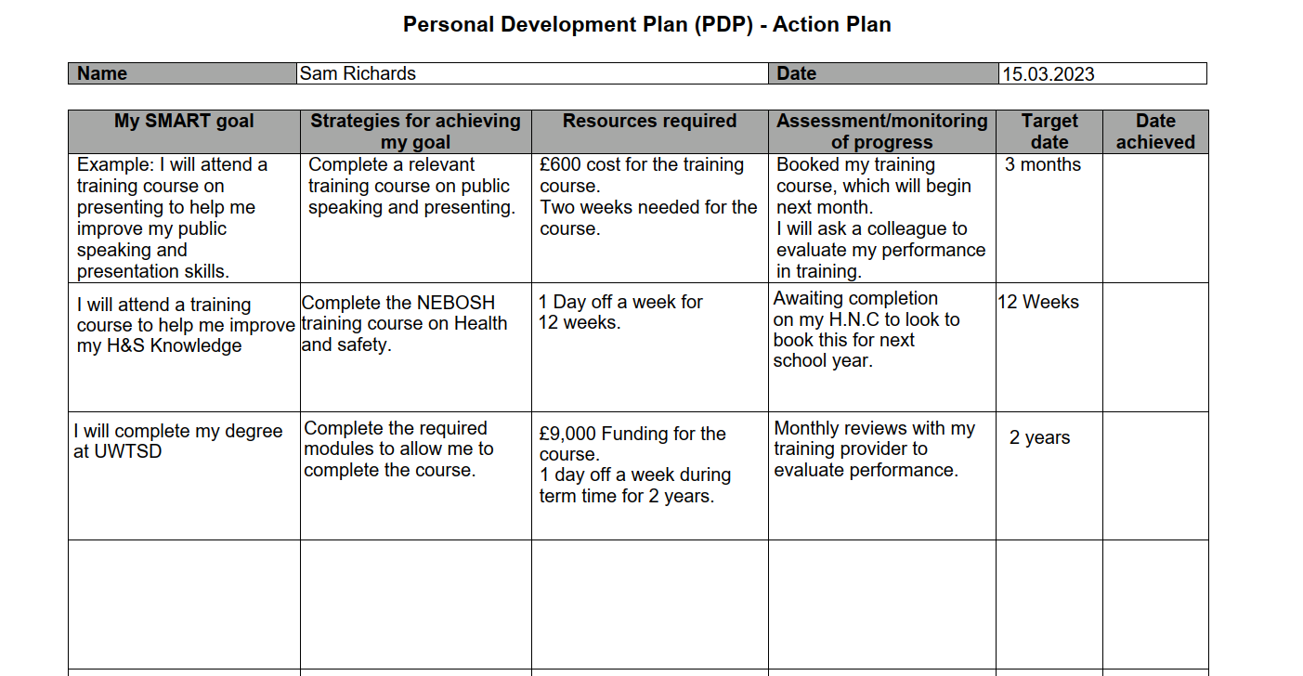

Understanding the importance of organisational behaviour and the benefit this would add to your personal development.
  - What is organisational behaviour?
The study of how individuals and groups act within organisations is known as organisational behaviour (OB). It entails investigating and comprehending how individual behaviour impacts organisational performance. (Kopp, 2023)
Communication, leadership, inspiration, decision-making, team dynamics, and organisational culture are just a few of the subjects covered by OB. Organizations can increase employee satisfaction, boost productivity, and achieve better overall performance by understanding these factors.
Employee engagement, job satisfaction, organisational communication, diversity and inclusion, and change management are some of the areas of focus in OB. Organizations can learn more about how to better lead and inspire their staff, develop stronger teams, and foster a positive and effective work environment by researching these subjects.
Kopp, (2023) tells us that organizational behaviour, as a whole, is a multidisciplinary field that incorporates ideas and theories from management, sociology, anthropology, and psychology. Organizations can more effectively manage their workforce and enhance overall performance by having a better understanding of how individuals and groups behave within those organisations.
  - Understanding the importance of organisational behaviour.
The study of organisational behaviour examines how individuals behave within organisations, including their interactions with one another and with the structure and culture of those organisations. This is because it can improve one's understanding of oneself and others, communication, and leadership abilities, an understanding of organisational behaviour is crucial for personal growth. Understanding organisational behaviour has the following advantages for one's personal development: (Kopp, 2023)
Self-awareness: Being aware of organisational behaviour can help people become more aware of their actions and the effects they have on others. People can learn how to interact with others and become more self-aware by studying subjects like motivation and communication. (Kopp, 2023)
Communication that works: Success in any organisation depends on effective communication. Understanding organisational behaviour can help people improve their interpersonal communication skills, such as active listening, feedback-giving, and conflict management.
Leadership skills: By learning about various leadership approaches and styles, people can develop their leadership abilities by understanding organisational behaviour. (Kopp, 2023)
Resolution of conflicts: Conflicts inevitably arise in all organisations, but better conflict management is possible when people are aware of organisational behaviour. People can discover the causes of conflict and come up with solutions that are agreeable to all parties by learning about various conflict resolution techniques. (Kopp, 2023)
  - What benefit does organisational behaviour add to my personal and professional development?
My personal and professional development can be significantly impacted by realising the significance of organisational behaviour in several ways.
Enhanced interpersonal abilities: Information about organisational behaviour can be used to understand how individuals interact within a company. Understanding various personality types, communication preferences, and motivations will help me improve all of my interpersonal skills to then allow me to forge closer bonds with co-workers. (Kopp, 2023)
Improved leadership abilities: Organizational behaviour theories can help me comprehend how to effectively manage and motivate employees. I can create more efficient plans for leading people, resolving conflicts, and achieving organisational objectives by adapting these theories to my leadership style. Understanding organisational behaviour can help people better understand their own and other people's motivations. Studying motivation theories can help people develop work environments that encourage intrinsic motivation, which can boost output and increase job satisfaction.
Making decisions: By giving people a framework for analysing situations and being aware of the effects of their choices, an understanding of organisational behaviour can assist people in making better decisions. People can improve their effectiveness in their roles by learning to make decisions that are consistent with the objectives and values of the organisation. (Kopp, 2023)
Enhanced self-awareness: Organizational behaviour also aids in the growth of my sense of self-awareness which is crucial for both my personal and professional development. I will be able to identify areas for improvement and create a strategy to reach my own goals by comprehending my motivations, strengths, and weaknesses.
Better decision-making: By comprehending organisational behaviour ideas like decision-making procedures, allows me to make more informed decisions that consider the effects on other people and the organisation as a whole.
Better job performance: By giving you insights into how to work more effectively with others, communicate more effectively, and be more productive and efficient, an understanding of organisational behaviour can also help you improve your job performance. (Kopp, 2023)
  - In conclusion, understanding organisational behaviour is crucial for personal development. It can help you develop crucial skills like self-awareness, effective communication, leadership, conflict resolution, motivation, and decision-making. By applying these skills in both their personal and professional lives, people can increase their success and effectiveness in their roles.
  - does your organisation offer any rewards to encourage professional development?
My company offers many rewards to encourage professional development. They offer an annual bonus depending on performance. This encourages us all to develop as a team to ensure all requirements are met. All courses I go on are funded by the company so that in itself is a reason to encourage professional development due to the fact I can progress my knowledge to the best of my ability.

CV
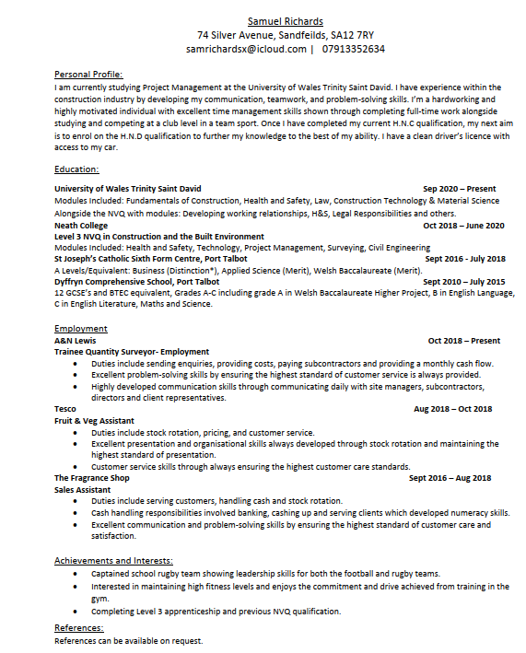

Leadership
  - What is leadership?
The ability to motivate, direct, and influence others to realise a shared objective or vision is referred to as leadership. A leader is someone who can inspire and motivate others to take action by sharing their clear vision of where they want to go in the future.
Communication, decision-making, problem-solving, empathy, and the capacity to inspire and motivate others are just a few of the skills needed for effective leadership. Additionally, leaders need to be able to handle conflict, adjust to changing conditions, and foster an environment where their team members can work effectively.
Success in the construction industry depends on having a strong leader. They need to be able to manage resources well, communicate expectations clearly, and set goals and objectives for the team. They must also be able to forge strong bonds with fellow team members, offer support and direction when required, and make difficult choices when necessary. In general, having strong leadership is essential for success in any industry, including construction.
(Mind Tools, 2020).
  - Understanding Leadership & Leadership Styles
Understanding leadership theories is crucial for aspiring professionals because it is a necessary skill in the workplace. A team, organisation, or project's success can be significantly impacted by effective leadership. You can better understand leadership and the traits and abilities required to be an effective leader by understanding leadership theories.
Indeed, (2021) tells us that there are various theories of leadership, each with a unique viewpoint on what makes a great leader. Trait theory, behavioural theory, situational theory, and transformational theory are a few of the most popular theories of leadership. These theories can assist you in comprehending the various elements that go into effective leadership, including personality traits, behavioural patterns, environmental factors, and the capacity to motivate and inspire others.
Leadership styles refer to the different approaches that leaders use to lead their teams. There are various leadership philosophies, and each has advantages and disadvantages. These are a few of the most prevalent leadership philosophies:
Autocratic leadership: In this style, the boss makes all the decisions without consulting the team. It can be helpful in circumstances where decisions must be made quickly or where the leader has extensive knowledge.
Democratic Leadership: In this approach, the boss consults with the group before making a choice. It can be helpful when a leader wants to promote innovation and creativity.
Laissez-Faire Leadership: In this approach, the boss gives their team a lot of discretion and little guidance. When a team is highly skilled and motivated, it may be helpful. Transformational In this leadership style, the team is inspired and motivated to work towards a common objective. It can be helpful when a team needs to collaborate to complete a challenging task.
Servant leadership involves a leader prioritising the needs of their team and concentrating on their development. When a leader wants to create a solid and devoted team, it can be helpful.
Transactional leadership: In this approach, the leader establishes definite objectives and offers incentive es for reaching those objectives. When the team needs structure and clarity, it may be helpful. (Mind Tools, 2020).
You can develop your leadership style and select the strategy that works best for you and your team by being aware of these various leadership philosophies. You can improve your leadership skills and help your organisation succeed by learning about various leadership theories and styles.
According to Mind Tools, (2022), I lean towards a democratic style of leadership. I tend to set the parameters for the work and have the final say on decisions, but I need to actively involve my team members in the process. This style can build trust between me and my colleagues, as they'll likely feel engaged and valued. But it's not great in a high-pressure situation that requires a fast turnaround, as it will slow me down. If you dislike disagreement or conflict, you might struggle with how people respond to the consultation.

Critical Analysis
  - The conflict between us and a client representative was due to poor workmanship. (15-25 Red Street)
Last year our company had an altercation between myself and the clients representative on a project down in Carmarthen as the company in question didn’t follow the correct protocol for using the Sika product which method included starting with jet washing the existing paintwork with high-pressured steam with a chemical that strips the paint back to bear brick before applying 2no primer coats and allow correct drying time before to applying the 3no topcoats over 3 days (a coat a day). As the project was in early spring I should have pushed the job to summer but with the help of my contracts managers, surveyor and other members of the team we decided to proceed with the job on the basis the clients representative provided us with his recommended sika contractors who specialise in this system. The first stage of the project went as it should paintwork was stripped and ready for the primer and top coats. We had a meeting on site 2 days since they had done the primer coats client’s representative was happy with the quality of work at this time. As the company started applying the top coats we noticed the paint starting to blister and run down the building (see Appendix 1). This happened due to the primer not being dry. As a result, caused our company to lose thousands in LDs due to the programme running over massively and the loss of clientele. I argued the fact that the sub-contractor was an approved contractor suggested by himself to carry out these works but the client’s representative argued that it was our duty as principal contractor to ensure a good standard of workmanship and that I should have done more research on the product beforehand. However, I argued the fact regarding the client suggesting this contractor but I did take fault for not doing my research. If I had been In this situation again I would have used the collaborating section of our conflict management system to liaise direct with the client’s representative to discuss progress meetings on-site so he could clarify early on if he isn’t happy with the quality of work. In regards to the recommended coats etc, I would call out a representative from Sika to observe any contractor’s method of application.
  - Write a personal statement about your leadership style, philosophy and key approaches.
According to Mind Tools, (2022), I tend to favour democratic leadership. I usually decide what needs to be done and who gets the final say, but I need to actively involve my team members. With this approach, I can increase trust with my co-workers because they'll probably feel appreciated and engaged. But because it will make me slower, it is not ideal in a situation where there is a tight deadline. You might find it difficult to deal with how people react to the consultation if you don't like disagreement or conflict.

Conflict Management
  - What is conflict management?
According to Couresa (2014), The process of recognizing, addressing, and resolving conflicts or disagreements that develop between people or groups is referred to as conflict management. Conflict can happen in any situation, including interpersonal relationships, workplaces, and communities. It can result from several things, including divergent objectives, opposing viewpoints, miscommunication, or power imbalances.
  - Successful conflict management can be accommodated by a variety of tactics. Which are:
  - Accommodating
  - One who is accommodating puts others' needs and wants ahead of their own. You would be putting other people's worries ahead of your own. This kind of behaviour typically occurs when you simply give in or are persuaded to do so.
  - This approach may be appropriate to use when you have a lower level of concern for the subject than other people, want to maintain the status quo, believe you are in the wrong, or feel compelled to accept the opposing point of view.
  - Avoiding
A style of avoiding completely avoids the conflict. You wouldn't pursue your own beliefs or the beliefs of the other participants. Simply put, whenever a conflict arose, you would continually put it off or avoid it altogether.
This approach may be appropriate if the conflict seems unimportant, you need more time to think or don't have any, you believe you have no chance of winning, or you are concerned about receiving resentment. (Herrity, J, 2016).
  - Compromising
  - A compromising approach looks for a solution that, at the very least, partially satisfies all parties. Finding a middle ground between all the needs would require effort, and the results would typically leave people feeling either somewhat or not at all satisfied.
When a deadline is quickly approaching, you're at a dead end, you need a temporary solution for the time being, or it's more important to find a solution than it is for the solution to be great, this approach might be appropriate.
(Herrity, J, 2016).
Collaborating
Finding a solution that will satisfy the needs of all parties is the goal of collaborating. You would strive for a solution that pleases everyone and ends up being a win-win scenario rather than trying to find a compromise.
This approach may be appropriate when it's necessary to consider multiple viewpoints, when there is a significant relationship between the parties, when the outcome is too important for anyone to be dissatisfied, or when the opinions of various stakeholders need to be represented.
(Herrity, J, 2016).
  - Competing
An opposing approach adopts a rigid stance and declines to consider the viewpoints of the other parties. Until you were successful in imposing your opinion on others or rejecting their suggestions, you would keep doing it.
This approach may be appropriate when you need to defend your rights or morals, make a snap decision and convince others to agree, put an end to a protracted argument, or stop a terrible, opposing decision from being made.
(Herrity, J, 2016).
  - Why is conflict management important?
According to Indeed, (2022) conflict management is crucial for several reasons:
The conflict has the potential to negatively affect workplace morale, motivation, and productivity. Organizations can avoid process hiccups and uphold a productive work environment by managing conflicts skilfully.
Relationships can be strained by conflict, both personally and professionally. Effective conflict management can help keep these relationships intact by resolving conflicts before they become irreparable.
Promotes Open Communication: Dealing with disagreements in a constructive way can promote open communication among people or groups. People are more likely to speak honestly and work towards a solution when they feel heard and understood.
Enhances Problem-Solving: Dealing with conflicts can present chances for problem-solving, which can improve judgement and inspire creativity.
Reduces Stress: Unresolved disputes can make those involved anxious and stressed. Stress levels can be decreased and well-being can be enhanced by effective conflict management.
In general, conflict management is crucial because it helps people and organisations maintain positive working relationships, boost productivity, and lessen the stress and negative effects of conflict.
(Herrity, J, 2016).

Teamwork
  - What is teamwork?
Indeed, (2022) tells us that the cooperative effort of a group of people working towards a shared goal or objective is known as teamwork. It involves using each team member's strengths and skills to accomplish a common goal and calls for effective teamwork, coordination, and communication. Mutual respect, trust, a willingness to collaborate, and a shared commitment to the team's objectives are necessary for effective teamwork. Working as a team is crucial for success in any field, including construction, and for producing high-quality outcomes.
‘Construction is a collaborative activity – only by pooling the knowledge and experience of many people can buildings meet the needs of today, let alone tomorrow. But simply bringing people together does not necessarily ensure they will function effectively as a team. Effective teamwork doesn’t beat occur automatically. It may be undermined by a variety of problems such as lack of organisation, misunderstanding, poor communication and inadequate participation.’.
That statement is true. Any construction project needs strong teamwork to succeed, which takes a lot of work and commitment from all team members. Simply having a team of talented people working on a project is insufficient because their efforts can easily be thwarted by a lack of organization, misunderstandings, poor communication, and insufficient participation.
It's crucial to define each team member's roles, responsibilities, and goals up front to create an efficient team in the construction industry. To make sure that everyone is on the same page and can cooperate to achieve the shared objectives, regular communication and feedback are also crucial. (Herrity, J 2014)
Additionally, it's crucial to foster an atmosphere that encourages cooperation, innovation, and open communication. This can be accomplished by participating in team-building exercises, enrolling in training courses, and fostering an environment that values diversity and promotes idea-sharing.
Finally according to Constructing Excellence, (2004). It is critical to identify and resolve any issues that develop within the team as quickly as possible. This can be achieved through routine check-ins, candid conversations, and a readiness to hear and respond to any issues that team members may be experiencing.
In conclusion, successful teamwork is crucial for any construction project. Construction teams can collaborate effectively to meet today’s and tomorrow’s demands by establishing clear goals and roles, encouraging collaboration and open communication, and addressing issues as they arise.
(Herrity, J 2014)

Why is teamwork so important?
  - Fraiser, S. (2014) creates the impression that all team members come together during the forming phase of team development to get to know one another's personalities and working methods. It's crucial to establish the team-specific goals and objectives at this stage, as well as to specify roles and responsibilities. Tuckman's Model of Group Development is a well-known model that describes the stages of team development.
  - Summary of the module's learning objectives:
- The value of clear communication in interpersonal and professional interactions
- The advantages of empathy and active listening in conflict resolution
- Knowing the various conflict types and how they can occur in various circumstances
- developing conflict management and resolution techniques, such as collaboration and compromise
- The function of emotions in conflict and effective emotion management
- identifying and addressing unintentional prejudices that could lead to conflicts
- The significance of upholding respect and professionalism in conflict resolution
- Recognizing how cultural differences can affect how conflicts are resolved
- The importance of self-awareness and reflective practice for personal and professional development.

Appendix






Reference List
Herrity, J. (2017). 10 Ways To Demonstrate Professional Behaviour at Work. [Online]. Indeed. Last Updated: 1st February 2023. Available at: https://www.indeed.com/career-advice/career-development/professional-behavior-workplace [Accessed 17th November 2022].
BBC. (2009). Ethics. [Online]. www.bbc.co.uk. Available at: https://www.bbc.co.uk/ethics/introduction/intro_1.shtml [Accessed 12 December 2022].
Indeed. (2022). What is teamwork? [Online]. www.indeed.com. Last Updated: 5th November 2022. Available at: https://sg.indeed.com/career-advice/career-development/what-is-teamwork [Accessed 12th January 2023].
Ehsanfar, M. (2019). Understanding and Defining the Organizational Context. [Online]. www.linkedin.com. Available at: https://www.linkedin.com/pulse/understanding-defining-organizational-context-mohsen-ehsanfar [Accessed 23rd Jan 2023].
Indeed. (2021). 8 Common Leadership Styles. [Online]. www.indeed.com. Last Updated: 16th March 2023. Available at: https://www.indeed.com/career-advice/career-development/10-common-leadership-styles [Accessed 11 February 2023].
Mind Tools. (2020). What Is Leadership? [Online]. www.mindtools.com/. Available at: https://www.mindtools.com/a2fjsj1/what-is-leadership [Accessed 25th February 2023].February 2023].
Constructing Excellence. (2004). Effecting Teamwork. [Online]. www.constructingexcellence.org.uk. Available at: www.constructingexcellence.org.uk [Accessed 15 March 2023].
Kopp, C. (2023). What Is Organizational Behaviour (OB), and Why Is It Important? [Online]. www.investopedia.com. Last Updated: 14th March 2023. Available at: https://www.investopedia.com/terms/o/organizational-behavior.asp [Accessed 23rd March 2023].
British Standards Institution. (2017). Why British Standards? [Online]. www.bsigroup.com. Available at: https://www.bsigroup.com/en-GB/standards/bsi-knowledge/why-british-standards/ [Accessed 5 April 2023].
Fraiser, S. (2014). What makes a good leader? [Online]. www.gov.uk. Last Updated: 12th May 2014. Available at: https://www.gov.uk/government/speeches/what-makes-a-good-leader [Accessed 12 March 2023].
RICS. (2022). Standards. [Online]. https://www.rics.org/profession-standards. Last Updated: 27th October 2022. Available at: https://www.rics.org/profession-standards [Accessed 05.04.2023].
Couresa. (2014). Conflict Management. [Online]. www.coursera.org. Last Updated: 21.02.2023. Available at: https://www.coursera.org/articles/conflict-management [Accessed 5 April 2023].
Herrity, J. (2016). 5 Conflict Management Styles and How To Use Them Effectively. [Online]. Indeed. Last Updated: 1st October 2022. Available at: https://www.indeed.com/career-advice/career-development/conflict-management-styles [Accessed 4 April 2023].
Mind Tools. (2022). What's Your Leadership Type? [Online]. https://www.mindtools.com/azr30oh/whats-your-leadership-style. Available at: https://www.mindtools.com/azr30oh/whats-your-leadership-style [Accessed 6 April 2023].
BBC. (2021). Miami building collapse: What could have caused it? [Online]. www.bbc.co.uk. Last Updated: 1st July 2021. Available at: https://www.bbc.co.uk/news/world-us-canada-57651025 [Accessed 11 April 2023].
Herrity, J. (2014). 12 Reasons Why Teamwork Is Important in the Workplace. [Online]. www.indeed.com/. Last Updated: 27 February 2023. Available at: https://www.indeed.com/career-advice/career-development/teamwork-important [Accessed 11 April 2023].

