An Examination and Analysis of How the ‘Early Help’ System Is Signposted to UK Families by Three Local Authority Websites

Student Name: Pavlin Enchev
Student Number: 2327272
Professor’s Full Name: Amanda Jones

Table of Contents
Introduction 3
Explanation of the Early Help System 3
Explanation of Multi-Agency Working 4
Evaluation of the Three Local Authority Websites 5
1. Leeds City Council 5
2. Norfolk County Council 7
3. Nottinghamshire County Council 8
Comparative Analysis: Strengths and Weaknesses across the Three Websites 9
Conclusion and Recommendations 10
Reference List 13

Introduction
‘Early Help’ constitutes a crucial component of support that is offered to children and families in the United Kingdom. The local authorities have to make information easier to understand to make the families see what Early Help is, how it works, and how they can obtain the support when it is the right moment. This report discusses the communication of Early Help on the public websites of three local authorities: Leeds City Council, Norfolk County Council, and Nottinghamshire County Council. The critique is based on clarity, access, the level of information, and conformity to national guidance. In writing the report, the Early Help System Guide (Department for Education, 2022) and Working Together to Safeguard Children (HM Government, 2023) proved imperative. The report concludes and recommends areas for early help communication with local authorities for improvements.

Explanation of the Early Help System
Early Help is a national strategy that aims to assist children, youth, and families at the earliest opportunity when the difficulties have not yet become severe issues. It involves identifying needs at an early stage and providing long-term practical, emotional, or developmental support to avoid escalation. It would be proactive prevention and not an intervention to save the crisis. The Early Help System Guide provides that Early Help should be perceived as “a whole-system response comprising partnership, shared responsibility, and early action” (Department of Education, 2022). This implies that the system is based upon close inter-dependence of schools, health services, local authorities, voluntary organisations, and community groups.
The Early Help process can involve an Early Help assessment, the settlement of an action plan with the involved family and agencies, and periodic reviews in which the progress can be observed. It is aimed at reinforcing protective factors, minimizing risks, and offering coordinated assistance based on the needs of the family. The assistance can be in the areas of parenting, behaviour, school attendance, physical or mental, housing, financial, or relationship difficulties. Notably, Early Help is voluntary, consensual, and focused on meeting families and not doing to them.
The significance of this approach is supported by national guidelines. Working Together to Safeguard Children emphasises that Early Help “is necessary since children can require assistance from numerous organisations” (HM Government 2023, p. 12). It further provides that it is the role of local authorities to make sure that clear information about Early Help is readily available, and families know what assistance is provided, the manner in which the process is released, and how to request support. Good communication with the public is thus a cornerstone of an efficient Early Help system, where families can identify problems early in life before they run out of control.

Explanation of Multi-Agency Working
Working across the board with multiple agencies is one of the fundamental ideas of the Early Help system since the needs of children are multifaceted and broad. Every task of a family situation cannot be sorted through a single practitioner or organisation because of the lack of capacity and experience to cater to all the facets of the family. The individuals involved in early identification, assessment, and support are schools, early years providers, health visitors, GPs, youth workers, police, housing teams, community groups, and children's social care. With such professionals collaborating, families get a unified and integrated response instead of having to retell their stories or use multiple and unlinked services.
The national guidance emphasizes the need to have organized collaboration. Open exchange of information, collective review, and collaborative planning are a few essential needs. The Early Help System Guide urges local areas to develop systems where partners share responsibility to achieve results in such a manner that the support seems to be integrated and coherent in the eyes of the family. Moreover, Working Together to Safeguard Children explains that local safeguarding collaborations should be in the lead and coordinate multiagency collaboration, which fosters interagency responsibility and constant enhancement.
The concept of multi-agency working is based on sound professional relationships, accepted referral channels, and open communications, both operational and public. Local authority websites, thus, are valuable in clarifying the interaction between agencies, the contribution of each service, and the way families should expect professionals to collaborate.
To the families, the knowledge of the people involved and how the system operates gives confidence and trust. With such information available to families through clear and easily accessible means, such as public websites, they are more likely to pursue help at an early stage and take an active part in the services provided to assist them.

Evaluation of the Three Local Authority Websites

1. Leeds City Council
Leeds City Council describes Early Help information openly and understandably. The design is plain, and the text is not hard to comprehend. Data falls under the “Children and Families” category, under which families can find Early Help easily.
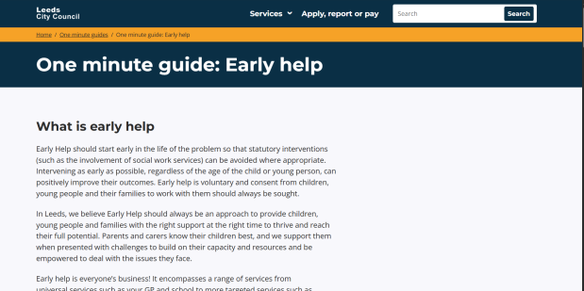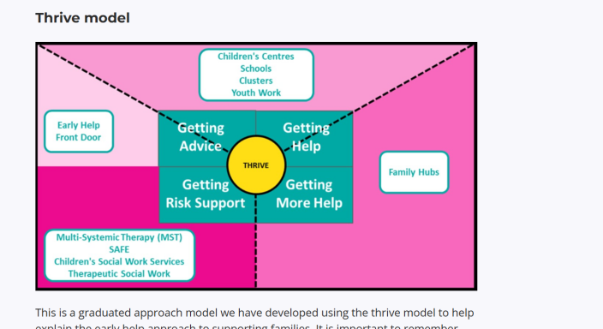
Fig 1: Leeds Early Help Landing Page, Thrive Model
The site provides a simple definition of Early Help. It explains the aim of the support as well as provides examples and outlines to families the benefits. The page is not loaded with technical terms. The language is informal and encouraging, and it contributes to the interaction. The description explains the way in which Early Help can assist in school attendance, emotional well-being, behaviour, or family relationships. This assists parents in associating Early Help with what they have experienced in life.
There is also a clear explanation of access routes. Leeds gives telephone and online enquiry alternatives, as well as direct connections to allied services. Families have a way of knowing who to reach and how to begin the process. The Leeds Early Help Assessment form is also available on the site. This provides the same base information to the public and professionals.
Leeds also mentions the contribution of various partners. It has information regarding community hubs, schools, health teams, and voluntary organisations. This is in line with the values of multi-agency working laid out in Working Together (2023). The website states that families can collaborate with multiple agencies simultaneously, depending on their requirements.
Strengths | Weaknesses
- Clear and simple explanations.  - Contemporary and convenient design.  - Suitable for parents with limited digital skills.  - Clear referral routes.  - Links to local partners. | - Fewer downloadable resources compared with Norfolk.  - Limited diagrams for visual learners.

2. Norfolk County Council
Norfolk County Council has one of the most developed Early Help webpages among local authorities. The information is displayed under the “family section” and is divided into a few comprehensive sections. The demonstration also has more text than Leeds; however, it also provides several downloadable leaflets and forms.
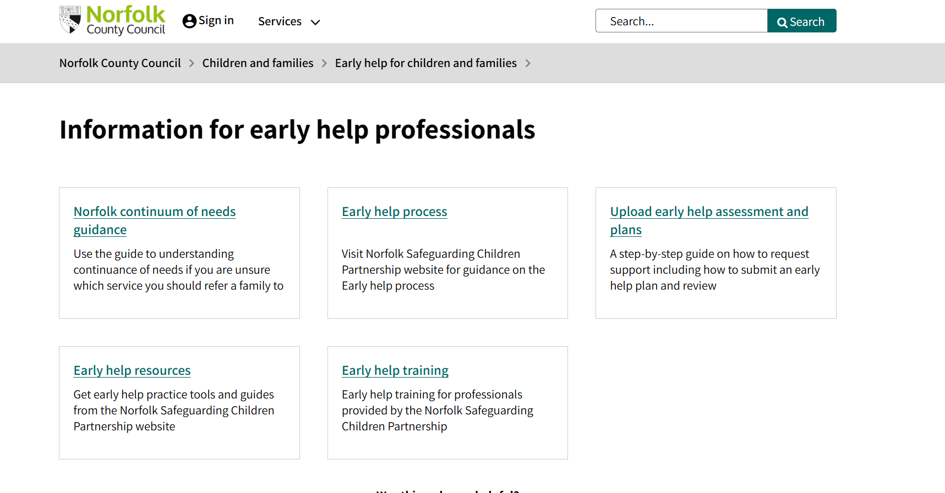
Fig 2: Norfolk Early Help Information Interface
Norfolk provides an extremely precise description of Early Help, its purpose, and ways in which families can enjoy assistance. The site emphasises that the Early Help maintains the togetherness of families and alleviates issues in time. It clarifies that help can be in short-term or long-term work, based on the requirements. The tone is supportive but more formal than Leeds.
Norfolk features good referral information. It contains several guidance notes, steps, and online forms. It is possible to download material that clarifies the process by families and professionals. Examples of these are instructions on how to fill out assessments and descriptions of the work of partner organisations. These reports enhance honesty and accountability.
There is a lot of multi-agency information available on the website. Norfolk emphasizes collaboration of the health services, schools, social care team, police, and voluntary groups. It also shows the details of the multi-agency safeguarding hub within Norfolk. This is highly consistent with the requirements of Working Together (2023).
Strengths | Weaknesses
- Extensive Early Help documentation.  - Clear guidance on referrals.  - Several downloadable resources.  - Strong explanation of multi-agency working.  - Accessible leaflets for the public. | - Text-heavy structure may feel overwhelming.  - Website design is less modern than Leeds.

3. Nottinghamshire County Council
The ‘Early Help’ section offered by Nottinghamshire County Council is well-organized and balances the levels of clarity and detail. The pages of Early Help can be found in the section “Children and Families.”
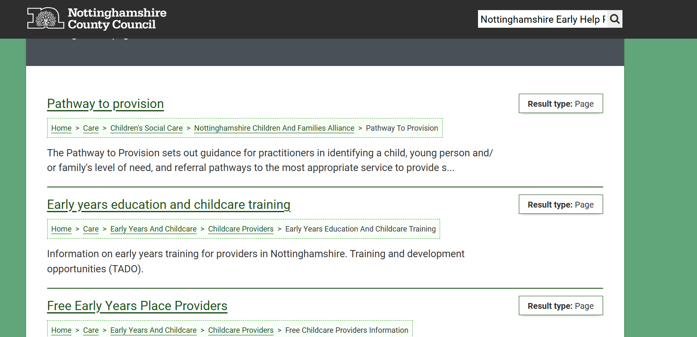
Fig 3: Nottinghamshire Early Help Pathway
The site describes the Early Help in an easy language. It states the purpose and nature of Early Help, how it will prevent the escalation of the problem, and the way families can be supported with behaviour, attendance, or emotional well-being. The language is clear and speaks to a general audience.
The process of referral is clear. Nottinghamshire provides Early Help forms of assessment and guidance. It also presents new players' contacts of local teams. The site provides information in a structured fashion and has fewer examples than Leeds.
The website also outlines multi-agency arrangements. It also points to a well-structured Early Help Framework that defines partner collaboration. They are recognised as schools, health services, and social care teams. On the other hand, when compared to Norfolk, Nottinghamshire has fewer elaborate records explaining these roles.
Strengths | Weaknesses
- Clear and structured information.  - Simple access to referral forms.  - Well-organised layout.  - Balanced level of detail. | - Less visual content.  - Not as many multi-agencies as in Norfolk.  - Limited real-life scenarios for families.

Comparative Analysis: Strengths and Weaknesses across the Three Websites
Leeds, Norfolk, and Nottinghamshire introduce Early Help well, although they vary in the approach, complexity, and availability.
Accessibility and Navigation: The site that is most accessible is Leeds. It has a plain and contemporary design. Norfolk offers more in-depth content, yet it is heavier text-wise. Nottinghamshire is less visual with good clarity.
Clarity of Early Help Information: Leeds provides the most understandable explanations to non-specialists. Norfolk is the most detailed, though it might not be easily digestible by families that may prefer short and concise messages. Notably, Nottinghamshire offers a middle-ground approach.
Referral Guidance: Norfolk scores best in this aspect. Another advantage is that access routes in Leeds are clear, and a download in Nottinghamshire is solid though not as comprehensive.
Multi-Agency Working: Norfolk gives the most intuitive data concerning multi-agency positions and systems. Leeds quibbles over this field less elaborately. The county of Nottinghamshire has a strong framework, but has fewer examples to support it.
Overall Effectiveness: Leeds has the most balanced approach to be adopted by the family, as it is straightforward, easy to understand, and has a friendly tone. Norfolk is packed with both professionals and families who would like more details. Nottinghamshire has a clear structure, but may increase the level of multi-agency solutions.

Conclusion and Recommendations
The report has explored the manner in which Leeds, Norfolk, and Nottinghamshire market the Early Help offer and the efficacy of the communication methods they utilize to serve families requiring support. All three local authorities have understandable and relatively open information available, but they differ significantly in their focus, structure, and style of presentation. Leeds proves the most presentable because of its simple design, the use of clear language, and clear navigation, as the reader can easily read and access available support opportunities. Norfolk offers the most comprehensive detail, especially to professionals, which offers detailed information but with a more formal tone that might not be easy to read for the common man. Nottinghamshire also has an opportunity to provide a well-arranged and structured presentation, but uses fewer visuals and involvement elements, and this aspect decreases intuitive interpretability.
To enhance the Early Help communications across the country and facilitate the continuity and family-focused messages of the message across the local authorities, the recommendations are as follows:
- Consolidate and cement the diagram usage - making the Early Help pathways more visual and helping families see the way they get support better.
- Prepare short downloadable leaflets in all councils - making sure that there is a consistent level of access to information and also easy-to-read information across the different local authorities (Sapiets et al. 2022).
- Streamline referral advice to non-professionals - make this process less complicated and allow the family without specialist expertise to complete the referral process by themselves (Grant et al., 2025).
- Strengthen governance through public description of the multi-agency role functions - enhancing clarity regarding the role of schools, health services, social care, and community organisations in the Early Help (Munro, 2011).
- Incorporation of more real-life examples within public materials – making families identify the guidance with their personal situations and promote preliminary use of support resources (Brandon et al., 2012).

Fig 4: Suggested Early Help Pathway Diagram
Together, these suggestions facilitate more effective and regular communication and help to receive Early Help in time before complications might arise.

Reference List
Brandon, M., Sidebotham, P., Bailey, S., Belderson, P., Hawley, C., Ellis, C. and Megson, M. (2012). New learning from serious case reviews: a two year report for. [online] Available at: https://assets.publishing.service.gov.uk/media/5a7a0893ed915d6d99f5cab0/DFE-RR226_Report.pdf.
Department for Education (2022) Early Help System Guide. London: DfE.Early Help System Guide (publishing.service.gov.uk)
Grant, L., Bostock, L., Kinman, G., Shephard, L. and Tinarwo, S. (2025). Child and family social worker knowledge and skills Rapid evidence review April 2025. [online] Available at: https://assets.publishing.service.gov.uk/media/6808da570324470d6a394efc/Child_and_family_social_worker_knowledge_and_skills.pdf.
HM Government (2023) Working Together to Safeguard Children 2023: Statutory Guidance. London: HMSO. http://Working together to safeguard children 2023: statutory guidance (publishing.service.gov.uk)
Munro, E. (2011). Munro review of child protection: a child-centred system. [online] GOV.UK. Available at: https://www.gov.uk/government/publications/munro-review-of-child-protection-final-report-a-child-centred-system.
Sapiets, S.J., Hastings, R.P., Stanford, C. and Totsika, V. (2022). Families’ Access to Early Intervention and Supports for Children With Developmental Disabilities. Journal of Early Intervention, 45(2), p.105381512210839. doi:https://doi.org/10.1177/10538151221083984.
Leeds City Council (2024). Early Help for Family Support. [online] Leeds.gov.uk. Available at: https://www.leeds.gov.uk/..
Norfolk County Council (2024). Early Help - Norfolk County Council. [online] www.norfolk.gov.uk. Available at: https://www.norfolk.gov.uk/.
Nottinghamshire County Council (2024). Early Help Services. [online] Nottinghamshire County Council. Available at: https://www.nottinghamshire.gov.uk/.

