Assignment 2

Skills Development For HRM Issues In Apple Inc.

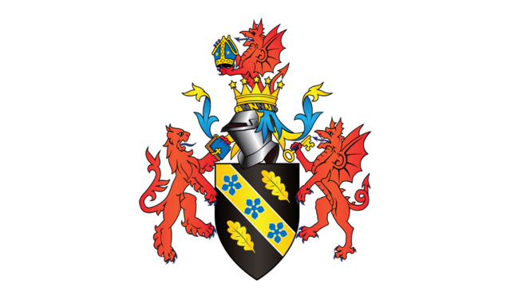
April 2023

MODULE NAME： Human Resource Management (BMMB7007)
NAME: Tian Gan
STUDENT NUMBER: 2206225

Link to my video on Microsoft Stream：
https://web.microsoftstream.com/video/4a697215-efa9-4b3e-81e5-01f46f60738c

Reference list
Farris, D., 2022. We Culture: 12 Skills for Growing Teams in the Future of Work - ProQuest. [online] Available at: https://search.proquest.com/openview/c3ed05d49a70bdb2fd7b3f9b2a9cea13/1?pq-origsite=gscholar&cbl=34671 [Accessed 28 Apr. 2023].
Gounaris, S. and Tzempelikos, N. (2014). Relational key account management: Building key account management effectiveness through structural reformations and relationship management skills. Industrial Marketing Management, 43(7), pp.1110–1123. doi:https://doi.org/10.1016/j.indmarman.2014.06.001.
Guillaume, Y.R.F., Dawson, J.F., Otaye-Ebede, L., Woods, S.A. and West, M.A. (2017). Harnessing demographic differences in organizations: What moderates the effects of workplace diversity? Journal of Organizational Behavior, 38(2), pp.276–303. doi:https://doi.org/10.1002/job.2040.
Khodakarami, F. and Chan, Y.E. (2014). Exploring the role of customer relationship management (CRM) systems in customer knowledge creation. Information & Management, [online] 51(1), pp.27–42. doi:https://doi.org/10.1016/j.im.2013.09.001.
Kim, Y. (2021). Building organizational resilience through strategic internal communication and organization–employee relationships. Journal of Applied Communication Research, 49(5), 1–20. https://doi.org/10.1080/00909882.2021.1910856
Laricchia, F., 2023. Apple number of employees 2005-2022. [online] Statista. Available at: <https://www.statista.com/statistics/273439/number-of-employees-of-apple-since-2005/> [Accessed 23 Mar. 2023].
Lopes, H., Lagoa, S. and Calapez, T. (2014). Work autonomy, work pressure, and job satisfaction: An analysis of European Union countries. The Economic and Labour Relations Review, 25(2), pp.306–326. doi:https://doi.org/10.1177/1035304614533868.
Rajhans, K. (2018). Effective Communication Management: A Key to Stakeholder Relationship Management in Project-Based Organizations Effective Communication Management: A Key to Stakeholder Relationship Management in Project-Based Organizations. [online] Available at: https://www.projektassistenz-blog.de/wp-content/uploads/2020/02/Effective_Communication_with_Stakeholders.pdf.
Rawashdeh, A. (2018). The impact of green human resource management on organizational environmental performance in Jordanian health service organizations. Management Science Letters , 8(10), 1049–1058. http://growingscience.com/beta/msl/2886-the-impact-of-green-human-resource-management-on-organizational-environmental-performance-in-jordanian-health-service-organizations.html
Sabharwal, M. (2014). Is Diversity Management Sufficient? Organizational Inclusion to Further Performance. Public Personnel Management, 43(2), pp.197–217.
Skelton, S.K., 2021. Apple Workers Challenge Company on Toxic Workplace Culture: Computer Weekly. [online] ComputerWeekly.com. Available at: <https://www.computerweekly.com/news/252506157/Apple-workers-challenge-company-on-toxic-workplace-culture#:~:text=A%20group%20of%20current%20and,human%20resources%20(HR)%20department.> [Accessed 23 Mar. 2023].
Terera, S.R. and Ngirande, H. (no date) The impact of rewards on job satisfaction and employee retention, Mediterranean Journal of Social Sciences. Available at: https://www.mcser.org/journal/index.php/mjss/article/view/1925 [Accessed 28 Apr. 2023].
Wohlers, C. and Hertel, G. (2016). Choosing where to work at work – towards a theoretical model of benefits and risks of activity-based flexible offices. Ergonomics, 60(4), pp.467–486. doi:https://doi.org/10.1080/00140139.2016.1188220.

‌
‌

‌
‌

‌

‌

‌

‌

‌

